Programme: BA International Hotel Management
Module: Foreign Languages & Cultural Awareness
Module code: BMIH5003
Lecturer: Giulia Chifari, Antoinette Milne

Assignment Title: Intercultural Competence Report

Student name: Golam Mohammed Polash
Student ID number: : 2238997

Executive Summary
This report is made to explore intercultural competence within the hotel industry. The report’s background is an assumption that I am a General Manager at a 5-star Multicultural Hotel & Spa in London, England (Anglo Cluster) which is headquartered in Spain. It analyses the overview of the cultural sensitivity of these two countries. It also analyses the report of the Globe Project of these 2 countries to identify cultural gaps and values. It also provides the critical challenges of intercultural leadership. Lastly, it concludes and suggests some recommendations.

Table of Contents
Introduction 4
Main Body 5
Cultural Overview of England and Spain 5
GLOBE Project Analysis for England and Spain 5
Critical Analysis of Challenges to Intercultural Leadership 9
Conclusion 11
Recommendations 12
References 13

Introduction
The newly appointed assistant general manager of Langham Hotel and Resorts, assuming the organization's headquarters are located in Spain, made a preliminary visit to the country to examine the hotel's value chain and operations.The following report integrates the observations made during the tour to Spain in advance of the integration of Spanish personnel into the London branch. Cultural differences, variances in work ethic, and leadership styles as reported by the GLOBE projects are also covered in this paper. In a dynamic and diversified environment and workforce, intercultural management is of the utmost importance for the hotel.

Main Body

Cultural differences between England and Spain
England
A great deal of individualism is inherent in English culture. An important cultural implication that it raises is the importance of individual agency and success. Acknowledging the value of personal initiative and accountability is a hallmark of more independent thinkers. Meetings and negotiations in a business environment are executed directly, emphasising the importance of time management and efficiency. The English society attaches great importance to and adheres to the standards of reliability, functionality and pragmatism (Nazarian et al., 2022). The language of English speech usually is a little distinct, latent, figurative, and symbolic. The UK culture is closely attached to the use of euphemisms and aversion to straightforwardness in professional encounters.
Spain
Spanish society is more collective in its approach, which is different from the individualistic orientation in English culture. Spanish society has a lot of group coherence, loyalty to a group, and family relationships. The main point of this unifying viewpoint is on common accomplishments and the needs of the whole team. Spanish vulture lays weight on the direct, expressional, and passionate way of communication. Communication among Spanish persons is emotional rather than intellectual (Arnedo et al., 2021). It may seem offensive to a conservative person when those hand gestures are highly visible. Spanish culture indicates that time is important and work ethic should be emphasised for the work-life balance. A defining feature of this attitude trait is a strong focus on developing relationships and informality in business dealings.

GLOBE Project Analysis for England and Spain
Power Distance
Spain has a higher tolerance for variances in hierarchical structures in society and institutions. The result is an example of a more authoritarian style of decision-making prevalent in corporate environments (López‐Fernández et al., 2023).
Power distance has decreased effects in England, which tends to encourage participative leadership and horizontal organisational structures (Adelina & Suprayogi, 2020). There is the possibility of conflicts as cultures with a norm of established hierarchy can be affected.
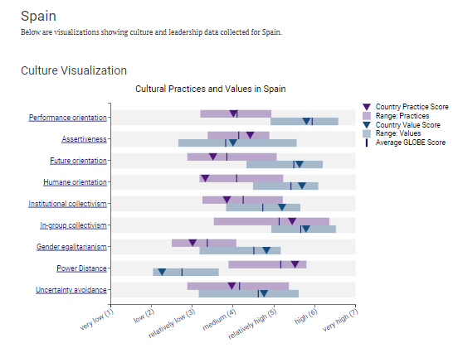
Figure 1: Globe Project Result of Spain (Globeproject.com, 2020)

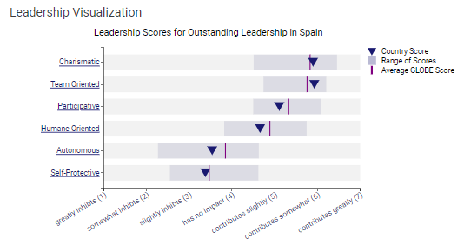
Figure 2: Figure 1: Globe Project Result of Spain (Globeproject.com, 2020)
Uncertainty Avoidance
Spanish society very often behaves so that stable, predictable and regular life rules are preferred. This could be an indication of the Survival Response which is likely displayed when there are unfamiliar things (Rienda et al., 2020). This cultural trait of planning, structure, and rule-following has commonalities with Spain.
Those from an English cultural background are more prone to risk-taking and adapting to new life because they have less anxiety about the unknown than other ethnicities. The culture becoming receptive to social stability and harmony could happen through this flexibility.
Assertiveness
The cultural influence of both the English and the Spanish is characterised by a moderate degree of assertiveness. Expression in Spanish culture is characterised by a more direct and expressive style of communication (Adelina & Suprayogi, 2020). Conversely, the expression of assertiveness in English culture is characterised by restraint and subtlety.
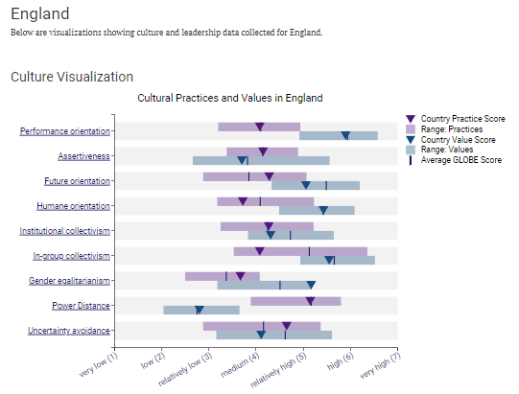
Figure 3: Globe Project Result of England (GLOBE, 2020)
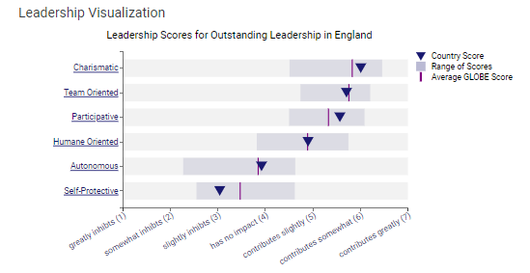
Figure 4: Globe Project Result of England (GLOBE, 2020)
Performance Orientation and Human Orientation
A result-centric strategy is central to the English cultural norm in business, which is very performance-oriented. Advancement and accomplishment are encouraged. An approach to problem-solving that is pragmatic is incorporated (Nazarian et al., 2022).
Human performances, with a focus on human orientation, are highly valued in the Spanish setting (Ushakov et al., 2020). It is highly valued in Spanish culture to prioritise social support, as well as the well-being of both the community and individuals inside an organisation.

Critical Analysis of Challenges to Intercultural Leadership
Communication Style
The employees' straight and explicit interaction style could result in not understanding the indirect and reserved people in English (Armstrong, 2020). As an example, a Spanish manager's feedback during team meetings could be considered overly critical or personal by their English colleagues which could result in discomfort or resentment. On the other hand, this expressive style helps communication with guests who are open for personal interactions to further strengthen guest satisfaction at the lounge, the dining area or the occasion.
Time- Management and Work Ethics
The time management way of Spanish attitude is a relaxed approach that sometimes leads to mix-ups and frustration in the working environment of English which fosters a punctual approach (Nazarian et al., 2022). A Spanish chef may opt for high quality and innovation in dish preparation over punctuality of service and irritate the English colleagues who need punctuality to be in line with guest expectations. Despite this relaxed approach possibly being a factor of a more flexible and innovative environment, where employees will be minimally put under pressure and motivated to deliver exceptional service, guests could benefit in time-sensitive settings.
Adaptation to Hierarchical Structures
English management is known for its egalitarianism and emphasis on employee participation (Köster, 2020). The Spanish staff, on the other hand, are very hierarchical, which could cause friction in the workplace. Delegating responsibilities and making decisions are consequently complicated. The hierarchical system can facilitate rapid decision-making during rush hours or emergencies, allowing accurate crisis management.
Cultural Sensitivity and Customer Interaction
A Spanish receptionist, working in his position, will be probably more close-contact-oriented, using gestures like a handshake or a pat on the back, which might be uncomfortable to guests from cultures where such interactions are not normal or appreciated. Thus, the hotel can customise its guests' welcome methods and menu choices provided that it has a staff of different cultures.

Conclusion
The significance of providing service while respecting cultural values is emphasised by cultural awareness and sensitivity in the hospitality and tourist business. Differences in organisational values and cultural norms provide both opportunities and threats to the smooth integration of Spanish workers into the London branch. The GLOBE projects that sought to determine what intercultural management requirements existed are detailed in this report. Recognising these distinctions between England and Spain is crucial to begin bridging the gap. As a result, the workplace will be more efficient and harmonious.

Recommendations
- Incorporating integrated cross-cultural training programmes: Sessions on cross-cultural understanding and communication should address the important points that centre on the main variations in work ethics and communication styles.
- Embracing a flexible leadership approach: Management teams can better accommodate employees' diverse cultural norms and sensitivity needs by embracing and implementing flexible leadership approaches.
- Encouraging Team Meetings and Social Events: Creating opportunities for employees from all backgrounds to regularly meet through planned team-building exercises and social gatherings.

References


