Hotel Standards, Reputation Management and Service Culture

STUDENT NAME: FLORIN BUDESCU

STUDENT ID:2230200

Module: BMIH4003 Hospitality & Guest Services

Word Count: 1654

Executive Summary

The report discussed the hotel sector in the United Kingdom and its importance on the economy. The report analysed the standards and culture of customers service in the hospitality sector in the UK and how these standards are impacting the administration of reputation, service culture and hotel standards. The report presented the methods that can be used in the hotel sector in UK to gather data emphasising on reputation management, service culture and hotel standards. The findings and recommendations for the hotel sector of United Kingdom were discussed in this report.

Table of Contents

Introduction 4
Main Findings 4
Recommendations…………………………………………………………………………..7Conclusion 8
References 9
Appendices 10

Introduction

The hotel sector in the United Kingdom is an important one that has a big impact on the economy and tourism of the nation. Millions of tourists from around the world visit the UK each year because of its famous tourist attractions, rich history, and diverse culture. As a result of the rising demand for lodging, the hotel business has expanded significantly. This research topic would further deal with reputation administration, service culture and hotel standards of the hotel properties of the entire United Kingdom.

Main Findings
The UK hotel sector has a solid track record for its exceptionally high standards, excellent service, and dedication to client happiness. To ensure a great visitor experience, the industry has established strict standards and created a culture of excellent service over time.

Administration of Reputation:
In the UK, hotels' reputations are very important since they have a direct impact on how customers view them and how successful they are. UK hoteliers are aware of the value of online reviews and actively manage their online presence across a range of channels, including social media, travel forums, and review websites (Lu and Tabari, 2019). Many hotels keep an eye on customer reviews and respond quickly to any faults or complaints voiced by visitors. Positive feedback and word-of-mouth recommendations are highly prized, and hotels work hard to maintain a high standard of service (Litvin et al, 2008).

Service Culture:
To give great hospitality to visitors, the UK hotel sector places a high priority on service culture. Employees are trained to provide visitors with attentive, personalised service, making sure they are made to always feel welcome and well-cared for. The goal is to give guests a satisfying and memorable stay, from front desk employees to housekeeping, restaurant staff to concierge services (Ndiuini and Baum, 2021). To improve customer service abilities and uphold excellent service standards, hotels frequently invest in staff training programmes.
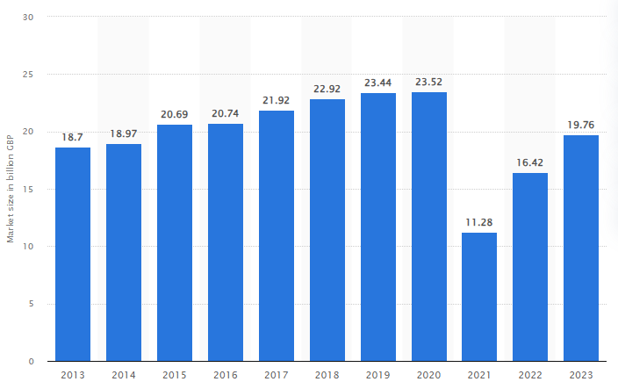
Figure 1: Market size of the hotel industry in the United Kingdom
(Source: Statista.com, 2023)

Hotel Standards:
To guarantee quality, safety, and comfort for visitors, the UK hotel business follows strict standards. Hotels must adhere to rules and specifications set by the “British Hospitality Association” (BHA) and other regulating authorities. These requirements cover a wide range of topics, such as hygienic conditions, security, accessibility, and amenities for visitors.
In the UK, hotels are also categorised based on their amenities and services using hotel classifications (Sufi,2019). The star rating system, which has a rating scale from one to five stars, is the most well-known classification scheme. The hotel's overall quality, comfort, and scope of services are reflected in its star rating (Alvarez et al. 2021). Hotels with higher ratings typically provide more opulent lodgings, extras, and dining choices.

Methods
The following technique can be used to do primary research on the hotel sector in the UK with an emphasis on reputation management, service culture, and hotel standards:
Defining the study objectives is the first stage in the primary research technique. The data collection process will be more effectively guided if the precise goals are articulated clearly. The goals could be to evaluate the adherence to hotel norms and laws, comprehend the service culture and its effect on client happiness, and examine the present reputation management practices in UK hotels (Khalifa et al. 2022). The target audience would be hotel management, employees, and clients in the UK hotel market. For a balanced representation of various hotel kinds (such as luxury, boutique, and budget) and geographical areas around the UK, a combination of random sampling and stratified sampling can be utilised.
Organisations can gather data using surveys, interviews, and focus groups. The target population might be surveyed to collect quantitative data (Jeaheng et al. 2019).

Results
The following significant findings came from performing primary research on the UK hotel business. Most of the studied hotels regularly monitor and manage their internet reputations, according to research on reputation management. They carefully consider customer feedback and rankings on numerous websites, including TripAdvisor and Google Reviews and rapidly respond to customer feedback, resolve issues, and keep a favourable internet reputation (Mueller and Sensini, 2021).
According to a study on service culture, providing guests with individualised and attentive service is a top priority for UK hotels. Staff employees are instructed to be polite, informed, and attentive to the requirements and preferences of guests. Hotels showed high levels of compliance in the areas of fire safety, cleanliness, and accessibility (Yu, 2020). There were some gaps in sustainability practises, nevertheless, and more eco-friendly programmes need to be adopted.
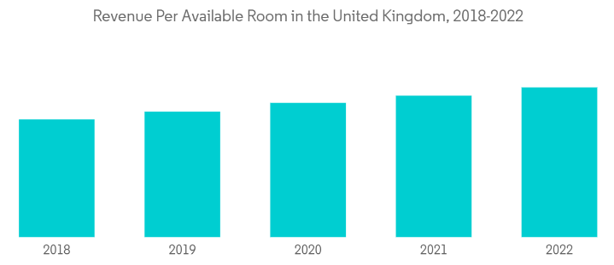
Figure 2: Revenue Per Available Room in the UK
(Source: Mordorintelligence.com, 2023)

In the UK hotel industry, the study emphasised the value of reputation management, service culture, and adherence to hotel standards. The results can be used as a starting point by hotels to evaluate their current procedures, pinpoint areas for development, and put plans in place to improve reputation management, service culture, and standard compliance (Nathan et al, 2019).

Recommendations
The findings of primary research on the UK hotel business offer insightful information on present practices and potential areas for development. The research on reputation management emphasises the significance of Internet reviews and ratings in influencing how people view hotels (Kamble, 2020). Hotels can manage their web presence and preserve a favourable reputation by immediately responding to customer feedback and resolving issues.
The industry's emphasis on delivering satisfying visitor experiences is reflected in the training of staff workers to be polite, informed, and responsive (Madgavkar et al, 2022). Luxury hotels typically excel in providing first-rate service, but it's crucial to understand the differences in service cultures among various hotel categories. This implies that there is an opportunity for development in the service culture of mid-range and low-cost hotels, where better staff empowerment and training could improve the overall client experience. The generalizability of the results may be impacted by the sample size and selection procedure (Kim et al. 2020).

Conclusion
In summary, the main research undertaken on the UK hotel business with a focus on reputation administration, service culture, and hotel standards illuminates key facets of the sector and offers insightful information. Furthermore, the study finds that UK hotels actively maintain their web presence and are aware of the value of reputation management. They are focused on upholding a good reputation, as evidenced by their attention to tracking customer evaluations and responding to criticism very away. This demonstrates how crucial online platforms are in shaping consumer opinion and luring new customers.
Besides that, the UK hotel business may improve its reputation management procedures, promote a consistent service culture, and give high standards compliance priority by utilising the research findings. This will improve customer satisfaction, boost competition, and increase long-term success.

References
Alvarez, T., Sensini, L., Bello, C. and Vazquez, M., 2021. Management accounting practices and performance of SMEs in the Hotel industry: Evidence from an emerging economy. International Journal of Business and Social Science, 12(2), pp.24-35. DOI: 10.30845/ijbss.v12n2p3

Jeaheng, Y., Al-Ansi, A. and Han, H., 2019. Halal-friendly hotels: Impact of halal-friendly attributes on guest purchase behaviors in the Thailand hotel industry. Journal of Travel & Tourism Marketing, 36(6), pp.729-746. DOI: https://doi.org/10.1080/10548408.2019.1631940
Kamble, Z. (2020) The significance of online reviews for hotel entrepreneurial success. Available at: https://www.researchgate.net/publication/342252302_The_Significance_of_Online_Reviews_for_Hotel_Entrepreneurial_Success (Accessed: 08 June 2023).
Khalifa, G.S., Trung, N.V.H. and Hossain, M.S., 2022. Predicting Customer Engagement Behaviour: The mediating role of hotel functional quality in the Vietnamese Hotel industry. International Journal of Services and Operations Management, 43(3), pp.312-337. DOI: https://doi.org/10.1504/IJSOM.2022.126979

Kim, W.H., Lee, S.H. and Kim, K.S., 2020. Effects of sensory marketing on customer satisfaction and revisit intention in the hotel industry: the moderating roles of customers’ prior experience and gender. Anatolia, 31(4), pp.523-535. DOI: https://doi.org/10.1080/13032917.2020.1783692
Litvin, S., Goldsmith, R. and Pan, B.P. (2008) Electronic word-of-mouth in hospitality and tourism management. Available at: https://www.researchgate.net/publication/222394083_Electronic_Word-of-Mouth_in_Hospitality_and_Tourism_Management (Accessed: 08 June 2023).
Lu, L. and Tabari, S., 2019. Impact of Airbnb on Customers' behaviour in the UK hotel industry. Tourism Analysis, 24(1), pp.13-26. DOI: https://doi.org/10.3727/108354219X15458295631891
Madgavkar, A. et al. (2022) Human capital at work: The value of experience, McKinsey & Company. Available at: https://www.mckinsey.com/capabilities/people-and-organizational-performance/our-insights/human-capital-at-work-the-value-of-experience (Accessed: 08 June 2023).
Mordorintelligence.com (2023). Revenue Per Available Room in the UK. Accessed from: https://www.mordorintelligence.com/industry-reports/hospitality-industry-in-the-united-kingdom (Accessed on: 08 June 2023)

Mueller, A. and Sensini, L., 2021. Determinants of financing decisions of SMEs: evidence from hotel industry. International Journal of Business and Management, 16(3), pp.117-127. DOI: 10.5539/ijbm. v16n3p117
Nathan, L., Hair, J. and Cho, M. (2019) The implications of research methodologies for hospitality ... Available at: https://journals.sagepub.com/doi/full/10.1177/1938965520974126 (Accessed: 08 June 2023).
Ndiuini, A. and Baum, T., 2021. Underemployment and lived experiences of migrant workers in the hotel industry: policy and industry implications. Journal of Policy Research in Tourism, Leisure and Events, 13(1), pp.36-58. DOI: https://doi.org/10.1080/19407963.2020.1743487

Statista.com (2023). Market size of the hotel industry in the United Kingdom from 2013 to 2022, with a forecast for 2023. Accessed from: https://www.statista.com/statistics/1364712/hotel-industry-market-size-uk/. (Accessed on: 08 June 2023)
Sufi, T. (2019) (PDF) principles of hotel star ratings - ResearchGate. Available at: https://www.researchgate.net/publication/334785283_PRINCIPLES_OF_HOTEL_STAR_RATINGS (Accessed: 08 June 2023).
Yu, C.E., 2020. Humanlike robots as employees in the hotel industry: Thematic content analysis of online reviews. Journal of Hospitality Marketing & Management, 29(1), pp.22-38. DOI: https://doi.org/10.1080/19368623.2019.159273

Appendices
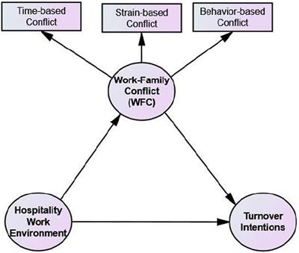
(Source: Self-developed)
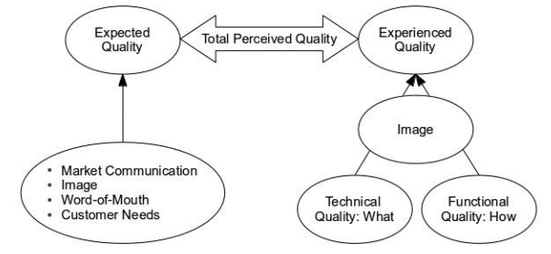
(Source: Self-developed)

