

Changemakers: Building your Personal Brand for Sustainable Employment (BMHP5015)

Component 2: Assignment Report

Student Name:Florentina Crina Matei
Student Number:2325866

Executive Summary
Self-reflection plays a pivotal role for students and professionals to identify their strengths and loopholes that restrict them in career advancement. The report aims to critically examine the specific job role in the health and social care, occupational therapist. In addition, the job advertisement regarding the concerned designation have been provided in the report. As an occupational therapist, it becomes significant to focus on the enhancement of certain skills that can ensure better patient care and an improved quality of life. These skills include communication approaches, teamwork, and the use of assistive technology. Personal branding as an occupational therapist is also important in terms of standing out from other therapists present within the health and care sector. The strategies regarding the promotion of personal brand such as through cover letter and active in different job portals have been provided in the report.
Table of Contents
1. Introduction 3
2. Main Analysis 4
2.1 Job Advertisement 4
2.2 Job Role Employability Skills 5
2.3 Evaluation of personal skills 6
2.4 Action Plan and Timeline 7
2.5 Building the personal brand 10
2.6 Promotion of professional Identity 11
2.7 Building a network for successful employment 11
3. Conclusion 13
4. References 14

1. Introduction
In a competitive environment, students focus on enhancing skills to build stronger careers and drive future growth. The inclusion of self-reflection helps students to identify their strengths and weaknesses to gain a competitive advantage (Bubnys, 2019). In this regard, the report will emphasise the specific job role in the health and social care sector, examining its importance and relevance. The Occupational Therapist (OT) is selected as the preferred job role to pursue in the future. In addition, the key responsibilities of the role comply with treatment planning, providing education and training, advocacy, environmental modifications and many more. It plays a crucial role in health and social care to optimise the quality of life, supports mental and emotional health, facilitates adaptation and recovery that enhances the overall well-being (Baron et al. 2019). In my context, I am interested and motivated enough to pursue this job role due to my desire to help people, working with diverse populations and want career stability and outlook.

2. Main Analysis

2.1 Job Advertisement
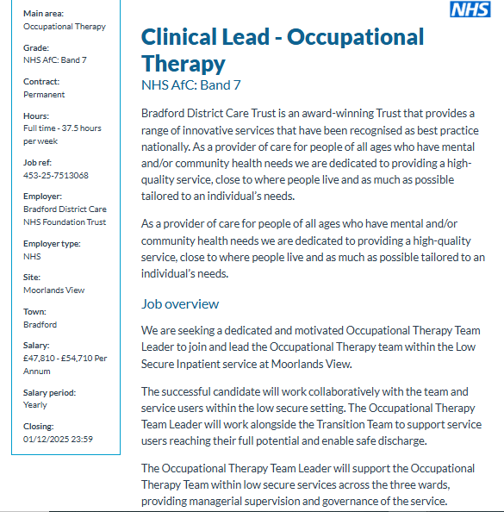

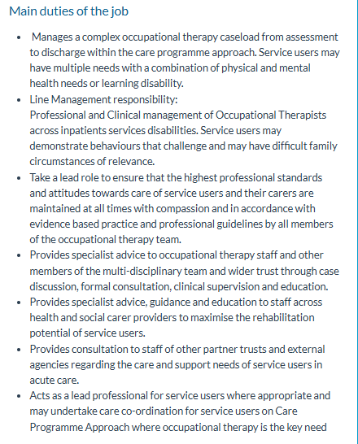
Figure 1: Online Job Vacancies for Occupational Therapists
(Source: Healthjobsuk, 2025)

2.2 Job Role Employability Skills
The key skills that are needed to work successfully in the position are efficient teamwork skills, empathy and compassion, effective problem-solving and creative thinking skills and strong communication skills. These employability skills collectively shape the overall performance of occupational therapists and bring better operational performance and client satisfaction. In this regard, the importance of these skills and its contribution to effective performance are mentioned below.
Teamwork skills: An effective teamwork skill enables the delivery of a holistic approach of OT towards patients and makes them comprehensive. It builds better collaboration that improves patient outcomes and safety (Nieuwoudt et al. 2021). It positively contributes towards the effective performance through shared goal settings, building of advocacy and efficient resource management.
Empathy and compassion: It is needed to gain the ability to understand others’ feelings to build trust and provide emotional support without fail. Moreover, empathy allows OTs to critically examine the unique experiences of clients rather than just focusing on the medical diagnosis. As a result, it upgrades the client outcomes, which increases the engagement and develops better adherence, significantly contributing towards the effective performance of OT.
Problem-solving and creative skills: Creativity and problem-solving skills are necessary for OTs to assess patients in different situations and find creative solutions to benefit them in overcoming challenges in daily activities. These skills collaboratively deliver personalised treatment, adaptability and tailored interventions that directly impact the effective performance of OT (Oven and Lobe, 2020). It boosts the cognitive skills and builds the emotional regulation and social skills that positively enhance the overall performance of OT
Strong communication skills: Clear communication eliminates confusion between the patient and professional, which builds trust and rapport. In addition, it enhances the patient engagement with OT that helps them to understand their conditions and the rationale behind their care plan. As a result, it builds efficient collaboration and interprofessional teams that directly contribute towards the effective performance of OT.

2.3 Evaluation of personal skills
Personal skills, or the soft skills, are those intangible qualities and traits that define the ways individuals work and interact with others. These included elements like communication, problem-solving, adaptability, and emotional intelligence (O’Toole, 2024). Personal skills in the health care sector hold significance regarding enhancement in patient care, establishment of trust, and upliftment of the professional and effective workplace environment.
I am currently involved in boosting my core transferable skills, which are necessary in occupational therapy. It primarily includes communication, empathy, teamwork, problem-solving, and a practical patient-centred social care experience. Currently, I am enrolled as a learner in the BSc Health and Social Care, the entry-level requirement towards achieving a strong career in this sector. After the completion of this degree program, I will enrol in a post-graduate occupational therapy program. At the time of attending these degree courses, I am also involved in gathering a significant amount of practical experience through the clinical placements. Most of my experiences till now have been gathered from volunteering in community centres, especially for seniors with physical disabilities.
From my qualifications and experiences gathered to date, I can count on skills like communication, patience, adaptability, and creative problem-solving. From volunteering at the community centres, I have come across stories and situations of multiple patients who have recovered or are recovering to get back on their feet. Offering support to these patients requires open communication to establish trust. Creative problem-solving helps occupational therapists to think outside the box and help people overcome daily challenges (Nielsen et al. 2023). Adaptability brings flexibility in dealing with different individuals within a limited period of time. These skills add value by increasing independence and improving the quality of daily life through an amalgamation of clinical, interpersonal, and organisational expertise.
Despite the skills present as my core competencies, I have to focus on acquiring other skills like clinical reasoning, teamwork, and the use of assistive technology. Clinical reasoning supports clear identification of the patient’s needs, addresses the challenges, and establishes appropriate strategies. Familiarity with the assistive technologies has also become an integral part that enables clients to adapt to their environment. Practitioners also benefit through an upliftment in their performance (Larsen et al. 2019). I can consult my university faculty to enhance my clinical reasoning skills. I can also have a consultation with the clinical educators who can help me by making me accustomed to real-life scenarios, where I can interpret data and formulate management strategies on my own.

2.4 Action Plan and Timeline
Short-term Objective
Objective | Specific | Measurable | Achievable | Relevant | Time Bound
To improve clinical reasoning skills aqnd team working through gathering real-life experiences within 1 year | Clinical reasoning is a vital component of occupational therapy that contributes to informed, patient-centred care decisions through personalised interventions and better patient outcomes (Latella, 2024). Teamwork enables fostering a collaborative approach to client-centred care by enhancing communication, professional development, and a supportive environment for both the patient and the staff (Latella, 2024). | Some KPIs, like diagnostic accuracy rates, medication error rates, and patient outcomes, can be used to measure improvement in this skill. | It can be achieved by continuously applying theoretical knowledge through a case-based learning approach and clinical simulations. It is also beneficial in improving working within a team. Engagement in reflective practices, along with seeking active help from professionals, can also help in this regard. | With the improvement in clinical reasoning, I can focus on establishing a well-informed patient care approach by gathering and integrating relevant data. Addressing teamwork skills will enable me to collaborate with my peers more efficiently on complex cases to ensure better care of the patient under treatment. | Within 1 year
Medium-term Objective
Objective | Specific | Measurable | Achievable | Relevant | Time Bound
To enrol in HCPC courses and get certification within 3 years | This is an important coursework for the Occupational Therapists in the UK that enables them to register themselves with the government-registered council of healthcare professionals (Hcpc-uk.org, 2025). | Assessment methods, achievement of learning outcomes, practical hours, and standards of proficiency are some of the KPIs that helps in measuring the improvement and progression in the HCPC course. | In order to gain a stable progression throughout the course, it is important to understand and align with the standards of HCPC. Practical experiences are can also be documented to enhance the learning approach and offer evidence of learning. | It is a legal requirement that I must acquire to enhance professional credibility and set higher standards for patient safety and treatment. | Within 3 years
Long-term Objectives
Objective | Specific | Measurable | Achievable | Relevant | Time Bound
To acquire and enhance knowledge on assistive technologies used in occupational therapy within 4 years | Knowledge of assistive technologies has now become a mandatory aspect for occupational therapists, driven by the growing use of technology in healthcare. It is a major contributor to increased efficiency of the therapies, improving patient care, and the overall quality of life (Slegers et al. 2020). | KPIs to measure enhancement in the knowledge of assistive technologies in occupational therapy might include training completion rates, self-assessed competence, and the overall frequency of AT use and intervention plans. | I can focus on gaining this knowledge through practical experience during placements. I am also encouraged to conduct research on current advancements like AI and Virtual Reality. | It is relevant in my field of interest, as being an Occupational therapist in the future, I will also be responsible for using these technologies to ensure better care of my patients and clients. | Within 4 years

2.5 Building the personal brand
Personal branding as an occupational therapist involves the strategic process of establishing a unique, credible, and recognisable professional identity that illustrates specific expertise, values, and approach to help patients (Smolarek and Dzieńdziora, 2022). Alternatively, it is the approach that helps set a differentiated public image from that of other occupational therapists and gain the trust of the patients more efficiently. As an occupational therapist in the near future, I can establish my personal brand through defining my unique value proposition, creating a consistent online presence through professional websites and social media, and building trust by exchanging valuable information and content with peers and clients. In this aspect, networking can also serve as a key strategy.
In order to build my online presence, I can create a professional webpage to showcase my experience, services offered, and the brand story. Platforms like LinkedIn and other professional networking sites can be leveraged to connect with individuals sharing similar interests and professional goals. On the webpage. I can post stories, blogs, videos, and client testimonies to establish authenticity and trust. However, I have to ensure that the website and social media pages remain visually attractive to the clients and the patients showing interest in occupational therapy.

2.6 Promotion of professional Identity
The promotion of professional identity plays an important role for both students and professionals to stand out from the crowd and establish a competitive edge (Liu et al. 2023). In my context, I can use several strategies like building an efficient and tailored CV or a cover letter in order to highlight my skills, knowledge and experiences to highlight my relevancy with the job role. Moreover, I focus on maintaining a strong online presence through building profiles on different job portals to engage with different recruiters and stay updated with the latest job vacancies. Apart from this, I feel that I should incorporate building my personal website in which I will list down all my achievements, unique skills and knowledge as well as my future goals. The personal website brings a significant competitive advantage for professionals through expanding the professional network, and enhances the visibility (Liu et al. 2023). Moreover, I embrace continuous learning to seek out opportunities and execute my skills and knowledge through attending various professional events and facilitating networking. Hence, these strategies can be helpful for me in promoting my professional identity among recruiters.

2.7 Building a network for successful employment
Networking plays a crucial role in health and social care to improve overall patient care, boost professional growth and stay updated with the current trends. In addition, networking facilitates an exchange of clinical knowledge, access to mentorships and facilitates better solutions in complex issues (Wu and Sheng, 2019). It enhances collaboration, improves resource sharing, and supports patients in multiple contexts. Furthermore, it offers professional development and support to OT through providing of support system, upgrading career advancement and facilitating a continuous learning process. Hence, networking works as a fundamental role in health and social care to achieve both personal and professional objectives.
In the UK, multiple professional associations hold networking conferences or events specifically for healthcare professionals to provide them with opportunities to build a successful network with others. In this regard, Convenzis is one of the professional associations which conducts several networking events or conferences for all categories of professionals (Convenzis.co.uk, 2025). In addition, the NHS conducts a mentoring program for healthcare professionals for both learning and networking purposes that brings positive results in all aspects for health and social care individuals (Nationalhealthcarementor, 2025).

3. Conclusion
Reflection plays an integral role in enhancing the overall quality and effectiveness of professionals. The report has shed light on the job role of an occupational therapist and its significance and role in health and social care. It has been found that the concerned professionals provide treatment planning and improves the quality of life. The key employability skills that are needed to pursue this role are effective teamwork skills, communication skills, and problem-solving. In regard to personal skills, the core transferable skills, adaptability, and emotional intelligence have been recognised. The action plan has been developed based on the personal weaknesses to turn them into strengths. Furthermore, the building of personal brands and the strategies to promote them have been highlighted in the report. In conclusion, a tailored CV and strong online presence are effective in promoting the personal brand and bringing positive professional results. In this regard, I am motivated and committed towards pursuing the goals to become a successful occupational therapist in the future to execute my desire to help people in multiple contexts.

4. References
Baron, H., Hawrylyshyn, N., Hunt, S.S. and McDougall, J. (2019) ‘Understanding quality of life within occupational therapy intervention research: A scoping review’, Australian occupational therapy journal, 66(4), pp. 417-427. Available at: https://onlinelibrary.wiley.com/doi/abs/10.1111/1440-1630.12570
Bubnys, R. (2019) ‘A journey of self-reflection in students’ perception of practice and roles in the profession’, Sustainability, 11(1), pp. 194. Available at: https://www.mdpi.com/2071-1050/11/1/194
Convenzis.co.uk (2025) Events. Available at: https://www.convenzis.co.uk/events?silo=estates-facilities&gad_source=1&gad_campaignid=22101726863&gbraid=0AAAAAoLO8swGDbskfRQjkqpARvfJ_R7VY&gclid=Cj0KCQiArOvIBhDLARIsAPwJXOaDyNtDmHtk9hrqrQOzjINhRSP7TuZ6juifQz7N6YILuKi225jRwXQaAnWhEALw_wcB [Accessed on: 18th of November, 2025]
Hcpc-uk.org (2025) Regulating health and care professionals. Available at: https://www.hcpc-uk.org/ [Accessed on: 18th of November, 2025]
Healthjobsuk (2025) Clinical Lead - Occupational Therapy NHS AfC: Band 7. Available at: https://www.healthjobsuk.com/job/UK/West_Yorkshire/Bradford/Bradford_District_Care_NHS_Foundation_Trust/Occupational_Therapy/Occupational_Therapy-v7513068?_ts=1 [Accessed on: 18th of November, 2025]
Larsen, S.M., Hounsgaard, L., Brandt, Å. and Kristensen, H.K. (2019) ‘“Becoming acquainted” The process of incorporating assistive technology into occupations’, Journal of Occupational Science, 26(1), pp. 77-86. Available at: https://www.tandfonline.com/doi/abs/10.1080/14427591.2018.1542337
Latella, D. (2024) ‘Teams and teamwork’, In The successful occupational therapy fieldwork student, pp. 95-101, Routledge. Available at: https://www.taylorfrancis.com/chapters/edit/10.4324/9781003526629-12/teams-teamwork-donna-latella
Liu, C., Wan, P., Hwang, G.J., Tu, Y.F. and Wang, Y. (2023) ‘From competition to social interaction: A mobile team-based competition approach to promoting students’ professional identity and perceptions’, Interactive Learning Environments, 31(2), pp. 1158-1172. Available at: https://www.tandfonline.com/doi/abs/10.1080/10494820.2020.1823855
Nationalhealthcarementor (2025) Committed to mentorship. Available at: https://nationalhealthcarementor.org/mentoring-programmes/ [Accessed on: 18th of November, 2025]
Nielsen, T.L., Holst-Stensborg, H.W. and Nielsen, L.M. (2023) ‘Strengthening problem-solving skills through occupational therapy to improve older adults’ occupational performance: A systematic review’, Scandinavian Journal of Occupational Therapy, 30(1), pp. 1-13. Available at: https://www.tandfonline.com/doi/abs/10.1080/11038128.2022.2112281
Nieuwoudt, L., Hutchinson, A. and Nicholson, P. (2021) ‘Pre-registration nursing and occupational therapy students’ experience of interprofessional simulation training designed to develop communication and team-work skills: A mixed methods study’, Nurse Education in Practice, 53, pp. 103073. Available at: https://doi.org/10.1016/j.nepr.2021.103073
O'Toole, G. (2024) Communication-E-Book: Core Interpersonal Skills for Healthcare Professionals, Elsevier Health Sciences. Available at: https://books.google.com/books?hl=en&lr=&id=98oVEQAAQBAJ&oi=fnd&pg=PP1&dq=importance+of+personal+skills+in+health+and+social+care&ots=KOoY30zJ40&sig=ckWlttYCgSfeBRDcquTNQjHYddM
Oven, A. and Lobe, B. (2020) ‘Creative occupational therapist: It's about the client using focus groups to explore creativity in occupational therapy’, The Journal of Creative Behavior, 54(1), pp. 51-61. Available at: https://onlinelibrary.wiley.com/doi/abs/10.1002/jocb.344
Slegers, K., Kouwenberg, K., Loučova, T. and Daniels, R. (2020, April) ‘Makers in healthcare: The role of occupational therapists in the design of DIY assistive technology’, In Proceedings of the 2020 CHI Conference on Human Factors in Computing Systems (pp. 1-11). Available at: https://dl.acm.org/doi/abs/10.1145/3313831.3376685
Smolarek, M. and Dzieńdziora, J. (2022) Impact of personal branding on the development of professional careers of managers. Available at: https://www.um.edu.mt/library/oar/handle/123456789/97580
Wu, F. and Sheng, Y. (2019) ‘Social support network, social support, self-efficacy, health-promoting behavior and healthy aging among older adults: A pathway analysis’, Archives of gerontology and geriatrics, 85, pp. 103934. Available at: https://doi.org/10.1016/j.archger.2019.103934

