Sakara Campbell Smith 1908201
Lecturer: Timothy Hopkins
Course: Group 9
certificate for higher education for skills for the workplace
Date: January 6th 2020
BWSW4001

ACADEMIC AND EMPLOYABITY SKILLS

CONTENTS
1) SUMMARY ……………………………………. PG 3
INTRODUCTION……………………………………PG 3
2) METHODOLOGY…………………………….. PG 4
3) FINDINGS …………………………………… PG 5
5.1) SWOT
5.2) PDP
5.3) EISENHOWER METHOD
DISCUSSION……………………………….PG 6
CONCLUSION………………………….PG 7
REFERENCE………………………………………. PG 8

SUMMARY
This report is an analysis of my progress, understanding and improving my academic and employability skills. It includes examples of in class exercises and research journals of accounts of where I am and where I want to be in 3 years’ time. Its purpose is to know what I need to improve on especially in relation to my professional aims and goals.

INTRODUCTION
In this report I am going to look in detail into my own academic and employability skills using various methods, research analysis and in class exercises.
I can now effectively know my strengths and weaknesses academically and in the working world.
As a self-employed hairdresser the findings of this report has given me more awareness of where I need to improve , time management and prioritizing my life are skills I will discuss about in this report, talking about my strengths, weaknesses, opportunity and threats in full understanding of my studies.
Skills are special to each individual as everyone is different and everyone has the ability to do unique things which means u are unique in your skills, you have taking the time to build on your life building yourself up with the unique skills you process to better your academic and professional life .There are many skills I have as a professional hairdresser which are
. soft skills
. hard skills
. paraphrasing
. note taking
. critical thinking
. presentation skills
. report writing
. refection skills
. computer skills
. Harvard referencing
. business plan writing
. creative skills
. time management
. prioritizing
METHOLDOLGY
Methodology mean the process of which I carried out my research, to undertake my week by week in class exercises and research articles and activities I did a swot analysis, Personal development plan and Eisenhower method.
My swot analysis the purpose for doing this was to be able to identify my strengths, weaknesses, opportunity and threats, how I did this was by looking at myself and brainstorming all my qualities good or bad and by putting them under headings I was able to pinpoint what my strengths are, weaknesses and opportunities and threats. I found that my strengths are that I can communicate very well, my strengths work hand in hand with my job as a hairdresser by being able to adapt to any situation I have the skills to make my customers feel welcome and at home.
The purpose of my PDP analysis was to look at myself from a self- reflection point of view , so this was to look at myself and see the skills I already have and use them to make a development plan of where I would like to be short term, mid term and long term looking at my goals and skills and knowledge I would like to learn. How I went about dong my PDP was by doing a table graph and on there I had to really think hard and far ahead and really set my life in goals so that my long term goals can be successful, you have to set goals and limitations for yourself if you have a journey you wish to go on a complete in
life.
The purpose of doing the time management Eisenhower method was to look at my life in a more casual way. To get an understanding of this method I firstly needed to understand what was important in my life and what is not so important and then categories my life into what is urgent and what is not urgent. I did this by doing a table graph mapping out my life making sure I’m taking into consideration time and urgency of each activity because I found a lot of things where not important and time consuming but they was in my daily routine, so this exercise help me prioritise my life.
FINDINGS
SWOT ANALYSIS
My exercises showed several skills sets for example I found that I am a great team player and that I have a willingness to learn and develop myself academically which will help me in my line of profession as a self-employed hairdresser the more you learn the better you become in doing your skills.
Please see table graph 5.1
PERSONAL DEVELOPMENT PLAN
My PDP showed me that prioritising my life I can achieve anything that I really wish to, by setting goals for myself and having a time frame on it I am putting my life into a realistic visual plan. I found that doing this exercise made me think long and hard about my life now and where I would like to be in the future not only professionally but academically and I can see I would really like to finish with a degree and further myself by opening my own hair dressing salon in multiple countries.
Please see table graph 5.2
TIME MANAGEMENT: THE EISENHOWER METHOD
This exercise showed me that I do not need to do so much in a day not everything is so important and most of the time a lot of the activities you do on a daily basis can be delegated to somebody to free me of some time. Eisenhower method I found was effective, as a self-employed hairdresser I don’t find that I have a lot of free time, as if I am not working I have my children to look after and my household, but from doing this exercise I could pinpoint what is urgent in my life and make sure I focus more on wat is urgent and important more than what is jus urgent or just important, by doing this you are not wasting time on activities that could wait, you are using your time to its fullest potential.
Please see table graphs 5.3

DISCUSSION
As the evidence suggests I am very good at prioritising myself, a great team player and I have a willingness to learn and achieve the best for myself, all of this is great for me as I wish to own my own hair salons in multiple countries having the skills I know I have is a step in the right direction. My ability to realise that its important to want to learn new things every day, as a hair dresser you have to keep up to date with da latest hair fashions and educate yourself on the best products to use for clients, so my willingness to want to learn is very significant in my line of profession because we are always learning new things. ( Grace Bourner, 27th February 2019) as stated by Grace Bourner with a list of skills to be a successful hairdresser you need to have interpersonal skills, be a team player, manage your time efficiently and have a willingness to learn new skills and techniques, business management and marketing skills, flexibility and care about your appearance and cleanliness as being a hair dresser you will be judge from how you look to how clean and tidy your station is. From this article I can see that a lot of the skills she talks about having I hold most of the qualities from doing my research earlier and thinking about all my skills I have already and skills I may need to work on. Bourner talks about time management which I have come to see that being a hairdressing its important to manage your time effectively that is how u make yourself successful, my swot and Eisenhower method show me how well I use time, highlighting areas where I can improve such as with urgency I find that I leave a lot of things to last minute always thinking I have time to complete a task when in fact I need to do things as I get them in order to use my time efficiently.
I have learnt a lot about my academic skills and my employability skills from the research I did, in-class exercises I can see clearly my strengths, weaknesses and my future goals. Academically I have learnt a lot how to Harvard reference, paraphrasing and academic writing all skills I can develop but I have a good understanding of them which will help me in my profession as a self-employed hair dresser its important I know how to write academically to customers and sellers to show I am professional and know what I am doing. I have attached a copy of my paraphrasing exercise to show how I have developed a skill.
“NICK COOPER (2018)”Nick cooper says states that the beauty industry is very popular of latest years with lots of opportunities for people to get into the business from courses provided from the government to paid courses, he also go on to say how it’s important to have some academic skills as you will need to understand the products you are using on clients, you will be required to be able to read the label for all products making sure you are meeting health and safety regulations so being academically smart is essential in da beauty business.
Overall I believe I have developed a great understanding of myself I know my good qualities which will help me in my line of work and the future such a great team player, always willing to learn and good communication skills and a people person love to meeting new people. I also have now set goals for myself to complete and can see my life in a more clearer scope prioritising myself which I didn’t realise before was so important but it is as you can waste a lot of time doing things that will not benefit you in the future so learning how to put my life in importance has overall help my whole professional experience as I find I have more time to do what is needed to be done and can get in a lot more clients in one day.
CONCLUSION
Although I have gained all the skills I have spoken about academically and professionally, there is still so much that I need to work on to be successful. One of my biggest weakness is public speaking as I do not have much confidence in myself even doe I know what I am taking about sometimes it’s hard to speak to a crowd of people an in my industry and where I want to be in the future I know this is something I am going need to develop and get better at doing. Also, time management is something this research has brought to my attention that I really need to be more efficient with my time, yes I know how to prioritise my time now but I also need to put it into daily practice to get better with my time. Academically I need to still work on my spellings and numeracy as these two go hand in hand for a hair dresser as I will need to be able to spell products correctly for my suppliers, work out measurements for hair dyes, perms and texturiser all need to have a good understanding of numbers adding them together. Drawing my conclusion from all I have spoken about in this report I can say it has given me awareness of myself and discipline for my life, to be successful and reach my future goals I need to continue to do swot analysis, PDP, Eisenhower method for myself as my challenges in life can change so if I keep up to date and on track of my development I can be all that I want to be.
Appendices
The table graphs below are from section 5.1 in my report this is the research and data I have collected about myself.
5.3)
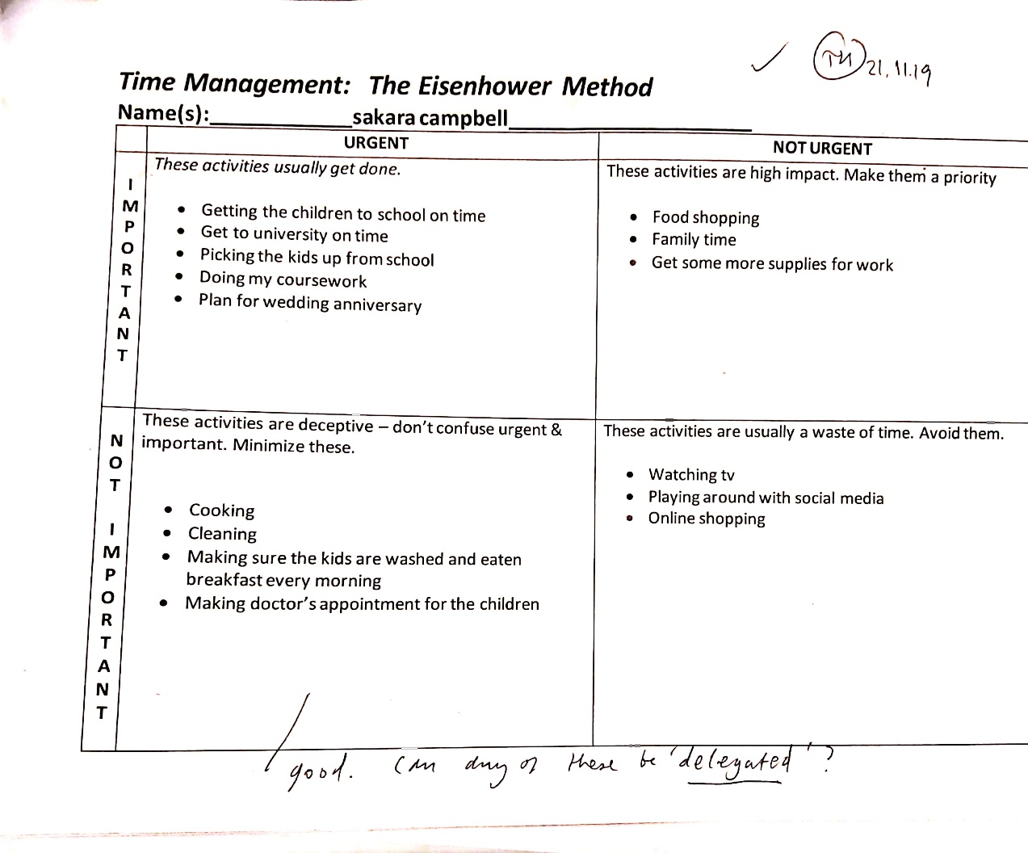

5.1
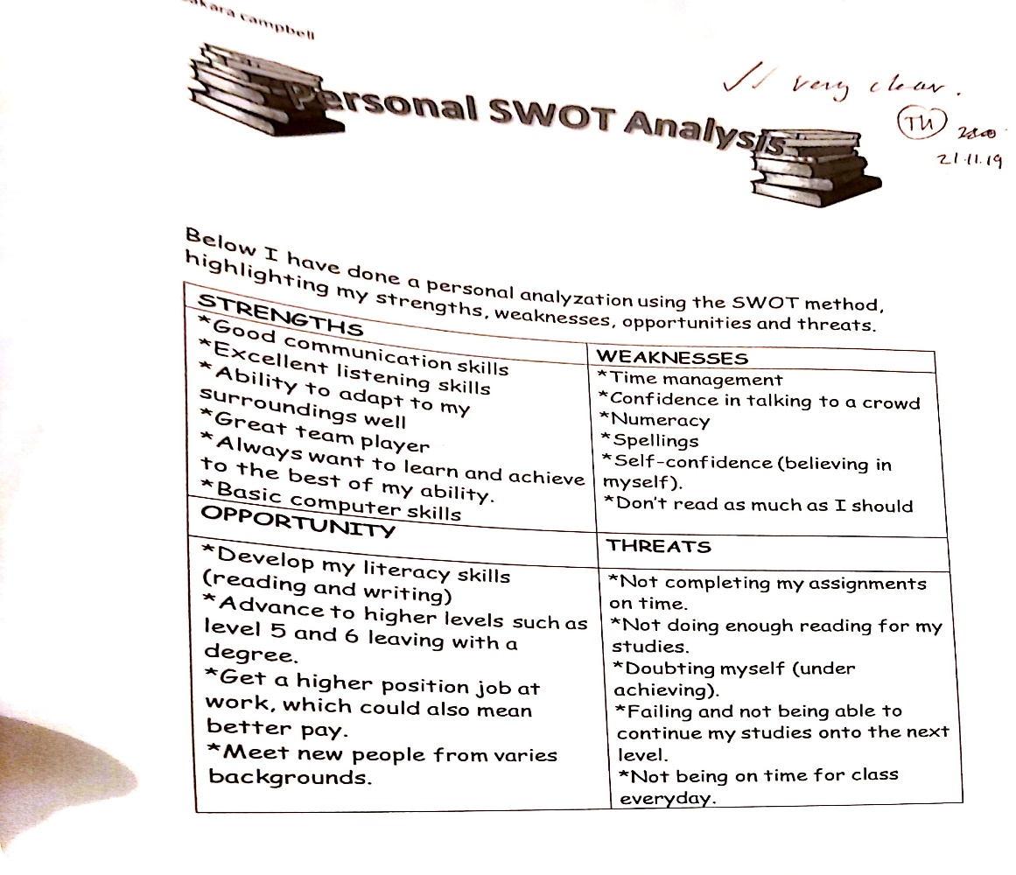
5.2
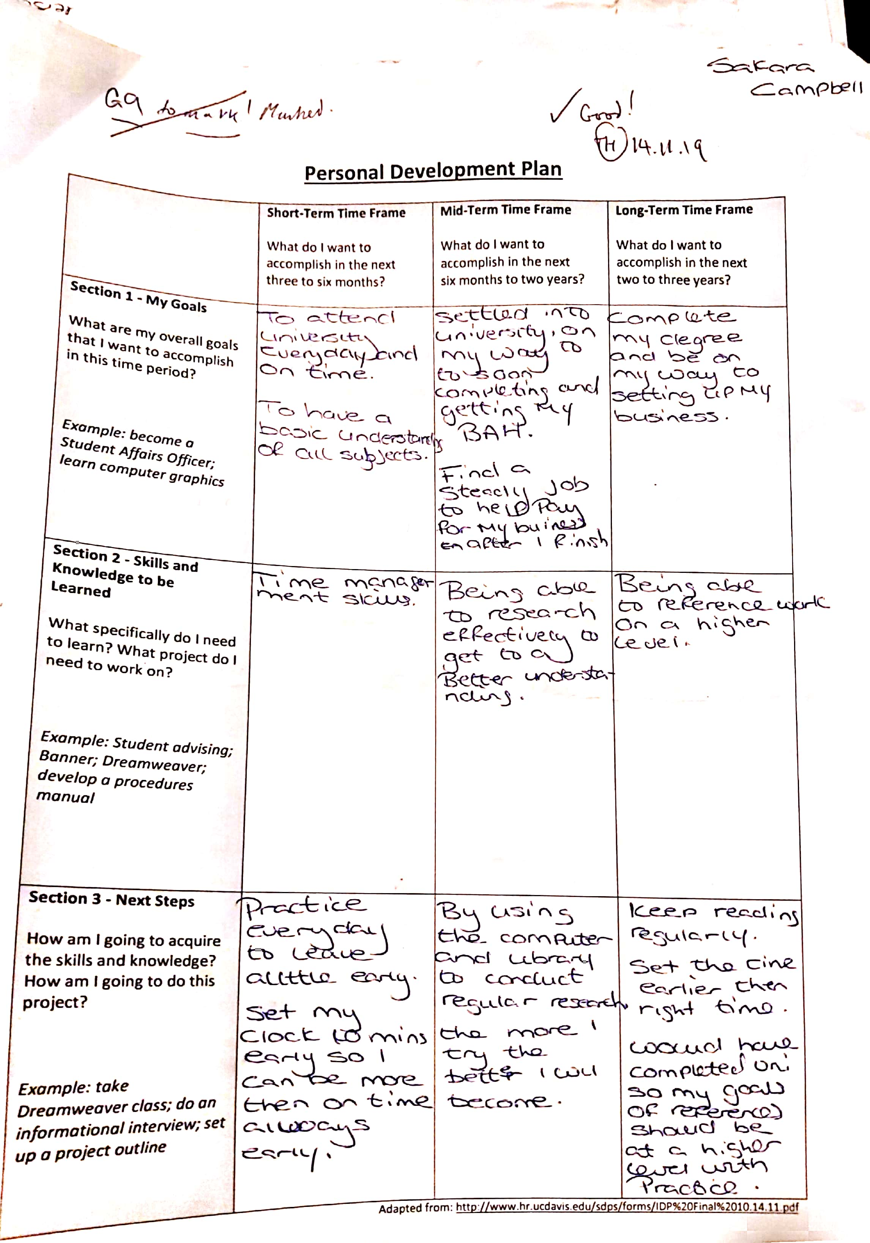

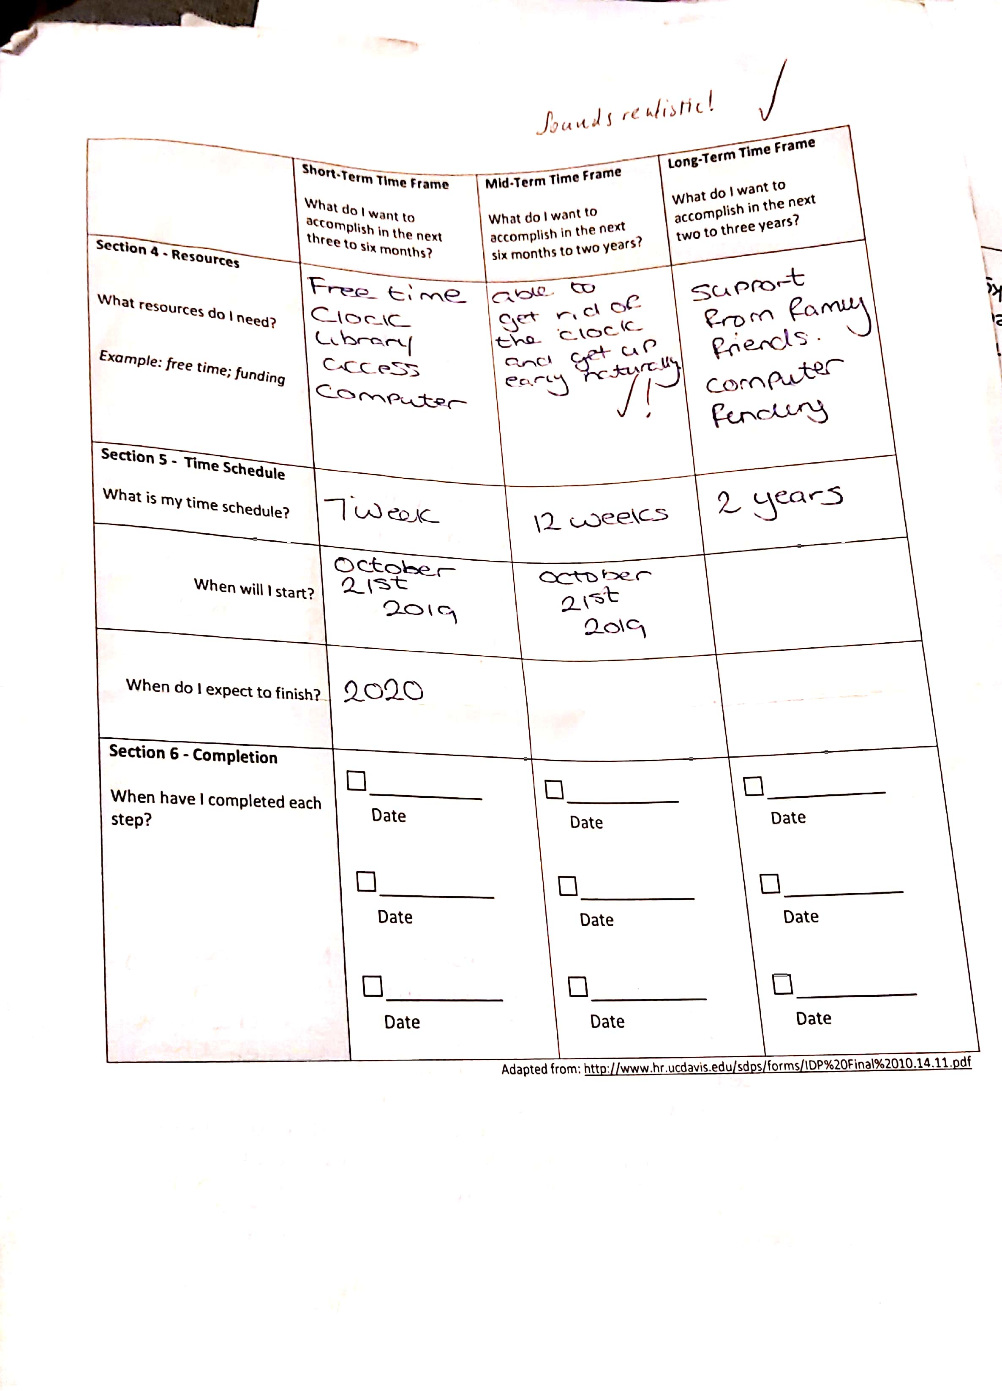

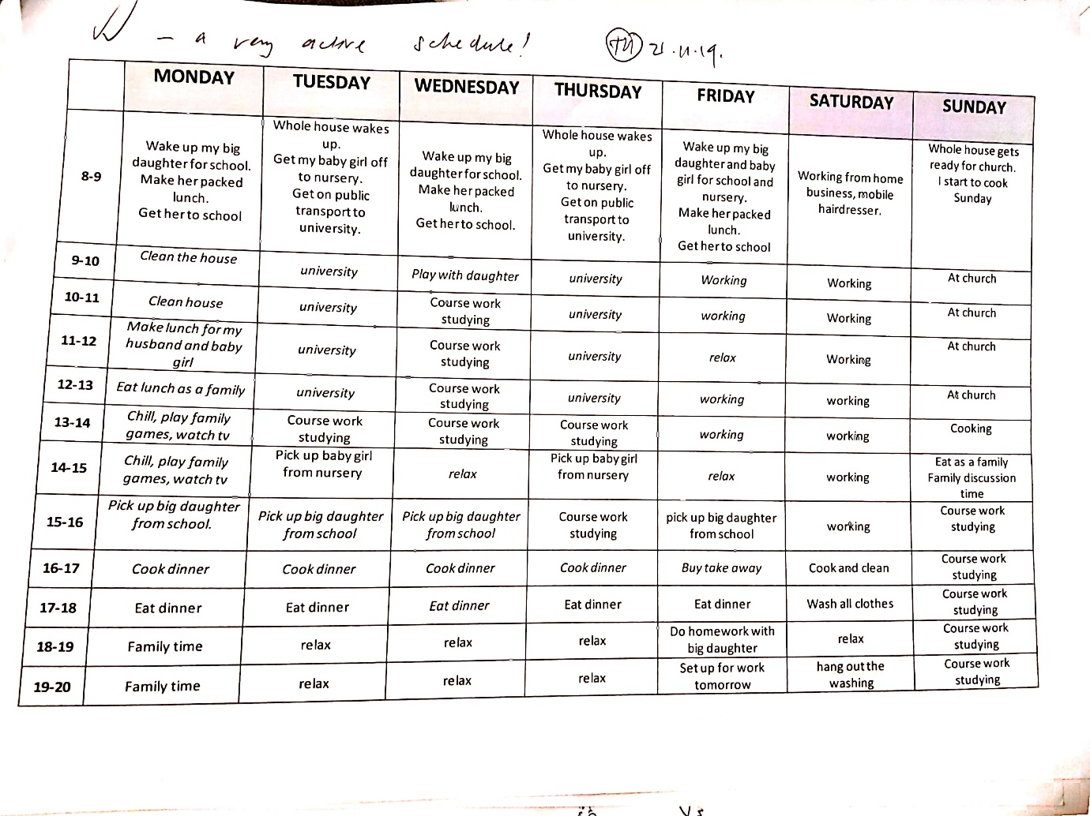

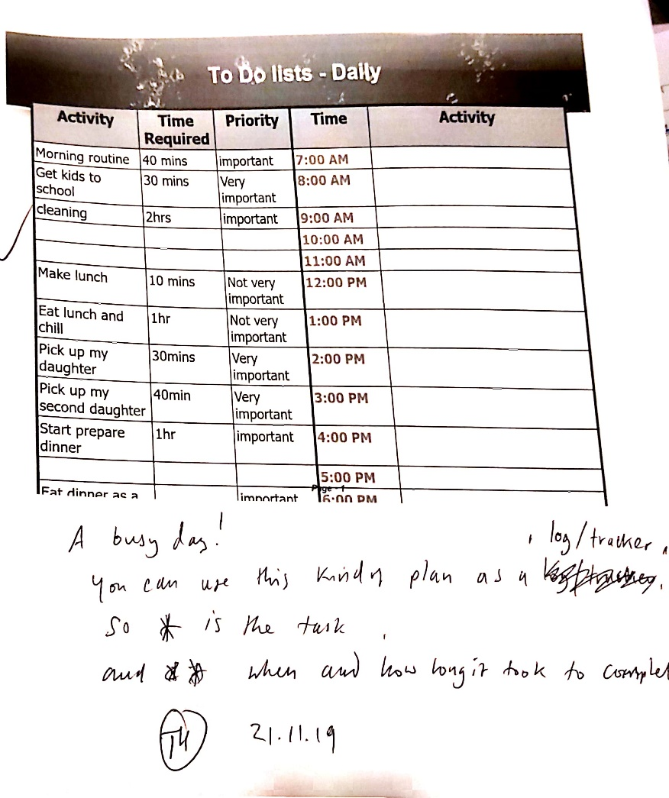
REFERENCE
“HOW TO LAND A JOB IN THE BEAUTY INDUSTRY” by Nick Cooper 2018 www.ncchomelearning.co.uk/blog/land-job-beauty-industry/

( Grace Bourner, 27th February 2019 www.careers.rush.co.uk/careers/careers-hairdressing-can-expect

