UNIVERSITY OF WALES TRINITY ST DAVID
Risk Assessment Technical Report
Risk Management and Failure Mode and Effect Analysis
Workshop and Practice (ACHA4011)
Harvey Britland
1902072
February 2020

Document detailing the use effectiveness of FMEA on a brake assembly line from the view of a process engineer


Table of Contents
1 Introduction i
1.1 Aims i
1.2 Objectives i
1.3 Risk Management i
2 Literature Review ii
2.1 What is Failure Mode and Effect Analysis? ii
2.2 What are Risk Priority Numbers? ii
2.2.1 Probability of occurrence (P) ii
2.2.2 Severity (S) ii
2.2.3 Likelihood of detection (D) ii
2.3 Risk Management on an Automotive Production Line iii
2.4 Limitations of FMEA and Risk Management iii
2.5 IMecheE iii
3 Initial Failure Mode and Analysis v
3.1 Initial FMEA Table v
3.2 Failure #1 v
3.3 Failure #2 v
3.4 Failure #3 vi
3.5 Failure #4 vi
3.6 Conclusion vi
4 Amended Failure Mode and Analysis vii
4.1 Amended FMEA Table vii
4.2 Failure #1 vii
4.3 Failure #2 vii
4.4 Failure #3 vii
4.5 Failure #4 viii
4.6 Conclusion viii
5 Conclusion ix
6 Bibliography x

Table of Figures
Equation 1: RPN Calculation ii

Table 1: Initial FMEA v
Table 2: Ammended FMEA vii

Introduction

Aims
The scope of this investigation is to understand risk management from the mindset of a process engineer working for a large-scale vehicle manufacturer.

Objectives
To achieve this aim, realistic Risk Priority Numbers (RPNs) will be given to several potential failures along a vehicle assembly line process, along with actions to mitigate these failures. A rerun of the Failure Mode and Effect Analysis (FMEA) will be processed to reduce the original RPNs. Relevant research is to be carried out to find out how to mitigate the issues.

Risk Management
Risk management is an important and relevant area in the engineering sector. Not only does it ensure that a product or process being produced properly to avoid any issues with quality, safety, or correct specifications, but it helps to ensure that the engineers and the company that they work for remain free from liability. If the failure was covered in the risk assessment, then it could help protect the company from any financial complications such as lawsuits. However, for a more company and cost driven risk management plan, a separate FMEA is normally produced for this key area (Ahsen, 2008).

Literature Review

What is Failure Mode and Effect Analysis?
Failure Mode and Effect Analysis (FMEA) is a step-by-step process by which potential failures – be that in a design, product or engineering process - are identified, assessed to work out how high of a priority it is and then the mitigating actions needed to overcome these (ASQ, 2019). Used in many industries, FMEA helps businesses and engineers alike to investigate and analyse every possible failure that can be thought of, no matter how unlikely, and from there set in place mitigating actions (Forrest, 2010).

What are Risk Priority Numbers?
A risk priority number is an assessed value given to a potential failure, be that a process or component (Institute for Healthcare Improvement, 2014). It is produced from three fields: likelihood of detection, level of severity and probability of occurrence. It is then calculated using multiplying all three numbers together (Kiran, 2017). Equation 1 shows how the values is calculated.
Equation 1: RPN Calculation
$$RPN=P×S×D$$
When assessing what failure is most critical and takes priority, equalling numbers then be assessed on which has the highest severity. Failing this, the combination of severity and occurrence will then be considered (FMEA-FMECA, 2008).

Probability of occurrence (P)
This first element of the RPN is a value that looks at the likelihood of a failure happening. This is a value between 1 and 10, with 1 being extremely unlikely to occur and 10 being it happening every time. This can be given as a quantifiable unit; x amount per 1000 components or over a set time period (Basu, 2017).

Severity (S)
The second component of an RPN figure is the severity rating. Rated from one to ten, a one will be a very low impact or risk of injury/death (almost negligible) while a ten will be a very high impact (very high risk of serious injury/death). It can also be extreme business damage, be that reputation or value (Forrest, 2010).

Likelihood of detection (D)
The third and final component on an RPN value is the likelihood of detection. This is a number from 1 to 10, with 1 being very likely to detect and so not an issue and 10 being the worst: extremely unlikely to detect. The values are listed in this ranking to help ensure the final RPN values are as accurate as possible.

Risk Management on an Automotive Production Line
RPN values are frequently used in the automotive sector to help mitigate key areas of concern (Dhillon, 1999). As well as the failure modes being discussed and mitigated in this document, there are many other potential areas of risk. Some of these risks include falls, improper use of machinery or poor machine guarding, electrical faults and lockout/tagout faults (Admin, 2017). As well as these human hazards, disruption to a production line could halt movement of components/vehicles which in turn could affect the production line output, therefore losing potential profit for the delay (Northbridge Financial Corporation, 2017). Along a production line, there are several areas of risk management mitigations that can be applied. From streamlining the flow of just-in-sequence production (JIS), used by Porsche for example, to the use of proper personal protective equipment (PPE) (Porsche, 2015). As well as this, specified floor markings help to designate specific areas for both workers and larger automated machinery movement zones (Stop-Painting, 2020). The use of proper machine guards and a checklist to ensure they are protective before machine use would also help prevent potential amputation or death (Pitt, 2018). In an automated area with machines, the three C’s of Safety (consider, communicate and connect) should also be considered (Wilkins, 2018).

Limitations of FMEA and Risk Management
Although a seemingly useful tool used across many industries, there are some limitations to how effective carrying out FMEA can be. Knowing what these various issues are can help to move the analysis in a positive direction, rather than being caught out (ODwyer, 2010). One of these issues is keeping a consistent ranking. This must be used to ensure that the RPN values calculated are accurate. Failure to do this would make the values skewed and therefore throws the investigation and analysis into disarray. It is also important not to have a bias towards severity ratings. Doing so creates issues because rarely does the severity change for a process/component failure, only the detection and occurrence (ODwyer, 2010). Other areas where FMEA can be limited in its use is that all it does is help to find and prioritise higher risk failures and not solve them. A third issue is that the quality of an FMEA investigation is only as good as the team leading it. If engineers or other team members that are inexperienced are running the analysis then it could lead to several high risk failure modes being missed (Hodge, 2014).

IMecheE
The Institution of Mechanical Engineers (IMechE) is a professional engineering institution that many industry professionals use, from students studying at university in IMecheE accredited courses to doctorate level specialists (Institution of Mechanical Engineers, 2000). Because it is so widely accepted as being the face of engineering, it means that members must uphold the Code of Conduct set out under sections 28 to 31 of the Royal Charter and By-Laws of the Institution of Mechanical Engineers to ensure the industry is held in as high of a regard as possible. These set out to tell members they are representing the Institution and are ambassadors of it. Therefore, they must behave in an appropriate matter, should conduct work with integrity and objectively for all parties involved and should continue to learn to remain professionally competent in their field (The Institution of Mechanical Engineers, 2014).

Initial Failure Mode and Analysis

Initial FMEA Table
Table 1: Initial FMEA
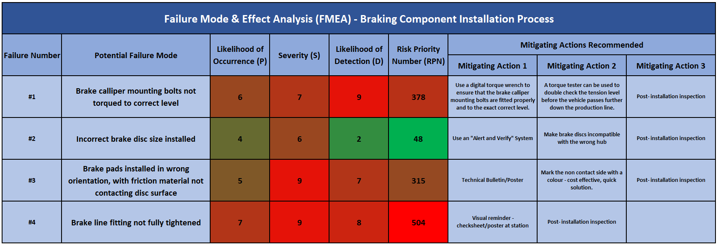

Failure #1
This looked at the brake calliper mounting bolts not being torqued to the correct level. If they are not torqued to the correct level, the bolts could either become stuck, meaning a potential hazard in the future if the brake callipers themselves have an issue or they may not hold the brakes in place. The likelihood of occurrence was given a 6 because although it could occur relatively frequently, it would be difficult to torque wrong because the wrench should click. The severity of an issue like that is high, therefore given a 7, because although the bolts may be torqued incorrectly, they could be tightened too much. This isn’t too much of an issue as the brakes will still work properly but becomes a pain when attempting to service the brake assembly. However, if they were too loose, this could lead to a catastrophic failure in which the brakes would fail, resulting in the car crashing at a high speed instead of slowing to a halt. The likelihood of detection is given a 9 because it would be very difficult to detect visually if it were not torqued correct. To mitigate the issue, a torque tester as well as a digital torque wrench will help to get the correct required torque (Mountz, 2018). As well as this, ensuring accurate and up-to-date information on the production line is available at all times for the correct torsion level of that particular bolt (Bayou City Bolt, 2018).

Failure #2
An incorrect brake disc size installed is relatively serious as if a disk is too small. However, it would be clearly visible if it is too big or small so would be detected easily meaning it was given a 2. The likelihood of occurrence is a 4 because although the wrong size could be put on, it would still be relatively unlikely. If the wrong brakes are put on it’s a relatively serious failure mode and so the severity has been given a 6. A potential mitigation for this issue is to have the brake discs separate in very different coloured bins with the component name on the front. Then, when it comes to the engineer fitting the discs to the hub, the prompt that will come up for that vehicle on the screen will have the part highlighted in the same colour as the bin, helping to eliminate any doubt due to the visual aid (Martin, 2020). The hubs could also be made to fit only the correct brake discs.

Failure #3
If brake pads are installed in the wrong orientation, with friction material not in contact with the disc surface, it becomes a major issue. Many brake pads are directional and so will need to be installed correctly, and therefore if installed improperly will produce a screeching sound (due to the wear indicator on the pad), ultimately damaging the disks. Brakes having no use (as the contact pad would be the wrong way round) would result in a very disastrous accident. Therefore, the severity rating was given a 9. The occurrence of this was given a 5 because it would be relatively easy to install incorrectly and would also be hard to detect (given a 7). Because the brake pads are covered by the callipers, certainly on more performance-based vehicles, it would be difficult to check further on the process line at a quality control check. It is then key that a visual reminder to check that the pads are the correct way round such as a brightly coloured paint mark at the top of the non-contact side would be a good solution as it would make it very clear in which orientation the pad should be in. This would help to reduce the value for detection. As well as this, using a technical poster or visual reminder at the workstation to check should help reduce occurrence (Apec Braking, 2017).

Failure #4
This failure is the brake line fitting not fully tightened. This is quite a big issue because if the brake line is not tightened properly then the brake lines may allow air inside and therefore a leak, causing a potentially calamitous failure as the brakes would have poor pressure resulting in a longer brake time and distance (Firestone, 2017). Consequently, it has a severity rating of 9, with the probability of occurrence at 7 due to it being easily done. The clips can also be overtightened because they are made of thin and relatively flexible metal which restricts flow inside the line. The likelihood of detection was also given a high rating of 8 due to being very difficult to detect. Therefore, the mitigating action for this is to have a visual prompt at the workstation, possibly a poster or a screen alert before the component/vehicle moves down the process line (Apec Braking, 2017). As well as this, a quick check post installation with the tool used to ensure it is firm and in place.

Conclusion
Failure #4 should have priority due to the highest RPN value at 504, followed by Failures #1, #3 and #2 in that order.

Amended Failure Mode and Analysis

Amended FMEA Table
Table 2: Ammended FMEA
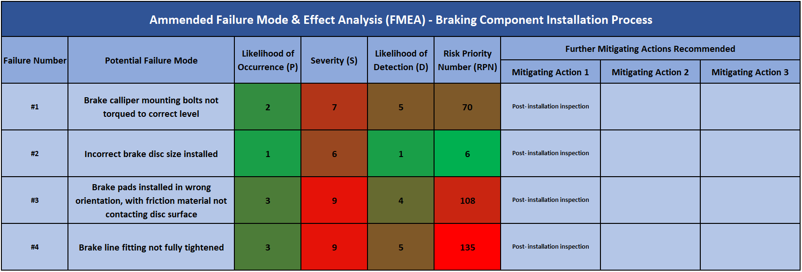
Due to the nature of a failure mode, the value for severity will not change for any mode since the risk of injury/death if the failure happens remains the same.

Failure #1
Once the mitigating actions have been taken care of, the values of the probability of occurrence and the likelihood of detection have both reduced to 2 and 5 respectively. This is because the actions taken are robust and have ensured that the failure should occur a lot less due to several checks before the vehicle moves along the process line.

Failure #2
Both the occurrence and the likelihood of detection has reduced to 1. Though the incorrect brake disc failure mode did not originally hold a high RPN value, this has been reduced to 6 because by following both the “Alert and Verify” system and making the discs incompatible with the wrong hubs, it removes almost any possibility of the wrong brake discs being installed because they just would not fit onto the vehicle.

Failure #3
The brake pads being installed incorrectly (wrong orientation and non-contact side) has had both its probability of occurrence and its likelihood of detection of detection improved significantly. With both a passive (colour coded component to ensure correct orientation) and active (technical poster bulletin to check component orientation against), this has helped to ensure the fault is not likely to happen.

Failure #4
The brake line fittings have reduced significantly from 7 and 8 to 3 and 5 for occurrence and detection respectively. With the use of a prompt, either from the system at that workstation or a check sheet to mark off against any issues, and a post installation inspection before the process moves on, the brake line fittings have a far lower RPN and are deemed to be easier to check for faults. The likelihood for a leak and therefore the chance of a sudden loss of braking has been diminished (Hunting, 2017). This failure still has the highest RPN value out of all 4 failure modes and so would need to be looked at again to ensure that the failure can be reduced in its possibility of going undetected.

Conclusion
Failure #4 still has priority due to the highest RPN value at 135, followed by Failures #3 and #1 respectively. Failure mode #2 has been mitigated effectively to warrant no further action.

Conclusion
The findings made show that by using FMEA, applying RPN values to the failure modes and then prioritising those with the highest values, an actionable plan could be produced to help mitigate these risks. With the highest risk, Failure #4, the new RPN value from the rerun FMEA was more than halved. In an ideal world, FMEA should be accompanied with a combination of other strategies for processing potential risk areas (ODwyer, 2010). Viewing the FMEA process as a quality improvement tool rather than for quality control us is an issue and so will need active thinking to ensure this doesn’t happen (Bongiorno, 2001). However, as a tool to use to help mitigate failure modes, the process works at its best when combines good management, an organised method, a good team to lead the process that have experience in the areas under observation and effective and actionable mitigations (Vanyi, 2016). As well as this, ensuring that FMEA is an ongoing process and not just a one-off event in the planning and design stage of either a process, component, or product will mean that the FMEA model is being used to the best of its effectiveness. Further limitations and effectiveness are covered in section 2.4.

Bibliography
Admin. (2017, February 16). Top 5 safety hazards in the manufacturing industry. Retrieved March 1, 2021, from Vector Solutions: https://www.industrysafe.com/blog/safety-management/top-5-safety-hazards-in-the-manufacturing-industry
Ahsen, A. v. (2008, May 23). Cost‐oriented failure mode and effects analysis. International Journal of Quality & Reliability Management, 25(5). Retrieved February 22, 2021, from https://www.emerald.com/insight/content/doi/10.1108/02656710810873871/full/html?utm_source=TrendMD&utm_medium=cpc&utm_campaign=International_Journal_of_Quality_%2526_Reliability_Management_TrendMD_0&WT.mc_id=Emerald_TrendMD_0
Apec Braking. (2017, July 06). Directional Pads - observations for fitting. Retrieved March 1, 2021, from Apec Braking: https://www.apecbraking.co.uk/Resources/TechniciansGuides/Directional-Pads-observations-for-fitting.aspx#:~:text=It%20should%20feature%20on%20the,pads%20below%20the%20minimum%20threshold.
ASQ. (2019, July 24). FAILURE MODE AND EFFECTS ANALYSIS (FMEA). Retrieved February 16, 2021, from ASQ: https://asq.org/quality-resources/fmea
Basu, S. (2017). Guided Word Hazard Analysis. In S. Basu, Plant Hazard Analysis and Safety Instrumentation Systems (pp. 201 - 302). Amsterdam: Elsevier. Retrieved February 25, 2021, from https://doi.org/10.1016/B978-0-12-803763-8.00004-2
Bayou City Bolt. (2018, February 20). Torque to Bolts. Retrieved March 1, 2021, from Bayou City Bolt: https://www.bayoucitybolt.com/torque-to-bolts.html
Bongiorno, J. (2001, April 17). Improving FMEAs. Retrieved March 2, 2021, from Quality Digest: https://www.qualitydigest.com/Oct00/html/fmea.html
Dhillon, B. S. (1999). Maintainability Tools. In B. S. Dhillon, Engineering Maintability (pp. 50 - 81). Amsterdam: Elsevier. Retrieved February 23, 2021, from https://doi.org/10.1016/B978-088415257-6/50004-1
Firestone. (2017, September 25). GET TO THE BOTTOM OF YOUR SPONGY BRAKE PROBLEM. Retrieved March 2, 2021, from Firestone: https://blog.firestonecompleteautocare.com/brakes/spongy-brakes/
FMEA-FMECA. (2008, December 05). FMEA RPN. Retrieved from fmea-fmeca.com: https://www.fmea-fmeca.com/fmea-rpn.html
Forrest, G. (2010, December 31). FMEA (FAILURE MODE AND EFFECTS ANALYSIS) QUICK GUIDE. Retrieved February 26, 2021, from ISIXSIGMA: https://www.isixsigma.com/tools-templates/fmea/fmea-quick-guide/
Hodge, S. (2014, July 21). Understanding FMEA, Its Benefits and Pitfalls. Retrieved February 28, 2021, from Six Sigma Daily: https://www.sixsigmadaily.com/understanding-fmea-benefits-pitfalls/
Hunting, B. (2017, November 17). SUDDEN SOFT BRAKES: DON’T PANIC WITH THESE 3 TIPS. Retrieved March 1, 2021, from Napa: https://knowhow.napaonline.com/sudden-soft-brakes-dont-panic-3-tips/
Institute for Healthcare Improvement. (2014, February 27). Risk Priority Number (from Failure Modes and Effects Analysis). Retrieved February 23, 2021, from ihi.org: http://www.ihi.org/resources/Pages/Measures/RiskPriorityNumberfromFailureModesandEffectsAnalysis.aspx#:~:text=Formula%3A%20The%20Risk%20Priority%20Number,detection%2C%20and%20severity%20of%20impact.
Institution of Mechanical Engineers. (2000, October 17). Institution of Mechanical Engineers. Retrieved February 26, 2021, from imeche.org: https://www.linkedin.com/company/institution-of-mechanical-engineers/about/
Kiran, D. R. (2017). Failure Modes and Effects Analysis. In D. R. Kiran, Total Quality Management (pp. 373 - 389). Amsterdam: Elsevier. Retrieved February 23, 2021, from https://linkinghub.elsevier.com/retrieve/pii/B978012811035500026X
Martin. (2020, September 29). Defeating the Predictable: How to Detect and Prevent Manufacturing Mistakes. Retrieved February 28, 2021, from Metis Automation: https://www.metisautomation.co.uk/detect-and-prevent-manufacturing-mistakes/
Moultrie, J. (2017, February 28). FMEA (Failure Modes and Effects Analysis). Retrieved March 2, 2021, from IfM: https://www.ifm.eng.cam.ac.uk/research/dmg/tools-and-techniques/fmea-failure-modes-and-effects-analysis/
Mountz. (2018, November 30). Three Proven Methods of Verifying Torque Specifications. Retrieved March 1, 2021, from Mountz Torque: https://www.mountztorque.com/Three-Proven-Methods-of-Verifying-Torque-Specifications#:~:text=Mark%20the%20tightened%20fastener%20and,way%20to%20determine%20residual%20torque.
Northbridge Financial Corporation. (2017, July 04). Hidden risks that can damage your manufacturing business. Retrieved March 1, 2021, from Northbridge Insurance: https://www.nbins.com/blog/manufacturing/hidden-risks-manufacturers/
ODwyer, M. (2010, May 25). FMEA: Weaknesses of a Risk Management Tool That Calculates a Risk Priority Number. Retrieved March 1, 2021, from Bright Hub PM: https://www.brighthubpm.com/risk-management/72064-weaknesses-of-fmea/
Pitt, J. (2018, November 21). Six Common Safety Hazards in the Manufacturing Industries. Retrieved March 1, 2021, from manufacturing.net: https://www.manufacturing.net/safety/article/13247787/six-common-safety-hazards-in-the-manufacturing-industries
Porsche. (2015, May 13). The assembly line. Retrieved February 27, 2021, from porsche-leipzig.com: https://www.porsche-leipzig.com/en/production/the-assembly-line/
Stop-Painting. (2020, Sep 21). Why Mark Safety Lanes on a Workshop or Facility Floor? Retrieved February 28, 2021, from Stop-Painting.com: https://blog.stop-painting.com/why-mark-safety-lanes-workshop-facility-floor/
The Institution of Mechanical Engineers. (2014, May 28). ROYAL CHARTER & BY-LAWS. Retrieved February 26, 2021, from IMechE: https://www.imeche.org/docs/default-source/governance-documents/royal-charter-and-by-laws-2014_updated200417.pdf
Vanyi, G. (2016, March 04). Improving the effectiveness of FMEA analysis in automotive - a case study. Acta Universitatis Sapientiae, Informatica, 8, 93. doi:10.1515/ausi-2016-0005
Wilkins, J. (2018, September 04). The 3 C's of Machine Safety. Retrieved March 1, 2021, from automation.com: https://www.automation.com/en-us/articles/2018/the-3-cs-of-machine-safety

