

Assessment 1 – Reading Task Template
PART 1: Upload your photo of your A3 in-class notes here:

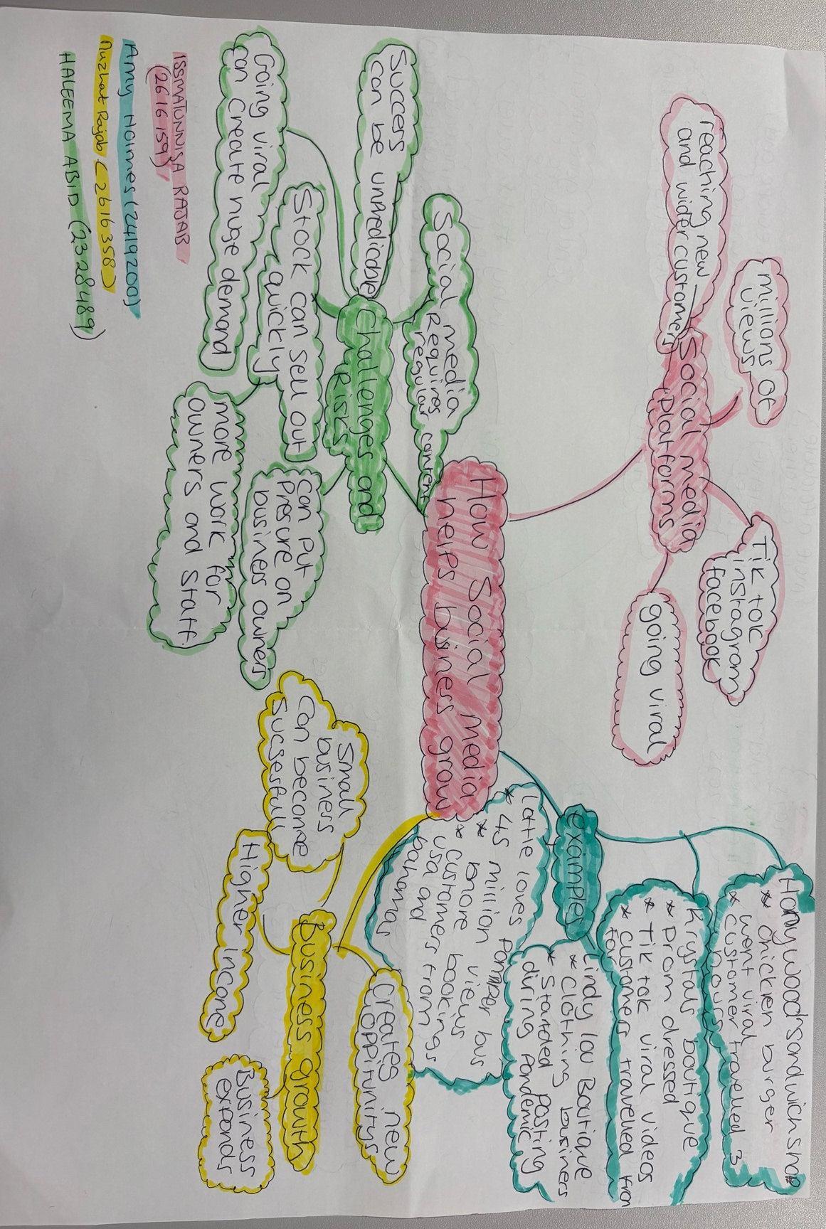

PART 2:
- Answer every question below in 1-3 full sentences.
- Use your own words. Do not use generative AI to answer these questions.
- Include a specific detail from the text when asked.
REMINDER
- The main idea is the overall message of the whole text.
- A key point helps to explain the main idea.
- A specific detail or example from the text shows that the key point is true.

- What is the main idea of the whole text?
The main idea of the text is based on social media and how it is being used to boost success. From the article we can see how social media has changed the way businesspeople promote themselves online and how they are able to communicate and interact with the customers. It shows that even small businesses can build a large following online.

- What is one key point that supports the main idea, and which specific example from the text shows this?
One key point to support the main idea is that businesses can use the online space to show off their products using more personal and entertaining marketing instead of just making normal adverts or leaflets. One example of this is Linda from Linda’s boutique she started posting clothes on instagram in lockdown now she has around 320,000 followers on the platforms such as instagram and facebook.

- What is a different key point that supports the main idea, and which specific example from the text shows this?
Another key point that supports the main idea is customers can also help make a business become popular by sharing content themselves. A key example is of this is Murat owner of Honywood sandwich shop he became viral after posting chicken burger content with a secret recipe that caught the attention of the public. This led to other people sharing their content and people would travel to him even people travelling for up to 3 hours.

- Which part of the text do you think is most important, and why?
The part I find most important out of the text is the businesses getting new opportunities through social media. Little love’s pamper bus is a good example because after posting one of their videos it received around 45 million views. Social media has enabled them to reach customers they would never have reached through your average advertising.

Reflection:
- What did you find difficult in this task (including in-class components), and why was it difficult?
What I found difficult was that I had not been able to take to much information in so I was not ready for the assessment I starting the note taking in a completely wrong subject by accident. This was difficult because I was very confused and was not sure how to get my head around the task as previously mentioned I was a little behind.

- What helped you with this difficulty, and how did it help you?
Some key factors in how I was able to resolve my difficulties were my peers in class that was able to get me on track and give me a sense of direction we was going in and I also received help from my lecturer Caroline that was able to spot my error and I was able to amend this to base my note taking of the correct article and with the help of learning support Caroline I was able to compile everything together and fill myself with confidence to complete and submit my assessment.

