Developing Workplace Critical
Thinking
Module: BMSW5101_LON
Student name: Eleonora Mariana
Filip
Student number:1807163
Lecturer: Ze Zook

Table of Contents
Introduction......................................................................................................................................3
Pizza Hut Background .....................................................................................................................3
Explanation of beliefs, attitude and value along with difference between them as per theoretical model...........................................................................................................................................3
Explanation of role at workplace along with management theories relevant to role..................5
Critical assessment of my belief, attitude and values on particular management theory in context to assistant manager....................................................................................................................9
Critical Thinking and management theories ..................................................................................9
Critically make a assessment of the attitude , belief and value on the behaviour of a workplace....................................................................................................................................9
Identification of a range of management theories to assistant manager role in the workplace and what range of activities are undertaken......................................................................................10
CONCLUSION..............................................................................................................................15
REFERENCES 16

Introduction
Critical thinking is a process that is related with a skill that can help in taking decisions for achievement of the laid down business objectives. It is very necessary from point of every organisation for increasing their overall profitability and productivity. Critical thinking is also regarded as a person ability of developing and understands the situation in a correct manner. It has different course of advantages for every organisation. In the present report there is Pizza Hut selected as the base organization and a scenario of the post of a assistant manager working in this organisation has been developed in order to understand the overall process of critical thinking associated with this position ad responsibilities & function associated with the human resource departments.
Pizza Hut Background
Pizza Hut is a American restaurant and it has a international franchise that was started in the year 1958 and it is known for its Italian cuisine. They are making world’s largest pizza and side dishes. There has been discussion of the value, attitude and belief associated with the help of different management theories that have been given by many great philosophers.

Explanation of beliefs, attitude and value along with difference between them as per theoretical model
Believes attitudes and values are those three features which have direct impact on organisation working and influence the culture within the organisation which is helpful in development and growth. These are internal factor which have impact on staff of organisation in performing better growing their abilities and skills for achievement of personal goals. But can be filled by performing the different task which brings specialisation in work. That’s why these factors have different outcomes which are shown in the table mentioned below.
Difference among Belief, Attitudes and Values
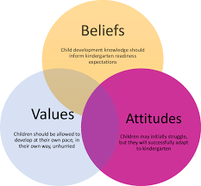
Figure 1 Key aspects of belief, values and attitudes for a organisation
Sources :https:// owlcation.com>social-sciences/slide share .net
Believe attitude and value are those factors which have direct impact on the performance of employees in an organisation where employees perform their duty for achievement of organisation goal (Sturdy, Wright and Wylie, 2016). This can be said that a satisfactory staff always lead to good performance and effective management because of optimistic thinking, this also promote good efforts as well as improvement in management and working abilities but there are some difference between believes attitude and values. These differences must be specifically known by management staff for increasing performance of employee as well as managing behaviour in organisation.
Basis | Belief | Value | Attitude
Meaning | Believes can be said as the understanding of community this is because of the religion which is being understand by an individual in whole life (Meisenbachand Jensen, 2017). | Value can be defined as the component which helps a person in directing the behaviour in particular time duration. This is also factor which motivates employees of an organisation to do their work in specific direction. | Attitude can be said as and tendency which is related to reaction of a person in an optimistic pessimistic me for certain circumstances. This reaction also helpful in identifying the behaviour of an individual and classify them according to the need of organisation.
Importance | It always helps in identifying the behaviour and concepts related to external factors of an organisation. It also helpful in creating and optimistic belief of staff towards it managers of the organisation which is important for Pizza Hut to examine work within organisation and try to develop a good management function where performance of an organisation can be improved. | It is important function as it support organisation in hiding as well as deciding the good and bad items. The manager in Pizza Hut accomplishes the staff desire and develops the values in front of them for better performance of organisation (Ljungholm, 2016). | Attitude is related to likes and dislikes of a people toward in something specific. This is an important part of organisation which helps in maintaining behaviour. For Pizza Hutt it can be said that it will helpful in developing good team behaviour in organisation which will helpful in task management as well as maintaining the behaviour of employees for effective decision making.

Explanation of role at workplace along with management theories relevant to role
Pizza Hut is famous for their pizza chain across the world. In the organisation, assistant manager play an important role where is accountable for learning and growth of organisation as well as formation of working strategies within organisation. Here manager can use number of management theories which are helpful in identification of a way by which they can achieve success and growth. Management theory are consists of various tools and techniques which are related to effective management with the help of planning, organising, controlling and directing (Casiraghi and Aragão, 2019). There are number of theories which will helpful in representing the company for performing its business in a market. Management theories related to set certain guidelines for a manager and leaders of organisation which can motivate their employees to work better.
Bureaucratic management theory:
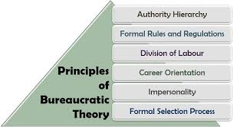
Figure2 Key Principles of Bureaucratic Theory
Source:https://www. theinvestorsbook.com / Max Weber Bureaucracy

This theory was propounded by Max Weber, he said that bureaucracy is the most effective way which can used by and firm for developing and managing its operations effectively. This theory has main focus on management of organisation in a fair way as well as information to every employee about distribution of labour work. For assistant manager of a company it is essential to perform the rules and all the activities related to the organisation (Kamis, and Khan, 2019). Good manager must have critical knowledge about the rules, regulations and process within the company which are helpful in management of activities; it must also have knowledge of higher authorities of organisation. This become the reason that the theory aids in increasing the factors which are related to development of information and smooth flow within poll organisation from top to lower administration and clearly identification of roles and responsibilities within the organisation where relations can be established for improvement of employees performance.
Scientific management theory:
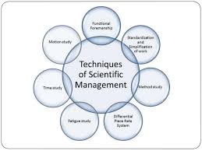
Figure 3 Main aspects of theory of scientific management
Source: htps:// www.slideshare.net / F.W.Taylor-Father of Scientific Management
These theories related to management of work in an organisation as well as managing the flow of work in organisation in an effective manner (Ning, and You, 2018). The main aim of the theory is to increase the economic efficiency as well as labour productivity in an organisation for achievement of goals in and cost-effective manner. This theory was founded by Frederick Winslow Taylor, according to tailor there are number of principles which an organisation should follow for increasing the productivity as well as economic efficiency. Instead of assigning any kinds of job to workers, this is essential for business entities to allocate jobs in accordance of capabilities & skills of employees there must be monitoring of the performance of every employees suggestion to improve their efficiency and effectiveness.
There must be differentiation in work of employees and manager so that they both can create an effective planning in strategies which will help them introduction of wasteful activities (Su, 2017). There must be additional benefits in terms of monetary and non-monetary things to motivate employees which can help them in increasing their performance. Effective training and development is also essential according to this theory this is because it help in performing complex task within the specific time limits. so overall it can be said that scientific management theory is based on the mechanism and automation in theoretical concepts and development of management.
Human Relations
Relations are the important part of organisation as they will help in managing the culture as well as functioning of organisation and reduce the chances of conflicts because of strong relationship between employees of firm (Parker, 2016). Human relations can be identified as a process or a manner which helpful in identification of reaction of an individual for another individual. In context of pizza hut, it is important to us for organisation to conduct different activities where it can manage the relationships within the organisation. This is because it has number of advantages and benefits which can be helpful in increasing the performance of organisation. As effective relationships within organisation will help up and retaining employees for a long period of time because of their personal interest within organisation this will also improve the performance of employees for particular task and enhance productivity of organisation.
Tuckman's Teamwork Theory:
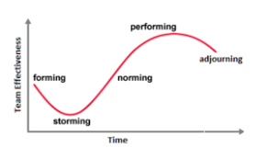
Figure 4 Stages in Tuckman’s theory
Source:https:// www.medium .com / 4 Stage of Team Formation
Tuckman theory is a theory related with the team that has to nb managed in such a way that information ahs to be passed on complete before completion of a project. This theory as a in to deal with challenges that are associated with team building. According to this theory there are some challenges that can help in development of a team as given below:
- Forming: it is the initial and first stage in which the team has to collect and gather at a particular place and then a particular task is assigned to them. All the members of the team have to perform their assigned responsibilities according to their leader. In the first stage all the team members to know each other and neither do they posses any type of trust at this stage.
- Storming: In this stage there us a a time at which the team has to start finding various tasks that hive to be performed by them and the end stage that they have to reach towards. They posses and start developing some relationships with each other as there are sharing of ideas and thought of how to perform the assigned work by all the team members. Such as ways of how to work collectively and individually has to be developed at this stage.
- Norming: In this stage there is the point where team actually starts to find different type of risk that is associated with the performing with the work and various responsibilities. Such type of risk must be identified earlier only us that they can contribute towards the overall and ultimate objective the team, the risk mostly occur because of the creativity that is lacking and tram member strategy to rely on each other (Kwon, 2017).
- Performing: At this stage, there is a fixed structure and a clear structure that is created so that team members are able to focus on their overall mission. There are different problems that can occur and those have to be dealt in such a manner that there are positive results that can be came out from the overall contribution made by such team members (Parker, . and Jeacle,2019)
- Adjourning: It is the last stage were the most of the goals have been achieved and this the decision making time and evaluation stage where the identification is done of the amount of exact contribution made by each team members and the appreciation take place at this stage, also, there is compilation of gaols that is taking place at this stage where team members also are willing to move away and finally are working on the allotted responsibilities in the usual course of the business as the team is finally resolved.
Contingency theory:
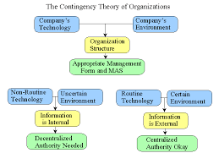
Figure 5 Appliaction of contingency theory in an organisation
Source:htps://www.maaw.info.com/What is the Contingency Theory
Contingency theory is a management theory that was founded by Fred Fiedler and this theory is based on a assumption that there is not a single best way of leading a organisation so this theory suggested that there are certain factors on which the overall attitude and behaviour of the person is depending (Joslin, , 2019). It is also very necessary for the manager of an organisation that they have to make a analysis of the factors and elements that can posses a impact on the employees. This theory pf management is identified to enhance the performance of the organisation. In pizza hut there are certain ways through which overall behaviour of employees. There are many different ways that can be used by managers and leaders according to contingency theory it is a concept that is related with the concept of situation and management theory in three various factors as discussed below:
Leader member relations: It consists of the relationship that exists between managers and leaders with their employees (Csaszar and Ostler,., 2020). It is going to have an impact on the employee performance and also consist of the feeling of loyalty, confidence. It is necessary that manager and leader in organisation have to develop trust from their workforce so that they can be taught how to work and make higher amount of contribution.
The position power : It is a factor that is related to the structure and its accomplishment, it is necessary that employees must possess clarity related with the job and the overall job role so that business activities can be performed with high amount of motivation of employees. It is a factor that is related with the power that is posses by leaders and managers for punishing and rewarding of their employees who have to actually perform their work (Williams, Ashill, . and N
Task structure: It is the element that is related with the structure and accomplishment of various associated activities. It is very important that employee must possess clarity about the functions that have to be performed by them and their job role in perform various activities of business in a efficient way.
System theory
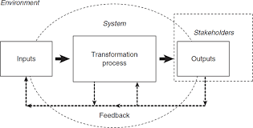
Figure 6 Process of application of system theory
Source:https://www.sagepub.com / SAGE Books-Systems Theory
This is a theory of the management that is related with the disciplinary system (Hall, 2016). It is a theory that is related to state that is very important for a organisation to conduct work in appropriate manner (Otley, 2016). It is a theory that is effective to deal with various complex situations in an organisation. System theory is a management theory that is a very important framework, helping in management of the organisation in understanding the employee attitude in following up of a particular situation.

Critical assessment of my belief, attitude and values on particular management theory in regards to assistant manager.
Management theory has been regarded various aspects that can aid for strategy for direct manager in management practises in efficacious manner. It will also aid in assisting the staff alignment of efforts worth the objectives of a organisation.
As the assistant manager in Pizza Hut, for their staff management that is very vital for performing their respective role as a scientific management theory. It is a theory that has been established Fredrick Taylor. It is concentring on development of the effectiveness and skills of performing in an organisation.
It is a theory related to the management that helps in performing the enhancement of employee performance and achievement of goals of the organisation. Such as Taylor has recommended that task has to be done that has to be performed each day. It does leads towards maximisation of the efficiency & skills for increasing productivity. Assistant manager has to concentrate for management of work in the organisation at regular time intervals that can help in maximisation of productivity. Manager has to keep their focus on improvement of employee capabilities & skills. It will lead to accomplishment of set objectives according to the changing attitude of the workforce. It will help in affecting the attitude, belief and values of employees which play a crucial in performance of employees and affecting their working so scientific management theory, the assistant manager for Pizza Hut so that employees and their performance.

Critical thinking and management theories

Critically make a assessment of the attitude , belief and value on the behaviour of a workplace
In every organisation there are employees working at different levels and all of these posses their own set of belief and attitude that help them in working towards smooth functioning of overall organisation. All of these, posses a huge impact on the overall organisational performance and also employee behaviour towards various activities of the organisation. It is very necessary for a assistant manager that they have to manage performance of each employees and try to enhance it according to the respective gaols and objectives of their organisation. The belief and values of a employee poises a impact on the task and profitability of a organisation. Such as employee who possess a negative attitude many not perfume their assigned task and responsibilities in a more appropriate manner and contribute to the maximum of their present level of potential. It can lead to high amount of conflicts that are talking place between employees and organisation. It is the duties and responsibility of the employee working at the pose of assistant manager that they have to manage employees and help ion converting their negative attitude towards the organization into a positive attitude. It is also going to support them and help them in working towards their organisations overall goals.

Identification of a range of management theories to assistant manager role in the workplace and what range of activities are undertaken.
There are different management theories that can lead to provide assistance to managers so that they are able to perform their job role in a better manner. It is also necessary to conduct the activities of business for a respective organization. Such as assistant manager on Pizza hut has the responsibility of establishing clear lines of communication with all the employees and also mangers in every functional department.

HAWTHRONE STUDIES
It is a study that was done on the workers that were working on the Hawthorne plant at the western electric company. The study was conducted in the 120s by Elton Mayo & Fritz Roethlisberger. Hawthorne studies, is a very important part of the managerial strategies that can help in development of understand the concept of various socio psychological that are part of human behaviour in a organisation. It is a study that can help assistant manager of a organisation so that they can influence the transition from a classical approach towards a human relations approach.
According, to the classical approach of the employees, management those posses physical and economical needs. It is very important part of every organisation to have a focus on the overall financial needs and also physical needs of the workforce. HAWTHRONE effect is helpful in enhancement of the employee output by understanding the employee output by understand their response. It is helpful for the assistant manager in establishment of relationship with their employees and understands their overall response. It will also identify different types of social factors that can lead to impact on the productivity of employees. In case of Pizza Hut, assistant, manager has to identify certain requirement and needs of employees and then try to fulfil the so that they can establish better relationship amongst them and with them.
Stage of problem solving & decision making
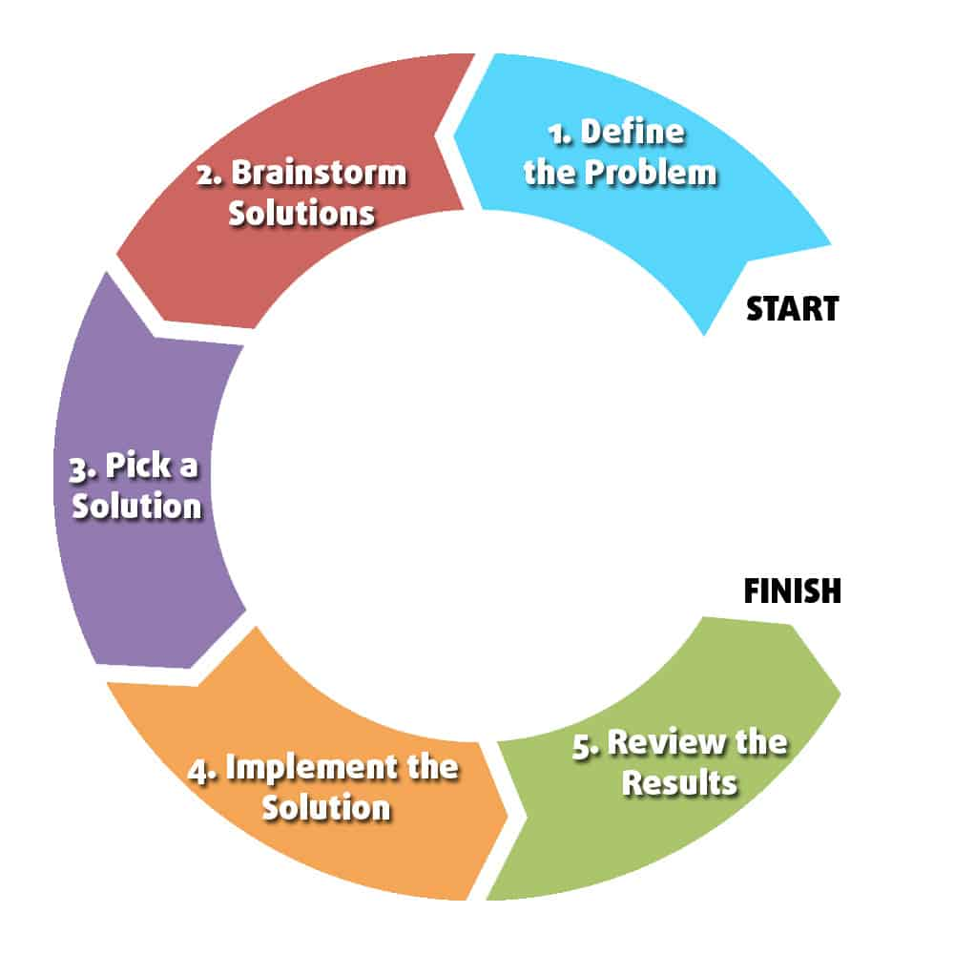
Figure 7 Stages of decision making in a organisation
Source:https://www.humorrthotworks.com /The 5 Steps of Problem Solving

Problem solving is a very important skill that is required to be present in manager and employees working at different levels. It is very important that in case of a assistant manager of a organisation such skills have to be present so that they are able to perform their responsibilities in a better manner. There are various stages that can help in making proper decision and solving of issues. It is very important for the manager to identify and evaluate each stage so that correct and timely decision can be made. It is also important for manager to make an evaluation of each stage for better decision making. Different stages of problems solving are mentioned below:
Identifying problem: For the purpose of resolving various issue and problems that are very important for an assistant manager for making better decisions so that various problems can be resolved. Problems are to be identified with the help of collection of data related to observing employees and making a detailed analysis of various issues that are being faced by such employees.
Searching alternatives: There are various alternatives that can be helpful in solving various issues and in case of a assistant manager it becomes very essential to identify and make a detailed research of all such problems and alternatives so that better decision can be made as if the alternative courses will be effective then it is going to automatically lead towards selection among the bets courses of action available with the decision maker. It is also going to lead towards solving of issues and in a more efficient and effective way.
Selecting appropriate alternative: After identification of the various courses of alternative it becomes very important to select the best course of alternative as it has been identified by the assistant manager and which is best according to his way of critical thinking. It is going to help towards identification and selection of an alternative based on the prose and cons associated with every action. It will lead towards selection of the most appropriate choice of decision making in a organization.
Implementing alternative or choice – after the best course of action has been selected among the available alternatives then it becomes the responsibility of the assistant manner that they have to implement that action properly and in the most appropriate manner.
Evaluating results: After there has been selection and implementation of the best course of l alternative it is the last stage where the problems are solved or it is not solved. In this stage there is the growth of the organization that has to be evaluated in detail and various results have to be also assed based on the understanding of the decision maker.
Frederick Taylor
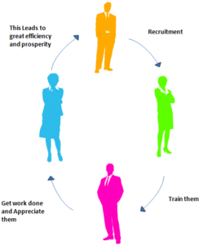
Figure 8 Taylor's theory of scientific management
Source:https://www.hrmpractice.com/Principles of Scientific Management
Frederick Taylor is a father of the theory of scientific management. He has able to develop management theories and scientific principles that are very helpful in a organization for carrying on their business functions, according to the theory of scientific management the assistant manager of Pizza Hut must not use any hard decision for the employees who are having any type of misconduct or wrong behavior in the organization (Burtz, Bright, and Shortsleeve, 2020). Instead they must try in a way that they should be made understand what they are doing is wrong and to apologies for the wrongful activities that they are doing in the organization. It will help in improving the performance of employees and make them realize their mistakes that have been committed and are responsible for reduced organizational productivity. This theory has been developed for the purpose of making employees more effective and creative at the same time to perform various activities and assigned responsibilities to them.
Henry Gantt-Gantt Chart Information
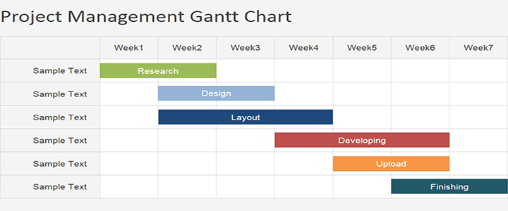
Figure 9 Sample preview of preparing a Gantt chart
Source:https://www.teamgannt.com/Project Management Gantt Chart
Gantt chart is an effective tool that can be applied by various assistant managers to ensure more effectiveness in the structure of their organization. Gantt chart was founded and established by Henry Gantt in the year 1919 and the major objective of this chart was to provide assistance to the managers in performing their work in a better manner (Doran, Hanss, . and Larsen, 2017). Gantt chart is basically responsible for shoeing the various activities according to the time frame aligned with each set of activity that has to be performed in a organization. It is very essential to list activities that have to be completed in the allotted time frame, it lead to completion of activities and actually the whole work is completed in specified time period.

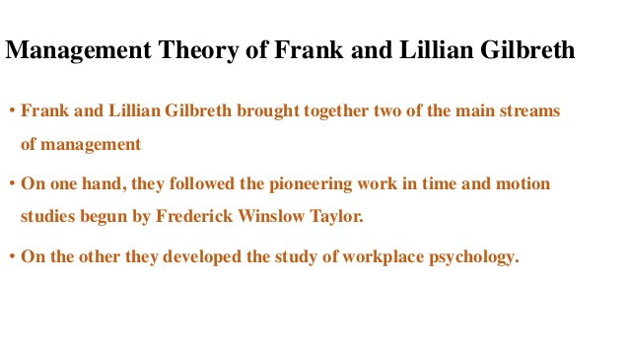
Key points of theory of Frank and Gilbreth
Frank and Lillian Gilbreth are the ones for development of a theory related with increasing the employee performance at a workplace (Albarracin, and Shavitt, 2018). They are majorly responsible for developmental and formation of various regulations and rules according to the productivity of employees, with the help of regulation and consistency among employees they will be able to focus on their work and identify the specific process that needs to be adopted and followed in a organization. According to the theory of management in case of Pizza Hut there is a requirement to reduce the number of task that are in motion is that there can be more focus that has to be done on the increment in employee performance.

Bureaucratic Management
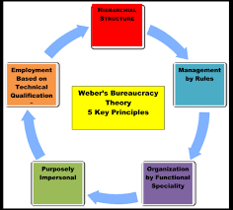
Figure 10 Key principles of bureaucratic management
Source:https://www.pinterest.com/theory of bureaucratic management
It is a management theory that was developed by max Weber and It is considered and is related to the functions of public activities, Bureaucratic Management
Can be described as a structure of a organization that consist of various regulations and rules that have been identified. It is characterized by the standardized procedures, process and the number of task that has to be performed by labor. Max Weber ahs developed this theory so that they can provide guidelines to the organization and the assistant manager of the company so that they can focus on enhancement of production of a organization according to set rules and regulations.
Mechanistic vs. Organic Structures
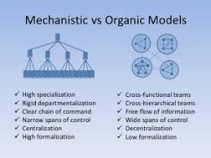
Figure 11 Mechanistic vs. Organic Structures
Source:https://www.makemyassignments.com /Organic Organisational Structure
There are various types of structure in a organization that can help a organization in conducting their business functions in a more effective manner. Such as the structure of organization can be classified in two different parts such as organic structure of the mechanistic structure (Seo and Choi, 2019). Both these structures are different but posses their own advantages and disadvantages. Mechanistic organization structure can be defined as a bureaucratic structure that consist of set and rules pro0cedure, the organization has to follow this structure that is flat organization structure. In this the employees are free to make communication and interact with each other and companies are following up the organic structure and encourage group participation.
Lawrence and Lorsch (1960’s)

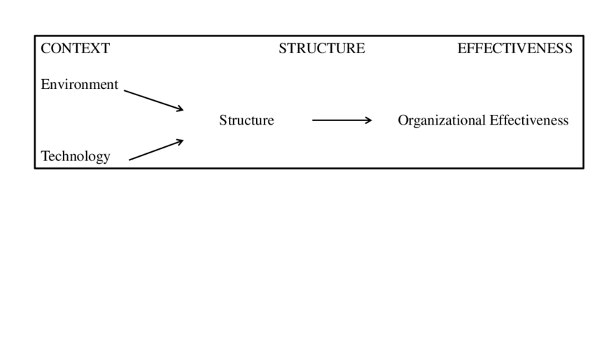
Figure 12 Key aspects of Lawrence and Lorsch theory
Source:https://www.researchgate.net.com/Structural Contingency Theory
Jay lorsch and Paul Lawrence ahs implemented the contingency theory of management in the year 1960’s they have the belief that there does not exist just one way of performing the best business activities and functions (Fergen, and Jacquet, 2016). It is being analyzed that there are different types of contingency has factors that can have a impact on the behavior and employee performance, it is very necessary that in case of assistant manager there has to be identification of the evaluation of both the external and internal factors so that productivity can be enhanced and at same time there exist a balance between the integration for the success of a organization.

CONCLUSION
From the above report it can be said that there are certain factors that are associated with the critical thinking that play a very crucial role in the growth of a organisation .It is very necessary for organisation to increase their overall productivity so that various business activities can be performed in a efficient manner. Such management theories that can help identification of such problems and then resolving them to enhance the performance. It can also be said that belief, values and attitude are totally different from each other and can posses a impact on the organisation. So, for every organization ,both for the manager and the employees it becomes very necessary to consider all the aspects of management theories and then apply them to a organisation.

REFERENCES
Books and Journals
Sturdy, A., Wright, C. and Wylie, N., 2016. Managers as consultants: The hybridity and tensions of neo-bureaucratic management. Organization, 23(2), pp.184-205.
Meisenbach, R.J. and Jensen, P.R., 2017. Bureaucratic theory. The International Encyclopedia of Organizational Communication, pp.1-13.
Ljungholm, D. P., 2016. Bureaucratic reputation management in the public sector. Review of Contemporary Philosophy, (15), pp.46-52.
Casiraghi, B. and Aragão, J.C.S., 2019. Problem-Solving Methodologies Structured On The Stages of Critical Thinking. Psicologia Escolar e Educacional, 23, p.e190902.
Kamis, A. and Khan, B. K., 2019. Synthesizing Huber's problem solving and Kolb's learning cycle: A balanced approach to technical problem solving. Journal of Information Systems Education .20(1). p.10.
Ning, C. and You, F., 2018, December. A Transformation-Proximal Bundle Algorithm for Solving Multistage Adaptive Robust Optimization Problems. In 2018 IEEE Conference on Decision and Control (CDC) (pp. 2439-2444). IEEE.
Su, Y., 2017. Taylor scientific management theory carding and significance of organization management. Social Sciences, 6(4), pp.102-107.
Parker, L. D., 2016. From scientific to activity based office management: A mirage of change. Journal of Accounting & Organizational Change.
Kwon, N. H .C., 2017. Scientific Management in Healthcare at the International Level. The PPE Review, 6, pp.82-92.
Parker, L.D. and Jeacle, I., 2019. The Construction of the Efficient Office: Scientific Management, Accountability, and the Neo‐Liberal State. Contemporary Accounting Research, 36(3), pp.1883-1926.
Otley, D., 2016. The contingency theory of management accounting and control: 1980–2014. Management accounting research, 31, pp.45-62.
Joslin, R., 2019. Project Management Methodologies, Project Success, Project Governance, Contingency Theory, Agency Theory, and Stewardship Theory. In Project Management Methodologies, Governance and Success (pp. 17-30). Auerbach Publications.
Csaszar, F. A. and Ostler, J., 2020. A contingency theory of representational complexity in organizations. Organization Science.
Williams, P., Ashill, N. and Naumann, E., 2017. Toward a contingency theory of CRM adoption. Journal of Strategic Marketing, 25(5-6), pp.454-474.
Hall, M., 2016. Realising the richness of psychology theory in contingency-based management accounting research. Management Accounting Research, 31, pp.63-74.
Seo, M.K. and Choi, M.C., 2019. Contingency theory and the institutionalism in terms of management organization.
Fergen, J. and Jacquet, J. B., 2016. Beauty in motion: Expectations, attitudes, and values of wind energy development in the rural US. Energy Research & Social Science, 11, pp.133-141.
Albarracin, D. and Shavitt, S., 2018. Attitudes and attitude change. Annual review of psychology, 69, pp.299-327.
Doran, R., Hanss, D. and Larsen, S., 2017. Intentions to make sustainable tourism choices: do value orientations, time perspective, and efficacy beliefs explain individual differences?. Scandinavian Journal of Hospitality and Tourism, 17(3), pp.223-238.
Burtz, R. T., Bright, A .D. and Shortsleeve, A., 2020. Attitudes Toward Water Allocation: Segmenting the Public on Beliefs toward Water Conservation. Environmental Management, pp.1-15.
Online
The importance of critical thinking in the Modern Workplace .[Online]
Available thru <https://en.m.wikipedia.org> wiki. 2008
Beliefs, values, attitudes .Figure 1. [Online] <https://owlcation.com> social-sciences/slide share .net
Principles of Bureaucratic Theory.2018. Figure 2.[Online] https://www.theinvestorsbook.com / Max Weber Bureaucracy.
Theory of Scientific Management . Figure 3 .[Online] https://www.slideshare.net / F.W. Taylor.
Stages in Tuckman’s theory .Figure 4 [Online] https:// www.medium .com / 4 Stage of Team Formation
Appliaction of contingency theory in an organisation. Figure 5.[Online] https://www.maaw.info.com/What is the Contingency Theory.
Process of application of system theory.Figure 6.[Online]https://www sagepub.com/Sage Book System Theory
Decision making in Organisations. Figure 7[Online]https://www humrrthotworks.com/Tha 5 Steps of Problem Solving
Taylor’s theory of scientific management.Figure 8.[Online]https://www . hrmpractice.com/Principles of Scientific Management
Gantt chart .Figure 9.[Online]https://www teamgantt.com/Project Management Gantt Chart
Key principles of bureaucratic management. Figure 10.[Online]https://www pinterest.com/Theory of Bureaucratic Management
Mechanistic vs.Organic Structure.Figure 11[Online]https://www.makemyassignments.com Organic Organisational Structure
Lawrence and Lorsch theory.Figure 12 [Online]https://www researchgate.net.com/Structural Contingency Theory

