VASILE ENE
1817171

MARKETING FUNDAMENTALS

PRET A MANGER
Assesment 2
Lecturer: TUSHARA BALADRAN

PRET A MANGER
Essay providing a critical analysis and evaluation

Definition of marketing
Marketing is defined by the American Marketing Association as "the activity, set of institutions, and processes for creating, communicating, delivering, and exchanging offerings that have value for customers, clients, partners, and society at large".[1]
The term developed from the original meaning which referred literally to going to market with goods for sale. From a sales process engineering perspective, marketing is "a set of processes that are interconnected and interdependent with other functions of a business aimed at achieving customer interest and satisfaction". [2]
Marketing process of Pret a Manger company is planning, developing and implementing maneuvers to obtain a competitive edge in niche a Fast Casual Dining . This process is necessary to outline and simplify a direct map of the company’s objectives and strategy how to achieve them. “A company wanting to secure a certain share of the market, should ensure they clearly identify their mission, to survey in the food industry, define specific objectives and develop new produce, implement and evaluate a plan to guarantee they can provide their customers with the products they need, when they need them.
The central objective of any company will be customer satisfaction so they may dominate the market and become leaders in their industry and thus providing substantial business satisfaction. In order to do that, three phases of marketing strategy must be perfected to create delight in their customers and beat out the competition”.[3]
- mission of the company
Pret a Manger’s Mission is to “creates hand made, Natural food, avoiding the obscure chemicals, additives and preservatives common to so much of the ‘prepared’ and ‘fast’ food on the market today.”
Prêt’s Mission Statement is targeted to its customers to emphasize that they are a healthy food shop’s chain.
- strategy
Prêt continues to focus on quality of shops rather than increase in number of shops.
Prêt is renowned for being passionate about quality food and service.
Pret maintaining their quality standards and taking each step carefully before moving further ahead
- objectives
They are more concerned about long term strategic planning rather than meeting short term goals.
In 2001 McDonalds purchased a minority stake of 33% in Prêt. Its international influence and expertise help Prêt in its expansion beyond UK borders.
Prêt was acquired by Bridgepoint in Feb 2008, with planning expansions to other countries.
Pret a Manger – PESTEL – analysis
The macro-environment is “the larger societal forces that affect the whole microenvironment” (Kotler et al. 1998, pp. 885-886).
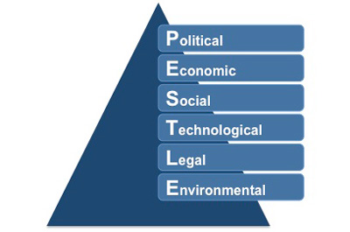
http://www.free-management-ebooks.com/images/stpa0101.jpg
This is the external factors, where a business barely or has absolute no control on, that changes may adversely affect the organisation. PESTEL is an analysis of external factors, generally considered to be outside the control of a business. The PESTEL analysis is to identify both presents and future’s opportunities and threats.
PESTLE and Porter’s Five Forces analysis are used to
evaluate the market-based competitive position of Pret A Manger because profitability of afirm is strongly influenced by the structure of its industry (McIvor, 2005, p. 51).[4]
- Political forces - These are factors that are controlled by the government policies.
Governmental policies and laws that affect the industry.
UE integration – opportunities
BREXIT – opportunities
Prêt exercises with a Fair Trade policy. E.g.:-Coffees
- Economical forces - These factors are related to political and are concerned about interest rates, exchange rate, economic growth and income levels.
Economic recession situation since 2008
Price of the fuel that may affect the transport of goods
Current situation and the firm desire to leave the EU
Exchange rate pound sterling – dollar
- Social and Cultural forces - Concerning the factors of age, size of families, healthy lifestyle and religions
The food are created fresh daily, all excess would be given to the homeless, and even the packaging is made up of recycled cardboard paper. There are no preservatives at all: only fresh, pure food to be enjoyed by those who enjoy healthy lifestyles.
Pret’s customers are familiar with the Pret attitude, which is an environment friendly service coupled with enthusiastic, over-eager staff.
Identify ways to segment market
Segment the market – keep it simple
Veggie products
The Pret Foundation supports over 40 charities up and down the UK in the communities local to our shops.
- Technological forces – the technology that the company needs from the communication, technical information system for the kitchen, etc.
Pret, they have used technology to keep track of their in-house resources, stocks, list of groceries to buy, and other things.
The company uses it to check their employee resources, delegations, tasks, and leaves.
- Environmental forces
Less carbon footprint because of preparation of food at shops
- Legal forces
Pret a Manger has agreed to full ingredient labelling on all its freshly made products following the case of Natasha Ednan-Laperouse, who died after having an allergic reaction to one of its baguettes.

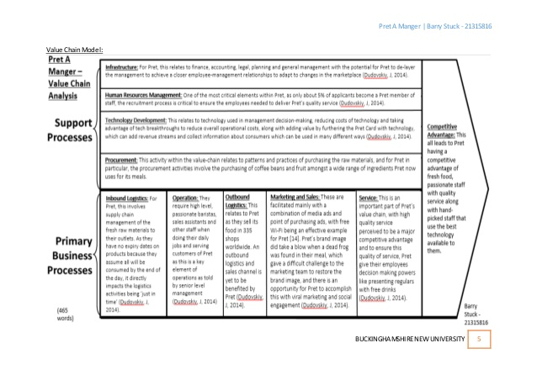
SWOT analysis
Strengths
- Non-stop producing fresh products
- Always create new advertisements.
- Services are fast and easy.
- Many Pret A Manger stores
- Pret has twenty-four years of experience as a famed sandwich maker.
Weaknesses
- Some would say that the prices are too high for a sandwich
- Too many stores sharing the same items
Opportunities
- The quality of their sandwiches and products would precede them.
- Since there are many followers, it would be easier to know what consumers want, and how to retain these wants to keep the customers loyal to Pret.
Threats
- By entering the mainstream competition in other countries and continents: Asia, America, Europe.
- Other opportunities after BREXIT
SEGMENTATION
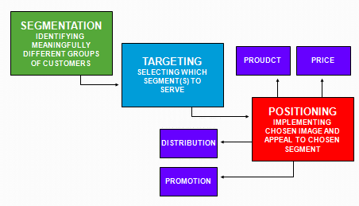 https://www.consumerpsychologist.com/images/cb/STP.png
“The STP process demonstrates the links between an overall market and how a company chooses to compete in that market. It is sometimes referred to as a process, with segmentation being conducted first, then the selection of one or more target markets and then finally the implementation of positioning. The goal of the STP process is to guide the organization to the development and implementation of an appropriate marketing mix, as highlighted in the following diagram.”[5]
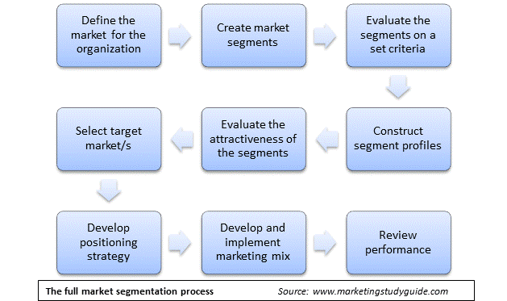
Demographic variables essentially refer to personal statistics such as income, gender, education, location (rural vs. urban, East vs. West), ethnicity, and family size.
Geographic – By country, region, city, county, etc.
Psychographic – Their personality, values, lifestyle, attitudes, interests, and opinions. Among the strongest sources that form these factors are families, region, schooling, and society.
Behavioral – How they use the products? Are they loyal to any product? What benefits are people looking for from these products?
Behavioural Segmentation - Veggie Pret!
Veggie Pret has been a huge success since it opened its first pop-up shop in an existing Pret store in Soho. It triggered many new product suggestions for the main Pret stores which then installed more veggie / vegan display units as a result.
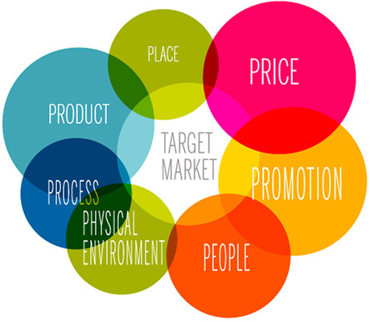
https://marketingmix.co.uk/content/uploads/marketing-mix-defined.jpg
The marketing mix definition is simple. It is about putting the right product or a combination thereof in the place, at the right time, and at the right price. The difficult part is doing this well, as you need to know every aspect of your business plan.

Added value is an important tactic that can be used by small businesses to acquire and retain customers, increase brand awareness, and differentiate one’s place in the marketplace.
1. Always consider your customers’ perspective
The art of creating added value starts with the ability to see your business through the eyes of your customers.
2. Consistently work to improve customer satisfaction
Although the debate over whether the customer is always right continues, lack of customer satisfaction is a sure-fire way to keep people from coming back.
What is a marketing concept?
Succeeding by meeting the needs of customers is one of the most commonly held ideas of the marketing concept. Organizations that embrace this certain principle eagerly recognize that consumers are the dynamic strength behind their organizations. The concept of marketing is a fundamental piece of the marketing arrangements. Achievement is straightforwardly related to what the client needs.
The concept of marketing accordingly depends on three key perspectives:
1) What is the target market – The first step is to focus precisely which the object market is. This can be achieved by market research and choosing which, the target business sector, will give the best returns.
2) What are the needs as well as the demands of the target market – A further venture in market research is the ‘buyer preference’ study. This study will help the firm to focus on the needs and demands of the target market, consequently helping the firm in choosing their policies.
3) How better would we be able to convey a value proposition – In this step, the firm will decide on the policies that it would adopt. What sort of quality the firm would create and convey? In what capacity would it be advisable for the firm to incorporate its distinctive offices? Eventually, the firm chooses how to apply the concept of marketing to convey a better consumer experience.
What is Branding?
Branding is all of the ways you establish an image of your company in your customers’ eyes.
By building a website that describes what you offer, designing ads that promote your goods and services, selecting specific corporate colors that will be associated with your company, creating a logo, and featuring it across all your social media accounts, you are branding your company. That is, you are shaping how and what people’s perceptions of your business are.
And what your customers say about your brand is the reality (not what you’d like them to think). It’s the impression that pops into their minds when they hear your business’ name. It’s based on a feeling they have that is based on their experiences they’ve had with you, good or bad.[6]
What Is a Stakeholder?
“A stakeholder is a party that has an interest in a company and can either affect or be affected by the business. The primary stakeholders in a typical corporation are its investors, employees, customers and suppliers. However, the modern theory of the idea goes beyond this original notion to include additional stakeholders such as a community, government or trade association.”
Stakeholders are organizations, individuals or groups that are concerned about the activities of a business. Stakeholders can be internal or external and each group has a different interest in the company. Let's examine these stakeholders in more detail.
Internal Stakeholders
First, let's start by defining internal stakeholders. Internal stakeholders are those individuals or groups within a business such as employees, owners, shareholders and management who have an interest in the company. For example, Jake's employees at the Books Worth A Look bookstore are concerned about the company's ability to operate into the future since they obviously want to know if they'll still have their jobs. Management employees like Jake will always be concerned about whether the business will continue to operate, his advancement opportunities, and his possible salary increases.
External Stakeholders
External stakeholders are groups, individuals or organizations outside of a company such as its customers (those individuals who purchase its goods and services), creditors (individuals or groups to whom the company owes money), the government, suppliers (companies from whom the business purchases its products), or society in general.
What is integrated marketing communications?
“This strategy is all about integrating the different promotional tools, strategies, and materials that you use, so that they work together as a “branding suite”, rather than a loose collection of ideas. After all, when all of your company marketing elements work together in harmony, you create a more seamless journey from one communications channel to the next. That’s better for your company, and your customers.”[8]
A product is an item that is built or produced to satisfy the needs of a certain group of people. The product can be intangible or tangible as it can be in the form of services or goods.

You must ensure to have the right type of product that is in demand for your market. So during the product development phase, the marketer must do an extensive research on the life cycle of the product that they are creating.

References
[1] Marketing definition approved in October 2007 by the American Marketing Association
[2] Paul H. Selden (1997). Sales Process Engineering: A Personal Workshop. Milwaukee, WI: ASQ Quality Press. p.23.
[3] The Strategic Marketing Process: A Complete Guide - https://www.cleverism.com/strategic-marketing-process-complete-guide/
[4] McIvor, R. (2005). The outsourcing process: strategies for evolution and management.Cambridge: Cambridge University Press.
[5] https://www.segmentationstudyguide.com/stp-process/what-is-the-stp-process/
[6] https://www.shopify.co.uk/encyclopedia/branding
[7] https://www.investopedia.com/terms/s/stakeholder.as
[8] https://fabrikbrands.com/what-is-integrated-marketing-communications/

