Ecological motel ‘Green Habitat’ business concept

Student: Emilia Ramona Sipos
ID: 2211874
Entrepreneurship BMIH5001
Lecturer: Ben Chong

This essay is a work that illustrates the business concept for an ecological motel from an analytical perspective, meaning that the sum of the ideas presented will offer a comparative overview of sustainable hospitality through evaluation of appropriate theories.
The first definition of sustainability was given by the United Nations Brundtland Commission: “meeting the needs of the present without compromising the ability of future generations to meet their own needs” (UN, 1987), definition which is relevant to the current world situation, as hospitality industry is in a continuous global growth (Hospitality Global Market Report, 2023) (Appendix 2), fact that leads to planet degradation, therefore sustainability is the only was to ensure hospitality and tourism of today will not harm hospitality and tourism for the future generations by destroying the environment, as stated by the definition, thus the importance of as many sustainable approaches.
The sustainable measures taken by Green Habitat are several (please see appendix 1, section ‘value proposition’), and each will be debated separately. Firstly, the motel sources its electricity through solar panels, which is beneficial for the motel because energy costs for any hotel is the highest fixed cost after salaries (Kite- Powell, 2011) the same way it is for the environment because it is known that the usage of solar panels supports a cleaner and healthier environment by reducing carbon footprint (UN, 2023), and this correlation is the reason behind the decision of Green Habitat to adopt this specific sustainable measure. Solar panels are chosen out of all many sustainable opportunities, as the return of using them as source of energy is significant. Trying to implement other complex sustainable measures would be expensive and being a new business, solar panels represent best option, as they are not too expensive, and as soon as they are installed, they start saving money and cutting costs for the business.
Secondly, the motel uses only eco- friendly products for guests (they are provided with ecological soap, shampoo, conditioner, bath and shower gel) and staff (all the cleaning products used by the housekeeping team are ecological) both, and the reason behind this approach is that tourism and its continuous growth brings along progress and hospitality cannot remain with old habits and new ones must be adopted, ones that enhance the well- being of individuals whilst safeguarding the environment (UNWTO,2023).
This particular sustainable measure has been chosen, as research show that guests appreciate a business commitment to sustainability a high percentage of 74% (Michalis, 2024) of travellers commit to an accommodation type that offers more sustainability, furthermore, 43% (Michalis, 2024) are willing to pay more for a sustainable service. Green Habitat uses this research find outs to enhance its success, and eco- friendly products are used as it is the most obvious sustainable habit that guests can observe. Guests may not realise sustainable efforts made in the kitchen, as it is not something placed right in front their own eyes, and even if Green Habitat adopts transparency and promotes its sustainable measures, not all of them are palpable, however ecological products are something they can palpate, therefore implement in their minds that Green Habitat is a sustainable business.
Society and environmental measures have been detailed so far, however Green Habitat adopts sustainability also in the economical pillar by ensuring entire stock in the motel’s kitchen is sourced from local farms, which has a massive advantage of supporting local economy growth, and then by giving all the food waste to the farms which then separate it in compost or food for animals, the reason behind these measures being that sustainable habits create the effective way to stand out from competitors (Ragunanan, 2019).
Despite the advantages of sustainable measures enumerated so far, the case can be argued, supporting local business brings along economic dependence (if the motel is not successful, the local economy will suffer alongside) and it can also affect the guests due to the fact that sustainability requires investment which can lead to a price increase so that the business can cover the expenses (The Travel Foundation, 2016).
The key activities are the exact steps that the motel has to take in order to deliver to guests the value ‘promised’ of an eco- friendly accommodation different from competitors (appendix 1, section ‘key activities’). Researchers suggest a formal recognition is required so that the eco- friendly image is gained, therefore the first key activity is for Green Habitat to obtain a ‘Green Tourism Certificate’, and the second one is to gain recognition by registering with the eco- travel sites. (Site Minder, 2024).
Next steps are initiating recycling programs where in detail description of the motel’s recycling policies is given, then ensuring the motel has sustainable resources from local producers, and also eco- friendly ones (cleaning and cosmetic products), both of which impose the following two key steps, and those are staff training- to ensure that recycling measures are applied correctly, and monitoring- which is important in order to evaluate progress.
The derivates of the key activities are the key resources (Appendix 1, section ‘Key Resources’) which are also the intermediary tool between value proposition and key activities, without the key resources none could be achieved, therefore solar panel and eco- friendly products are key resources to ensure sustainability is achieved, and staff are essential as they are the one physically implementing all the sustainable activities, and further, managers are essential to ensure the message is delivered correctly, progress is monitored, and errors are rectified (The Hospitality Daily, 2023). To continue, the channels chosen to use in order to deliver potential guests all the unique features that Green Habitat have are mainly social media platforms (Facebook, Instagram, TikTok), and the basis of that is the statistic according to which 68% (Appendix 3) of consumers make at least one purchase after being convinced by an add circulating on the online (Sprout Social, 2022).
Cost structure is critical for the success of any accommodation business, Schmidt (2023) point out that it is essential to prioritise all the costs, and for Green Habitat this implies that the first sectors receiving funds will be the ones that derivates from the key activities, as without these activities the reputation could be jeopardized, all of them listed in their importance order (Appendix 1, section ‘Cost structure’). Marriott Hotel adopts a similar structure, where the majority of funds are allocated to their essential activities: purchasing new properties to fulfil their globally expansion goal (Marriott 2023 annual report), thus the importance of prioritising costs is highlighted and represents an inspiration for Green Habitat. However, in order to ensure there are funds for all the ambitious sustainable measures, Green Habitat has a strategy in place which will allow the motel to have more revenue streams (Appendix 1, section ‘Revenue streams’) that will support the motel in obtaining more money, thus, apart from room occupancy rate, the motel will generate profits from the percentage received from the vending machines placed in the lobby and from allocating spaces in the official website that other businesses can purchase for advertising.
As Soler states (2024) Generation Z is the one that is more digital than the other generations, also, people belonging to generation z are more drawn to eco- tourism, and these are the two arguments behind the fact that Green Habitat targets exactly Generation Z, however at the same time, with this occasion the choice of media channels as advertising backgrounds is proved to be wise. To be noted here that generation Z are the most important customers that appreciate the value proposition, however not the only ones.
“Building partnerships with others is a key skill for success in any field or industry. Partnerships can help you leverage resources, expand your reach, create value, and achieve your goals” (Abraham, 2024). Based on this quote, Green Habitat will partnership in a way to ensure sustainable measures will run smoothly, thus the key partners are local suppliers, as this affiliation will ensure sustainability is achieved.
According Reiling (2022) customer relationship can be developed on two levels, customer acquisition and customer retention and, if implement correctly, a good strategy respecting this area will lead to building trust among customers. Green Habitat will attract customers by the transparency on the social media, where sustainable measures will be promoted and will then further be retained by delivering everything that the motel promotes, in other words keeping its ‘promise’ to customers. Premier Inn had a similar approach where it shifted the main focus on guest experience by using a so-called method ‘listen and learn’ that enabled the hotel to find out customer expectations in order to fulfil them, thus attracting and retaining them (Marketing Week, 2018).
The business concept was presented in an order which would outline the fact that Green Habitat motel is a business that relies mainly on value creation and the execution of value, rather than focusing on enhancing profits or expanding, such as the given example of Marrott Hotel International, therefore Green Habitat differentiates itself by being a ecological motel that places the accent not just on promoting sustainability, but also on adding value for its guests.
To sum up, Green Habitat has a strategy of implementing sustainable measures that are most efficient (solar panels), most visible for guests (ecological products), and more beneficial for the business alongside economy (local sourcing and food waste management). The advantages of sustainability identified are market differentiation, positive public relations, local community support, and positive global impact, and the disadvantages are price rises and economic dependence. Placing the advantages and disadvantages in a balance, the advantages can overcome the disadvantages, as there are more advantages, and added to that, they weigh more from the importance point of view, meaning that any hotel seeks a favourable image which attracts customers, and sustainable practices represent one way to achieve this common goal.

Reflective essay
Upon testing my entrepreneurial skills, via Get2Test Enterprise rating (please see appendix 4), I have found out about myself that I am ‘occasionally enterprising’, and that result surprised me as I already run a business that I have grown from zero and it is successful and in the process of expanding (a venue for celebrations and parties), however I soon took the result and turned into an opportunity. Using Gibb’s reflective cycle, I will ensure to have a positive outcome out of this situation that initially upset me, therefore there will be six stages discussed (appendix 5).
First stage consist in describing- during class we were required to perform a test by answering a few questions to find out exactly how enterprising we are, and my results were not the ones expected, I was assuming I have strong entrepreneurial skills for the reason already mentioned above. Second stage of the Gibb’s reflective model consists in describing the feelings resulted from the situation- in my example, I felt surprised, disappointed on some level, however my main feeling was one of frustration; all these feelings flooded me and were mix for the entire rest of the day, and by the evening I was starting to feel like I should just accept the situation and use it to my advantage, I was cross-examining myself if there is anything I am already doing wrong in my business and I am not even aware of, and as soon as that thought passed through my mind a feeling of curiosity stepped in, now I was feeling eager to find out the areas where I can improve.
Third stage consists in evaluating the positive and the negative of the situation- I strongly believe that this is a relevant example for the saying ‘every bad situation has a good thing behind it’ as I can use it as a tool to help me in achieving better results as an entrepreneur.
Fourth stage consists in the description of what one can do- I believe the best thing I can do is to carefully read my results and identify exactly what areas I should improve. Fifth stage consists in concluding- to be honest I am now happy of the opportunity given by my University, through Entrepreneurship module, and specifically of this particular test and I wouldn’t want to change it by all means.
Sixth and last stage is to build an action plan- this is the best part, as it is exactly what I plan to apply in real life, and the actions I will take are: I will take the advice given in the result and enrol myself in business courses, that will support my entrepreneurial skills by gaining new knowledge in the business field and I am sure that I will also strengthen the skills I already possess.

References
Abraham, N (2024) How do you build partnerships with others. Available at: How to Build Effective Partnerships with Others (linkedin.com) (Accessed: 20 May 2024)
EHL Insights (2024) What is the hospitality industry? All your questions answered. Available at: Hospitality industry: All your questions answered (2024 update) (ehl.edu) (Accessed: 20 May 2024)
Forbes, Kite- Powell (2011) Solar Powered Energy Management for Hotels. Available at: Solar Powered Energy Management for Hotels (forbes.com) (Accessed: 20 may 2024)
Marketing Week (2018) How Premier Inn proved the value of service. Available at: How Premier Inn proved the value of service (marketingweek.com) (Accessed: 20 May 2024)
Marriott International (2024) 2023 Annual Report. Available at: b82978a6-9d28-4e38-9855-fc4ae2cebe11 (gcs-web.com) (Accessed: 20 May 2024)
Michalis, B (2024) Sustainability in Hotels: Creating a greener future for hospitality. Available at: https://www.canarytechnologies.com/post/sustainability-in-hotels#:~:text=Sustainable%20hotel%20practices%20are%20not,support%20certified%20sustainable%20travel%20options. (Accessed: 23 May 2024)
Ragunanan, S (2019) Food in the hospitality: why sourcing it locally matters. Available at: Food in the hospitality industry: Why sourcing it locally matters (bizcommunity.com) (Accessed: 20 May 2024)
Reiling, J (2022) Customer Relationships in the Business Model Canvas. Available at: Customer Relationships in the Business Model Canvas (bethestrategicpm.com) (Accessed: 20 May 2024)
Report Linker (2022) Hospitality Market Outlook 2022- 2026. Available at: Hospitality Market Outlook 2022 - 2026 (reportlinker.com) (Accessed: 20 May 2024)
Schimdt (2023) Cost Structure. Available at: Cost Structure: Direct vs. Indirect Costs & Cost Allocation (corporatefinanceinstitute.com) (Accessed: 20 May 2024)
Site Minder (2024) Hotel sustainability: A full guide for hotel owners. Available at: Hotel sustainability: A full guide for hotel owners - SiteMinder (Accessed: 20 May 2024)
Soler, J (2024) Unlocking Generation Z: How to captivate the next Wave of travelers. Available at: Genz and Hotels, the digital generation (linkedin.com) (Accessed: 20 May 2024)
Sprout Social (2022) Social Shopping in 2022: Consumer Behaviours in the Social shopping cart. Available at: Research: Social Shopping in 2022 | Sprout Social (Accessed: 20 May 2024)
The Hospitality Daily (2023) Sustainability in Hospitality Industry: A Comprehensive Guide. Available at: Sustainability in the Hospitality Industry: A Comprehensive Guide - The Hospitality Daily (Accessed: 20 May 2024)
The Travel Foundation (2016) Tourism must decarbonate and adapt. Available at: Home Page - Travel Foundation (thetravelfoundation.org.uk) (Accessed: 20 May 2024)
UN (2023) Environment Programme. Available at: UNEP - UN Environment Programme (Accessed: 20 May 2024)
United Nations (2023) Academic Impact. Available at: Sustainability | United Nations (Accessed: 20 May 2024)
UNWTO (2023) World Tourism Organisation. Available at: UN Tourism | Bringing the world closer (unwto.org) (Accessed: 20 May 2024)

Appendix
Appendix 1
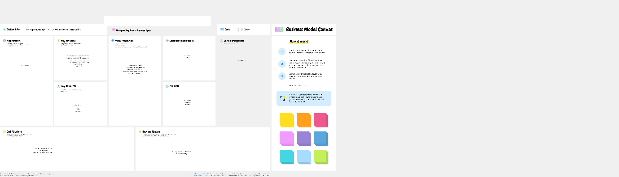
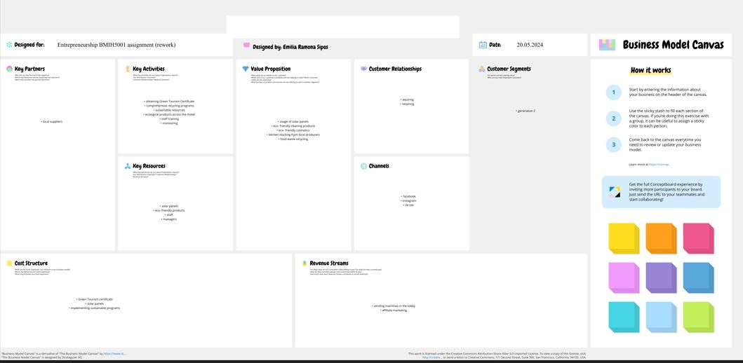
https://app.conceptboard.com/board/6p9u-20zx-g9yr-pn2a-outq

Appendix 2
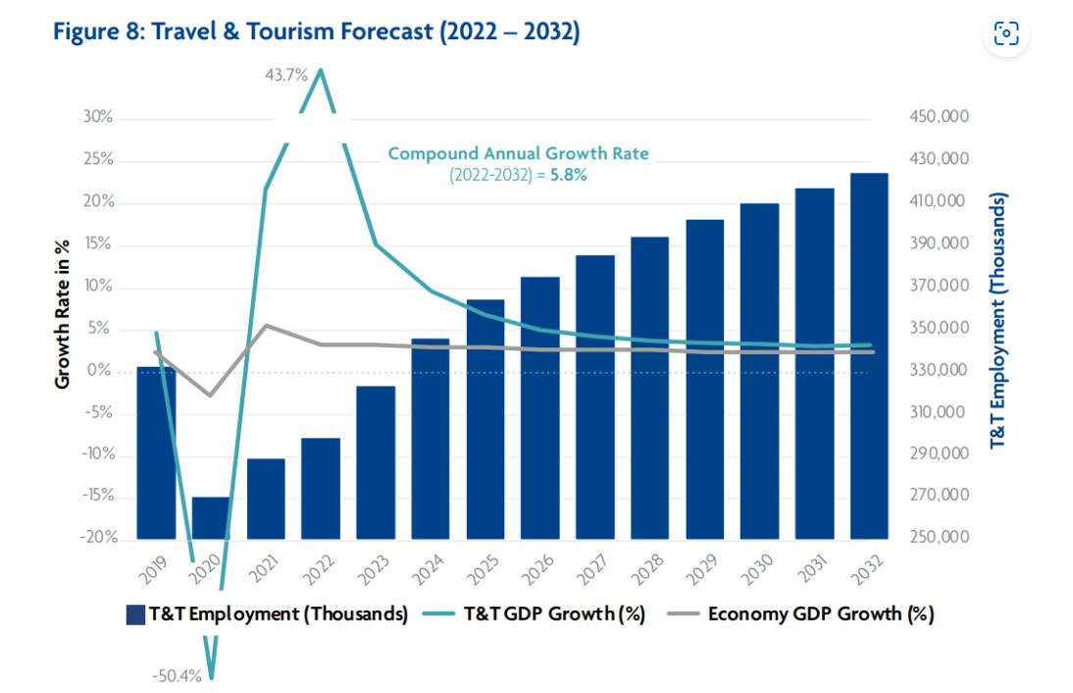

Source: EHL Insights Hospitality industry: All your questions answered (2024 update) (ehl.edu)

Appendix 3
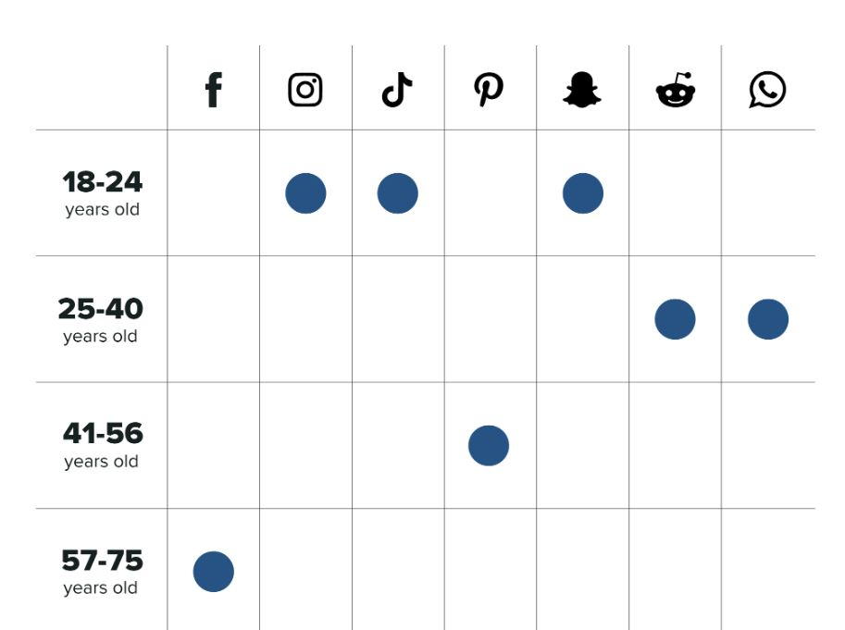
Source: Sprout Social Research: Social Shopping in 2022 | Sprout Social
Appendix 4
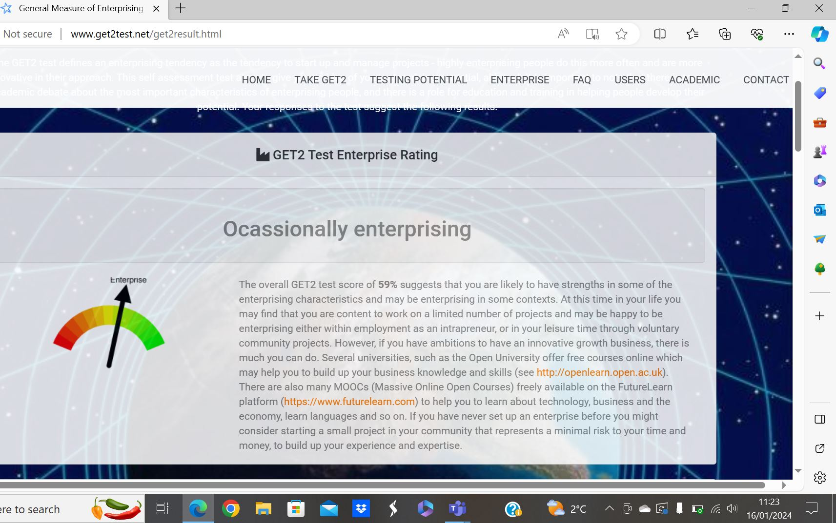

Appendix 5
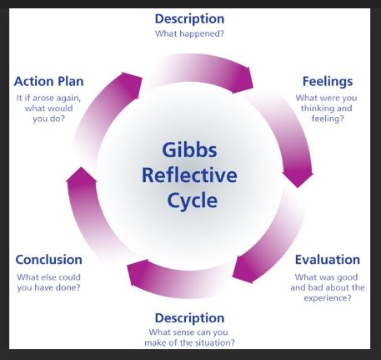
Source: Gibb’s Reflective Cycle | Sarah Stewart's Eportfolio (glowscotland.org.uk)

