ASSESSMENT 2 - HUMAN RESOURCE MANAGEMENT
REPORT AS HUMAN RESOURCE DIRECTOR
LCMB7000

LINA BIRMANTE
STUDENT NUMBER 2010698
Module Leader Dr Gladius Kulothungan
30/04/2021

TABLE OF CONTENTS
Introduction 3
1. Human Resource Strategies developed and deployed in different fields of the organization BJSS 3
A. Staffing- Recruitment and availability of skilled local labor 3
B. Learning and development 4
C. Compensation 6
2. The strategy implications on the team members 6
3. Critical appreciation of the principles, models, and concepts of current HRM AND IHRM theories 7
Conclusion 11
Reference List 12

Introduction
BJSS is a top technology consultancy for business purposes. The organization practices client management and is committed to providing innovative industry solutions. Their digital transformation methods and engaging user services have been successful due to their efficient strategy planning- its implementation, and administration. An organization is responsible for developing strategies to maintain effective management, retention of employees, deploying different HRM models to enhance the working capability of the organization. As a Human Resource Director, the responsibility of efficient working of the entire company is bestowed on the shoulder. It is the sole duty of the director to improve and reshape the models in order to facilitate the smooth functioning of the brand. They are also entitled to ensure the employees do not face any discrimination and are able to work in a healthy atmosphere. Developing strategies, analyzing their outcomes are the key functions of Human Resources. The Human Resource is considered as the asset of the organization as it entails the future of the brand with its leadership qualities and rationale behind recruitment.

1. Human Resource Strategies developed and deployed in different fields of the organization BJSS

A. Staffing- Recruitment and availability of skilled local labor
Recruitment and availability of skilled local labor is an important responsibility of Human resource management. In addition, the organization BJSS needs highly skilled and knowledgeable employees who efficiently manage their day-to-day operations. For the purpose to ensure that they have skilled employees in their different fields like management, operation, IT solution they keep links with each of the departments on a daily basis so that in case any vacancy arises they can start the procedure of recruitment. The recruitment procedure needs to be effective and strategic that meets the departmental criteria (Waxin et al., 2018). Each recruitment advertisement for each department needs to provide all relevant information regarding the post like job responsibility, the number of vacancies, required qualification and experience, the date and place of interview, and other information needs to be present in the advertisement. The recruitment notice needs to channel with effective media like digital media, through various newspapers, via job advertising portal and other different channels. With effective discussion, the process of selection needs to be determined by the recruitment board. The interview board representative of each department needs to be present. They need to decide how many rounds of interviews will be there if there will be only a written interview or also group discussion will be there.
The time of selection is needed to make sure only based on the test result, qualification, and experience the selection process needs to be conducted. No discrimination of bias activities needs to be entertained at the time of recruitment. Higher authority is needs to make effective rules regarding this, and in case any HRM employee breaks this rule is bound to get notable punishment. It is essential to recruit local employees as they are aware of the local market and make easy connections with the local people (Sissons, and Green, 2017). At the time of emergency or heavy work pressure, it will be easy to get support from the local employees. The training and development opportunities need to be present in the organization and once every two months employees need to provide training to upgrade their skills. In these ways, new employees will learn new things, and old employees able to revise their knowledge by sharing their experience with newcomers. HRM always needs to develop a work culture that will provide employees an atmosphere where they can work peacefully that will help them to make critical decisions for organizational growth and development.

B. Learning and development
The digital revolution is based on unsubstitutable assets in the form of the skills and knowledge of the employees. As a technology firm, BJSS, the learning, and development requirement are quite high as compared to other organizations. The strategy in this field hovers around 5 main aspects as shown in the figure. In today's world, every individual is responsible for his or her own professional and personal growth. Every individual is seeking opportunities to learn and upskill themselves. Failing to meet the expectations of the employees may lead to losing some potential members. It is strategic to invest in learning and development in order to retain and upgrade skilled employees.
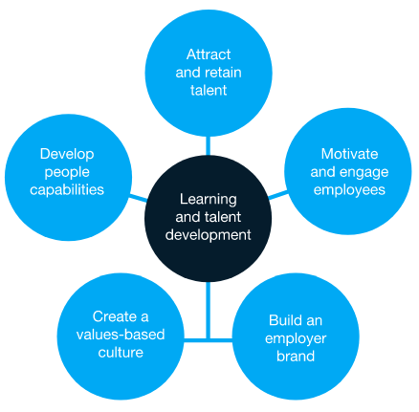
Figure 1: Learning and Development Objectives
(Source: Haemer et al., 2017)

Technology is growing at such a rate that knowledge becomes outdated frequently. In such a situation, the human capital has to be fed with new information and relevant working experiences.
As the director, training programs for familiarizing new technologies is important. Seminars must be conducted and proper evaluation of skill is mandatory. Such strategies also erase any existing conflict. Periodical arrangements are to be made for vocational training in order to keep employees motivated. The company has to keep itself updated with the new developments in the fields of technology and try to create seminars on it to create awareness. Groups can be formed and assigned tasks to apply their knowledge (Haemer et al., 2017).
Strategies that focus on L&D are vital as they help generate the employer brand. The organization is known for the output generated by its employees. The composition of the human capital employed keeps on changing due to retirement or joining of freshers. Therefore it is very important that the balance is maintained.

Application of the change management theory
By the implication of the change management procedure, this can be possible to keep incurring

the valuation regarding the business-based productivity and procurement. Herein, the application

of the Kotter’s change management model can be implied which can help to generate possible

output. In this regard, the enhancement of the team building procedure, effective communication

based development and focus on the short-term goals can be effective which can help to make

occurrence of the response to change management procedure also.

C. Compensation
The first and most important part of compensation strategy is to allocate the resource into salary, benefits, and reinvestments. It is a crucial step and mandatory before developing salary ranges. The ranges should then be decided according to the skills and contribution of different groups working under the organization. Benefits packages are a must; salary audits, legal compliance along structured administration form the criteria for effective strategy building. The base salary must be set and not subjected to frequent changes. Fluctuating or irregular payments to both employees and clients shall be avoided.
Salary structures are to be designed following the 3P's compensation rule. Person, performance, and position shall design compensations according to payment. Salaries are paid according to their merits and on time. The organization follows compensation in broad 4 categories namely hourly, salary, bonuses, and commission (Khalid and Nawab, 2018).
There are individuals who are deployed on contracts and visit the organization as and when required. The technicians who are appointed for the smooth working of the devices and software also fall in these categories. A proper scheme of payment to those individuals must be mentioned. The next most important thing to be ensured is the time of disbursements of the salaries. The time must be maintained throughout the year and HR should come out transparent if at all there arises any issue.
Other than these responsibilities, HR is required to formulate a plan on how to proceed with the resources.

2. The strategy implications on the team members
All the steps that are taken by an organization are to maintain a healthy balance between the employees' demands and expectations and company objectives. Every employee must feel valued, appreciated, and respected in their workplace. Developing strategies based on staffing, learning, and development, and compensation is closely associated with taking care of the mental and physical needs of the employees.
Recruitment of skilled labor increases the performance of the entire batch through the working of positive externalities. An individual is often motivated to learn and work as par with their colleagues. Therefore, proper recruiting strategies will motivate and grow their interests to grow with the organization (Brouwer and Hessels, 2019). Employing local labor is an extra incentive as it reduces the energy loss due to travel. Living away from families to earn their livelihood leads to poor mental health. Here, it can be stated that recruiting from the locality, staying with families does act as a bonus to better performance.
Learning and development opportunities provide them with motivation and aspiration. The opportunity of learning new things is often appreciated more than ever. It helps to retain employees who are well potential and would leave the organization the moment they achieve a better opportunity (Ekhsan et al., 2019). The BJSS is committed to providing its members with the newest ideas and trending technologies. The organization equips its employees with the best-featuring software in order to increase their interest. The training programs, seminars will all act as a bonus to improve their work quality.
The basic motivation to work comes from the compensation they receive. Proper compensations shall enable them to trust the organization and feel secured. When the employees stop fearing, they work better and hence produce better (Al Mamun and Hasan, 2017). Bonuses and incentives based on their performance also encourage them to get into a healthy competition among peers. It shall motivate them to learn and improve themselves every day.

3. Critical appreciation of the principles, models, and concepts of current HRM AND IHRM theories
The current models of Human Resource Management are broadly classified into soft and hard models. The soft models deal with employee training, their development, quality, and motivation. It creates the outlines for the approach best suited for complete commitment and strategic integration of different groups of employees.
The Harvard model of HRM and Michigan model are examples of soft and hard models respectively. The basic difference between the principles of the two models is that the soft models focus on long-term workforce planning whereas the hard model focuses on short-term changes required in the number of employees. There is a lack of two-way communication between the higher authorities and employees in the case of hard models (Rahman et al., 2017). They are employed on a minimum wage basis whereas the employees under the long-term scheme enjoy profit shares, incentives. They even enjoy delegation of authority compared to little power of delegation given to the short-termed employees. In short, the soft HRM model practices democratic leadership and treats every employee with respect. The hard model of HRM has complete control over their employees, an autocratic structure of leadership.
Though it seems that Hard models are harmful in practice, it is truly useful in times of crisis. If there is already an expert in the team, it is always better to follow hard models in order to pacify the job. It helps in making quicker decisions. Brands like Cadbury, BHP completely follow principles of soft models whereas Westfield has ideologies based on both models. Guest models, the Fombrun model, Warwick models, Dave Ulrich model are some other models that are presently practiced by different companies (Cheng and Hackett, 2021). The models are created based on the functions and responsibilities under them.
The Fombrun model is somewhat criticized for being incomplete as it only focuses on the four functions namely selection, appraisal, development, and rewards. The model has completely ignored the environmental and contingent factors that are to be kept in mind. In the same respect, the Harvard model is appreciated as it has included all 6 vital components of HRM. Stakeholders, Interests, situational factors, HRM policy choices, HR outcomes, consequence, and the complete feedback and its correction have found importance in it (Jiang and Li, 2019).
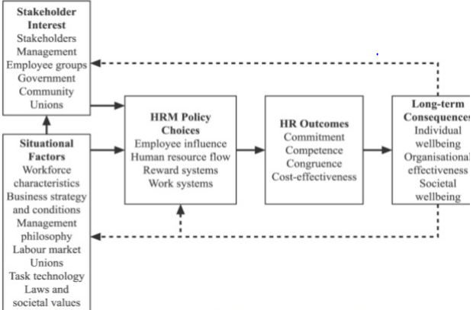
Figure 2: Harvard Model of HRM
(Source: Jiang and Li, 2019)

The Guest Model was further appreciated due to its inclusion of behavioral outcomes. The model clearly stated that the commitment, quality, or flexibility of an employee is highly influenced by HR. Therefore, the practices of HR must align with their strategies. Due to this additional improvement, the Guest model is often considered superior to other models (Prikshat et al, 2018). Next in line comes the Warwick model that gained momentum after entering the environmental factors that influence HR in their model. This model acts as a connection between the external and environmental issues that together help in the growth of an organization.
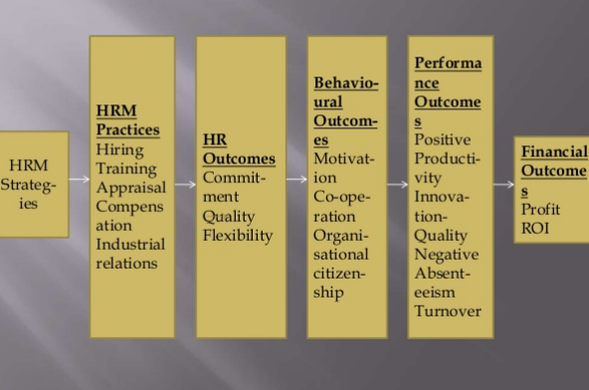
Figure 3: Guest Model of HRM
(Source: Cheng and Hackett, 2021)

The International Human Resource management models are well classified into 3 sections. It divides the HR activities into procuring, utilizing, and allocating. The second section deals with the types of employees and the third section is dealing and maintaining a healthy connection with the countries. The model organizes the employees and countries on the basis of the home where headquarters are located, the host where the subsidiary is located, and third countries from where the human and finance resources are accumulated (Horwitz, 2017). This modeling helps them to divide the tasks and jobs efficiently. Depending on the choice of nationals, their approach for recruitment is chosen. The international models are highly recommended as it differentiates between the employees on the basis of their potential.
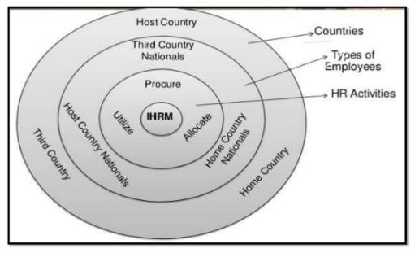
Figure 4: IHRM model
(Source: Horwitz, 2017)

The ethnocentric approach believes that nationals from their home country serve better as they can easily communicate with the headquarters and there is no lag before they adapt to the culture. The next approach followed by them is known as the polycentric approach. This is based on the principle that the nationals of the host country will be best to understand the pulse of their country. They would be able to coordinate with the localities and perform well in achieving the company objectives. The last approach is known as the geocentric approach where they simply employ on the basis of their talents and skills (Farndale et al., 2017). It helps them to acquire the best assets from all over the world. It reinforces the competitive advantage of the company by bringing in the most eligible people.
The models do come with their own disadvantages. The last approach is quite expensive and can also lead to cross-culture issues at the workplace. The first two approaches of the model are often criticized due to the discrimination based on countries. Other scholars also point out the coordination failure aspects that exist when working on a global platform. Again, there are also critiques who say that there is discrimination in the compensations offered as well (Lavelle, 2018). The home country nationals are often more respected than the third-country employees. Despite the existing conflicts between which models to be followed, the IHRM models are respected for their well-organized steps and HRM models for their explicit problem-resolving attitude.

Conclusion
It is seen that the top companies invest in acquiring knowledge for the next generation more than other things. Learning and development must be prioritized as it helps in generating a culture based on values. Each employee must feel that they are contributing to the organization. The strategies of recruitment and compensation are important to motivate the employees to give in their best for the organization. The models of management are developing each day, they are inculcating the recent requirements. It is the responsibility of each organization to adapt to the new laws and rules in order to progress (Rana and Malik, 2017). Special importance must be given to those strategies that help in the management of the behavioral and environmental aspects in order to experience sustainable growth. The HRM and IHRM models discussed above should therefore be implemented after checking whether the organizational demands are met by the principles of perspective.

Reference List
Al Mamun, C.A. and Hasan, M.N., 2017. Factors affecting employee turnover and sound retention strategies in business organization: A conceptual view. Problems and Perspectives in Management, (15, Iss. 1), pp.63-71.
Anbu, D., 2019. A review on human resources management (HRM) theories and effective human resource management models. Asian Journal of Multidimensional Research (AJMR), 8(5), pp.81-93.
Brouwer, S. and Hessels, L.K., 2019. Increasing research impact with citizen science: The influence of recruitment strategies on sample diversity. Public Understanding of Science, 28(5), pp.606-621.
Cheng, M.M. and Hackett, R.D., 2021. A critical review of algorithms in HRM: definition, theory, and practice. Human Resource Management Review, 31(1), p.100698.
Ekhsan, M., Aeni, N., Parashakti, R. and Fahlevi, M., 2019, November. The Impact Of Motivation, Work Satisfaction And Compensation On Employee's ProductivityIn Coal Companies. In 2019 1st International Conference on Engineering and Management in Industrial System (ICOEMIS 2019) (pp. 406-415). Atlantis Press.
Farndale, E., Raghuram, S., Gully, S., Liu, X., Phillips, J.M. and Vidović, M., 2017. A vision of international HRM research. The International Journal of Human Resource Management, 28(12), pp.1625-1639.
Haemer, H.D., Borges-Andrade, J.E. and Cassiano, S.K., 2017. Learning strategies at work and professional development. Journal of Workplace Learning.
Horwitz, F., 2017. International HRM in South African multinational companies. Journal of International Management, 23(2), pp.208-222.
Jiang, K. and Li, P., 2019. Models of strategic human resource management. Sage handbook of human resource management, pp.23-40.
Khalid, K. and Nawab, S., 2018. Employee participation and employee retention in view of compensation. SAGE Open, 8(4), p.2158244018810067.
Lavelle, J., 2018. 13: International Human Resource Management. Human Resource Management, p.252.
Prikshat, V., Kumar, S., Nankervis, A. and Khan, M.M.S., 2018. Indian HR competency modelling: Profiling, mapping and an investigation of HRM roles and competencies. The Journal of Developing Areas, 52(4), pp.269-282.
Rahman, T., Tabassum, A. and Sultana, N., 2017. Identifying the Reliability and Validity of Hard and Soft HRM Measures: A Study on the Banking Sector of Bangladesh. ABAC Journal, 37(2), pp.104-117.
Rana, M.H. and Malik, M.S., 2017. Impact of human resource (HR) practices on organizational performance. International Journal of Islamic and Middle Eastern Finance and Management.
Sissons, P. and Green, A.E., 2017. More than a match? Assessing the HRM challenge of engaging employers to support retention and progression. Human Resource Management Journal, 27(4), pp.565-580.
Waxin, M.F., Lindsay, V., Belkhodja, O. and Zhao, F., 2018. Workforce localization in the UAE: recruitment and selection challenges and practices in private and public organizations. The Journal of Developing Areas, 52(4), pp.99-113.

