Critical Analysis Of The Issues (HRM&IHRM)
Employee attrition is one of the HRM issues TCS is dealing with, and it is caused by the rising salary competition from the nation's proliferating IT firms (Verma, A., & Venkatesan, 2021). To ensure that its employees are competitive in the market, TCS must review its compensation plan in light of this. Additionally, TCS must concentrate on giving its employees adequate training and development opportunities in order to keep them with the business. The gender gap in the IT workforce is another HRM issue TCS is dealing with. Even though there is a focus on closing the gender gap, women tend to have lower levels of education and specialise in IT nationally, which furthers the availability and skill gap for women (Saini, N., & Mahapatra, 2019). To attract and keep female employees while ensuring they have equal opportunities for professional advancement, TCS must take proactive measures.
In terms of IHRM, TCS faces challenges in international recruitment selection, with legal cases filed stating that local people are not being hired, whereas Indian and South Asian candidates gain preference (Business Today, 2022). This highlights the need for TCS to ensure that its recruitment and selection processes are unbiased and based on merit rather than ethnicity or nationality. Moreover, TCS needs to focus on building a diverse workforce that reflects the local communities it operates in. TCS also faces challenges in recruiting talent that is willing to work in onshore locations due to the preference of GenZ over productivity (L. Lo, 2023). This requires TCS to revisit its work policies and provide flexible work arrangements to attract talent that values work-life balance.

Theoretical Perspectives of HRM Effective Measurement with Fombrun Model of H

Businesses must implement specific Key Performance Indicators that enable an understanding of the efficacy of the adopted strategies in order to improve the robustness of HRM measures from the perspective of employee recruitment and availability. The Fombrun Model of HRM is a theoretical perspective that focuses on aligning HR practices with organizational goals to create a competitive advantage (Fombrun, C., Tichy, N. M., & Devanna, 1984). One of the key aspects of the model is measuring the effectiveness of HR practices through various metrics.
- Employee Net Promoter Score (eNPS): which measures the probability that workers will endorse the company as a place to work. This metric is significant because it shows the level of engagement and satisfaction among employees, both of which are essential for an organisation's success (Branham, 2005).
- New hire performance: which measures how well the company's hiring and selection procedures are working. This metric evaluates new hires' performance during the first few months of employment and aids in pinpointing areas where the recruitment and selection process can be strengthened (Breaugh, 2008).
- Quality of hire: This evaluates the hiring process's overall effectiveness. This metric assesses new hires' performance over a longer period of time and aids in evaluating the effectiveness of the company's recruitment efforts (Collins, 2018).
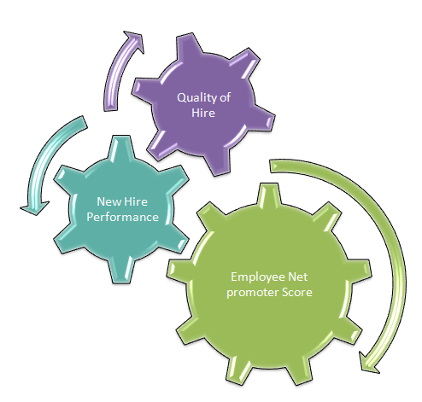
Figure 4, source: self-prepared

Theoretical Perspectives of IHRM Effective Measurement with Guest Model of IHRM
The Guest Model of IHRM is a theoretical framework developed by David Guest in 1997 to understand the relationship between HRM practices, HR outcomes, and organizational performance. The model emphasizes the importance of a strategic and integrated approach to managing human resources in global organizations.
HRM strategies consist of four main elements.
- HRM practices: An organisation uses various strategies to efficiently manage its human resources. Recruitment and selection, training and development, performance management, and compensation and benefits are some of these procedures. The Guest Model emphasises how crucial it is to match HRM practises with organisational strategic goals in order to improve HR outcomes (Purcell, J., Kinnie, N., Hutchinson, S., Rayton, B., & Swart, 2003).
- HR Outcomes: it cites the influence of HRM procedures on staff members' attitudes and actions. These results include the growth of human capital within the organisation as well as employee satisfaction, commitment, and engagement. The Guest Model emphasises the significance of tracking these results because they serve as important gauges of how well HRM procedures are working (Guest, 2017).
- Behavioural Outcomes: It is the impact of HRM practices on employee behaviour, including job performance, absenteeism, and turnover. The Guest Model suggests that HRM practices should be designed to enhance employee motivation and engagement, which can lead to improved behavioural outcomes (Guest, 1997).
- Financial Outcomes: HRM practices on the overall performance and financial results of the organization. The Guest Model suggests that effective HRM practices can lead to improved performance outcomes, such as increased productivity, quality, and innovation (Budhwar, P. S., & Debrah, 2013). Additionally, effective HRM practices can lead to improved financial outcomes, such as increased profitability, revenue growth, and return on investment.

Conclusion
With an effective HR strategy that takes into account the needs of the organization, TCS has established itself as a top IT company in India. TCS has put in place an efficient HR policy that takes into account the need for hiring professionals within the organisation. In any organization, the qualities of the HR team play a significant role in how effective HR policies are. Even after putting in place a number of measures, TCS still has trouble finding enough workers, particularly to close the gender gap and reduce the attrition rate. The challenges faced by IHRM include discrimination in the hiring process abroad and finding workers willing to relocate abroad.
TCS's effective HR policy has played a crucial role in the success of the organization. The recruitment of professionals based on their skills and expertise has enabled TCS to provide innovative and effective solutions to its clients. However, finding the right talent is an ongoing challenge for TCS, especially in reducing the gender gap and attrition rate. TCS needs to focus on diversity and inclusion in its recruitment process to address these challenges. In any organization, the qualities of the HR team determine how effective the HR policies are. The HR team should be equipped with the necessary knowledge and abilities to create and implement efficient policies that support the strategic objectives of the company. TCS can invest in training its HR team to make sure they have the necessary expertise to handle the challenges the company faces.
TCS should continue to focus on its HR policies to attract and retain top talent. Additionally, TCS needs to address the challenges faced in finding the right talent and improving diversity and inclusion in its recruitment process. By doing so, TCS can further strengthen its position as one of the leading IT firms in India

