Assignment – ECAD 4001 Lucy Badham 1800114

As Bruner states “the aim of education is to learn”; while I have been on placement, I have thought about this quote throughout the process. Education aims to prepare pupils for their future and give them the chance to succeed in their lives. While I have been on placement, I have taught multiple lessons to the pupils in a year six class and following on from that, I have reflected on my teaching. I reflected on my teaching in order to recognize what aspects were strong and what aspects I could improve on. Reflection is an important part of the teaching process as it allows you to improve your work by being critical and setting targets for yourself. H, M, Shandomo would agree with this statement as he believes that ‘Critical reflection enables teacher candidates to understand the ways which their styles enhance pupils’ ability and how their teaching will grow’ (The Role of Critical Reflection in Teacher Education, pg.112 (No date)). By reflecting on my teaching, it enabled me to produce targets for myself which were useful for improving my teaching. The education union would agree strongly with this statement as they state that reflecting and setting targets is a “key issue”, Teachers Appraisals: Setting Objectives (ATL; The Education Union (No date) pg.1).

I reflected on my teaching styles and planning in multiple ways; such as ARC’s and in an observation note book. These strategies allowed me to reflect on my teaching and be critical with my teaching styles used. I reflected also on the targets that I produced before teaching the lesson to see if I had achieved the objectives that I set for myself. Reflecting on my objectives, targets and my teaching allowed me to further develop my teaching, so I could produce more effective outcomes for the learners. In the diagram below, it shows that the reflection process is a vital part of teaching as it allows you to draw on what you need to improve on following on from that lesson. (The Reflective Teacher, Gibbs model of ‘learning by doing’, MH Education (No date), pg, 14). Gibbs recognises that you need to reflect on teaching in order to progress in your career. Gibbs states that “If we don’t think about, analyse and evaluate our professional practice we cannot improve” (The Reflective Teacher, MH Education, (No date), pg.15).
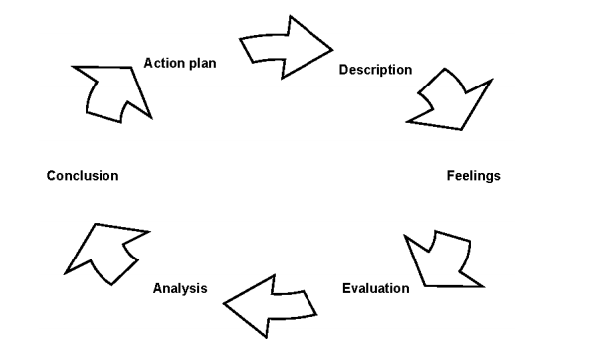

Clearly, reflective practice is a vital part of teaching, that is why I have focused on reflecting on my teaching practice in order to recognize my strengths and to also work on improving my teaching. While on my professional teaching practice, I completed multiple ARC’s to discuss my teaching and work on improving my teaching; Completing ARC’s enabled me to go into depth and reflect on my teaching and allowed me to produce targets for myself.

ARC 1; Multiplication Cards (Maths Activity). Dated – 06/03/19.
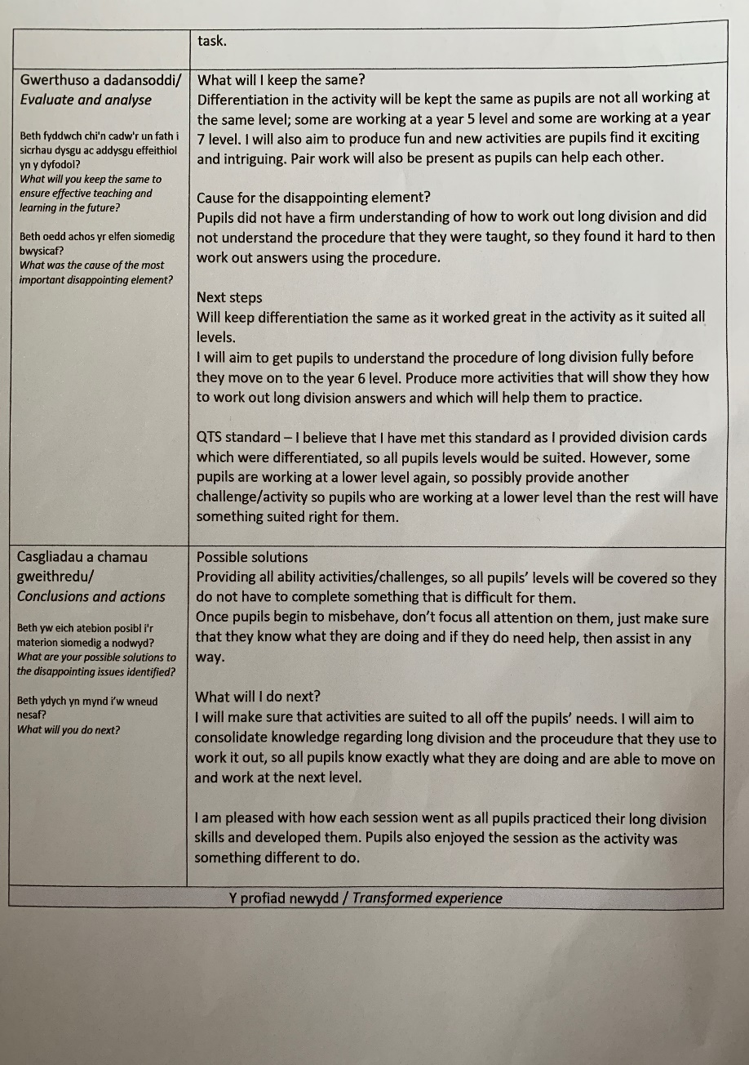
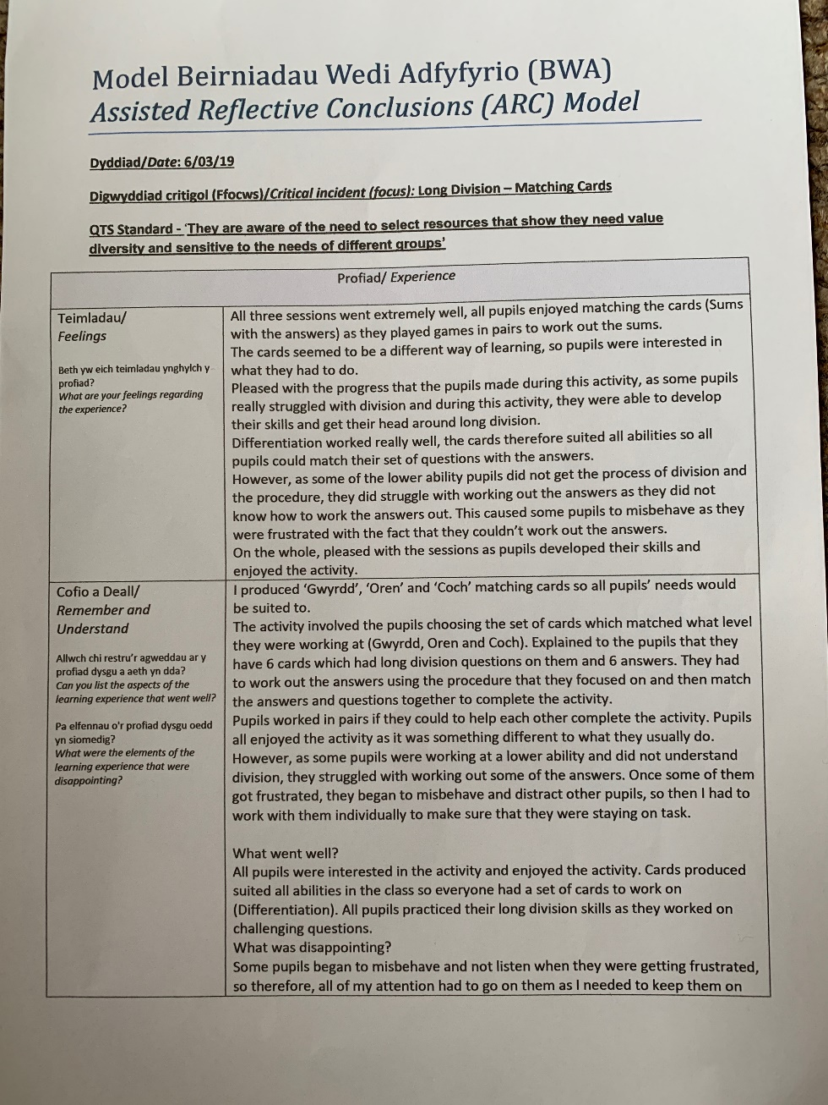

The first ARC that I will be discussing will be focusing on one of the many lessons that I taught during my professional teaching practice. The ARC below reflected on a maths, long division lesson that was taught. The lesson involved teaching pupils of different abilities long division and practicing what they had been taught by the class teacher. The activity involved the pupils matching up division questions with the correct answer; I had to differentiate the cards in order to suit the different abilities that were present in the class. Differentiation was vital in the year six class as some pupils were working at a different ability, so therefore, all needs needed to be suited to. Gardener, H (No date) makes it clear that differentiation is needed within the classroom as he states that “The biggest mistake in teaching is to treat all children as if there were variants of the same individual and thus to feel justified in teaching them all the same subjects in the same way”. Once I recognised that there was differentiation in the class, I focused on the QTS standard which focused on differentiation (as seen in the ARC above). I addressed my target by observing the pupils within the class and figuring out what ability they were and then producing ‘Coch’, ‘Oren’ and ‘Gwyrdd’ division cards which focused on the different abilities within the class. I needed to make sure that all abilities were suited to, so all pupils could learn and develop their skills. I chose to differentiate my activity as when I observed I recognised that not all pupils abilities are the same. I used the ‘Blooms Taxonomy’ theory as I believe that it is useful as it allows teachers to categorise activities to a critical level.

The first thing that I reflected and focused on was my initial feelings; the lesson went well as all pupils developed their knowledge and understanding regarding long division and all pupils’ needs were suited to. I recognised that the differentiation within this activity worked extremely well as pupils were challenged but their needs were suited to, therefore, I recognised that I needed to produce differentiated activities for the pupils in the following lessons which focused on long division. For my next steps, I wanted to focus once again on the differentiation in class, so therefore focusing on the QTS standard which is ‘They are aware of the need to select resources that show they need value diversity and sensitive to the needs of different groups’. (Education Wales, 2009). I believe that differentiation in the class regarding long division activities is useful as not all pupils are working at the same levels. Bruner would agree that differentiation in class is vital as he states that it is important for any pupils working within the zone of proximal development to organise and plan activities that will mean that the pupil will not be working below their ability and not learning anything, however, not organising activities that means the work is inaccessible for the child. Therefore, I believe that producing activities that are suited to all abilities is vital.

ARC 2; Timetables (Maths Activity). Dated – 12/03/19.
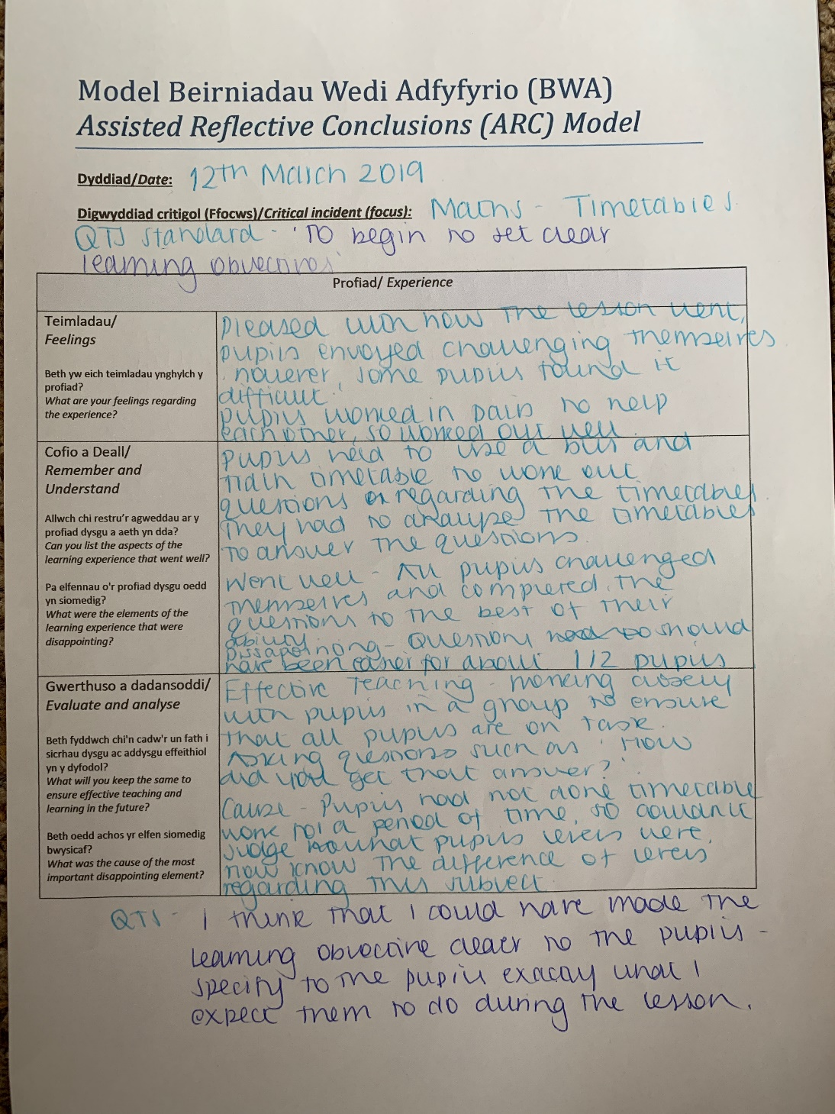

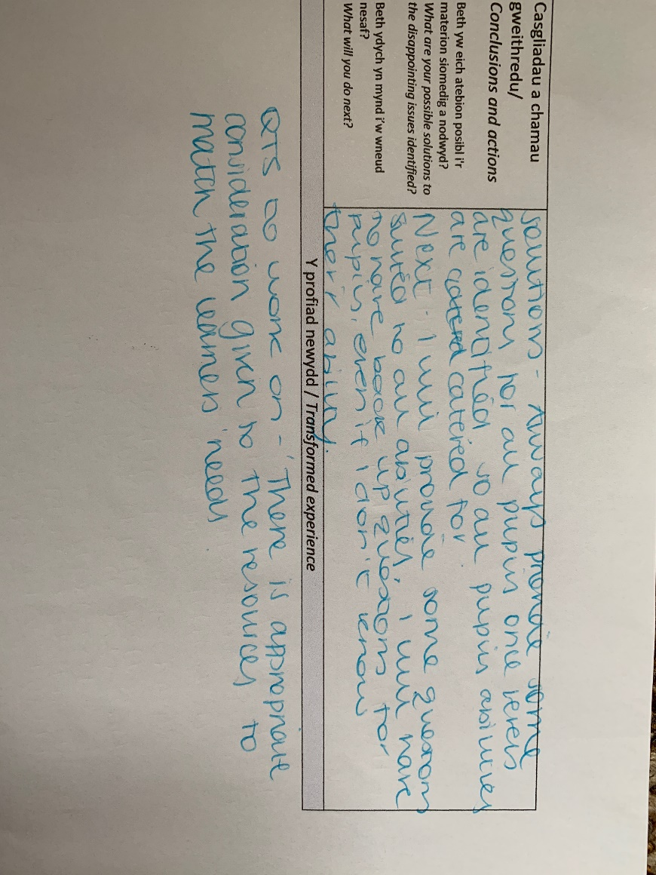

While on professional teaching practice, I planned and taught a range of maths lessons, including long division and teaching timetables. The next ARC that I will focus on will look at the teaching of maths; timetables. The ARC attached above reflects on a maths lesson that was taught by myself. The QTS standard that I focused on for this activity was ‘To begin to set clear learning objectives’ (Education Wales, 2009). I chose this target to focus on as I was observed by the deputy head teacher of the school that I attended and one of the improvements that he assigned to myself was to make the leaning objectives clearer. I addressed this target by making sure that I made the lesson objective clear to all pupils at the beginning of lesson, to ensure that they knew exactly what they should aim towards. I needed to make sure that all pupils understood what they should achieve, so they could work towards it. I believe that this was a useful target to work on as I believe that the pupils found it beneficial to know what they were working towards.

Throughout this arc, I focused on trying to make sure that I reflected on the target that I set for myself. While reflecting, I have shown that I believed that I should have made the learning objective clearer as I didn’t go into depth about what I think they should achieve by the end of the lesson. By reflecting, I produced next steps; my next steps included making the learning objective clearer so all pupils will know exactly what they should achieve. Additionally, by reflecting, I recognised that for this specific activity, I needed to differentiate more regarding timetable lessons; I recognised that not all pupils were confident with timetables and needed extra help. Therefore, from reflecting, I recognised that some pupils were more confident and able than their peers. The QTS standards that I believed that I should work towards were ‘There is appropriate consideration given to the resources to match the learner’s needs’ and ‘To begin to set clear learning objectives’ (Education Wales, 2009). These QTS standards were carried on to the following maths sessions taught by myself and were worked on in order to achieve and progress in my teaching career.

ARC 3; Topic Lesson (English). Dated – 11/03/19.
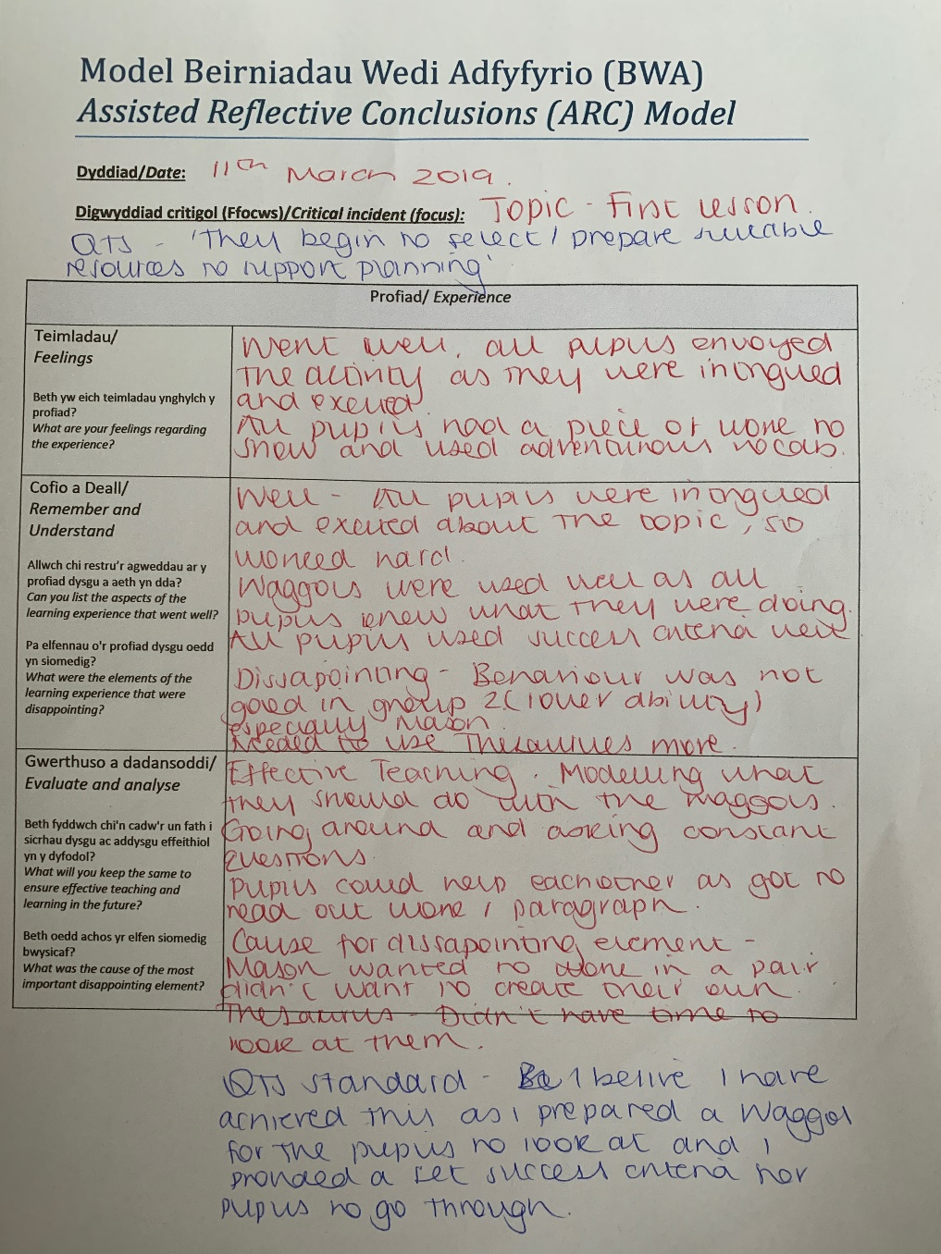

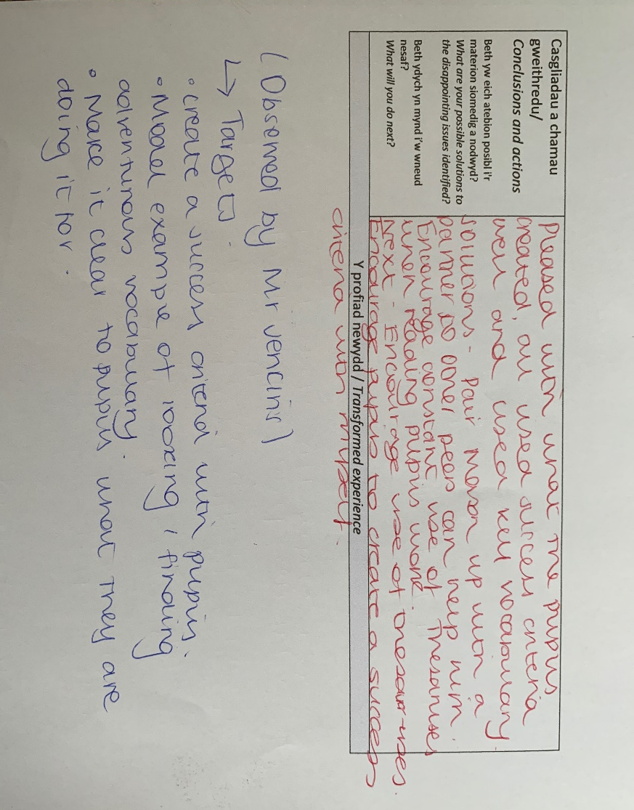

Another ARC that I believe was useful regarding developing my teaching skills was when I was observed by the deputy head teacher of the school. The ARC above discusses multiple improvements given to myself which are useful to develop my skills. By being observed, it allowed me to make purposeful targets with the information that was given to me. The lesson was praised by the teacher as he believed that the lesson was fun and intriguing, and all pupils were engaged with the task also. However, there are always improvements to be made; Mr Jenkins discussed many targets such as improving my classroom management as some pupils began to misbehave. Classroom management is a part of effective teaching and Robert J. Marzano, Jana S. Marzano and Debra J. Pickering would agree as they state that “Effective teaching and learning cannot take place in a poorly managed classroom”. (Classroom Management That Works, pg.1). From this feedback, I decided to set myself the QTS Standard of ‘They seek to establish a purposeful learning environment where learners feel secure and confident’ (S3.3) (Education Wales, 2009). My classroom management could be enhanced by reinforcing ‘Positive Reinforcement’; Skinner (1948) suggested that positive reinforcement does strengthen behaviour in the classroom as If you reward the pupils that are doing well, the pupils that are misbehaving may recognise what they are missing out on and possibility change their ways to obtain the rewards. I recognise that classroom management is very important as pupils need to respect you and the classroom in order to achieve effective learning and teaching. Another target that was specified was modelling what I wanted the pupils to do. This target was suggested by Mr Jenkins as he believes that it would benefit the pupils. Social Constructivist teaching approach would suggest that this is important as it suggests that you should interact with pupils and discuss idea’s; Discussing idea’s and discussing what you would like the pupil to do is important and beneficial.

Reflection is a key part of the process of self-examination and self-evaluation which can enable educators to improve their professional practice. Therefore, it is essential to reflect on my teaching and produce suitable targets and improvements to achieve effective teaching. By reflecting on my professional practice, it not only allows myself to improve my teaching, but more importantly, it allows the pupils to achieve the best possible outcome in their school lives. “Personal learning goals are more about improving students’ learning and achievement and building students’ capacity to learn” (Developing, Monitoring and reporting on personal learning goals, pg.3).

References.

ATL; The Education Union (No date). Teachers Appraisals; Setting Objective. Available at; https://www.atl.org.uk/Images/adv72-teacher-appraisals-setting-objectives.pdf (Assessed; 18th March 2019).

Department of Education and Early Childhood Development (2006). Developing, Monitoring and Reporting on personal learning goals. Available at; https://www.education.vic.gov.au/Documents/school/teachers/teachingresources/social/personal/devperslearngoal.pdf (Assessed; 18th March 2019).
Education Wales. (2009) Qualified Teacher Standards Wales 2009. Cardiff: Welsh Government.

Hibajene M. Shandomo (No date). The Role of Critical Reflection in Teacher Education. Available at; https://files.eric.ed.gov/fulltext/EJ915885.pdf (Assessed; 16th March 2019).

McLeod, S (2018 Updated), Simply Phycology, Skinner – Operant Conditioning. Available at; https://www.simplypsychology.org/operant-conditioning.html (Assessed; 18th March 2019).

MH Education (No date). The Reflective Teacher. Available at; https://www.mheducation.co.uk/openup/chapters/9780335222407.pdf (Assessed; 16th March 2019).

Robert J. Marzano, Jana S. Marzano and Debra J. Pickering (No date). The Critical Role of Classroom Management. Available at; http://www.ascd.org/publications/books/103027/chapters/The-Critical-Role-of-Classroom-Management.aspx (Assessed; 18th March 2019).

