Key Words – Leadership, Inventory, Change Management and Logistics
Engineering Management Leadership
The need for leadership, good financial practices, change management and ethics in an engineering environment.
Darryl Jackson, Student No:2219398
University Wales Trinity Saint David
Contents
3. Introduction
4. Evaluation of spares supply
9. Outsourcing, the consequences and areas for consideration
11. Performance measures for outsourcing
13. Recommendations
15. References

Introduction
Within the following literature, a critical review of the strategy and leadership required to ensure the competitive nature of a small UK airline is maintained whilst not compromising the health and safety of its customers is explored. The review considers multiple industrial examples of how maintenance scheduling, inventory management, business costs, lead times and financial control can influence each other when not managing the engineering function with a holistic mindset, accompanied by a deep-rooted understanding of one’s business and process.
The health and safety of the airlines customers is paramount and enforced by aviation law, this in itself adds a level of complexity to the engineering strategy based on the required statutory inspections required at different intervals. We will develop an understanding of how this impacts inventory management throughout the literature.
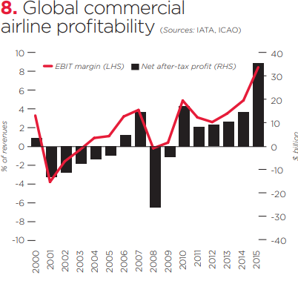
The aviation industry is extremely competitive in nature in part due to their high operating costs, this in turn requires the engineering strategy to be dynamic enough to cope with unplanned maintenance whilst ensuring the legal requirements of the business are achieved to remain competitive and profitable as shown in figure 1.
Figure 1 – Global commercial airline profitability (IATA 2016)
Over the years multiple airlines have ceased business due to multiple reasons but one common flaw we see is a lack of adaptability to the market and poor strategy implementation such as Pan American (1991), Swiss Air (2002) and more recently Monarch (2017), Thomas Cook (2019) and Flybe (2020), (Slotnik, 2020).

Evaluation of Spares Supply
Toon Air is maintaining a small fleet of aeroplanes that flies regionally within the UK and to a small number of Greek islands. From my initial findings it is evident that Toon Air is lacking control in the following areas related to or impacting the supply of spare parts:
- Sourcing of spare parts
- Inventory Management
- Cost Control
- Standards and traceability, including updating of documentation
- Investment strategy
- Poor or No leadership
Sourcing of spare parts, Standards and Traceability
The sourcing of spare parts in every manufacturing, service and engineering-based industry must be handled with care and due diligence, this is a result of the potential risk to the end user or customer. In industries such as aviation the potential for substandard components not functioning correctly or failing catastrophically could result in aeroplane failure, which in turn could lead to injury or death.
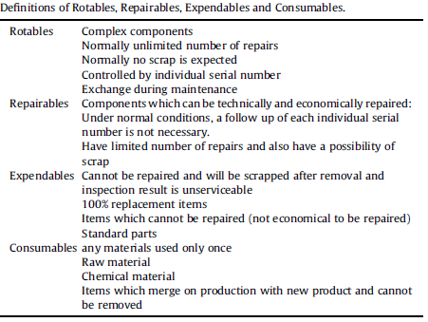
A critical role of any purchasing department is to ensure the product details and specifications are up to date to ensure spares are sourced correctly and accurately, this allows for the traceability of spares in the case of recall or failure. This should be controlled using a management of change system which identifies new part of processes that supersede that of an older part or process and therefore all details of the previous should be archived or deleted from the live system.
When sourcing these spares, quality, cost, spare type and lead time must be considered. As demonstrated by (Friend, 1996) in figure 2, there are typically 4 types of spares in aviation, Rotatable, Repairable, Expendables and Consumables. The different types and their characteristics are demonstrated in figure 2. Each of these must be sourced with a level of assessment due to their frequency of use. Figure 2 – Types of Aviation Spare Parts
For example, a rotatable element is likely to be repaired instead of replaced in comparison to consumable which will only be used once. The sourcing strategy must consider that consumables will need to be sourced more regularly and in larger numbers than that of a rotatable part, in essence only by the nature and use of the part itself.
Inventory Management & Cost Control
Another critical role of the purchasing department is to track the level of spares inventory, if bypassed like Toon Air this could result in hidden working capital cost. Two such examples of the level of working capital sometimes involved in airline operation is that of Eastern Airlines & Pan Am who went into bankruptcy with $700 million and in excess of $200 million respectively of spares inventory. (Friend, 1996)
With such large working capital of inventory, a stringent cost control mentality must be exerted throughout the workforce to ensure all costs are captured by the purchasing department. Once captured these are then passed onto the engineering leadership for review with the financial department to highlight areas of high spend, high frequency high spend, and low frequency high spend. This review is critical to a budgeted engineering strategy to allow engineering schedules to be put in place for these high value items, this can then be reflected in financial forecasts alongside managing the business cash flow to reduce spikes in spend as a result of the aforementioned forecast of the high value items usage.
The purchasing department and engineering scheduler need to work hand in hand when considering aviation maintenance as the schedule of the required tasks will dictate the amount and location of the required spares. Demonstrated by (Ta-Hui Yang, 2003) in figure 3 the maintenance demand profile over the working day, this give insight to the potential amount of available spares required in the evening alongside the required resource levels to manage the demand.
(Viktoriia Ivannikova1, 2013) validated this information in figure 4 using their simulated model of the requirements of Kyiv airport, which suggest peak technician utilisation during the day shift. Although opposite to the trend the reality is a consequence of the low man hour demand required for quick checks of turn around aeroplanes whereas the heavy checks that require long downtime and higher demand on technician hours are completed during the evening.

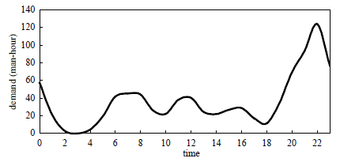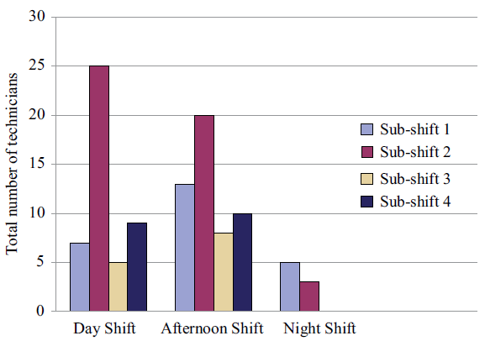
Figure 3 – Man Hour Maintenance Demand Profile Figure 4 – Technician Demand
The basic requirements of heavy engineering maintenance as stated by (Kiridena, 2012) are as follows:
- “planning of materials and resources, considering the interdependencies between activities at various points and unplanned activities arising out of inspections.
- Scheduling of operations, considering the new activities arising out of inspections, routes of their progression and variations in activity durations.
- Capacity loading and levelling of resources in the context of unplanned activities.”
The heavy engineering strategy will directly impact all other maintenance tasks as again mentioned by (Kiridena, 2012) where “the proportion of unplanned maintenance activities arising out of inspections carried out during an aircraft lay-up can be as high as 50 per cent of the total work involved in heavy maintenance”. This statement demonstrates the need for readily available spares throughout the heavy maintenance process to cope with the unplanned issues that arise from inspection, which as previously stated occurs in the evening. With this in mind we have to be conscious that typical working days are 9-5 which can limit our supply of spare parts as the maintenance is being conducted outside of what most businesses consider core hours.
Toon Air’s inventory is currently stored in a central location with some maintenance being conducted abroad, the obvious risk and limitations of such a practice are evident by the previous examples. The distribution of spare parts on substitute aeroplanes is also a reflection on the poor maintenance schedules. Substitute planes are expensive to lease and also rework into the brand image of the current airline, by grounding regional aircraft this also limits contracts with global airlines that want to outsource short haul flights to regional carriers (Tan, 2017).
We also see from (Airways, 2023) that British Airways maintenance is conducted across 30 hangers with 2000 engineers, bringing to the forefront the required infrastructure and resource level to manage a global airline. With Toon Air also struggling to manage the lead time of the spares this adds additional complexity to the business by having either a poor Material Requirements Planning (MRP) system or the MRP not setup correctly. This practice leaves the business vulnerable to the unknown failures found during statutory inspections which lead to aircraft downtime. (Friend, 1996) found during their study of 246 airlines that 77% utilised safety stock as their main inventory system. 54% of airlines were using the average aggregate inventory value as their method of inventory monitoring, whilst 14% used % of weeks supply available. With poor inventory management being considered an issue, the study also demonstrated in the case of stock out 45% of airlines expedited, loaned or borrowed parts depending on the circumstance to ensure aircraft uptime. This is a perfectly acceptable action to take to maintain uptime of the fleet, but this is not a strategy for managing stock and should only be used in emergencies. The additional costs involved with expediting parts, time of workforce adjusting schedules and the potential knock-on effect to the customer alongside the reputation damage of the business for delays is unquantifiable but a real and huge risk to the business.
There is now a growing understanding of the management of inventory by (R. Fritzsche a, 2014) that shows that having a prognostic health management system on the aircraft fleet, a carrier can significantly reduce downtime and cost. (R. Fritzsche a, 2014) also states that “A significant improvement in the forecast quality of maintenance optimisation algorithms is achieved within the prognostic distance. This allows a possible backward shift of the latest possible instance of time for spare parts delivery. It increases the probability that the required spare parts are available at the right time and at the right place. It also avoids the delivery of spare parts to wrong destinations because of a too early delivery and a premature unscheduled failure. Selection of an appropriate prognostic horizon, therefore, will avoid unnecessary shipments and hence the decrease in transport cost”. In Figure 5 we can clearly see the critical element of such a system is determining the prognostic distance, this is the time a business needs with the information available to predict a failure or forecast the failure of a given part. The table considers the costs and available information from both manual inspections and online date to determine the best schedule for each part.
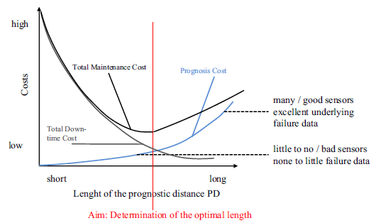
Figure 5 - Relationship of various cost components and prognotic distance. (R.Fritzsche)
(Grommesh, 1990) states that cycle inventory will be used for the low to medium demand spares whereas in times of high demand pipeline inventory is used. Anticipation inventory is utilised for the special maintenance programs such as statutory inspection and safety stock utilised for immediate replacement to minimise aircraft ground time.
Investment & Leadership
Investment from Toon Air is considered high and non-impactful due to the significant amount of technical obsolescence and changes required by civil aviation laws therefore, we must consider how best to approach the investment strategy. Reviewing figure 6 gives insight to the growing costs of maintaining aircraft throughout their life cycle. With growing costs as the asset grows older, investment must be considered on new aircraft between year 25-30, this ensures the most technical advanced planes are available with online monitoring the reduce maintenance tasks. (Berkcan Okan, 2022) highlights the high operational costs in the middle of the operations phase, as the operations phase reduce the costs reduce as less maintenance is conducted before disposing of the aircraft.
Figure 6 - Maintenance Costs Index Vs Age of A320 fleet Figure 7 - Aircraft lifecycle vs Cost
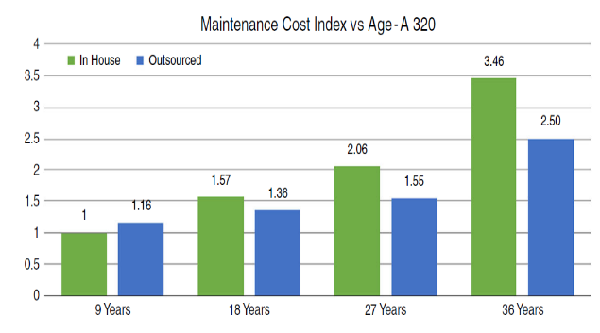
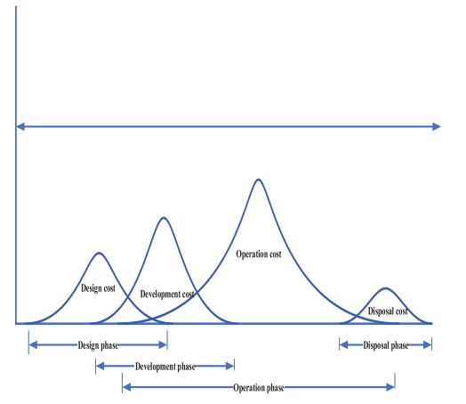
The leadership of Toon Air is an obvious area for improvement due to the accepted standards and practices shown throughout the workforce. The leadership is not exerting its presence and strategy throughout the business and therefore mistakes, shortcuts and bad practices are occurring. Practices such as bypassing purchasing for spare parts, use of substitute aircraft for spare parts distribution and spare parts being ordered without a purchase order is unacceptable and leaves the business at significant risk legally, financially and operationally.

Outsourcing, the consequences and areas for consideration
When considering outsourcing for the spare parts warehouse and supply of spare parts we have to consider some key elements before moving forward with such an agreement.
We have to consider is the contract financially viable? The cost of outsourcing can often be attractive to a business not typically in part due to the contract cost but in terms of the reduction of headcount and capital employed, these savings can be significant and allow leadership teams to focus on other important areas. This also allows a reduction in responsibility to a department but in most cases especially aviation the responsibility will always fall with the airline due to its responsibility to provide its customer with a safe and efficiency form of transport as per aviation laws.
Is it cost effective in terms of return on investment? The Return on investment must always be considered when outsourcing, this can be done in many ways such as cost vs man hours, cost vs spare part availability, cost vs quality. This is very dependent on how the business see the outsourcing working and the main driver for implementation.
How many functions of the department would be outsourced? Depending on how many departments are outsourced determines how much consideration we give to the process changes required internally. Typically with only one department being outsourced the change can be managed with regular meetings and ensuring the outsourced department is represented at meetings, strategic decision sessions as well as problems solving areas. This integration is critical to the success of outsourcing departments to make them and the workforce feel as one rather than “them and us”.
How will the relationship work both internally and externally? The relationship is often a forgotten area when outsourcing as the attention is on the costs rather than the people. Internal relationships both peer to peer and leadership to employee can be left strained by outsourcing, in part a result of more workload for other departments due to reallocation of responsibilities, redundancies can be made with severance packages outside of a TUPE which in turn can harm the workforce moral and relationship with leadership.
What are my legal requirements of Transfer of undertakings protection of employment? Outsourcing can sometimes include the need to transfer employees over to the outsourced company, this should be treated sensitively and respectfully for the employee to ensure no ill feelings.
How big is the change and what processes would need to change to implement outsourcing? Process changes especially in the way we work should not be overlooked as outsourcing can affect many departments way of working. Changing a department to an outsourced department is only a small part of the process change, achieving a full rework of an organisation to fit outsourcing is extremely difficult due to many hidden processes that happen seamlessly in an organisation to now having to work in a different manner to fit outsourcing processes.
All of these factors have to be considered when moving to outsourcing and should not be underestimated on the impact it can have on a business. Most businesses typically turn to outsourcing due to cost as a way of managing difficult tasks or out of control departments, this itself should be considered as point for self-reflection in terms of “can we do this task in house? Is the leadership strong enough to manage the department?”.
We have seen in recent years that maintenance spend has increased significantly in the airline industry as per figure 8, these costs come from inventory, statutory inspections and resource. Figure 8 - Global maintenance spend
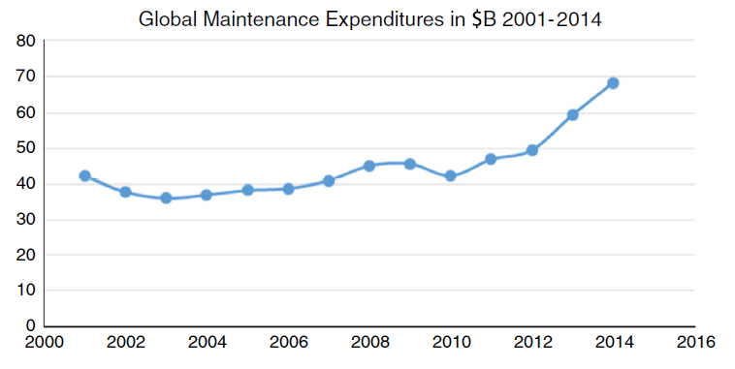
(Bazargan, 2016) also states the cost of setting up hangers represents a small percentage of an overall cost structure, although this relates to the maintenance of aircraft a similar approach could be considered for warehousing ensuring location and size is fit for purpose.
Although outsourcing can seem attractive the pitfalls of its implementation can have significant impact on a business, in fact losing money as a result of failure. (Rasheed, 2005) indicated that the advantages of outsourcing are not always clear; contracting-out key elements of a business can be risky, difficult to implement and manage, and there have been instances where the hoped for advantages have not materialised.
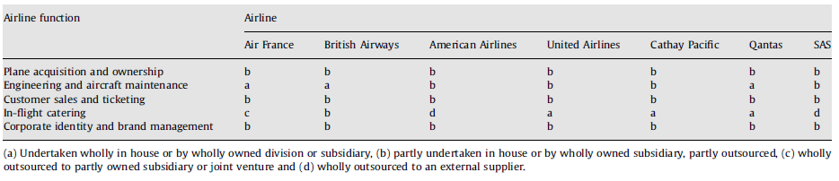
We can review how some of the larger airlines globally manage outsourcing within their business in figure 9. This gives insight to the levels of outsourcing but also the trend that most airlines have a hybrid in house and outsourced departments illustrated by “b”.
Figure 9 - Level of outsourcing

Performance measures for outsourcing
Performance measures are used in outsourcing as a form of tracking against the defined contract agreements. Depending on the agreement these measures will change for example cost of spare parts, spare part availability, zero stock cases and cost take out vs non outsourced parts.
These measures are hard targets as part of the contractual agreement but gives little insight to the true value of the outsourcing or indeed the damage it has done. We must consider that the outsourcing of a department should be measured alongside areas such as relationship with the business, willingness to assist, access to specialist support, communication levels, participation in problem solving and generating improvement ideas.
The true measures of outsourcing should be kept to a minimal but with impactful Key Performance Indicators, having too many indicators can leave areas for interpretation when analysing the success of an outsourcing exercise. The measures should be in keeping with the business needs such as cost take out, reduction of headcount, zero stock cases, reduction in inventory. The outsourced company should be informed of the measures and before agreeing any contract these measures discussed, how the measure will be calculated agreed and also listening to the outsourced company on their requirements as setting unachievable measures at the start is a loss for both companies.
Managing these measures going forward will require regular updates and analysis of any failures to comply, this allows more information to be gathered on the direction of the outsourcing as well as any hurdle that needs to be overcome to ensure its success. These type of reviews need to be a two way discussion to ensure all obstacles are understood, who is responsible for their cause and removal alongside control measures to ensure they do not happen again.
These statements are supported by the work of (Wisner, 2005) that stated, world-class firms establish strategically oriented performance criteria among each of the functional areas of the firm within the categories of quality, cost, flexibility, dependability, and innovation and then revisit these measures as problems are solved, competition and customer requirements change, and supply chain and firm strategies change.
To develop performance measures (Amornsawadwatana, 2008) created the following 8 steps to define the measure correctly, following this gives a good framework for any performance measure.
- Identify the firm's strategic objectives.
- Develop an understanding of each functional area's role and the required capabilities for achieving the strategic objectives. Identify internal and external trends likely to affect the firm and its performance over time.
- For each functional area, develop performance measures that describe each area's capabilities.
- Document current performance measures and identify changes, which have to implement.
- We must assure the compatibility and strategic focus of the applied performance measures.
- Implement the new performance system.
- Periodically evaluate the firm's performance measurement system as competitive strategies change.

Recommendations
During my review of ToonAir I would conclude the following recommendations by priority to enhance the business performance.
The highest priority for the business is to gain leadership throughout its processes, the lack of control in the supply chain, inventory management and the inexcusable financial practices being overlooked must be addressed immediately. I recommend this as the changes to the supply chain, inventory management, maintenance strategy and business process cannot be implemented without the discipline and integrity of the leadership team. A change management procedure would benefit the leadership team to allow them the guidelines and procedures to follow when operating within a highly regulated process.
Secondly I would recommend that the central inventory of spares be dissolved into satellite holdings at the major airports the airline flies to, this will allow for quicker turnaround of planes alongside a greater resource to deal with the ongoing maintenance of aircraft. With the recommendation to follow, stock level of rotatable and repairable parts will significantly reduce allowing for consumable and expendables to be stocked more readily which typically have lower lead times, lower cost and a more repeatable usage allowing for stock levels to be predicted more accurately. With this strategy in place the business can then decide a suitable stock level management system by evaluation the reorder points alongside the economic order quantity to review the total cost of the holding.
Heavy checks to the aircrafts typically included in statutory inspections should be outsourced to the Original equipment manufacturer (OEM) or specialist. This would free up high cost inventory removing a significant risk to the business and reducing working capital. This is reflective of other EU airlines in figure 10 demonstrating in house costs increasing with aircraft cost vs outsourcing decreasing with aircraft cost. Figure 10- Aircraft age vs cost vs inhouse vs outsourcing
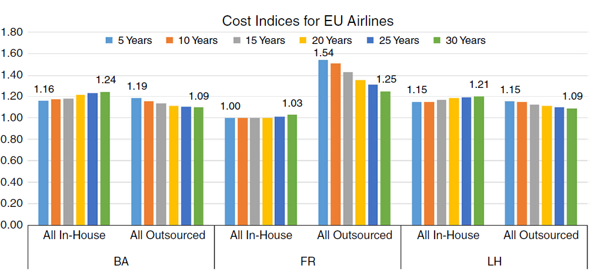
Investment to the fleet should be targeted at new aircraft and the older models taken out of service, this will allow for more predictive maintenance to be conducted therefore allowing a greater level of scheduling. This practice in turn improves the spare parts availability and first time right % as the parts can be sent to the location of service in preparation for a scheduled overhaul based on data as per the example in figure 11. (Jianzhong Sun, 2018)
Figure 11 - Inspection vs defect tolerance
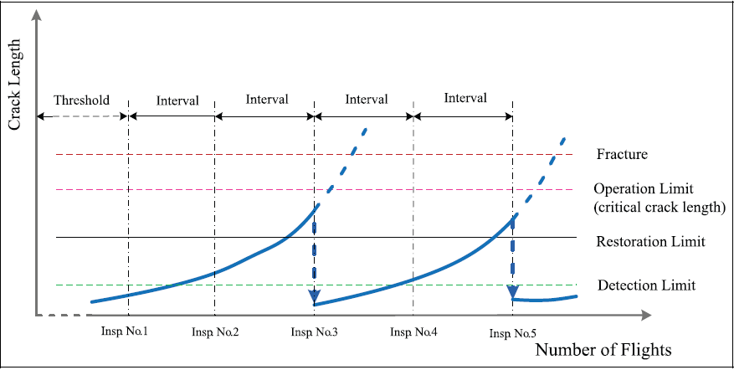
The replacement of the older aircraft in line with the satellite stock warehouses will allow for the substitute planes to be removed from the operating costs resulting in great financial savings and potential to increase our customer satisfaction.

References
- Airways, B., 2023. British Airways. [Online]
Available at: http://www.ba-mro.com/baemro/aircraftMaintenance.shtml#:~:text=We%20maintain%20an%20impressive%20range,major%20maintenance%20and%20structural%20repairs
[Accessed 20 March 2023].
- Amornsawadwatana, Y. P. a. S., 2008. A Framework Development for the Aviation Supply Chain. Kitakyushu, s.n.
- Amornsawadwatana, Y. P. a. S., 2009. A Framework Development for the Aviation Supply Chain. Kitakyushu, s.n.
- Association, I. A. T., 2016. Annual Report, s.l.: IATA.
- Bazargan, M., 2016. Airline Maintenance strategies - In house vs outsourced - an optimisation approach. Journal of quality in maintenance engineering, 22(2), pp. 114-129.
- Berkcan Okan, T. A., 2022. Assessing the effect of proactive maintenance scheduling on maintenance costs and airline profitability: The case of Turkish Airlines Technic. Reasearch In Business & Social Science, 11(4), pp. 213-238.
- Friend, A. G. a. C., 1996. Aircraft maintenance and inventory control using the reorder point system. Internation Journal of Production, pp. 2863-2878.
- Grommesh, 1990. MRP 2 will work in a defense repair / remanufacturing environment. s.l., APICS P575-578.
- Jianzhong Sun, D. C. C. L. a. H. Y., 2018. Integration of scheduled structural health management with airline maintenance program based on risk analysis. Journal of risk and reliability, Volume 232, pp. 92-104.
- Kiridena, S., 2012. Aircraft maintenance planning. Journal of Quality in Maintenance Engineering, 18(4), pp. 432-445.
- R. Fritzsche a, n. J. b. R. c., 2014. Optimalprognosticdistancetominimizetotalmaintenancecost:. International Journal of Production Economics, Volume 151, pp. 76-88.
- Rasheed, A. G., 2005. Outsourcing: national and firm level implications.. Thunderbird International Business Review, Volume 47, pp. 513-528.
- Slotnik, D., 2020. Business Insider. [Online]
Available at: https://www.businessinsider.nl/airlines-that-go-out-of-business-2019-3?international=true&r=US
[Accessed 20th March 2023].
- Ta-Hui Yang, S. Y. H.-H. C., 2003. An Airline maintenance manpower planning model with flexible strategies. Air Transport Management, Volume 9, pp. 233-239.
- Tan, K. M., 2017. Outsourcing and Price Competition: An Empirical. Review of industrial organisation, Volume 53, pp. 275-294.
- Viktoriia Ivannikova1, K. K., 2013. APPLICATION OF SIMULATION APPROACH TO MANPOWER PLANNING AT UKRAINE INTERNATIONAL AIRLINES’ MAINTENANCE DEPARTMENT, Kyiv: s.n.
- Wisner, J. D. L. G. K. &. T. K.-C., 2005. Principles of Supply Chain Management. s.l.:Thompson.

Figure 1 – Global commercial airline profitability (IATA 2016) 3
Figure 3 – Man Hour Maintenance Demand Profile Figure 4 – Technician Demand 6
Figure 5 - Relationship of various cost components and prognotic distance. (R.Fritzsche) 7
Figure 6 - Maintenance Costs Index Vs Age of A320 fleet Figure 7 - Aircraft lifecycle vs Cost 8
Figure 8 - Global maintenance spend 10
Figure 9 - Level of outsourcing 10
Figure 10- Aircraft age vs cost vs inhouse vs outsourcing 13
Figure 11 - Inspection vs defect tolerance 14

