

Darrell Byrne
2420160
Degree Apprenticeship in Logistics and Supply Chain Management
Digital modelling and simulation of logistics systems to support lean management
ACMA5018
10/5/2025

Table of Contents
1. Introduction 4
2. Problem Definition and Operational Context 4
3 Rationale and Purpose of Digital Modelling in Logistics 5
3.1 Digital modelling within a process improvement framework 5
3.3 Strategic role in supply chain management 6
4. Modelling Approach and Software Selection 7
5. Evaluation of the Modelled Solution 8
5.1 Initial modelling outputs 8
5.2 Cost Pressure Associated with the In-house Transport Fleet 8
5.3 Core and Non-Core Route Segmentation 9
5.4 Core Fleet Model: Four Drivers, Five Days per Week 9
5.5 Non-Core deliveries and Tramper Drivers 10
6. Critical discussion and Learning Outcomes 11
8. References 14

Figure 1 output of local deliveries Figure 2 Non-Core deliveries 8
Figure 3 Data output of local deliveries 9
Figure 4 Data output of assets required to service cores 9
Figure 5 Example of subbed frequency and cost estimate 9

1. Introduction
Logistics and supply chain operations are increasingly required to operate with enhanced efficiency, flexibility and resilience in response to intensifying market pressures. Rising costs, volatile fuel prices, labour constraints and escalating customer expectations have significantly increased the complexity of transport operations. In this context, reliance on intuition and experience-based decision-making is insufficient to achieve optimal performance and sustainable competitive advantage. Digital modelling and simulation have therefore emerged as critical tools within modern logistics and supply chain management. These approaches enable organisations to represent complex systems in a virtual environment, allowing proposed changes to be tested prior to implementation. By quantifying the impact of alternative system configurations on cost, service levels and resource utilisation, digital modelling supports evidence-based decision-making while reducing operational risk (Shapiro, 2007; Ivanov, 2021). This report critically evaluates the application of digital modelling to a real-world logistics challenge involving the transition from an in-house transport fleet to a fourth-party logistics (4PL) model. Using Paragon route optimisation software, the study analyses routing efficiency, fleet structure and cost-to-serve. It is argued that digital modelling not only enables operational optimisation but also supports strategic decision-making by revealing structural inefficiencies and informing system redesign. The report also critically examines the limitations of modelling approaches and their implications for real-world logistics operations.

2. Problem Definition and Operational Context
Tata Lisburn historically operated an in-house transport fleet of eight drivers servicing regional and long-distance deliveries. While this provided operational control, several inefficiencies were evident, including high fixed costs, manual route planning, underutilisation and significant empty running, particularly on return journeys.
Beyond cost inefficiencies, the in-house fleet introduced operational risk. Driver availability was sensitive to absence, annual leave and working time regulations, reducing service reliability without external support. Long-distance deliveries removed drivers from the operation for extended periods, reducing regional capacity and increasing reliance on overtime or third-party cover. During peak demand, this limited flexibility increased service risk, while in quieter periods both drivers and assets were underutilised.
Management time was increasingly absorbed by reactive planning and compliance, limiting focus on strategic improvement. These factors reduced system resilience and scalability, prompting consideration of alternative operating models supported by digital modelling and simulation.

3 Rationale and Purpose of Digital Modelling in Logistics

3.1 Digital modelling within a process improvement framework
Digital modelling supports process improvement by enabling evidence-based decision-making and system-level analysis. It allows organisations to evaluate alternative system designs under different assumptions rather than relying on historical performance.
Shapiro (2007) argues that modelling reveals structural interdependencies not visible through operational data. In this case, it enabled a fundamental redesign of the transport network rather than incremental improvement. Modelling also supports scenario evaluation under controlled assumptions (Robinson et al., 2011; Ivanov, 2021).
3.2 Comparison with value stream mapping
Value stream mapping (VSM) is a widely used lean tool that visualises material and information flows. While effective for identifying waste and process inefficiencies, it provides a largely static representation and is limited in its ability to capture routing complexity, capacity integration and operational variability. Digital modelling complements VSM by enabling quantitative scenario testing and system-level analysis. Tipi (2021) notes that optimisation-based modelling tools translate conceptual improvement ideas into measurable operational outcomes, thereby supporting more robust and evidence-based decision-making. While VSM offers a valuable qualitative assessment of process flow, it does not capture stochastic variability or the dynamic interactions between system components. In contrast, simulation-based approaches enable the quantification of operational performance under varying conditions, providing a more realistic representation of logistics systems (MacCarthy et al., 2021). This distinction is particularly important in transport operations, where variability and interdependencies can significantly influence system performance.
3.3 Strategic role in supply chain management
From a strategic perspective, transport systems are well suited to digital modelling due to their non-linear behaviour, where small changes in routing, fleet allocation or driver availability can disproportionately affect cost and service performance. Digital modelling enables these interdependencies to be evaluated systematically, reducing reliance on intuition and minimising unintended consequences.
This is particularly important in complex logistics environments, where traditional planning may fail to anticipate system-wide effects. As Christopher (2016) highlights, even minor structural changes can significantly impact performance. Digital modelling therefore supports both operational optimisation and strategic alignment.

4. Modelling Approach and Software Selection
Paragon route optimisation software was selected for its suitability in solving complex vehicle routing problems under multiple operational constraints. It incorporates factors such as driver working time regulations, vehicle capacity and delivery schedules, applying optimisation algorithms to minimise cost and distance while maintaining service levels.
The model utilised historical delivery data, cost inputs, driver schedules and asset constraints. Key assumptions included stable demand and regulatory compliance. While necessary for tractability, these assumptions limit real-world applicability, as actual operations are subject to variability in demand and traffic conditions. Accordingly, outputs should be interpreted as decision-support insights rather than precise predictions (Robinson et al., 2011).
Model outputs were validated against observed operational performance and planner experience to ensure practical feasibility. However, the approach remains dependent on data accuracy and does not fully capture real-time disruptions. It should therefore be treated as an iterative tool requiring ongoing refinement (Robinson et al., 2011; Ivanov and Dolgui, 2020).

5. Evaluation of the Modelled Solution

5.1 Initial modelling outputs
The modelling demonstrated that a 4PL solution could service the network more efficiently than the in-house fleet, improving mileage, utilisation and cost performance. Further gains were achieved through route segmentation.

5.2 Cost Pressure Associated with the In-house Transport Fleet
Analysis of the cost structure reinforced the case for outsourcing. Fuel represented a significant variable cost, with exposure to price volatility and limited economies of scale compared to a 4PL provider.
Vehicle-related costs, including maintenance, insurance and trailer hire, further reduced efficiency. Trailer capacity aligned to peak demand led to underutilisation during lower activity periods.
Labour remained the most significant constraint, with fixed driver wages incurred regardless of utilisation, alongside costs associated with absence and compliance. Long-distance deliveries further reduced regional capacity by removing drivers from local operations.
During transition, short-term cost duplication occurred as drivers remained on payroll while external transport was used. However, modelling enabled this to be anticipated and managed, aligning decisions with long-term efficiency.

5.3 Core and Non-Core Route Segmentation
Paragon outputs enabled segmentation into core and non-core routes. Figure 1 shows that core deliveries consist of high-frequency, geographically clustered locations within Northern Ireland, while Figure 2 shows non-core deliveries as low-frequency, long-distance routes. This segmentation was critical in redesigning the transport model.
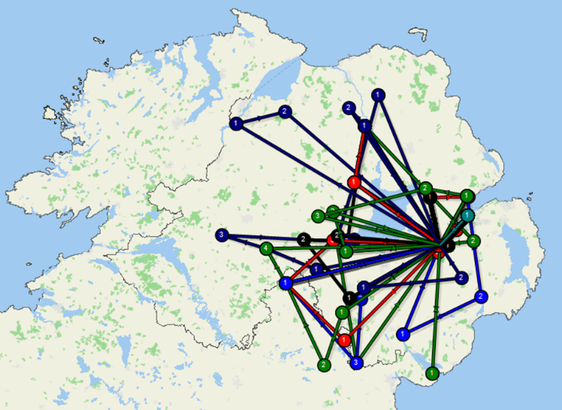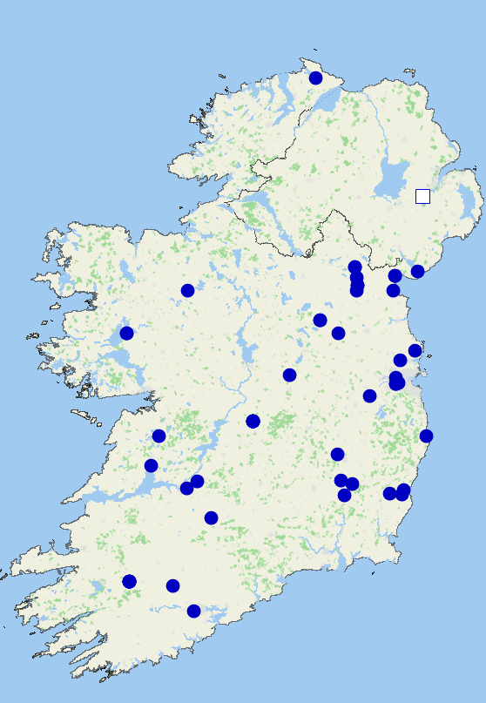
Figure 1 output of local deliveries Figure 2 Non-Core deliveries

5.4 Core Fleet Model: Four Drivers, Five Days per Week
Following segmentation, all core deliveries could be serviced by four drivers operating five days per week. Figure 3 demonstrates clustering, supporting higher route density..
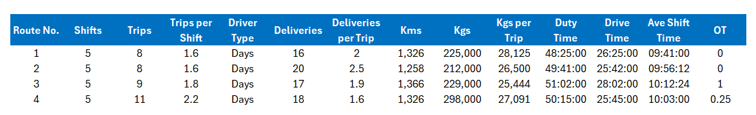
Figure 3 Data output of local deliveries

5.5 Non-Core deliveries and Tramper Drivers
Non-core deliveries were outsourced to 4PL tramper drivers on a fixed cost-per-delivery basis, eliminating extended driver absence and empty return mileage. Banks et al. (2013) identify empty running as a key inefficiency exposed through simulation.
The modelling outputs indicate significant efficiency improvements. Reducing drivers from eight to four represents a 50% labour reduction, while trailers reduced from 16 to 12 (25%) as shown in Figure 4. With drivers costing approximately £35,000 each, this equates to £140,000 annual savings, excluding additional reductions in fuel, maintenance and overheads.
Route optimisation also reduced empty running, which typically accounts for 20–30% of total distance (Flock Freight, 2025). Outsourcing non-core routes eliminated unproductive mileage and improved utilisation also reducing transport cost as shown in Figure 5.
Scenario testing assessed model robustness under increased demand (+10%), driver absence and fuel volatility. While the core fleet remained stable under moderate increases, higher demand required flexible 4PL capacity, reinforcing the strategic value of outsourcing.
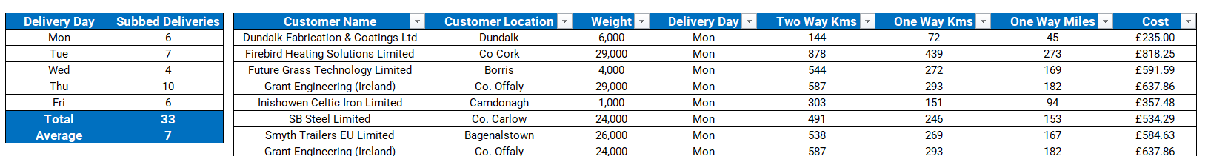
Figure 5 Example of subbed frequency and cost estimate

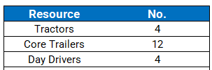
Figure 4 Data output of assets required to service cores

6. Critical discussion and Learning Outcomes
This case demonstrates that digital modelling and simulation can deliver structural improvements in logistics system design, rather than incremental operational adjustments. While traditional lean tools such as Value Stream Mapping (VSM) provide a useful visualisation of process flows, they are inherently static and limited in their ability to capture system variability, routing complexity and capacity interactions. In contrast, digital modelling enables dynamic scenario testing, allowing decision-makers to evaluate multiple system configurations before implementation. However, the effectiveness of digital modelling is inherently constrained by the assumptions on which it is built. In this case, the model relied on relatively stable demand profiles, fixed delivery locations and consistent driver availability. In practice, logistics systems are subject to significant variability, including traffic disruption, demand volatility and operational uncertainty. As (Ivanov and Dolgui 2020) argue, simulation models often fail to fully capture disruption risks within supply chains, meaning that outputs should be interpreted as decision-support tools rather than definitive predictions. Furthermore, the use of optimisation software such as Paragon introduces methodological limitations. Optimisation models prioritise efficiency based on predefined cost functions, which may overlook qualitative factors such as customer relationship management, service flexibility or operational resilience. As a result, there is a risk that “optimal” solutions in the model do not fully align with real-world strategic priorities. While the modelling strongly supported the transition to a 4PL solution, alternative approaches could also have been considered. For example, a hybrid logistics model combining a reduced in-house fleet with selective outsourcing may have provided a balance between cost efficiency and operational control. (Hübner et al., 2016) suggest that hybrid fulfilment strategies are increasingly adopted to retain flexibility while benefiting from external scale efficiencies. Additionally, improvements in internal planning through advanced scheduling or real-time routing optimisation could have delivered partial efficiency gains without full outsourcing. The decision to outsource also introduces long-term strategic considerations. While cost savings and efficiency improvements were evident, reliance on a third-party logistics provider reduces direct control over service delivery and creates dependency risks. This may impact the organisation’s ability to respond to future changes in demand or market conditions. Therefore, effective contract management, performance monitoring and governance structures are essential to ensure sustained value. From a learning perspective, this case highlights the importance of combining modelling with managerial judgement. Digital modelling provides powerful insights into system behaviour, but should be complemented by critical evaluation, scenario planning and ongoing performance review. The integration of quantitative modelling with strategic decision-making represents a key capability in modern logistics and supply chain management. This case highlights the importance of combining modelling with managerial judgement. While modelling provides valuable insights, it must be supported by critical evaluation and continuous performance monitoring.

7. Conclusion
This report has critically evaluated the role of digital modelling and simulation in the redesign of a real-world logistics operation. Through the application of Paragon route optimisation software, the organisation was able to move beyond experience-based decision-making and gain a comprehensive understanding of inefficiencies within the existing in-house fleet model, including underutilisation, empty running and exposure to fixed and variable cost pressures. The modelling process enabled the segmentation of deliveries into core and non-core routes, facilitating a structurally improved operating model. A reduced core fleet supported high-frequency regional deliveries, while long-distance deliveries were outsourced to a 4PL provider, improving cost efficiency, utilisation and operational resilience. Importantly, the study highlights that while digital modelling provides significant decision-support capability, it is not without limitations. Model outputs are dependent on assumptions and data quality, and may not fully capture real-world variability or disruption risks. As such, modelling should be integrated with managerial judgement and continuous performance monitoring. Overall, this case demonstrates that digital modelling is a critical enabler of modern logistics strategy, supporting not only operational efficiency but also informed strategic decision-making and sustainable process improvement.

8. References
Banks, J., Carson, J., Nelson, B. and Nicol, D. (2013) Discrete-Event System Simulation. Harlow: Pearson.
El Karkouri, N., Hassine, L., Ledmaoui, Y., Chaibi, H., Saadane, R. and Enneya, N. (2025) ‘Enhancing route optimization in road transport systems’, Future Transportation, 5(2). Available at: https://www.mdpi.com/2673-7590/5/2/60 (accessed 21 May 2025)
Flock Freight (2025) New study finds 58% of truckloads moved over half empty in 2024. Available at: https://www.flockfreight.com/company/press-releases/new-study-finds-58-of-truckloads-moved-over-half-empty-in-2024 (accessed 21 May 2025)
Inbound Logistics (2024) ‘Fourth party logistics: definition, advantages and disadvantages’. Available at: https://www.inboundlogistics.com/articles/fourth-party-logistics/ (accessed 21 May 2025)
Ivanov, D. (2021) ‘Digital supply chain simulation and optimisation’, Annals of Operations Research, 299(1).
Ivanov, D. and Dolgui, A. (2020) ‘A digital supply chain twin for managing disruption risks’, Production Planning & Control. Available at: https://doi.org/10.1080/09537287.2020.1768450 (accessed 21 May 2025)
Korder, B., Maheut, J. and Konle, M. (2024) ‘Simulation methods and digital strategies for supply chains’, Sustainability, 16(14). Available at: https://www.mdpi.com/2071-1050/16/14/5957 (accessed 21 May 2025)
MacCarthy, B., Blome, C., Olhager, J., Srai, J. and Zhao, X. (2021) ‘Supply chain evolution’, Production Planning & Control, 32(7).
Robinson, S., Kotiadis, K., Brooks, R. and van der Zee, D. (2011) Conceptual Modeling for Discrete-Event Simulation. London: CRC Press.
Shapiro, J. (2007) Modeling the Supply Chain. Belmont: Thomson.

