
By Jake Tyrrell
QinetiQ

Lecturer: Dr Steve Mosey

Test Range Engineering BEng (Hons)

2017-2018

Advanced Instrumentation Systems:
RADAR Assignment 1

Contents
1 Introduction 3
1.1 Purpose 3
1.2 Background 3
2 Research 5
2.1 Types of RADAR 5
2.1.1 Surveillance 5
2.1.2 Tracking 6
2.2 Aspects that effect RADAR 8
2.2.1 Clutter 8
2.2.2 Interference 8
3 Commissioning of 2 RADAR Sites 9
3.1 Site 1 Surveillance 9
3.1.1 Comparisons and Range Calculations 10
3.1.2 Chosen technology 13
3.1.3 Discussion 14
3.1.4 Advantages and Disadvantages of using other technologies 15
3.2 Site 2 Tracking 19
3.2.1 Comparisons and Range Calculations 20
3.2.2 Chosen technology 22
3.2.3 Discussion 25
4 Conclusion 27
5 References 28
6 Bibliography 30
7 Appendix 31

Figure 1 E-3 Sentry (AWACS) 4
Figure 2 Tracking RADAR Diagram 1 6
Figure 3 Tracking RADAR Diagram 2 7
Figure 4 Birds Eye View of the Peninsula 9
Figure 5 Horizon of the RADAR 10
Figure 6 ARSR 4 Calculation 11
Figure 7ARSR (Altered) Calculation 11
Figure 8AN/SPS-49 Calculation 12
Figure 9AN/SPS-49 (Altered) Calculation 12
Figure 10 Air Surveillance RADAR Lobe Shape 14
Figure 11 Black Spots 15
Figure 12 Over-The-Horizon RADAR 16
Figure 13 Phased Array- Beam Steering 17
Figure 14 Bistatic Configuration 18
Figure 15 Birds eye view of Site 2 19
Figure 16 AN/FPS-16 Calculations 20
Figure 17MFTR-2100/45 Calculations 21
Figure 18MFDR-2100/40 Calculations 21
Figure 19MFDR-2100/40 Tracking RADAR 23
Figure 20MFDR-2100/40 Specification 24
Figure 21Waves and Frequencies used by RADAR 31
Figure 22RCS Conversion 31

1 Introduction

Purpose

The purpose of this report is to give an understanding of what RADAR is and how it is used. Specifically looking into Surveillance and Tracking RADAR, with the overarching task of specifying the upgrades to the existing RADAR systems at two different sites.

Background

RADAR stands for Radio Detection And Ranging. It is a complex system that can detect the speed, range and direction of single and multiple targets at one time. The main principles of RADAR had been established over a period of 20-30 years from the 1880’s where the concept of RADAR as it is known today had not been thought of. Fast forward to 1935 in Great Britain [1] “In February 1935 Watson-Watt demonstrated to an Air Ministry committee the first practical radio system for detecting aircraft. The Air Ministry was impressed, and in April Watson-Watt received a patent for the system and funding for further development. Soon Watson-Watt was using pulsed radio waves to detect airplanes up to 80 miles away.” Since then continuous development of RADAR through war and peacetime has created RADAR as we know today.
RADAR has many uses and is utilised throughout industry, both civil and military. Some of RADARs many uses are listed below:
- Military – Tracking and Surveillance RADAR are employed to monitor the airspace and borders for unfriendly ships, aircraft and missiles.
- Shipping – Marine RADARS allow for ships to navigate by locating the landmarks needed, they also help detect other ships.
- Airports – Air traffic control utilises multiple different types of RADAR to track aircraft and see what aircraft are incoming and outgoing.
- Space – Surveillance and monitoring of the various satellites (used and disused) in space as well as detecting unknown objects (asteroids, space junk & potentially UFO’s).
- Weather systems – To track and get an up to date record of where they are.
- Geological observations – Ground penetrating RADAR can detect what is below the ground that isn’t visible.

Since its conception RADAR has become widely used and has got powerful, complex and in some cases smaller. This has allowed capable RADAR systems to become portable as shown in Figure 1.
The E-3D Sentry is a Royal Air Force aircraft that utilises the Northrop Grumman AN/APY-1/2 Airborne Warning and Control System (AWACS) that is embedded in is airframe [2] “The E3 look-down radar has a 360° view of the horizon, and at operating altitudes has a range of more than 320km. The radar can detect and track air and sea targets simultaneously”

[3]
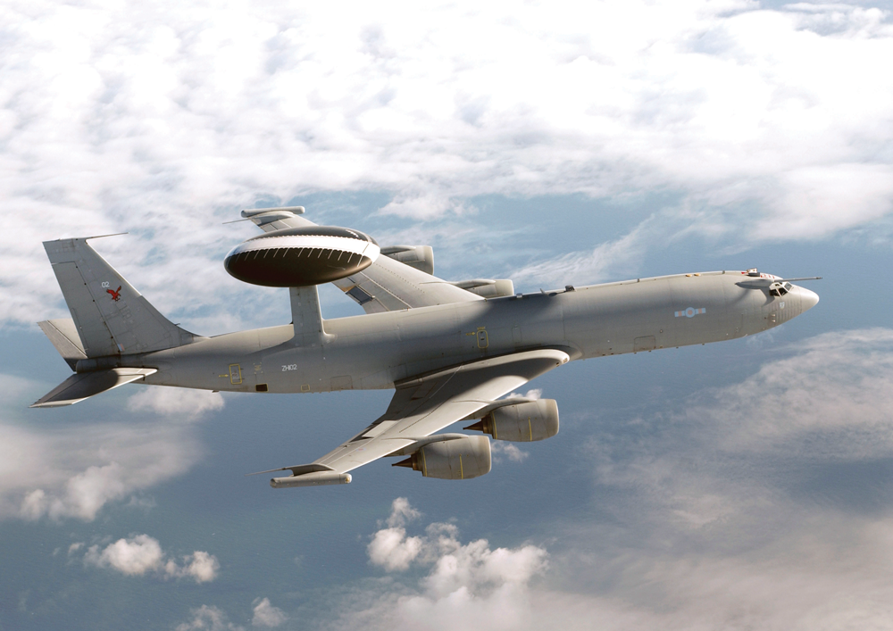
Figure 1 E-3 Sentry (AWACS)

The following sections will provide a wider understanding of Surveillance and Tracking RADAR.

2 Research

2.1 Types of RADAR

2.1.1 Surveillance

A Primary Surveillance RADAR (PSR) is a passive system it works by transmitting signals out and receiving a weak, or faint signal that has bounced back from an object like an airplane.
A Secondary Surveillance RADAR (SSR) is an active system it transmits and receives strong signals (known as replies) that are produced by transponders. Transponders allow for the power to be reduced as the distance travelled is halved, [4] "The cooperation of the target (transponder) is necessary to reach a drastic reduction of the transmit power in case of the same maximum range. Because the transmit power influences the RADAR equation at the primary RADAR with the two way travel, at the secondary surveillance RADAR only one way.”
Alternatively, SSR also allows for an exponential increase in range and the potential increase in accuracy if it used the same amount of power as a PSR.
SSR would mean that:
$$r_{max}= \sqrt[2]{\frac{P_{T}G_{T}G_{R}σλ^{2}}{{(4π)}^{3}P_{Rmin}L_{ges}}}$$
Because the transponder is powered from the aircraft it’s not reflective it is incidental, whereas with PSR it would be:
$$r_{max}= \sqrt[4]{\frac{P_{T}G_{T}G_{R}σλ^{2}}{{(4π)}^{3}P_{Rmin}L_{ges}}}$$
PSR tracks airplanes as objects meaning that the transmitted signal is reflected, or bounced off it and a weak signal is received back. One of its biggest drawbacks is its inability to Identify Friend or Foe (IFF). SSR transmits and receives strong signals from the transponders on each individual aircraft. This means that it is able to identify, label and receive other vital information from the aircraft.
Some examples of PSR and SSR:
Airport Surveillance RADAR (ASR) is a system that is used to detect aircraft around an airport. Its maximum range differs from system to system, but is roughly 85-140km. It mainly utilises S band and has a peak power transmitted of 25kW-1.3MW. Larger airports will use an ASR with an SSR. The SSR will in most cases sit above the Main ASR dish meaning that it is a monostatic setup, but bistatic versions do exist.
Air Route Surveillance RADAR (ARSR) is a longer ranged RADAR that instead of detection aircraft around the airport will look further out and into the routes the aircraft take. [5] The range of ARSR is around 370km and works on L band. It has a peak power transmitted of approximately 5MW, it will also have horizontal, vertical and circular polarisation.

2.1.2 Tracking

The idea of tracking RADAR is to detect and track a target. It can determine the location of the target and follows its trajectory. [6] “An ideal tracking system would maintain contact and constantly update the target's bearing (azimuth), range and elevation”
Most Tracking RADARs have the ability to automatically track the target. Once the Tracking RADAR has “captured” the target for example a fighter jet, the jet can then be constantly tracked and its positional information is recorded.
Tracking RADAR tends to have a lot of range due to the fact that the beam is directed (pencil). All the energy is focussed allowing significant range compared to surveillance RADAR. The RADAR tracks the fighter jet by emitting dual beams. These pencil beams depicted in Figure 2 reflect off of the target and a signal is received. The RADAR knows that it is on target if both signals are identical as shown in Figure 2.
[7]
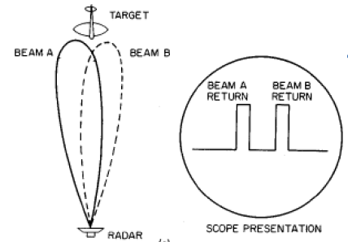
Figure 2 Tracking RADAR Diagram 1
If the Tracking RADAR is off target then the signal received will be similar to that depicted in Figure 3. The Tracking RADAR will correct itself by moving in the direction of the stronger received signal. The pencil beams are constantly pulsed and make the system highly accurate. [6] “Since the return strength is changing rapidly to either side, the location of the target can be determined with great accuracy. For a typical radar beam that is 30 wide, a dual-beam system could track the target with 0.10 accuracy, which is sufficient for weapons delivery.”

[7]

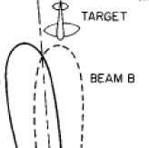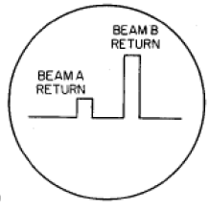
Figure 3 Tracking RADAR Diagram 2

The dual beams can be used for tracking the elevation as well, with a Monopulse system utilises one set of dual beam pencils for the bearing, or azimuth and the other set for the elevation.
[8]
“Following are the types of tracking RADAR:
• STT RADAR (Single Target Tracking RADAR)
• ADT RADAR (Automatic Detection and Tracking RADAR)
• TWS RADAR (Track While Scan RADAR)
• Angle Tracking RADAR
• Phased Array Tracking RADAR
• Monopulse Tracking RADAR”
The Phased Array Tracking RADAR started to make an appearance in the later 1980’s in the form of the Army Navy Mobile Pulsed systems Multiple Object Tracking Radars – 39 (AN/MPS-39 MOTR). It is capable of [9] “simultaneously tracking up to 40 objects within a scan volume of 60 degrees by 60 degrees. Each MOTR phased array antenna is mounted on an azimuth over elevation pedestal so that full hemispheric coverage is possible. The precision of the radar is 0.2 mils (approximately .02 milliradians) in angles and 1.5 yards in range. The peak power of the radar is one-megawatt, but a mix of six different waveforms provides for a total average transmitted power of 5000 watts, the highest of any of the WSMR radars. The MOTR is capable of tracking a six-inch sphere to range in excess of 120 km.” The adaptability, accuracy and the simultaneous tracking of the system make it ideal for a tracking RADAR especially with the military.

2.2 Aspects that effect RADAR

2.2.1 Clutter

RADAR waves are transmitted and the return from targets, objects, buildings, landscape and weather can all be registered. This can be frustrating when for example trying to detect an aircraft, as multiple returns will be received. It also limits the ability of the RADAR as it takes time to distinguish between the different returns. Two mitigations for this limitation are:
- Doppler frequency shift
- Circular polarisation
[10] “The Doppler frequency shift is the usual means by which moving targets are distinguished from the clutter of stationary objects.” So in the case of tracking the aircraft, the signal that reaches the receiver has a change in frequency because the aircraft is closer, or further away from where it was originally.
[10] “With circular polarization, the electric field rotates at the RADAR frequency. Because of this, the electromagnetic energy reflected by the rain and the aircraft will be affected differently, which thereby makes it easier to distinguish between the two. (In fair weather most RADARs use linear polarization; i.e., the direction of the electric field is fixed.)” With the example of detecting an aircraft this helps identification of the aircraft in harsh weathers like rain and snow.

2.2.2 Interference

Interference can cause problem with identifying targets. It can come from weather, other RADAR, moving vehicles, tall buildings and wind turbines. It can even be from wildlife in the case of Colorado [11] “Recently a 70 mile wide swarm of butterflies was detected by meteorological RADAR in Colorado USA”.

3 Commissioning of 2 RADAR Sites

When developing sites such as these there are some important aspects to keep in mind:
- What is the RADAR needed for?
  - Military – Threat detection, or Testing
  - Civilian – Aircraft and Small Vessels
  - Commercial – Shipping, Aircraft, or Aerial drone testing
- What is the target; Ships, Small Vessels, Aeroplanes or Missiles. From this the following information can be gathered in order to get the appropriate specification for the RADAR:
  - What is the target size?
  - How fast does the target move?

3.1 Site 1 Surveillance

The specification details the need for a Surveillance RADAR with the following requirements at Site 1:
- Cover an area extending for 350km
- Span 270° over the sea
- Detect a reflector with an RCS of 10m²
- Ability to meet the requirements above with a minimum detectable signal of -150dBW
.
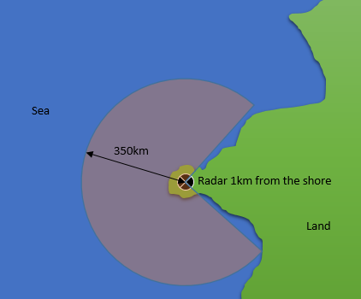
Figure 4 Birds Eye View of the Peninsula

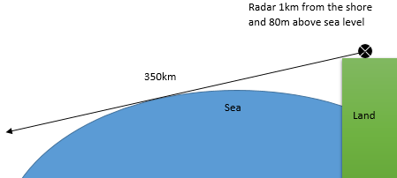
Figure 5 Horizon of the RADAR

3.1.1 Comparisons and Range Calculations

The maximum range was calculated in excel for the most suitable Surveillance RADAR systems. The excel calculations utilised Equation 1.

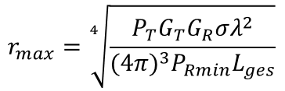
Equation 1 Maximum Range

There were however discrepancies between the calculations and the RADAR specifications/datasheets. Some details are harder to get hold of as they would reveal the true ability of the system. These figures are the Gain Transmitted, Gain Received, Losses (L_{ges}) and Prmin. The following calculations are based on various sources to combat this.
In all calculations the RCS, Losses and Prmin have all been fixed at 10m², 0.9 and -150dBW to abide with the specification.

Air Route Surveillance Radar 4
Sources calculate the max range at 463km with a target RCS of 1m², whereas, in the calculation in Figure 6 with a fixed RCS of 10m² the range max is74.7km.
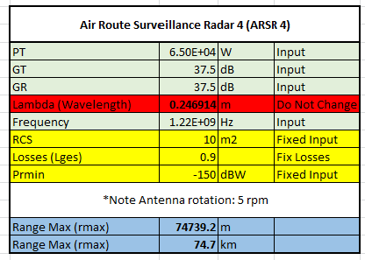
Figure 6 ARSR 4 Calculation

To fit the sites needs of 350km range the 1215MHz Frequency has stayed the same as the ARSR 4 system, but the Power Transmitted has been significantly increased from 65KW to 1.4MW and the G_{T} and G_{R} from 37.5dB to 180dB.

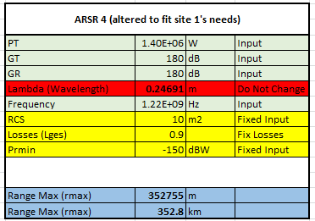
Figure 7ARSR (Altered) Calculation

AN/SPS-49
Again sources state the range for this system at over 370km, whereas our calculation in Figure 5 shows 116km. The AN/SPS-49 would be calibrated to an RCS of 1m², a fixed RCS of 10m² has been given so in theory in the calculation (Figure 5) because the RCS is larger the range max should increase massively.
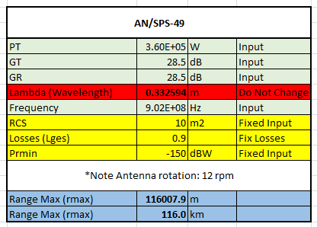
Figure 8AN/SPS-49 Calculation

To fit the sites needs of 350km range the 902MHz Frequency has stayed the same as the AN/SPS-49 system, but the Power Transmitted has been significantly increased from 360KW to 1.4MW and the G_{T} and G_{R} from 28.5dB to 150dB.
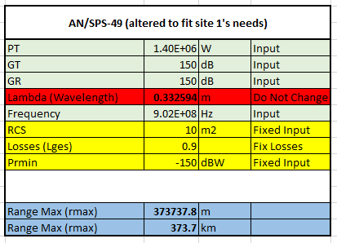
Figure 9AN/SPS-49 (Altered) Calculation

3.1.2 Chosen technology

The system chosen for site 1 is an AN/SPS-49 RADAR. It is a long range RADAR that is mainly used for air surveillance and is utilised by multiple countries. The specification below:
[12]
“Band: L
Frequency Band: 850 to 942 MHz, three selectable 30MHz bands, 48 discrete frequencies
Transmitting Power: 360 kW peak, 280 kW specified peak power, 12-13 kW average power
Antenna Parameters: Parabolic Reflector stabilized for roll and pitch 7.3m/24 ft wide, 4.3m/14.2 ft high
Rotating Clearance 8.7m/28.4 ft diameter
Beamwidths: 3.3, -3.3 azimuth, 11 elevation
Cosec2 to 30, csc2 to 20 elev
Gain 28.5 dB
Scan rate 6 or 12 rpm
Line-of-sight mechanical stabilization to 25 deg roll
IFF antenna (AS-2188) mounted on boom
Range 250 nm
Minimum Range: 0.5 nmi
Frequency Selection: Fixed or frequency agile
Range Accuracy: 0.03 nmi
Azimuth Accuracy: 0.5 deg
PRF: 280, 800, 1000 pps
Pulse width: 125 microsecond”

The configuration would be monostatic due the size of the RADAR and the amount of room in the peninsula at site one.
The AN/SPS-49 meets all the criteria and is a proven system:
- [13] It utilises both UFH and L band and has a range of 463km (tweaked version 373km see Figure 9), so is more than capable of meeting the 350km range specified.
- The RCS of 10m² is small at such vast distances, the UFH and L bands suit the needs of the specification. [14] “Operation in the 902-928 MHz band is critical because it offers unique propagation characteristics that permit detection of small, fast moving targets over water, referred to as sea skimmers.” Enhancing on this ability, the frequency of scans is a lot more than other RADAR types at 12rmp, so enables the RADAR to scan for fast moving objects like missiles. The frequency of rotation can be reduced if needed allowing for a more focused scan.
- The RADAR uses 2D technology rather than 3D as the longer duration of scans with 3D means that targets can move vast distances between each scan. [15] “This time approach is not suitable for an air surveillance radar because very fast aircraft can travel a huge distance in a very short time. An airplane with supersonic velocity travels nearly 300 km during this interval!” 2D therefore allows a more constant surveillance.

3.1.3 Discussion

The lobe shape on traditional air surveillance RADAR is due to the antenna shape, depicted in Figure 10. A disadvantage of this shape is the black spot shown as Area 3. The AN/SPS-49 would not have this problem as [14] “The AN/SPS-49 uses a line-of-sight, horizon-stabilized antenna to provide acquisition of low-altitude targets in all sea states, and also utilizes an upspot feature to provide coverage for high diving threats in the high diver mode.” This means the for an AN/SPS-49 system Area 3 would not exist as it would be covered in the lobe shape.
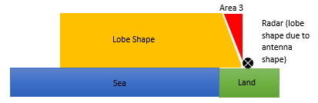
Figure 10 Air Surveillance RADAR Lobe Shape

The peninsula depicted in Figure 4 is perfect for a Monostatic configuration. The system is perfect for surveillance over the specified area, it is however a small site that requires the building of an AN/SPS-49 and a base station that is a suitable distance away.

Advantages
- Distance covered, or Range Maximum – With the tweaked version the range is actually larger than specified.
- There is an ability to extend the surveillance area if needed beyond 350km in the future.
- Size of target tracked at range (RCS) – the tweaked version meets the specification, but according to the sources the range of AN/SPS/-49 is 370km with an RCS 10 times smaller than specified (1m²) which would mean:
  - It could pick up smaller targets than specified.
  - If was calibrated to 10m² (RCS) then the range would increase exponentially.
- Rotations 12rpm – more rpm means that the frequency of scan is increased and faster moving objects can be captured.
- Can operate in the presence of clutter
- Fairly fast return (or small window)
- Military Off The Shelf (MOTS) – if the system is not tweaked then is readily available (within a certain timeframe).
- Available equipment – As it is not a one off bespoke item.
- Substantial vertical coverage
Disadvantages
- The Size of the RADAR
- Cannot identify target (like with SSR’s)
- Blind/Black spots (over the horizon and close in)
- Danger area (around RADAR)
- Geographic inability to make it bistatic – because of the peninsula
- Cost

3.1.4 Advantages and Disadvantages of using other technologies

3.1.4.1 Challenges

The vast range and the curvature of the earth creates a black spot beyond the horizon. Anything beyond the horizon (Area 1) would not be picked up unless a certain height above the earth.
$$R_{nm}= \left(1.23 × \sqrt{H_{T}}\right)$$
Rnm = Range in Nautical Miles HT = Height of the transmitter in feet
80m = 262.467ft
$$19.927 = \left(1.23 × \sqrt{262.467}\right)$$
19.927nm = 36.9km
So the RADAR Horizon is 36.9km away from Site 1.
The height of the land (80m above sea level) and the distance from the shore (1km) does not allow for surveillance of ships and even some low flying aircraft close to shore (Area 2).

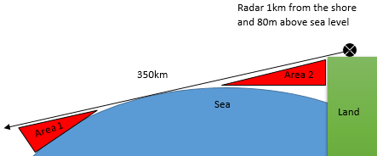
Figure 11 Black Spots

Solutions

Using an Over The Horizon RADAR (OTH), Area’s 1 and 2 shown in Figure 11 could be seen. OTH works by using [16] “shortwave, or high-frequency (HF), portion of the radio band (from 3 to 30 MHz)” the frequencies hit the ionosphere (see Figure 12) and are refracted to the surface. In the case of Figure 11 they enable Area’s 1 and 2 to be visible.

Advantages
- Early warning – the OTH can see beyond the Surveillance RADAR.
- Can cover a huge area – [16] “The U.S. Navy’s HF OTH radars known as relocatable over-the-horizon radar (ROTHR), or AN/TPS-71…Each radar can provide surveillance of approximately 1.3 million square nautical miles (4.5 million square km)”

Disadvantages
Although there are many advantages the OTH system is rather overkill in addition to the Surveillance RADAR at Site 1 because:
- Expensive – multiple phased array antennas.
- Large structures – multiple large antenna installation, the peninsula wouldn’t easily fit an OTH RADAR.
- Losses – due to backscatter and noise.

[16]
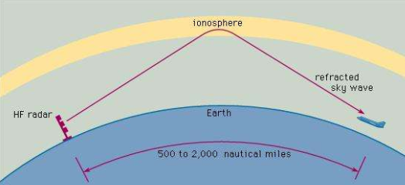
Figure 12 Over-The-Horizon RADAR

Another technology using a Phase Array RADAR would enable Area 2 to be visible due to its ability to beam steer as depicted in Figure 13. [17] “A phased array antenna is composed of lots of radiating elements each with a phase shifter. Beams are formed by shifting the phase of the signal emitted from each radiating element, to provide constructive/destructive interference so as to steer the beams in the desired direction.”
Advantages
- Beam steering ability.
- Can be both surveillance and tracking – so could support the surveillance RADAR.
- Can detect multiple targets.
Disadvantages
- Expensive
- Limited coverage compared to the Surveillance RADAR
- Complex setup

[17]
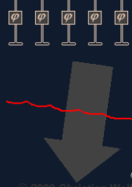
Figure 13 Phased Array- Beam Steering

Using SSR at Site 1 as well as the surveillance RADAR would allow for an exponential increase in range (as mentioned in section 2.1.1 Surveillance) and the potential increase in accuracy.
Unless the SSR was installed on top of the Surveillance system, one of the downfalls would be that the speed, of which the target is detected, will be affected. This is due to the lack of room for a receiver (Bistatic) close to site 1, so it may have to be installed further down the peninsula (Figure 6). This would mean that the Total Round Trip Time ($T_{rt}$) is longer. An example shown below:
Figure 14 depicts an incoming aircraft with a Bistatic configuration, where:
$r_{T}$ = 4000m an $r_{R}$ = 5000m
$$T_{rt}= \frac{ r_{T}+ r_{R} }{{3 ×10}^{8}}$$
$${30 ×10}^{-6}= \frac{ 4000+ 5000 }{{3 ×10}^{8}}$$
$$T_{rt}= 30μs$$
Whereas with a Monostatic configuration $r=4000m$
$$T_{rt}= \frac{2×r }{{3 ×10}^{8}}$$
$${26.67×10}^{-6}= \frac{ 8000 }{{3 ×10}^{8}}$$
$$T_{rt}= 26.67μs$$
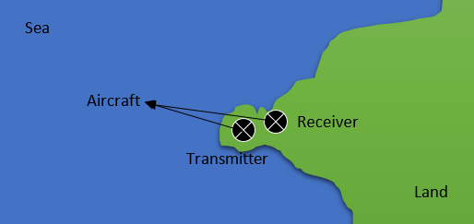
Figure 14 Bistatic Configuration

3.2 Site 2 Tracking

The specification details the need for a Tracking RADAR at Site 2. This should have the following requirements:
- Cover an area extending for 50km
- Span 45° over the sea
- Detect a reflector with an RCS of 10m²
- Ability to meet the requirements above with a minimum detectable signal of -150dBW
Two of the main points taken from the specification are:
- It gives the impression that missiles will be the main target [18] “Site 2 is used for tracking fast moving objects travelling away from the site.”
- That the ideal system should be able to track multiple objects at the same time if possible.

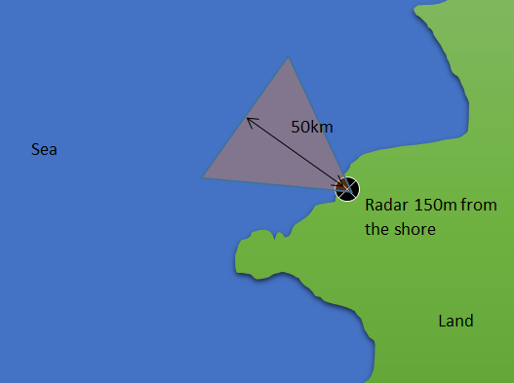
Figure 15 Birds eye view of Site 2

3.2.1 Comparisons and Range Calculations

The following calculations have the same discrepancies as 3.1.1 Comparisons and Range Calculations.
AN/FPS-16
This tracking RADAR is used on military test ranges and is easily capable of tracking missiles. It is a Single Object Tracking RADAR (SOTR). However it is unsuitable for the role as the requirement specifies 50km range and this would be to powerful, even with reduced Power Transmitted.

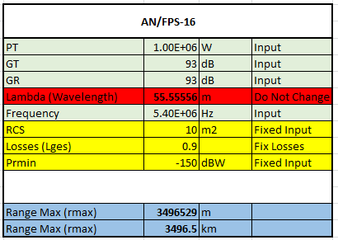
Figure 16 AN/FPS-16 Calculations

WEIBEL MFTR-2100/45 High Accuracy Long Range TSPI RADAR
The stated specification: [19]
- “Power Transmitted 8KW
- Frequency 10GHz (X-Band)
- Transmitter and receiver gain 45dB
- Max Range 450km”
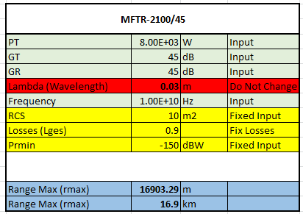
Figure 17MFTR-2100/45 Calculations

WEIBEL MFDR-2100/40 Multi Frequency Doppler RADAR
The stated specification: [19]
- “Power Transmitted 5KW
- Frequency 10.3GHz (X-Band)
- Transmitter and receiver gain 40dB
- Max Range 250km”

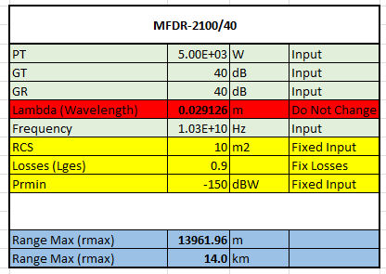
Figure 18MFDR-2100/40 Calculations

The next three RADAR systems are current and as a result a lot of the information is hidden, so their range cannot be calculated.
Compact Tracking RADAR-37250X (CTR-37250X)
BAE states its abilities as: [20]
- “Max Range 300km
- Maximum Tracking Range 43km
- Power Transmitted 100KW
- Frequency 8.5GHz (X-Band)”

Compact Tracking RADAR-4850-KA (CTR-4850-KA)
BAE states its abilities as: [21]
- “Max Range 75km
- Maximum Tracking Range 34km
- Power Transmitted 50KW
- Frequency 34GHz (K-Band)”

Innovative Multiple Object Tracking RADAR (IMOTR)
BAE states its abilities as: [22]
- “Maximum Tracking Range 100km
- Frequency C or X Band (so 4-12GHz)
- Tracks >20 targets in real time“

3.2.2 Chosen technology

Whilst the BAE Systems IMOTR is the most suited for the role, details of the system are not easily available. That said the WEIBEL MFDR-2100/40 Multi Frequency Doppler RADAR (Figure 19) is more than suitable for the role of Tracking RADAR at Site 2. It meets all of the specifications listed in 3.2 Site 2 Tracking.

[19]

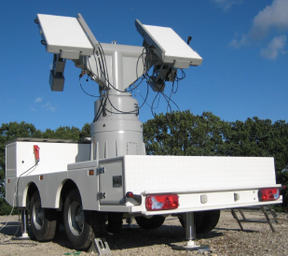
Figure 19MFDR-2100/40 Tracking RADAR

The specification depicted below (highlighted in yellow): [19]
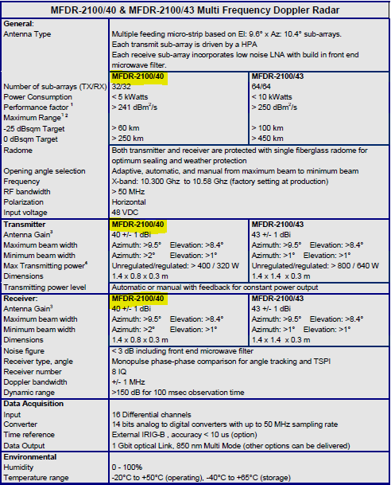
Figure 20MFDR-2100/40 Specification

It has a maximum range of 250km so would easily cover the specified 50km range and would allow for an increase of range if needed at Site 2.
The Tracking RADAR features modes such as:
- [19] Active real time tracking – where it tracks and follows the target on its own, estimating the targets new position if it loses it, allowing missiles the are hard to track to be picked up again as a target when lost.
- Pre-programmed illumination operation – the trajectory of the target is fed into the system and it tracks it from that data.
- Manual Tracking – the operator can adjust and move the antenna to suit and pick up the target. This would allow the operator to scan a different sector that that set in the specification if needed.
- Scanning – the system can scan an area looking for a target that happens to enter this area, this would suit Site 2’s specification as the 45 ° 50km area would need to be scanned.

The specification shows that it can pick up a target of:
- -25dBsqm at 60km
- 0dBsqm at 250km
Converting dBsqm into RCS (using the formula in Annex B):
1.
$${10}^{\left(\frac{-25}{10}\right)}=3.16227766×{10}^{-3}$$
$$RCS=0.0031m^{2}$$
2.$${10}^{\left(\frac{0}{10}\right)}=1$$
$$RCS=1m^{2}$$
The results show that the system can pick up a reflector less than the specified size at more than 250km.
The configuration would be monostatic. One of the main advantages of the system is that it is easily transportable / manoeuvrable so would allow flexibility in the setup at Site 2.
The system allows for vast operating temperatures (-20 °C to +50 °C) that are seen in Site 2, which is very open to the elements on the coast.

3.2.3 Discussion

Selecting the chosen RADAR system means that it is future proofed as commissioning a years old RADAR will not enable much life of the system, as technology constantly progresses. Meaning that in near future the system will again have to be upgraded.
Advantages
- Designed for purpose – the RADAR is design to be able to track small fast moving targets like missiles and planes.
- Size of target tracked at range (RCS) – the calculations (in section 3.2.2 Chosen technology) show that the system is more than capable of detection a target specified at 50km and can actually pick up a target more than 10 times smaller.
- Distance covered, or Maximum Range – is larger than specified.
- There is an ability to extend the Tracking area if needed beyond 50km in the future.
- Low Power Consumption – Compared to similar systems.
- Vast Operating Temperatures.
- Small mobile system – the RADAR can be fitted with a trailer (see Figure 19) making it manoeuvrable and easily deployable.
- Rugged – all components are solid state.
- Commercial Off The Shelf (COTS).
Disadvantages
- Single tracking ability – cannot track multiple targets at once.
- Polarisation – it is only horizontal, meaning that the RADAR is vulnerable to interference and clutter.
- Blind/Black spots – over the horizon and close in.

4 Conclusion

The report has provided an understanding of different RADAR systems and there many capabilities and uses.
At Site 1 the RADAR selected more than meets the specification and will allow the range specified of 350km to be surpassed if need. It also can detect targets 10 times smaller than specified.
At Site 2 again the system surpasses the specification, as it is able to pick up targets with and RCS of 0.0031m² at 60km range. So 10km more than specified and with more than 10 times smaller RCS. The system is designed to detect and track small fast moving targets.
Overall both systems selected, meet and excel past the specification. This will help to future proof the two sites and reduce the need for upgrades in the future.

5 References

[1] E. Tretkoff, April 2006 (Volume 15, Number 4), This Month in Physics History, April, 1935: British Patent for RADAR System for Air Defence Granted to Robert Watson-Watt, Online, https://www.aps.org/publications/apsnews/200604/history.cfm, Accessed 27/05/18
[2] E-3 AWACS (Sentry) Airborne Warning and Control System, Online, https://www.airforce-technology.com/projects/e3awacs/,Accessed 09/06/18
[3] About the E-3D, Online, https://www.raf.mod.uk/aircraft/e-3d/, Accessed 09/08/18
[4] Primary Surveillance RADARs. Secondary Surveillance RADAR, Online, http://www.RADARtutorial.eu/02.basics/PSR%20vs.%20SSR.en.html, Accessed 05/06/18
[5] ARSR vs ASR RADAR-Difference between ARSR and ASR RADAR, Airport RADARs for Air traffic control, Online, http://www.rfwireless-world.com/Terminology/ARSR-RADAR-vs-ASR-RADAR.html, Accessed 06/06/18
[6] Tracking Systems, Introduction to Naval Weapons Engineering, Online, https://fas.org/man/dod-101/navy/docs/es310/trksys/trksys.htm, Accessed 12/06/18
[7] Tracking RADAR, Online, https://www.iist.ac.in/sites/default/files/people/IN14204/Lecture%2028-32%20Tracking%20Radar.pdf, Accessed 12/06/18
[8] Tracking RADAR, RF Wireless World, Online,http://www.rfwireless-world.com/Terminology/Tracking-RADAR-basics-and-types.html, Accessed 12/06/18
[9] RADARS, Targets and Instrumentation, Online, http://www.wsmr.army.mil/testcenter/tai/Pages/Radars.aspx, Accessed 12/06/18
[10] Factors Affecting RADAR Performance, RADAR, online, https://www.britannica.com/technology/RADAR/Factors-affecting-RADAR-performance, Accessed 05/06/18
[11] RADAR Interference, PagerPower, Online, https://www.pagerpower.com/news/RADAR-interference/, Accessed 06/06/18
[12] J. Pike, AN/SPS-49 Very Long-Range Air Surveillance Radar, Online, https://fas.org/man/dod-101/sys/ship/weaps/an-sps-49.htm, Accessed 16/06/18
[13] AN/SPS-49(V) RADAR set, United States Navy Fact File, Online, http://www.navy.mil/navydata/fact_display.asp?cid=2100&tid=1262&ct=2, Accessed 06/06/18
[14] AN/SPS-49 Very Long-Range Air Surveillance RADAR, Military, Online, https://www.globalsecurity.org/military/systems/ship/systems/an-sps-49-variants.htm, Accessed 06/06/18
[15] C. Wolff, 2D or 3D RADAR, 3D RADAR Online, http://www.radartutorial.eu/02.basics/2D%20or%203D%20radar.en.html, Accessed 28/05/18
[16] Over-the-horizon RADAR, RADAR, Online, https://www.britannica.com/technology/radar/Factors-affecting-radar-performance#ref398743, Accessed 17/06/18
[17] C. Wolff, Phased Array Antenna, RADAR Basics, Online, http://www.radartutorial.eu/06.antennas/Phased%20Array%20Antenna.en.html, Accessed 17/06/18
[18] Assignment Brief
[19] WIEBEL Datasheet, Tech-bel, Online, www.tech-bel.com/wp-content/uploads/2017/03/MFTR-2100_Medium-Range.pdf, accessed 17/0618
[20] Compact Tracking Radar (CTR-37250X), BAE Systems, Online, https://www.baesystems.com/en/product/compact-tracking-radar, Accessed 16/06/18
[21] Compact Tracking Radar (CTR-4850-KA), BAE Systems, Online, https://www.baesystems.com/en/product/compact-tracking-radar, Accessed 16/06/18
[22] Innovative Multiple Object Tracking RADAR (IMOTR), BAE Systems, Online, https://www.baesystems.com/en/product/imotr, Accessed 16/06/18
[23] C. Wolff, Waves and frequencies used by RADAR, D-Band (L-Band RADAR), Online, http://www.RADARtutorial.eu/07.waves/Waves%20and%20Frequency%20Ranges.en.html, Accessed 05/06/18
[24] Decibels and RADAR, Big Book of Warfare, “and other stuff”, Online, http://www.alternatewars.com/BBOW/Radar/Decibels_Radars.htm, Accessed 17/06/18

6 Bibliography

Manual on the Secondary Surveillance RADAR (SSR) Systems, International Civil Aviation Organisation, Third Edition, Canada, 2004
J. Nespor, E. Hudson and R. Stegall, Doppler Radar Detection of Vortex Hazard Indicators, Government Electronic Systems, MITRE Corp

7 Appendix

Annex A [23]

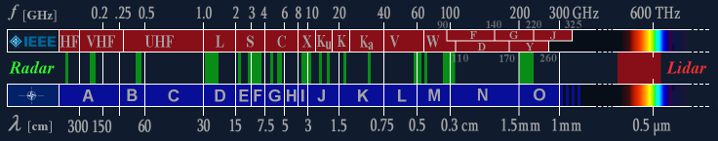
Figure 21Waves and Frequencies used by RADAR

Annex B [24]

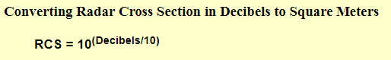
Figure 22RCS Conversion

