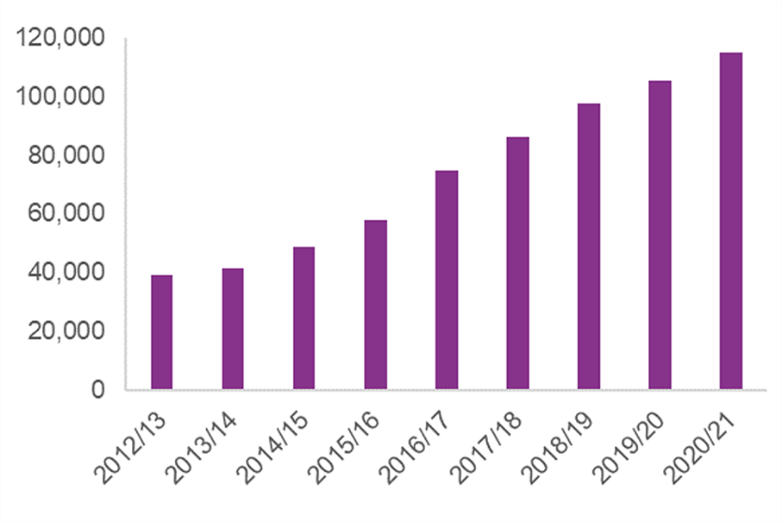
Hate crime is a well-known and recorded phenomenon, there have been a significant number of investigations into the effect that hate crime has on a person and is sadly, all too common. In the year prior to March 2021 there were 124,094 hate crimes recorded by the police in England and Wales (Home Office, 2021, p. 1). With 74% or 85,268 of these attacks being based on race, 17,135 being based on sexual orientation, 9,208 based on disability, 5,627 based on religion, and finally 2,360 hate crimes stemming from abuse related to a transgender identity (Home Office, 2021, p. 5). Recorded Hate crimes have been on a steady increase year upon year in the past decade as table 1 shows, this represents an increase of +194% (Home Office, 2021, p. 1; Allen and Zayed, 2021, p. 10). It is important to note however, that these statistics simply represent the number of hate crimes recorded to the police, hate crimes are commonly underreported in police statistics and the actual number of hate crimes or the “dark figure” is proposed to be higher (Pezzella, et al. 2019, p. 3)

Table 1.
(Home Office, 2021, p.1)
While hate crimes recorded have seen an increase, so too have the number of minorities and women in the police service. In March of 2012, minorities represented 5% of all serving officers, while as of March 2021 they represented 7.6% of all serving officers (Home Office, 2012, p. 10; Home Office, 2021, p. 23). The number of women in the police workforce has also seen an increase, rising from 26.8% in 2012 to 32.4% in 2021, however both statistics are provided in the context that there was a significant cut in the number of police officers between 2011 and 2018 (Home Office, 2012, p. 10; Home Office, 2021, p. 23). Both underrepresented in relation to population statistics.
However, despite this increase in the number of hate crimes reported and the number of women and minorities in the police, there has been little done in research to explore how any of these intersect. Police are seen as respondents to hate crimes, as service providers but they can too be victims. This would be the purpose of this study, to explore the experiences of police officers who are victims of hate crime, and the primary research question, to what extent does hate abuse directed towards police officers affect their occupation and personal identity?
As stated above there has been very little done in exploring this concept, so much so that Mawby and Zempi (2018, p. 536) assert that they may be the first to provide an academic study exploring this topic. So, one major objective of this research is to add and further explore a realm of criminological literature that is in critical need of additional analysis. The researcher will also explore how police officers responded to the abuse received, existing literature explores this and highlights that normalisation via desensitisation and challenging the abuse were common responses, an appropriate comparison would be to analyse how other professions responded to hate abuse (Mawby and Zempi, 2018, p. 536). While there is little existing literature on this specific topic, the police as victims have been explored in prior research to a limited extent, in topics such as, victims of violence, sex assault and victimisation through secondary means, these will help guide this research, so too will existing literature on the effects of hate abuse on an individual (Sands et al, 2022; Williams and Tredidga, 2014; Menard and Arter, 2014; Stocktad, 2000; Blasdell et al, 2021; Reiser and Geiger, 1984 ) Of particular interest to the researcher is the comparison of those who view policing simply as a job versus those who view it as a vocation, and how these intersect with conceptions of work-related burnout. Work related burn out is of analytical and exploratory interest, as female and minority officers, whether that be from gender, race, or sexual identity, receive unique stressors in policing. Those unique stressors being victims of hate crime. Not only do minority officers experience stressors that are universal to police officers, but they may also experience hate related abuse (Mawby and Zempi, 2018, p. 531).
In past literature there has been evidence to support that police work has a higher rate of job- or work-related burn out than other professions (Dowler, 2005. p. 476). Dowler (2005, p. 477) continues by highlighting two distinct avenues that work related stress or burn out can stem from. Organisational stressors, and Inherent stressors. Organisational stressors revolve around issues such as departmental policies, promotional opportunities and poor wages. While inherent stressors would be issues like exposure to danger and violence, and use of force. Issues that may cause harm but are considered part of the day-to-day routine of police work. Hate related stressors again would be added on top of these already existing organisational and inherent stressors.
Much of the research already in this field is focused on white male officers, so exploring this avenue among female and minority officers may provide valuable insight, particularly from those officers who may experience an intersection of abuse based on both race and gender and several other identities (McCarty et al, 2007, p. 673; Christiansen, 1999)
It can be difficult according to Mawby and Zempi (2018, p. 536) to ascribe the label of hate crime victim to a police officer, for they do not lack in power and authority and cannot be labelled as an oppressed group, playing into the concepts of the ideal victim. Continuing, the concept of dirty work however may cause the police to be a target for abuse because of the stigma associated with their occupational identity (Mawby and Zempi, 2018, p. 528; Ashforth et al, 2007; Ashforth and Kreiner, 1999). Should the interview candidates be appropriate, a comparison of an officer’s response to the hate abuse between an experienced officer and a new officer will take place.
The very limited research which is present in this field of study has used qualitative methods of gathering data, this research will intend to do the same. The reason for using qualitative data over quantitative is that quantitative methods have been accused of having “a static view of social life” (Bryman, 2021, p. 160). Qualitative methods have been often generalised to be focused on numbers, to quantify certain variables into a known and measurable context (Bryman, 2021, p. 239). Continuing, this statement would be supported by quantitative methods often having a positivist objectivist ontological consideration (Bryman, 2021, p. 240). And by analysing responses from previous literature in this field we can see that they are anything but objective, each answer was unique and constructed from the participants own point of view. It is for this reason this research will take an interpretive research paradigm approach as it would also allow qualitative “methods to gain deep insights based on a specific context” (Alharahsheh and Pius, 2020, p. 43)
A positive of qualitative research in this regard is that the human involvement in methods such as interviews and focus groups allows for the researcher, with the use of probes, to advance the conversation down avenues which may provide valuable data, allowing the theoretical framework to gradually develop over the data gathering process, this being a inductive approach to research, the researcher will use this approach.
It is also for this reason that the researcher will use semi-structured interviews in order to gain that data. An advantage of this semi structured approach is that it allows for the development of a “strong therapeutic relationship”, a very important part of qualitative data gathering is the development of a rapport, and this approach is very conducive to this (Mueller and Segal, 2015, p. 1). However, a criticism of this semi structured approach is that you may in fact hamper quality answers. This hampering may happen when attempting to develop this rapport, should the researcher say the wrong thing or offend the participant then the participant may end up “safeguarding” themselves, thus bringing the validity of the answers into question (Burtt, 2021, p.824).
This is of particular interest to the researcher as the topic chosen is of a potentially sensitive nature; meaning that the interview may cause harm to the participant (Peled and Liechtentritt, 2002, p. 149-150). The researcher will use various methods to avoid causing harm to the participant such as empowering the participant, treating them with respect and giving the participant complete information about the research, among other methods found in literature (Allmark et al, 2009, p. 49-51; Peled and Liechtentritt, 2002, p. 149-150; Kavanaugh and Ayres, 1998, p. 92-95).
Due to this study focusing on hate crimes the researcher has a particular interest in gaining respondents who represent and would fall under the 5 protected characteristics, those being:
- Race
- Religion
- Disability
- Sexual orientation
- Transgender identity
While these characterises may be the focus of the study, officers who believe they have been victims of hate related abuse of any kind will not be turned away. As the researcher intends to target and gain insight on a specific subset of the population, the purposive sampling method will be used. This is ideal as it allows the researcher a “deliberate choice of participant due to the qualities the participant possesses.” (Etikan et al, 2015, p. 2). However, purposive sampling in a non-probability sampling method and as such it is non generalisable (Etikan et al, 2015, p. 4). Interviewees will be approached via personal contacts who can connect the researcher and the participant. The researcher will also approach local forces about gaining respondents and through pre-arranged contacts gained during university lectures.
Each interview with the participants consent will be recorded which will allow the researcher to analyse data recorded. The analysation method will be thematic analysis (Braun and Clarke, 2006, p. 82). Due to limitations such as time constraints, methodological approaches and, perhaps, difficulty in gaining interview participants, any data gathered, and conclusions made will not be generalizable. Anonymity of participants will be ensured, and the participants will be provided with a consent form stating that they may withdraw at any time.
As time is limited a time frame has been created to assist in ensuring that targets are hit and enough time is accounted for to allow for in depth discussion and analysis.
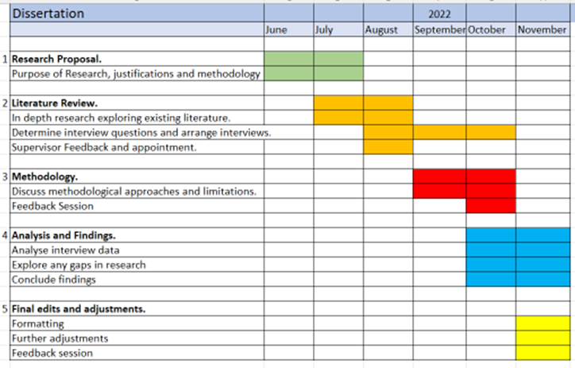
Expected significant budget considerations will be mainly found around issues of transport, these will be funded personally by the researcher as will any unexpected financial costs.

References

Alharahsheh, H. and Pius, A. (2020) ‘A Review of key paradigms: positivism VS interpretivism’. Global Academic Journal of Humanities and Social Sciences, 2(3), pp. 39-43.
Allen, Graham. And Zayed, Yago. (2021) Hate Crime Statistics.Available at: https://researchbriefings.files.parliament.uk/documents/CBP-8537/CBP-8537.pdf#page=25&zoom=100,228,90 (Accessed 15 June 2022).
Allmark, P., Boote, J., Chambers, E., Clarke, A., McDonnell, A., Thompson, A., & Tod, A. M. (2009) ‘Ethical Issues in the Use of In-Depth Interviews: Literature Review and Discussion’. Research Ethics, 5(2), 48–54.
Ashforth, E. and Kreiner, G. (1999) ‘"How can you do it?": Dirty work and the challenge of constructing a positive identity’. The Academy of Management Review, 24(3), pp. 413-434.
Ashforth, E., Kreiner, G., Clark, M., & Fugate, M. (2007) ‘Normalizing Dirty Work: Managerial Tactics for Countering Occupational Taint’. The Academy of Management Journal, 50(1), pp. 149–74.
Blasdell, R., Krieger-sample, L., & Kilburn, M. (2021) Invisible Victims and the Pursuit of Justice: Analyzing Frequently Victimized Yet Rarely Discussed Populations. Hershey: Information Science Reference.
Braun, V. and Clarke, V. (2006), ‘Using thematic analysis in psychology’. Qualitative Research in Psychology, 13(2), pp. 77-101.
Bryman, A. (2021) Social Research Methods. 6th Ed. Oxford: Oxford University Press.
Burtt, E. (2020). ‘When access is denied: Conducting an interview through letter writing’. Qualitative Research. 21 (6). Pp. 813 – 828.
Christiansen, C. (1999) ‘Defining Lives: Occupation as Identity: An Essay on Competence, Coherence, and the Creation of Meaning’. American Journal of Occupational Therapy, 53(6), pp. 547-558.
Dowler, K. (2005) ‘Job Satisfaction, Burnout, and Perception of Unfair Treatment: The Relationship Between Race and Police Work’. Police Quarterly, 8(4), pp.476–489.
Etikan, I., Musa, S., and Alkassim, R. (2015). ‘Comparison of Convenience Sampling and Purposive Sampling’. American Journal of Theoretical and Applied Statistic, 5(1), pp. 1-4.
Home Office (2012) Police Service Strength in England and Wales. Available at:https://assets.publishing.service.gov.uk/government/uploads/system/uploads/attachment_data/file/115783/hosb0912.pdf (Accessed 15 June 2022).
Home Office (2021) Hate crime, England and Wales, 2020 to 2021. Available at: https://www.gov.uk/government/statistics/hate-crime-england-and-wales-2020-to-2021/hate-crime-england-and-wales-2020-to-2021 (Accessed: 12 June 2022).
Home Office (2021) Hate crime, England and Wales, 2020 to 2021. Available at: https://www.gov.uk/government/statistics/hate-crime-england-and-wales-2020-to-2021/hate-crime-england-and-wales-2020-to-2021 (Accessed: 12 June 2022), p.1, graph.
Home Office (2021). Police workforce, England and Wales: 31 March 2021 second edition. Available at:https://www.gov.uk/government/statistics/police-workforce-england-and-wales-31-march-2021/police-workforce-england-and-wales-31-march-2021 (Accessed 15 June 2022).
Kavanaugh, K. and Ayres, L. (1998) ‘Not As Bad As It Could Have Been”: Assessing and Mitigating Harm During Research Interviews on Sensitive Topics’. Research in Nursing & Health, 21, pp. 91–97.
Margerita, M. (1980) `POLICE AS VICTIMS OF VIOLENCE. ’The Justice System Journal, 5(3). pp. 218–33.
Mawby, R. and Zempi, I. (2018) ‘Police officers’ experiences as victims of hate crime’. Policing, 41(5), pp. 526-538.
Menard, K. S., & Arter, M. L. (2014). ‘Stress, Coping, Alcohol Use, and Posttraumatic Stress Disorder Among an International Sample of Police Officers: Does Gender Matter?’ Police Quarterly, 17(4), 307–327.
Mueller, A. and Segal, L. (2015) ‘Structured versus Semistructured versus Unstructured Interviews’, in Cautin, R and Lilienfeld, S. (1st Edn). The Encyclopedia of Clinical Psychology. New York: John Wiley and Sons Inc.
Pezzella, F. S., Fetzer, M. D., & Keller, T. (2019) ‘The DarkFigure of Hate Crime Underreporting’. American Behavioral Scientist, 0(00), pp.1 – 24.
Sands, A., Westerman, L., Prochnau, J., & Blankenau, H. (2022) ‘Police Sexual Violence: A Study of Policewomen as Victims’. Police Quarterly, 0(0), pp. 1-21.
Williams, M. and Tregidga, J. (2014) ‘Hate Crime Victimization in Wales: Psychological and Physical Impacts Across Seven Hate Crime Victim Types’. The British Journal of Criminology, 54(5), pp. 946–967.

