
Mixed seed balls to support AND MIMIC natural regeneration and vector seed dispersal in British woodlands
A proposal

Februray 2020
University of Wales Trinity Saint David
Sophie Bennett

Contents
1. Introduction 2
2. Aims and Objectives 2
3. Methodology 3
2. What data will to be collected? 5
Base line data 5
Experiment data 6
4. Literature Review 7
Research Constraints 8
References 9

Figure 1 Area outlined in red is Neath Port Talbot. Image from Google Maps 3
Figure 2 Habitat map of Neath Port Talbot area. Dark green for coniferous woodland, red for broadleaf woodland, brown represents acid grassland, light green for improved grassland, lilac for salt mash and dark yellow for bog. Image from Digimap, Edinbugh Univesity 4
Figure 3 Graphic showing the stages and vegetation type for forest Succession copyright Sheri Amsel, 19/02/2020 5
Figure 4 Field experiment design used by Paulo and Martins, 2018. Each red dot is a seed bomb, planted 0.5m interval in a 2m by 4m area of untilled forest T denotes the tree species and ND denotes the grouping for statistical analyses 6

Introduction
As well as being Britain’s richest and most diverse habitat (RSPB, n.d.), woodlands and forest are probably the most iconic of the British landscapes. From our vision of the post Ice Age Wild Wood (Rackham, 2006), to Pooh Bear’s Hundred Acre Wood and the small copses our children play in at parks, woodlands and trees are a staple of the British countryside and our urban environment. At no time in recent memory has our affinity to these majestic and comforting icons been as indicative as the 2010 government proposal which threatened to sell off our public woodlands (Hickman, 2010) and its subsequent abandonment due to public outrage (Watt & Vidal, 2010; Fiennes, p. 2). Forests and woodland not only have a benefit to our physical and psychological health and wellbeing they are also important for biodiversity and carbon sequestration (Independent Panel on Forestry, 2012; Welsh Government, 2015). Our Government has pledged to plant 11 million trees (Forestry Commission, 2018) in England and create a new forest in the North of England (O'Sullivan, 2018; Gov.uk, 2018). To achieve these targets a massive amount of planting would need to be done, targets for which are already being missed (Harvey, 2019).

Aims and Objectives
The aim of this research is to test the theory that there is the potential for a planting method using seed balls containing a mix of tree, vascular plant and fungi species seeds appropriate to the area being propagated, to successfully mimic the random growth of natural regeneration and volunteer specimens delivered by birds and other vectors to populate an area, by:
- allowing natural generation of woodland to cycle through continuous stages of succession, with the input of a wider genetic base, therefore, increasing the woodlands resilience to climatic, social, genetic and disease challenges?
And
- Seed balls containing a mix of species from different stages of succession, creating a mixed succession biome (as would naturally happen via volunteer propagation through vector delivery), therefore, increasing the species, genetic and age mix that could support the increase in flora and fauna biodiversity? Thus, increasing resilience in that biome?
Having a method to make woodland easier and cheaper to plant and regenerate will make the Government’s commitment to planting eleven million trees by 2022 (Forestry Commission, 2018) become an achievable goal. The traditional method of planting whips or saplings, takes time and can become obsolete if the planter has little or no knowledge of tree planting techniques and caring for the trees whilst waiting to be planted, wind burn of the roots has a major impact on the viability of the specimen’s survival in the ground (Agate, 2010). Biodiversity is important to environmental health and resilience and as the Welsh Government has pledge (Future Generations Commissioner for Wlaes, 2015), the need for resilience in our natural world needs to be achieved. I think seed balls can help support this by mimicking the natural regeneration process.

Methodology
In line with Mendes, et al., 2015, Paulo, et al., 2018 and Farjon & Hill, 2019, testing sites should be clear or selectively felled areas, which have been left fallow and untilled after felling. Ideally there should be test sites with different locational attributes to provide data from varying woodland communities and topographical conditions; within existing plantation woodland; adjacent to native broadleaf woodland and on the margins of both plantation and native broadleaf woodland. The geographical area for site selection is Neath Port Talbot Borough council as highlighted in red in figure 1. This area has been chosen because,
- There are areas of clear and selectively felled plantation woodland and native broadleaf woodlands.
- Travel and time restrictions constrain the distances travelled.
Figure 2 shows the habitats present, a relatively even mix of improved grassland and coniferous woodland (light green and dark green respectively), with small but with more dispersed areas of broadleaf woodland (areas shaded red).
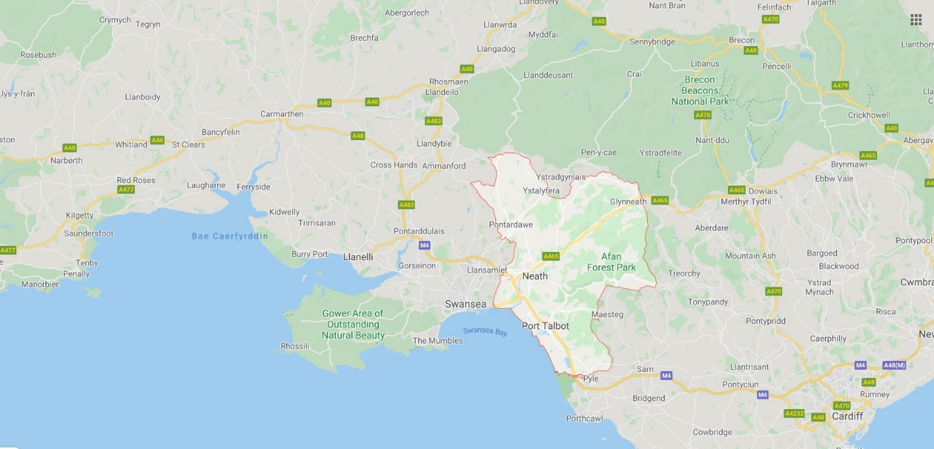
Figure 2 Area outlined in red is Neath Port Talbot. Image from Google Maps
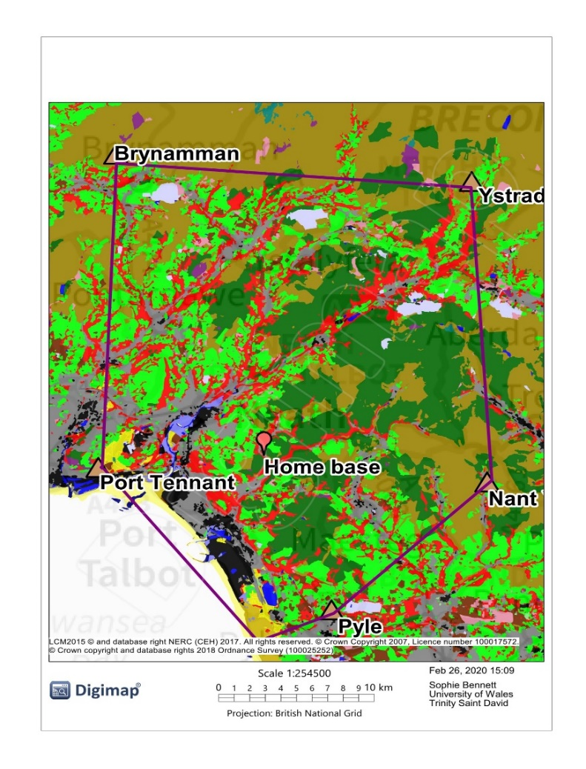
Figure 3 Habitat map of Neath Port Talbot area. Dark green for coniferous woodland, red for broadleaf woodland, brown represents acid grassland, light green for improved grassland, lilac for salt mash and dark yellow for bog. Image from Digimap, Edinbugh Univesity

Whilst agreement to access has not as yet been obtained to conduct this study on any land in the chosen area, there are a number of nature reserves, country parks and woodland in the area that could provide suitable test sites. To access the areas needed, the relevant organisations will need to be contacted. Organisations and groups consist of;
- Natural Resource Wales (NRW) who own a lot of the woodland in the Neath Port Talbot area as well as Afan Forest Park, where a big felling project due to infection by the Phytophthora ramorum fungus has been taking place over the last 7 years. The intention is to take the opportunity to use of areas that have not been re planted.
- TATA Steel, who are conducting research using trees for soil remediation. Initial cantact has been made face to face wit the environmental officer, email confirmation is being waited on.
- Neath Port Talbot Council, there a number of council owned parks in the area including Gnoll Park in Neath and Craig Gwadlys Country Park
- The Woodland Trust
- The Wildlife Trust of South and West Wales
- Llys Nini RSPCA Centre and woodlands
- Local Parish Councils, Miners Welfare Trusts, private landlords and owners

The woodland categories will the used to collect data; Upland; Lowland and Plantation on ancient woodland site (PAWS). This should allow for substantial data collection whilst keeping the research consistent and making it easier to get an overview without confusing the research with lots of varying yet similar data sets.

What data will to be collected?

Base line data
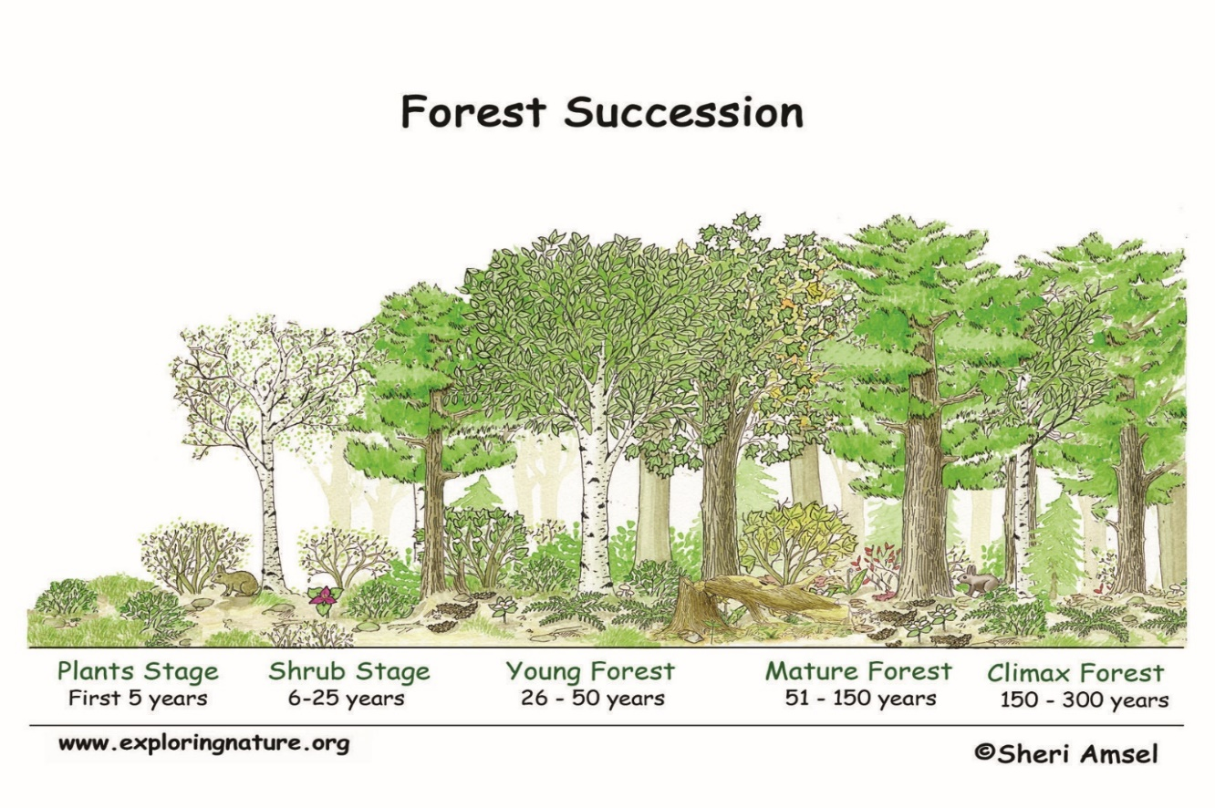
To set base line data, the woodlands chosen will need to be classified according to the NVC classification system (Hall, et al., 2004) along with the stages of succession present as depicted in figure 3.
Figure 4 Graphic showing the stages and vegetation type for forest Succession copyright Sheri Amsel, 19/02/2020
Once successional stage, as depicted in figure 3, is determined, the species, both flora and fauna present should also be catalogued. Table 1 shows a suggested collection form template.
- Species to be catalogued could include:
  - vascular plants, shrubs and trees
  - Fungi, insects and lichen
  - Small and large mammals
  - Birds
- The overall health of the woodland should also be noted,
  - canopy cover percentage
  - any management and how recent
  - who owns the woodland
  - woodland use
  - how often it is used
Table 1 possible data collection form for initial phase 1 habitat survey and species survey, form designed by the author

Experiment data
The seeds balls will be placed on the sites between October and February, with each site being split for baseline reference and testing. This will allow for collection and obtaining of seeds if being collected from local stock and in line with the growing and propagation variations for different British deciduous trees (Agate, 2002). As this research is looking to see if the seedball method can mimic natural regeneration, using a grid system as in figure 4 (Paulo, et al., 2018) would not be suitable. The proposal for this research is to randomly place the balls by throwing. Each placement will be marked with a marker suitable to the area used. If an area likely to be left undisturbed then a flag marker should suffice. Following natural growing time initially
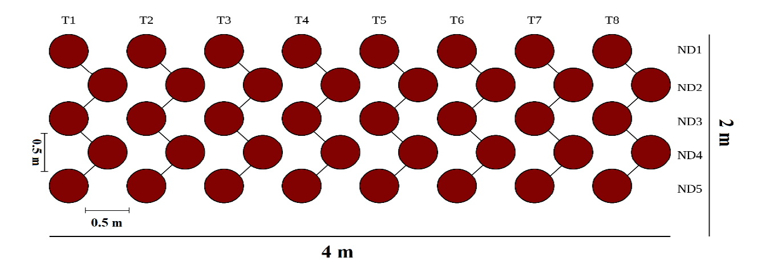
Figure 5 Field experiment design used by Paulo and Martins, 2018. Each red dot is a seed bomb, planted 0.5m interval in a 2m by 4m area of untilled forest T denotes the tree species and ND denotes the grouping for statistical analyses
Each site, both base line and test, will be surveyed at intervals. Once a month until the growing season, then weekly until the dormant season. Data collected will be;
- species present,
- if those species were included in the seed balls (for test sites)
- vigour of specimens
To give a comparison between natural growth and expected growth rates, there will be balls contain each species planted growing in a controlled environment either in a laboratory setting or in a green house at the authors home.

Literature Review
This proposal came about after reading the article “Natural Woodland Generation as an
Alternative to Tree-planting” by Aljos Farjon and Louise Hill in the April 2019 edition of British wildlife Journal. The article points out that whilst there is undeniably a need for reforestation in the UK, appeals for which can be dated as far back as John Evelyn 1665 (Farjon & Hill, 2019; Rackham, 2006; Agate, 2010; Welsh Government, 2015), the origin and provenance of the seeds or saplings used in reforestation is as important if not more so than the reforestation itself (Natural Resource Wales, 2017; Melo dos Santos, et al., 2018; Farjon & Hill, 2019). The organisations Plant Life, The joint Council for Landscape Industries (JCLI) and Natural Resource Wales recommends natural regeneration from the seed bank and vector sources such as bird droppings as the priority method of regeneration of woodland in the levels of origin suitability given by these organisations figure 3 shows the origin suitability table given by the plant life document “keeping the wild in wildflower”
Table 2 Plantlife reconmendations to the origin of seeds used to regenerate or plant a wildflower meadow
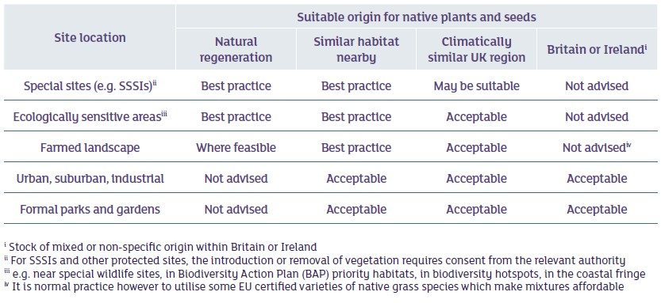
the following the observations made by Hill, Farjon and Rackham (2006) it is my conclusion that this suitability table should be used for the execution of seed ball construction for both flower and tree seeds. Whilst allowing natural regeneration is the preferred method it has been found that seed bank density can be poor in deforested areas (Mendes, et al., 2015; Melo dos Santos, et al., 2018). It is these deforested areas, that could benefit from this method. This has been shown, by a community project in Colorado USA (Clarkson, 2004). Treeball.co.uk are a company specialising in using seed balls containing Alnus glutinosa seeds. Alder is a nitrogen fixer and therefore can be used on poor soils to improve quality. Seed bombs are a cheap, time saving way to increase tree communities. (Davidson, 2020). Seed bombs Kenya has also had success in using seed balls to regenerate decertified land in Kenya, which give me confidence that even if there is no difference in planting whips and using seed balls to the biodiveristy, there will be a difference in speed, costs and stakeholder participation, thus increasing the perception of ownership and the connection to the environment.

Research Constraints
Through email correspondence with treebombs.co.uk founder Ben Davidson and personal knowledge, time will be the most prominent constraint as the time frame of this research is unlikely to allow anything more than seedling growth of the species in the seed balls (Bennett, 2020)
Restriction in the geographical area available for survey and the time frame for this research mean that the woodland types chosen may have to be limited and some variance will be seen. All literature read pertaining to seed ball propagation, natural regeneration (with the exception of farjon and Hill, 2019) and regeneration from seed bank has been based on research done in the dry forests of Brazil and Kenyan. There is anecdotal evidence from newspaper articles and reviews of work done by masanobu fukuoka in Japan that the seed ball method named by Masanobu Fukuoka as Nendo Dango has had good results, but as it cannot be verified through peer-reviewed research these claims must be seen as supposition.
As this research is about the ability of seed balls (also known as seed bombs and Nendo Dango) to mimic natural regeneration and generations from seed bank and vectors, using the zigzag grid method as used by Paolo and Martin’s ( (Paulo, et al., 2018) would be to systematic to produce a random effect.
However, the accuracy of identification of species surveyed would depend on the skill and knowledge of the surveyor. It may be possible to enlist the help of more knowledgeable volunteers from local community groups such as The Bryncoch Environmental group, but a level of knowledge would need to be ascertained prior to involvement.

References
Agate, E., 2002. Tree Planting and After Care: A Practical Handbook. s.l.:The Conservation Volunteers.
Agate, E., 2010. woodlands: A Practical Handbook. third ed. s.l.:BTCV.
Bennett, S., 2020. Treebombs - Effectivness of using tree seed bombs to regenerate woodland. s.l.:s.n.
Clarkson, L., 2004. The Seed Ball Project: Greening a charred landscape. Green Teacher, pp. 21-24.
Davidson, B., 2020. Tree bombs. [Online]
Available at: https://www.treebombs.co.uk
[Accessed 02 02 2020].
Farjon, A. & Hill, L., 2019. natural woodland generation as an alternative to treeplanting. British wildlife, pp. 177- 185.
Fiennes, P., 2017. Oak and Ash and Thorne. s.l.:Oneworld Publications.
Forestry Commission, 2018. Government supported new planting of trees in England, s.l.: Forestry commission.
Future Generations Commissioner for Wlaes, 2015. Well-being of Future Generations (Wales) Act. [Online]
Available at: https://futuregenerations.wales/about-us/future-generations-act/
[Accessed 28 02 2020].
Gov.uk, 2018. News. [Online]
Available at: https://www.gov.uk/government/news/new-northern-forest-gets-government-backing
[Accessed 28 02 2020].
Haigh, M. et al., 2019. Composted Municipal Green Waste Enhances Tree Success in Opencast Coal Land Reclamation. Air, Soil and Water Research, Volume 12, pp. 1-10.
Hall, J., Kirby, K. & Whitbread, A., 2004. National Vegetation Classification: Field guide to woodland, s.l.: JNCC (Joint Nature Conservation Committee.
Harvey, F., 2019. The Guardian Environment. [Online]
Available at: https://www.theguardian.com/environment/2019/jun/13/tree-planting-in-england-falls-72-short-of-government-target
[Accessed 28 02 2020].
Hickman, L., 2010. The Guardian. [Online]
Available at: https://www.theguardian.com/environment/2010/oct/29/forest-sell-off-government
[Accessed 23 02 2020].
Independent Panel on Forestry, 2012. Final Report, s.l.: DEFRA.
Melo dos Santos, D., Andrade da Silva, K., Fraga dos Santos, J. M. F. & Lima Araujo, E. d., 2018. soil seed bank and its importance in the natural regeneration of degraded areas. Ethenobiology and Conservation, 7(5).
Mendes, L. B. et al., 2015. what happens to the soil seed bank 17 years after clearcutting and vegetation?. International Journal of Tropical Biology, 63(two), pp. 321-332.
Natural Resource Wales, 2017. Forest Resilience Guide 3: Managing the genetic diversity of Welsh woodlands, s.l.: Natural Resource Wales.
O'Sullivan, F., 2018. City Lab. [Online]
Available at: https://www.citylab.com/environment/2018/01/northern-forest-united-kingdom/550025/
[Accessed 28 02 2020].
Paulo, R. L., Zararize, D. G. & Martins, I., 2018. Applying the Nendo Dango Teechnique for Germination and Pre-Establishmnet of Native species on deforested Areas. Agriculture & Forestry, 64(2), pp. 33 - 42.
Rackham, O., 2006. woodlands. s.l.:Collins.
RSPB, n.d. Woodlands. [Online]
Available at: https://www.rspb.org.uk/fun-and-learning/for-kids/facts-about-nature/facts-about-habitats/woodlands/
[Accessed 23 02 2020].
Watt, N. & Vidal, J., 2010. the Guardian. [Online]
Available at: https://www.theguardian.com/environment/2011/feb/16/forests-sell-off-cameron-uturn
[Accessed 23 02 2020].
Welsh Government, 2015. Woodlands For Wales Action Plan, s.l.: Welsh Government.
Wildlife Trust of South & West Wales, n.d. Melincwrt Falls. [Online]
Available at: https://www.welshwildlife.org/nature-reserve/melincwrt-waterfalls-resolven-neath-port-talbot/
[Accessed 23 02 2020].

