

Strategic Management Report
An Evaluation of the Strategic Position of Tesco Finest Belgian Chocolate in the UK Grocery Retail Market
Prepared for the Board of Directors
Programme: Master of Business Administration
Module: Strategic Management
Module Code: LCMB7003

Lecturer: Amare Desta & Ghulam Mujtaba
Name: Md Naeem Rezwan
ID: 2122417

Table of Contents
Section 1: Report 3
1. Introduction 3
2. Organisational Context and Overview 3
3. External and Internal Analysis 6
PESTEL Analysis 6
VRIO Analysis 9
SWOT Analysis 11
4. Comprehensive and Holistic View of the Organisation 14
Corporate Social Responsibility Strategy 14
The Balanced Scorecard 15
5. Strategic Choices and Implementation 18
Cost Leadership, Differentiation, and Combined Approach 18
Porter's Five Forces Framework 19
Ansoff's Matrix 20
Potential Challenges in Implementation and Propose Solutions 21
Section 2: Reflective Account 22
References 25

Section 1: Report

1. Introduction
This report is a strategic analysis of Tesco Finest Belgian Chocolate, the high-quality own brand product of Tesco PLC in the UK grocery retailing market. Tesco PLC was chosen as it is the largest grocery store in the UK with over 100 years of trading history. The assignment is to analyse one product in one market, thus the flagship of Tesco's premium brand, Tesco Finest Belgian Chocolate was selected because it has been a key factor in Tesco's growth and differentiation strategy. Analysis is confined to the UK market only, and does not include the Irish or Central European markets due to differing markets and competition. The report is written in the perspective of a strategic management consultant and it reviews Tesco Finest Belgian Chocolate external and internal environment in terms of PESTEL, VRIO and SWOT frameworks. It also delves into the corporate social responsibility and the Balanced Scorecard for the brand and suggests strategic recommendations for Tesco Finest Belgian Chocolate, followed by a reflective account.

Figure: Tesco Finest Belgian Chocolate Belgian Chocolate; Source: (Tesco.com, 2026)

2. Organisational Context and Overview
Jack Cohen started selling surplus groceries from a London (Tesco PLC, 2025) market stall in 1919 to found Tesco (Tesco PLC, 2025). The business prospered throughout the twentieth century and evolved when self-service supermarkets and own brand ranges and out of town superstores became increasingly popular. As of today, Tesco runs 4,572 stores in the UK and the Republic of Ireland and can claim to have more than 340,000 colleagues working in its stores (Tesco PLC, 2025). It continues to be the largest grocery store in Britain, and trades on the London Stock Exchange.
This report is about Tesco Finest Belgian Chocolate. It was introduced in March 1998 in 200 stores across the UK, as the country's first supermarket premium own brand and was designed in conjunction with the involvement of supermarket chefs such as Anton Mosimann, Anton Edelmann, Nick Nairn and Brian Turner (The Grocer, 2025). It is the top of the three-level own brand strategy followed by Tesco. The range has grown from some 130 products to over 1,000 stock keeping units fresh products account for about 80 per cent of the sales (The Grocer, 2025). Total sales from its businesses now exceed £2 billion, every year (The Grocer, 2025).
Tesco's vision is to make ‘a little bit better every day' (Tesco PLC, 2025) for customers, communities and the planet. It strives to be the "most trusted" shop in terms of value, quality and service. The mission is around the convenience, affordability and choice; the long-term vision is around connection of commercial growth and responsible sourcing and healthier eating. This purpose is the basis for product ranges and community investments decisions, and also for pricing. This purpose is best expressed in “Tesco Finest Belgian Chocolate”, which aims to offer an easy point-of-entry for value-mindful shoppers to restaurant-grade meals without having to venture further out of their comfort zone to find them.
Tesco has a multi format retail business, with Tesco Extra, Superstore and Metro and Express stores, and supplemented by online grocery delivery and click and collect. The Clubcard loyalty programme helps to collect personal data and allows Tesco to offer customised pricing, making it a key element in Tesco's strategy (Turner and Wilson, 2006). Booker is currently in its bank division, having sold the same to Barclays (Tesco PLC, 2025), but it still has a presence in the wholesale and catering segment, where it offers insurance and money services. The company has a target to expand its convenience store network to open approximately 150 outlets in the next 3 years, generating approximately 2000 jobs, as there has been an increase in the demand for more frequent and smaller shopping trips (Tesco PLC, 2025).
Tesco is a major player in the supermarkets market in the UK which has been a fiercely competitive industry with Sainsbury's, Asda, Morrisons, Aldi, Lidl, Co-op, Waitrose and Iceland. Together, Aldi and Lidl generate nearly 19% of the market, which is forcing traditional supermarket chains to step up the game (Danielle, 2025). However, Tesco continues to hold the top spot with almost one in three of all grocery spending in the UK in 2025 due to their size and distribution network as well as the loyalty of their customers (Danielle, 2025).
Tesco Finest Belgian Chocolate is not a competitor to the broad retail food marketplace. It is a direct competitor to the high-quality own brand ranges of other supermarkets: Sainsbury's Taste the Difference, Morrisons The Best, Asda Extra Special, Aldi Specially Selected and the branded premium supermarket lines of Marks and Spencers and Waitrose, with its Waitrose No.1 range introduced in part to counteract the competition from Tesco Finest Belgian Chocolate (The Grocer, 2025). Within the grocery market, this is a smaller and less price sensitive competitive set than the broader grocery market and it is this product set that the subsequent analysis will examine.
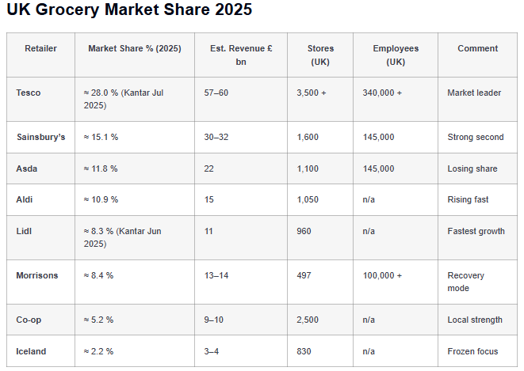
Figure: UK Grocery Market Share; Source: (Danielle, 2025)

3. External and Internal Analysis

PESTEL Analysis
PESTEL analysis can help to determine the external factors influencing Tesco's decision-making process (Regner et al., 2020).
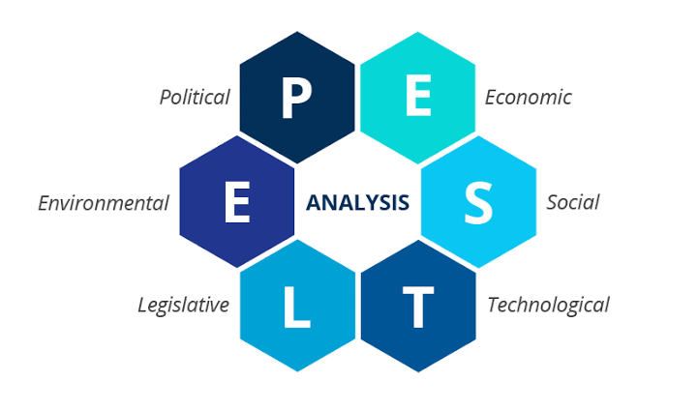
Figure: PESTEL Analysis; Source: (Ormston, 2025)
Political factors
Employment costs have risen due to government policies that have implemented higher wages, which have also increased compliance costs for new government regulations on placing and promoting foods high in fat, salt and sugar (Tesco PLC, 2025; Danielle, 2025). However, Brexit remains to have an impact on the price and supply of imports from the EU. These changes will cost Tesco, but they are more easily adapted to than by the smaller competitors. High fat, high salt and high sugar placement rules are crucial for Tesco Finest Belgian Chocolate, with a significant portion of the range being classified as these categories, including desserts, chocolate and wine, meaning that care must be taken to ensure store placement and promotional planning does not result in non-compliance whilst still achieving sales.
Economic factors
The food price inflation has been higher than the wage inflation, which has grown the demand for discount retailers like Aldi and Lidl (Competition and Markets Authority, 2024). Tesco has replied with Aldi Price Match and Clubcard Prices, which means it has remained the lowest cost supermarket to shop from for more than two years (Tesco PLC, 2025). The continued pressure on margins due to rising energy, labour and logistics costs is being offset by a Save to Invest programme, which enabled Tesco to generate savings of around £510m and maintain lower prices (Tesco PLC, 2025). The same conditions have a bi-fold impact on Tesco Finest Belgian Chocolate in particular. The high cost of living has also driven many consumers to eat at home, weighing on Tesco Finest Belgian Chocolate margins, but the price press on grocery has also resulted in many consumers cutting back on restaurant meals and favouring home cooking, boosting the sales growth for Tesco Finest Belgian Chocolate.
Social factors
Customers are becoming more demanding, craving convenience, healthier fare, and high-quality food. For example, around 60% of Tesco UK sales are of healthier products and Tesco Finest Belgian Chocolate sales increased by 15% over a 12-month period (Tesco PLC, 2025). The smaller household size and ageing population are also driving a need for increased frequency of shopping trips and smaller pack sizes. The social trend most closely related to this report is premiumisation – this is the range of products which reflect this trend. Despite the fact that many consumers are cutting back on their daily spending, the 15 per cent annual increase in Tesco Finest Belgian Chocolate sales illustrates that a significant proportion of expenditure is going to restaurant style and occasion driven food, and Tesco Finest Belgian Chocolate is well placed to benefit from this change.
Technological factors
Tesco is taking the plunge into automation, robotics and AI in its distribution and Clubcard programme. Clubcard Challenges also utilises predictive analytics to tailor offers for individual customers, while micro fulfilment centres help increase the efficiency of online delivery (Tesco PLC, 2025). But, to keep up with the changing technology, it's important to invest in them on a continuous basis (Danielle, 2025). For Clubcard Challenges, Tesco Finest Belgian Chocolate can leverage predictive analytics to target shoppers who have a proven track record of premium buying and tailor their offers to those individuals, ensuring they are offered products from the Tesco Finest Belgian Chocolate range as opposed to a competitor price; for app based personalisation, the same is true, as the correct offer for the right consumer can be made at a relevant time, therefore increasing basket value and repeat purchase of the range.
Environmental factors
Tesco is committed to being net zero by 2035 and net zero across its value chain by 2050 (Tesco PLC, 2025). The opportunities for packaging reforms and reducing food waste come with an associated compliance cost. Environmental sourcing standards are particularly evident in Tesco Finest Belgian Chocolate, as many of the lines already have higher welfare, RSPCA Assured or sustainably sourced seafood credentials as part of the quality positioning of the range, making changes to environmental regulation more a continuation of current sourcing practice rather than an additional cost.
Legal factors
There are more compliance requirements from data protection, consumer protection and employment laws. Additionally, Tesco's expansion via acquisition is hindered by competition law (Competition and Markets Authority, 2024). The area of trading standards and food labelling law is particularly relevant to Tesco Finest Belgian Chocolate because the range relies heavily on provenance and quality claims including named regions, breeds/chef development and misinformation would have disproportionate reputational and legal consequences when compared to the size of the range.

VRIO Analysis
The VRIO model looks at the capability and resources of the firm whether they can give Tesco sustained competitive advantage (Barney, 2000).
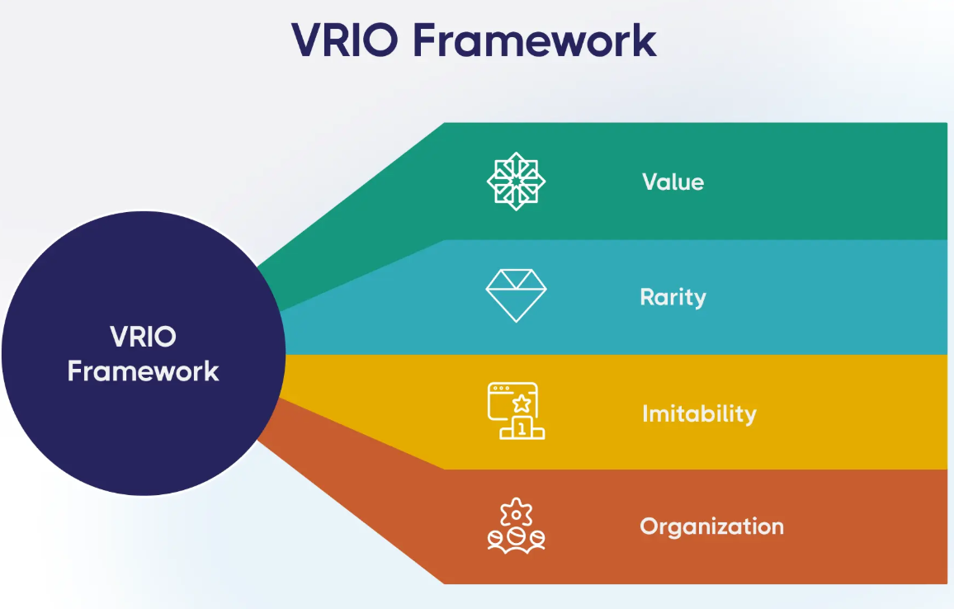
Figure: VRIO Framework; Source: (Messineo, 2026)
Value
Value is if a resource gives Tesco Finest Belgian Chocolate an opportunity or helps it to handle a threat. The Tesco Finest Belgian Chocolate brand itself is a valuable asset, as it has been around for 25 years and enjoys the quality of association with the Tesco brand that enables the retailer to command premium prices whilst still trading on the trust established with the broader Tesco brand. Clubcard data is also used to value-add by informing Tesco of those shoppers who are already purchasing the high-quality branded food products at other stores for which they can be targeted with Tesco Finest Belgian Chocolate offers (Turner and Wilson, 2006). But Tesco's purchasing power, and the fact that it has close ties with chefs and suppliers, also contribute value as it allows Tesco Finest Belgian Chocolate to be developed and produced at a lower unit cost than a completely independent premium brand would achieve.
Rarity
Rarity asks if there is a comparable resource among the few competitors. A premium tier is not unusual as every major UK supermarket now offers their own premium tier. Tesco Finest Belgian Chocolate's comparative rarity is its mix of first mover status (it's the UK's first supermarket premium own brand, launched in 1998), its size of more than one thousand SKUs and sales of over two billion pounds a year (The Grocer, 2025). There are plenty of rivals, including Sainsbury's Taste the Difference and Waitrose No.1, but no one else combines the scale, breadth of range and history that this does.
Imitability
Imitability is a question of how easily a resource can be replicated. One premium product can be reproduced easily and often is – rival ‘own brand’ ranges are often imitating Tesco Finest Belgian Chocolate products during a season. What's more difficult to copy is the relationship that Tesco has created with chefs and specialist suppliers over two decades to develop the recipes, and the trust of customers that have been gained over the years, not a new launched range. Another way in which it is difficult for other businesses to replicate Tesco's supply chain, particularly Booker, which is Tesco's wholesale arm, is that they have established good long-term relationships with their suppliers that ensure that they are able to consistently provide the best quality product in large quantities (Tesco PLC, 2025).
Organisation
Tesco is highly structured to maximise the value of Tesco Finest Belgian Chocolate, with dedicated product development and range management, and a Media and Insight Platform which uses Clubcard information to target premium shoppers (The Grocer, 2025). Relaunches on a regular basis show Tesco's desire to keep the brand relevant.
The Tesco Finest Belgian Chocolate brand and packaging is useful but not unique as competing premium ranges are also marketed with the same branding as the Tesco Finest Belgian Chocolate. Therefore, Tesco's competitive advantage is more reliant on resources which are hard to imitate such as the strong relationship with their suppliers, their expertise in developing recipes and the customer data (Peteraf and Barney, 2003).

SWOT Analysis
The external and internal findings are combined into a single view: a SWOT analysis (Regner et al., 2020).

Figure: SWOT Analysis Source: (jenslin, 2024)
Strengths
Tesco Finest Belgian Chocolate's asset is the size and heritage of its business in the UK grocery sector, accounting for nearly 28% of the grocery expenditure in the UK (Danielle, 2025). Tesco's Clubcard loyalty data has been used to identify the best benefits for the club card owner, Tesco's national distribution network has been utilised to ensure that products are always on offer and Tesco's more than one thousand stock keeping units with sales of over two billion pounds a year (The Grocer, 2025). Fifteen per cent annual sales growth in the range also indicates real commercial momentum for Tesco Finest Belgian Chocolate as well as Tesco's overall financial performance as their adjusted operating profit rose by nearly 11% in the prior financial year, 2025 (Tesco PLC, 2025).
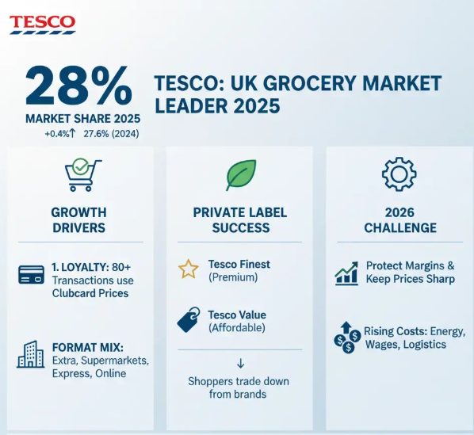
Figure: TESCO UK Grocery Market Share; Source: (Danielle, 2025)
Weaknesses
Tesco Finest Belgian Chocolate's key areas of weakness are cost exposure and visual differentiation. Standard margins are thinner for Tesco Finest Belgian Chocolate than the range's absolute margin given that premium ingredients are more labour & energy expensive to produce and fresh, chef developed food is more energy expensive to produce than the standard food. The fact that the range is marketed on trust and provenance more than any other part of the Tesco offer means that wider Tesco failures to meet sustainability targets, such as halving operational food waste by the end of 2025, which was only partially achieved, and a gap in internal auditing of food waste data (CSR Reporters 2026), also carry reputational risk to Tesco Finest Belgian Chocolate.
Opportunities
Opportunities for Tesco Finest Belgian Chocolate can be seen in the roughly 150 new Express convenience stores that are planned over the next 3 years as a curated Tesco Finest Belgian Chocolate offering could have a beneficial impact on generating greater basket value for the smaller format convenience stores, as seen in Tesco PLC (2025). Retail media based on Clubcard data can be used to create supplier financed revenue in particular at Tesco Finest Belgian Chocolate promotions and premium shelf positioning. The increased consumer interest in health, plant-based eating and provenance also provides opportunities to expand Tesco Finest Belgian Chocolate into this sector, supported by the existing plant-based Tesco Finest Belgian Chocolate lines. Wholesale growth through Booker provides an alternative avenue to premium catering customers, building margin over retail price competition.
Threats
The biggest danger for Tesco Finest Belgian Chocolate is not from the discounters, as they offer a better value for money but from the other already established premium ranges. Sainsbury's Taste the Difference, Waitrose No.1 and Marks and Spencer are all competing with each other for the same high spend segment, and Sainsbury's have also improved their offering of loyalty with Nectar Prices, making it closer to Tesco overall (Danielle, 2025). Other risks unique to Tesco Finest Belgian Chocolate are the growing cost of premium ingredients compared to the general cost of ingredients, new regulation on the promotion of indulgent high fat, salt or sugar products comprising part of the range, and the reputational risk should such claims of provenance or quality ever be challenged.
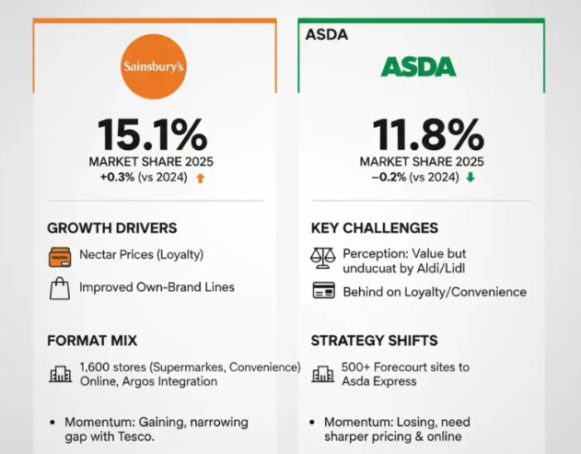
Figure: UK Market Share of Sainsbury's and ASDA; Source: (Danielle, 2025)

4. Comprehensive and Holistic View of the Organisation

Corporate Social Responsibility Strategy
Tesco's corporate social responsibility (CSR) strategy is implemented through its strategy on sustainable sourcing, store operation, transport and healthy diet and waste reduction (Tesco PLC, 2025). This aligns with stakeholder theory which states that creating value for the stakeholders of the business (the customers, employees, suppliers, communities and the environment) is more important than creating value for the shareholders (Freeman, 1994). It also fits into Carroll's (1991) CSR framework which incorporates economic, legal, ethical and philanthropic obligations into the day-to-day operations of business. This is where a lens of ‘ethical sourcing' claims, such as ‘higher animal welfare' and ‘sustainable seafood,' are most apparent to the consumer and so most directly linked to commercial trust in the range, as is the case with Tesco Finest Belgian Chocolate.
In an economical context, Tesco's price led strategy and Save to Invest programme makes it more affordable and still profitable (Tesco PLC, 2025). Under a law, Tesco is meeting packaging and food safety and reporting requirements and was the first UK retailer to voluntarily report on food waste data (Tesco PLC, 2025). Ethically, it has cut emissions of Scope 1 and 2 by approximately 65% and established science-based emission goals. Tesco PLC has helped schools through the Stronger Starts programme and with its partnership with FareShare and OLIO, the equivalent of over 60 million meals has been redistributed (Tesco PLC, 2025).
Many of the lines in Tesco Finest Belgian Chocolate have higher welfare credentials, including RSPCA Assured meat and free-range eggs; sustainably sourced seafood with a Marine Stewardship Council (MSC) certification; and Fairtrade certified wine and coffee products. These standards are applied as part of Tesco Finest Belgian Chocolate's quality marketing, which is not only Tesco's CSR commitment as a compliance exercise for Tesco Finest Belgian Chocolate, but as a reason for the premium value that the range offers to the customer.
However, Tesco has not yet met their CSR goals. It failed to meet its 2025 target of halving operational food waste because of problems with reporting, and the progress made with renewable electricity has not been as rapid as planned (CSR Reporters, 2026). In general, the CSR approach is well positioned with regard to Tesco's business goals, with the need for better execution, supplier oversight, and sustainability reporting to enhance performance and accountability. The gaps are more important for Tesco Finest Belgian Chocolate than for the rest of the business as customers are willing to pay a premium based on the standards that Tesco Finest Belgian Chocolate brings, so if the sourcing or waste targets are not met it could lead to a loss of that trust for the range than for the normal lines.

The Balanced Scorecard
To connect Tesco's strategy to the way the performance is measured, the balanced score card (Kaplan and Norton, 2005) provides a structured approach to doing this by relating the strategy to each of four perspectives as outlined below.
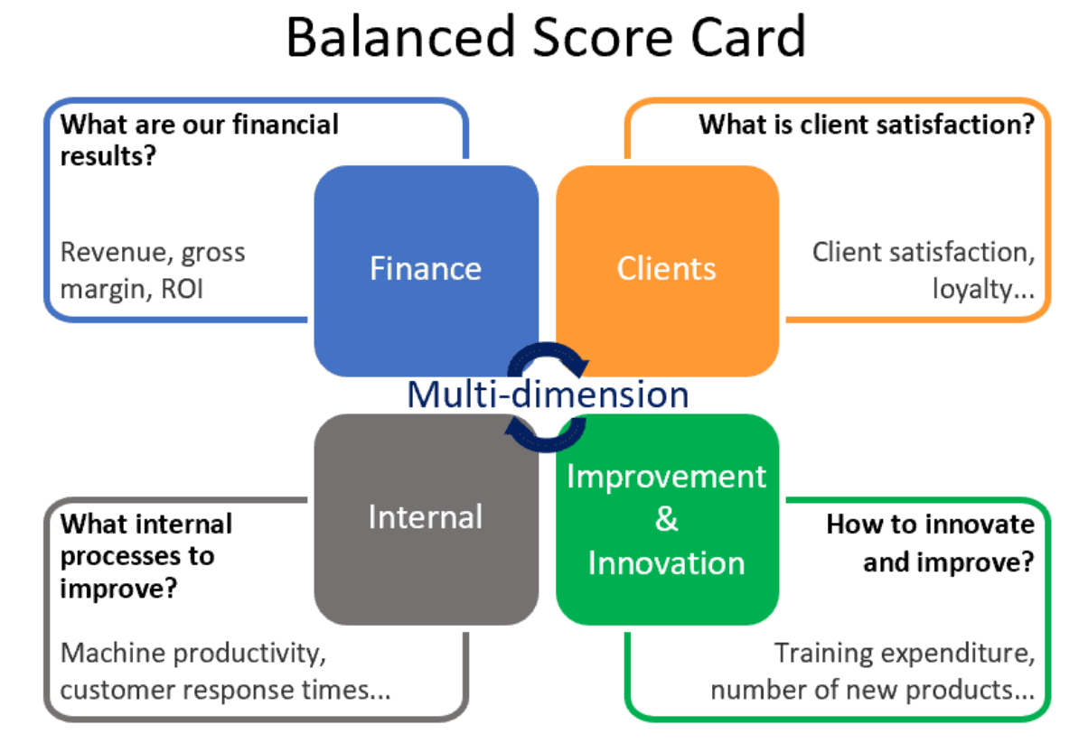
Figure: The Balanced Scorecard; Source: (Wevalgo, 2026)
Financial perspective
Tesco Finest Belgian Chocolate's financial outlook is based on growth of the range and margin protection – not Tesco's overall profitability. The objective relevant is to maintain Tesco Finest Belgian Chocolate sales at a level higher than the grocery market and to ensure the margin premium that the range offers against this market. The most obvious sign is that of the company's own sales growth, which has risen by 15 per cent over the last year good, but not enough to beat Tesco's group adjusted operating profit growth which was nearly 11 per cent (Tesco PLC, 2025). A realistic goal is to continue to grow Tesco Finest Belgian Chocolate's sales in double digits while keeping ingredient inflation below that, for example through the expanded Save to Invest scheme at Tesco, where the funds released can be used to invest in premium products.
Customer perspective
The customer perspective for Tesco Finest Belgian Chocolate is more about the belief in quality claims, and repeat purchasing rather than value alone. The goal is for Tesco Finest Belgian Chocolate to continue to be the UK grocery's trusted premium own brand range. There are also a number of relevant indicators such as Tesco Finest Belgian Chocolate specific repeat purchase and the proportion of Clubcard users who purchase Tesco Finest Belgian Chocolate regularly, along with overall Clubcard uptake, which is around 23 million UK households (Turner and Wilson, 2006). Growth in the number of Tesco Finest Belgian Chocolate buyers is a realistic target, with initiatives targeting premium buyers like Clubcard Challenges, and Tesco Finest Belgian Chocolate branded promotions via the Tesco app, which has approximately sixteen million users and provides a direct route for personalised Tesco Finest Belgian Chocolate recommendations.
Internal business process perspective
For Tesco Finest Belgian Chocolate, the internal business process perspective relates to the reliability of the supply chain which is more complex and developed by the chef. Maintaining consistent quality and availability of Tesco Finest Belgian Chocolate lines, which are often more specialist and seasonal than regular lines. Key performance indicators that are relevant are supplier quality audit scores and Tesco Finest Belgian Chocolate specific stock availability rates. One objective may be to keep core Tesco Finest Belgian Chocolate lines available even at busy times of the year, like Christmas, while making investments in cold chain facilities like the Aylesford chilled distribution centre appropriate for much of the Tesco Finest Belgian Chocolate range, which is fresh and chilled in nature (Tesco PLC, 2025). The reduction of waste of higher cost Tesco Finest Belgian Chocolate ingredients would also be in keeping with this view as both quality and cost control would be more prominent for the premium range than for the standard lines.
Learning and growth perspective
The learning and growth perspective for Tesco Finest Belgian Chocolate is to develop the expertise of colleagues in premium food and relationships with chefs and specialist suppliers. Key performance indicators are the retention of key suppliers and development chefs, completion of Tesco Finest Belgian Chocolate product training. Tesco plans to increase the amount of structured training in the stores; they have invested in technology and employ approximately 5,000 specialist technology staff (Tesco PLC, 2025). The Balanced Scorecard is generally effective at helping to achieve Tesco's quality and trust goals, but would benefit from a sourcing integrity perspective to enhance accountability for the claims of the Tesco Finest Belgian Chocolate brand (Kaplan and Norton, 1996).

5. Strategic Choices and Implementation

Cost Leadership, Differentiation, and Combined Approach
On the business level, Tesco has the option of adopting the low cost, differentiation and/or a mix of both business level strategies (Porter, 1980).
- Cost leadership is the most extreme form of competition, which targets low prices and close monitoring of costs, and is the strategy adopted by Aldi and Lidl the most.
- Differentiation is achieved by competing on quality, service or range breadth, as Waitrose and to a certain extent Marks and Spencer do.
- A hybrid approach combines the best of both, providing customers competitive pricing while providing points of quality and service that discounters can't replicate. In this hybrid strategy, Tesco Finest Belgian Chocolate is a product that differentiates Tesco. Tesco combines cost leadership and differentiation, but Tesco Finest Belgian Chocolate is not expected to be cost competitive. It's intended to provide Tesco with a viable differentiator offering, counterbalancing the likes of Waitrose and Marks and Spencer who are prepared to specialise, but not at the expense of Tesco's cost leadership on day-to-day lines.

Porter's Five Forces Framework
Tesco are in a position to take this combined strategy which is sometimes referred to as 'best value'. This is supported by Porter's five forces model (Porter, 2008).
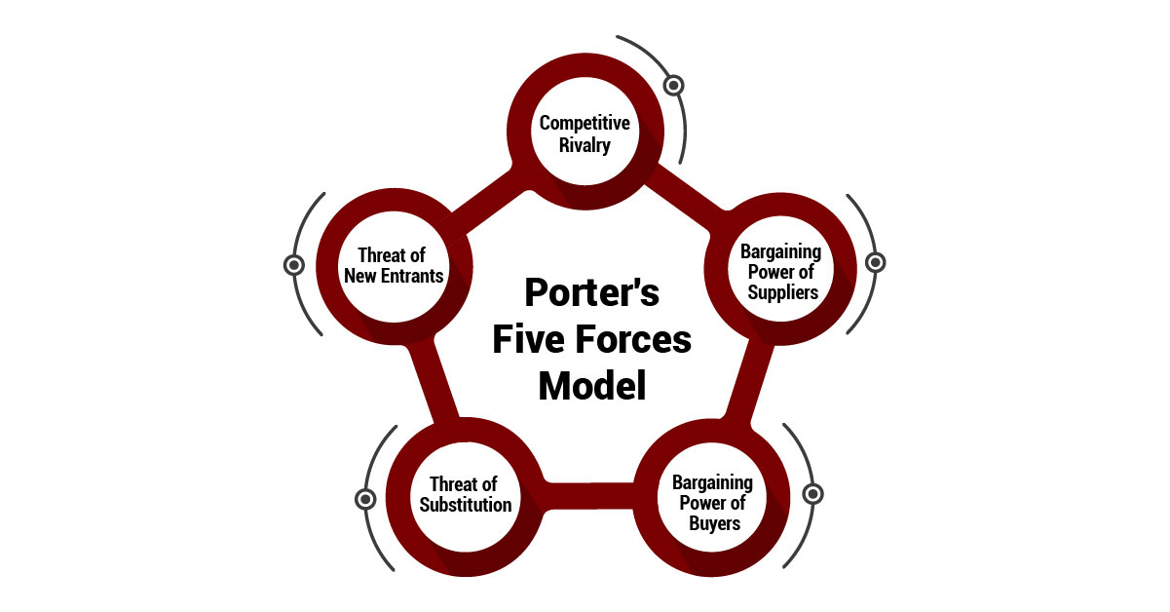
Figure: Porter's five forces; Source: Porter's five forces
- The premium segment is particularly competitive, because Tesco Finest Belgian Chocolate is only really competing against the other premium brands that might be Sainsbury's Taste the Difference, Waitrose No.1, Morrisons The Best, Asda Extra Special and Marks and Spencer – all vying for the same premium spenders, as opposed to the discounters who are not that big a threat in this segment anyway.
- Buyer's bargaining power is moderate in the case of Tesco Finest Belgian Chocolate. However, premium customers are not as price-sensitive as average customers – they are willing to pay more for good quality products – but can still opt for an alternative premium brand or for going out to eat and reduce the price Tesco can charge for the Tesco Finest Belgian Chocolate range without cannibalising volume.
- Suppliers have more power over Tesco Finest Belgian Chocolate than normal Tesco lines. Many Tesco Finest Belgian Chocolate products rely on specialist or artisan suppliers or named areas or individual chefs, providing the large-scale commodity producer, such as Tesco, with less negotiating power than the specialist suppliers.
- The level of new entrants to Tesco Finest Belgian Chocolate is particularly low. However, the only real contender would be an existing grocer in the UK who could expand its brand portfolio by offering a premium food brand, not a new competitor who would have to develop a network of stores and a successful premium food brand at the same time.
- The biggest threat to Tesco Finest Belgian Chocolate is the possibility of substitutes. The key strategic challenge for the range is to get customers to see that Tesco Finest Belgian Chocolate can provide similar levels of quality and service in the home as they do in restaurants, as there are several occasions led spending categories that Tesco Finest Belgian Chocolate is competing in: Restaurant meals, Premium meal kit services and high-end delivery apps.

Ansoff's Matrix
Ansoff's matrix supports this recommendation further (Ansoff, 1957).
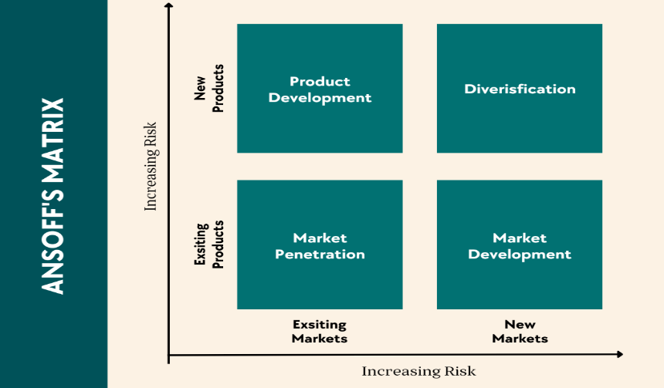
Figure: Ansoff’s Matrix; Source: (VanZandt, 2023)
- Market penetration for Tesco Finest Belgian Chocolate is an increase in the volume of the existing range by existing Tesco shoppers and involves identifying occasional Tesco Finest Belgian Chocolate buyers and promoting them with Tesco Finest Belgian Chocolate specific offers to encourage more frequent Clubcard ‘trade up'.
- Market development for Tesco Finest Belgian Chocolate involves making the range available to more shoppers via new distribution routes, in particular the delivery of a bespoke Tesco Finest Belgian Chocolate selection into the approximately 150 new Express stores that will be opening over the next three years, within stores that may not be visited by shoppers that go to a large Tesco Extra.
- Product development is the most obvious growth driver for Tesco Finest Belgian Chocolate, with fresh seasonal collections, an increased plant-based Tesco Finest Belgian Chocolate range and ongoing reformulation according to shifting tastes, a trend that has already seen the range grow since its relaunch in 2013.
- A diversification opportunity for Tesco Finest Belgian Chocolate may be broadening the brand out of the retail space, such as Tesco Finest Belgian Chocolate branded products into catering and food service through Booker, or Tesco Finest Belgian Chocolate branded non-food gifting ranges - a way for the brand to grow that is not purely reliant on Tesco store traffic.

Potential Challenges in Implementation and Propose Solutions
There are several challenges faced in implementing this recommendation for Tesco Finest Belgian Chocolate. Continued savings through the Save to Invest programme will offset investment in new product development but further input cost inflation may compromise the budgets for new product development (Tesco PLC, 2025). The challenge is also sustainability, with difficulties in food waste reporting and not reaching targets, which lead to reputational risk for a premium brand (CSR Reporters, 2026). Increased supplier data requirements and a higher level of accountability on the boards would enhance credibility. Lastly, a fast-expanding Tesco Finest Belgian Chocolate in excess of its convenience stores may not help its premium standing. Premium food product selection and colleague training in a premium food merchandising way would help in brand exclusivity and growth.

Section 2: Reflective Account
This section is a reflection on the process employed as a Gibbs reflective cycle (Gibbs, 1988, cited in Regner et al., 2020) was followed for researching, analysing and preparing Section 1. The cycle consists of the following steps: description, feelings, evaluation, analysis, conclusion and action plan.

Figure: Gibbs reflective cycle; Source: (McLeod, 2024)
Description
This task consisted of choosing an organisation, using strategic frameworks and writing a report for a board of directors. We selected Tesco due to the large amount of public reporting. I have analysed Tesco's sustainability and annual report, explored the UK grocery market and academia about PESTEL, VRIO and SWOT and Balanced Scorecard. Completed each section in a systematic fashion, tracked word count, checked citations and maintained a running reference list to keep on track with the accurate referencing. Following the initial feedback, I also had to rework the entire analysis to break down it down from Tesco as a business to Tesco Finest Belgian Chocolate as a product and therefore re-check each section to ensure that each of the frameworks were used for the range and not the business as a whole.
Feelings
Initially I felt confident as this is a well-known and established business, Tesco. This confidence waned somewhat as I started the internal analysis, as it wasn't as easy as I thought it would be to avoid only repeating strengths in applying the VRIO. It was easier to work through Porter's five forces and Ansoff's matrix, as these frameworks fit readily into the strategic decisions that Tesco is making. The CSR and balanced scorecard section caused some interest, some frustration because, as far as I can see, Tesco's own reporting is mostly positive, but in order to find independent commentary on the failures to meet targets, I went to greater lengths.
Evaluation
The approach that worked well was to begin with the annual report and sustainability report as the starting point, then expand out to journal articles and market commentaries. It provided a good factual foundation for the analysis. I did not do as well in drawing clear connections between these factors and strategic implications, and had an initial tendency to describe without evaluating, especially in the first draft of PESTEL that I submitted. A revision of this had to start by examining each factor and question what this meant for Tesco's decisions, rather than what it was.
Analysis
One of the key issues was to achieve a level of depth that was appropriate, but not too overwhelming, for the word count of the assignment. I did not include all PESTEL and SWOT factors as I did believe strategic frameworks were more about making informed judgement than checking off factors. (Regner et al., 2020) Finding sources that were independent, critical and not promotional company material was another difficulty, especially in the CSR section. This underscored the critical need to assess information with a critical perspective, and to search for information outside of a company's self-perception. Overall, the process enhanced my capacities of strategy analysis, evidence evaluation and clear recommendation in academic and practical environment. Further complicating this situation, however, was the need to reason the figures used through the product level analysis from partial disclosures, such as Tesco's "fifteen per cent growth in sales of Tesco Finest Belgian Chocolate" figure, instead of a breakdown of Tesco Finest Belgian Chocolate's revenue and margin.
Conclusion
Overall, the process helped me become more proficient in the capacity to switch from description to evaluation, and to choose the tool or tools that are relevant to the question being answered instead of using all the tools I can. I could have better managed time by preparing the internal analysis beforehand, as this took longer than the external analysis; and by spending more time on looking for independent commentaries on how Tesco is doing in sustainability, as opposed to relying on reporting from the company.
Action Plan
For future assignments, I will start an analytical part of the assignment such as VRIO and follow it with a more descriptive part of the assignment, which is usually the longer one. I will also incorporate a specific section in which I will find independent or critical sources early on in the process, not as an afterthought. I will also start each subsection with a draft of word count limits, rather than writing it down and then cutting at the end for word count, because this will tend to minimize the word count editing work at the end of each section and will help ensure that each section is focused on its major points.

References
Ansoff, H.I., (1957). Strategies for diversification. Harvard business review, 35(5), pp.113-124.
Barney, J.B., (2000). Firm resources and sustained competitive advantage.
Carroll, A.B., (1991). The pyramid of corporate social responsibility: Toward the moral management of organizational stakeholders. Business horizons, 34(4), pp.39-48.
Competition and Markets Authority (2024). Loyalty pricing in the groceries sector: findings report. Available at: https://assets.publishing.service.gov.uk/media/6749f2a7ebabe47136b3a2c0/_____Findings_report___2.pdf (Accessed: 12 July 2026).
CSR Reporters (2026). A closer look at the latest Tesco sustainability report. Available at: https://csrreporters.com/a-closer-look-at-the-latest-tesco-sustainability-report/ (Accessed: 10 July 2026).
Danielle, A. (2025). UK Grocery Market Share 2025 – Tesco Leads Again. [online] Grocery Trade News. Available at: https://www.grocerytradenews.com/uk-grocery-market-share-2025/ [Accessed 12 July 2026].
Freeman, R.E., (1994). The Politics of Stakeholder Theory: Some Future Directions, in “Business Ethics Quarterly”, 4 (4).
Grant, R.M., (2021). Contemporary strategy analysis. John Wiley & Sons.
‌Jenslin (2024). What is SWOT analysis and how to use it to improve your business (With examples). [online] Exeed College. Available at: https://exeedcollege.com/blog/what-is-swot-analysis-and-how-to-use-it-to-improve-your-business/ [Accessed 12 July 2026].
Kaplan, R.S. and Norton, D.P., (1996). Using the balanced scorecard as a strategic management system.
Kaplan, R.S. and Norton, D.P., (2005). The balanced scorecard: measures that drive performance (Vol. 70, pp. 71-79). Boston, MA, USA: Harvard Business Review.
McLeod, S.P. (2024). Gibbs Reflective Cycle. [online] Simply Psychology. Available at: https://www.simplypsychology.org/gibbs-reflective-cycle.html [Accessed 12 July 2026].
Messineo, R. (2026). VRIO Analysis: The Framework to Identify Competitive Advantages. [online] Clearpointstrategy.com. Available at: https://www.clearpointstrategy.com/blog/vrio-framework [Accessed 12 July 2026].
Ormston, A. (2025). PESTLE Analysis: A Guide to Understanding Market Influences. [online] B2B International. Available at: https://www.b2binternational.com/2025/04/03/pestle-analysis/ [Accessed 13 July 2026].
Peteraf, M.A. and Barney, J.B., (2003). Unraveling the resource‐based tangle. Managerial and decision economics, 24(4), pp.309-323.
Porter, M.E. and Strategy, C., (1980). Techniques for analyzing industries and competitors. Competitive Strategy. New York: Free, 1, p.76.
Porter, M.E., (2008). The five competitive forces that shape strategy. Harvard business review, 86(1), p.78.
Prahalad, C.K. and Hamel, G., (2009). The core competence of the corporation. In Knowledge and strategy (pp. 41-59). Routledge.
‌Regnér, P., Angwin, D., Johnson, G. and Scholes, K., (2020). Exploring Strategy: Text and Cases. Pearson Education.
Teece, D.J., Pisano, G. and Shuen, A., (1997). Dynamic capabilities and strategic management. Strategic management journal, 18(7), pp.509-533.
Tesco PLC (2025). Annual report and financial statements 2025. Available at: https://www.tescoplc.com/media/ky0bfwpo/tesco_ar25_interactive.pdf (Accessed: 11 July 2026).
Tesco PLC (2025). Sustainability report 2024 to 25: making a positive impact. Available at: https://www.tescoplc.com/media/wvkj1yic/tesco-sustainability-report-2025.pdf (Accessed: 15 July 2026).
Tesco.com. (2026). Tesco Finest Belgian Chocolate Ganache 400G. [online] Available at: https://www.tesco.com/shop/en-GB/products/306937443?srsltid=AfmBOorRlbkB-wHshAKorp9bEF8Q9Wi0OMi4JF2lYCTTWjwPVoRlgvUM [Accessed 2 Aug. 2026].
The Grocer (2025). How will Tesco Tesco Finest Belgian Chocolate reach £3bn in sales? [online] Available at: https://www.thegrocer.co.uk/comment-and-opinion/tescos-Tesco Finest Belgian Chocolate-hour-is-still-to-come-a-1bn-festive-blowout-could-occur/693417.article [Accessed 20 July 2026].
The Strategy Institute (2024). Porter’s Five Forces: The Ultimate Competitive Strategy Blueprint. [online] TSI_Insights. Available at: https://www.thestrategyinstitute.org/insights/porters-five-forces-the-ultimate-competitive-strategy-blueprint [Accessed 12 July 2026].
Turner, J.J. and Wilson, K., (2006). Grocery loyalty: Tesco Clubcard and its impact on loyalty. British Food Journal, 108(11), pp.958-964.
VanZandt, P. (2023). Analysis and Advantages of Ansoff Matrix. [online] IdeaScale. Available at: https://ideascale.com/blog/analysis-and-advantages-of-ansoff-matrix/ [Accessed 02 July 2026].
Wernerfelt, B., (1984). A resource‐based view of the firm. Strategic management journal, 5(2), pp.171-180.
‌Wevalgo (2026). Balanced Scorecard (BSC) approach: definition, limits and benefits. [online] wevalgo. Available at: https://www.wevalgo.com/know-how/operational-excellence/performance-management/balanced-scorecard [Accessed 20 July 2026].
‌

