
Student’s Name: Md. Shajal Mia
Student ID: 2437642
Module Name: Marketing Management
Module Code: LCMB7024
Lecturer's Name: Dr Laila Maazouz (London)
Poster: Marketing Strategy Pitch
Term 1

Table of Contents
1.0 Introduction of the Company 1
1.1 Concept Behind ‘The Fuel Pod’ 2
1.3 Segmentation 3
1.4 Target Market and Marketing Strategy 4
1.5 Differentiation and Positioning 5
2.0 Marketing Mix 5
2.1 Product 6
2.2 Price 6
2.3 Place 7
2.4 Promotion 7
2.5 People 8
2.6 Process 8
2.7 Physical Evidence 9
3.0 Poster 10
4.0 Reflection 10
References 13

1.0 Introduction of the Company
The Foundation of the Company
In 2012, Ben Francis founded Gymshark. It started off as a fitness apparel brand and was based in the United Kingdom. As the business expanded, it began to branch into several areas, including wellness events, training studios, and digital activations that support fitness beyond just apparel (Angela-Beevers and Angela-Beevers, 2024).

The Development of the Company
Gymshark’s rapid growth began in Instagram and has been escalated through TikTok influencers in recent years (House of Marketers, 2024). Its thoughtful marketing approach has enabled it to stand out in the athletic apparel industry amidst heavy competition (Zwayyed, 2025).

Growth and Strategies
Instead of going the traditional advertising way, it placed its reliance on influencer marketing. Studies reveal that influencer marketing has an immense impact on consumer mindset (Agrawal, 2025) which Gymshark realized from a very early stage. Customers often find influencers more trustworthy and reliable than brands due to an emotional connection with the audience which is a substantial instrument in driving the behaviour of consumers (Esther and Andrew, 2022). Hence, by investing in building relations with content creators on YouTube, Instagram, and later TikTok (Tribu Marketing, 2022), Gymshark has grabbed significant attention. Through creative alignment with popular fitness influencers, it was able to connect to its target audience consisting of young fitness enthusiasts in an authentic manner (Simicart, 2025). This makes it strategically reasonable for Gymshark to introduce a nutrition-focused brand extension named ‘The Fuel Pod’, which aligns with its core mission of supporting people on their fitness journey from multiple angles.

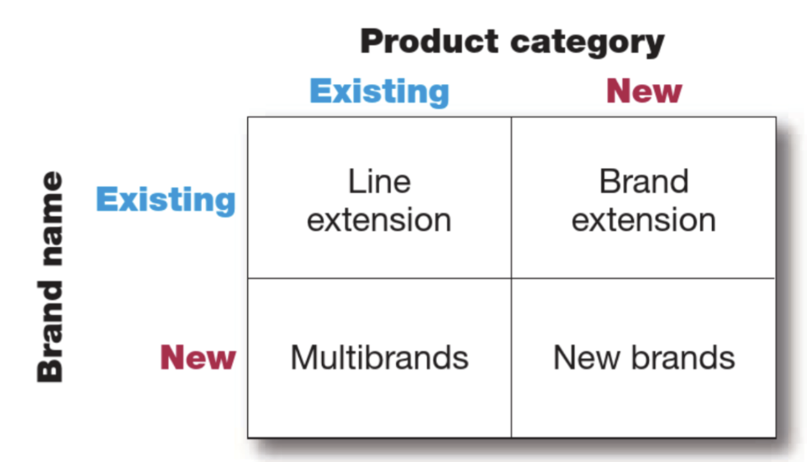
Figure 1: Brand Development

(Kotler et al., 2020)

1.1 Concept Behind ‘The Fuel Pod’
The Fuel Pod is a meal service that gives gym-goers and young adults quick, high-protein meals that are healthy and easy to eat on the go. One reason why this new brand would fit well with Gymshark is that its existing customers are already concerned about staying healthy. Moreover, while young people still consume a lot of traditional fast food, they are increasingly turning to meal-prep options (Grubox, 2025). They are not doing this as a replacement, but as a healthier balance between convenience and nutrition. This is supported by research that found that in recent years, a measurable increase was observed in the demand for convenient meal solutions and performance-oriented nutrition. It was most probably driven by the busy lifestyles of young people in addition to the wider consumer interest in health and fitness (Renub Research, 2025). This makes The Fuel Pod very attractive right now, as it offers convenience, good nutrition, and personalised meals. The process used in order to choose the brand and the product is inspired by the idea expressed in the image below

Figure 2: Product/Service Choice Criteria


(Hooley et al., 2020)

1.3 Segmentation
When defining key market segments, four areas are considered. These are geography, demographics, psychographics, and behaviour (Kotler et al., 2020).

Figure 3: Customer Segmentation Variable
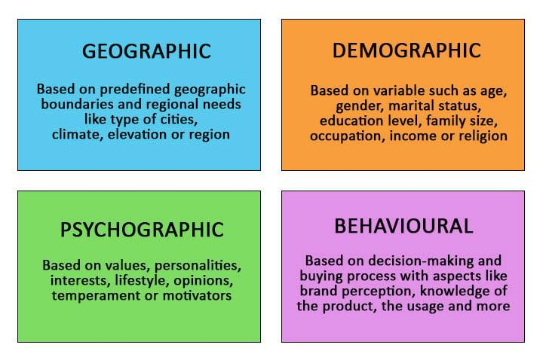
(Dubey, 2024)
The most realistic starting point for The Fuel Pod would be the United Kingdom itself since Gymshark is based in the UK and it already has a large customer base there. In the initially stage, it would make more practical sense if the focus is on major UK cities, like Manchester, Birmingham, and London. Moreover, these cities already have strong fitness communities and well-established delivery services (Midland Health, 2025) which will help accelerate the growth of The Fuel Pod.

When thinking demographically, the brand is most suitable for adults between the age of 18 to 35. This age group forms a large portion of Gymshark’s existing audience (Canvas Business Model, 2025). People in this age group are also generally more engaged with regular exercise, healthy routines, and convenience-based services. People in this age group are also expected to be busier and hence both men and women within this age category are major target customers.

Psychographic factors also play an important role as customers who would value The Fuel Pod would be the same ones who take their fitness seriously. These people would mostly be interested in maintaining a balanced lifestyle. Conversely, from a behavioural point of view, the target customers are generally people who already work out several times a week and prefer meals that are easy to prepare, clearly labelled, and predictable in quality. They often choose products from brands they trust and are okay with weekly or monthly subscriptions given that those subscriptions make their lives easier.

1.4 Target Market and Marketing Strategy
Given the specific characteristics of the chosen target audience, The Fuel Pod is best suited to a concentrated (niche) marketing strategy. Therefore, instead of trying to reach everyone who eats ready-made meals, the brand will be focused on a clearly defined group. Therefore, a niche strategy is to be taken. This will also ensure that The Fuel Pod can design its products, the pricing, and promotional strategies around the needs of this niche segment (Mukherjee and Mukherjee, 2025). Additionally, since Gymshark has already successfully built a strong reputation and has earned trust within this community, concentrating on this particular segment will increase the likelihood of strong brand acceptance, repeat purchases, and long-term loyalty (Mukherjee and Mukherjee, 2025b).

1.5 Differentiation and Positioning
The Fuel Pod is to be differentiated in three ways: nutrition, community, and curated options. Meals are to be portioned and macro-calculated for specific gym goals like bulking or cutting. It avoids the generic “one-size-fits-all” deal and instead offers goal-focused lines like Bulk, Cut, Plant, and Influencer Editions, supporting The Fuel Pod’s vision of becoming more of a performance-focused nutrition service over a regular meal delivery, ultimately positioning it as Gymshark’s “performance nutrition partner”. It is designed to provide active young adults with ready-to-eat meals. This positioning focuses on results, convenience, and trust, making it different from regular meal-delivery services.

2.0 Marketing Mix
In order to successfully launch The Fuel Pod, one important step is to carefully design the marketing mix. Since The Fuel Pod involves both product and service, its marketing mix shall include the 7Ps: Product, Price, Place, Promotion, People, Process, and Physical Evidence. These elements work together to show how the service will meet customer needs and stand out in the market (Barrington and Barrington, 2024).

Figure 4: Marketing Mix
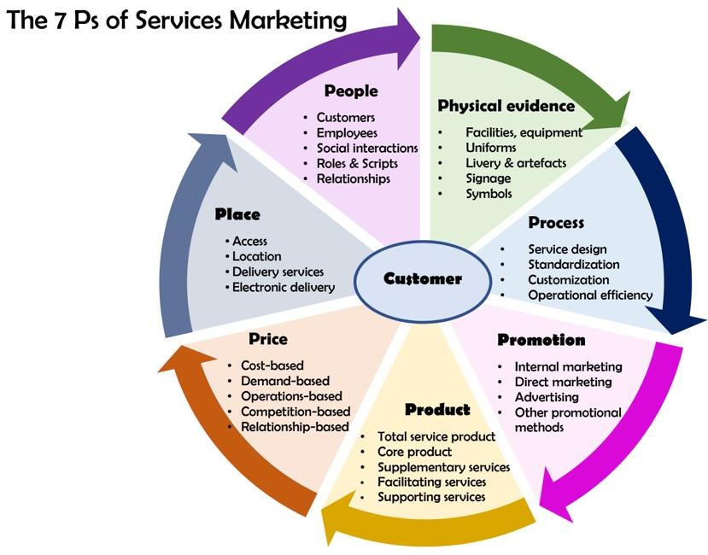

(Fiveable, 2025)
The following section portrays:
- How the product and service is designed
- How it is to be priced
- Where it is to be offered
- How it shall be promoted
- How the overall service experience will be delivered to customers.

2.1 Product
The Fuel Pod offers pre-cooked, high-protein meals. The product is designed for fitness-focused customers, for people who want quick and healthy food. All meals take under three minutes to heat, making it ideal for people who have super busy schedules. The brand is offering four meal lines to suit different goals:
- The first one is named ‘Bulk line’ which offers higher-calorie and high-protein meals for people who are desperately trying to gain muscle.
- The second one is ‘Cut line’, which offers lower-calorie meals intended to help with fat loss while still supporting muscle maintenance.
- The Third line is ‘Plant line’, this line is designed for vegan and vegetarian customers who demand plant-based meals that are still rich in protein.
- Lastly, the ‘Influencer Edition line’ includes meals that are specially designed with Gymshark athletes based on what they actually eat, making the offer more exciting and relatable.
All meals are to be portion-controlled and macro-calculated. They are made with fresh ingredients so that customers get consistent nutrition every week.

2.2 Price
The Fuel Pod will be offering a premium subscription model with three weekly plans, each costing £119, £139, and £159. The prices have been set in order to match other higher-end meal-prep brands in the UK with a confident expectation that customers who prioritize accurate macro tracking, along with convenience, freshness, and performance-focused nutrition will be willing to pay this price. The pricing is also expected to support Gymshark’s aspirational brand image and assist in attracting individuals who are motivated to invest in their fitness.

2.3 Place
Initial plans involve The Fuel Pod to be operating online. There will be a dedicated app and it will also be available on the Gymshark website. This way, the service can be accessible for customers from anywhere. Additionally, through this app, users can
- choose their meal plan
- set their weekly delivery schedule
- track their macros in one place
Hence, increasing convenience and ease.

Just to ensure a practical and successful launch, it has been decided that deliveries will first begin in major UK cities where Gymshark already has a strong community presence. Moreover, these cities also have reliable delivery networks which makes it easier to deliver pre-packed and refrigerated meals, requiring a dependable cold-chain system.

In addition, the app will also play an important role in helping customers monitor their fitness progress by showing them clear nutritional details for every meal. Although the service is designed to initially focus on the UK, the digital nature of the platform gives Gymshark the possibility to expand globally in the future. While physical stores are not a main priority for the brand, Gymshark pop-ups and community events can still act as useful touchpoints for sampling, demonstrations, and building customer familiarity with The Fuel Pod.

2.4 Promotion
Promotion of the brand will rely heavily on Gymshark’s strong and established marketing ecosystem, including influencers, athlete ambassadors, and social media storytelling. To create an impactful launch, Gymshark athletes can showcase Fuel Pod meals as part of their daily training routines, hence helping customers see the product used in real fitness settings. Moreover, the Influencer Edition meals add even more excitement because with each athlete promoting their own signature menu, attention from their followers will be naturally drawn.

To further build engagement, multiple community-based challenges shall be arranged, for example, “30-Day Fuel Challenge”, encouraging customers to track their progress using Fuel Pod meals. Additionally, first-week discounts will be offered and referral rewards can also be offered to help attract first-time users and drive early adoption.

2.5 People
The Fuel Pod’s success depends on a coordinated team of skilled nutritionists, chefs, packaging staff, delivery partners and customer service representatives, in addition to the influencers and users who promote the brand. How these people will be supporting The Fuel Pod’s success are discussed below:
- The nutritionists are to ensure that every meal meets the required macro standards while following proper health guidelines.
- The chefs are then to prepare the meals in a centralised kitchen before they move to the packaging team.
- Afterwards, the packaging team will handle all the labelling and will carry out intensive quality checks.
- Subsequently, customer service teams will be supporting users through the management of subscriptions. Other major responsibilities of the customer service team will include answering customers’ questions and solving their issues.
- The delivery drivers play a very crucial role in this process. Their duty is to make sure that the meals reach the customers fresh and on schedule.
- Beyond this, support from the community team of Gymshark will also be needed. The support includes online engagement and response to feedback. They will also be encouraged to support conversations about meals and fitness progress in different platforms to accelerate the reach of The Fuel Pod.

2.6 Process
The Fuel Pod plans to follow a very clear as well as efficient process. It is designed in such a way that makes healthy eating as simple as possible. The process starts with customers subscribing through the app, selecting their preferred meal line, and setting their delivery dates. Once the orders are placed, the meals are cooked, cooled, and carefully packed. Next, the meals are delivered to the customers each week on schedule. Other than that, every meal includes clear labels showing calories, macros, and ingredients, making tracking straightforward and reliable. Since each of the meals only requires three minutes of heating, customers do not need to cook or prepare anything. The app also includes a one-tap logging feature to help users track their meals alongside their fitness routines. Even if customers wish to change plans or cancel their subscription, the process is quick and easy, reducing frustration and improving overall satisfaction.

2.7 Physical Evidence
It is true that The Fuel Pod is mainly intended to operate online, however, physical evidence plays a very substantial role in building trust. So, meals are packaged in clean and minimalist Gymshark-style boxes that reflect the brand’s modern image. The package consists of clear labels with macros, ingredients, and short motivational messages that match Gymshark’s personality. Alongside the physical packaging, the digital experience also plays a vital role in strengthening trust. The app’s professionals design and organised layout is manufactured to provide reassurance to customers about the quality of the service. On top of that, social media posts from influencers and athlete contents are expected to act as external proof that real people use, enjoy, and support the meals.

3.0 Poster
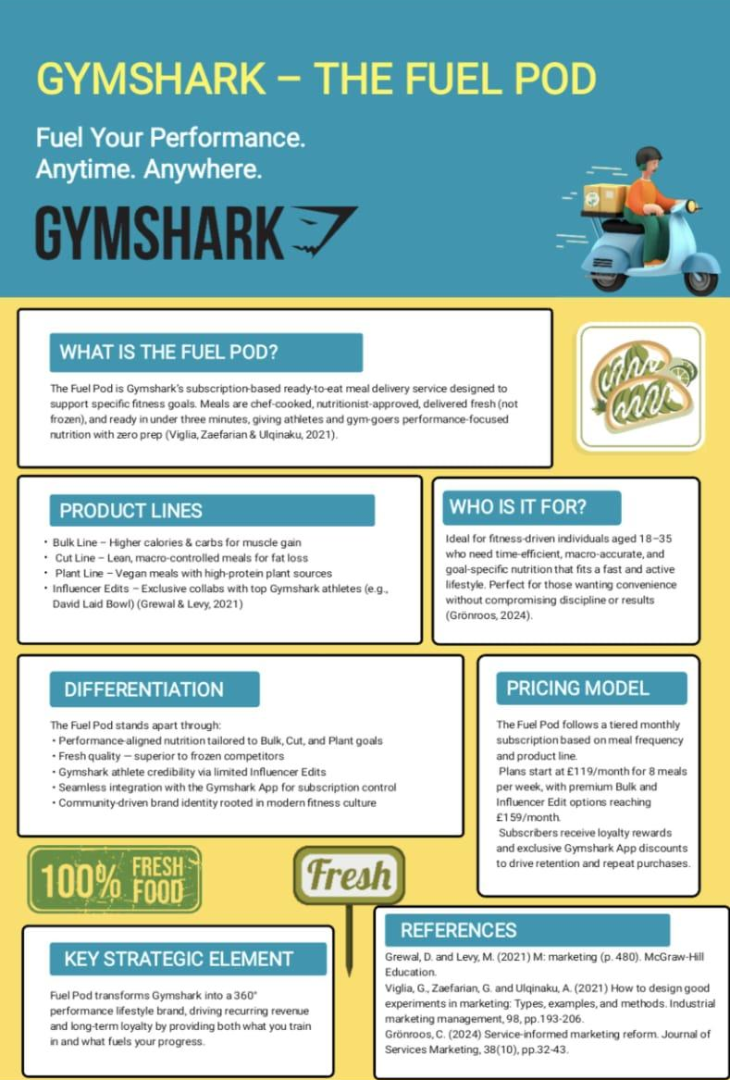

4.0 Reflection
Developing this new brand concept of The Fuel Pod has deepened my understanding of brand extension and marketing insights. Moreover, building a full marketing strategy around it has honestly been a super challenging yet a rewarding experience. At the initial stage, it was quite overwhelming to come up with strategies in order to turn a simple idea into something that could realistically fit Gymshark’s brand, audience, and values. However, with extensive research about the company and about the mindset of young fitness enthusiasts, the pieces started to connect and I realized how important it is for a brand extension to make sense both creatively and strategically. This is to ensure that the brand extension feels like a natural part of what the existing brand already stands for and not just a superficial attempt to build something irrelevant. This realization pushed me to look closely at market trends, consumer habits and the actual needs of people who lead a fast-paced, fitness-focused life.

When I was conducting my research on Gymshark, I found out how brand communities, athlete partnership and influencer content creation has built credibility and marketing leverage for the company. This inspired me to make influencer and ambassador-based promotions a central part of The Fuel Pod concept because this will enable the brand to benefit from the existing trust that Gymshark enjoys and the brand narratives can help reduce customer acquisition costs (Sanita and Sanita, 2025). As a result, there might be an increase in early adoption as the extension feels relevant to the audience.

When I looked from the perspective of STDP, my point of view shifted from vague ideas about ‘fitness customers’ to a much clearer picture of who the brand should actually target. I realized that choosing a segment rather than trying to target the whole population would be more efficient in terms of resource allocation, customer needs comprehension, and accurate stratification. Therefore, the brand extension is designed to attract young and active adults who have a busy schedule but wish to prioritise their health as well. A thorough understanding of this specific group made it easier to shape the product and its pricing in such a way that would complement the brand’s lifestyle.

When I proceeded with the preparation of the marketing strategy, I got to learn how each element of the marketing mix support and complement each other. It was a lot more insightful and deeper when applied to real cases than in theory. Acknowledging limitations and coming up with logical explanations when crafting the strategies have been an exhilarating experience. The whole process made me more aware of how strategic decisions must be practical, evidence-based, and customer-focused. One of the biggest skills I improved was learning to simplify complex ideas and present them clearly while still keeping everything consistent with the brand identity.

Preparing and delivering the pitch was yet another learning curve. I realised that having a solid idea is not enough, the way you communicate it matters just as much. The more I practised the pitch, the better I became at structuring information, keeping the flow smooth, and highlighting the most persuasive points. This helps me ensure that the audience will not be overwhelmed with unnecessary details. It also taught me how to stay calm, adapt my explanations when needed, and maintain engagement. Looking back, I think I could improve by adding more visuals, practising my timing more carefully, and making my tone even more confident.

In summary, this project helped me combine research, creativity, critical thinking, and communication skills. It also showed me how important it is to understand the customer deeply before designing anything. In future projects, I want to push myself to explore even more data, compare competitor strategies more thoroughly, and practise pitching more often so I can present ideas with stronger clarity and impact.

References
Agrawal, S. (2025) The impact of social media influencers on consumer behaviour: Trends, opportunities, and challenges. International Scientific Journal of Engineering and Management. [Online] Vol.04 (01), pp.1–8. Available: https://doi.org/10.55041/isjem02230.
Angela-Beevers and Angela-Beevers (2024) Gymshark unveils bold expansion plans for 2024 | Retail Bulletin [Online]. Retail Bulletin | Daily UK Retail News. Available: https://www.theretailbulletin.com/sports-and-leisure/gymshark-unveils-bold-expansion-plans-for-2024-23-02-2024/.
Barrington, R. and Barrington, R. (2024) Understanding the 7Ps of the marketing mix [Online]. Oxford College of Marketing Blog. Available: https://blog.oxfordcollegeofmarketing.com/2020/10/08/understanding-the-7ps-of-the-marketing-mix/.
Dubey, H. (2024) Market Segmentation Strategies [Online]. EDUCBA. Available: https://www.educba.com/market-segmentation-strategies/.
Canvas Business Model (2025) What are Gymshark’s customer demographics and target market? [Online]. Available: https://canvasbusinessmodel.com/blogs/target-market/gymshark-target-market?srsltid=AfmBOorJ0LLFDecb6prbEcW9PGAgbtz8uCLmcIRNDoLUghry3OlmbcQt.
Esther, D. and Andrew, J. (2022) The Role of Social Media Influencers in Shaping Consumer Buying Behavior in Digital Markets.
Fiveable (2025) Service Marketing Strategies [Online]. Fiveable. Available: https://fiveable.me/fundamentals-marketing/unit-5/service-marketing-strategies/study-guide/gOKMR0UwsMiaNqA1.
Grubox (2025) Why millennials and Gen Z prefer healthy meal subscriptions over traditional dining. grubox-smart-vending. [Online]. Available: https://www.grubox.in/post/why-millennials-and-gen-z-prefer-healthy-meal-subscriptions-over-traditional-dining#:~:text=This%20generation%20demands%20more%20than,making%20it%20easier%20than%20ever.
Hooley, G., Nicoulaud, B., Rudd, J. and Lee, N. (2020) Marketing Strategy and Competitive Positioning, 7th Edition. Pearson UK.
House of Marketers (2024) Gymshark’s Success Story: Growing with Influencers [Online]. House of Marketers. Available: https://houseofmarketers.com/how-gymshark-grew-a-100m-business-in-7-years-with-influencers/.
Midland Health (2025) The UK’s most Fitness-Obsessed cities revealed in a new study [Online]. Midland Health. Available: https://midlandhealth.co.uk/2025/01/08/health-obsessed-cities/.
Kotler, P., Armstrong, G., Harris, L. C. and He, H. (2020) Principles of marketing. Pearson UK.
Mukherjee, S. and Mukherjee, S. (2025) Concentrated Marketing: Know your target audience. CleverTap - All-in-One Customer Engagement Platform. [Online]. Available: https://clevertap.com/blog/concentratedmarketing/#:~:text=Although%20the%20company%20focuses%20on%20a%20smaller,businesses%2C%20promising%20profitability%20and%20optimizing%20marketing%20resources.
Mukherjee, S. and Mukherjee, S. (2025b) Concentrated Marketing: Know your target audience. CleverTap - All-in-One Customer Engagement Platform. [Online].Available: https://clevertap.com/blog/concentratedmarketing/#:~:text=Although%20the%20company%20focuses%20on%20a%20smaller,businesses%2C%20promising%20profitability%20and%20optimizing%20marketing%20resources.
Renub Research (2025) Convenience Food Market Size, Trends & Forecast 2025–2033 | Renub Research [Online]. Available: https://www.renub.com/convenience-food-marketp.php#:~:text=Convenience%20Food%20Market%20Size%20and%20Forecast%202025%2D2033,Country%20and%20Company%202025%2D2033.
Sanita, M. and Sanita, M. (2025) How storytelling shapes brand identity and how it gained attention in recent years - Departement of Communications. Departement of Communications - Fakultas Psikologi Sosial dan Budaya. [Online]. Available: https://communication.uii.ac.id/how-storytelling-shapes-brand-identity-and-how-it-gained-attention-in-recent years/#:~:text=Through%20compelling%20storylines%2C%20brand%20storytelling%20has%20emerged,that%20only%20highlight%20facts%20and%20product%20attributes.
Simicart (2025) Decoding Gymshark Marketing Strategy: A Comprehensive analysis. SimiCart Blog | Empowering Ecommerce Growth with Mobile Solutions since 2011. [Online]. Available: https://simicart.com/blog/gymshark-marketing-strategy/.
Tribu Marketing (2022) The Marketing Strategy that Lead to Gymshark's Success | Tribu. Tribu Marketing. [Online]. Available: https://www.wearetribu.com/blog/how-gymshark-became-a-titan-in-the-fitness-apparel-industry-marketing-strategy.
Zwayyed, Z. (2025) Gymshark’s Marketing Strategy: a case study in digital innovation and community building [Online]. Research Gate. Available: https://www.researchgate.net/publication/390535155_A_Case_Study_in_Digital_Innovation_and_Community_Building_Gymshark's_Marketing_Strategy_A_Case_Study_in_Digital_Innovation_and_Community_Building.

