Student Name | Abbie preston
Student Number | 2516463
Module No: | BMSK4015
Module Title : | Academic and Research skills
Contents
Introduction 2
Employee 3
Advantages 3
Disadvantages 3
Workplace example and Recommendations 4
Management 4
Managers perspective of advantages: 4
The disadvantages: 5
Recommendations for managers 6
The company 6
Advantages of remote management for the company 6
Disadvantages of remote management for the company 7
Recommendations and workplace for the company 8
Conclusion 8
Reflection using model GIBBS 10
Description 10
Feelings 10
Evaluation 10
Analysis 10
Conclusion 10
Action plan 10

References 11

Introduction
Remote management refers to the process of overseeing and leading a team of employees who are not physically present in the same location as their manager. Instead of working together within the office setting teams is used a virtual tool and along with other platforms to be able to stay connected. This approach increases flexibility for employees and reduces the overhead costs of maintaining a physical office space. (Rigo,2026)
Remote management will be a different experience for employees, the employer and the company. From the employee’s perspective remote management directly impacts wellbeing motivation and productivity. The perspective of the employer will be different because they will rely on the guidance and training from their management.
If management practices ignore these realities employees may feel disengaged, burnt out or over monitor which can reduce the performance
Finally, the company will experience remote management by using tools online with a greater communication. Apps such as video calls, shared documents and chat apps. Employees will work from different locations from one another whilst staying connected using the interment, this will then help the company to stay organized and to continue running smoothly whilst people are not at the same office.
Theres a lot of things that go into being a good boss, you need to be able to manage your team effectively by setting clear goals and giving clear instructions with regular updates. The manager will talk with employees through phone calls, video chats and messages. They will keep check of the teams work progress and answer any questions to help solve any type of problems that may arise or occur whilst the managers role is to correctly guide the team and make sure everyone thoroughly understands their tasks they have been set whilst working in different places it should help them all work well together (Jackings,2026)
In this assignment report I will be discussing the advantages and disadvantages of remote management from an employees, managers and companies’ perspective. I will be providing workplace examples and recommendations.

Employee

Advantages
Remote working has become more common in many organisations and offers several advantages for employees. One key benefit is flexibility, as employees can often choose when and where they work. This helps them manage their time more effectively and balance work with personal responsibilities. As a result, employees can spend more time with their families and maintain a better work–life balance (Eurofound.(2020). This shows that flexible working arrangements can improve employees’ overall well-being and satisfaction.
Another important advantage of remote working is the removal of daily commuting. Travelling to work can take a significant amount of time and cost money. By working remotely, employees can save both time and transportation expenses. This can also reduce stress and make employees feel more positive about their jobs Welz,C.,& Wolf, F.(2010). Therefore, eliminating commuting can lead to improved job satisfaction and better use of time.
Remote working can also increase productivity for some employees. Many people find it easier to concentrate at home due to fewer workplace distractions. Employees can also create a comfortable workspace that suits their needs, which can help them work more efficiently. This suggests that a personalised environment can support better performance.

Disadvantages
However, remote working also has disadvantages for employees. One major issue is social isolation, as employees do not interact with colleagues regularly. This can make them feel lonely and less connected to their team (Grant,C.A.,Wallace,L.M.,& Spurgeon,P.C.(2013) As a result, reduced social interaction can negatively affect teamwork and morale.
Another disadvantage is the difficulty of separating work from personal life. Employees may find it hard to stop working at the end of the day and may work longer hours. This can lead to stress and reduce work–life balance (Eurofound & International Labour Office, 2017). Therefore, remote working can sometimes increase pressure on employees.
In addition, communication can be more difficult in remote working. Employees mainly use emails or online meetings, which can lead to misunderstandings or delays (Wojewoda. (2023). This indicates that lack of face-to-face communication can affect clarity and teamwork.
Finally, employees may face distractions at home and have fewer opportunities for career growth. Household noise or responsibilities can reduce focus, and being away from the workplace may limit networking opportunities. Overall, while remote working offers flexibility and convenience, it also presents challenges that can affect employees’ experience.

Workplace example and Recommendations

Employees who work remotely should follow several recommendations to work effectively and maintain good performance. First, employees should create a clear work schedule. Setting regular working hours helps employees stay organised and separate work from personal life. Time management is important because remote work can sometimes lead to longer working hours or distractions (Advisory, Conciliation and Arbitration Service (ACAS) (n.d.)
Second, employees should maintain regular communication with their managers and team members. This can include attending online meetings, responding to messages on time, and updating managers about work progress. Good communication helps avoid misunderstandings and keeps the team connected.
Employees should also create a suitable workspace at home. A quiet and comfortable workspace can help employees focus better and improve productivity. It is also important to reduce distractions such as television, noise, or other household interruptions.
For example, an employee working as a customer service representative from home may need to answer customer emails and phone calls during specific hours. If the employee sets a daily schedule, checks emails regularly, and attends online team meetings, they can provide better service to customers and stay connected with their manager.
Another recommendation is to take regular breaks and manage stress. Remote workers should take short breaks during the day to maintain concentration and protect their well-being (Eurofound & International Labour Office, 2017).
Overall, employees can improve their remote working experience by managing their time well, communicating regularly with their team, creating a productive workspace, and taking care of their well-being.

Management

Managers perspective of advantages:
Managers need to make proper arrangements for remote working to ensure employees can work effectively from home. One key arrangement is providing the right technology and tools, such as laptops, secure internet, and communication platforms. These tools allow employees to stay connected and complete their work efficiently (Association for Information Systems (AIS) (n.d.). This shows that having suitable technology is essential for successful remote working.
Another important arrangement is clear communication. Managers should clearly explain tasks, deadlines, and working hours so employees understand what is expected of them. Regular online meetings and check-ins can help managers track progress and offer support when needed. This helps employees feel more connected to their team, even when working remotely (Hibbert, 2024). Active communication plays a key role in maintaining teamwork and productivity.
Managers should also focus on building trust and supporting employees. Remote working requires managers to trust employees to complete their work without constant supervision. At the same time, managers should provide guidance and feedback to keep employees motivated. This suggests that trust and support can improve employee performance and confidence.
In addition, organisations should provide training and support for remote working. Employees may need help learning how to use digital tools, manage their time, and communicate online. This can improve their skills and reduce potential problems (Eurofound & International Labour Office, 2017). Overall, proper arrangements can help remote working run smoothly and improve employee outcomes.

The disadvantages:
However, remote working also creates challenges for managers. One major disadvantage is the difficulty in monitoring employee performance. Managers cannot directly observe employees, which can make it harder to ensure tasks are completed on time (Rigo,2026). This shows that remote working can reduce managerial control.
Another issue is communication challenges. Managers rely on emails and online meetings, which can lead to misunderstandings or delays (Allen et al., 2015). As a result, communication may be less effective compared to face-to-face interaction.
Remote working can also make it harder to build strong team relationships. Without regular in-person contact, team bonding and collaboration may decrease. This indicates that remote work can affect team culture and engagement.
In addition, managers may face technology-related problems. Issues such as poor internet or system failures can disrupt work and reduce productivity (Teamly. (n.d.). Finally, managers may find it difficult to support employee well-being, as it is harder to notice signs of stress or workload pressure remotely. Overall, although remote working offers benefits, it also presents several challenges for managers.

Recommendations for managers
Effective management is important for maintaining productivity, communication, and employee satisfaction, especially in a remote working environment. There are several recommendations that can help managers lead teams successfully.
First, managers should maintain clear and regular communication with their team members. In a remote workplace, employees may sometimes feel isolated, so managers should schedule regular virtual meetings, provide updates, and encourage open discussions. This helps ensure that everyone understands their responsibilities and feels connected to the team.
Second, managers should set clear goals and expectations. Employees need to understand what tasks they are responsible for and the deadlines they must meet. Clear instructions and realistic targets help employees stay organised and manage their time effectively while working remotely.
Another important recommendation is to use digital tools and technology effectively. Communication platforms, video meetings, and shared documents make collaboration easier and help managers monitor progress without needing to be physically present in the office.
For example, in a customer service company where employees work remotely, a manager might hold a short online meeting every morning to discuss daily tasks and answer questions. The team can also use a shared system to track customer requests and update the progress of their work. This ensures everyone stays informed and work is completed on time.
Finally, managers should trust their employees and support their wellbeing. Encouraging work-life balance and recognising good performance can increase motivation and productivity.
By improving communication, setting clear expectations, and using technology effectively, managers can successfully manage remote teams and maintain a productive workplace.

The company

Advantages of remote management for the company
Remote working can provide several advantages for companies. One major benefit is cost savings. Companies can reduce expenses related to office space, electricity, office equipment, and other workplace costs when employees work from home. This can help organisations save a significant amount of money (Bloom et al., 2015).
Another advantage is increased productivity. Many employees work more efficiently in a remote environment because they experience fewer workplace distractions and can manage their time more effectively. Research has shown that remote working can improve employee performance and productivity in some organisations (Bloom et al., 2015).
Remote working also allows companies to access a wider talent pool. Organisations are not limited to hiring employees who live near the office. They can recruit skilled workers from different cities or even different countries. This helps companies find the best talent and improve overall business performance (Allen et al., 2015).
In addition, remote working can improve employee satisfaction and retention. Employees often value flexibility and better work–life balance. When employees are satisfied with their working conditions, they are more likely to stay with the company for a longer time (Eurofound & International Labour Office, 2017).
Finally, remote working can help organisations continue operating during unexpected events, such as natural disasters or health crises. Remote systems allow employees to continue working even when offices are closed.
Overall, remote working can benefit companies through cost savings, higher productivity, access to global talent, and improved employee satisfaction.

Disadvantages of remote management for the company
Remote working can also create some disadvantages for companies. One major disadvantage is difficulty in managing employees. When employees work from home, managers cannot directly supervise their work. This can make it harder to monitor productivity and ensure that tasks are completed on time (University of Scranton (2025)
Another disadvantage is communication problems. In a traditional office, employees can easily share ideas and solve problems through face-to-face conversations. However, remote working depends on online communication such as emails, messaging, and video calls. This can sometimes lead to misunderstandings, slower decision-making, and reduced teamwork (Leadership and Much More (n.d).
Remote working can also weaken company culture and teamwork. When employees are not physically present in the workplace, it may be more difficult for companies to build strong relationships among team members. This can reduce collaboration and employee engagement.
In addition, companies may face technology and security risks. Remote work relies heavily on digital systems and internet access. Technical problems, poor internet connections, or cybersecurity threats can interrupt business operations and affect company data security (Eurofound & International Labour Office, 2017).
Finally, companies may need to spend money on technology, training, and remote management systems to support employees working from home.
Overall, while remote working offers many benefits, companies may face challenges related to employee supervision, communication, teamwork, and technology management

Recommendations and workplace for the company

There are several recommendations a company can follow to improve remote working and ensure that employees remain productive and motivated.
First, the company should provide the right technology and equipment for employees working remotely. This includes reliable internet access, laptops, and communication software. Having the correct tools allows employees to complete their tasks efficiently and stay connected with their team.
Second, companies should encourage clear communication between managers and employees. Regular online meetings, emails, and messaging platforms can help staff stay informed about company goals, updates, and project progress. Good communication helps avoid misunderstandings and keeps everyone working towards the same objectives.
Another recommendation is to provide training and support for employees. Some staff may need guidance on using digital tools or managing their time while working from home. By offering training sessions and support, the company can help employees develop new skills and improve their performance.
Companies should also promote a healthy work-life balance. Encouraging employees to take breaks and avoid working excessive hours can improve wellbeing and reduce stress. When employees feel supported, they are more likely to stay motivated and productive.
Finally, companies should regularly review their remote working policies and ask employees for feedback. Listening to staff opinions can help the company identify problems and make improvements.
By providing proper technology, encouraging communication, offering training, supporting wellbeing, and reviewing policies, companies can create a successful and productive remote working environment.

Graph
The graph shows that chat tools are used the most (78%) because they help workers communicate. Project tools and remote access tools (65%) help organise work and allow IT staff to access computers remotely. Monitoring tools (50%) check work activity, while time tracking tools (28%) are used the least. Quantitative data is information shown with numbers. Qualitative data is information that describes qualities or opinions instead of numbers.
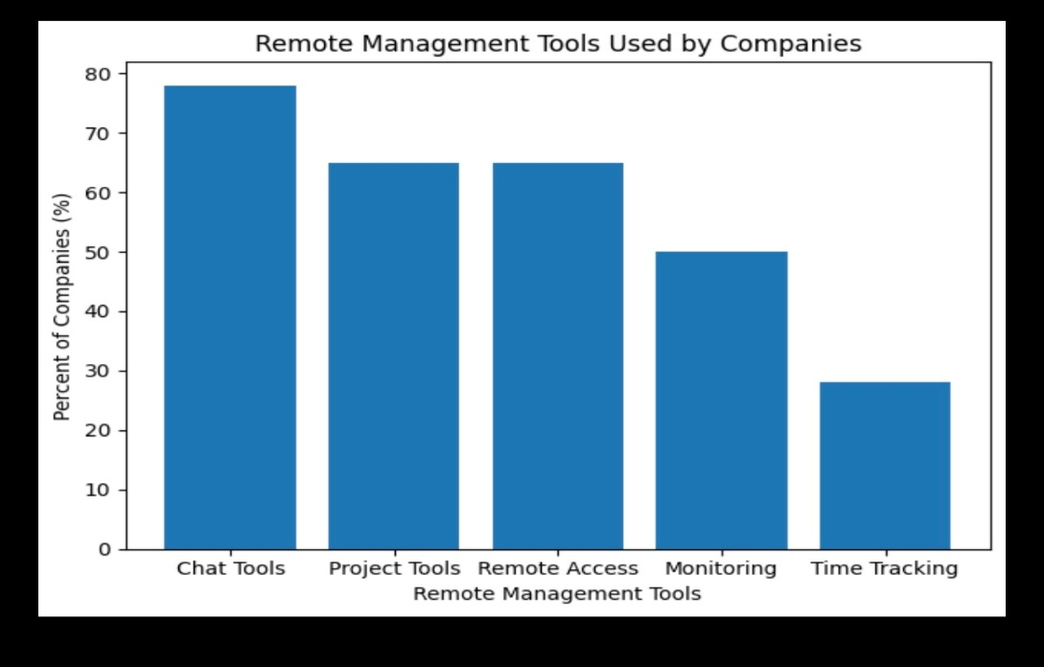

Conclusion
In conclusion, remote management is becoming very common in many organizations today. It means that managers and employees work from different places instead of the same office. With the help of technology like video calls, emails and online apps such as zoom so they can communicate closely with each other and work together.
One main advantage of remote management is flexibility. Employees can work from home or in another place which saves the travel time and reduces stress. Many employees feel more comfortable when they have flexible working hours. Companies can also save money because they may not need large office spaces and facilities.
However, remote management also has some challenges. Sometimes communication is not as easy as when people work face to face. Messages can be misunderstood and team members may feel less connected. Because of this, managers need to communicate clearly and have regular check ins. They should also set clear goals to meet any deadlines they need to.
Technology is important for remote management. Tools such as teams, zoom help share information and allow colleagues to continue working with each other. By using these tools managers are also able to keep track of each member of staff and their progress. They are also able to provide support via these platforms if need be.
Overall remote management is a useful way of working in these times along as good communication was to continue throughout, great technology and support from managers and the company. Remote management will likely grow in the future.

Reflection using model GIBBS

Description
In this assignment I investigated remote management and how it works through organisations. I wrote about the advantages and disadvantages in the point of view from the employees, managers and the organisation

Feelings
At first, I was unsure how to write about remote management but as I understood the assignment more and after researching the topic I felt more comfortable talking about my findings.

Evaluation
I feel like the assignment went well as I was able to understand the main points of remote management from the 3 points of view. I found out how important technology is to remote management as it helps keep all employees connected through different platforms.

Analysis
This assignment helped me understand that in today’s generation remote management is very important. It has showed me that having good communication and trust is necessary to successfully managing remotely.

Conclusion
I have learned how remote management works from employees, managers and organisations and how this is very successful.

Action plan
In the future I will improve my research and skills by reading more sources and practising on how to explain what I have found out to help me with other tasks.

References

Allen, T. D., Golden, T. D., & Shockley, K. M. (2015). How effective is telecommuting? Assessing the status of our scientific findings. Psychological Science in the Public Interest, 16(2), 40–68.
Advisory, Conciliation and Arbitration Service. (n.d.). Managing staff who work from home. https://www.acas.org.uk/managing-staff-who-work-from-home
Association for Information Systems. (n.d.). Article. https://ajis.aaisnet.org/index.php/ajis/article/view/362
Bentley, T. A., Teo, S. T. T., McLeod, L., Tan, F., Bosua, R., & Gloet, M. (2016). The role of organisational support in teleworker wellbeing: A socio-technical systems approach. Applied Ergonomics, 52, 207–215.
Bloom, N., Liang, J., Roberts, J., & Ying, Z. J. (2015). Does working from home work? Evidence from a Chinese experiment. The Quarterly Journal of Economics, 130(1), 165–218.
Calamari. (n.d.). Communication in remote work: 5 difficulties and how to overcome them. https://www.calamari.io/blog/communication-in-remote-work-5-difficulties-and-how-to-overcome-them
Eurofound. (2010). Telework in the European Union. Eurofound.
Eurofound. (2020). Living, working and COVID-19: First findings. Publications Office of the European Union.
Eurofound. (2017). Working anytime, anywhere: Effects on the world of work. https://www.eurofound.europa.eu/en/publications/all/working-anytime-anywhere-effects-world-work
Grant, C. A., Wallace, L. M., & Spurgeon, P. C. (2013). An exploration of the psychological factors affecting remote e-workers’ job effectiveness, well-being and work-life balance. Employee Relations, 35(5), 527–546.
Leadership and Much More. (n.d.). Managing remote teams. https://leadershipandmuchmore.com/managing-remote-teams/
Office for National Statistics. (2023). Characteristics of homeworkers, Great Britain. https://www.ons.gov.uk/employmentandlabourmarket/peopleinwork/employmentandemployeetypes/articles/characteristicsofhomeworkersgreatbritain/september2022tojanuary2023
Scranton University. (n.d.). Pros and cons of remote work. https://gradadmissions.scranton.edu/blog/articles/business/pros-and-cons-remote-work.shtml
Teamly. (n.d.). How managers can support employees. https://www.teamly.com/blog/how-can-managers-support-employees/
University of Birmingham. (2026). Remote working challenges linked to organisational capabilities, new study finds. https://www.birmingham.ac.uk/news/2026/remote-working-challenges-linked-to-organisational-capabilities-new-study-finds

