An Enquiry into the Perceptions and Attitudes of the Importance of Climate Change Education in the Context of Curriculum Design.

Stephen Hadley
1709675
ECEG7002Q
31st March 2023
Yr Athrofa: Education and Humanities
16,492 words

DECLARATION FORM


Name of the Programme of Study: MA EDUCATION - ECEG7002Q – DISSERTATION.

Name of Student (Capital Letters): STEPHEN HADLEY

DECLARATION

I certify that the whole of this work is the result of my individual effort, and that all sources have been acknowledged.

Signed Stephen Hadley (Student)

Date 30th March 2023

DECLARATION

I am satisfied that this work is the result of the student’s effort.

Signed  (Lecturer)

Date 30th March 2023

Abstract
The existential threat of climate change has dominated public discourse following a succession of extreme weather events and a growing awareness of projected changes to future global weather patterns. The current rate of climate change will lead to a transformation of future social and economic models. This in turn will demand changes to individual and collective behaviour, thus placing focus on preparing young people for this through school-based climate change education (CCE). Debate exists over the position of CCE in the school curriculum given the challenges facing future generations. This has led to discussion over which curriculum model could provide the best platform for the delivery of purposeful CCE as well as what content CCE should cover.
This study explores the perceptions and attitudes of CCE in the context of curriculum design. It engages with debates over the priorities in curriculum design and content and what is deemed to be ‘essential knowledge’. Furthermore, it examines how a school curriculum can deliver CCE more effectively in the future. In addition, it looks at the delivery of CCE within a curriculum, assessing the interdisciplinary, multidisciplinary, and disciplinary approaches in building awareness and understanding of climate change.
Two research methods were used for this study. Questionnaires investigated respondents’ experiences with CCE in the context of curriculum design. This determined the prior experience of the respondent and explored attitudes to CCE within the Curriculum for Wales. It also asked how a curriculum design can best facilitate awareness and understanding of climate change. The questionnaire used mixed methods to produce quantitative and qualitative responses. Questionnaires were offered to the full range of professionals within seven schools. In addition, four semi-structured interviews were conducted to elicit qualitative data from senior professionals in schools responsible for the decision making around curriculum design and content.
This enquiry was considered in the context of the new Curriculum for Wales. This has provoked focus on curriculum reform and discussion over what key knowledge, skills and understanding are important today and in the future. An additional context to note is the Well-being of Future Generations Act (2015) which places a legal responsibility on policy makers to improve the social, economic, environmental, and cultural well-being of Wales. No other country in the world has made this commitment.
Findings suggest there is a strong awareness of the importance of CCE and an appreciation of its overall importance in the school curriculum. Responses stated that CCE is addressed by all teachers in a range of settings within school. There was little resistance or complacency with the idea of further development of CCE. This is combined with a willingness to make progress in the development of CCE in schools. The context of education reform in Wales has contributed to a greater awareness of different curriculum designs. Links were made with progress in the implementation of the new curriculum with the evolution of CCE in schools. Furthermore, there is an awareness of a multidisciplinary mode of delivery and aspiration to progress to a more embedded interdisciplinary approach, which recognised by previous research the most effective method in delivering CCE. This research identified there is strong knowledge and understanding of climate change from a global perspective in schools. However, more focus is needed with actions and responses on a local level and looking at CCE through more authentic contexts.

Acronyms
CCE - Climate Change Education
KS3 - Key Stage 3
KS4 - Key Stage 4
LNF - Literacy and Numeracy Framework.
DCF - Digital Competence Framework.
AoLE - Area of Learning and Experience.
CAMAU -The Camau i’r Dyfodol project (Steps to the Future) is a joint project of the University of Wales Trinity Saint David and the University of Glasgow in collaboration with Welsh Government. The project is designed to develop new knowledge and support the realisation of Curriculum for Wales.

CONTENTS PAGE

1. | Introduction | 6
2. | Literature review | 9
2.1  2.2  2.3  2.4 | Themes  Curriculum design in relation to effective CCE  Approaches to delivering CCE in a school curriculum - the relative value of disciplinary, multidisciplinary, and interdisciplinary approaches in teaching CCE.  The role of knowledge in CCE  Conclusion | 9  13  16  17
3. | Methodology | 18
3.1  3.2  3.3  3.4  3.5  3.6 | Research design – case study, use of constructivist paradigm.  Sampling Methods  Questionnaire  Interviews  Ethics  Conclusion | 18  19  20  21  24  25
4. | Presentation of Data | 27
4.1 | Research Results - Questionnaire | 27
4.2 | Research Results - Semi-structured interviews | 34
5. | Discussion and Interpretation of Data | 40
6. | Conclusions and Recommendations | 45
6.1  6.2  6.3  6.4 | Summary of main findings  Conclusions and directions for further research  Critical evaluation of the research  Recommendations | 45  46  46  47
7. | References | 49
8. | Appendices | 54
 | Appendix 1 Ethics Forms  Appendix 2 Participant information  Appendix 3 Participant consent form | 54  74  77

- Introduction

My interest in this area of study is both professional and personal. As a Lecturer of Education, with a responsibility for PGCE Geography students, my teaching covers the topic of climate change. I aim to develop the student teacher’s knowledge and understanding in these areas. This also involves considering the use of effective pedagogy in the delivery of this element of the curriculum. Furthermore, my involvement in the Welsh government funded CAMAU project, designed to support education strategy in building a new curriculum, pedagogy and assessment arrangements, has directly led to work with curriculum design. This enquiry can inform my work at UWTSD for the students, schools, and colleagues that I support.
From a wider perspective, interest and motivation comes from the appreciation of the importance of the climate change issue. There is a growing acknowledgement of the magnitude and speed of climate change and discussion has evolved on the actions needed to mitigate and adapt to its impact. With future generations facing dramatic change to climatic, societal, and economic models, focus has fallen on how to educate and prepare for response and adaptation in the short-, medium- and long-term contexts. The importance of this is clear in a statement released by UNESCO (2017)
‘Education plays a paramount role in raising awareness and promoting behavioural change for climate change mitigation and adaption. It helps increase the climate change mitigation and adaptation capacity of communities by enabling individuals to make informed decisions.’
In addition, from a global perspective, the prominence given to this issue is evident in the ‘UN Agenda 2030 Sustainable Development Goal (SDG) 13 “Take urgent action to combat climate change and its impacts”. This document includes a specific aim to improve climate change education (CCE).
However, recent observations of the education system have led me to consider the importance and profile of CCE in the current curriculum in Wales. I have noted increased focus and professional dialogue around issues such as the impact of Covid 19, decolonising the curriculum and social inclusion. This is evident in the professional learning offered, module design or agenda items in meetings. Clearly, these are all important issues that require action, but I have questioned why CCE has not received the prominence and attention other educational issues/initiatives have had.
This point needs to be considered in the context of Wales being the first country in the world to place a legal responsibility on policy makers to create holistic solutions to improve environmental well-being, through the Well-being of Future Generations Act (2015). This legislation also outlines an ambition for a healthier and environmentally resilient society. Therefore, it is important to stress the necessity of addressing climate change as part of education policy in Wales as clear a legal position for all involved in the design and delivery of the curriculum.
These observations concerning the profile of CCE are reflected in the position taken by the UK Student Climate Network (2021) over the current state of education in preparing the young people of today to cope with the challenges of tomorrow.
‘Our education system is failing us. We're not being adequately taught about the climate crisis in our classrooms. Schools are not preparing us for the world we're about to enter, yet still prepare us for jobs and a society based on the system that caused the crisis. We must urgently reform the national curriculum and learn to address the ecological crisis as an educational priority.’
Although this would be an expected position for an activist group with a sole focus, the points are nonetheless pertinent. Similarly, concerns over the place of CCE in the curriculum were explicit in the ‘Teaching the Future’ (2021) survey which involved 4,680 secondary school teachers from England. In the survey, 41% of respondents claimed that climate change is rarely or never mentioned in their schools and only 5% of teachers stated that climate change is integral to many aspects of the curriculum. In addition, 65% of respondents felt climate change was not taught in a meaningful way within their subject, even though 90% said the climate was relevant to their subject area. Finally, 40% of respondents said they would like more time and capacity to devote to climate issues, as well as more cross-subject collaboration. These results highlight the concern over the prominence of the CCE in the school curriculum.
These concerns were identified earlier by Cantell et al. (2019) who stated that direct questions need to be asked about the viability of models, structures and programmes for building effective CCE. Earlier influential research on the delivery of CCE by Kagawa & Selby (2010) stressed that confronted by increasing climate change a total paradigm shift in education is necessary.
Overall, personal and professional experience, and an awareness of a growing debate over the place of CCE in the school curriculum has created the desire to understand more about the teacher’s perceptions and attitudes around this. This will allow those involved in the research to evaluate their own, or their school’s approach. Dialogue around this topic can be a starting point for developing CCE and its impact or reinforce and support approaches already developed. I propose that this research can aid my own practice in assisting teachers and schools to evaluate their own practice and support the aim of delivering effective CCE in secondary schools. It also links to the overall process of curriculum design which has been prominent because of current educational reform. Redesigning and implementing a new curriculum in Wales has been the key focus since Professor Graham Donaldson’s Successful Futures report (2015), a seminal curriculum blueprint based on distinctive purposes delivered by six Areas of Learning and Experiences. This national focus of curriculum evaluation and design provides an ideal opportunity to examine specific features of the curriculum, such as CCE, and consider the relationship between CCE and the overall purpose of the curriculum.

- Literature Review
This review focuses on several major themes which emerge repeatedly throughout the literature and are particularly relevant to education in Wales. These themes are:
  - Curriculum design in relation to effective Climate Change Education.
  - Approaches to delivering CCE in a school curriculum - the relative value of disciplinary, multidisciplinary, and interdisciplinary approaches in teaching CCE,
  - The role of knowledge in CCE.
With the research focus on education in Wales, literature that related the specific context around curriculum design, and CCE’s place in that played an important role. However, it was crucial to use a full range of literature from all over the world, looking at a range of education systems. This is because it would be problematic to focus solely on literature from countries with more acute climate change issues, or potential climate issues, as every country is experiencing climate change in some form. Furthermore, it was important to engage with research spanning the last 30 years as the debate around climate change has evolved, with climate change denial subsiding in the face the increasing range of data provided and the visibility of increased extreme climate events. This is a potential influence on the research on CCE.

2.1 Curriculum design in relation to CCE
When discussing the position of CCE in curriculum design it is necessary to consider a range of desired outcomes from a curriculum. Curriculum design can be defined as the deliberate, purposeful and systematic organisation of a curriculum with the goal of improving learning (Schweitzer, 2017). It is also important to investigate which type of curriculum design would foster the most effective delivery of CCE that would allow students to understand climate change and respond effectively to the environmental, social and economic challenges presented. Irwin (2020) stresses the crucial role education can play in combating climate change and moving to a post-carbon world. For this to happen effectively, curriculum designers need to have a clear grasp of the problems, and a plan for remedial action that will make necessary changes to what is taught in schools. However, Whitehouse (2006) identifies that a major issue with a majority of formal curriculum is that they are constructed from previous experiences and tend to reproduce what has occurred before. This provides an obvious problem when considering climate change as previous decades have been characterised by greater climate stability and climate change was not commonly viewed as an existential threat. This perspective was reasserted by Irwin (2020) that curriculum in most areas is unchanged by climate awareness. If it is to be acknowledged that our curriculum should reflect the needs of society in the present and in the future as noted by Enser (2021) then is important to acknowledge CCE’s position in the curriculum as society will need to adapt to the impact of climate change.
The following section explores a range of factors that can drive curriculum design and what approach might best accommodate effective climate change. Enser (2021) identified that curriculum should be designed to equip children with the skills for life whilst looking after mental health and wellbeing. In addition, a curriculum can be designed to develop character, making pupils resilient and in turn developing moral character leading to empathetic and socially responsible adults. In a more general sense, a curriculum can be designed to be broad and balanced leading to range of academic activities. In earlier research, a different perspective was offered by Kilpatrick (1926) who stated that schools should be places of experience. If the experience is to be relevant and personal to the pupils, then surveying pupils can be important to discover their precise interests so that we can tailor the curriculum to them. However, this approach can be problematic. Enser (2021) argues that the fundamental flaw is by basing a curriculum on the experiences that pupils can readily access, or have already had, we don’t add anything new; they are denied access to knowledge from beyond their own narrow range of experiences. This point is evident in research by Kagwa & Selby (2010) who stress the necessity for teachers to reconsider the impact of the uncertainty of climate change and the new experiences that will arise from that. Because of this, they suggested that teachers need to respond with urgency and be radical in their curriculum and lesson planning.
Stenhouse (1975) identifies three starting points for school level curriculum design. Firstly, a content curriculum, where specification of content is delivered as a starting point. It can be argued that a content curriculum can provide essential knowledge that can empower young people. A knowledge-driven curriculum is evident in England, driven through government policy and OFSTED. Furthermore, this approach is evident in the social realism advocated by Young (2010) which stresses that school study should be based on academic disciplines creating a powerful knowledge. This perspective is further developed by Dewey (2011) who advocates decisions on curriculum should be centred on the criterion of social worth. It is possible to see how a content driven curriculum design could lead to exposure to powerful knowledge (Young, 2010). Enser (2021) understood this knowledge is created in academic disciplines which are engaged in their own search for truth. The sense of clarity and truth in knowledge is crucial in an impactful delivery of CCE.
However, it can be argued that there are limitations with a content curriculum. It can allow scope for gaps to form in curricula, particularly if it is built around the traditional subject disciplines. This approach runs the risk of neglecting the sociological, political and economic knowledge required for action in confronting climate change. There is also potential for a content driven curriculum to become too focused on the transmission of facts and information at the expense of knowledge and understanding. This point is taken further by Whitehouse (2006) who stressed that the traditionally discipline-based curriculum, while providing a framework for learning about climate change, does not lend itself to the creation of more integrated approaches to the delivery of CCE.
Stenhouse’s (1975) second design focus identifies the specification of outcomes to be achieved. As with a content driven curriculum, an outcomes-based curriculum is subject articulated. However, the learning outcomes drive design and as a result accountability on a pupil, teacher and school become inevitable features. This has been a key feature of curriculum design in England and Wales since the introduction of the National Curriculum and the subsequent use of levels in assessing pupils. The recent and deliberate shift away from this approach in Wales, following the Successful Future’s report (2015), highlights the issues that can arise with basing curriculum design around outcomes. It can lead to a focus on strategic compliance and performativity combined with a sense of losing focus on the big picture (Enser, 2021). This is supported by Whitson (2008) who identifies a tendency to view education through the lens of production, as opposed to formation if curriculum design is outcomes based. This reinforces the work of Britzman et al. 1997 who notes that across the age range, classrooms had become essentially places to practice techniques, particularly from an assessment perspective, without addressing the complexities of the pupil’s life in the present and the future.
With that in mind, it is possible to understand why education systems might consider a process driven curriculum as vehicle for effective CCE. Stenhouse (1975) identifies this as a third starting point, which has the specification of long-term goals combined with educational purposes acting as key drivers for content and methods. This involves the foundation for curriculum design being based on concern regarding the nature of the child and its development as a human being, rather than being based around the idea of knowledge, the transmission of culture, or a statement of the outcome to be achieved (Kelly, 2009). Biesta (2013) addresses this perspective, concluding that schools should be providing an education that meets the needs of society, largely by training children ready for employment and possibly developing their character in such a way as to be useful to wider society.
However, it is important to note that Biesta (2013) argues beyond this one perspective in curriculum design, arguing that education is multidimensional and that schools should balance the competing demands of qualification, socialisation and subjectification. This suggests that it is problematic to solely focus on one of the three approaches to curriculum design offered by Stenhouse (1975). Qualification without exposing pupils to subject traditions or affecting their awareness of themselves in relation to that knowledge. Biesta’s perspective on curriculum design offers a way to incorporate the delivery of effective CCE. Reid (2019) identifies this as viewing the qualification context as concerning the gaining of skills, knowledge and dispositions and seeing this in the context of CCE. This might involve allowing students to understanding why it is important to address climate change in their lives and those of others. Biesta’s socialisation domain addresses the ways in which, via education, we become part of established customs of being and doing. Again, Reid (2019) indicates that could be demonstrated through learning to collaborate with others to promote solutions to climate change issues in the local to broader communities they are connected to. Finally, Reid (2019) argues that Biesta’s subjectification domain offers the most relevant view on delivering effective CCE education within a curriculum. This is because subjectification centres on the personal, responsible actions within a context. Therefore, the process of subjectification in a classroom can be a vehicle for introducing new ideas to address the unprecedented challenges of climate change.
Marsden (1997) agrees with the stance taken by Biesta (2013) and believes that all three of multidimensional educational purposes co-exist. However, he suggests that it is difficult to deny that there are shifts in which a purpose dominates at any one time in the curriculum and that there is overlap between them. Marsden (1997) argues that the shifts between subject knowledge transmission, wider educational orientation and social dimensions of education are part of a constant flux in schools. This idea is also seen in Lambert and Hopkin’s (2014) approach to curriculum construction. This is based on the idea that the curriculum will ultimately be an outcome of the fluid interaction between the three domains: the pupil, the teaching of the subject, plus the wider social purposes of education.
The idea of process-based curriculum is central to education reform in Wales. The Curriculum for Wales displays many elements of a process/purpose curriculum and through the Successful Futures report (2015) has set out a clear direction for the future of education in Wales. The Welsh government (2020) states that this curriculum will contribute to national and global policy initiatives in the shape of the Well-being of Future Generations Act and with the United Nations Sustainable Development Goals. This shift in curriculum design has given opportunities for teachers to be empowered and creative, and to provide a relevant vehicle for learners through four clearly designed purposes placed in a local context. This links to Kenis & Mathijs (2012) findings that identified great value in encouraging young people to act as catalysts for wider change within their communities and as a result becoming more effective in responding to climate change.
In contrast, direct reference to CCE in the English National Curriculum is found in the disciplines of Geography and Science. Howard- Jones et al (2021) identifies that despite this and unrelated to their subject discipline, teachers preferred a cross-curricular method, with a majority already discussing this with their students. In addition, this research also noted that the National Curriculum in England does not currently mandate students to understand the wider impacts of climate change on the environment, society, and economy, or to consider the issues around social justice. This position offers an alternative to Wales and the Well-being of Future Generations Act (2015), as there is no legal requirement in England for students to understand or interact with forms of social action that could lead to changes in society.

  - Approaches to delivering CCE in a school curriculum.
Within a curriculum there are three approaches evident in delivering CCE, disciplinary, multidisciplinary, and interdisciplinary. Traditionally, CCE has been delivered via the subject disciplines of Geography and to a lesser extent, Science. This point is reinforced by Thornton et al (2022) who notes that the curricular focus of a discipline-centred model mirrors the focus of educators in the subject disciplines, and this leads to teachers in this model, consequently viewing themselves as "geography” teachers alone.
From a disciplinary approach, Geography as a subject provides the knowledge and skills necessary to engage critically in discussion on climate change (Chang, 2012). This point helps explain the traditional position of CCE in curricula. Furthermore, the use of a disciplinary approach to teach about climate change is intrinsically linked to the ability of geography teachers to provide considerably more knowledge and understanding about the issue, particularly the scientific features of climate change (Ho, Li-Ching, Seow, 2017). This dynamic was also identified by Anyanwu et al (2017) who researched CCE in South Africa, Canada, Greece, and Turkey. They identified a statistical difference between teachers of various specialisms, which indicates that specialisation impacts on teachers' understanding and knowledge about climate change. This supports the widely accepted premise that experience was identified to have a significant bearing on teachers' understanding and knowledge of climate change. (Anyanwu et al 2017)
Chang (2016) argued that the subject of Geography is the best setting to teach about climate change using a range of geographical concepts such as human–environment interaction. This is supported by Chalkey et al. (2015), who stated that Geography is suitable for learning about complex environmental problems and issues because it is characterised by an integrated and multi-layered approach towards relationships between people the environment. This is further developed by Reid (2019) who observed that Geography taught in schools is characterised by specific pedagogies based around media and text-based resources, fieldwork, and enquiry. These are particularly relevant to teaching and learning about climate change issues. With this in mind, there is greater responsibility for Geography and environmental teachers to provide careful attention to the framing and positioning of CCE in schools. (Ho, Li-Ching, Seow, 2017)
However, the use of the single discipline of Geography as a vehicle for CCE, has been questioned for its traditional approach, such as reducing the range of content taught and focusing more teaching of physical processes. These findings have been supported by Gaudelli and Heilman (2011) have also criticised the traditional discipline-centred approach to CCE that views students as geographers who attempt to build knowledge of a subject discipline. This theme is reinforced by Aarnio-Linnanvuori (2013) who concludes that where schools are organised around subject specific structures the wider human perspective and societal understanding of environmental studies can be missing. Consequently, the holistic understanding of climate change and its impact has thus been lacking. In addition, the focus on subject based, disciplinary model identified by Gaudelli & Heilman (2011) provides challenges in using a process curriculum domain and the subjectification domain which are both identified as important drivers in constructing effective CCE. (Biesta, 2013)
Yet, it is important to note that research suggests that Geography teachers, despite the obvious connection to CCE, are not resistant to the multidisciplinary or interdisciplinary approaches. Hinde et al (2011) found that Geography teachers explicitly believed the subject facilitated effective resources for reading and comprehension exercises. Furthermore, it complimented the sciences, because the interaction of human-environment and earth science are two common traditions in studying Geography.
Ho, Li-Ching, Seow, (2017) also identified in their research that the delivery of climate change studies is often placed in the hands of geography teachers. However, this can have a negative impact as many geographers that assume their subject discipline is ideal for the teaching of all key environmental issues above all other disciplines. This mindset can produce a lack of appreciation of alternatives, including a multi-disciplinary approach. In contrast to the disciplinary approach, CCE can be delivered, and arguably more effectively, through a multi-disciplinary approach. Lawrence (2012) suggested that teachers could consider alternative subjects and consider combining them in a in disciplinary manner, rather than just viewing climate change solely as a Geography topic. This point is developed in research conducted by Schreiner, Henriksen, and Hansen (2010) who noted that the climate issue is extremely complex and encompasses a range of established academic disciplines such as natural, social and political sciences as well as History, Geography, Economics Psychology, Philosophy and Ethics. In most educational systems, these disciplines are usually delivered apart from one another and therefore not conducive in providing effective CCE.
In stressing the benefits of a multidisciplinary approach to CCE, Klosterman & Sadle (2010) observed that students had improved their content knowledge through the integration of socioscientific issues such as climate change, into the science curriculum. This approach asked pupils analyse, evaluate, and synthesise information as they learn, using higher order thinking skills. This can then trigger discussion of the climate change issues with peers, thus further facilitating their knowledge, and understanding. Similarly, Cordero (2001) noted CCE also presents a clear opportunity to investigate how science works alongside Politics and Economics.
This multidisciplinary approach is evident in the new Curriculum for Wales. The ‘Inclusion of sustainability and climate change in the national curriculum’ research briefing (2021) made specific reference to how climate change might be addressed in Areas of Learning and Experience. It suggests that the Geography aspect of the Humanities Area of Learning and Experience in a school’s curriculum should offer a rich context for investigating the challenges of sustainability, climate change and energy choices, whilst the Humanities in general could examine the context of the climate emergency through exploring the Industrial Revolution, the unique topography and geography of Wales, and international relations. It also identifies Science and Technology as an area that can address the climate emergency.
Further support for the multidisciplinary approach can be found in research conducted by Dupigny-Giroux (2010) who notes an effective way to facilitate climate literacy, an understanding of the influence of climate on yourself and society and your impact on climate, was through a multi-disciplinary approach that covers both the social and natural sciences. This study stresses that delivering the climate change topics needed teaching and learning that encompassed a critical investigation of human interaction with the environment. Linking to this theme, Ho, Li-Ching & Seow’s, (2017) study of the education system in Singapore and the Philippines noted the importance of different areas of the curriculum delivering CCE. However, they identified another dynamic around the necessity to build connections and collaboration across subject disciplines to address the links that exist across various socio-economic and ecological systems. This acknowledges an interdisciplinary approach as being more effective in delivering CCE. This also supports Kagawa & Selby’s (2010) assertion that wherever it is delivered, CCE will be most effective if it is a holistic and social learning process stressing the importance of an interdisciplinary response. More recently, Hawkey, James, & Tidmarsh (2019) support this position stating that climate change must be addressed by frameworks of understanding, that includes ethical dimensions, positioned in an interdisciplinary curriculum.
The importance of an interdisciplinary approach was furthered by Oldakowski & Johnson’s (2018) research into the use of interdisciplinary curriculums has indicated improved delivery of CCE. They highlighted a range of studies that demonstrated that by embedding geographic principles such as basic place familiarisation, earth science and physical geography, and local identity and culture into literacy, mathematics, and science lessons impacts student-learning outcomes in a positive fashion (Gehlhar & Duffield 2015). Furthermore, the cross curricular impact of combining Geography with literacy, Maths, and Science has been positively received by educators (Jo & Bednarz 2014). However, despite the evidence that interdisciplinary formats have real benefits in delivering CCE Schreiner, Henriksen, & Hansen (2010) highlight that the structure of most schools are not conducive to interdisciplinary collaborations.

  - The role of knowledge in CCE.
Discussion around curriculum design can lead to questions around what knowledge students need. As a result, in examining perceptions and attitudes to CCE, it is appropriate to consider climate change knowledge and its relationship with curriculum design and content. From a CCE perspective, this idea of knowledge has been examined by Monroe et al (2019) whose literature review on assessing the degree of effectiveness of CCE strategies identifies that making climate change content personally relevant and meaningful for students is key. There is real value in these findings as it covers a range of studies from different parts of the world on the CCE issue. Monroe et al (2019) also found that for learners there was great value in engagement in designing and implementing school/community projects to target some element of climate change. It vital to avoid climate change knowledge being constructed from inaccurate and incomplete conceptualisations given its acknowledged importance and relevance (Chang, 2014). Earlier research from McCaffrey & Buhr (2008) notes a similar theme where a disconnect was noted between perceived knowledge and actual climate science knowledge. These findings provoke questions regarding what knowledge is the most appropriate to teach when we are considering CCE.
Henderson (2019) identifies that educators and researchers have attempted to shift CCE away from earlier and simple models of information transmission and on to a more socially complex approach. This links to the work of Dijkstra & Goodhart (2012) who note that more environmental knowledge by itself, does not trigger changes in attitudes or behaviour. In contrast, Bassy (2020) argues beyond the transmission of knowledge, that young people need to know what the causes of climate change are, but also to develop personal skills and attributes to deal with future challenges. This position is supported by Kenis & Mathijs (2012) who state the knowledge of basic causes of climate change, visions on alternatives and more importantly, strategies to achieve these is key for progress. However, any attempts at transformative change will have to challenge the entrenched conservative understanding of school knowledge identified by Dewey (2011).
This theme is further developed by Enser (2021) who noted the importance of those with knowledge being best placed to deal with society’s problems. If climate change is to be successfully addressed, then we need people who possess the powerful knowledge to solve them. A commonly covered topic used to illustrate that point, the challenges around single-use plastics are not going to be addressed by those who can design an engaging leaflet, but by people with excellent disciplinary knowledge on environmental geography and resource management. As a result, it is important to acknowledge the importance knowledge has on the curriculum. This theme is also evident in the work of Munroe (2019) who identifies when learners are given the chance to interact with specialist knowledge and experience the relevant processes for themselves, they gained a greater understanding.

2.4 Conclusion
In summary, this literature review provides a range of insights on CCE in the context of curriculum design. Previous research identifies problems with formal curriculum models that need to evolve urgently and radically to accommodate purposeful CCE. This is stressed in the seminal work of Kagawa & Selby (2010) who identified a range of actions required to address climate change issues. This work was published in 2010, a time when there was less focus in society on climate change and the challenge of climate change denial was greater. The urgency and radical nature of their recommendations appears more in tune with contemporary debate and discussion. Biesta’s work on curriculum design highlights that a curriculum should meet the needs of society. This links to the theory that a process curriculum can provide the best format for effective CCE. However, there is evidence of other models, such as content, working alongside a process model, in what Biesta labels a multi-dimensional approach. This relates strongly to the Welsh context and the development of the Curriculum for Wales, which is built around ‘four purposes’. The debate in the literature over the most effective framework for CCE places value on disciplinary, multidisciplinary, and interdisciplinary approaches. However, there is more research that favours an interdisciplinary approach. Kagawa & Selby (2010) and Oldakowski & Johnson (2018) highlight interdisciplinary curriculums as essential to improved delivery of CCE. The literature regarding the role of knowledge, and what is appropriate knowledge in CCE, has identified benefits in moving away from the transmission of content around the causes of climate change. It is suggested that making CCE personally relevant and focusing personal skills will equip students to be more effective is addressing present and future challenges.

3. Methodology

3.1 Design
The research paradigm of constructivism has been used for this enquiry. The constructivist paradigm is based on the assumption that meaning of experiences and events are formed by individuals. Consequently, individuals form the realities in which they exist. In addition, the researcher needs to understand the broad assumption underpinning the constructivist paradigm is that knowledge is a social construct made by all participants involved with the enquiry. As a result, the researcher should try to comprehend the reality that participants are experiencing (Schwandt, 2000). This is reinforced by Charmaz (2006) who noted that a researcher using this paradigm must be conscious that their own interpretation of the subject matter is constructed. In developing this position, it is useful to appreciate that an awareness of the co-construction of the researcher’s interpretation in constructivist research demands that the enquiry is both transparent and reflective in its nature. (Mills, Bonner, & Francis, 2006).
Within this paradigm, the school context plays an active role alongside the researcher’s values in shaping the perceptions of interviewees and respondents. Consequently, there needs to be consideration of ethics around researcher responsibility. Safeguards were needed to mitigate any challenges to the validity and reliability of the findings. These safeguards involved the use of two research methods and the provision of a clear rationale for the enquiry for all participants. The constructivist paradigm emphasises that research is an outcome of the values of researchers and therefore they cannot be separate of them. With my own career in education spanning 28 years, with direct experience of implementing the new curriculum for Wales in a pioneer school, combined with my work with curriculum and pedagogy at UWTSD, it is inevitable that I will have constructed my own reality. It would be unwise to approach this research believing that I could be independent from this focus.
The constructivist paradigm is generally related to qualitative methods such as interviews, and questionnaires. Both methods were used in this enquiry with the understanding of the social construction of reality, emphasising that research is best conducted through the interaction between researcher and respondents. This was apparent in the use of four semi- structured interviews. The level of interaction seen with the interviews was not visible with the questionnaires, but was still placed comfortably in this paradigm, where interaction is a feature.
A case study approach provided the design frame for this research. Yin (2009) noted that case studies offer an in-depth study of current phenomenon as part of a real-life context. This is based on a range of evidence sourced from information, both qualitative and quantitative. This highlights the suitability of a case study approach for this enquiry. According to Hamilton and Corbet (2013), there are eight forms of case study. Within this enquiry, there are four types that arguably fit best. This case study can be viewed through an exploratory lens, with the collection of data trying to identify patterns in attitudes and perceptions relating to CCE in the context of curriculum design. Also, it is credible to view this enquiry as a reflective case study, where the research methods allowed the interviewees/respondents to reflect on the status of curriculum design and CCE in their own school. Arguably, a descriptive element can be identified, looking at theories around curriculum design and the link to purposeful CCE. Finally, the explanatory lens that attempts to explain why attitudes and perceptions have evolved, could also be evident. There was scope for the active use of these four types of case study in this enquiry, thus reinforcing the overall suitability of the design frame.
The approach to researching the perceptions and attitudes of CCE were predominately qualitative as it is based on experiences and understanding of climate change education (CCE) in the context of curriculum design in Wales. The use of semi-structured interviews and questionnaires were qualitative in nature, however there were quantitative features arising from the responses and analysis of the range of questions used. The aim was for the interviews to take place following the completion of the questionnaires. The questions in the interview would aim to develop themes from the questionnaire.

3.2 Sampling methods.
The questionnaire was issued to seven schools, four of which were used to select participants for the four semi-structured interviews. All teaching staff were invited to complete the questionnaire. Convenience sampling was used as non-probability sampling method due to ease of accessibility of the school and teachers linked to the university. The level of response was dependent on which individuals were the most willing and able to participate. The advantages for using this approach lie in its practical criteria relating to availability and proximity of respondents (Musa et al, 2016). In addition, the data was available for use quickly. However, it is important to acknowledge that convenience sampling should not be seen as fully representative of all teachers and can be vulnerable to respondents’ hidden biases. (Mackey & Gass, 2005)
With regards to the questionnaire, the sample was self-selected and it reflected the range of teachers within a school. This was based on a range of experience, subject specialism and positions held within school. A total of 47 teachers (10% cohort) responded to the request. They were spread across a range of disciplines and roles in school. The matter of response rates was perceived as a risk to the validity of the findings. This concern is reinforced by Drever (2006) who noted that questionnaires are at risk from low response rates as well a lack of control, based on questions being potentially misunderstood. Although the 47 responses fell short of the initial target of 50 identified for the sample in the ethics form, it still provided a viable number to address the validity of the enquiry.
The research interviews focused on four secondary schools in South Wales. The targeted participants for interviews were decision makers in schools, including a Head Teacher, a Deputy Head and an Assistant Head Teacher. By inviting those in leadership roles it allowed questioning of educators who are involved in curriculum design and have the capacity to provide an overview of different elements of the curriculum within their school. However, this did not ignore that the 4 participants had a unique professional background and range of experiences which would potentially lead to differences in their responses. As with the questionnaire, this approach was based on convenience sampling. The selection of the four schools resulted from my professional relationships arising from my roles in Welsh education as a PGCE tutor, CAMAU researcher and ERW External Consultant. These roles have involved collaboration with a range of secondary school across South Wales. This made it easier to approach schools to invite participation in interviews and questionnaires. Furthermore, there was a conscious decision to target a diverse range of schools for this research. This led to the sample including schools of different sizes, dealing with a range of catchment areas, in different regions of South Wales. Also, the context of curriculum reform in Wales and an understanding of the four schools’ engagement with this provided another factor in the identification of participants for interviews.

3.3 Questionnaire
A questionnaire was designed to determine prior experience of the respondent and explore attitudes to curriculum design and CCE within Wales. It also asked about the importance of climate change, and how a curriculum can evolve to facilitate awareness and understanding of this particular focus. The questionnaire used mixed methods to produce quantitative and qualitative responses. However, there was more weighting of questions that produced quantitative responses, this balanced the rich qualitive data that the interviews provided. Numeric and measurable data which identified previous and current experiences with curriculum design and CCE were complemented by more in-depth qualitative responses at the end of the questionnaire, where richer thought and opinion were gained.
In constructing the questionnaire, attention was given to Youngman’s (1982) seven question format including scale-based questions and open/closed questions which were used together to investigate attitudes to CCE in the context of curriculum design. The Microsoft ‘Forms’ software was used as a research tool to deliver the questionnaires as it is recognised and authorised by UWTSD. Also, the ‘Forms’ questionnaire format offered familiarity and simplicity in use for researcher and respondents. This range of questions provided both qualitative and quantitative responses that required statistical analysis, aided by the facility of transferring data into MS Excel for further scrutiny.
A questionnaire pilot was employed using a small group of educational professionals who had experience in teaching and research within a school context. According to Bell (2010) data gathering tools benefit from being piloted. This allows testing the duration of time respondents take to complete the questionnaire, and to assess the clarity of all instructions and questions. Moreover, a pilot can help improve the reliability and validity of the questionnaire (Oppenheim 1992). Direct consultation with the respondents from pilot did raise minor queries regarding two questions. As a result, amendments were made with the wording of questions. Bell (2010) notes that accuracy is required with positioning and wording of questions when asking for sensitive information about learning experiences. In addition, pilot feedback was also used to develop the scale of responses for the questionnaire. It led to the addition of a neutral option on the list of responses, avoiding a dichotomy in the respondent’s position to a series of statements relating to CCE. Finally, feedback provoked the redesign of the final question to facilitate more qualitive responses. Comments from the pilot noted with the emotive nature of climate change any respondent should have an option to explain their opinions and position in all issues raised across the questionnaire. By developing the questionnaire this way, it reinforced the use of the constructivist paradigm as any qualitative responses given will be socially constructed by the participants active in the research.

3.4 Interviews
Cohen et al, (2009) stated that questionnaires do not offer the best method in exploring complex issues. This is supported by Burns (2000) who questioned this method if additional investigation is required. Therefore, to enhance the reliability and validity of the enquiry, semi-structured interviews would be used as a second research method. These interviews targeted a range of senior leaders and developed themes used in the questionnaire. All interviewee completed the questionnaire before the interview. The sample for the semi-structured interviews differed from the questionnaires as they focused on one group of educators, senior leaders in school. This sample included a Head Teacher, a Deputy Head and two Assistant Head Teachers, as opposed to the full spectrum of teaching staff targeted by the questionnaires. The interviews were based on a semi-structured format and took approximately 25 minutes to complete. The questions developed themes present in the questionnaire, with the semi-structured approach allowing flexibility for both the interviewer and respondent. The semi-structured approach also allowed a degree consistency between the four interviews. The use of an unstructured format would not have facilitated consistency. The responses arising from the interviews were analysed using the themes drawn from the literature.
A range of open and closed questions were included in the interview to elicit qualitative data. The interviews were conducted via the online platform of Microsoft Teams. Archibald et al. (2019) identified the viability of online platforms as a tool for collection of qualitative data because it is easy to use, the data management features, cost-effectiveness and security features. This research emphasised how this tool is useful in building and maintaining rapport with the researcher. It also identified the possibility of greater flexibility in where and when interviews can be conducted. This was evident with the 4 interviewees as the use of Teams facilitated greater cooperation with the participants as it was easier to schedule and allowed greater flexibility. All interviewees were familiar with the platform since the pandemic, were used to this form of meeting and dialogue. The platform allowed for the recording and transcribing of the interview. In addition to this, notes were taken to record key points and themes arising from the interviews. It might be suggested that the absence of in person interviews could have impacted on the semi-structured format, with the online method creating barriers in eliciting the rich data associated with this research method. It is possible the researcher would be unable to respond fully to some of the more nuanced signals from the interviewee, that may lead to further questioning. However, this potential weakness was mitigated through the professional relationship and rapport that already existed between the researcher and the participants. Also, the findings of Archibald et al (2019) did not identify the online format as a hindrance in the outcomes of research interviews.
The sample selection of 4 interviews attempted to minimise the subjective nature of response that can arise from interpersonal variables. However, with the research based in a constructivist paradigm, it was accepted and welcomed that biases were constructed in any participants’ experience, and therefore valid in this research. The semi-structured interview allowed questioning to develop themes from the in the questionnaire. However, the difference in the questioning reflected the difference in the perspective presented.
In the planning and use of the research methods it was acknowledged that potential weaknesses could exist. For example, researcher bias could affect the semi-structured interviews, as interviewers are human and their behaviour can influence participants (Selltiz et al, 1962) Also, with all interviews being led by a single researcher there could be concerns with the interpretations of an individual’s perspective (Bell & Opie, 2002) As a result, awareness regarding this, and a degree of criticality regarding the interpretation of the data was deemed crucial to the validity and reliability of the inquiry (Bell, 2009). This reinforced the choice of mixed research methods that offer triangulation and balance the potential impact of researcher bias. Researcher bias could also impact the semi-structured nature of questioning with the perception of questions being guided by the position of a university tutor, rather than a researcher. Similarly, there was recognition of further issues surrounding the use of semi-structured interviews. The interviewer could be exposed to the inconsistencies of the participants’ interpretation and presentation of reality (Burns, 2000). Again, this was mitigated using questionnaires as another research method to strengthen the overall methodology.
Another potential weakness related to the ‘halo effect’. It was conceivable that my own position as researcher, and my previous work and collaboration with the schools in question as part of the partnership network, could influence the process. With the questionnaire being issued by a UWTSD Lecturer of Education, and the interviews being conducted by the same lecturer, responses could be influenced by the position of the researcher and the institution. This could provoke responses that aimed to please or fit with the expected position on CCE and curriculum design. Furthermore, it was necessary to consider prestige bias on behalf of the respondent. This could elicit responses designed to not look bad or deflect issues that may have arisen within the school, particularly given the recent educational reform in Wales and the ongoing process of redesigning the curriculum. These points were mitigated through clear guidance regarding anonymity. In addition, it can be argued that the halo effect and prestige bias would be mitigated by the existing relationship between the researcher and the interviewee and by the experiences that the interviewees would have had in working directly with other researchers and external agencies.
Thematic deductive analysis was used with the qualitative data gained from the interviews. This approach was driven by the emerging themes arising from the literature review. The themes identified from the interviews were:
- The level of importance attributed to CCE.
- The combination of curriculum designs.
- Multidisciplinary vs interdisciplinary approach within a curriculum.
- CCE based knowledge (local vs global).
- The obstacles/additional support needed.
This thematic analysis was based on Braun & Clarke’s framework (2006). Within this framework, the coding of the transcripts was used as the starting point which led to five key themes, and this allowed effective interpretation of the rich data from the interviews. Richards & Morse, (2007) noted that coding is the initial step towards in-depth interpretation and analysis. However, it can be argued there are some issues around coding that need consideration. This is related to coding not being an exact science, and some aspects of the transcripts could be unclear and do not work with the codes and themes established for the process. In addition, the use of multiple quotations from both methods needed careful attention as the meaning may have been lost in the interpretation of the data. The quotes used needed to typify the data. To mitigate this issue the constant comparative method was used to analyse the four transcriptions. This involved the comparison of different elements of the interview including sentences, phrases and paragraphs (Thomas, 2017).

3.5 Ethics
The BERA ethical guidelines for educational research provided the basis for the ethical scrutiny of this enquiry. The first ethical guideline of the responsibilities to participants required the most attention. It was important to be aware that the two research methods identified for this project were an intrusion into the professional domain of the respondent (Bell, 2010). Also, with the research focusing on the sensitive issue of climate change there were potential ethical issues around the health and well-being of participants/respondents. The questioning process in both the questionnaire and the semi-structured interviews probed significant questions around an existential threat and the response of the education system to this. Consequently, it was necessary to be sensitive to causing anxiety and alarm in the interviewee/respondent that could be related to teaching, or life outside teaching. As a result, an explanation of the research rationale, and why school leaders had been invited to participate in the interview process, or complete a questionnaire was provided (Bell, 2010). This process ensured that there was no doubt over whether an informed decision had been made to engage with the interview/questionnaire. Another health and wellbeing factor considered was the workload pressure associated with the senior roles asked to be interviewed, attempting to avoid a situation where participation in this project created stress. The use of online interviews was a means of negating the time pressure that comes with engaging with a research process.
According to Cohen et al (2009) the voluntary aspect of the questionnaire and the agency to withdraw at any point has to clear. The online questionnaire was designed with an initial page to read before the survey. It included a summary of the project, the information from the participant information sheet and the researcher’s contact details. A covering email accompanied the link to the questionnaire, explaining the nature of the research and stressed the optional nature of the questionnaire and the confidential nature of it. The final page of the questionnaire contained a ‘Submit’ button, combined with a statement reminding the participant that clicking the ‘Submit’ button at the end of the survey would constitute the participant providing consent. It was essential that the respondents were aware that the questionnaire would be anonymous and, therefore, it would not be possible to identify individuals in any publication or report. The questionnaire allowed respondents to state their subject specialism, position, and years of experience. Any identifying features of the school were removed from raw data, if this became a feature of qualitive data the school would be referred to as school X in data analysis.
These principles were applied to the semi-structured interviews. The interviews offered anonymity to safeguard the interviewee and allow the opportunity to speak freely. Interviewees were provided with a prepared consent form to sign prior the interview. This was issued alongside a detailed information sheet about the research. This was designed to inform the participants what they were required to do and highlighted their rights regarding participation and withdrawal at any point of the interview. This was repeated at the beginning of each interview. The interview notes/transcripts used pseudonyms to prevent identification. As with the questionnaire, it was also stressed to the four interviewees that that the research adhered to the policy of the University of Wales, Trinity St David’s Ethics Committee.
Along with the ethics policies of UWTSD, the other 4 BERA guidelines for educational research were also applied to this enquiry. With respect to responsibilities to sponsors, clients and stakeholders in research, it was clearly communicated that the data collection, and analysis techniques, and the inferences drawn from their findings were conducted in a rigorous and robust manner. This occurred within the context and boundaries of the chosen paradigm of constructivism and the design framework of case study. In considering the responsibilities to the community of educational researchers, the research was conducted to the highest possible standards with an awareness of the importance of protecting the integrity and reputation of educational research in dealing with all respondents and participants.
In addressing the responsibilities for publication and dissemination it was acknowledged that this research on the relevant and immediate issue of CCE and curriculum design would provoke interest. Therefore, communicating the findings and highlighting the practical significance of the research would require clarity in language deemed appropriate for the intended audience. Discussion with participants during the research led to future plans to share the findings within their school community to address their needs in developing purposeful CCE, all within the confidentiality parameters set out in the ethics process. Finally, the responsibilities for researchers’ wellbeing and development were also considered in the ethics process. It was recognised that safety is a concern in qualitative research, as it can be conducted in situations that carry risk. However, these risks were mitigated using online questionnaires and interviews.

3.6 Conclusion
In summary, the methodology of this research was conducted through the constructivism paradigm using the case study framework. The questionnaire sample included teachers from all subject disciplines from classroom teachers to Headteachers. The other research method, semi-structured interviews, targeted four senior professionals in four different schools in South Wales. The ethical policies of UWTSD and the BERA guidelines were adhered to at all times.
The key issues of validity and reliability were constantly addressed by the methodology of the enquiry. Validity was addressed through the construction of the questionnaire and interview question framework relating to the key points and themes arising from the literature. The use of a pilot further reinforced the validity of this research method. Prior knowledge of the participants and their role in school offered reassurance of their engagement in the research. The validity of sample was addressed using four schools for the interview and seven in total for the questionnaire. The validity of sample was enhanced by covering a range of schools according to size and catchment area. successfully targeting education professionals from different elements of senior management for the interview. In addition, all teachers were targeted in school and the results indicated that the full range of teaching staff, spread across all disciplines and all levels of responsibility responded. Awareness of reliability focused on the consistency in the application of the research methods. Following the use of a pilot, the same questionnaire combined with the same process of issuing the questionnaire was used with the seven schools. Similarly, the semi-structured interviews were also constructed around the same framework of questions. Overall, the use of mixed methods provided the basis of reliability and validity and helped mitigate issues such as researcher and prestige bias.

4. Presentation of the data
This research used two data gathering instruments, questionnaires and semi-structured interviews. Firstly, questionnaires were sent to seven schools and the semi-structured interviews that followed focused on four of those schools.

  - Research results - questionnaire
The questionnaire contained 19 questions. It aimed to establish the profile of the respondent before looking at curriculum design in a broader context. It then focused on CCE with the final section asking respondents to reflect on CCE and curriculum design together whilst offering an opportunity to write about any element of the questions they wished to expand on. The questionnaire received 47 responses, just short of the target of 50. This reflected 10% of the total cohort.
1. What is your subject specialism?
The 47 responses covered the full range of subjects in the secondary school context. The highest number of responses came from Geography (9) and Science (8), these subjects would be the most comfortable with the focus of this research. The other subjects covered were Maths (6), English (5), History (4), ICT (5), RE (3), Welsh (1), Art (1), Drama (1), Law (1), Design & Technology (1) Vocational (1), ALN (1).
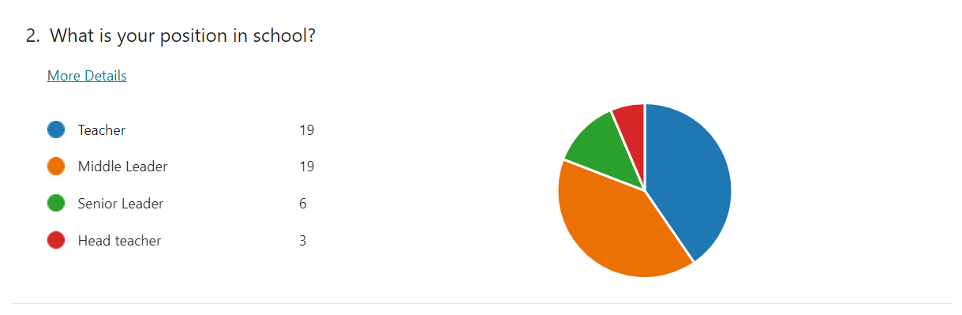
The questionnaire was issued with the aim that all teaching staff in school would be covered in the responses. This was achieved. The responses covered the full range of positions in school, 40% of respondents were teachers, 40% middle leaders, 13% senior leaders and 6% headteachers.

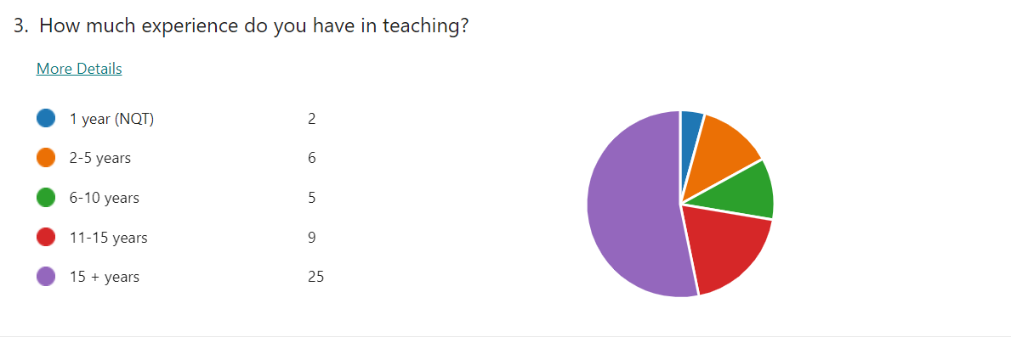
Most respondents had considerable experience in teaching, 53% had over 15 years, 19% had 11-15 years of experience, 11% had 6 to 10 years, 13% had 2-5 years of experience and only 4% were NQTs.

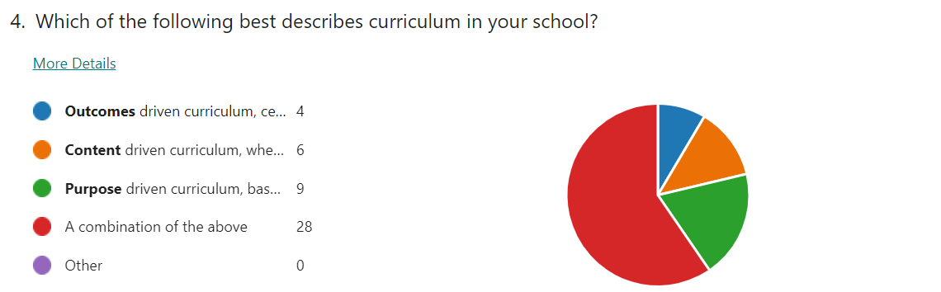
Most respondents, (60%) identified a combination of drivers to the curriculum in their school, 19% identified a purpose driven curriculum, 13% content, and 8% outcome. What is interesting here is the low % on outcomes driven curriculum given the accountability factor secondary schools experience with GCSE and A Level exam results.

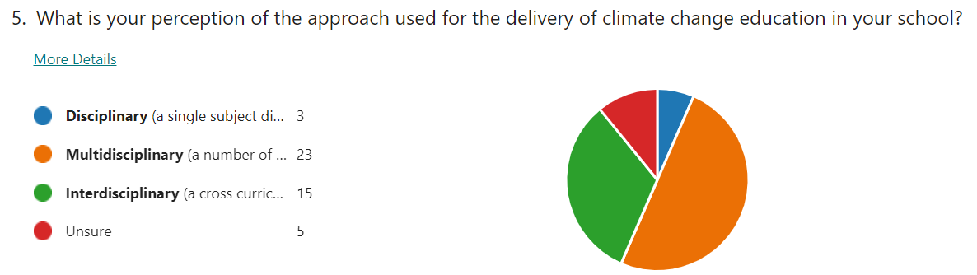
Most respondents, (49%) acknowledged a multidisciplinary approach to CCE in their school, 30% believed an interdisciplinary approach was used, 6% a disciplinary approach and 11% were unsure.

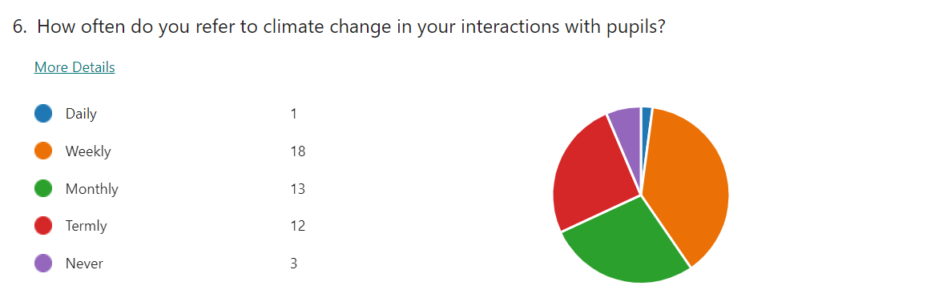
The greatest frequency identified by respondents was weekly (18%), 28% referred to climate change monthly and 26% termly. Daily reference to climate change was noted by 2% of respondents and 6% stated that they never referred to it at all.

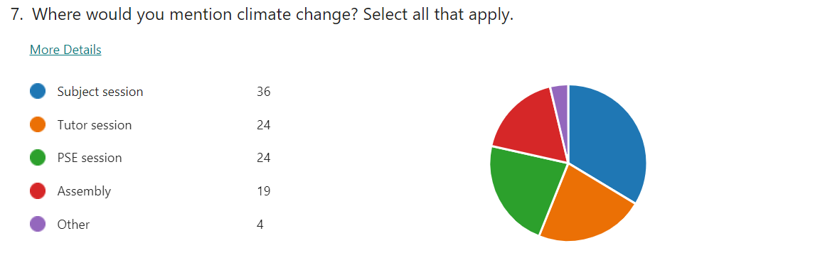
This question allowed participants to select all that apply from the list. The subject session was identified as the most likely setting to focus on climate change, at 34%. There was little difference between tutor session (24%), PSE session (24%) and assembly (19%).

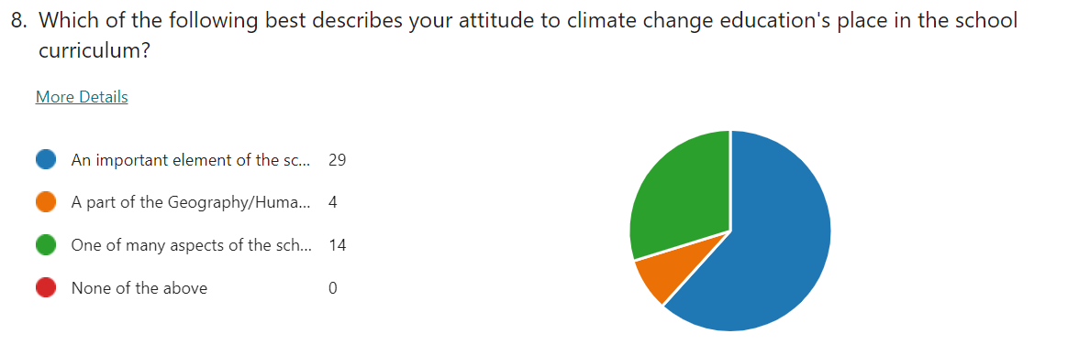
A majority of respondents (62%) believed that CCE was an important element of the school curriculum, 30 % believed it was one of many aspects of the school curriculum, and only 8% felt that it was part of the Geography/Humanities curriculum.

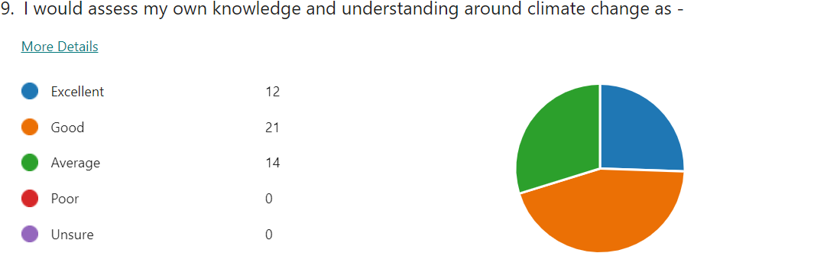
Respondents were asked to self asses their own understanding of CCE. All respondents felt their knowledge and understanding was average or above, 30% at average, 45% good and 26% excellent.

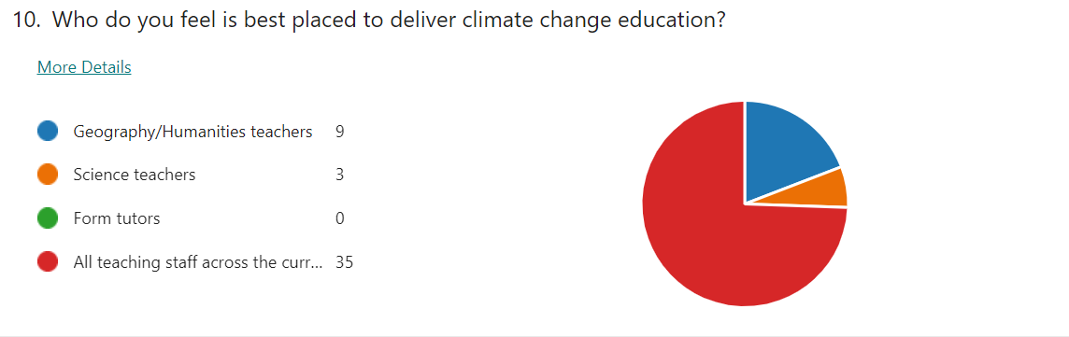
There was a strong reaction to the final option ‘All teaching staff across the curriculum’ with 74% of respondents selecting this, 19% identified the disciplinary focus of Geography/Humanities teachers, 6% Science teachers. No respondents felt that form tutors were best placed to deliver CCE.

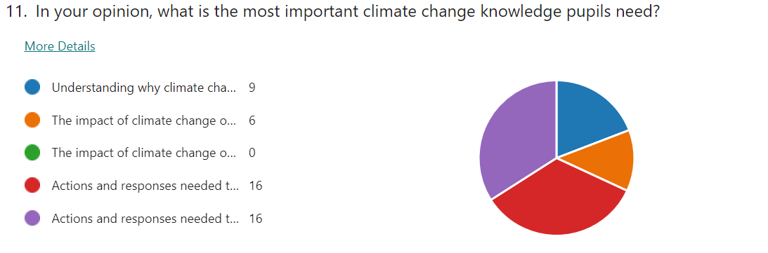
The actions and responses options, at global level and local level was selected by 34% for each one. The impact option on a global level was seen as the most important by 13% and interestingly no one believed that impact at a local level was the most important. Understanding why climate change happens was selected by 19% of the respondents.

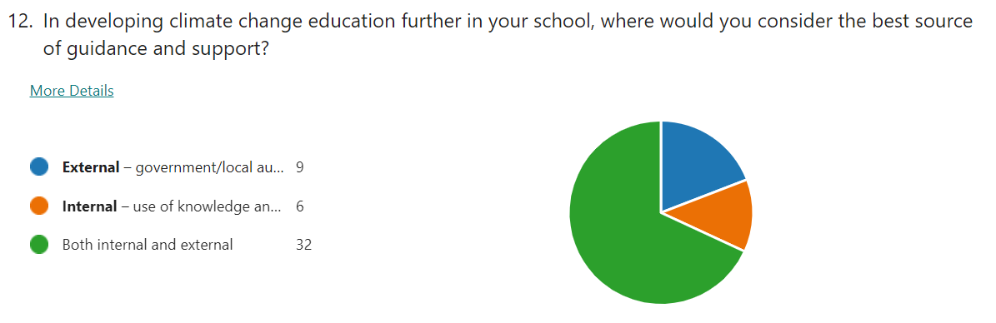
Both internal and external support was deemed to be the best source of guidance and support with the development of CCE (69%), whilst 19% believed that solely external support and guidance would help develop CCE, and 13% believed expertise existed in the school to develop it further.

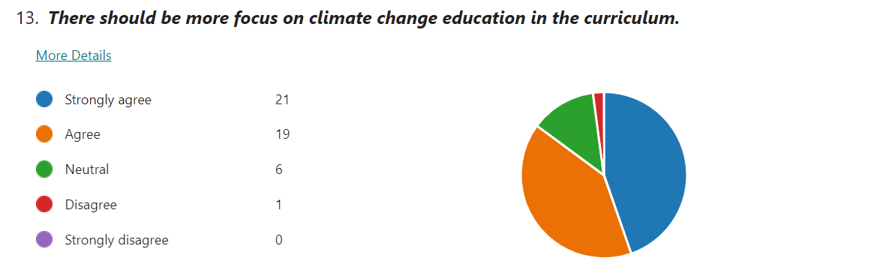
This stage of the questionnaire, Q13- 17, offered a series of statements to respond to. Regarding more focus on CCE in the curriculum 45% strongly agreed and 40% agreed. Only 2% disagreed and 13% took a neutral stance.

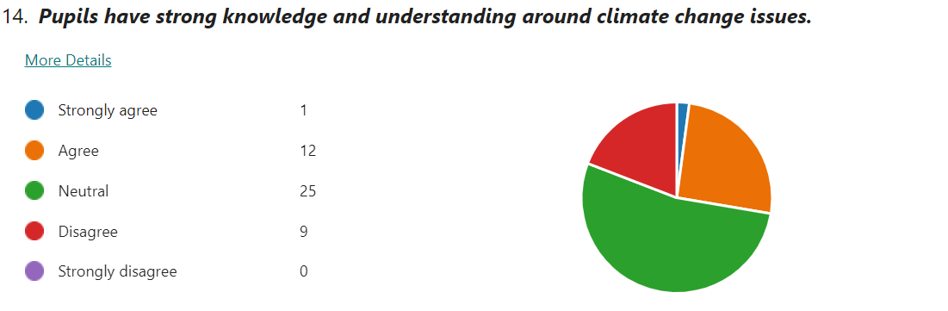
53 % of respondents remained neutral in considering pupils knowledge and understanding around CCE. This statement had the greatest range of responses, with 26% agreeing and 19% disagreeing. Only 2% strongly disagreed with the statement.

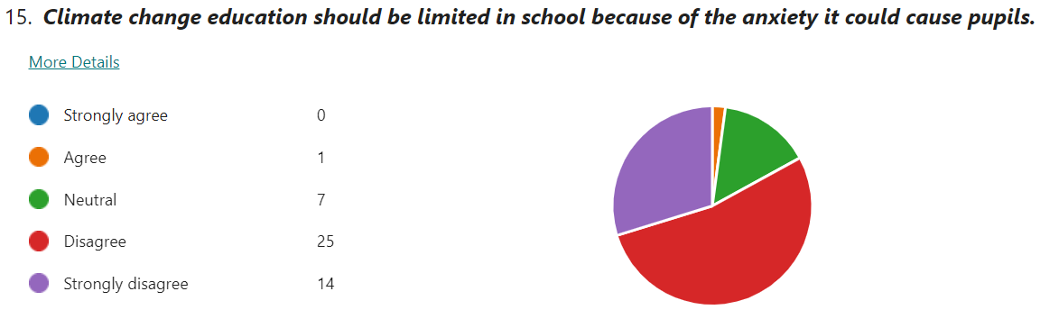
There was strong response against this with 53% pf respondents disagreeing and 30% strongly disagreeing. A neutral stance was taken by 15% and only 2% agreed.

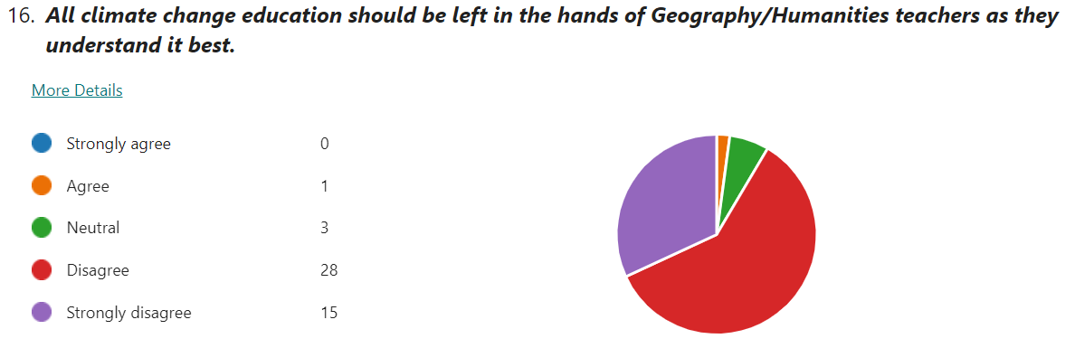
There was strong response against this with 68% of respondents disagreeing and 32% strongly disagreeing. A neutral position was taken by 6% and only 2% agreed.

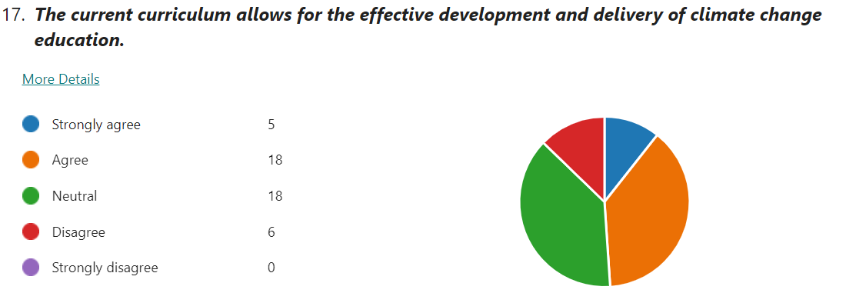
The response to this statement was less clear cut with 38% of respondents remaining neutral, 38% agreeing and 11% strongly agreeing. Only 13% of respondents disagreed with the statement.

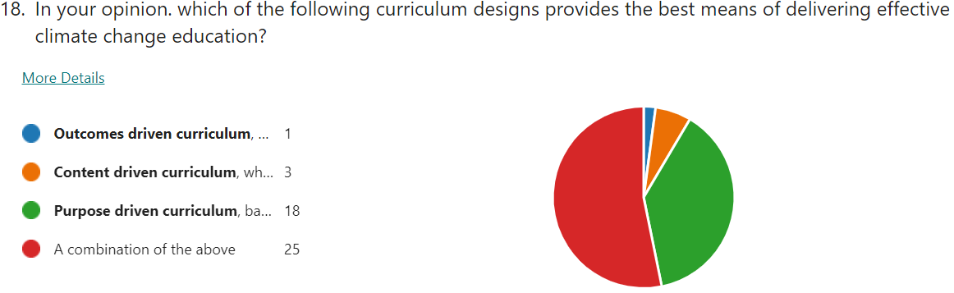
The final 2 questions acted as a conclusion, and an opportunity for respondents to connect CCE with the wider context of curriculum design. There was a high degree of similarity with the response to Q4. Once again, the combination of curriculum designs was the most popular opinion held (53%), purpose 37%, content 8% and just 2% believing that an outcomes curriculum is best placed to deliver effective CCE.

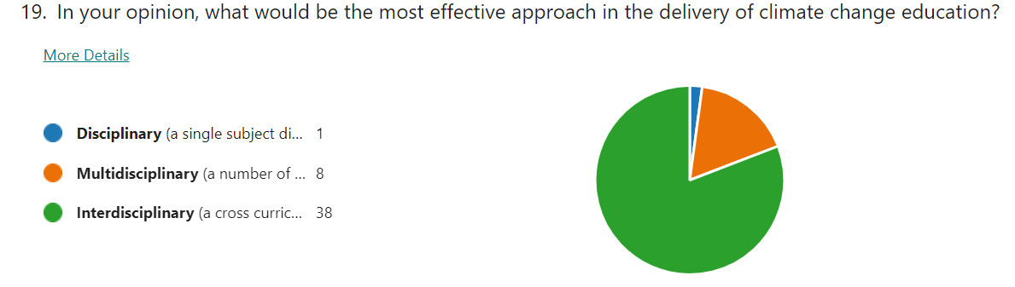
These categories were used in Q5. Most respondents (81%) identified the Interdisciplinary approach as being the most effective, 17% selected the multidisciplinary approach and just 2% selected the disciplinary approach.
20. Please use the box below if there are any points from the previous questions that you wish to expand on.
An opportunity was given to respondents to expand on any of the questions in the questionnaire, creating more qualitive data. The one main theme to arise from the 8 responses was the sense of all areas of the curriculum having a responsibility to deliver CCE.
‘we are able to incorporate climate change information and topics into many of our subjects or our registration classes’
‘I really hope this questionnaire sparks conversation in school about where climate education fits in multiple subjects.’
‘all subject areas can introduce elements into their curriculum that discuss directly or touch upon the causes, effects and response to current climactic changes’.
‘…with every subject incorporating some aspects of CC into their curriculum where appropriate’.

  - Research results - Semi-structured interviews
Four semi-structured interviews were conducted. The interviewees came from a range of secondary schools in South Wales. They all held positions of responsibility in their schools that gave them a working knowledge of curriculum design. A professional relationship and rapport existed between the researcher and the participants before the research started. The interview questions were designed to allow development of issues already raised in the questionnaire, which participants completed before the interview.
1. What is the overall purpose of your curriculum, what do you want it to do for your pupils?
This opening question was designed to engage with the context of curriculum design before moving into the more specific focus of climate change education (CCE). There was a degree of commonality in the responses, with two main strands arising. Firstly, p.1, p.2 and p.3 focused on the curriculum being designed to provide skills and knowledge which allows students to make informed decisions in the future. Secondly, all interviewees referred to the type of individual that they want the curriculum to produce. p.1 and p.4 referred to producing ‘resilient learners’, p.3 identified healthy, confident, and ethical individuals p.2 and p.3 made explicit links to the four purposes that underpin the curriculum for Wales. Alongside this, p.1 and p.4 noted that it was not all about GCSE grades, there was a bigger picture in looking at curriculum, whilst p.3 made a distinction between the focus of content to the process of how learning happens.
‘It is about giving our children the skills and knowledge and experiences to enable them to be the best they can be’p.1
‘Give them the breadth and depth of skills and knowledge to be informed and be able to critique what is around them.’p.2
‘Not all about results… its not be all and end all, because it is about the individual’p.4
2. Which one of these headings best describes the curriculum in your school? -Outcomes/ Content /Process driven curriculum / A combination of all.
Relating directly to the questionnaire, this question provided an opportunity to explain any curriculum design that the interviewees worked with. Responses shared an acknowledgement that it was difficult to use one design and that a combination of outcomes, content and process was evident, with the balance of these different in different places. Both p.1 and p.3 referred to this being holistic.
‘It’s a blend, it’s about knowledge, it’s about content…and being able to apply those skills to other situations’p.4
However, unsurprisingly given the secondary school focus on exams, the outcome dimension was noted strongly.
‘I might be inclined to say outcomes, because of the GSCE focus. However, I say that with a heavy heart as life in education is more than that. I want the next generation to love learning and continue learning and the only way to do that is not teaching to the exams…. ‘p.3
This sentiment was reinforced by p.4 in relation to the overall purpose of the curriculum.
3. How does the Well Being of Future Generations Act impact on the curriculum design within the school?
All interviewees recognised the mandatory nature of this legislation and its impact on the Welsh curriculum with regards to CCE. Differences were found in how much attention it was given and how it is used, p.2 stated it would not be explicit in curriculum design, this was apparent in the response from p.4. Both p.1 and p.2 identified that only some senior members of staff would have a clear grasp of this specific piece of legislation and its impact on curriculum design.
‘We make reference as a leadership team to the national priorities, we discuss some of the documents and make reference to them when sharing with staff, I don’t think teachers on the ground, on an operational level have the time to do everything’p.1
4. How is climate change delivered in your school & who do you think is best placed to deliver CCE?
All interviewees identified the disciplines Geography and Science as the main drivers. p.3 directly referred to Humanities, as that is where the subject specialism lies and noted dialogue with the Science ALoE to avoid repeating what is covered in CCE. Other areas of the curriculum were also identified, p.1 stressed the Welsh Baccalaureate and highlighted how Design & Technology look at the sustainability of materials. p.2 identified the Health and Wellbeing AoLE and a genuine consideration of how learning is sequenced and the purpose of what is being taught. p.4 noted its presence in RVE, with Hinduism, and environmental strands that work across the LNF, happening ‘informally in pockets’ the authentic contexts element, stressed in the new curriculum, allows this to happen if used properly. p.4 also identified the pastoral system as a vehicle for CCE. This was through PSE lessons and the house system. One house had focused on an environmental project of creating greener classrooms and had successfully applied for funding.
With the above answers, it was identified that Geography and Science teachers would be best placed to deliver CCE, given they have the best subject discipline knowledge. p.3 offered a different angle on this, explaining that it was not as simple as identifying a particular group of teachers, about the quality of the work that is planned. This was also advocated by p.2, who highlighted the importance of planning over the subject knowledge of one or a group of teachers.
5. How would you label the approach to climate change education in your school - Disciplinary, Multi-disciplinary or Interdisciplinary?
This question allowed interviewees to explain the approach to climate change in their school.
The overall picture from the four participants was that there was a degree of a multidisciplinary approach, with more than one subject delivering some form of CCE. However, all identified the disciplines of Geography and Science as the key drivers of CCE. CCE was evident in other parts of the curriculum, such a RE, across the LNF.
However, p.1, p.2 and p.4 acknowledged that this multidisciplinary approach with CCE happens informally across the curriculum but not in a planned way. p.4 referred to it as ‘incidental’ and p.2 said the current approach had evolved ‘organically’ and needed to be more purposeful in its development.
All interviewees expressed an appreciation of what a more interdisciplinary approach could bring, p.1 said that teachers would be open to greater links, a move to something that resembled a more interdisciplinary approach. p.3 described the transition to an interdisciplinary approach, based on the collaborative work of middle leaders. p.4 explained the aspiration to move to an interdisciplinary approach, noting this has potentially the greatest impact as an approach.
‘I think specifically for climate change education I don’t see how else we do it, otherwise it becomes compartmentalised and responsibility of Geography and Science’.
The interview itself initiated ideas about how different areas of the school could come together. Like p.3, p.2 acknowledged the value of specialists from different areas coming together, to look at things like CCE, how that joined up thinking works, and ‘changing the culture of how you plan’.
6. What are you trying to achieve with the current forms of climate change education?
The common link between the interviewees was the idea of looking at impact of climate change.
‘Looking at potential impacts on different levels of awareness, looking at the evidence, evaluating that evidence and looking at what can be done to reduce the impacts of climate change on and at different scales, local, national and international’p.3
All interviewees referred to an understanding of the global perspective and case studies from across the world. These responses were more frequent and detailed than those that referred to an understanding of a local context.
p.2 also noted impact of climate change, raise awareness and to think about their role. p.3 developed that further so that students can differentiate between what governments can do and what individuals can do in response. p.4 highlighted the importance of developed well-reasoned opinions that prepare students for the future. p.2 raised an interesting point, trying to achieve progress not telling students what to do, but by being more subtle, providing a rationale for why we have to do what we need to do, thus giving a big picture. Also, p.2 identified the role schools should play in challenging climate change denial that may originate from home. - ‘you can have the best education in school, but they come in with their own preconceived ideas, often from home’.
7. What can be done to move climate change education forward?
Responses to this question revealed several themes. p.1 saw the value in moving to an interdisciplinary approach, all interviewees looked at linking curriculum areas together. p.1 identified the benefits in combining the STEM subjects with Geography and Science on a theme of sustainability.
All interviewees acknowledged the need for developing the use of local examples to support climate change education.
‘Schools can be very good at looking at things across the world, as opposed to the impact of things locally’p.2
According to p.3, this would allow greater emphasis on what individuals can do in their locality –
‘They were becoming more aware of how of how to care for the environment, in that sense they find it easier, less abstract’ p.3
All interviewees stressed the importance of using experiences away from the classroom.
‘I think climate change education just delivered from a textbook or just a paper exercise is not enough, you really need to get out there’ p.2
p.2 also noted that ‘the answer doesn’t just lie in school’ and that there were benefits for getting CCE experts in school to talk to students and teachers.
The idea of improved planning and collaboration was highlighted by p.2 and p.3 as key factors in improving CCE. p2 believed that a change in the culture of planning was needed, creating the time for teachers to talk, promoting collaboration in school and between schools. p.3 believed that planning CCE needed to start with the end in mind, focusing on what do we actually want to learn and what skills will we need.
8. What are the obstacles in pursuing CCE in school?
Three interviewees identified time as an obstacle. P.1 offered concerns about the limited space in a congested curriculum for more time on CCE.
‘Something has to give somewhere, what do you take out to put that in?’ p.1
This theme was noted by p.2, pressures on the curriculum meant that there isn’t enough time for CCE and there are other priorities, which suggests that CCE is not valued in the way it should be. p.4 stated that current approaches to the curriculum are not sufficient.
‘Time is squeezed in so many ways and until education is properly funded, we are robbing Peter to pay Paul ’p.4
The idea of teachers not having enough time to plan and deliver effective CCE was seen as an obstacle by p2. p.4 offered a different angle on this, observing that teachers new to the profession may not have the ‘goodwill’ to invest the time that is needed to make this sort of change, as it tends to happen after school or at lunchtime or at the weekend. ‘Goodwill’ is needed to respond to good ideas around CCE and this may have to happen out of the confines of the accepted working day in the current model.
The lack of funding was also seen as an obstacle. p.2 noted that funding for curriculum development has been scaled back. Funding experiences outside of the classroom, identified by all as part of effective CCE, also needs consideration.
‘You need to take those pupils on field trips to really experience that, and the resource, in terms of paying you have to fund it or know someone who can get you something’p2.
Other obstacles were noted. p.1 identified a potential issue around forming a consensus amongst staff, forming a decision that it is a school priority, although it was suggested that this should not be the problem given the profile of the issue. p.1 also noted the potential risk of tokensim and avoiding the delivery of CCE becoming a box ticking exercise. p.2 highlighted obstacles from outside school, the students having preconceived ideas, from home, ones that may challenge the legitimacy of the climate change argument.
9. Is there any additional support that the school could use in pursuing climate change education at school?
All interviewees identified external help, CCE experts, additional funding and time. p.1 and p.2 strongly believed that staff and students would benefit from experts, although acknowledged that expertise available in school.
‘ you could have experts in the room because I think they hear the same teacher voice, and I think other voices are critical’p.2
‘External help, the sort that can come and work with teachers… developing their knowledge’
Interestingly, p.1’s school had secured external input from a globally respected university. p.3 acknowledged that expertise from local universities was useful, but it had to be at an appropriate level, describing a previous unsuccessful experience where input had been pitched at the wrong level for the students involved.
Funding was a common theme with this question.
‘Climate change education is going to require investment along with clear, easy to follow, accessible guidance form government’p.1
p.4 and p.3 identified that additional money allows the time for a school to make the most of the innovation and creativity that exists with staff and students. p.3 developed this by describing the professional learning time given to staff every other Friday pm when the students go home early. This is valuable time to collaborate and design and write curriculum.
p.4 identified that support, perhaps from Welsh Government, would be useful around careers, looking at what opportunities could arise, not just now, but the jobs in the future that don’t currently exist.
10. Do you see the links between overall goals for your curriculum and climate change education?
All interviewees believed that links did exist between the principles that guided the curriculum and CCE. Differences existed between the extent of the relationship at this point. Both p.2 and p.3 saw links, primarily due to the four purposes that underpins the new Curriculum for Wales.
‘Yes, definitely, because you are keeping the four purposes in mind.’p.3
‘Yes, I think the curriculum for Wales is a good thing and that’s what is aspires to…that’s what the four purposes are all about’p.2
p.1 and p.4 acknowledge links, but more cautiously. p.1 felt there were not enough and that CCE needs to be more explicit in the curriculum. p.4 also believed more could be done to link CCE to the overall principles of the curriculum,
‘I think people would say so, I don’t think it does, but if we looked at it could work…we need to exploit the expertise in the subjects that we have talked about, we have done it with the LNF and the DCF, but it’s critical, because where are we going to end up if we don’t?’p.4

5. Discussion and Interpretation of data

Theme 1 – The level of importance attributed to CCE.
A clear theme arising from the research is the high level of importance that CCE is viewed, important as a focus in the current curriculum and important to develop it further. These positive attitudes were identifiable across all groups of teachers, and were not dependent on position, subject specialism, or level of experience. All interviewees, and 85% of questionnaire respondents agree, or strongly agree that there should be more focus on CCE in the curriculum. Only 2% of respondents felt that CCE should be limited because of the anxiety that it could cause for pupils. This research suggests climate change is mentioned on a regular basis in a range of school settings. Whilst all respondents and interviewees identified that improvements could be made, there was knowledge and understanding of how progress could happen in the bigger picture of curriculum design and approaches within the curriculum, which supported previous research. Most of the respondents and interviewees displayed an understanding of the next steps needed for this to happen, with a greater focus on an interdisciplinary approach within a process driven curriculum. All interviewees and qualitative responses from the questionnaire stressed that greater collaboration over planning and sharing of good practice, supported by expertise within school and outside of schools, will aid progress. Overall, this research suggests that the concerns outlined by Cantell et al (2019) regarding the adequacy of models, structures and programmes built around effective CCE are being addressed.

Theme 2 – The combination of curriculum designs.
Both questionnaire and interviews highlighted a perception of a combination of curriculum designs working at the same time in school. All interviewees and 60% of respondents perceived that it was possible to see an outcomes, content and purpose driven curriculum across their secondary school. The acknowledgment of these 3 drivers reflect the work of Stenhouse (1975) However, there is a greater connection to Biesta (2013) and his assertion that education is multidimensional and that schools should balance the competing demands of qualification, socialisation, and subjectification, thus suggesting that it is problematic to solely focus on one of the three approaches to curriculum design. In addition, these findings support Marsden (2007) that all three multidimensional educational purposes co-exist and that moves between subject knowledge transmission, wider educational orientation and social dimensions of education are part of a continuous flux in schools.
All interviewees noted outcomes as a driver of curriculum design, and 8% of respondents noted it as the sole driver. Stenhouse (1975) stated that when learning outcomes drive curriculum design, pressure of accountability on pupils, teachers and schools becomes inevitable. This is particularly relevant when it comes to accountability for GSCE results. This has been a key feature of the previous curriculum design in Wales which centred on the National Curriculum and the subsequent use of levels in assessing pupils. However, the recent curriculum reform in Wales, underpinned by the 4 purposes, has delivered a clear move away from the National Curriculum. Reference to the new curriculum and its principles was clear throughout the 4 interviews yet only 13% of respondents identified it as the only driver. This low figure might be explained by the fact that are different curriculum designs used in secondary schools as reforms to Key Stage 4 are yet to be implemented.
When asked about the curriculum design that provides the best means of effective CCE, 53% saw a combination of designs as key. Interestingly, the second most popular choice was process/purpose curriculum (37%), which is the basis of the new curriculum in Wales. Two of the interviews made positive and explicit links to the new curriculum and the 4 purposes as integral to the development of purposeful CCE. This indicates that there are evolving positive attitudes towards the new curriculum and a perception that it will provide the best platform for effective CCE. This challenges Irwin (2020) that curriculum in most areas is unchanged by climate awareness.

Theme 3 – Multidisciplinary vs Interdisciplinary approaches with a curriculum.
The literature review identified that within a curriculum the multidisciplinary approach will deliver more effective CCE than a disciplinary approach. The 4 interviews and 49% of questionnaire responses identified that a multidisciplinary approach was currently used in all schools in the delivery of CCE, with multiple disciplines involved beyond the most frequent point of delivery, Geography. The qualitive aspect of the questionnaire produced further support for this, with the most common response referring to CCE being delivered by multiple subjects.
However, when asked about the most effective way to deliver CCE, 81% of respondents selected the interdisciplinary model. This corresponded with the data from the interviews, where all interviewees aspired to move to an interdisciplinary model, although the stage of implementation varied. This perception that an interdisciplinary approach will be the most effective is supported by the research. Kagawa and Selby (2010) asserted that wherever it is delivered, CCE will be most effective if it is holistic and highlights the importance of an interdisciplinary model. This is reinforced by Oldakowski & Johnson’s (2018) research into interdisciplinary curriculums which indicated improved delivery of CCE. This raises the question of how teachers and schools can make the successful transition to an interdisciplinary format and how would CCE evolve in that process. This point has some relationship with the findings of Schreiner, Henriksen, & Hansen (2010) who noted that despite the evidence that interdisciplinary formats have genuine benefits in delivering CCE, discovered that the structure of most schools is not conducive to such interdisciplinary collaborations. It can be argued that as the new curriculum in Wales evolves that curriculum design in schools will allow this. This is supported by most of the respondents who believed the new curriculum could allow for the effective development of climate change.
Most respondents believed that CCE was an important element of the school curriculum, or one of the many aspects noting its whole school presence, supporting the perceived multidisciplinary approach. Only 8% saw it as part of Geography and Science. This was supported by the interviewees who all stressed the importance of it and were able to identify its place across the school curriculum, particularly at KS3. Two of the interviews highlighted that effective planning and collaboration was more important than the subject specialism of the teachers delivering it. This supports research by Howard- Jones et al (2021) that teachers favoured a cross-curricular approach with a majority already communicating to their students about it, and this position was unrelated to subject discipline. This theme is further reinforced by the questionnaire where the presence of CCE was identified across the school timetable, in subject, tutor and PSE sessions, assemblies and 66% respondents mentioning climate change at least monthly.
However, this was not mirrored in terms of responses to the questionnaire, where the largest number of responses in the sample came from Geography and Science teachers. Arguably, these are the teachers most familiar with the content and more likely to deliver it. Also, the interviews highlighted that the starting point for CCE was in these subject areas, and that these disciplines would dominate the delivery of CCE, despite the aspiration for a more interdisciplinary approach. This links to Chang (2012) who highlighted the preference of Geography as a subject to deliver the knowledge and skills necessary to engage critically in the discussion on climate change. This could also relate to Reid’s (2019) observations that that Geography delivered in schools is characterised by specific pedagogies centred on text and media resources, place-based fieldwork, and inquiry. These are particularly relevant to teaching and learning about climate change issues. In addition, the high number of respondents with a Science specialism, and the identification of Science by interviewees as a key driver of CCE, is reflected in the ‘Inclusion of sustainability and climate change in the national curriculum’ research briefing (2021). This explicitly identifies Science and Technology as an AoLE that can address CCE.
These results provide a contrast to the ‘Teaching the Future’ (2021) survey. In the survey, 41% of respondents claimed that climate change is rarely or never mentioned in their schools and only 5% of teachers stated that climate change is integral to many aspects of the curriculum. In addition, 65% of respondents felt climate change was not taught in a meaningful way within their subject. One explanation is that the survey was conducted in England and the difference in responses could be attributed to the direction that curriculum design has evolved in Wales. The curriculum in England has not undergone this extent of reform. Dewey (2011) identified the entrenched conservative understanding of school knowledge provides obstacles to at transformative change and this could explain the differences between the English and Welsh education systems.

Theme 4 – CCE based knowledge (local v global).
Monroe et al (2019) in their literature review assessing the effectiveness of CCE strategies, identify that making climate change information personally relevant and meaningful for learners is key. They also found there was great value for learners with engagement in designing and implementing school/community projects that target some element of climate change. This theme is developed by Bassy (2020) who stresses the need for students to develop the personal skills to face future challenges. This theme, of the local and personal focus, was only partially seen in the research conducted. Only 17 % of respondents identified that actions and responses on a local level was the most important climate change knowledge needed, and no respondents selected the impact of climate change at a local level. This was replicated in the interviews where only one participant focused on the local perspective. The other 3 interviews had more references to global impacts and global actions, mirroring the weighting of the responses to the questionnaire. A possible reason for this could be the media presentation of climate change, which focuses on the extreme global events such as wildfires in Australia or recent floods in Pakistan, and less on the local perspective.
These findings indicate that action is needed in thinking about climate change through the lens of locality and agency. This would respond to Kenis & Mathijs (2012) focus on the value in encouraging students to be agents of wider change within their communities and as a result becoming more effective in terms of addressing climate change. These findings challenged my own presumptions, I expected this local context to be more apparent in the responses. There is strong emphasis in the literature on the importance of a local focus and placing CCE in authentic contexts. The findings of this research suggest that this needs to be built into present and future CCE for it to be more purposeful.

Theme 5 – The obstacles/additional support needed.
The research identified that additional support in pursuing CCE at school would be desirable. All interviews noted the benefits that external input could have in developing CCE and 88% of respondents highlighted the importance of external support. There is a link here to the authentic experiences based around CCE mentioned by all interviewees. This connects to the importance of local perspectives in ensuring that CCE is relevant to students, highlighted by Monroe et al (2019). Another angle in examining external input is support for teachers in their pursuit of designing more effective CCE through developing knowledge and the implementation of a fully interdisciplinary approach.
All interviews shared the same perceived obstacles in developing CCE in schools, more time needed for CCE in a crowded curriculum and more funding to develop it. With regards to the curriculum, more than half of the respondents were either neutral or disagreed with the notion that the current curriculum allowed for the effective development of CCE. This suggests that more progress is needed with curriculum design. The need for additional financial support links to desire to have greater external input on this topic. All interviews noted the importance of teachers collaborating and planning together in school and between schools. Again, this comes with a cost impact in creating the space and time for teachers to do this.
In summary, both sets of results highlighted that CCE is deemed as very important in school. This is tempered with an acknowledgement that progress is needed to improve its place in the curriculum. The qualitive and quantitative data highlighted an awareness of overall curriculum design. This was a likely outcome given the focus on curriculum reform in the last 5 years leading up to the launch of the Curriculum for Wales in 2022.There was an understanding of different modes of curriculum design occurring at the same time, but an overall acceptance by a majority that a process curriculum provides the best framework for CCE to be more effectively taught. Furthermore, the data highlighted an aspiration to move towards an interdisciplinary approach to strengthen the delivery of CCE across school. Despite this awareness of the benefits of an integrated cross curricular approach, the results indicate that Geography and Science teachers are seen as key in the planning and teaching of CCE. The place of knowledge in relation to CCE raised interesting issues. Results suggest that there is still progress be made in building programmes around local climate change issues and personal responses to the challenges in students own communities. There was widespread recognition of external support needed to make progress in this area of the curriculum.

6. Conclusions and recommendations

6.1 Summary of main findings
All respondents and interviewees displayed an understanding of the importance of CCE in school. It is addressed by all teachers in a range of school settings and there was little resistance or complacency with the idea of the further development of CCE. It is acknowledged that the current delivery of CCE is not enough, although there is a perception that CCE is evolving. This research revealed a clear intention to move forward with CCE, combined with a positive outlook on what can be achieved in the future. This research identified an understanding of the legal responsibility based in the Well-being of Future Generations (Wales) Act (2015) however, it also suggests that it was referred to by senior leaders in school, but rarely beyond that, and sometimes not even explicitly within senior leadership teams.
There is an awareness of multiple curriculum designs operating in schools. The recognition of a content, outcome and process curriculum operating alongside each other is a point noted by Biesta (2013) and Marsden (1997). This would seem to be attributable to the engagement by teachers and schools with the process of curriculum reform. It is also related to the transition period in curriculum design since the publication of Successful Futures (2015) with significant changes at KS3 and no change with KS4. Most responses from the interviews and the questionnaire were consistent with the findings of Reid (2019) that a identifies the process curriculum centred on Biesta’s (2010) subjectification domain as the basis for the most effective CCE and that the new curriculum in Wales has process/purpose elements that will aid progress towards more effective CCE.
The most common approach identified in delivering CCE is the multidisciplinary approach, some identified an interdisciplinary approach with most schools aspiring to build an interdisciplinary model. This is supported by Kagawa & Selby’s (2010) and Ho, Li-Ching & Seow’s, (2017) findings that CCE will be most effective if it is a holistic, interdisciplinary learning process. This can be related to recent curriculum reform in Wales which has driven a cross curricular approach, particularly in establishing Areas of Learning and Experience, rather than single subject specialisms. This contrasts with the work of Chang (2016) and Chalkey et al. (2015) who asserted that Geography is the most suitable vehicle for learning about complex environmental issues. This research produced an acknowledgement that collaboration between teachers and between schools will aid future development of effective CCE.
In terms of appropriate knowledge and content supporting CCE, this research noted a tendency for teachers to be drawn towards global perspectives on CCE, only a small number appreciating the importance of local perspectives. Henderson (2019) observed that this was a position that many educators have tried to move away from. This contrasted with the research of Monroe et al (2019) which strongly identifies the value of placing most focus on local and personal perspectives set in authentic contexts. The findings of this research identified this was happening in a limited way in some schools. Obstacles were identified that hamper the further development of CCE, these are a congested curriculum and pressures on time and money, both needed to give the necessary attention to building an interdisciplinary curriculum and improving CCE knowledge within the profession.

6.2 Conclusions and directions for further research
It can be concluded that there is an acute awareness of the importance of CCE and an appreciation of its overall importance in the whole school curriculum. This is combined with a willingness to make progress in the development of CCE in the school curriculum.
Recent education reform in Wales has led to a greater awareness of different curriculum design. Progress in the implementation of the new curriculum, with a predominately process approach, will be conducive to the improvement of CCE in schools. In addition, there is an awareness of the current mode of delivery and aspiration to move to a more embedded interdisciplinary approach, which again is recognised by research as the most impactful way to deliver CCE.
There is knowledge and understanding of climate change from a global perspective, However, the research indicates that more focus is needed regarding actions and responses on a local level. This is more in tune with Bassy’s (2020) findings highlighting the importance of moving beyond the transmission of knowledge around the reasons for climate change, to the development of the personal skills to tackle the challenges that lie ahead.

6.3 A critical evaluation of the research
In critiquing the enquiry, the small size of the sample raises issues of validity. The research was valid within the context established for this enquiry, using standardised a questionnaire and a semi-structured interview format based on existing research. However, the validity of the enquiry would be increased with a larger sample, targeting more schools and more teachers, including the primary sector. The sample could be further strengthened by engaging with policy makers as well as teachers. This would provide a different perspective on the key issues. The location of the study also needs to be addressed, with schools in South Wales only, providing the sample for this enquiry. To improve the validity of the research the sample would include schools from all over Wales. Moving beyond Wales and engaging with other education systems in the UK would also increase the validity and reliability of the results. Arguably, increasing the sample size to include schools in countries that are acutely threatened by climate change, such as schools in the Netherlands at risk from rising sea levels or schools in Southern Spain faced with extreme heat and drought, would add more validity and reliability to a study on CCE. Addressing the validity of the sample size and location also would improve reliability. This also needs to be critiqued when examining the position of the researcher. My own background in the teaching of the Humanities, Geography and CCE is a factor. Reliability can be found in the possession of knowledge and understanding relating to the enquiry, however, there are potential drawbacks, with biases that form as a consequence of working closely with CCE which then impact the research.
In further research on curriculum design, there is scope to examine the advantages and disadvantages of a process driven curriculum and the functionality of other parts of the outcomes and content approaches alongside this. From a CCE perspective, there is value in further research into how to convey the local impact of climate change in conjunction with developing ideas around individual actions and responses on a local level.
Finally, there are potential benefits to investigating contrasts in this research to CCE in England. This would also need to consider the context of curriculum design as there has been divergence in curriculum models used in the two education systems. There was an original intention of gathering data across several schools in England and Wales which changed in the planning process. Following advice from other researchers it was identified that the scale of the data gathering would become too large for the parameters of this research and the inquiry would also become comparative in its nature. However, it the future, this comparative enquiry could develop a greater understanding of the current and future position of CCE in the Welsh curriculum.

6.4 Recommendations
It is recommended that there is continued development of CCE across the curriculum with external support drawn from all stakeholders, including government, local consortia, and universities.
Support and guidance for schools is recommended in both curriculum design and CCE, this research has highlighted the intrinsic link between key elements of this enquiry. The new Curriculum for Wales has process elements underpinning its design and research suggests that this provides the best means of delivering CCE. Therefore, supporting curriculum design in schools will provide the framework in which more purposeful CCE can exist. This would also involve support for schools moving from the multidisciplinary model to the interdisciplinary model. Defining and sharing this process of this transition, combined with offering a case study of how CCE can be delivered purposefully over all Areas of Learning and Experience could offer a possible approach.
However, recent education reforms in Wales are based on schools and teachers having agency to design and implement their own curriculum. Consequently, using a top-down approach, where models of effective CCE are issued externally, could be detrimental and confusing. This is pertinent given the findings from CCE research that a focus on the local and personal perspective is the most impactful, which suggests that schools planning around their locality for their students would be the best approach. It can be argued that in terms of external support, assisting with the process, rather than simply offering a model that can be implemented would be the most effective route forward. It would also align with how schools have addressed the new Curriculum for Wales. Future developments in CCE could include greater emphasis on the Well-being of Future Generations (Wales) Act (2015). There is much to gain from this unique position of having a legal commitment to addressing climate change in Welsh educational policies. The fact that Wales is the only country in the world to embed this in law should be a source of pride and celebrated, whilst at the same time implemented in a rigorous and robust manner.
The importance of planning and teacher collaboration featured in this enquiry. Further discussion is needed regarding the use of funding to support teachers in developing CCE in a new curriculum design model and accessing external support. The research identified the belief that there was a large source of expertise in schools to harness. It also identified that some schools have arranged timetables to facilitate team planning and collaboration across the school. The sharing of good practice across schools could facilitate changes and adaptations to how teachers are given time and space to plan.
Finally, it is also recommended that assistance is given to schools in identifying appropriate external support, both in curriculum design and CCE. An obvious source of support can be found in sharing the outcomes of this enquiry. All interviews finished on the note of future collaboration, with an interest in the results and a desire for future consultation and intervention. This will be the next step.

- Reference list
Aarnio-Linnanvuori, E. (2013). Environmental issues in Finnish school textbooks on religious education and ethics. Nordidactica: Journal of Humanities and Social Science Education, (2013: 1), pp.131-157.
Anyanwu, R., Le Grange, L., & Beets, P. (2015). Climate change science: The literacy of Geography teachers in the Western Cape Province, South Africa. South African Journal of Education, 35(3), 1–9.
Archibald, M. M., Ambagtsheer, R. C., Casey, M. G., & Lawless, M.(2019). Using Zoom Videoconferencing for Qualitative Data Collection: Perceptions and Experiences of Researchers and Participants. International Journal of Qualitative Methods, 18.
Bassey, M. (2020) Forum for promoting 3-19 comprehensive education, Vol. 62 Issue 2, p227-234, 8p; DOI: 10.15730/forum.2020.62.2.227.
Bell, J. (2010) Doing Your Research Project. 5th Edition. OU Press: Maidenhead.
Bell, J. and Opie, C. (2002). Learning from research: getting more from your data. OU Press: Maidenhead.
Berkowitz, A. R., Ford, M. E., & Brewer, C. A. (2005). A framework for integrating ecological literacy, civics literacy, and environmental citizenship in environmental education. In E. Johnson & M. Mappin (Eds.), Environmental education and advocacy: Changing perspectives of ecology and education (pp. 227–266). Cambridge: Cambridge University Press.
Biesta, G. (2013). The Beautiful Risk of Education. Boulder, CO: Paradigm Publishers
Biesta, G. (2013) Receiving the gift of teaching: from “learning from” to “being taught by”, Studies in Philosophy and Education 32(5): 449–461.
Bord, R. J., O'Connor, R. E., & Fisher, A. (2000). In what sense does the public need to understand global climate change? Public Understanding of Science, 9(3), 205–218.
British Educational Research Association [BERA] (2018) Ethical Guidelines for Educational Research, fourth edition, London.
Britzman, D., Dippo, D., Searle, D. and Pitt, A. (1997). Toward an academic framework for thinking about teacher education. Teaching Education, 9(1), pp.15-26.
Burns R. (2000). Introduction to Research Methods. 4th Edition. Sage: London.
Clarke, V., Braun, V. (2013). Successful Qualitative Research: A Practical Guide for Beginners. United Kingdom: SAGE Publications.
Cantell, H. Salonen, A.O. and Lehtonen, A. (2019). Climate change education: A new approach for a world of wicked problems. Sustainability, human well-being, and the future of education, pp.339-374. (2019)
Chalkley, B., Blumhof, J. and Ragnarsdottir, V.K. (2010). Geography, earth and environmental sciences: A suitable home for ESD? In Sustainability education (pp. 93-107). Routledge.
Chang, C. (2012). International Research in Geographical & Environmental Education; Nov2012, Vol. 21 Issue 4, p283-295, 13p
Chang, C. (2014). Climate Change Education – Knowing, doing and being. Abingdon: Routledge.
Chang, C.H. and Pascua, L. (2016). Singapore students' misconceptions of climate change. International Research in Geographical and Environmental Education, 25(1), pp.84-96.
Charmaz, K. (2006). Constructing grounded theory: A practical guide through qualitative analysis. Thousand Oaks, CA: Sage.
Cohen, L. et al (2009) Research Methods in Education. 6th edition. Routledge: Oxford.
Cordero, E. (2001). Misconceptions in Australian students' understanding of ozone depletion. Melbourne Studies in Education, 4], 85-97.
Dewey, J. (2011). The sources of a science of education. Read Books Ltd.
Dijkstra, E.M., and M.J. Goedhart. (2012). “Development and Validation of the ACSI: Measuring Students’ Science Attitudes, Pro-Environmental Behaviour, Climate Change Attitudes and Knowledge.” Environmental Education Research 18(6): 733–749. doi:10.1080/13504622.2012.662213
Donaldson, G. (2015). Successful Futures: Independent review of curriculum and assessment arrangements in Wales.
Drever, E. (2006). Using semi-structured interviews in small scale research.
Dupigny‐Giroux, L.A.L. (2010). Exploring the challenges of climate science literacy: Lessons from students, teachers and lifelong learners. Geography Compass, 4(9), pp.1203-1217.
Enser, Mark. (2021) Powerful Geography. Crown House Publishing.
Etikan, I., Musa, S.A. and Alkassim, R.S. (2016). Comparison of convenience sampling and purposive sampling. American journal of theoretical and applied statistics, 5(1), pp.1-4.
Gehlhar, A.M. and Duffield, S.K. (2015). Deconstruction Geography: A STEM Approach: Strong Teacher Leaders Help to Ensure That Middle Level Ideals Have Fruition in Actual Practice as Demonstrated When Featured Teachers Collaborated to Open a New Middle School Focused on STEM Education. Middle School Journal, 46(3), pp.3-9.
Gaudelli, W., & Heilman, E. (2009). Reconceptualizing geography as democratic global citizenship education. Teachers College Record, 111(11), 2626.
Hamilton, L. and Corbett-Whittier, C. (2012). Using case study in education research. Sage.
Hansen, P.J.K. (2010). Knowledge about the greenhouse effect and the effects of the ozone layer among Norwegian pupils finishing compulsory education in 1989, 1993, and 2005—What now? International Journal of Science Education, 32(3), pp.397-419.
Harvey, F (28/1/2022) The Guardian, UK pupils failed by schools’ teaching of climate crisis, experts say’ article.
Hinde, E.R., Popp, S.E.O., Jimenez-Silva, M. and Dorn, R.I. (2011). Linking geography to reading and English language learners’ achievement in US elementary and middle school classrooms. International research in geographical and environmental education, 20(1), pp.47-63.
Ho, Li-Ching, Seow. (2017). Disciplinary boundaries and climate change education: teachers' conceptions of climate change education in the Philippines and Singapore. International Research in Geographical & Environmental Education, Vol. 26 Issue 3, p240-252, 13p; DOI: 10.1080/10382046.2017.1330038.
Howard- Jones, P. Sands, D., Dillon, J. & Fenton-Jones, F. (2021). The views of teachers in England on an action-oriented climate change curriculum, Environmental Education Research, 27:11, 1660-1680, DOI: 10.1080/13504622.2021.1937576.
Irwin, Ruth. (2020) Climate change and education. Educational Philosophy & Theory; May2020, Vol. 52 Issue 5, p492-507.
Jo, I. and Bednarz, S.W.( 2014). Dispositions toward teaching spatial thinking through geography: Conceptualization and an exemplar assessment. Journal of Geography, 113(5), pp.198-207.
Kate, H., James, J. & Tidmarsh, C. (2019). Using Wicked problems to foster interdisciplinary practice among UK trainee teachers. Journal of Education for Teaching, 45(4), pp.446-460.
Kelly, P. A. V. (2009). The Curriculum: Theory and Practice. United Kingdom: SAGE Publications.
Kenis, A. and Mathijs, E. (2012). Beyond individual behaviour change: The role of power, knowledge and strategy in tackling climate change. Environmental Education Research, 18(1), pp.45-65.
Kilpatrick, William Heard. (1971). Education for a Changing Civilization: Three Lectures Delivered on the Luther Kellogg Foundation at Rutgers University, 1926 (New York: Arno Press and the New York Times).
Klosterman, M.L. and Sadler, T.D. (2010). Multi‐level assessment of scientific content knowledge gains associated with socioscientific issues‐based instruction. International Journal of Science Education, 32(8), pp.1017-1043.
Kulakiewicz, A Long, R, Roberts N. (2021). Inclusion of sustainability and climate change in the national curriculum -Research Briefing.
Lambert, D. and Hopkin, J. (2014). A possibilist analysis of the geography national curriculum in England. International Research in Geographical and Environmental Education, 23(1), pp.64-78.
Lawrence, P. (2012). Justice for future generations: environment discourses, international law and climate change. Anyanwu, R., Le Grange, L., & Beets, P. (2015). Climate change science: The literacy of Geography teachers in the Western Cape Province, South Africa. South African Journal of Education, 35(3), 1–9.
Mackey, A. & Gass, S. (2005). Second language research: Methodology and design. New Jersey: Lawrence Erlbaum Associates.
Marsden, B. (1997). On taking geography out of geographical education: some historical pointers. Geography: Journal of the Geographical Association, 82(3), p.241.
McCaffrey, M.S. and Buhr, S.M. (2008). Clarifying climate confusion: Addressing systemic holes, cognitive gaps, and misconceptions through climate literacy. Physical Geography, 29(6), pp.512-528.
Mills, J., Bonner, A. and Francis, K. (2006). Adopting a constructivist approach to grounded theory: Implications for research design. International journal of nursing practice, 12(1), pp.8-13.
Monroe, M.C., Plate, R.R., Oxarart, A., Bowers, A. and Chaves, W.A. (2019). Identifying effective climate change education strategies: A systematic review of the research. Environmental Education Research, 25(6), pp.791-812.
Oldakowski, R & Johnson, A. (2018). Combining Geography, Math, and Science to Teach Climate Change and Sea Level Rise Ray Journal of Geography.
Oppenheim, A. (1992). Questionnaire design, interviewing and attitude measurement. Pinter: London.
Reid, A. (2019). Climate change education and research: possibilities and potentials versus problems and perils? Environmental Education Research, 25(6), pp.767-790.
Richards, L., & Morse, J.M. (2007). Users guide for qualitative methods (2nd Ed.). Thousand Oaks, CA: Sage.
Schwandt, T.A. (2000). Three epistemological stances for qualitative inquiry: Interpretivism, hermeneutics, and social constructionism. In Handbook of qualitative research (pp. 189-213). SAGE Publishing.
Schweitzer, K. (2017). Curriculum design: Definition, purpose and types. https://www.thoughtco.com/.
Selby, D. and Kagawa, F. (2010). Runaway climate change as challenge to the ‘closing circle’ of education for sustainable development. Journal of education for sustainable development, 4(1), pp.37-50.
Selltiz C. et al, (1962) Research methods in social relations. Holt: New York
Stenhouse, L. (1975). An introduction to curriculum research and development. London: Heinemann.
Thomas, G. (2022). How to do your research project: A guide for students. How to Do Your Research Project, pp.1-100.
Thornton, S., Bleazby, J., Burgh, G. and Graham, M. (2022). Responding to climate change ‘controversy’ in schools: Philosophy for Children, place-responsive pedagogies & Critical Indigenous Pedagogy. Educational Philosophy and Theory, pp.1-13.
Transforming Our World: The 2020 Agenda for Sustainable Development; United Nations General Assembly: New York, NY, USA, 2015.
Youngman, L. (1982) Designing and analysing questionnaires TRC rediguides: Oxford.
Young, M. (2010). The future of education in a knowledge society: The radical case for a subject-based curriculum. Journal of the Pacific Circle Consortium for Education, 22(1), pp.21-32.
Well-being of Future Generations (Wales) Act (2015).
Whitehouse, H. (2006) Climate change -- A burning curriculum issue; Primary & Middle Years Educator; Jul2006, Vol. 4 Issue 2.
UK Student Climate Network. (2019). A Manifesto for Tackling the Climate Change Crisis. In The Guardian, March 15. https://www.theguardian.com/commentisfree/2019/mar/15/uk-student-climate-network-manifesto-declare-emergency.
UNESCO. 2017a. Education for Sustainable Development: Partners in Action. Paris: UNESCO.
Yin, R.K. (2009). Case study research: Design and methods (Vol. 5). sage.

Appendix 1
APPLICATION FOR ETHICAL APPROVAL

In order for research to result in benefit and minimise risk of harm, it must be conducted ethically. A researcher may not be covered by the University’s insurance if ethical approval has not been obtained prior to commencement.

The University follows the OECD Frascati manual definition of research activity: “creative work undertaken on a systematic basis in order to increase the stock of knowledge, including knowledge of man, culture and society, and the use of this stock of knowledge to devise new applications”. As such this covers activities undertaken by members of staff, postgraduate research students, and both taught postgraduate and undergraduate students working on dissertations/projects.

The individual undertaking the research activity is known as the “principal researcher”.

Ethical approval is not required for routine audits, performance reviews, quality assurance studies, testing within normal educational requirements, and literary or artistic criticism.

Please read the notes for guidance before completing ALL sections of the form.

This form must be completed and approved prior to undertaking any research activity. Please see Checklist for details of process for different categories of application.

SECTION A: About You (Principal Researcher)
1 | Full Name: |  | Stephen Hadley
2 | Tick all boxes that apply: |  | Member of staff: | x | Honorary research fellow: | ☐
 | Undergraduate Student | ☐ | Taught Postgraduate Student | ☒ | Postgraduate Research Student | ☐

3 | Institute/Academic Discipline/Centre: | Yr Athrofa: Centre of Education IEH
4 | Campus: | Swansea – SA1
5 | E-mail address: | stephen.hadley@uwtsd.ac.uk
6 | Contact Telephone Number: | 0775633961
 | For students:
7 | Student Number: | P1709675
8 | Programme of Study: | MA Education
9 | Director of Studies/Supervisor: | Elaine Sharpling

SECTION B: Approval for Research Activity
1 | Has the research activity received approval in principle?  (please check the Guidance Notes as to the appropriate approval process for different levels of research by different categories of individual) |  | YES | ☒ | NO | ☐
 |  |  |  |  | Date
2 | If Yes, please indicate source of approval (and date where known): Approval in principle must be obtained from the relevant source prior to seeking ethical approval | Research Degrees Committee |  | ☐
2 |  | Institute Research Committee |  | ☐
2 |  | Other (write in) |  | ☒ | Elaine Sharpling

SECTION C: Internal and External Ethical Guidance Materials
 | Please list the core ethical guidance documents that have been referred to during the completion of this form (including any discipline-specific codes of research ethics, location-specific codes of research ethics, and also any specific ethical guidance relating to the proposed methodology). Please tick to confirm that your research proposal adheres to these codes and guidelines. You may add rows to this table if needed.
1 | UWTSD Research Ethics & Integrity Code of Practice | ☒
2 | UWTSD Research Data Management Policy | ☒
3 | BERA Ethical Guidelines for Educational Research, fourth edition (2018)  https://www.bera.ac.uk/publication/ethical-guidelines-for-educational-research-2018 [List any other relevant documents here] | ☒

SECTION D: External Collaborative Research Activity
If there are external collaborators then you should gain consent from the contact persons to share their personal data with the university. If there are no external collaborators then leave this section blank and continue to section E.
1 | Institution
2 | Contact person name
3 | Contact person e-mail address
4 | Is your research externally funded? |  | YES | ☐ | NO |  | ☐
5 | Are you in receipt of a KESS scholarship? |  | YES | ☐ | NO |  | ☐
6 | Are you specifically employed to undertake this research in either a paid or voluntary capacity? | Voluntary | YES | ☐ | NO | ☐
7 |  | Employed | YES | ☐ | NO | ☐
8 | Is the research being undertaken within an existing UWTSD Athrofa Professional Learning Partnership (APLP)? | If YES then the permission question below does not need to be answered. | YES | ☐ | NO |  | ☐
9 | Has permission to undertake the research has been provided by the partner organisation? | (If YES attach copy)  If NO the application cannot continue | YES | ☐ | NO |  | ☐

Where research activity is carried out in collaboration with an external organisation
10 | Does this organisation have its own ethics approval system? | YES | ☐ | NO | ☐
 | If Yes, please attach a copy of any final approval (or interim approval) from the organisation (this may be a copy of an email if appropriate).

SECTION E: Details of Research Activity
1 | Indicative title: | An enquiry into the perceptions and attitudes towards the importance of climate change education in the context of curriculum design.
2 | Proposed start date: | July 15th 2022 | Proposed end date: | 25th Sept 2022
Introduction to the Research (maximum 300 words per section)
Ensure that you write for a Non-Specialist Audience when outlining your response to the points below:
- Purpose of Research Activity
- Proposed Research Question
- Aims of Research Activity
- Objectives of Research Activity
Demonstrate, briefly, how Existing Research has informed the proposed activity and explain
- What the research activity will add to the body of knowledge
- How it addresses an area of importance.
3 | Purpose of Research Activity  This enquiry will examine the perceptions and attitudes towards the importance of climate change studies in the context of curriculum design. The purpose and drivers of a school curriculum have been a source of academic debate. Dewey (2020) argues that decisions on curriculum should be based on the criterion of social worth. In contrast, Kilpatrick (1926) has suggested that a curriculum should be based around pupil’s experiences, what they have had, and what they can access. Biesta (2013) noted that a curriculum can have a multidimensional approach as a school must always balance the competing demands of qualification, socialisation and subjectification. A different perspective is offered by Enser (2021) who argues that curriculum should reflect the needs of society and should fundamentally be directed by the interests of pupils.  In this context, the existential threat of climate change and increased public awareness. This has provoked discussion over climate change studies and its importance and role within the school curriculum. Bord, O'Connor and Fisher, (2000) observed that knowing what causes climate change, and what does not, is the most powerful predictor of stated intentions to take voluntary actions to tackle the threat of climate change. Effective action requires real knowledge and education programmes need to adapt accordingly for the benefit of society. This would support Enser’s (2021) perspective on the purpose of a curriculum.  The position of climate change studies with a curriculum has also been challenged. Traditionally lessons on climate change and the environment have been delivered by the subject disciplines of Geography and Science, where teachers have subject specific knowledge. Consequently, the wider human perspective and societal understanding can be missing (Aarnio-Linnanvuori, 2013). In the discussion around climate changes studies in the curriculum, it has been suggested that using a blend of greater knowledge and acknowledging how cultural factors play a role will create a more effective learning experience. (Guy et al. 2014).  Results from ‘Teaching the Future’ (2021) survey highlighted the challenges in delivering climate change studies. It stated that 41% of respondents claimed that climate change is rarely or never mentioned in their schools and only 5% of teachers say that climate change is integral to many aspects of the curriculum. It can be argued that climate change could be neglected if the curriculum is driven by the factors outlined by Biesta (2013) highlighting the importance of the link between the overall purpose and effective delivery of climate change studies.  Both English and Welsh governments have encouraged the development of climate change studies through curriculum reform. This research will the examine the attitudes to climate change studies in the curriculum. It will explore the idea of its frequency and weighting and position within curriculum design with a view to adapting and improving the way climate change studies are taught in the future.  (this box should expand as you type)
4 | Research Question  An enquiry into the perceptions and attitudes towards the importance of climate change education in the context of curriculum design.  (this box should expand as you type)
5 | Aims of Research Activity  The aim of this research is to understand attitudes towards the position of climate change studies in the curriculum. This research has been devised because of a heightened public awareness of the short-, medium- and long-term impact of climate change and the subsequent debate around how this should be approached in schools.  As a result, this project will engage with debates over the priorities in curriculum design and curriculum content and what is deemed to be ‘essential knowledge’. Furthermore, it will explore attitudes and perceptions around why climate change studies can be neglected as a topic, and how a curriculum might deliver climate change studies more effectively in the future. In addition, it will explore the debate around the delivery of climate change studies in a curriculum, with the suggestion of a multidisciplinary approach, rather than a single subject focus, being best suited for building awareness and understanding (Dawson, 2015)  (this box should expand as you type)
6 | Objectives of Research Activity  Understanding will be developed via focused reading of professional and academic literature.  Questionnaires will be devised and issued, interviews conducted that will explore and analyse perceptions and attitudes around the position of climate change studies in the curriculum.  The findings will used to help frame one approach in addressing climate change studies in future curriculum design experiences. This would be piloted in one partnership school.  (this box should expand as you type)
Proposed methods (maximum 600 words)
Provide a brief summary of all the methods that may be used in the research activity, making it clear what specific techniques may be used. If methods other than those listed in this section are deemed appropriate later, additional ethical approval for those methods will be needed. You do not need to justify the methods here but should instead describe how you intend to collect the data necessary for you to complete your project.
7 | Two main research methods will be used for the study.  Firstly, an online questionnaire to inquire about respondents’ experiences with climate change studies in the context of curriculum design. This will be done through Microsoft forms. A link to the questionnaire will be sent to the schools in question and sent to staff. A covering email will accompany the link to the questionnaire, explaining the nature of the research and stress the optional nature of the questionnaire and the confidential nature of it. At no point will a respondent have to enter their name into the questionnaire.  The questionnaire will determine prior experience of the respondent and explore attitudes to climate change studies with the current curriculum. It will also ask about the importance of climate change, and how a curriculum can evolve to facilitate awareness and understanding of this particular focus.  The questionnaire will use mixed methods to produce quantitative and qualitative responses. Numeric and measurable data which identifies previous and current experience with curriculum design and climate change studies will complement more in-depth qualitative responses where richer thought and opinion can be gained. Questionnaires will be offered to the full range of professionals within a school, from teachers to the Head teacher. The questionnaire will be sent to 4 different schools.  Sample – open to all professionals in school, target of 50 responses. Sample will be dominated by teachers.  Secondly, semi structured interviews. Open and closed questions will be included in the interview to illicit a range of qualitative data. Interviews will target key professionals responsible for the decision making around curriculum design and delivery. These will include senior leaders (head teacher /deputy) and middle leaders. One interview will specifically focus on two university lecturers involved directly in curriculum design in Wales.  Sample – 6 in total, over 3 interviews, 4 senior/middle leaders over 2 interviews, 2 university lecturers in one interview.  (this box should expand as you type)
Location of research activity
Identify all locations where research activity will take place.
8 | Interviews to take place at schools, the university and online via Teams if face to face is not possible  (this box should expand as you type)
Research activity outside of the UK
If research activity will take place overseas, you are responsible for ensuring that local ethical considerations are complied with and that the relevant permissions are sought. Specify any local guidelines (e.g. from local professional associations/learned societies/universities) that exist and whether these involve any ethical stipulations beyond those usual in the UK (provide details of any licenses or permissions required). Also specify whether there are any specific ethical issues raised by the local context in which the research activity is taking place, for example, particular cultural and/or legal sensitivities or vulnerabilities of participants. If you live in the country where you will do the research then please state this.
9 | (this box should expand as you type)

10 | Use of documentation not in the public domain: Are any documents NOT publicly available? | NO | ☒
10 |  | YES | ☐
11 | If Yes, please provide details here of how you will gain access to specific documentation that is not in the public domain and that this is in accordance with the current data protection law of the country in question and that of England and Wales.  (this box should expand as you type)

 | Does your research relate to one or more of the seven aims of the Well-being of Future Generations (Wales) Act 2015? | YES | NO
12 | A prosperous Wales | ☒ | ☐
13 | A resilient Wales | ☒ | ☐
14 | A healthier Wales | ☐ | ☒
15 | A more equal Wales | ☐ | ☒
16 | A Wales of cohesive communities | ☐ | ☒
17 | A Wales of vibrant culture and thriving Welsh language | ☐ | ☐
18 | A globally responsible Wales | ☒ | ☐
19 | If YES to any of the above, please give details:
With the essence of the Future Generations centred on improving the social, economic, environmental and cultural well-being of Wales there is a clearly identifiable link between this research that looks to engage with the effective delivery of climate change studies in schools.
There are links to a prosperous Wales with climate change studies focusing on an innovative, productive and low carbon society which recognises the limits of the global environment and therefore uses resources efficiently and proportionately.
In addition, there are specific links to a resilient Wales as greater importance for climate change studies will promote a ‘biodiverse natural environment with healthy functioning ecosystems that support social, economic and ecological resilience and the capacity to adapt to change’ Furthermore, it will also promote the idea of a globally responsible Wales where improved understanding of climate change studies in Wales will have an impact on global wellbeing.

The research relates to the introduction of the new curriculum for Wales following the 2015 Successful Futures report. With curriculum design and the identification of what key knowledge, skills and understanding important today and in the future, this research can act as part the ongoing discussion and reform.

(this box should expand as you type)

SECTION F: Scope of Research Activity
 | Will the research activity include: | YES | NO
1 | Use of a questionnaire or similar research instrument? | ☒ | ☐
2 | Use of interviews? | ☒ | ☐
3 | Use of focus groups? | ☐ | ☒
4 | Use of participant diaries? | ☐ | ☒
5 | Use of video or audio recording? | ☒ | ☐
6 | Use of computer-generated log files? | ☐ | ☒
7 | Participant observation with their knowledge? | ☐ | ☒
8 | Participant observation without their knowledge? | ☐ | ☒
9 | Access to personal or confidential information without the participants’ specific consent? | ☐ | ☒
10 | Administration of any questions, test stimuli, presentation that may be experienced as physically, mentally or emotionally harmful / offensive? | ☐ | ☒
11 | Performance of any acts which may cause embarrassment or affect self-esteem? | ☐ | ☒
12 | Investigation of participants involved in illegal activities? | ☐ | ☒
13 | Use of procedures that involve deception? | ☐ | ☒
14 | Administration of any substance, agent or placebo? | ☐ | ☒
15 | Working with live vertebrate animals? | ☐ | ☒
16 | Procedures that may have a negative impact on the environment? | ☐ | ☒
17 | Other primary data collection methods. Please indicate the type of data collection method(s) below. | ☐ | ☒
 | Details of any other primary data collection method:  (this box should expand as you type) | ☐ | ☒
If NO to every question, then the research activity is (ethically) low risk and may be exempt from some of the following sections (please refer to Guidance Notes).

If YES to any question, then no research activity should be undertaken until full ethical approval has been obtained.

SECTION G: Intended Participants
If there are no participants then do not complete this section, but go directly to section H.

 | Who are the intended participants: | YES | NO
1 | Students or staff at the University? | ☒ | ☐
2 | Adults (over the age of 18 and competent to give consent)? | ☒ | ☐
3 | Vulnerable adults? | ☐ | ☒
4 | Children and Young People under the age of 18? (Consent from Parent, Carer or Guardian will be required) | ☐ | ☒
5 | Prisoners? | ☐ | ☒
6 | Young offenders? | ☐ | ☒
7 | Those who could be considered to have a particularly dependent relationship with the investigator or a gatekeeper? | ☐ | ☒
8 | People engaged in illegal activities? | ☐ | ☒
9 | Others. Please indicate the participants below, and specifically any group who may be unable to give consent. | ☐ | ☒
 | Details of any other participant groups:  (this box should expand as you type) | ☐ | ☒

Participant numbers and source
Provide an estimate of the expected number of participants. How will you identify participants and how will they be recruited?
10 | How many participants are expected? | Participants will be taken from a rage of educational settings  1/2 senior/middle leaders in each school. Targeting a minimum of 50 responses from questionnaires across 4 schools.  (this box should expand as you type)
11 | Who will the participants be? | A range of teaching professionals from Wales/England.  A focus on 2 schools for interviews with senior/middle leaders. (1 in Wales, 1 in England)  An interview with 2 lecturers in Education at UWTSD.  Questionnaire sent to 4 different schools. Targeting 50 responses.  (this box should expand as you type)
12 | How will you identify the participants? | Identified through professional contacts and networks in Wales/England.  (this box should expand as you type)

 | Information for participants: | YES | NO | N/A
13 | Will you describe the main research procedures to participants in advance, so that they are informed about what to expect? | ☒ | ☐ | ☐
14 | Will you tell participants that their participation is voluntary? | ☒ | ☐ | ☐
15 | Will you obtain written consent for participation? | ☒ | ☐ | ☐
16 | Will you explain to participants that refusal to participate in the research will not affect their treatment or education (if relevant)? | ☒ | ☐ | ☐
17 | If the research is observational, will you ask participants for their consent to being observed? | ☒ | ☐ | ☐
18 | Will you tell participants that they may withdraw from the research at any time and for any reason? | ☒ | ☐ | ☐
19 | With questionnaires, will you give participants the option of omitting questions they do not want to answer? | ☒ | ☐ | ☐
20 | Will you tell participants that their data will be treated with full confidentiality and that, if published, it will not be identifiable as theirs? | ☒ | ☐ | ☐
21 | Will you debrief participants at the end of their participation, in a way appropriate to the type of research undertaken? | ☒ | ☐ | ☐
22 | If NO to any of above questions, please give an explanation
 | (this box should expand as you type)

 | Information for participants: | YES | NO | N/A
24 | Will participants be paid? | ☐ | ☒ | ☐
25 | Is specialist electrical or other equipment to be used with participants? | ☐ | ☒ | ☐
26 | Are there any financial or other interests to the investigator or University arising from this study? | ☐ | ☒ | ☐
27 | Will the research activity involve deliberately misleading participants in any way, or the partial or full concealment of the specific study aims? | ☐ | ☒ | ☐
28 | If YES to any question, please provide full details
 | (this box should expand as you type)

SECTION H: Anticipated Risks

Outline any anticipated risks that may adversely affect any of the participants, the researchers and/or the University, and the steps that will be taken to address them.

If you have completed a full risk assessment (for example as required by a laboratory, or external research collaborator) you may append that to this form.
1 | Full risk assessment completed and appended? |  | Yes | ☐
1 |  |  | No | ☒
2 | Risks to participants  For example: sector-specific health & safety, emotional distress, financial disclosure, physical harm, transfer of personal data, sensitive organisational information
 | Risk to participants:  • Participants may feel under pressure to give answers that they may feel like the researcher wants to hear/ correct answer to the question, particularly given the climate change focus – Potential risk for validity (Hawthorne effect)  • Anonymity - Ensuring that names, descriptions etc are omitted ensure participant anonymity  • Access to recording. Ensuring all recordings are deleted on completion of observation.  • Not acknowledging assent. Letting the participant know they can withdraw at any time.  Anxiety caused by discussing climate change and its implications  (this box should expand as you type) | How you will mitigate the risk to participants:  • Behaving in a professional manner.  • Not falsifying data.  • By taking the appropriate steps to remove raw data when it has been analysed.  • Ensuring that saved raw data is on password protected laptops and backed it up to the University drive which has sufficient firewall protection.  • At all stages of the study participants will be reminded that they have the right to withdraw.  • By acting in accordance with guidelines set out in BERA - Ethical Guidelines for Educational Research, fourth edition (2018)  https://www.bera.ac.uk/publication/ethical-guidelines-for-educational-research-2018 and UWTSD Research Ethics & Integrity Code of Practice throughout the research  (this box should expand as you type)
3 | If research activity may include sensitive, embarrassing or upsetting topics (e.g. sexual activity, drug use) or issues likely to disclose information requiring further action (e.g. criminal activity), give details of the procedures to deal with these issues, including any support/advice (e.g. helpline numbers) to be offered to participants. Note that where applicable, consent procedures should make it clear that if something potentially or actually illegal is discovered in the course of a project, it may need to be disclosed to the proper authorities
 | (this box should expand as you type)
4 | Risks to the investigator  For example: personal health & safety, physical harm, emotional distress, risk of accusation of harm/impropriety, conflict of interest
 | Risk to the investigator:  • Accusation of fabrication or falsification of data.  • Possible conflict of interest,  • Possible bias in the recording of data due to the researcher’s relationship with the participants/schools  A risk to the researcher is insufficient access to respondents or respondents’ unwillingness to participate in the research.  (this box should expand as you type) | How you will mitigate the risk to the investigator:  • By not falsifying data.  • Taking the appropriate steps to remove raw data when it has been analysed.  • Saving raw data on password protected laptops and backing it up to the University drive which has sufficient firewall protection.  • By clearly explaining to the participants their rights in participating and withdrawing from the research.  • Acting in accordance with guidelines set out in BERA Ethical Guidelines for Educational Research, fourth edition (2018)  https://www.bera.ac.uk/publication/ethical-guidelines-for-educational-research-2018 and UWTSD Research Ethics & Integrity Code of Practice.  A large sample of respondents for the questionnaire will initially be sought, with 4 schools involved to allow sufficient numbers for the sample.  (this box should expand as you type)
5 | University/institutional risks  For example: adverse publicity, financial loss, data protection
 | Risk to the University:  • The need to uphold the good name of the university.  • Not falsifying any data which could impact the representation and standards of the university.  • By not behaving in a way that could impact the relationship between participant/school and university.  (this box should expand as you type) | How you will mitigate the risk to the University:  • By not falsifying data.  • Taking the appropriate steps to remove raw data when it has been analysed.  • Saving raw data on password protected laptops and backing it up to the University drive which has sufficient firewall protection.  • By clearly explaining to the participants their rights in participating and withdrawing from the research.  • Acting in accordance with guidelines set out in BERA Ethical Guidelines for Educational Research, fourth edition (2018)  https://www.bera.ac.uk/publication/ethical-guidelines-for-educational-research-2018 and UWTSD Research Ethics & Integrity Code of Practice.  (this box should expand as you type)
6 | Environmental risks  For example: accidental spillage of pollutants, damage to local ecosystems
 | Risk to the environment:  No sufficient risk to the environment  (this box should expand as you type) | How you will mitigate the risk to environment:  (this box should expand as you type)

 | Disclosure and Barring Service
 | If the research activity involves children or vulnerable adults, a Disclosure and Barring Service (DBS) certificate must be obtained before any contact with such participants. | YES | NO | N/A
7 | Does your research require you to hold a current DBS Certificate? | ☐ | ☒ | ☐
8 | If YES, please give the certificate number. If the certificate number is not available please write “Pending”; in this case any ethical approval will be subject to providing the appropriate certificate number.

SECTION I: Feedback, Consent and Confidentiality

1 | Feedback  What de-briefing and feedback will be provided to participants, how will this be done and when?
An executive summary of key findings will be shared with interviewees. The findings of the research will be available to all participants on request. This will be done via email/Teams meeting/face to face once the dissertation has been marked.

(this box should expand as you type)
2 | Informed consent  Describe the arrangements to inform potential participants, before providing consent, of what is involved in participating. Describe the arrangements for participants to provide full consent before data collection begins. If gaining consent in this way is inappropriate, explain how consent will be obtained and recorded in accordance with prevailing data protection legislation.
Interviewees will be provided a prepared consent form to sign before the interview. This will clearly inform the participants who take part in the interviews are required to do and highlighting their rights regarding participation and withdrawal. Participants will be informed that they can withdraw at any point of the interview.

The online questionnaire will be designed with an around initial page to read before their survey starts. It will include a summary of the project, the information from the participant information sheet and the researcher’s contact details. The final page will contain a ‘Submit’ button, combined with a statement reminding the participant that clicking the final ‘Submit’ button of the survey at the end will constitute the participant providing consent to participate, in full knowledge of the information contained in the participant information sheet.

(this box should expand as you type)
3 | Confidentiality / Anonymity  Set out how anonymity of participants and confidentiality will be ensured in any outputs. If anonymity is not being offered, explain why this is the case.
Appropriate BERA (2018) and EWC guidelines will be followed.

Confidentiality will be a high priority. No personal data will be collected or stored for the questionnaire as respondents will remain anonymous. It will not therefore be possible to identify individual respondents from their questionnaire responses

Questionnaire - the participants and their school will not be identified, and any identifying features of the school will be removed from the raw data. The school will be referred to as school X in any further notes or data analysis.

Interview notes/transcripts will use pseudonyms to prevent identification only if the research is shared beyond the researcher, the research supervisor, and the marker.

Participants will be able to withdraw from the study verbally.

The data will be stored using cloud storage, One Drive, on the University Office 365 system. This will not be shared. All data transfers will be encrypted, and password protected. No passwords will be shared, and no data will be shared with anyone.

SECTION J: Data Protection and Storage

 | Does the research activity involve personal data (as defined by the General Data Protection Regulation 2016 “GDPR” and the Data Protection Act 2018 “DPA”)? | YES | NO
1 | “Personal data” means any information relating to an identified or identifiable natural person (‘data subject’). An identifiable natural person is one who can be identified, directly or indirectly, in particular by reference to an identifier such as a name, an identification number, location data, an online identifier or to one or more factors specific to the physical, physiological, genetic, mental, economic, cultural or social identity of that natural person. Any video or audio recordings of participants is considered to be personal data. | ☐X | ☐
If YES, provide a description of the data and explain why this data needs to be collected:
The position within the teaching profession, or the subject discipline that they are involved in could be a factor that that needs to be considered when examining attitudes and perceptions of climate change education.
2 | (this box should expand as you type)
 | Does it involve special category data (as defined by the GDPR)? | YES | NO
3 | “Special category data” means sensitive personal data consisting of information as to the data subjects’ –  (a) racial or ethnic origin,  (b) political opinions,  (c ) religious beliefs or other beliefs of a similar nature,  (d) membership of a trade union (within the meaning of the Trade Union and Labour Relations (Consolidation) Act 1992),  (e) physical or mental health or condition,  (f) sexual life,  (g) genetics,  (h) biometric data (as used for ID purposes), | ☐ | ☐X
 | If YES, provide a description of the special category data and explain why this data needs to be collected:
4 | (this box should expand as you type)

 | Will data from the research activity (collected data, drafts of the thesis, or materials for publication) be stored in any of the following ways? | YES | NO
5 | Manual files (i.e. in paper form)? | ☒ | ☐
6 | University computers? | ☒ | ☐
7 | Private company computers? | ☐ | ☒
8 | Home or other personal computers? | ☒ | ☐
9 | Laptop computers/ CDs/ Portable disk-drives/ memory sticks? | ☒ | ☐
10 | “Cloud” storage or websites? | ☒ | ☐
11 | Other – specify: | ☐ | ☒
12 | For all stored data, explain the measures in place to ensure the security of the data collected, data confidentiality, including details of backup procedures, password protection, encryption, anonymisation and pseudonymisation:
No personal data will be collected or stored for the questionnaire as respondents will remain anonymous. The use of Microsoft forms will mean that stored online in a personal Microsoft account, provided by the university. This is password protected During the interviews any recorded responses will be transcribed using anonymous representation of respondents and the recording of the interviews will be securely stored for an appropriate time. No passwords will be shared, and no data will be shared with anyone.

(this box should expand as you type)

 | Data Protection
 | Will the research activity involve any of the following activities: | YES | NO
13 | Electronic transfer of data in any form? | ☒ | ☐
14 | Sharing of data with others at the University outside of the immediate research team? | ☐ | ☒
15 | Sharing of data with other organisations? | ☐ | ☒
16 | Export of data outside the UK or importing of data from outside the UK? | ☐ | ☒
17 | Use of personal addresses, postcodes, faxes, emails or telephone numbers? | ☐ | ☒
18 | Publication of data that might allow identification of individuals? | ☐ | ☒
19 | Use of data management system? | ☐ | ☒
20 | Data archiving? | ☐ | ☒
21 | If YES to any question, please provide full details, explaining how this will be conducted in accordance with the GDPR and Data Protection Act (2018) (and any international equivalents, where appropriate):
The data will be stored until the completion of the project and then deleted. In accordance with the DPA2018, interview participants will have the right to ask to see what data is held relating to them, and this data will be deleted immediately if the participant requests this, in which case the data will not be used in the project. All data will be encrypted and kept in password protected cloud storage on the University Office 365 system which will not be shared. All data transfers will be encrypted, and password protected.

(this box should expand as you type)
22 | List all who will have access to the data generated by the research activity:
Only the researcher will have access to the raw data (i.e. questionnaire responses, interview notes, transcripts ) No raw data will be shared. The researcher will prioritise the anonymity of participants at all stages of the research.

(this box should expand as you type)
23 | List who will have control of, and act as custodian(s) for, data generated by the research activity:
The researcher will have control of, and act as a custodian for, data generated by the research activity

(this box should expand as you type)
24 | Give details of data storage arrangements, including security measures in place to protect the data, where data will be stored, how long for, and in what form. Will data be archived – if so how and if not why not.
All data will be encrypted and kept the password protected One Drive cloud storage, part of the University Office 365 system. This data will not be shared. Any USB sticks used to store or transfer data will be password protected. All data transfers will be encrypted and password protected.

(this box should expand as you type)
25 | Please indicate if your data will be stored in the UWTSD Research Data Repository (see https://researchdata.uwtsd.ac.uk/ ). If so please explain. (Most relevant to academic staff)
No, this does not contribute to the repository.

(this box should expand as you type)
26 | Confirm that you have read the UWTSD guidance on data management (see https://www.uwtsd.ac.uk/library/research-data-management/) | YES | ☒
27 | Confirm that you are aware that you need to keep all data until after your research has completed or the end of your funding | YES | ☒

SECTION K: Declaration
The information which I have provided is correct and complete to the best of my knowledge. I have attempted to identify any risks and issues related to the research activity and acknowledge my obligations and the rights of the participants.

In submitting this application I hereby confirm that I undertake to ensure that the above named research activity will meet the University’s Research Ethics and Integrity Code of Practice which is published on the website: https://www.uwtsd.ac.uk/research/research-ethics/
1 | Signature of applicant: | Stephen Hadley | Date: 28/6/22

For STUDENT Submissions:
2 | Director of Studies/Supervisor: |  | Date:
3 | Signature: |  | Date:

For STAFF Submissions:
4 | Academic Director/ Assistant Dean: | Elaine Sharpling | Date:28/6/22
5 | Signature: | E.Sharpling | Date:28/6/22

Checklist: Please complete the checklist below to ensure that you have completed the form according to the guidelines and attached any required documentation:
☒ | I have read the guidance notes supplied before completing the form.
☒ | I have completed ALL RELEVANT sections of the form in full.
☒ | I confirm that the research activity has received approval in principle
☐ | I have attached a copy of final/interim approval from external organisation (where appropriate)
☐ | I have attached a full risk assessment (where appropriate) ONLY TICK IF YOU HAVE ATTACHED A FULL RISK ASSESSMENT
☒ | I understand that it is my responsibility to ensure that the above named research activity will meet the University’s Research Ethics and Integrity Code of Practice.
☒ | I understand that before commencing data collection all documents aimed at respondents (including information sheets, consent forms, questionnaires, interview schedules etc.) must be confirmed by the DoS/Supervisor, module tutor or Academic Director.

RESEARCH STUDENTS AND STAFF ONLY
All communications relating to this application during its processing must be in writing and emailed to pgresearch@uwtsd.ac.uk , with the title ‘Ethical Approval’ followed by your name.
You will be informed of the outcome of your claim by email; therefore it is important that you check your University and personal email accounts regularly.
STUDENTS ON UNDERGRADUATE OR TAUGHT MASTERS PROGRAMMES should submit this form (and receive the outcome) via systems explained to you by the supervisor/module leader.

This form is available electronically from the Academic Office web pages: https://www.uwtsd.ac.uk/academic-office/appendices-and-forms/

Appendix 2
Participant Information Sheet
MA Education Dissertation Study:

An enquiry into the perceptions and attitudes towards the importance of climate change education in the context of curriculum design -

Researcher: Stephen Hadley stephen.hadley@uwtsd.ac.uk
Supervisor: Elaine Sharpling elaine.sharpling@uwtsd.ac.uk
Ethics Approval: Yes, issued 8/22.

Information Sheet for Participants:
Semi Structured Interviews - 12/22 – 2/23

What is the purpose of my study?
This research is being conducted is to understand attitudes towards the position of climate change studies in the curriculum. This research has been devised because of a heightened awareness of the short, medium, and long-term impact of climate change and the subsequent debate around how this should be approached in schools.
With regards to the curriculum, please consider both KS3 and KS4, although years 7-9 may be more applicable. In terms of climate change education, consider this as environmental education and education for sustainable development.

What will participation in the study involve?
The semi-structured interview will take place via Teams and will be recorded purely for the automatic transcript that will be generated. You will be given the choice of keeping your camera on or off, and of of re-naming yourself as ‘anonymous’. Following the transcript generation, which may take an hour or so, the recording will be permanently deleted. The interview will be an individual one, with the planned questions acting as a framework for wider conversation. You have the right to withdraw at any point or refuse to answer any questions you do not wish to answer.

Do I have to take part?
No, participation in this study is entirely voluntary so if you do not want to take part. Even if you do decide to take part and you change your mind, you can withdraw from the study at any point, and you do not need to tell me why you have decided to withdraw.

Will the semi-structured interview be anonymised?
Yes, I will make every effort to ensure that any identifiable information about you, or information you provide during the semi-structured interview, is anonymised and kept confidential, meaning that it cannot be traced back to you. You will be given the choice of keeping your camera on or off, and the option of re-naming yourself as ‘anonymous’. Your name and any names or descriptions you mention during the interview, for example, the name of your department, names of organisations, courses you have attended or teach on, colleagues you work with, will be anonymised. Your consent information will be kept separately from your responses in the questionnaire and interview, in order to minimise risk in the event of a data breach.

What will the information be used for?
The information provided in the interviews may be of interest to other researchers who want to understand climate change education and its place in curriculum design. Therefore, the information you provide (which will be anonymised) will be featured in the dissertation report, and this may be of interest to people involved in this area of work, for example, Academic Developers and other Higher Education professionals involved in the planning of professional learning. There is a possibility the (anonymised) research may be submitted for publication at a future date.

Are there any risks associated with taking part?
The research has been approved by the UWTSD ethics committee. There are no significant risks associated with participation.

Data Protection and Confidentiality
Your data will be processed in accordance with the Data Protection Act 2018 and the General Data Protection Regulation 2016 (GDPR). All information collected about you will be kept strictly confidential. Your data will only be viewed by myself the researcher and my research supervisor.
All electronic data will be stored on a password-protected computer file, and individual documents will also be password protected. It will be kept until the end of the degree, plus 3 years (September 2025).
Please note that the data we will collect for my study will be made anonymous as soon as the data is transcribed, thus it will not be possible to identify and remove your data at a later date, should you decide to withdraw from the study. Therefore, if at the end of this research you decide to have your data withdrawn, you must let me know as soon as possible.

Who can I contact for more information about the study?
If you would like to find out more information about my study, please feel free to contact me by emailing stephen.hadley@uwtsd.ac.uk. I am very happy to answer any questions you might have about the study.

Appendix 3
Participant Consent Form

Study: MA Education Dissertation -
An enquiry into the perceptions and attitudes towards the importance of climate change education in the context of curriculum design.

Name and Contact Details:
Stephen Hadley – Lecturer of Education, UWTSD
stephen.hadley@uwtsd.ac.uk

Participant Initials
- I (the participant) confirm that I have read and understood the information sheet for the above study (dated ) which is attached to this form.
- I understand that my participation is voluntary and that I am free to withdraw at any time, without giving any reasons.
- I understand what my role will be in this research, and all my questions have been answered to my satisfaction.
- I understand that I am free to ask any questions at any time before and during the study.
- I have been informed that the information I provide will be safeguarded.
- I am happy for the information I provide to be used (anonymously) in academic papers and other formal research outputs.
- I am willing for my information to be audio recorded.
- I have been provided with a copy of the Participant Information Sheet.
- I agree to the researchers processing my personal data in accordance with the aims of the study described in the Participant Information Sheet.
Thank you for your participation in this study. Your insight is very much appreciated.

Print name of researcher - Stephen Hadley Signature - S Hadley Date 22.12

Print name of participant Signature Date

This study is being conducted by University of Wales, Trinity St David, Yr Athrofa.
When complete: Original copy for the participant, one copy to be retained by the researcher.

