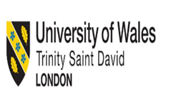

HEALTH, WELLBEING AND SUSTAINABLE DEVELOPMENT BMHP6021

NAME: JOHNSON BABATUNDE AKEJU
STUDENT I.D 1919481
LECTUREER: DIOLA D.

FEBUARY 2023

4 sub 3,991

Table of Contents

Introduction 3
Briefly discuss the 17 Sustainable Development Goals 3
Discuss Goal 3, Goal 4, Goal 17 12
Goal 3: Ensure Healthy Lives and Promote Well-Being for All At All Ages 12
Target Of Goal 3: 13
Goal 4: Quality Education 13
The Target of Goal 4: 14
Goal 17 Revitalize the Global Partnership for Sustainable Development 15
Introduction of Identified City/Borough -Enfield 16
UK Policies and Initiatives identified to Meet the 3 SDGs 16
Local policies Enfield city identified to meet the 3 SDGs and Reviewed the status of the city/borough to meet the 3 SDGs 19
Improvement of SD goals and recommendation 21
Conclusion 23
Reference list 24

Introduction
The World Health Organisation – WHO in 1948 described that health is a part of the mental, social, and physical state which is the absenteeism of sickness. This sustainable development goal was approved in 2015 for some areas of development goals with a target to be fulfilled within 2030. Equal education for all children and partnership with global and sustainable development are combined with the main two data of effort gathering (De Neve, and Sachs, 2020). The Sustainable Developmental Goal -SDG Index is an index of how much progress nations are making towards achieving their development goals (SDG). The Sustainable Wellbeing - SWB is a survey that looks at how well people feel about the worth of their lives and measures subjective well-being. (De Neve, and Sachs, 2020).
This report uses data from the Gallup World Poll, which includes responses from 98% of the world's people. The SDG guide is broken down into its 17 component objectives in the following part, where it is examined how each goal relates to well-being differently (SDG, 2019). This report mainly talks about the Borough of Enfield and its status on Sustainable Development Goals- SDG.

The 17 Sustainable Development Goals
The sustainable development goal is an Agenda for development which is adopted by the United Nation for 2030. This will consist of 169 targets with 17 goals (The Trustees of Indiana University; 2022). The goals are discussed in this paragraph bellow.

- Goal 1: No Poverty
The global eradication of absolute poverty by the year 2030 is one of the key goals of the 2030 Agenda for “Sustainable Development”. Between 2015 and 2018, there was a significant decline in global poverty, with the rate of poverty falling from 10.1% to 8.6%. Three years of progress were undone when the COVID-19 epidemic triggered a dramatic increase in the global poverty rate. Between 2015 and 2018, the percentage of people living in poverty all around the world decreased from 10.1% to 8.6%. (United Nations,2022)
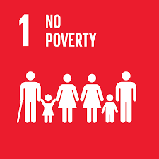
Fig1: Goal 1
(United Nations,2022)
- Goal 2: Zero Hunger
In 2030, the universe must always be rid of hunger, thus according to Sustainable Development Goal 2. About 720 million and 811 million people were starving in the globe in 2020, a rise of about 161 million concluded the previous year. A surprising 2.4 billion people were also food insecure in 2020. (United Nations,2022)
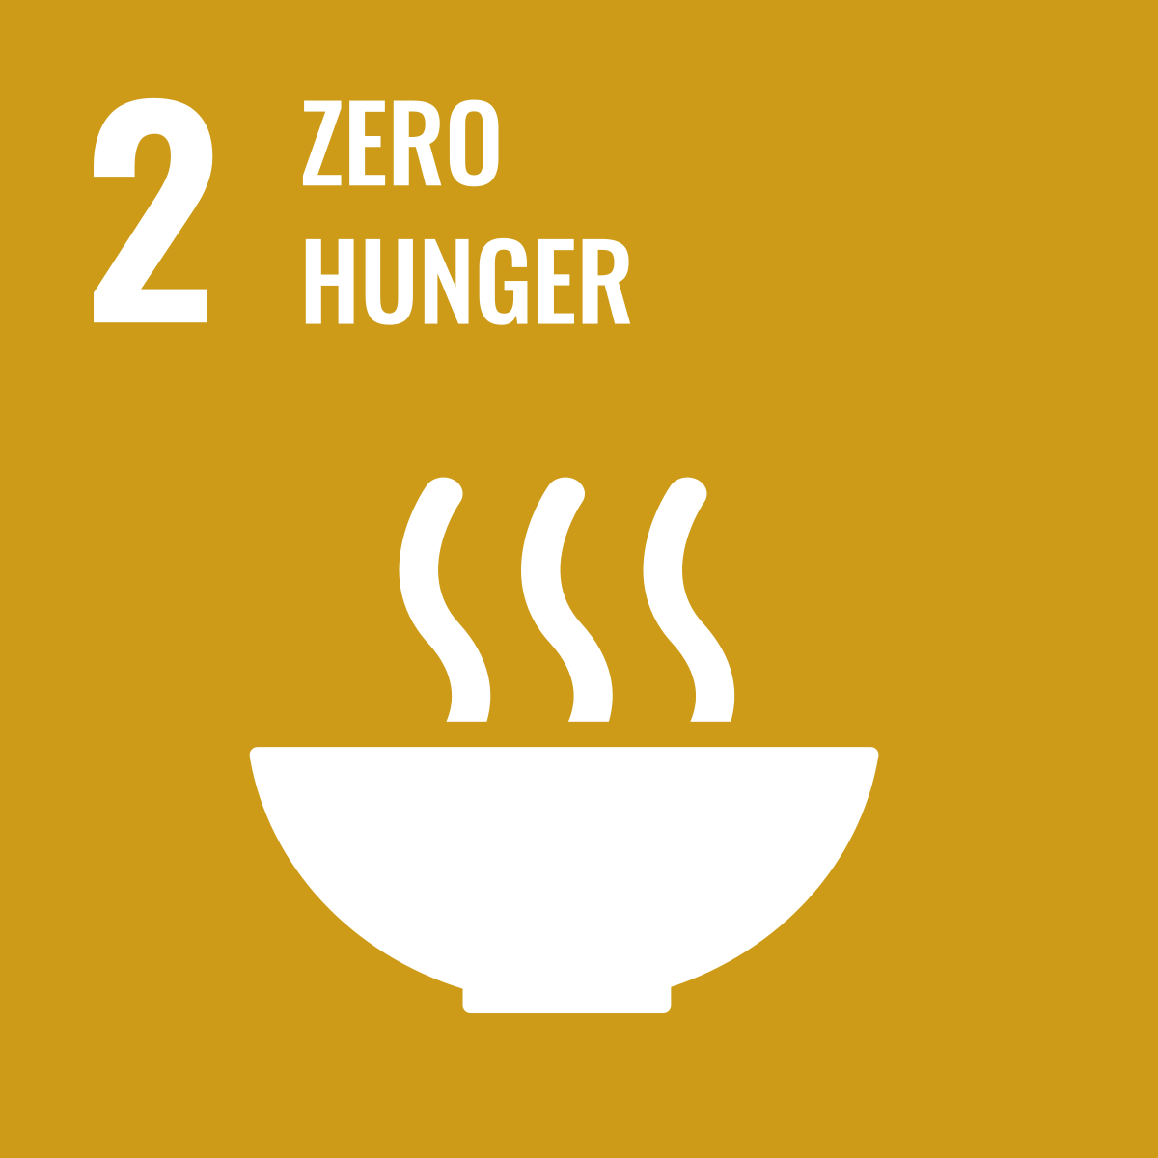
Fig2: Goal 2
(United Nations,2022)

- Goal 3: Good Health and Well Being
The COVID-19 epidemic is still spreading suffering among people. The most recent estimates indicate that by the end of 2021, there may have been as many as 15 million global "excess fatalities". The pandemic has severely interrupted vital health services, leading to a rise in the pervasiveness of anxiety and despair. (United Nations,2022).
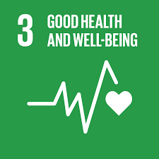
Fig3: Goal 3
(United Nations,2022)

- Goal 4: Quality Education
The ten purposes of “Sustainable Development Goal 4” include a wide range of educational topics. Seven objectives’ outcomes, three objectives of reaching these aims are set forth. SDG 4 contains three modalities of implementation, seven targets, and the mission of "ensuring inclusive and equitable quality of education and development can help for lifelong learning for all." (United Nations,2022)
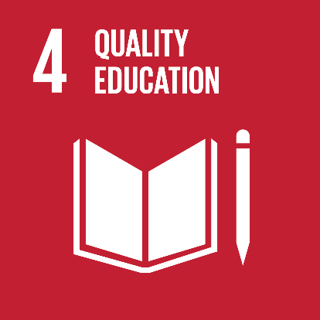
Fig4: Goal 4
(United Nations,2022)

- Goal 5: Gender Equality
The “Sustainable Development Agenda,” which “UN Member” States endorsed in 2015, established a limit of 2030 for equality and the empowerment of all women and girls. With only ten more years to accomplish it. The increasing global reaction against women's rights threatens even deeply in the independence and laws. (United Nations,2022)
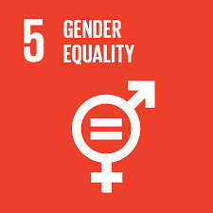
Fig5: Goal 5
(United Nations,2022)

- Goal 6: Clean Water and Sanitation
Access to sanitary facilities, such as clean water and toilets, is a basic requirement for optimal well-being and health. By 2030, billions of people would lack contact with these basic services if progress does not quadruple. There is an increase in water demand because of urbanisation, rapid population growth, and higher water needs from industry, agriculture, and the energy sector. (United Nations,2022)
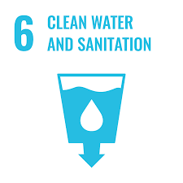
Fig6: Goal 6
(United Nations,2022)

- Goal 7: Affordable and Clean Energy
Development of the human and financial species is delayed by Solar, hydropower, wind, thermal, biofuels, coal, natural gas, petroleum, and nuclear are just a few of the sustainable and non-renewable sources of energy that the atmosphere offers. Climate change's global consequences will result from greater fossil fuel use without steps to reduce emissions of greenhouse gases. (United Nations,2022)
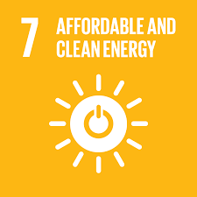
Fig7: Goal 7
(United Nations,2022)

- Goal 8: Decent Work and Economic Growth
Progress, the development of decent jobs for everybody, and better living standards can all be supported by inclusive and sustainable economic growth. The world economy is in peril and COVID-19 has impacted the lives of billions of people. The International Labour Organization believes that closely half of the world's workers look at the threat of losing their jobs as job losses increase. (United Nations,2022)
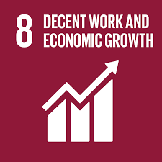
Fig8: Goal 8
(United Nations,2022)

- Goal 9: Industry, Innovation, and Infrastructure
Infrastructure development and innovation, combined with inclusive and sustainable industrialization, have the potential to unleash competitive and dynamic financial forces that generate revenue and employment. They play a serious role in the introduction and promotion of new technologies, in promoting international trade, and in allowing the effective use of resources. (United Nations,2022)
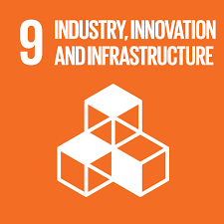
Fig9: Goal 9
(United Nations,2022)

- Goal 10: Reduce Inequality
Reaching the “Sustainable Development Goals” this rest on reducing dissimilarity and making sure no one is left behind. A constant source of concern is inequality within and between nations. Although some encouraging data suggests inequality is declining in some sectors, such as a fall in the relative wealth gap in some nations and favoured some trading status for lower-income nations, but inequality still exists. (United Nations,2022).
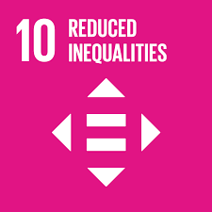
Fig10: Goal 10
(United Nations,2022)
- Goal 11: Make Cities Sustainable
Urbanization is spreading throughout the planet. The percentage of people living in cities has increased to more than 50% since 2007, and by 2030, that percentage is expected to reach 60%. With nearly 60% of the world's GDP coming from cities and urban areas, they are the engines of economic growth. (United Nations,2022)
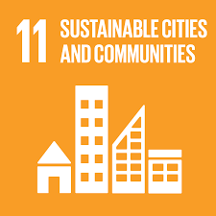
Fig11: Goal 11
(United Nations,2022)

- Goal 12: Ensure sustainable consumption and production patterns
The global economy's primary drivers of consumption and production, which endure having bad impacts on the environment and resources, these are global manufacturing and consumption. (United Nations,2022)
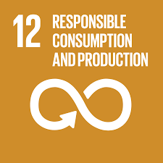
Fig12: Goal 12
(United Nations, 2022)

- Goal 13: Climate Action
The period from 2010 to 2019 (which was the hottest on record) came to an end with 2019 being the 2nd warmest year ever. 2019 saw record-breaking increases in atmospheric carbon dioxide (CO2) and other greenhouse gas emissions. Every nation and continent is being affected by climate change and extreme weather occurrences and weather patterns are altering. (United Nations,2022)
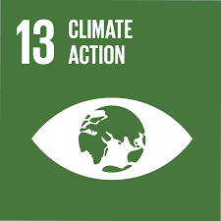
Fig13: Goal 13
(United Nations,2022)

- Goal 14: Life Below Water
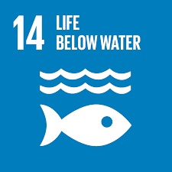
The ocean powers the world organisations that keep human life on Earth possible. The sea ultimately provides and controls everything necessary for survival, counting rainwater, climate, drinking water, coastlines, food, and even the oxygen in the air to breathe. This also has a detrimental effect on small-scale fisheries. (United Nations,2022)

Fig14: Goal 14
(United Nations,2022)

- Goal 15: Life on Land
The 2019 Global Evaluation Report on Ecosystem and Biodiversity Service estimates that about 1 million types of animals and plants are in danger of going extinct, many more of them within the next few years. It was found that the ecosystems, which are the basis of saving, livelihoods, health, and excellence of life worldwide, are failing more quickly than ever. (United Nations,2022)
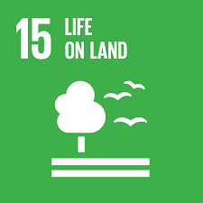
Fig15: Goal 15
(United Nations,2022)

- Goal 16: End Poverty in All Its Forms Everywhere
The United Nations Health and Children right - UNHCR saw the highest number of refugees in 2018 more than 70 million in nearly 70 years. They were fleeing war, oppression, and conflict. In 2019, there were 357 murders of journalists, union leaders, and supporters of individual rights across 47 countries, and there were 30 forced enforced disappearances. (United Nations,2022)
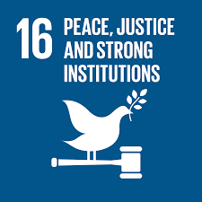
Fig16: Goal 16
(United Nations,2022)
- Goal 17: Global Partnership for Sustainable Development
For a development agenda to be successful, inclusive partnerships are needed at the international, national, and local levels. These partnerships must be created on shared values and morals, as well as a collective vision and common objectives that put people and the environment at the centre. (United Nations,2022)
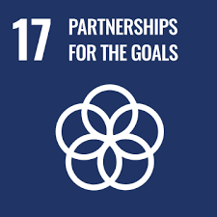
Fig17: Goal 17
(United Nations,2022)

Discuss Goal 3, Goal 4, Goal 17

Goal 3: Ensure Healthy Lives and Promote Well-Being for All at All Ages
Making sure people live healthy lives and improving comfort for all ages is vital to “sustainable development”. Presently, the globe is being plagued by a worldwide health disaster unlike any other: COVID-19 is destroying the lives of billions of people, bringing about economic instability, and escalating agony. Several of the major issues conducive to child and maternal death have reduced, and life expectancy has grown dramatically. (United Nations,2022)
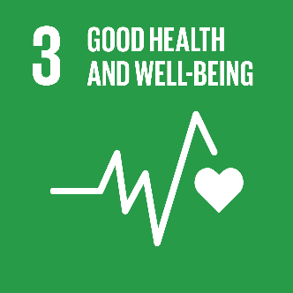
Fig 18: Goal 3
(United Nations; 2022)

Target Of Goal 3: Good Health and Well Being
- The rate of maternal deaths must be less than 70 for million live births.
- Boost efforts to prevent and treat substance abuse, particularly challenging alcohol consumption and the use of harmful drugs.
- Reduce the death rate below age 5.

Goal 4: Quality Education
The secret to escaping poverty is education that promotes social economic mobility. Significant progress has been made in the past 10 years, especially for females, to expand access to education and school enrolment rates. Additionally, half the number of students are not reaching the basic education of analysis and arithmetic. In 2020, as the COVID-19 pandemic lengthened over the globe, most nations broadcasted a complete lockdown which affected more than 91% of children in education globally. (United Nations,2022)
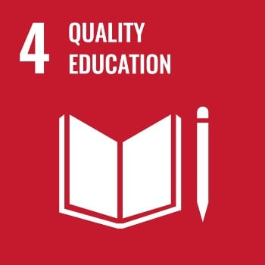
Fig 19: Goal 4
(United Nations; 2022)

The Target of Goal 4:

Assure that, by 2030, boys and all girls get a complete free primary and secondary education, are democratic, and provide effective knowledge outcomes that support Goal 4.
- Assuring that every child can use high-quality pre-primary schooling by the year 2030 will help them to prepare for primary school.
- By the year 2030, significantly, more children and adults will own the technical and professional skills required for service, respectable employment, and free enterprise.
- Remove gender disparities in schooling by 2030 and ensure that all marginalized assemblies, such as people with indigenous disabilities, and families living in unstable conditions, have fair admission to all levels of schooling and training.

Goal 17 Revitalize the Global Partnership for Sustainable Development
For the Sustainable Development Plan - SDGs to be implemented, there must be strong international collaboration and partnerships. A successful development strategy requires inclusive partnerships based on shared values and ethics, as well as a common idea and common goals that place persons and the environment at the canter. These partnerships must be formed at the local, regional, national, and global levels. To promote trade and economic growth, several nations require Official Development Assistance - ODA. Strong global collaboration is more important than ever to give nations the properties they need to improve from the pandemic, reconstruct properly, and reach Sustainable Development Goals. (United Nations; 2022)
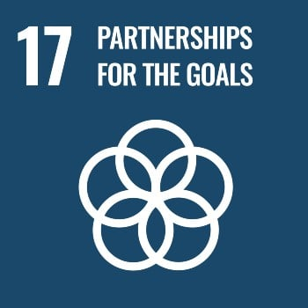
Fig 20: Goal 17
(United Nations; 2022)

The Target for Goal 17:

To strengthen domestic resource mobilization and domestic tax and other revenue collection capacity, particularly through international aid to developing countries.
- Adopt and implement least developed country investment promotion regimes.
- Help evolving nations to influence long-term debt sustainability over combined strategies.
- Developed countries should fully adhere to their commitments to provide official development assistance, such as the target of distributing 0.7% of their GDP (gross domestic product) to rising countries and 0.15–0.20% to the minimum developed countries.

- Introduction of Identified City/Borough – Enfield.
Here the London Borough of Enfield has been chosen to explain Sustainable Development Goals - SDGs. This already had the winning award of the Beacon Press and earned the inaugural Environment Business Outstanding Achievement Award at the Corporation of London's Liveable City Awards in 2005. (Sustainability programme and action plan 2 contents. n.d.). The Council's goal is to make Enfield an improved place to live and work by promoting equity, development, and sustainability, as well as strong communities. Its innovative approach is to place shaping which can be seen in its delivery successes, which include the first Council Housing development in 30 years at Dujardin Mews (with hundreds more in the pipeline), 36hectars of land acquisitions and a new station on site as part of the 10,000 home Meridian Water development, a £58m investment in its own energy company 'energetic,' the first phase of demolition for the 1,000 home £150m Alma Estate redevelopment underway, and a range of award-winning designs across. [online] Available at: https://governance.enfield.gov.uk/documents/s36634/4Enfield%202020%20Sustainability%20Programme%20final.pdf [Accessed 28 Nov. 2022].

UK Policies and Initiatives identified to Meet the 3 SDGs
The three main pillars of “sustainable development” are ecological sustainability, social sustainability, and economic sustainability, and require that everyone lives within their means and develops all their resources (De Neve, J.E. and Sachs, J.D., 2020). This includes all elements of the built environment as well as the natural world, all of which are vital to our health, equality, and general well-being. The department of education in the UK is the head of Early childhood service and academics, involving schools, higher and additional education policy, internships, and extended skills. Raising the bar on education will ensure that kids and teens have the skills, information, and credentials they need, no matter where they live in the nation (Public Health England, 2020). The UK was the first to negotiate for the SDGs and they will also be the first to deliver it. The UK strived hard for the SDGs programme to support further the work of the MDGs. The Uk support schools and colleges including Enfield in developing the character and wellbeing of pupils. They also improve the wellbeing of the people, including the Children, and the Mental Health Programme with Public Health England and NHS England. (NHS,2022)
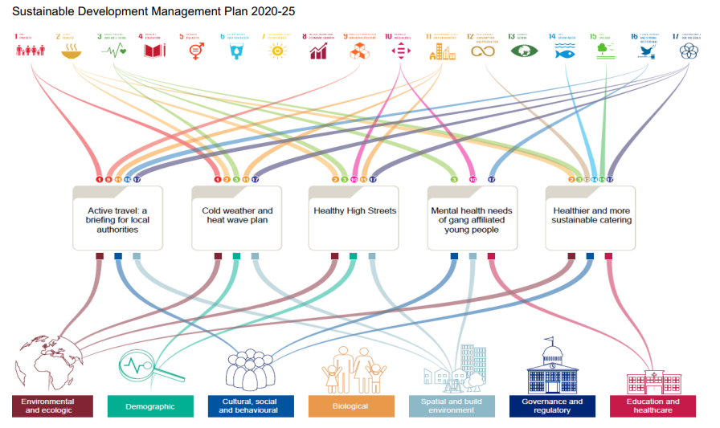

Fig 21: Sustainable Development Plan
(GOV.UK 2021)

Below the discussion will be the “Sustainable Development Goals” that have remained taken and implemented by the UK Government.
GOAL 4 – Quality Education will be the driving factor in unlocking UK's potential and restoring improvement following the coronavirus This document outlines our plans to stimulate economic recovery, boost academic quality across the community, offer children the fullest good start in life, and equal the playing field for everyone (Abad-Segura et al., 2020). Over the coming fiscal year, our engagement will achieve a significant, demonstrable advance toward four precision strikes (Abad-Segura et al., 2020).
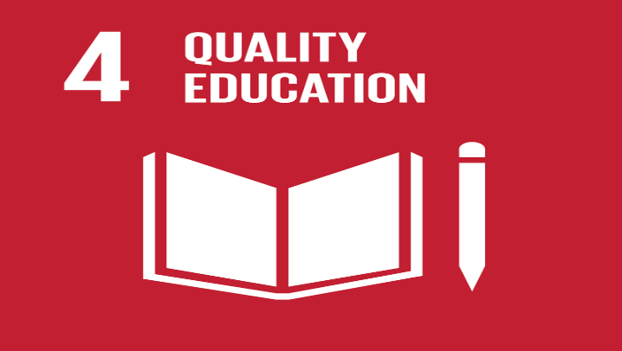
Fig 22: Goal 4 Quality Education
(Abad-Segura et al., 2020)
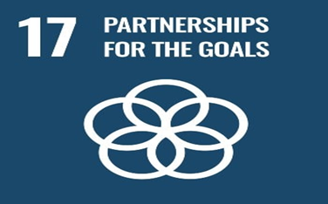
The depart of education in the UK is the head of Early childhood service and academics, involving schools, higher and additional education policy, internships, and extended skills. Raising the bar on education will ensure that kids and teens have the skills, information, and credentials they need, no matter where they live in the nation (Public Health England, 2020). To ensure that no one is left behind, provide high-quality local services to assist the most underprivileged and at-risk children and adolescents. Give children the best jump in life by providing high-quality early instruction and care to raise values and make it easier for parents to work. (Leal Filho et al., 2018).

FIG 23: GOAL 17 PARTNERSHIP
(United Nations; 2022)
GOAL 17: Through the “National Institute for Health Research” (NIHR), the main funder of health and care exploration in the country, the Department of Health, and Human Services (DHHS) makes significant investments in research and development. The world's most comprehensive system for health research is made up of our people, initiatives, centres of excellence, and infrastructure. The principal external mechanism for making solid indications to drive policy creation and application, including policy evaluation, and exploration to cover long-term indication needs and gaps, the NIHR devotes more than £33 million annually to the devoted “Policy Research Programme” (PRP). The NIHR- PRP is made up of 15 policy explore parts, the bulk of which are housed in universities and all of which are equipped with assessment tools. The fact that these units are self-contained promotes academic rigour and openness in the ratings of SSGs. (www.gov.uk. 2020).
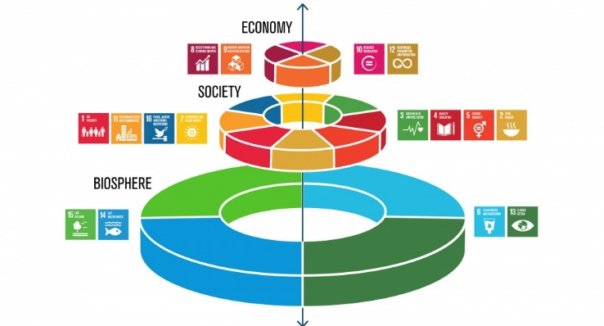
Fig 23: Sustainable Development Goals 3
GOOD HEALTH & WELBEIGN
(Public Health England, 2020)
The United Kingdom has been at the front of international partnerships' exertions to support a robust Agenda 2030, and it is an active and powerful member of several international forums. The agenda will be carried out. It is clearly in the national interest to export economic success, security, and stability (Daniela et al., 2018). It will continue to invest in partner nations' capacity to create and distribute data more effectively utilising digital technologies, as well as to capitalise on original databases from the business sector and civil culture. (Imerai, 2022).
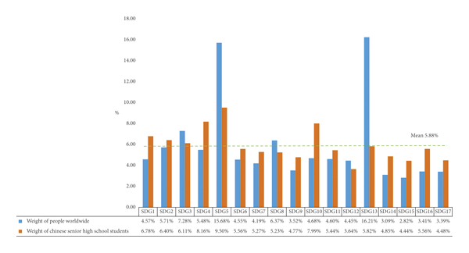
Fig 24: Sustainable growth in the UK
(www.gov.uk. 2020)

Local policies Enfield city identified to meet the 3 SDGs and Reviewed the status of the city/borough to meet the 3 SDGs
SDG 4: The Enfield 2020 “Sustainability Programme” and Action Plan are coordinated and supported by the “Council's Sustainability Service”. This is particularly crucial considering ongoing financial restrictions on local government and the requirement to preserve the level of services provided by the Council. To effect radical change in schools and colleges, Enfield 2020 has the essential support from the government, “programme management” processes, and local leadership. All Enfield stakeholders will benefit significantly from this when it is combined with effective stakeholder engagement and behaviour modification.
SDG 17: (Partnership) They utilize established “project management” techniques to transport together the vast array of sustainability ideas and action plans already in existence. Make use of interactions to offer charges for money, give bigger rewards than the total of all your efforts. Make it possible for the Council to execute current and future strategic sustainability programmes that: Emphasize sustaining the economy and investing in Enfield with the help of sustainable funding. By setting an illustration and creation it easy for others to act, the Council should make use of its special position as a "Coordinating Council." Ensure that all Enfield stakeholders receive the greatest possible economic, environmental, and social benefits. Enhance living, working, studying, and visiting conditions in Enfield. To help with the implementation of Enfield 2020, the Council will work carefully with the Enfield Strategic Partnership and the “Greater London Authority”. Create a self-funding model for Enfield 2020 to ensure that it more than pays its programme administration expenditures. Service for Sustainability, granting local, national, and international legitimacy and recognition. Much more work is needed to fulfil the SDGs by 2030, primarily by national governments in Enfield through policy and money. GOV.UK (2021).
SDG 3: The city of Enfield must provide SDGs in public health and wellbeing. An active health check programme is being implemented throughout the borough, to improve disease diagnosis and prevention. The 'Changing Habits in Enfield Families' (CHEF) programme is being moved out in Enfield to decrease obesity and is likely to influence about 400 families. Enfield 2020 will be made a reality through cooperation between Enfield Strategic Partnership and the “Greater London Authority”. Enfield 2020 delivers the framework for a strategy to do this, with a focus on financial sustainability. Enfield 2020 puts more emphasis on "What's in it for me?" a programme that make the best use of the planned limited resources. Enfield 2020, therefore, flips this narrative, putting more of an emphasis on cost savings, creating local jobs, reducing waste, improving the local environment, and improving public health. GOV.UK (2021).

Improvement of SD goals and recommendation
There is various way to improve the Sustainable Development Goals -SDGs in Enfield borough in the UK. Here are some recommendations for the development.
The Business Energy and Industrial Strategy-BEIS is very much prepared in creating a stronger, fairer, and successful future in Enfield and the in the United Kingdom at large, inclusive shared prosperity, growth and levelling up across all organisations. The great Mission is being ahead of all Britain’s Recovery, which will promote the work as we move on to conquer all obstacles before us in Enfield. For the coming year in Enfield, we will continue to focus on fighting coronavirus through our work to support businesses and workers through the pandemic and recovery, and, together with the Department for Health and Social Care, the continued development and supply of effective COVID-19 vaccines in the UK and overseas.
Beyond this, the Department’s longer-term portfolio focuses on crucial work to tackle climate change at home and abroad and reach net zero UK carbon emissions by 2050. Unleashing innovation across the country and helping the UK become a global science superpower, backing long-term growth and boosting enterprise by making the UK a great place to work and to start and grow a business, including delivering an improved national security and investment regimen.

- Recommendation for G3 Health and well-being Sector Development
As individuals seek new methods to participate in their health and well-being, technology and digital advances provide opportunities for advancement. These provide the possibility to alter the Health Check in all areas in Enfield, including accessibility, conduct, and delivery. (Department for education, 2021). Importantly, a digital solution for the programme enables the intended 2-way contact, and integration with other present and future services (such as obesity, and lung COVID). It also aim to minimise vulnerabilities, and promotes preparedness, surveillance and response to health emergencies that will prevent and reduce the health impacts of environmental emergencies.

- Recommendation for G4 Education Sector Development
The Govt. should keep responsibility for the 2019 strategy's goals of enhancing the value of our educational exporting to £35 billion per year and accommodating at least 600,000 overseas students in Enfield. They must follow the goal of achieving both by 2030. This update will outline how the government will aid the sector's transition from recovery to sustainable growth of good education standards. (Gov.uk (2021).
- Recommendation for G17 Global Partnership
To promote the SDGs to a large finance industry spectator in the UK, the UK Government should take the initiative. Powerful businessmen are openly present in Enfield. It ought to make use of the expertise of the Division for Commercial, Advancement, and Skills (BIS) and “UK Trade and Investment” (UKTI) to assist the recently established Business and Sustainable Development Commission in building a solid business case for remote sector participation in the Goals. The Group supports the “International Development” (Official Development Assistance) Act 2015, which needs the administration to apply 0.7% of the UK GNP on ODA
- Recommendation for G17 sustainable development
The “Sustainable Development Goals” are 169 goals that cover a wide variety of challenges impacting simultaneously on developed and developing counties. Poverty, inequality, climate change, inclusive communities, and access to education and health care are almost all challenges to be addressed. The primary commitment of the Goals is to ensure that development progress reaches the most marginalised and vulnerable communities. Enfield is accountable for completing the Goals both internationally and locally. The UK govt. must be aware of the development of the overall country. (Gov. UK 2019).

- Conclusion
In the conclusion of this report, it has been seen that to investigate the relationship between human development and comfort, equal education for all children and collaboration with global and sustainable development are combined with the main two data of effort gathering. It also describes that the borrow city of Enfield is highly appreciated by its SDGs programme as mentioned throughout the report. This report had been discussed with each goal relates to well-being and global partnership with sustainable development as it being examined. The key three objectives, such as goal 3, goal 4, and goal 17, are briefly listed among the 17th Sustainable Development Goals. Even though this report focuses on a few goals, it also depicts different initiatives implemented by the UK government. Some recommendations are also included in this report.

Reference list

Abad-Segura, E., González-Zamar, M.D., Infante-Moro, J.C. and Ruipérez García, G., 2020. Sustainable management of digital transformation in higher education: Global research trends. Sustainability, 12(5), p.2107.
Daniela, L., Visvizi, A., Gutiérrez-Braojos, C. and Lytras, M.D., 2018. Sustainable higher education and technology-enhanced learning (TEL). Sustainability, 10(11), p.3883.
De Neve, J.E. and Sachs, J.D., 2020. Sustainable development and human well-being. World happiness report, 112, p.127.
Department for Education (2021). DfE Outcome Delivery Plan: 2021 to 2022. [online] GOV.UK. Available at: https://www.gov.uk/government/publications/department-for-education-outcome-delivery-plan/dfe-outcome-delivery-plan-2021-to-2022.
Gov. uk (2019). UK Voluntary National Review of Progress Towards the Sustainable Development Goals - GOV.UK. [online] www.gov.uk. Available at: https://www.gov.uk/government/topical-events/uk-voluntary-national-review-of-progress-towards-the-sustainable-development-goals.
GOV.UK (2021). Implementing the Sustainable Development Goals. [online] GOV.UK. Availableat:https://www.gov.uk/government/publications/implementing-the-sustainable-development-goals/implementing-the-sustainable-development-goals--2.
Imerai, F. (2022). Explaining the attainment gap, and education inequality in the UK. [online] Action Tutoring. Available at: https://actiontutoring.org.uk/explaining-the-attainment-gap-and-education-inequality-in-the-uk/?gclid=CjwKCAiAmuKbBhA2EiwAxQnt79NfoQr2Xf1reOB1x70-L7co06d50zhbvwgrvB5E4QHhHSbmBE_rWxoCwzQQAvD_BwE [Accessed 19 Nov. 2022].
Jones, P. and Comfort, D., 2020. A commentary on the localisation of the sustainablement goals. Journal of Public Affairs, 20(1), p.e1943.
Leal Filho, W., Raath, S., Lazzarini, B., Vargas, V.R., de Souza, L., Anholon, R., Quelhas, O.L.G., Haddad, R., Klavins, M. and Orlovic, V.L., 2018. The role of transformation in learning and education for sustainability. Journal of cleaner production, 199, pp.286-295.
Leal Filho, W., Raath, S., Lazzarini, B., Vargas, V.R., de Souza, L., Anholon, R., Quelhas, O.L.G., Haddad, R., Klavins, M. and Orlovic, V.L., 2018. The role of transformation in learning and education for sustainability. Journal of cleaner production, 199, pp.286-295.
Making development co-operation more effective: How development partners are promoting effective, country-led partnerships. (n.d.). [online] Available at: https://www.oecd.org/dac/effectiveness/Part-II-of-the-Global-Partnership-Progress-Report.pdf.
Public Health England (2020). Sustainable Development Management Plan 2020/25. [online]Availableat:https://assets.publishing.service.gov.uk/government/uploads/system/uploads/attachment_data/file/907192/PHE_SDMP_2020_25-2.pdf.
SDG, U., 2019. Sustainable development goals. The energy progress report. Tracking SDG, 7.
Sustainability programme and action plan 2 contents. (n.d.). [online] Available at: https://governance.enfield.gov.uk/documents/s36634/4Enfield%202020%20Sustainability%20Programme%20final.pdf [Accessed 28 Nov. 2022].
The Trustees of Indiana University; 2022; Sustainable Development Goal, [Online] Available At: https://sdg.iupui.edu/about/introduction-to-the-sdgs [Accessed On: 19/11/2022]
UN WOMEN,2022; In focus: Sustainable Development Goal 5 [Online] Available At: https://www.unwomen.org/en/news-stories/in-focus/2022/08/in-focus-sustainable-development-goal-5 [accessed on: 27/11/2022]
United Nations,2022; Goal 1: End poverty in all its forms everywhere [Online] Available At: https://www.un.org/sustainabledevelopment/poverty/#:~:text=Eradicating%20extreme%20poverty%20for%20all,2030%20Agenda%20for%20Sustainable%20Development [accessed on: 27/11/2022]
United Nations,2022; Goal 10: Reduce inequality within and among countries [Online] Available At: https://unric.org/en/sdg-10/ [accessed on: 27/11/2022]
United Nations,2022; Goal 11: Make cities inclusive, safe, resilient, and sustainable [Online] Available At: https://unric.org/en/sdg-11/ [Accessed On: 27/11/2022]
United Nations,2022; Goal 12: Ensure sustainable consumption and production patterns [Online] Available At: https://unric.org/en/sdg-12/ [accessed on: 27/11/2022]
United Nations,2022; Goal 13: Take urgent action to combat climate change and its impacts [Online] Available At: https://unric.org/en/sdg-13/ [accessed on: 27/11/2022]
United Nations,2022; Goal 14: Conserve and sustainably use the oceans, seas and marine resources [Online] Available At: https://unric.org/en/sdg-14/ [accessed on: 27/11/2022]
United Nations,2022; Goal 15: Sustainably manage forests, combat desertification, halt and reverse land degradation, halt biodiversity loss [Online] Available At: https://unric.org/en/sdg-15/ [Accessed On: 27/11/2022]
United Nations,2022; Goal 16: End poverty in all its forms everywhere [Online] Available At: https://unric.org/en/sdg-16/ [accessed on: 27/11/2022]
United Nations,2022; Goal 17: Revitalize the global partnership for sustainable development [Online] Available At: https://unric.org/en/sdg-17/ [Accessed On: 27/11/2022]
United Nations,2022; Goal 2: Zero Hunger [Online] Available At: https://www.un.org/sustainabledevelopment/hunger/ [accessed on: 27/11/2022]
United Nations,2022; Goal 3: Ensure healthy lives and promote well-being for all at all ages [Online] Available At: https://www.un.org/sustainabledevelopment/health/#:~:text=Goal%203%3A%20Ensure%20healthy%20lives,for%20all%20at%20all%20ages&text=Ensuring%20healthy%20lives%20and%20promoting,continues%20to%20spread%20human%20suffering [accessed on: 27/11/2022]
United Nations,2022; Goal 6: Ensure access to water and sanitation for all [Online] Available At: https://www.un.org/sustainabledevelopment/water-and-sanitation/#:~:text=Goal%206%3A%20Ensure%20access%20to%20water%20and%20sanitation%20for%20all&text=Access%20to%20safe%20water%2C%20sanitation,in%202030%20unless%20progress%20quadruples [accessed on: 27/11/2022]
United Nations,2022; GOAL 7: Affordable and clean energy [Online] Available At: https://www.unep.org/explore-topics/sustainable-development-goals/why-do-sustainable-development-goals-matter/goal-7#:~:text=Target%207.,infrastructure%20and%20clean%20energy%20technology [Accessed On: 27/11/2022]
United Nations,2022; Goal 8: Promote inclusive and sustainable economic growth, employment and decent work for all [Online] Available At: https://unric.org/en/sdg-8/#:~:text=Goal%208%3A%20Promote%20inclusive%20and,and%20endangered%20the%20global%20economy [Accessed On: 27/11/2022]
United Nations,2022; Goal 9: Build resilient infrastructure, promote sustainable industrialization, and foster innovation [Online] Available At: https://unric.org/en/sdg-9/ [accessed on: 27/11/2022]
United Nations,2022; The 2030 Agenda for Sustainable Development [Online] Available At: https://www.sdg4education2030.org/the-goal [Accessed on: 27/11/2022]
United Nations; 2022; Department of Economic and Social Affairs Sustainable Development [Online] Available At: https://sdgs.un.org/goals [Accessed On: 19/11/2022]
United Nations; 2022; Ensure inclusive and equitable quality education and promote lifelong learning opportunities for all [Online] Available At: https://sdgs.un.org/goals/goal4 [Accessed On: 19/11/2022]
United Nations; 2022; strengthen the means of implementation and revitalize the global partnership for sustainable development. [Online] Available At: https://www.globalgoals.org/goals/17-partnerships-for-the-goals/ [Accessed On: 19/11/2022]
WHO,2022; Sustainable Development Goals; [Online] Available At: https://www.who.int/europe/about-us/our-work/sustainable-development-goals [Accessed On: 19/11/2022]
www.gov.uk. (2020). Welcome to GOV.UK. [online] Available at: https://www.gov.uk/government.

