Energy in a Flywheel
Author: Iriney Georgiev 190719
1
Contents:
1 Experimental procedure: 4
1.1 Experimental steps: 4
1.2 Storing energy: 4
1.3 Surroundings: 5
2 Results: 6
3 Analysis: 7
3.1 Total moment of inertia: 7
3.2 Graph relationship: 8
3.2.1 Calculating inertia: 8
3.2.2 Percentage error: 8
4 Evaluation: 9
4.1 Human errors: 9
4.2 Shaking effect: 9
4.3 Calculations: 9
4.4 Environment: 9
5 Further work: 10
5.1 Data: 10
5.2 Equipment: 10
6 Conclusion: 11
6.1 Storing energy: 11
6.2 Potential energy loss: 11
6.3 Comparing the experimental and theoretical moment of inertia: 11
7 References: 12

2
Iriney Georgiev

Introduction:
The main purpose of this experiment is to prove the flywheel can store energy. The Flywheel experiment consists of a large disc which is fixed to a revolving shaft on a horizontal axis. A fixed mass is attached to a cord and wrapped around the flywheel axle. Theoretically when the mass is dropped, from a certain height, its gravitational potential energy(PE) acts downwards until the cord is fully extended. Meanwhile a rotational kinetic energy is translated on the revolving shaft and the flywheel is turning. When the mass reaches its bottom phase the kinetic energy stored into the flywheel starts acting on the masses. As a result, the mass moves in an upwards direction until it reaches a height where the stored energy is not strong enough.
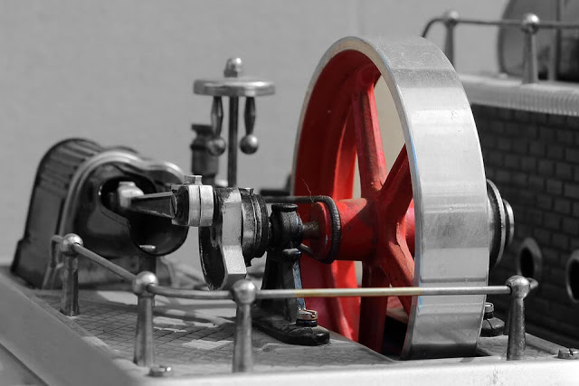
Figure 1:A basic example of a flywheel; (MECHOLIC, 2016)
Iriney Georgiev
3

Experimental procedure:

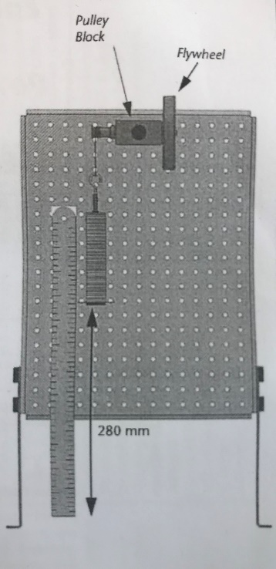
Experimental steps:
Figure 2: An image showing the ideal set up for the experimental procedure; (TecQuioment, 2012)
In order to set up this experiment a pulley block and a flywheel have to be mount to a work panel. Then a cord is attached to the flywheel pulley and a weight hanger, which must have a plastic guide fit to its bottom. Make sure that the bottom of the weight hanger can travel through a vertical drop of just under 290mm. Locate a magnetic ruler, 300mm long, behind the weight hanger as its 0mm edge is in line with the plastic guide.
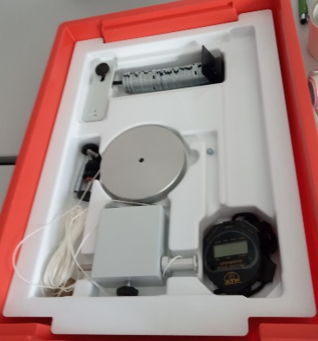
The weight hanger has a weight of 10g, by adding 90g masses the experiment starting total weight would be 100g. Next step is to set up the flywheel as the bottom of weight hanger has to be 280mm on the ruler. Stop watches are used to determine the time, in seconds, for the weight hanger to fall from its starting position to 0mm and back up to its maximum height. A specific person must watch the height which the weight hanger’s bottom reaches when it is coming back to its original position. Therefore, each trial should be made several times so the average values can be more accurate. (TecQuioment, 2012)
Figure 3: The equipment which is given to make the flywheel experiment (Georgiev)
The experiment will go through several intervals of 100g difference until the weight hanger does not reach 500g total weight.

Storing energy:
Taking into account the turning force, rotational kinetic energy, which is exerted on the flywheel means it can be related to Torque, T, which will cause a constant angular velocity and acceleration. (Macharia, 2019)
$$T=Ia$$
Where: T is torque
I is moment of inertia
A is angular acceleration
A logical pattern can be seen from the formula above. As the angular acceleration is proportional to the torque hence the moment of inertia(I) is a constant. The moment of inertia occurs in this experiment only during the time when the torque, T, acts. (Harlow, n.d.)
While the torque force is turning the flywheel it can store energy. However, the flywheel needs to have a certain mass and dimension because these values would affect its mass moment of inertia using this formula: $I=\frac{mr^{2}}{2}$
Where: m is the flywheel’s mass
r is the radius of the flywheel
A flywheel with greater mass or radius will be able to store more rotational energy because more work done will be needed. The moment of inertia will be bigger and hence the torque will be bigger as well. (Mammadov, n.d.)
Iriney Georgiev
4

Surroundings:
In this experiment there are factors which have to be taken into account such as friction, air resistance and others. Therefore, the potential energy will not be equal to the kinetic energy and the bottom of the weight hanger will reach a lower height, when it is moving upwards.
$$Pe=mgh$$
However, there are two values for height which will be used in this experiment. The first one is when the weight hanger goes form the starting position to the bottom, this is the falling motion. The second value is taken from the bottom position to the top, returning motion. Then the formula for potential energy will be: $Pe lost=mgh1-mgh2$
Where: m is the mass of weight hanger
g is a constant of gravity equal to 9.8m/s
h1 is the falling motion of the weight which is constant in this experiment, 280mm
h2 is the returning motion of the weight which varies depending from the different masses

Potential energy lost is meant to be the total energy lost from the downwards and upwards movement. In order to make this calculation more precise the kinetic energy should not be taken into account. Multiplying the potential energy lost by the ratio of height hence only the potential energy acting downwards will be used: (TecQuioment, 2012)
$$Pe loss\left(adjusted\right)=\frac{Pe loss×h1}{h1+h2}$$
5
Iriney Georgiev

Results:
Using “Excel” a table of all values, needed for this experiment, can be accurately plot. As it is said before, heading 1.1, there are five trials of the experiment with different values of the mass. Time fallen is measured during the procedure as from two similar times an average is calculated for more accurate assumption. The falling distance (h1) is unchangeable in this experiment and it is equal to 280mm or 0.28m. All other values in this table are calculated due to basic physics equations.
6
Iriney Georgiev

Analysis:

Total moment of inertia:
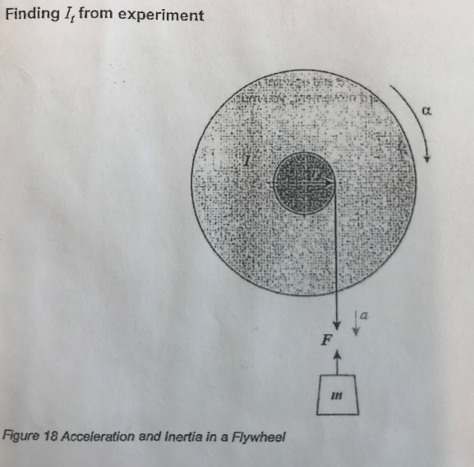
Assuming the direction of the weight hanger is going in a linear downwards direction Newton’s second law can be applied: (Pearson Education Limited, 1987)
Figure 4: This diagram shows the forces acting on the flywheel during its turning motion; (TecQuioment, 2012)
$$F=ma$$
The force (F) acting downwards must be in the same direction as the acceleration. However, looking at picture# there are two acceleration values acting on the flywheel. The formula would change like this:
$F=mg-ma$
Where: m is the mass of the weight hanger
g is the acceleration due to gravity
a is the accelerating mass
Assuming that the cord does not stretch, then the simple moment theory, the torque in this cord is equal to:
$$T=Fr$$
From where hence: $T=\left(mg-ma\right)r$
It is already known, from heading 2.2, the formula for torque is:
$$T=Ia$$
Where: a is the angular velocity

The angular velocity can be found by using:
$$a=\frac{a}{r}$$
Where: small a is the acceleration of the moving mass
R is the radius of the pulley

Then the formula of basic formula for torque can be rewritten such as: $T=I\frac{a}{r}$
Therefore, both equations for torque can be written as one: $\left(mg-ma\right)r=I\frac{a}{r}$
Using the formula, from the line above, a reasonably accurate value for the total momentum of inertia can be calculated from this experiment. (TecQuipment)
$I=\frac{\left(mg-ma\right)r}{m/r}$ or $I=\frac{(mg-ma)r^{2}}{m}$
7
Iriney Georgiev

Graph relationship:

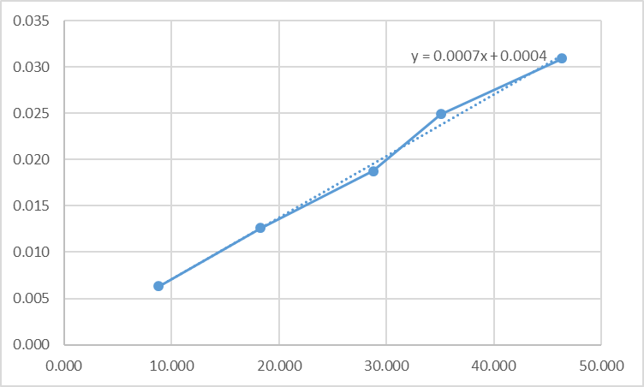
The gradient of this graph will be:
$$Gradient=\frac{change in \left(mg-ma\right)r}{change in m/r}$$
In this case” Excel” has an automatic option which can plot a scaler graph based on specific results. Another feature calculates and illustrates an equation of the curve.
It is known that an equation of a curve looks like:
$$y=mx+c$$
Where: m is the gradient of the graph
c is the point where the line touches the y-axis
x and y are the coordinates the line passes through

Calculating inertia:
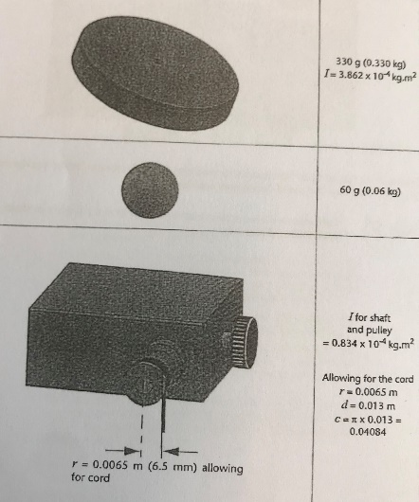
Using the equation from section 3.1 hence the gradient will be equivalent to inertia. However the experimental value of the mass moment of inertia is: $I=graident×radius of the pulley$
Figure 5:A page from the procedure book which provides the needed information to find the theoretical moment of inertia; (TecQuioment, 2012)
$$I=7×{10}^{-4}×0.0065$$
$$I=4.55×{10}^{-6}kg.m^{2}$$
In this procedure a specific book is given in order to make the experiment. A page shows the theoretical values for the flywheel and the pulley. Therefore, both values must be added together and the total inertia can be calculated.
$$I=(3.862×{10}^{-4}+0.834×{10}^{-4})×0.0065$$
$$I=3.05×{10}^{-6}kg.m^{2}$$
The theoretical and experimental values of the inertia are not exactly equal. Therefore, a percentage error can be calculated in order to assume from where the difference can come from.

Percentage error:
$$Percentage error=\frac{experimental moment of inertia-theoretical moment of inertia}{theoretical moment of inertia}×100\%$$
$$Percentage error=\frac{4.55×{10}^{-6}-3.05×{10}^{-6}}{4.55×{10}^{-6}}×100\%$$
$$Percentage error=33\%$$
Some of the reasons which causes those 33% difference might be because of assumptions taken in the experimental procedure. Human errors, external forces acting on the weight and others.
8
Iriney Georgiev

Evaluation:

Human errors:
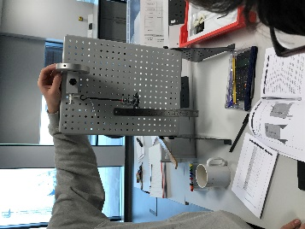
In this experiment a stopwatch is used to determine for how many seconds the weight hanger will fall, rebound and come back to a certain height (h2). A known fact is the human reaction is not fast enough to stop the timer in the exact moment. When the timer is stopped the next step is to record the rebounding height (h2), reached by the weight hanger. Vision ability plays a role in this case by watching and assuming values for the new rebounding height. However, vison is not an accurate way of taking precise reading because a lot of factors matter such as the angle of perception, reaction time, remembering information and etc. Human errors have a significant effect on all the readings, obtained from this experiment.
Figure 6: A picture taken during the experimental procedure ; (Georgiev)

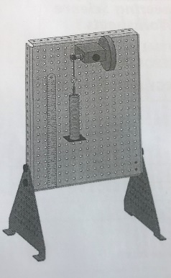
Shaking effect:
Figure 7: A diagram showing the flywheel experiment; (TecQuioment, 2012)
When the weight hanger is dropped the masses will cause a shaking effect. The potential energy can be lost and an inaccurate reading will be taken. Hopefully a plastic guide is located on the top of all the masses to prevent this shaking error but in reality it is not the most ideal way to conduct this experiment.

Calculations:
Fortunately, this experiment is easily repeatable. A lot of readings can be taken due to more precise calculations. Using basic physics laws and equations it is easy to determine certain values and plot a graph. The graph will show a clear relationship between torque (T) and angular acceleration(a). Using the gradient of the graph the moment of inertia (I) can be simply calculated as well. This method saves a lot of calculating time which is really useful.

Environment:
The experiment is tested in a controlled laboratory conditions. Therefore, no external forces such as air resistance will be acting on the flywheel components and more accurate date can be obtained.

9
Iriney Georgiev

Further work:

Data:
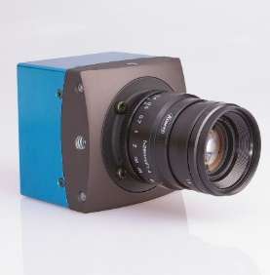
The human errors must be removed from this experiment in order to improve the data. If money is not a factor the people should be replaced with machine equipment. For example, high-speed video cameras can record the movement of the weight hanger and determine the rebounding height (h2). Electronic break release can be connected to these cameras and when the masses are released the video begins. As a result, an accurate cycle time can be obtained.
Figure 8: High-speed video camera; (LTD., 2019)

Equipment:
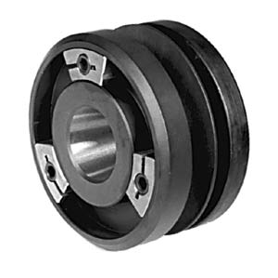
Equipment quality can be improved. The cord used in this experiment is assumed to be not extensible but in reality this is not a true statement. The condition of flywheel’s bearings is unknown hence the friction force can significantly affect the readings. Before each experiment procedure all rotating components should be checked and replaced, if it is needed. As it is said, in section:4.2, there is a shaking effect which occurs. It can be prevented by using a singular solid body mass component, attached to the weight hanger, with a lower center of gravity. The flywheel should be balanced in order not to lose energy during rotation motion. An adjustable sliding weight could be used to have a perfectly balanced flywheel.
10
Iriney Georgiev
Figure 9: An example of an adjustable sliding weight; (SOPKO, n.d.)

Conclusion:

Storing energy:
When the weight hanger reaches the bottom and rebound the flywheel uses its stored energy to lift the masses upwards. Therefore, a translation of energy is shown and the flywheel storing energy effect is proved.

Potential energy loss:
The potential energy loss can be found by watching the rebounding motion of the weight hanger. It does not return to its starting positon (h1) hence some energy is lost into surrounding factors such as friction, air resistance and others. Logically when the applied mass is greater the potential energy losses will be larger.

Comparing the experimental and theoretical moment of inertia:
The experimental values of moment of inertia have some huge deviations from the theoretical values. Experimental errors appeared in this flywheel experiment. Therefore, the experiment is not a hundred percent efficient for obtaining precise values.
11
Iriney Georgiev

References:
Georgiev, I. (n.d.). Georgiev's own collection. Flywheel experiment. Swansea.
Harlow, J. J. (n.d.). The Flywheel. Retrieved from University of Toronto Physics: https://www.physics.utoronto.ca/~jharlow/teaching/summerlab08/fcpdfs/flywheel.pdf
LTD., H. S. (2019). High Speed Recording Cameras. Retrieved from HOSCIN: http://www.hoskin.ca/catalog/index.php?main_page=index&cPath=3_47_49
Macharia, D. (2019). Flywheel Lab Report. Retrieved from ACADEMIA: https://www.academia.edu/36510440/Title_Flywheel_Lab_Report
Mammadov, N. (n.d.). Flywheel Experimentscribd. Retrieved from SCRIBD: https://www.scribd.com/document/288458003/Flywheel-Experiment
MECHOLIC. (2016). What is a flywheel? Function,application and equation for stored. Retrieved from MECHOLIC for mechanical engineering: https://www.mecholic.com/2016/12/what-is-flywheel-function-applications.html
Pearson Education Limited. (1987). Newton second moment of motion. In S.J.Zammit, Motor Vahicle Engineering Science. Longman Group UK Limited 1987.
SOPKO. (n.d.). Wheel Adapters for Kent and Norton Grinders. Retrieved from wmsopko: http://www.wmsopko.com/sopko_054.htm
TecQuioment. (2012). Engineering Science Worksheet Potential and Kinetic Eneegy Kit ES9 Energy in a Fllywheel. TecQuioment.
TecQuipment. (n.d.). Engineering Science Worksheet.

12
Iriney Georgiev

