

BMIH5006

SUSTAINABLE HOSPITALITY AND TOURISM MANAGEMENT

Title: REPORT

STUDENT NAME: KALLE CLEMENT DITOU

STUDENT ID: 2029083

LECTURER: LISA-MARIE BASSIER WORD COUNT: 2225

AI Acknowledgement

I confirm that I have not used any AI tools in the research and creation of this assignment. I confirm that I have not presented any AI-generated materials as my own work. I confirm I have copies of my drafts, notes, and other resources I used, which I may be asked to provide in evidence.

EXECUTIVE SUMMARY
The report evaluates a recommended waste management structure for Zetter Hotel to improve sustainability performance and productivity. First, it explains the meaning of greener practices, focusing on their importance to the hospitality industry to enhance environmental conservation and meet the growing customer demands for environmentally sustainable operations.
Waste management forms several strategic initiatives to reduce landfill waste and promote sustainability, known as the circular economy. Such strategies include waste assessment surveys to identify places where waste is likely to originate from, providing distinct ambassadors for recycling and waste collection to ensure waste disposal efficiency. It also spells out other important environmental impacts that the hotel will likely enjoy, including a dramatic cut in carbon emissions and economisation on materials, which should help the hotel sell itself as the industry pioneer.
Nevertheless, it elaborates on issues such as initial implementation costs, the possibility of staff resistance to change, and practical issues. To counter these difficulties, the report provides specific suggestions to increase employee participation and adequately plan the implementation process as key strategic dimensions. Such a program would greatly improve Zetter Hotel’s sustainability profile and appeal to a new type of client satisfied with low-impact, sustainable holidays.

Table of Contents
1.0 Introduction 5
2.0 Main Body 6
2.1 Green Practice Initiative: Thorough Waste Management Program 6
2.2 Other Hotels with Similar Programs 6
2.3 Benefits of Zetter Hotel on Sustainability 7
2.4 Barriers to the Implementation of the Project 8
2.5 Cost-Effectiveness and Viability of the Scheme 9
2.6 Environmental Gains from the 360-Waste Management Program 9
2.7 Gaps in the current sustainability practices at Zetter Hotel 10
2.8 Implementing Three Ps for Sustainable Practice 11
3.0 Conclusion 12
References 13

1.0 Introduction
Greener practice refers to the sustainable efforts and initiatives undertaken by organisations to reduce their environmental footprint and support resource conservation and operational effectiveness. It can be in various forms, including reducing waste, conserving water, saving energy, or sourcing in a sustainable manner. A greener practice would be the initiation of a holistic waste management program focused on the systematic reduction of waste generation while improving recycling and responsible disposition of waste materials.
Key sustainable activities implemented in Zetter Hotel, located in Clerkenwell, London, reflect the organisation’s conformity to legal frameworks ruling environmental issues. It complies with waste management policies in providing waste audits and setting up respective recycling stations. Consistent with Energy Efficiency Regulations, it utilises borehole water for water consumption, features natural light, and uses occupancy sensors for energy conservation. It meets sustainable sourcing in its use of environment-friendly materials in the construction of the compound; water conservation policies are also supported by water sensors and the borehole system, proving that the company is headed in sustainable and environmentally friendly hospitality. In this way, Zetter Hotel achieves compliance with local environmental policies in its functions and thus becomes an example of a sustainable hotel business in the competitive environment of London.
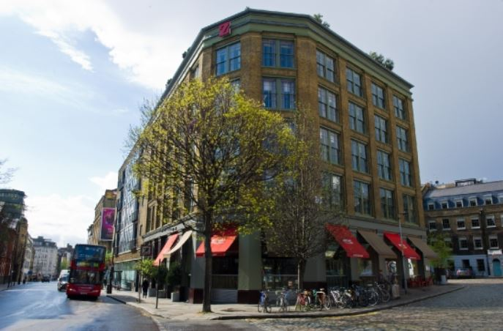
Figure 1: Zetter Hotel (Source: (The Ideal Venue, 2024)

2.0 Main Body

2.1 Green Practice Initiative: Thorough Waste Management Program
A proper waste management program will include planned interventions in systematic efforts to curtail waste generation, enhance the recyclability of waste products, and ensure sound disposal. This will also help avoid the impact of landfills and reduce the usage of natural resources (Cooper, 2021).
- Waste Audits: The program begins with regular waste audits and systematic evaluations of sources and types of waste generated in a hotel. This process informs key areas of potential improvements to target waste streams for reduction and diversion in the hotel (Moise, Gil-Saura and Ruiz Molina, 2021).
- Recycling Hoppers: To ensure effective collection, the program will also install well-identified recycling bins at strategic points in the hotel. These bins will be clearly identified as paper, plastic, glass, and organic waste to ensure a seamless recycling process for hotel guests and staff (Sloan, Legrand, and Chen, 2017).
- Partnerships with organisations in the locality: The hotel will partner with local recycling companies and food banks to ensure proper waste disposal and recover leftover food. This will further enhance waste management and help the community.
- Staff Training: The program would entail training the employees to separate waste and maintain environmentally friendly practices (Inkson and Minnaert, 2018). Instructing the employees on why waste management is important and how they contribute to promoting a culture of sustainability will enable the hotel to embrace an activist approach to environmental stewardship among its workforce.

2.2 Other Hotels with Similar Programs
Several hotels have undertaken holistic waste management programs that have successfully demonstrated how sustainability and resource conservation are part of their business.
Hoxton, Shoreditch, for instance, has a robust waste management system that is very much focused on recycling and composting. The hotel has conducted regular waste audits, identifying specific waste streams to focus on, thereby significantly reducing waste in landfills (hackney.moderngov., 2024). The Hoxton has installed clear signage and recycling stations at every corner of the hotel to encourage its guests and staff to actively segregate waste. Additionally, this hotel will partner with some local farms to recycle food waste for compost while reducing their environmental footprint to a minimum degree.
Hilton Hotels is another example that epitomises global efforts toward achieving sustainability through extensive waste management (Hilton, 2024a). Hilton has implemented food waste reduction strategies in nearly all its properties by utilising as much food as possible and donating excess food to local charities. This program's recycling initiatives take materials from landfills and make responsible disposal practices. Such efforts help protect the environment and lead to operational efficiency and improved guest satisfaction for Hilton (Hilton, 2024b). All the projects above showcase how both The Hoxton and Hilton embrace effective waste management and their overall operational methods to help upgrade their societal position.

2.3 Benefits of Zetter Hotel on Sustainability
A balanced waste management program at Zetter Hotel has several outstanding benefits, regarded as sustainability benefits.
- Resource Conservation: Zetter Hotel will effectively manage waste by reducing the amount of waste produced by the hotel. This reduction will save valuable natural resources and help reduce the hotel's carbon footprint (Wickham, Donnelly, and French, 2021). For example, recycling helps prevent materials from entering landfills, thus reducing the impact of environmental degradation related to decomposition processes and lowering the need for new resources.
- Operating Efficiency: An integrated waste management program can contribute to operational efficiency. The effect on efficiency can be great, as in the saving or even abolition of waste disposal costs due to fewer landfill visits in case of frequent trips there (Jauhari, 2021). Recovery operations such as recycling and composting in a well-structured waste management program consume fewer resources; therefore, the hotel can deploy its resources more effectively and avoid unwanted expenses.
- Strengthened Credibility: Zetter Hotel's strong commitment to a sustainable approach will strengthen its credibility as an environmentally sensitive business. Such commitment may attract green-conscious guests who place a top priority on sustainability when choosing their travel destination (Costa and Costa, 2022). In this regard, the hotel will strengthen its market position and brand loyalty because it will be the market leader in sustainable hospitality in the highly competitive London market.

2.4 Barriers to the Implementation of the Project
Implementing an integrated waste management system at Zetter Hotel faces many challenges, including approaches to achieving this.
- Setup costs: A waste management program is a capital-intensive activity. Zetter Hotel will need to buy recycling bins and composting systems, among other infrastructure. The training programs for the employees and partnering with waste management services might add up to the expenses (Korstanje, George and Nedelea, 2020). Such funding requirements might deter the hotel, especially if it is not financially strong enough.
- Staff resistance: The program must face resistance from the traditional, embedded waste disposal staff. Employees are unwilling to change their habits, and the program lacks adherence to new procedures. Zetter Hotel, therefore, will require more time and effort for detailed training sessions and open communication to counter this challenge (Edgell, 2020). Engaging the staff in decision-making and showing the initiative's benefits will be important in ensuring buy-in and creating a sustainability culture.
- Logistical Challenges: Managing logistics for waste collection and disposal in an overcrowded urban area like London poses significant challenges. Issues like managing scarce space, coordinating the collection schedule, and following the laid-down local requirements may prove a challenge in attempting to establish the system (Batabyal, 2018). Therefore, a structured and efficient logistics plan is needed to counter the logistical challenges as part of efforts to establish the waste management system effectively.

2.5 Cost-Effectiveness and Viability of the Scheme
Although the initial costs of establishing a comprehensive waste management system at Zetter Hotel may be high, the long-term cost savings will most probably outweigh such expenditure. Effective recycling and composting can result in less waste being sent to disposal sites, thus saving on fees associated with these wastes (Management Association, 2018). The more streamlined waste management system is likely to translate into more efficient operations and, therefore, lower consumption of resources plus their linked costs.
The initiative is also realistic for Zetter Hotel as it aligns with contemporary sustainability trends and responds to a growing demand from guests to stay in environmentally friendly accommodations (The Zetter, 2023a). Indeed, Zetter Hotel builds its marketability by becoming a leader in the hospitality industry's sustainability concerns while deepening brand loyalty among environmentally aware travellers.

2.6 Environmental Gains from the 360-Waste Management Program
Implementing the holistic waste management program at Zetter Hotel will deliver vast environmental benefits that align with the sustainability goals.
- Landfill Waste Minimization: The hotel can actively divert waste from landfills using effective recycling and composting strategies (Worsham, 2023). This can be a significant way in which the hotel reduces its environmental footprint, not just by reducing the burden on local waste management systems but also by reducing the impacts of landfill overflow on soil and water pollution.
- Reduced Carbon Emissions: The amount of waste produced is directly proportional to the level of greenhouse gas emissions linked to waste disposal. Most conventional waste management practices, especially landfilling, produce methane emissions, which are potent greenhouse gases (Andreeva, 2020). Therefore, through waste reduction, Zetter Hotel can play an important role in reducing its carbon footprint and supporting the wider effort in combating climate change.
- Encouragement of Circular Economy: Creating a circular economy with the local organisation can promote using materials for reusing, repurposing, and recycling to prevent waste (Okai, 2020). This saves resources and encourages local economic resilience, creating a positive feedback loop in strengthening sustainability in the community. The campaign will improve Zetter Hotel's commitment to the environment and sustainability.
- Upcoming Food Waste Regulations: The new legislation concerning food waste collection and management for Zetter Hotel has to include the Separation of Waste (England) Regulations 2024 and local London projects to reduce food waste by 50% by 2030. Meeting compliance will entail separating waste food collection, association with waste carriers, and monitoring systems. Synchronising with these policies will enhance the operational sustainability at Zetter and relate to the set regulations (legislation.gov.uk, 2024).

2.7 Gaps in the current sustainability practices at Zetter Hotel
Even though there are good existing sustainability practices at Zetter Hotel, significant gaps have been identified. Note that waste management is among the areas with significant gaps. Even though the hotel involves some recycling, there lacks an overall strategy regarding all kinds of organic, plastic, and hazardous wastes (Ng et al., 2023). Again, employees are not much involved in the sustainability practices that affect the current sustainability practices. In short, such a program of structural waste management would fill this gap while developing a sustainable culture in staff.
With the implementation by Zetter Hotel of an integrated program for its comprehensive waste management, much chance to develop further the practices in the areas of sustainability of the hotel can be tapped. With waste properly managed and segregated from waste being disposed of or recycled and composted, one will have fewer negative environmental impacts while operating with minimised operating costs. Indeed, although many problems, such as entry and employee training, may eventually occur, the long-term return in terms of financial gains and environmental advantage is far greater than such short-term barriers. Zetter Hotel will be at the forefront of establishing its base on sustainability, operation effectiveness, and positive influences on the environment. With this green practice, eventually, the hotel will be left ahead of other sustainable offerings from hospitality companies that appeal to a more than increasingly sensitive client towards the ecology.

2.8 Implementing Three Ps for Sustainable Practice
The organisational approach used by Zetter Hotel is the triple bottom line, which espouses the people, planet, and profit balances. Social responsibility minimisation of waste management training for the hotel’s staff and the food redistribution partnership was implemented to enhance responsible corporate posture. Environmentally, the company reduces waste, uses energy-saving systems in the properties, and sources goods and services sustainably, following London's waste reduction targets. From the business perspective, it is acknowledged that implementing these practices requires first cost, yet the operating costs are decreased, and money is made from environment-minded guests. TBL principles allow Zetter to obtain sustainable profitability and environmental and social returns, further improving its reputation as an environmentally appropriate hotel.

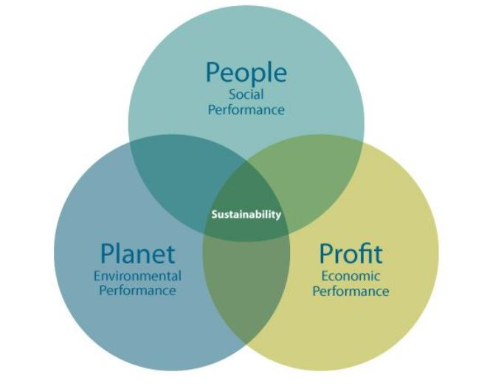
Figure 2: Triple Bottom Line (Source: Inachainge, 2022)

Conclusion
In conclusion, having a holistic waste management program implemented at Zetter Hotel is an excellent opportunity to enhance its sustainability practices as well as the overall operation efficiency. The report has therefore outlined the key components that make up an effective strategy for waste management, namely regular waste audits, putting in place clearly marked recycling bins, partnerships with local organisations, and staff training. These are the initiatives crucial for reducing landfill waste, lowering carbon emissions, and promoting the circular economy.
However, there exist potential barriers to implementation as follows: setup costs, resistance of employees, and logistical issues. For those, Zetter Hotel may focus on the engagement of all employees in decision making regarding the long-term gains. The hotel is supposed to provide resources for employee education and develop a detailed, structured logistics plan for collecting waste and its disposal.
These recommendations embraced by Zetter Hotel would help to ensure the hotel's leading place in sustainable hospitality. There is a likelihood of attracting these environmentally conscious guests to this particular hotel, which would improve its credibility in the London competitive market. The economically viable implementation of waste management is, therefore, beneficial for the hotel concerning the environment and the community for its betterment.

References
Andreeva, A. (2020) Sociocultural Aspects of the Business Culture in the Hotel Industry.
Batabyal. (2018) Managing Sustainable Tourism Resources. IGI Global
Cooper, C. (2021) Essentials of tourism. Third edition. London: SAGE.
Costa, and Costa, C. (2022) Sustainability and competitiveness in the hospitality industry (Costa & C. Costa, Eds.). Business Science Reference
Edgell. (2020). Managing sustainable tourism: a legacy for the future. Third edition. Routledge.
hackney.moderngov. (2024) Hoxton Street Conservation Area Appraisal and Management Plan. [Online] Available at: https://hackney.moderngov.co.uk/documents/s85868/14-1%20Appendix%20A%20-%20Hoxton%20Street%20Conservation%20Area%20Appraisal%20and%20Management%20Plan.pdf [Accessed on: 26/10/2024]
Hilton (2024a) Hilton Hotels in United Kingdom [Online] Available at: https://www.hilton.com/en/locations/united-kingdom/hilton-hotels/ [Accessed on: 26/10/2024]
Hilton (2024b) Hotels in United Kingdom [Online] Available at: https://www.hilton.com/en/locations/united-kingdom/ [Accessed on: 26/10/2024]
Inachainge (2022) What do we know about the triple bottom line? Inchainge. Available at: https://inchainge.com/knowledge/sustainability/what-do-we-know-about-the-triple-bottom-line/ (Accessed: 10 November 2024).
Inkson, C. and Minnaert, L. (2018) Tourism management: an introduction. 2nd ed. London: SAGE
Jauhari, V (2021) Managing Sustainability in the Hospitality and Tourism Industry: Paradigms and Directions for the Future. 9th edn. Oakville: Apple Academic Press. Inc
Korstanje, George, B., and Nedelea, A. (2020) Strategies for promoting sustainable hospitality and tourism services. IGI Global.
legislation.gov.uk (2024) The separation of waste (england) regulations 2024, Legislation.gov.uk. Available at: https://www.legislation.gov.uk/uksi/2024/666/made (Accessed: 10 November 2024).
Management Association. (2018) Sustainable Tourism. IGI Global.
Moise, M.S., Gil-Saura, I. and Ruiz Molina, M.E. (2021) The importance of green practices for hotel guests: does gender matter? Economic research-Ekonomska istraživanja, 34(1), pp.3508-3529.
Ng, W.K., Hsu, F.T., Chao, C.F. and Chen, C.L. (2023) Sustainable competitive advantage of cultural heritage sites: Three destinations in East Asia. Sustainability, 15(11), p.8593.
Okai, D.E. (2020) Recycling as a strategy for revenue generation and municipal plastic waste management: The case of Accra Metropolitan Area (Doctoral dissertation).
Sloan, P., Legrand, W. and Chen, J.S. (2017) Sustainability in the hospitality industry: principles of sustainable operations. 3rd edn. London: Butterworth-Heinemann.
The Ideal Venue (2024) The Zetter Hotel, The Ideal Venue. Available at: https://theidealvenue.com/united-kingdom/england/london/the-zetter-hotel-691.html (Accessed: 10 November 2024).
The Zetter (2023a) Zetter. [Online] Available at: https://thezetter.com/clerkenwell/bedrooms/?utm_source=triptease_attract&utm_medium=paid_search&utm_campaign=google_search&gad_source=1&tt_api_key=be27c18966785290e4becfac7119c1eca5728a4f&tt_ [Accessed on: 26/10/2024]
The Zetter (2023b). Zetter. [Online] Available at: https://thezetter.com/our-story/ [Accessed on: 26/10/2024]
Wickham, Donnelly, T., and French, L. (2021) Strategic Sustainability Management in the Event Sector. Event Management, 25(3), 279–296.
Worsham, J. (2023) Perceptions of a NRCS Program to Remediate Decommissioned Poultry Houses in Northwestern Arkansas (Master's thesis, University of Missouri-Columbia).

