What is reflective practice?
Reflective practice was first derived from Dewey and Schon (1910) as cited in Open Learn (No date). They define reflective practice as the continuing consideration of a belief based upon the knowledge that supports it.
Reflection according to the Cambridge Assessment International Education (No date) can be seen within their reflective cycle model and is stated as reviewing and learning through a process of assessment surrounding the practices and methods within which practitioners base their work.
Canning and Reed (2010) suggest that reflection may assist in the development of refining or changing the way a situation is handled, the exploration of new ideas, and adapting skills sets to enhance learning and professionalism.
Reflective practice is the opportunity to analyse and evaluate how we as practitioners can learn and improve practices for future reference as well as the improvement and challenging of one’s knowledge and understanding in order to promote, share and encourage others to reflect in order to support and grow from critically evaluating current practices.
Moon (2008) as cited in Reed and Canning (2010) suggests that reflection is a product of developing skills with the aim to make an analytic view. Gasper (2015) states that reflective practice is active listening and engaging with those around us, questioning and challenging.
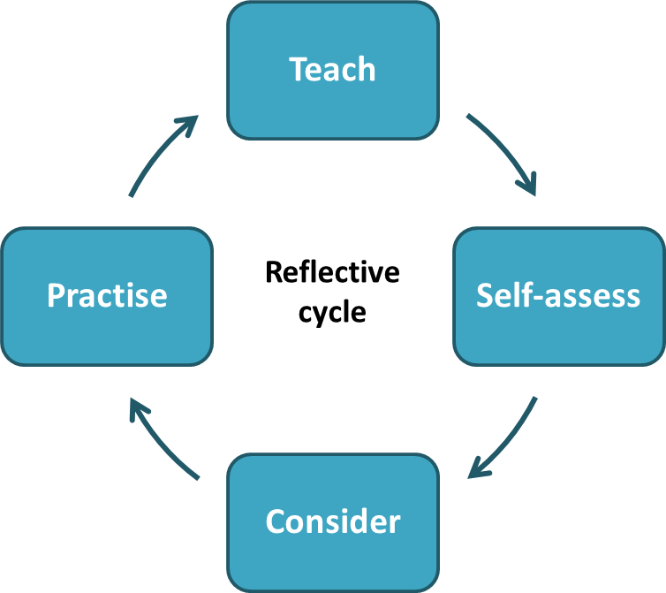
Why is reflective practice important within the early years?
Canning and Reed (2010) state that as the world changes, as do the roles of practitioners, reflection is an important element of learning to process and adapt to these constant changes that are required. It enables the practitioner to embrace, explore and develop new ideas and concepts in order to provide a more productive analysis of the world around us. Craft and Paige-Smith (2011) argue that reflective practice today when working within early years has increasingly become an important and embedded part of being a practitioner. Moss and Petrie (2002) as cited in Craft and Paige- Smith (2011) suggest that due to current changes in polices and services within the early years frameworks as practitioners we should focus on engaging reflectively in order to encourage our own ideas and concepts. It is important as a practitioner to revisit experiences in order to fully recognise and evaluate ways within which improvements can be made for personal growth and learning. Papatheodorou, Luff and Gill (2013) argue that reflection enables us to look more thoroughly and in more detail at events or processes to encourage the active formation of knowledge and new objectives. Colwell et al (2019) cited in EYFS (2019) suggest that in order to expand and achieve high quality provisions as a practitioner and within the workplace individual practices should be reviewed. One such method that promotes this is through the interaction with others, discussing, evaluating and sharing experiences to not only develop as a professional but provide an understanding for the basis behind the practices carried out. This level of understanding can be informative and aid the process of discussions with parents, multi-disciplinary workers and colleagues. This in turn develops personal confidence as a practitioner. Reflective practice according to Bruce (2010) cited in Gasper (2015) suggest that reflection aids in the process of identifying and valuing strengths alongside recognising where adjustments can be made in order to progress and develop.
The Theory behind reflective practice.

A key theorist of reflective practice is Donald Schon. In 1991 Schon suggested reflection has two main structures. Reflection in action and reflection on action.
According to Open Learn (No date) reflection in action is the process of reflecting whilst in the moment, this allows the practitioner to change methods or explanations of a topic for example as events are happening. Reflection on action is done after the effect. It is when a practitioner actively analyses the situation and makes use of their own levels of experience and awareness to determine if there could be an alternative or more productive strategy to enable a higher degree of understanding.
Solent University (2012-2019) state that reflection in action could be used by finding ways to help focus on a particular task, changing methods if a child doesn’t seem to understand a concept, adapting an activity to accommodate a smaller group of children with more tailored needs. Reflection on action may include thinking about how the activity could have been more productive, if anything could be improved for next time, changes to a technique that could be used. However, Loughran (2002) cited in Paige-Smith and Craft (2011) states that although Schon’s theory is popular in many sectors it is important when using reflection on practice to share our reflections with others in order to develop and question our understanding through other perspectives.

(Source: Cambridge Assessment International Education, No date)
Driscoll’s Model of Reflection (1994)

One of the easiest and simplistic models is Driscoll’s 1994 framework. It asks the learner or practitioner three questions.

- What? What was the event or situation, what were the feelings surrounding it.
- So What? What tools were in place during the event or what knowledge base applied.
- Now What? What actions can be implemented for the future to ensure better productivity and understanding.

Driscoll’s model has been adapted by numerous theorists including Rolfe et al (2001) cited in the University of Edinburgh (2020) and the three stages can be as in depth or simplistic as required. It is argued by the University of Edinburgh (2020) that the use of the three questions alone when reflecting may not be adequate in order to achieve an extensive level of substance. When these stages are elaborated on however further depth and quality of reflection may be achieved. For example, when asking the first question, to gain a fuller description it is possible to ask not only what the event/task/activity was, but also what were the reasons for the activity, what did I contribute? what methods were in place? what were the feelings surrounding the task? what were the positives and negatives of the task? The same can also be done for the other states of the model. So what? So what have I learnt from this experience? So what did it teach me? So what were my decisions? So what were they based off? So what could I have done differently?
The final stage, now what is the planning ahead for next time category. The question what now can be used as a guide for future events. Now what can I do to improve for next time? Now what may be achieved from this? Now what can I implement to ensure this is successful?

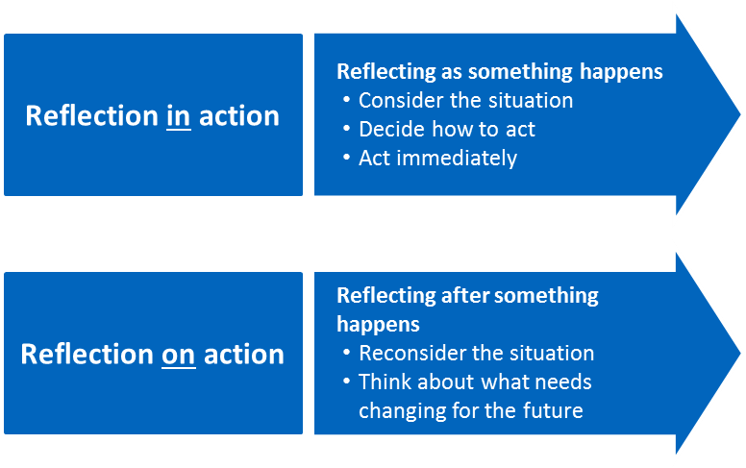

(Source: Cambridge Assessment
International Education, No date).
Gibbs Reflective Learning Cycle:
Models of reflection: Gibbs (1988) Reflective Learning Cycle

Gibbs reflective learning cycle has six core stages. These stages involve the exploration of an experience using each.

- Description – What was the task, experience.
- Feelings – How did it make you feel or think.
- Evaluation - Advantages and disadvantages.
- Analysis – What do the above answers mean to you.
- Conclusion – How could these things have been altered or improved.
- Action plan – What could you do to differently next time.
Gibbs framework is a popular and clear reflective model to emulate and follow. Its cyclical nature offers the practitioner the use of repeating its methodology throughout experiences.
In turn however the model can also be used for a singular use in order to determine the usefulness of the task or activity, how things could be improved upon, changes that need to be made, positive or negative contributions, and new ideas and concepts that can be used in the future. (The University of Edinburgh, 2020). Gibbs model of reflective learning as with Driscoll’s model of reflection (1994) can also be adapted and elaborated on dependant on the practitioner and activity. For example, the first stage description can be as detailed as required, who, what, where when and why type questions. The feeling within the second stage can relate not only to the practitioner but also the other participants and colleagues. Evaluation and analysis can be intrinsic elements of reflective practice, asking what went well, what wasn’t as successful, and why was or wasn’t it positive/negative. Conclusion and action plan draw in and summarise the event, asking the questions; how can I improve for next time? what skills can I use? How can I develop? How can I gain more knowledge for future use? (The University of Edinburgh, 2020).
Models of reflection: Kolb’s cycle of learning (1976)

Kolb’s cycle of learning involves four stages. Each stage focuses on the different attributes needed to in order to learn from an experience.

- Concrete experience – What was the situation/experience.
- Reflective Observation – Why and how things happened.
- Generalisation – Conclusion. What was the outcome of the experience. Reflection and reviewing of the process and impact.
- Action – How and what can be done differently next time to enhance productivity and understanding more efficiently.

Kolb’s model provides practitioners with the tools to not only learn from an experience but to also adapt and apply new methods for future situations. Kolb (1976) as stated in Open Learn (No date) argues that learning from an experience can prove challenging as many people find they are more efficient in one area of the cycle’s stages than another. Kolb’s theory focuses mainly on the cognitive processes and concepts that that practitioners can use in varied situations formatting the basis for new ideas. His four-stage model is designed to promote the merging of each stage into one another McLeod (2017) cited in Simply Psychology (No date) suggests that for the cycle to be effective each stage should be followed to produce a more compounded result.

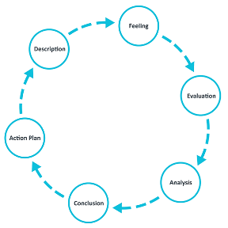

(Source: The University
of Edinburgh, 2020)

Tips to aid reflective practice:

- Be positive about the process.
- Be focused on what you want to achieve.
- Ask yourself what have you learned?
- What resources are available, such as new guidelines, training sessions.
- Ensure everything is confidential.

(Health and Care Professionals Council, 2021)
Kolb’s cycle of learning:

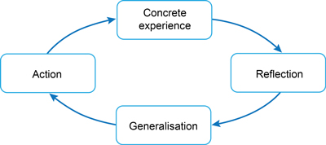(Source: Open University, No date)

How reflective practice can improve quality in the early years and support the development of a professional
Reflective practice can aid the process of improvement in quality in the early years and supporting the development of the professional by enabling the professional to actively engage with actions and events during and after they have taken place, Doing so helps the practitioner to consider and understand ways within which methods and techniques could be adapted to better suit the individual or situation itself. As a practitioner it is vital to look for ways to improve and gain further knowledge in order to improve not only relations with others in a working capacity but also those being taught. Working within the early years sector involves adapting to ever changing policies and procedures. It is imperative therefore that as an early year’s practitioner refining and exploring new roles and responsibilities becomes part of the process. Having insight into reflective practice and continued development not only benefits the practitioner by considering alternate ideas and motives but also how these as a collective can influence the relationships with other practitioners, team members, parents and children alike. Listening to other perspectives regarding how they have been challenged and adjusted ways of working is also fundamental in supporting the development of professional practice within the early years. In order to continuously strive for improvements a practitioner should identify and review the practices carried out within an early year setting, consider any alterations or changes that may need to be made and as stated in Colwell (2019) provide reasoning for these changes. Reflective practice when willing to fully question and implement new practices alongside working with others to support change provides the practitioner with the tools to achieve and improve quality within early years provisions. As a practitioner critically evaluating and the awareness of others is enhanced when the use of reflective tools can be promoted effectively, used and adopted.

References:

Brock, A. (2012) Building a model of early years professionalism from practitioners’ perspectives. Journal of Early Childhood Research 11(1) 27–44 Building a model of early years professionalism from practitioners’ perspectives (sagepub.com).

Cambridge Assessment International Education (No date) Getting started with Reflective Practice. Available at: https://www.cambridge-community.org.uk/professional-development/gswrp/index.htm (Accessed: 19 October 2022).

Cambridge Dictionary. (2022) Definition of Values. Available at: http://dictionary.cambridge.org/dictionary/english/values (Accessed: 24 October 2022).

Canning, N. and Reed, M. (2010) ‘Introduction’, in Canning, N. And Reed, M. (ed.) Reflective Practice in the Early Years. London: Sage Publications Ltd.

Cleaver, H. et al. (ed) (2009) Safeguarding Children: A Shared Responsibility. West Sussex: Wiley Blackwell Publication Ltd.

Collins Dictionary (2022) Definition of Professional. Available at: https://www.collinsdictionary.com/dictionary/english/professional
(Accessed: 23 October 2022).

Colwell, J. (2019). ‘The process of Reflective Practice’, EYFS, 2 October 2019. Available at: https://eyfs.info/articles.html/teaching-and-learning/the-process-of-reflective-practice-r262/ (Accessed: 21 October 2022).

Craft, A. and Paige-Smith, A. (2011) ‘Introduction’, in Craft, A. and Paige-Smith, A. (ed) Developing Reflective Practice in the Early Years. 2nd edn. England: Open University Press.

Department for Education (2004) Every Child Matters. Available at: https://assets.publishing.service.gov.uk/government/uploads/system/uploads/attachment_data/file/272064/5860.pdf (Accessed: 25 October 2022).

Gasper, M. (2015) ‘Professional Practice and Early Childhood Today’, in Reed, M. and Walker, R. (ed.) A Critical Companion to Early Childhood. University of Worcester: Sage Publications Inc.

Health and Care Professions Council (2021). Case studies to help you reflect on your practice. Available at: https://www.hcpc-uk.org/standards/meeting-our-standards/reflective-practice/case-studies-and-templates/ (Accessed: 21 October 2022).

McLeod, S. (2017). ‘Kolb's Learning Styles and Experiential Learning Cycle’, Simply Psychology, 24 October 2017. Available at: https://www.simplypsychology.org/learning-kolb.html (Accessed: 21 October 2022).

Norburn, A. (2013) Communicating effectively with children under five. Available at: https://www.researchinpractice.org.uk/media/2913/communicating_effectively_with_children_under_5_frontline_briefing_2013.pdf (Accessed: 25 October 2022).

NSPCC (2019) Multi-agency working. Available at: https://learning.nspcc.org.uk/child-protection-system/multi-agency-working-child-protection (Accessed: 26 October 2022).

Nutbrown, C. (2011) Key Concepts in Childhood Education & Care. 2nd edn. University of Sheffield: Sage Publications Ltd.

Open University (No date) Learning to teach becoming a reflective practitioner. Available at: https://www.open.edu/openlearn/education-development/learning-teach-becoming-reflective-practitioner/content-section-2.1 (Accessed: 19 October 2022).

Open University (No date) Kolb’s cycle of learning. Available at: https://www.open.edu/openlearn/mod/oucontent/view.php?id=21106&section=5.1 (Accessed: 20 October 2022).

Orey, M. (2014) Communication Skills Training. Virginia: ATD Press.

Papatheodorou, T. Luff, P. And Gill, J. (2013) Child Observation for Learning and Research. New York: Routledge.

Richards, M. (2010) ‘Safeguarding Children: Every Child Matters so Everybody Matters!’, in Canning, N. And Reed, M. (ed.) Reflective Practice in the Early Years. London: Sage Publications Ltd.

Smidt, S. (2015) Observing Young Children: The role of observation and assessment in early childhood settings. 2nd edn. Oxon: Routledge.

Solent University (2012-2019) Successful Reflection. Available at: https://learn.solent.ac.uk/mod/book/view.php?id=116229&chapterid=15206 (Accessed: 20 October 2022).

The Royal College of Paediatrics and child health (2019) Rights Matter – what the UN convention on the rights of the child means to us. Available at: http://www.rcpch.ac.uk/resources/rights-matter-what-un-convention-rights-child-means-us (Accessed: 26 October 2022).

The University of Edinburgh (2020) Gibbs ‘Reflective Cycle. Available at: https://www.ed.ac.uk/reflection/reflectors-toolkit/reflecting-on-experience/gibbs-reflective-cycle (Accessed: 19 October 2022).

The University of Edinburgh (2020) What? So what> Now what? Available at: https://www.ed.ac.uk/reflection/reflectors-toolkit/reflecting-on-experience/what-so-what-now-what (Accessed: 22 October 2022).

Welsh Government (2020). Developing a Vision for Curriculum Design. Available at: https://hwb.gov.wales/curriculum-for-wales/designing-your-curriculum/developing-a-vision-for-curriculum-design#developing-a-vision (Accessed: 25 October 2022).

Welsh Government. (2022) ‘Curriculum for funded non-maintained nursery settings.’ Available at: http://hwb.gov.wales/api/storage/3e89a21c-60fb-416c-99dd-6e1af3982409/a-curriculum-for-funded-non-maintained-nursery-settings2.pdf (Accessed: 26 October 2022).

Young, N. (No date) ‘Reflective Practitioner’ [PowerPoint presentation]. ECEY4002: Professional Practitioner. University of Wales Trinity Saint David. Available at: https://moodle.uwtsd.ac.uk/course/view.php?id=9758 (Accessed: 21 October 2022).

Young, N. (No date) ‘What do we mean by ‘values’? [PowerPoint presentation]. ECEY4002: Professional Practitioner. University of Wales Trinity Saint David. Available at: https://moodle.uwtsd.ac.uk/course/view.php?id=9758 (Accessed: 25 October 2022).

