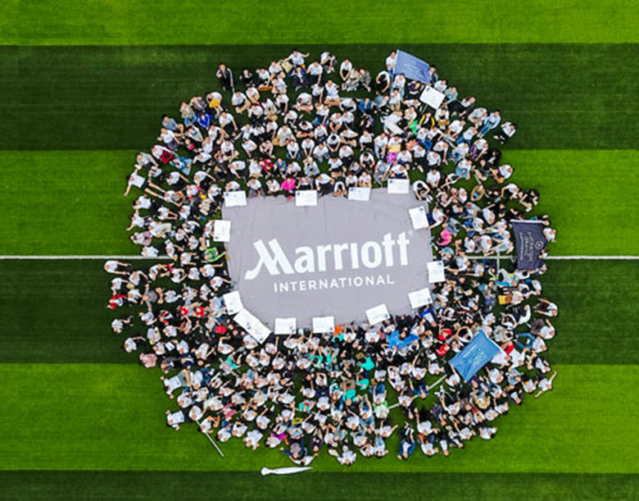  MArriott international  “Development of a plan by meeting the identified personal development needs and expectations of individual employees in a chosen organisation” | Lecturer: Nandish Patel  Module: BMSW5102  Student: Andrei Alexandru Agopian (1905498)  Developing Relationships and Workplace Achievements  

Contents

Introduction 2
Marriott International 2
Attitude Towards Employment 2
Historical Management Theories 3
Fayol’s Definition 3
The Scientific Method 3
The Bureaucratic Style 3
Human Relations Theories 5
Mayo and Schein 5
Neo-Human Theories 6
Maslow’s Pyramid 6
McGregor’s X and Y 6
Herzberg and Likert 6
Systems and Contingency 6
Marriott Development Tools 8
Essential Skills for Supervisors and Managers 8
The Voyager Programme 8
Digital Learning Zone Path 9
Personal Development 10
The Plan 10
Motivation 10
The Method 10
Conclusion 12
For the Next 100 Years 12
References 13

Introduction

Marriott International
One of the household names in the hospitality industry is Marriott International. As one of the biggest names in the industry, with over 7000 hotels spread across 131 countries, this gigantic company owes part of its success to developing reliable employees in different environments, which in turn enables it to provide the same high-quality service across the globe.
Marriott has its origins as a root beer stand in 1927, started by J.W. Marriott, and constantly growing to this day to be able to offer a variety of products within the leisure industry. Focused on putting people first and pursuing excellence, alongside acting with integrity and serving the world, and with a view locked on embracing change, Marriott, is one of the companies where an employee is truly an integral part of the business process, the latter being the demarcation line between a satisfied customer or a bad review on a site like TripAdvisor (Marriott International , 2021).

Attitude Towards Employment
That being said, the company has one of the most comprehensive systems of training for its employees and a wide array of tools to ensure personal development. Marriott offers job specific trainings, workshops, online classes, and proprietary voyage programs aimed at developing higher management.
Through the following lines we aim at evaluating the various development tools one has at their disposal within Marriott and carefully highlight a path a specific individual must follow.
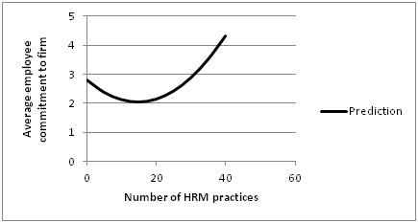
Figure 1: Attitudes to Work (Bryson, 2013)

Historical Management Theories

Fayol’s Definition
Similar to a game of chess, an enterprise’s ability to survive and thrive in a highly competitive environment is dictated by its ability to manage its assets and to predict the future. Amongst those initially mentioned, aside from physical and financial ones, we have the company’s employees – arguably the most important piece of the puzzle. And although there is strength in numbers, without organization, chaos soon ensues, so in late 19th century – early 20th century, Henri Fayol (1841-1925) coins the idea of management which is, in a more colloquial language: “to forecast and plan, to organise, to command, to co-ordinate and to control”. As a critique of this theory is the lack of focus on personal interests of the employee, flowing from the idea that the manager is a father figure that knows what is best and imposes authority (Fayol, 2013).

The Scientific Method
F.W. Taylor (1856-1915) take on management is a study of “time and motion” where each action is broken down into its smallest components and the most efficient method is identified and subsequently taught to the employee. The most notable benefits of this method are the reduction in time it took to complete tasks, thus increased production, the ability to measure accurately and therefore plan and predict more precisely, and most remarkably it improved working conditions because it promoted those environments that yielded the most results. Despite this earlier mentioned benefit, this approach reduced the employee to becoming another cog in the machine and it would not take in account the human aspect of management (Taylor, 2016).

The Bureaucratic Style
The third historical management figure is the German national Max Weber (1864-1924), author of the bureaucratic style of management which is characterized by a strict adherence to rules and that decisions are recorded in writing, a focus on hierarchy, achieving a position solely by merit and competence and a clear distinction between authority granted by the office held and not by identity. In terms of meaning, Weber is the one noticing a clear-cut difference between authority and power, stating that authority implies a form of acceptance on behalf of the entity is exercised upon. Furthermore, he divides authority in three distinct branches: traditional – derived from customs or traditions, charismatic – born out of loyalty or confidence in a leader, and legal – authority that was granted thanks to a position held within a structure. Although this management style leads to very rigid organizations unable to adapt to unpredictable scenarios, Weber paves the road to identifying the border between manager and leader (Waters & Waters, 2015).
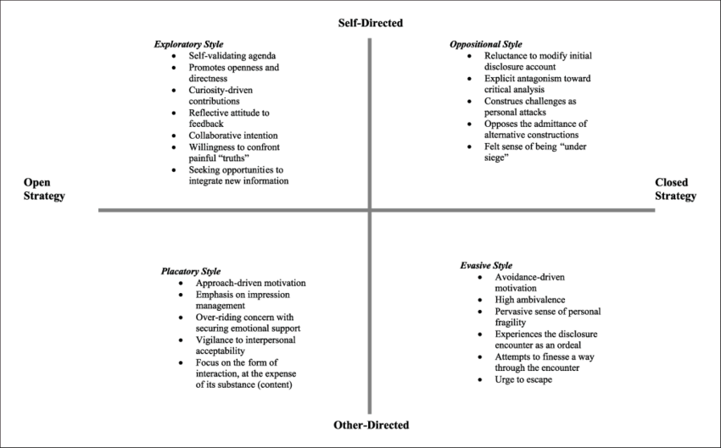
Figure 2: Disclosure Management (Ott, 2017)

Human Relations Theories

Mayo and Schein
Beyond the classical management styles, we move into a human relation approach, where the focus shifts from structure and mechanics to meeting the employee’s needs: the human. Its most prominent proponents are Elton Mayo (1933) and Edgar Schein (1965), both focusing on studying human behaviour to establish what motivates everyone, what gives the employee the impulse to achieve more in the workplace. The main achievement of the two was capturing the idea that humans must be understood as part of their social group, thus an attention shift to culture and social structure within a business and being the first to conduct a human behaviour study in a workplace context, most notably here Mayo’s Hawthorne Studies (Carey, 1967).
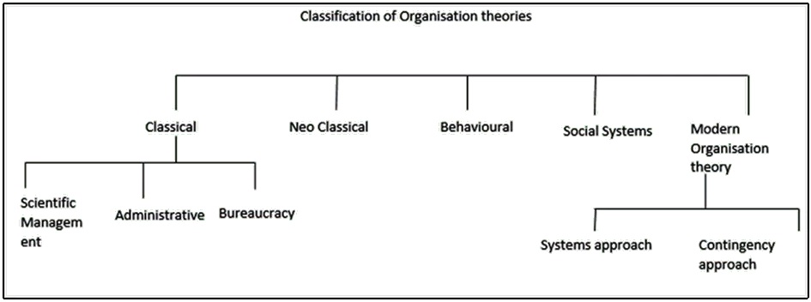
Figure 3: Organisation Theories (Frost, 2018)

Neo-Human Theories

Maslow’s Pyramid
The ideas coined by the human relations management adepts were further polished into neo-human relations, where social psychologists delved into more complex theories, born out of an analysis of satisfaction, incentive, and intrinsic. To this day, Maslow’s Hierarchy of Needs (1943) remains a reference point in literature, revolving around a person’s needs. Represented as a pyramid, it starts at the bottom with the need to fulfil psychological needs, followed by preservation of homeostasis, then love, self-esteem, and self-actualization. He hypothesises that a person will need to satisfy the need on the bottom before focusing on the superior one, i.e., a thirsty person will seek to quench it rather than seeking romance. This was met with scepticism, as life provides examples of people that do not follow this pattern (King, 2009).

McGregor’s X and Y
Another representative of the neo-human perspective is McGregor who divides employees in two types in terms of how a manager should motivate them, thus coining Theory X (a reinterpretation of scientific management) and Y (a modus operandi closer to Schein’s). Later, William Ouchi creates Theory Z, a collection of the best parts of X and Y, as an introduction to Japanese management for the American public (Mariotti & McGregor, 2004).

Herzberg and Likert
Herzberg analysis of satisfaction and dissatisfaction factors in the workplace led to a better understanding of what motivates employees, and Likert turned his attention to the manager, defining management in base of his attitude: rational, benevolent, consultative, and participative (from most authoritarian to the most relaxed).

Systems and Contingency
After the perspective offered by the authors in the third category, culminating with Argyris conclusion that individual objectives should be aligned with the company’s, an idea that merge the classical theory with the human relations one emerged, in the form of systems theory. The idea here was of looking at the whole picture rather than focusing on key components of the system and seeing organizations as an immense layer of Venn diagrams. Therefore, early system theorists sought to find a unifying explanation with the aid of closed systems, open systems, subsystems, supra systems, focal systems, and boundaries.
As an addendum to systems theory, we have the contingency concept, where is theorized that there is no set rule on how to manage, but a style must be chosen after thorough thought has been given to the size, technology, and environment of an organization (Kast, et al., 1985).
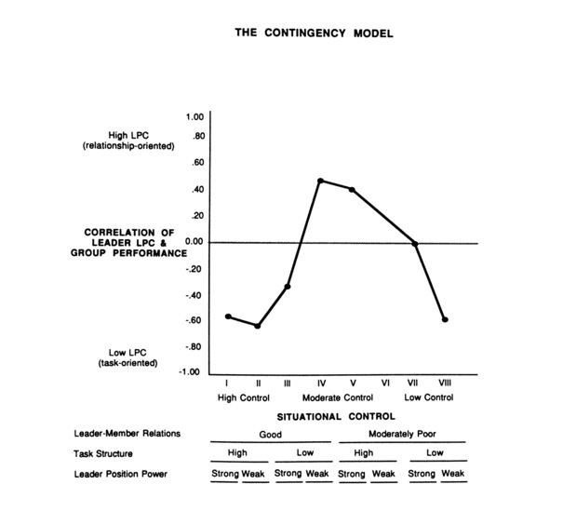
Figure 4: An Illustration of the Contingency Model (Taha, 2017)

Marriott Development Tools

Essential Skills for Supervisors and Managers
The notion of being a global company and able to provide the same high standard of quality of service across the board, entrenches the need for Marriott to develop top level performing staff, as well as maintaining them in its employment. Marriott prides itself in being a company where a bellman can reach the general manager position, provided that there is an existing desire for this, coupled with hard work and dedication (Kotter & Cohen, 2012).
As most global companies do, Marriott too, has various tools and programmes for a person willing to grow. Along the standard teaching materials and techniques, the hotel giant sports some that are unique to it and which we will look at more in depth below.
The ESSM – Essential Skills for Supervisors and Managers – is the first step an aspiring employee must undertake to establish themselves on a career growth path. The program is aimed at associates with little to no experience in a management role and is designed to give a person the right tools to rise to the occasion when a higher position will open. Once an employee signals to their respective line manager the desire to advance and enhance their knowledge, their name gets put forward for the program. Following that, a selection process takes place, where the associate must sustain a presentation in front of their peers and high-level management, including multi-property directors, general managers, HR representatives, and previous ESSM alumni. The program lasts for 12 months and comprises of bi-weekly meetings where skills pertaining to leadership and usage of Microsoft Office are enhanced and emphasized.

The Voyager Programme
The next step in grooming a future manager within the Marriott context would be the Voyager Programme (VP). The duration of this development tool spans from 12 to 24 months and its aim is to enrich the candidate in abilities and experiences related to international environments. It has a minimum requirement of work placement in a minimum of 3 countries and places the participant in entry level positions within all the departments of a property. As a development tool, the idea of traveling and emerging a person in the international aspect of the business, serves as means of uniformization and ensures that the same high-level requirements are met across the board. It also smoothens the cultural differences and improves diversity.
Both these unique features – alongside the traditional and widely encountered job trainings, workshops, and personal development plans -, ESSM and VP, played an important role in helping Marriott become a dominant player in the hospitality industry. However, their main set-back is the new environment that came out of the Covid19 pandemic: low volume of occupancy, increased redundancy, a necessity for a reduced budget, minimal international interaction, and overall a significant financial and psychological impact. The previous mentioned factors pulled the plug on all the programs and shone a light on the need to develop a tool that was ubiquitous and more adequate to the task at hand.

Digital Learning Zone Path
Which brings us to the end of 2020 – beginning of 2021 when Marriott launched the Digital Learning Zone, an online training platform meant to substitute and complement the existing Learning Centre. One of the reasons this tool is perceived as the natural evolution of training and development methods in a post-pandemic world has to do a lot with its multiple language approach to learning and its expansion into broader areas of interest. For instance, much as it may seem unrelated, a hotelier can learn how to code. Another mention-worthy aspect is the creation of two distinct growth branches for the individual, one imposed by the company (mandatory trainings and refresher courses), and another that allows a person to pursue their own passions.
Inasmuch as this newly developed tool attempts to be comprehensive, a drawback comes from the requirement of an internet enabled device on behalf of the user, as well as not acknowledging fully the psychological needs for in-person interaction. Whilst the issue of computer literacy and availability is an ever shrinking one, the hands-on aspect of the job is irreplaceable (Handy, 1993).
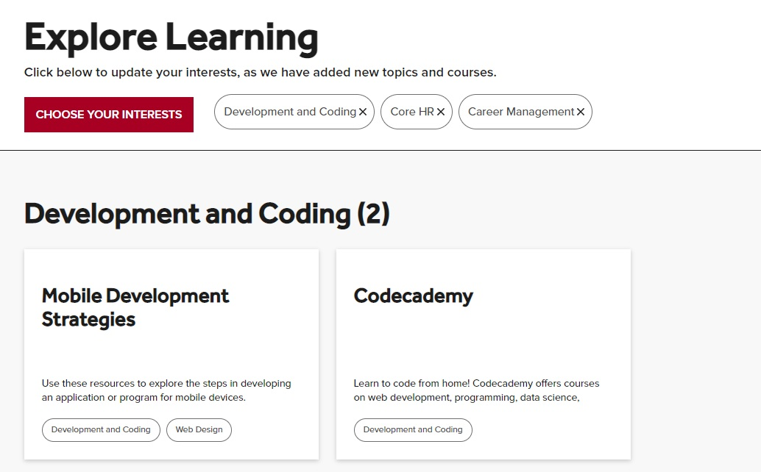

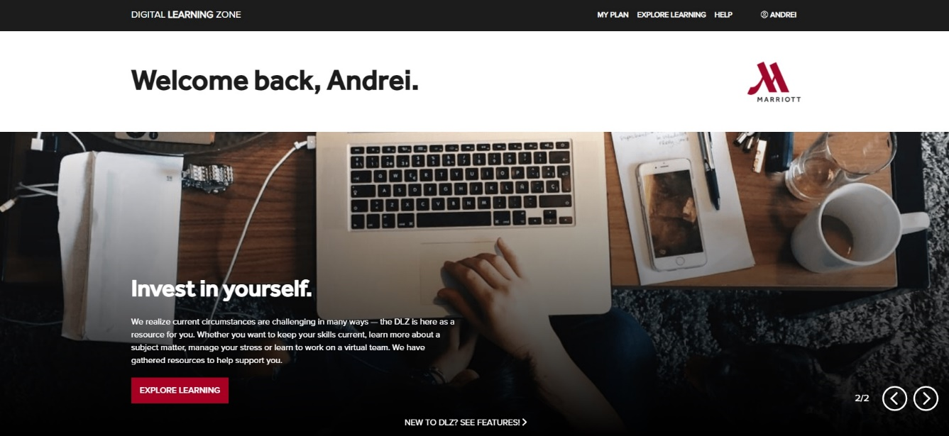
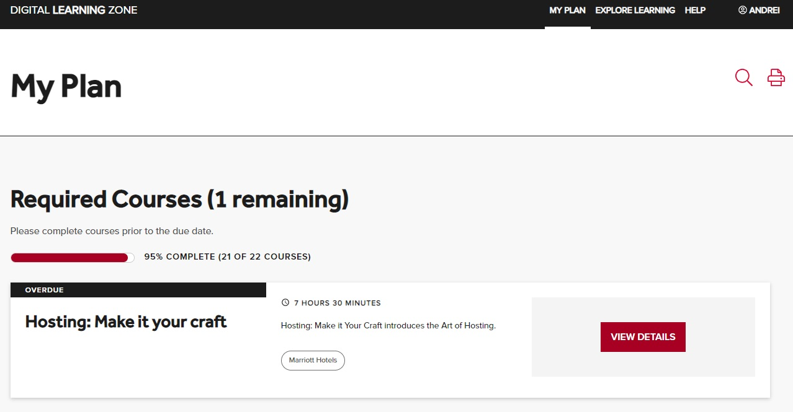

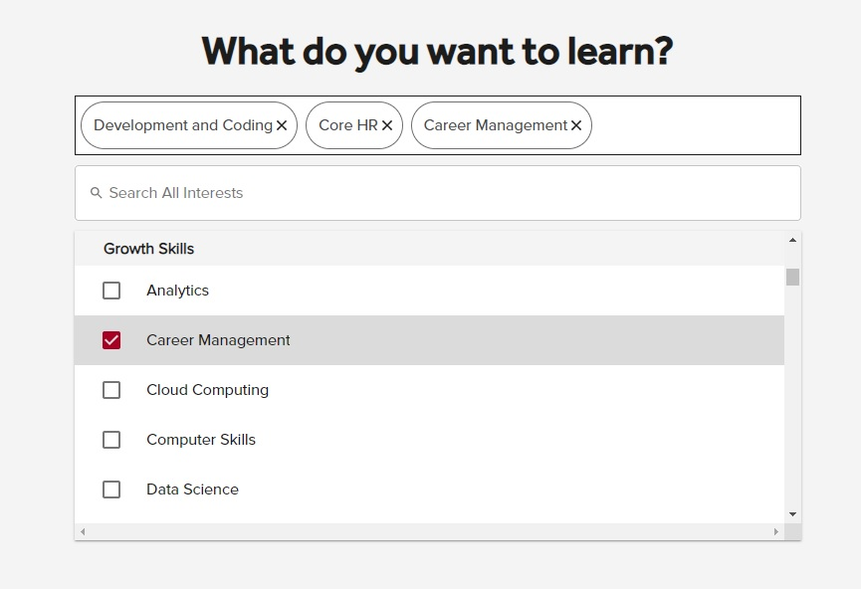
Figure 5.6.7 & 8: Presentation of DLZ (Marriott International , 2021)

Personal Development

The Plan
The most common method employed in the development of a person, be that an entry level position, an aspiring manager, or someone in the one percent of leadership, is through a personal development plan, in brief PDP. The initial stage of establishing an action plan starts with the job description for their current role and a consultation meeting (Mayo, 1933).

Motivation
It is worth mentioning that in the same way it is more cost-effective for a company to retain a client rather than making a new one, reducing attrition levels within the business’ ranks, has the same effect. A current employee – analysing here those that have successfully completed their probation period – is already ingrained in the company’s mindset, has already completed the introductory trainings, and is part of the workplace family. Pushing them past their current level, a developer must familiarize themselves with Maslow’s hierarchy of needs and decide what type of motivation they must employ and what needs to fulfil for the employee. When it comes to motivation, there is no “one size fits all” solution, rather a mix between the aforementioned Maslow, Jeremy Bentham – the idea of “carrot and stick” method, developed in the early 1800s during the onset of the Industrial Revolution where incentives and punishments were used as means of spurring people into action -, and Herzberg’s Two Factor theory (1959) – motivation being the result of carefully promoting satisfaction levels in the workplace, whilst pushing down on dissatisfaction (Maslow, 2019).

The Method
Therefore, a blueprint to develop identified development needs and expectations starts with stages that revolve around collection of information. The first one being a review of the current job description role and an assessment of whether that is still in line with what the employee does on a day-to-day basis, and whether the requirements are met daily. Once the foundation is set, a mentor – be that a superior manager, a director, or an HR representative – conducts a series of meetings aimed at establishing the needs and wants of a team/person. The purpose of these meeting is to get an understanding of how the person perceives themselves in the work setting, what are their challenges, frustrations, and aspirations. It is the most subjective part of the plan. The third stage of the plan is observing the individual working, here, the aim is to verify previously collected information and find connecting points of interest between the employee and the company. Following this, we have a stage of gathering additional data, a third-person perspective, represented by what the co-workers and customers think of the individual (Schein & Bennis, 1965).
By summarizing the above steps, we realize that we have data collected from three different perspective: personal, company, and customer/associates. Therefore, a step further is analysing this respective information, and, finally, putting it all together in a PDP.

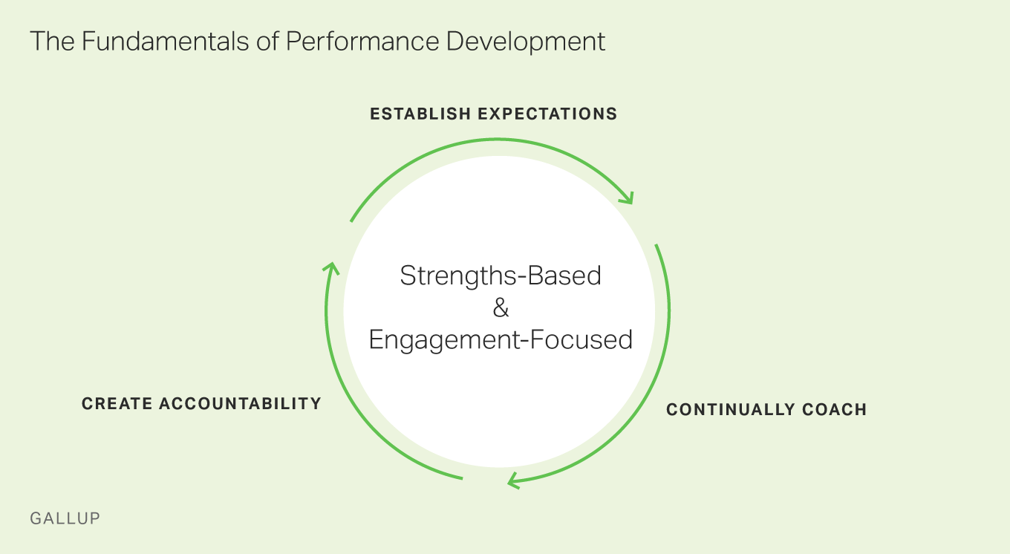
Figure 9: Development Circle (Ott, 2017)

Conclusion

For the Next 100 Years
Throughout this report we looked at how things were perceived historically when it comes to management and the theories put forward by various individuals. It is noticed how the focus shifted from “man as part of the machine” to “what does a person needs to perform optimally”, and then to “what are a person’s needs and aspirations and how can the company fit with it”.
Within the chosen organization, Marriott International, the focus followed the same path, moreover, the company seems to have found a focus on the need to develop an individual sooner than most, due to the nature of its business and global presence. They have constantly pushed for internal promotion and always set themselves at the forefront of developing tools that would enable one’s pursuit of personal goals and ambitions.
The broad conclusion is that the tools Marriott provides are present and efficient, and that – considering the uncertain times we live in – developing a plan to meet both what a company expects from an employee and the same thing in reverse order, is heavily reliant on information collection and consultation, coupled with goal setting and constant feedback.

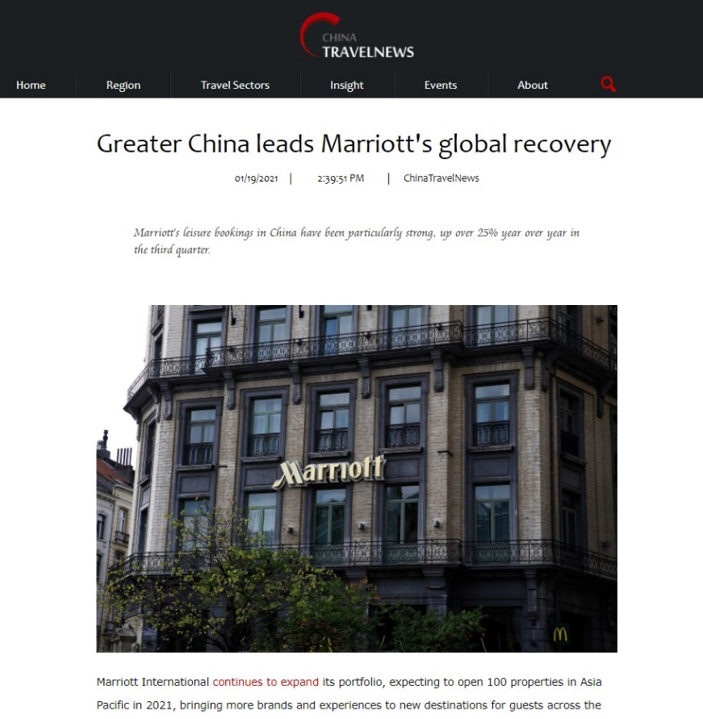

References

Beckhard , R. & Harris, R., 1987. Organisational Transitions: Managing Complex Change. Wokingham: Addison-Wesley.

Bertalanffy, L. v., 1951. Problems of General Systems Theory : A New Approach to the Unity of Science. National Library of Medicine, 23(4), pp. 302-312.

Bryson, A., 2013. National Institute of Economic and Social Research. [Online]
Available at: https://www.niesr.ac.uk/blog/positive-employee-attitudes-how-much-human-resource-management-do-you-need
[Accessed 11 04 2021].

Carey, A., 1967. The Hawthorne Studies. Indianapolis: Bobbs-Merrill.

Carnall, C. A., 1990. Managing Change in Organisations. London: Pearson Education Limited.

ChinaTravelNews,2021.ChinaTravelNews.com.[Online]
Available.at:https://www.chinatravelnews.com/article/142961
[Accessed 11 04 2021].

DoorStepTutor,2021.DoorStepTutor.com.[Online]
Available at: https://www.doorsteptutor.com/Exams/UGC/Commerce/Study-Material/Topic-Marketing-Management-5/Subtopic-Marketing-Planning-Organising-and-Control-7/Part-2.html
[Accessed 11 04 2021].

Fayol, H., 2013. General and Industrial Management. Eastford: Martino Publishing.

Frost,A.,2018.Researchgate.net.[Online]
Available.at:https://www.researchgate.net/figure/Disclosure-management-styles_fig1_326671629
[Accessed 11 04 2021].

Handy, C., 1993. Understanding Organizations. 4th ed. New York: Oxford University Press.

Heart of House Editor, 2020. Heart of the House Marriott International. [Online]
Available at: https://stories.marriott.com/articles/2020/02/run-to-give-in-asia-pacific.html
[Accessed 11 04 2021].

Kast, F., Kast, F. E. & Rosenzweig, J. E., 1985. Organization and Management. New York : McGraw-Hill.

King, P. W., 2009. Climbing Maslow's Pyramid. Kibworth: Troubador Publishing Limited.

Kotter, J. P. & Cohen, D. S., 2012. The Heart of Change. 5th ed. Boston: Harvard Business Review Press.

Luhman, N., 1995. Social Systems. 6th ed. Palo Alto: Stanford University Press.

Mariotti, N. & McGregor, D., 2004. A Qualitative Analysis of Douglas McGregor's Theory X and Theory Y. Duluth: College of St. Scholastica.

Marriott.International,2021.Marriott.com.[Online]
Available.at:https://www.marriott.com/marriott/aboutmarriott.mi
[Accessed 11 04 2021].

Maslow, A. H., 2019. A Theory of Human Motivation. New Delhi: General Press.

Mayo, E., 1933. The human problems of an industrial civilisation. New York: Macmillan.

Miller, E. J. & Rice , A. K., 1967. Systems of Organisation. London: Tavistock Publications.

Ott,B.,2017.Gallup.com.[Online]
Available at: https://www.gallup.com/workplace/231620/why-performance-development-wins-workplace.aspx
[Accessed 11 04 2021].

Schein, E. H. & Bennis, W. G., 1965. Personal and Organisational Change Through Group Methods: The Laboratory Approach. New York: John Wiley & Sons.

Taha,A.,2017.Ahmed-Taha's-Blog.[Online]
Available.at:https://culcahmedtaha.wordpress.com/2017/03/07/effective-leadership-management-styles-approaches/
[Accessed 11 04 2021].

Taylor, F. W., 2016. The Principles of Scientific Management. New York: Cosimo Inc..

Waters, T. & Waters, D., 2015. Weber's Rationalism and Modern Society. New York: Palgrave
Macmillan .

