Document of Intent

This animation project will be produced and designed independently by myself. The process includes, but is not limited to, constructing the background world setting, script writing, storyboard creation, character modeling, character texturing, rigging, scene modeling, scene texturing, animation frame sequence production, voice dubbing, special effects post-production, and more. For the production cycle, I plan to complete the model production in June. In the first half of July, I will work on character texturing, rigging, and scene texturing. In the second half of July and the beginning of August, I will focus on producing animation frame sequences. Following this, I will work on post-production effects and editing, aiming to submit the final draft in September.

In the original story setting, the entire world is set in a parallel universe. This world combines advanced technology with a classic Western style, inspired by Blizzard's game "StarCraft II." In this game, despite the ability to travel through space, the foundational construction retains a primitive Western style reminiscent of old taverns.

The story of this animation revolves around a group of people who believe in the existence of dragons in this magical, technological world. These believers are divided into different factions, and the conflict between these factions impacts the protagonist. The main storyline follows a Western cowboy seeking vengeance against another cowboy over a family feud. It's a straightforward story, featuring classic Western showdown scenes and exploring their narrative through various shots.

The scenes in my animation primarily use close-ups to portray and heighten the tension of a Western duel, relying on the micro-expressions of the characters to tell the story. I also use flashbacks and interludes to explain the feud between the two men. Throughout the film, I emphasize body movements and micro-expressions to drive the plot. Figures 1 and 2, for instance, utilize close-up micro-expressions to create a tense atmosphere between the two sides, setting the stage for the showdown.
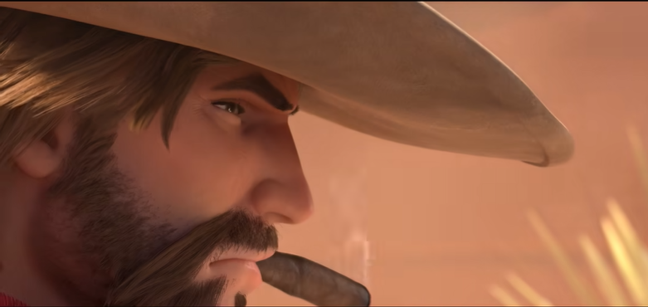
Reference: http://ow.blizzard.cn
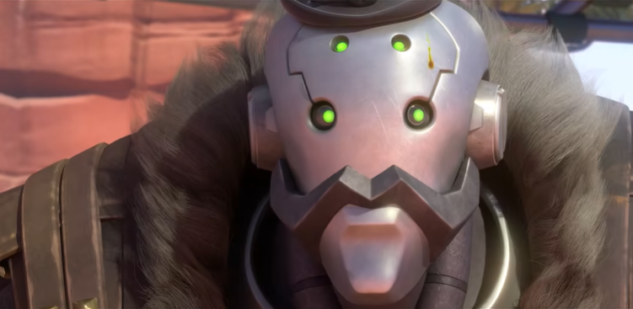
Reference: http://ow.blizzard.cn
For character modeling, I will use Maya, Unfold3D Network, and Photoshop. Maya will be used to create the character models, Unfold3D to unfold the UVs for later texturing, and Advanced Skeleton in Maya for rigging the bones and expressions. Photoshop will be used to create texture maps for the characters. If possible, a dragon model may also be created for the party.

In scene production, I will use Maya to build large environments and various props. Key scenes in the animation will include a bar, a Western street, and memory sequences. Most of the animation will consist of frame sequences, focusing on close-ups to convey the story through camera language. However, I will also use Maya's particle effects to depict muzzle flashes, fire, and smoke in memory scenes.

In post-production, I will use Maya's particle effects for necessary fire and smoke elements and Adobe Premiere Pro (PR) for editing the animation. My primary goal in post-production is to ensure the visual effects enhance the storytelling.

At the end of the day, I hope to learn a lot from this project and gain valuable lessons for my growth. Additionally, I hope my mentor can recommend some websites that offer free music and special sound effects, as creating sound effects like gunshots on my own is quite challenging.

