

ACCA 7015
DATA MINING AND VISUALISATION
ASSIGNMENT 2

SUBMITTED BY: SURENDAR REDDY DUBBAKA
STUDENT ID: 2314079
COURSE: MSC DATA SCIENCE AND ANALYTICS
PROFESSOR: NIK WHITEHEAD

Table of Contents
Dataset Description 3
Primary Pre-processing 5
Analyses Performed 10
Secondary Pre-processing 15
Sampling strategies 17
Discussion of any interesting patterns identified and how they would be reported back in an appropriate business or scientific context 18
Reflection on the process and its results 18
Reference List 20

Dataset Description
Data on air pollution from multiple monitoring sites in Hyderabad and Vishakhapatnam, Andhra Pradesh, India are found in the dataset and the dataset is taken from kaggle. The Central Pollution Control Board has generated the dataset. The dataset has 13 columns which are 15000 in number. The dataset is used for analyzing air pollution. Station number, sampling date, state, place, agency, type of place (residential, industrial 2-, etc.), concentration levels of pollutants such as nitrogen dioxide (NO2), sulfur dioxide (SO2), suspended particulate matter (SPM), respirable suspended particulate matter (RSPM), and particles with a diameter of less than 2.5 microns (PM2.5) The date format features the month and one-digit year. The set of findings from many tracking stations in Hyderabad and Vishakhapatnam, spanning the months from February 1990 through April 1992, is reported in the data compilation. Every monitoring point is labeled with a certain number assigned for the station code, which allows tracing and monitoring of location separately. Date scanned by the responsive machines is displayed by the sample date element. Date is in the form of "Month - MmmYYYY." The three initial letters of month remained the same as in Mmm and the four final letters of year remained same as in YYYY. Location "Hyderabad" or "Vishakhapatnam" is represented by means of location property. One such as an organization like APPCB, which is the Andhra Pradesh Pollution Control Board, will play the role of a collector and reporter, indicated by its agency characteristic (Attwal and Dhiman 2020). The attribute type catalogs the surrounding location, viz. residential, industrial, or rural, to make the station. A set of air pollution data, that involves particulate matter with less than 2.5 µm (PM_2.5), respirable suspended particulate matter (RSPM), nitrogen dioxide (NO_2), sulfur dioxide (SO_2) and suspended particulate matter (SPM) are included in the dataset. The reason why such pollutants are usually subjected to monitoring despite their harmful impacts on human health and air quality is that they may have serious effects on these areas. These contaminants are characterized with ranges listed in the respective properties of the elements, letting us know the levels varied where they are located. The data set contains missing values, NA is written into the cells. This is an issue of increasing frequency in real world data sets and it needs to be addressed during the pre-processing phase of the machine learning workflow. Additionally, the data features such as "location_monitoring_station" and "date" are already somehow present in other attributes. This might be, in fact, underlying reason for inclusion of these attributes in the dataset which doesn’t seem to be necessary for the analysis. The dataset contains mean and mode values of so2 mean: 16.96 so2 mode: 6.0 no2 mean: 25.61 no2 mode: 12.5 rspm mean: 76.77 rspm mode: No mode (all values are unique) spm mean: 255.07 spm mode: No mode (all values are unique). The dataset has been selected because it has a potential to analyze and detect the air pollution. Eventually, this dataset offers a complete data pool from areas of monitoring inlet into the most significant Andhra Pradesh, India, cities of Vizag and Amravati. It acts as a platform for environmental researchers and organizations to obtain information regarding levels of pollution and its trends so that they can evaluate proven causes for pollution and develop policies to reduce pollution and improve the air quality (Rezaei et al 2021). The dataset is unique in that it has some non-parameters, as some cells have "NA" in their values. It is a usual phenomenon that are going to deal with in real-world datasets and the need to have this in mind when preparing for the data flow in the startup phase. Additionally, for the attributes such as "location_monitoring_station" and "date", these attributes already provide the required information that is similar to those in numerous other attributes. As such, these attributes are either repetitive or might not be necessary for the analysis.
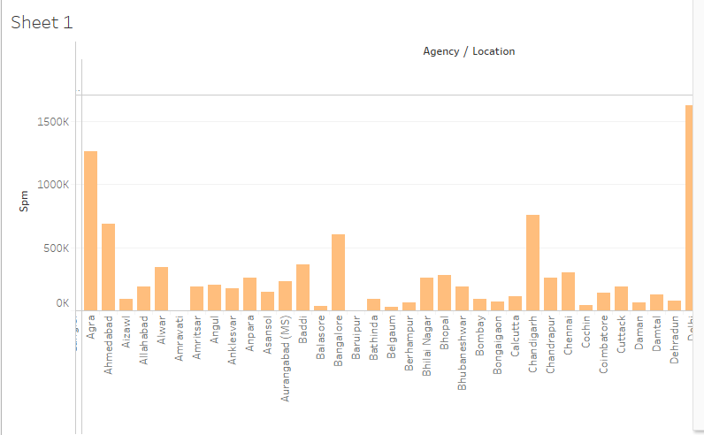
Figure 1: Histogram of dataset
(Source: Self-Created using Tableau)

Primary Pre-processing
Before getting on to analytical tasks, pre-processing of data must be carried out by identifying and handling missing values, cutting irrelevant information, and modifying the data into the format established by the selected machines/algorithms is considered a must step of data mining and machine learning activities (Kotak and Modi 2020). Regarding this dataset, the following could be the main pre-processing steps.
Handling missing values
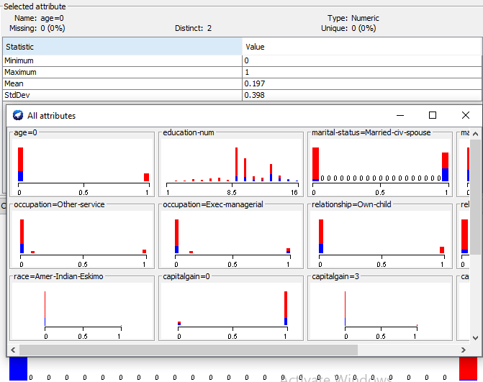
Figure 2: Handling Missing values
(Source: Self-Created using WEKA)
Missing values can be handled in two ways, depending on the analysis approach selected. whether the values are being filled in by following the appropriate procedures but not the ones with missing values are altogether removed (listwise deletion). Value averaging for missing ones can be done using the mean imputation, median imputation, and more complicated methods, like k-nearest neighbors imputation (Ratra and Gulia 2020). Row Wise deletion passing by the name of complete case analysis is a CSV row becoming non-existent if there is a missing value among its attributes. It is elementary, but rarely loses data, that is why fewer data could be lost and with it a lot of information reducing the statistical stamina with the existence of missing records. The mean imputation procedure is the technique of substituting this group mean statistic for an attribute with missing values (Ratra et al. 2021). It proves to be an easy-to-apply, yet, it is possible that it can result in distorting distribution of data, leading to biases, especially if data is missing in a nonrandom pattern (Alpan and İlgi 2020). By and large, the median imputation is as close to mean imputation as to level imputation. Having said that, this technique is more appropriate in circumstances where the data is skewed or contains extreme values sometimes, which might unnecessarily affect the mean since it is more robust to outlier.
Removing redundant attributes
Repetitive attributes and location monitoring station as well as date are redundant entries of the dataset because they are already contained in other attributes. Moreover, these not necessary attributes lead to information overload and they should be eliminated in order to decrease the computational time (Díaz et al. 2022). The location of the monitoring station might be conveyed through the "location_monitoring_station" tag with "location" suggesting the name and "monitoring_station" signifying the function. The "location" property, that determines the city (in which each of the two monitoring stations is located it is Hyderabad or Vishakhapatnam), is already on the data set (Dey 2020). As this is superfluous, "location_monitoring_station" attribute can be safely removed from the dataset which is done by default in the functionality and does not waste any valuable information. Additionally, in place of "date", it is mentioned that there is a "monthyear" form. Turning to a different kind of approach ("Month - MmmYYYY"), the date they were taken is however already noted in the "sampling_date" element. Both variables should be kept so that there might be repeating data. This will increase the complexity of the dataset and raise its dimensionality, which may complicate analysis that would need more computing resources (Maryum 2020). The data set can be made more efficient by minimizing these additional attributes as well as the data space dimension indexes which will reduce the computational load and possibly improve the analysis methods performance. The stage consisting of the data quality assessment proves very useful when dealing with enormous datasets or algorithms that are data sensitive regarding the number of features and features' parameters or qualities. On top of that, intense focus on the central, important non-duplicate detail may facilitate the structured reproduction of the analysis process due to the reduction of irrelevant attributes. Besides, it also deals with multicollinearity issue which arises when confounding features lead the model instability and noisy inputs such as in regression and classification (Tasfia et al. 2024). However it is important to tell that it should be careful and ensure that when it take these characteristics away it don’t miss all the relevant data and introduce any biases. Also, before starting the analysis, one needs to be well acquainted with the attributes of dataset and the analytics goal to be achieved.
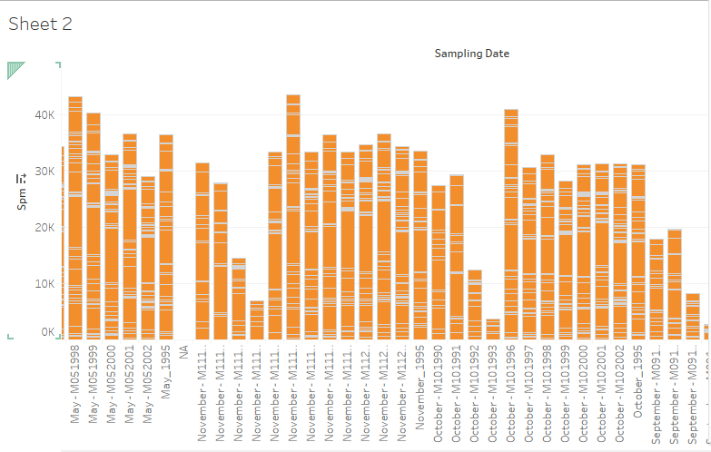

Figure 3: Sampling Histogram of dataset
(Source: Self-Created using Tableau)

Transforming categorical data
"Place," "the administrating body," "the type of community agency," and "the kind of organization" are aspects that can be grouped into one or more sections. This transformation may be mandatory, depending on the data processing methods (Li 2022). It may involve such techniques as label encoding or one-hot encoding. While in the case of label encoding each category is assigned with a separate numerical value in the one-hot encoding procedure, the binary columns are generated for every category (Triayudi et al. 2022). Machine learning techniques most of times fail to take the categorical features that are not numerical as input for the learning process thus making a lot of them ineffective. As a result, it gets very important for the algorithms to represent features of these categories as the numeric form that can be understood by the algorithm (Duran et al. 2023). A technique commonly used is "one-hot encoding," also known as "dummy variable encoding." It generates 0s and 1s under every distinct category property. One of the situations, where "location" attribute has two categories, "Hyderabad" and "Vishakhapatnam", would requite one-hot encoding to give rise to two additional columns. The respective column would have a value of 1 for the true category and 0 for the false category. A differentiating feature here is that no implicit ordering is needed, and therefore this code will not erase categorical information (Al et al. 2021). On the one side, label encoding identifies every category of the categorical attribute by using a unique integer value for them. For instance, the state attribute may have a value 1 for "Andhra Pradesh" and have any other value for another state included in the data e.g. value 2. Label encoding may very well create an arbitrary order of categories in some algorithms. It does not influence the analysis either since one-hot encoding process will take up more space. If the analytical method is one-hot encoding or label encoding and the nature of the data is categorical, the method to encode data should be used. For algorithms including decision trees and support vector machine that do not possibly consider categories with an inclined order one-hot encoding is usually recommended. Integration the categories which follows a natural order such as ordinal rating scales or when the algorithms are capable to handle ordinal data then the encoding might make sense (Dalla and Ahmad 2023). A new expression should be correctly operated on during testing, for example, by introducing new unique value or any default if it is missing. The uniform manner in which encoding should be implemented on the training and test sets should be emphasized, although first requiring. Moreover, one-hot encoding might lead to a few drawbacks when there are many categorical attributes or categories in the datasets. For instance, it may make the computational power reach its limits because of too many parameters to be found and hence the use of further preprocessing techniques, such as feature selection or dimensionality reduction is compulsory.

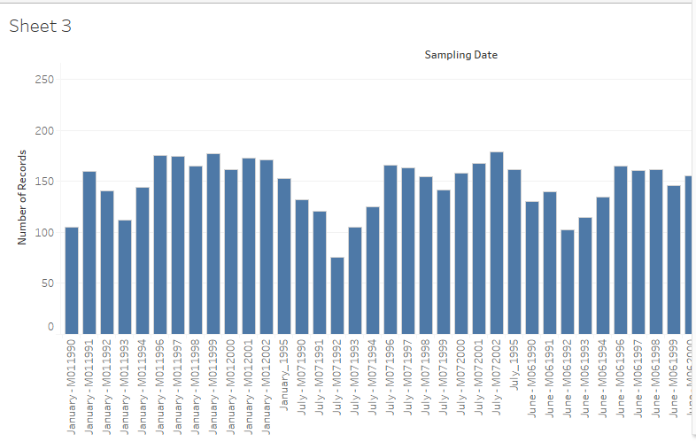
Figure 4: Bar plot of dataset
(Source: Self-Created using Tableau)

Normalizing or scaling numerical data
Pollutants ranging from SO2, NO2, RSPM, SPM, and PM2.5, which have differing gauges of measurement, can be an example of features that require scaling or normalizing to prevent that higher numerical ranges would dominate the analysis One of the most known scaling methods is standardization, it aims to standardize data by transforming it into a probability distribution centered at zero with a standard deviation of one (Wijaya 2022). Additionally, min-max normalization, which rescales the learning outcomes into a range between zero to one, is another common scaling technique. The dataset are capable to be imported into WEKA (an open source to perform data mining that having Waikato Environment for Knowledge Analysis name) which it has been used for another investigation after finishing the initial pre-processing steps (Chhillar 2021). This also involves correction of data after this processing is done by these methods and algorithms. As an example, regarding identifiers (categorical items), some methods must be applied to make them suitable, such as using labels encoding or one-hot-encoding if decision-tree methods are applied for classification in this case. For numerical attributes, however, scaled or normalized features can be required if cluster’s techniques are chosen to compare the measures to avoid any dominating of one upcoming from the other in distance calculations. The pre-processing steps that the dataset has to go through is crucial as it influences the results of the analysis and the patterns it is going to reveal (Triayudi and Widyarto 2021). Thus, it has implications on the extent to which their understanding may be achieved.
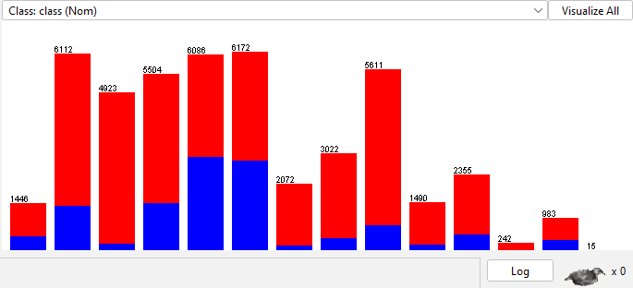
Figure 5: Bar plot of dataset
(Source: Self-Created using WEKA)

Analyses Performed
One of the possibilities with WEKA is the use of a directed discovery strategy which suits a few algorithms, like association analysis, clustering, or classification, for example.

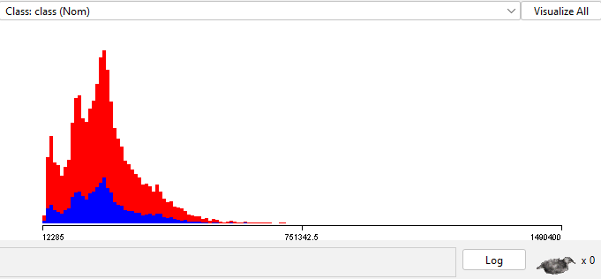
Figure 6: Line plot of dataset
(Source: Self-Created using WEKA)

Classification Analysis:
Companied by the given parameters, evaluation of deciding total contaminants' amount can use classification analysis. Such results of the research can be employed to create policies and to make decisions as much as possible by getting down to the aspects which give rise the high pollution rates. To achieve this, we may take advantage of classification methods such as the naive Bayes, support vector machine (SVM), and decision trees (tree analytics like Random Forest) (Manimannan and Priya 2020). Let alone, the data set can be used to train decision trees to forecast the PM2.5 level .The models will be based on features such as site , type of agency or pollutant (sulfur dioxide, nitrogen dioxide, particulates and dust), pollutant levels and so on. Visual outcome will be a decision tree model that allows reading decision rules and choosing the essential variables influencing the concentration of PM2.5. For instance holdout validation or k-fold validation techniques could be employed to assess the classification algorithm's ability. The data set is split k-fold to ensure that each of the subsets have equal part for k-fold cross- validation. It is then that the model is trained and is being tested k times by k means, using one subset for the test and the other subsets for the training. Hence the average performance over all folds is provided as the next step. This approach is designed to assess the ability of the model in a resilient state and its degree of generalization (Ghazal et al. 2020). Nowadays, data scientists use k-fold cross-validation as an effective way to evaluate the quality of machine learning models -l, more importantly, when the small dataset is used. The model is trained and evaluated after being divided into k folds which are again subsets of the data that are used in training. Always, training set serves as a source of information and testing set becomes a measure of how accurate a model is. By substituting this method, this decreases the bias that would be induced by entering the train-test split only once. Suppose, this model was to be tested on particular troubles as it was trained upon. Usually define k as a power of 10 because it provides us folding with a easy math, for example k=10 gives 10 folds, and so, 10% of the data will be tested, while 90% is used for training the model in each fold. Besides that, it is important to consider whether the specific data set has certain absolute limits or not, thus deciding on alternative values of k, such as 5 or 20 (Qamar and Raza 2023). The classifier's error rates, such as accuracy, precision, recall, F1-score, or area under the receiver operating curve are estimated for each fold during the k-fold cross-validation iterations. The final performance is feedback by the mean of these indicators across all the folding kernels. Multiple train-test partitions can be jointly taken into account and the extent of potential outliers peculiarities of any specific test split are lessened that add up confidence of the method accuracy for assessment of model generalization powers as against a single train-test split (Merlini and Rossini 2021). Particularly, k-fold cross-validation method can also help us detect whether the model overfits or not to the data. When a model overfits, it is likely to be a model that does really good on training folds as compared to seemingly worse ones on test folds. In this case, a model becomes simulating too complex and the thought as a result of it is being memorized than understanding patterns and relationships. By the contrary, a poor performance on both the training as well the testing folds may suggest a situation of underfitting, meaning the model is much straightforward that it might not be identifying the key trends. Researchers and analysts will be able to approve, with high reliability, the validity and quality of their classifications if they use k-fold cross-validation or other strengthening techniques like holdout validation. This makes certain that the models are not excessively influenced by the way data has been separated for the current experiment and will exhibit good a performance on unseen data.

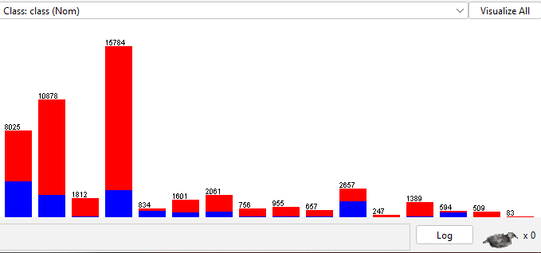
Figure 7: Line plot of dataset
(Source: Self-Created using WEKA)
Clustering Analysis
The monitoring stations can be grouped however clusters of the stations by defining their feature and trend of the pollution by employing the clustering analysis. Thus, these findings could be used for pattern identification and also discover factors which may cause those patterns. To achieve this, one can use K-means clustering or hierarchical clustering methods, namely, agglomerative and divisive. For instance, the dataset is submitted to clusters in k-means sense, with the location type treated as a set of features describing the pollutant levels. The homogeneous selected stations to be grouped depending on the level of pollution in that area. The clusters may represent typical kinds of environments of residential or business landscapes (Villavicencio et al. 2021). Methods such as approach of elbow and silhouette study can be used for determining the number of groups which is the best. Afterwards, "elbow" is applied which represents the point at which the within-cluster sum of squares (WCSS) becomes level (which means that it does not change significantly as the number of clusters increases). Silhouette analysis becomes the qualitative tool of measuring how separate the clusters are, with the clue used for each instance provided in cases of how well it is related to its own cluster and other clusters (Zamir 2023). One of the well known algorithms helpful in deciding the optimum number of clusters is the elbow principle which is greatly applied in k-means algorithms. The algorithm is aversive to the CWS which is a function of the number of clusters of k. The mean-squared distance of each data point from its cluster centroid is calculated with, by the WCSS. Considering the lowering WCSS due to the additional clusters being added, the algorithm tends to fit the data better as more groups are formed (Basha et al. 2023).The number of WCSS vs. k is plotted in the starting point of the elbow method. To explain more the shape that the resulting plot usually takesis that of the "elbow" where the WCSS line is dropping precipitously up to a certain point and after that it is either leveling off slowly or gentler decrease sets in. The “elbow” value is believed to be the optimal number of the clusters, because the WCSS is minimally aggravated by the additional over-clusters greater than the "elbow" value (Siafis and Rangoussi 2021). Nevertheless, the silhouette analysis is a more significant research technique that can comprehend the efficiency of clustering. Wherein the score is employed to denote the level to which the instance fits the nominated cluster relative to others. Higher advancements on the silhouette score mean better grouping. The neighborhood ranges from -1 to 1.
Association Analysis
The power of association analysis lies in registering common terms or possible correlations on the quality involved in the matter. It could for example, show relationships among certain pollutant levels and categories used in site characterization as well as revealing sets of contaminants or other pollutants that co-occur most of time. This analysis brings into the light both interesting conclusions and implementing plans for future endeavors in this area. The Apriori algorithm in WEKA is one common procedure for association rules identification. It starts from finding frequently occurring itemsets (combinations of items which appear together frequently) and generates association rules using those itemsets. The key metrics to measure association rules include support (the frequency with which the itemset occurs) and confidence (the frequency with which the rule is availed.) To rate the strength of the rules. Same as an example an association rule can be able to show at a given confidence and probability that stations with a high level of SO2 and NO2 are actually in industrial areas. These guidelines influence future studies focusing on the loss of biodiversity and its control through mitigation. It is highly significant to be very detailed about discovering and interpreting all findings in each and every stage of an analytical process, and drawing from the environment monitoring subject matter expertise and air pollution substantive knowledge.

Secondary Pre-processing
Preliminary process is usually followed with certain additional stages of preprocessing being introduced if the algorithms used demand it or if the knowledge is gained by using preliminary analysis. These complementary pre-processing stages could be used to improve the quality of the data and extract more influential outcomes or interpretations of the following studies as a result.
Feature selection
With the interim study insights, some features could be more important or valuable in forecasting a pollution level or picking out the other clusters than others. Feature selection approaches are the output when this eliminates the superfluous that does not fill in the most informative quality while removing redundant or unnecessary things . Approaches such as the information gain method, the recursive feature removal method, and the correlation-based feature selection method are necessary here. Seeing and handling deviations in data that are essential for the analysis outcomes, especially with respect to thematic analysis and regression models can be quite demanding. Outliers can considered as potential data point which can be found by different outlier detection techniques like local outlier factor (LOF), Isolation Forests or Z score analysis. It is contingent upon the scope of the research and informative background that aberrations may be excluded from the dataset completely, or, alternatively, they can be treated separately.
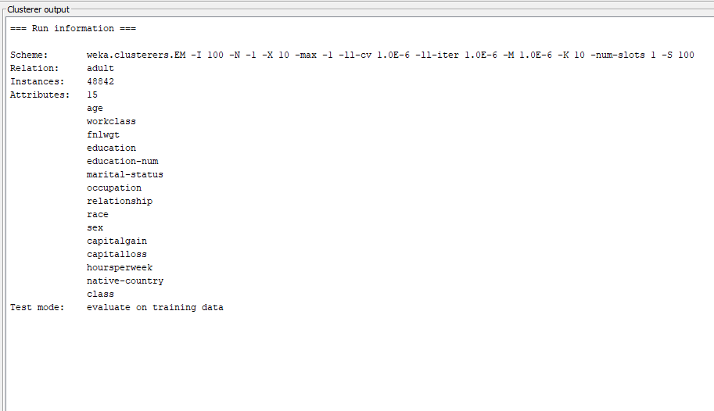
Figure 8: Clustering Analysis
(Source: Self-Created using WEKA)

Data transformation
Sometimes, additional data transformations may be needed to increase the functionality or readability of the models. This may occur after a preliminary study where various findings related to these transformations are discovered. Such as polynomial and logarithmic transformations can be utilized for the predictor variables in case the better relationship between predictor and the response variables which is non-linear is discovered.
Dimensionality reduction
Oftentimes when the dataset contains a vast number of attributes, the attributes can be projected into a lower-dimensional space that retains most of the relevant data without including unnecessary information this can be achieved by using dimensionality reduction techniques such as PCA or LDA. Perhaps the execution of these techniques will help improve some algorithms and reduce the costs of computer processing.
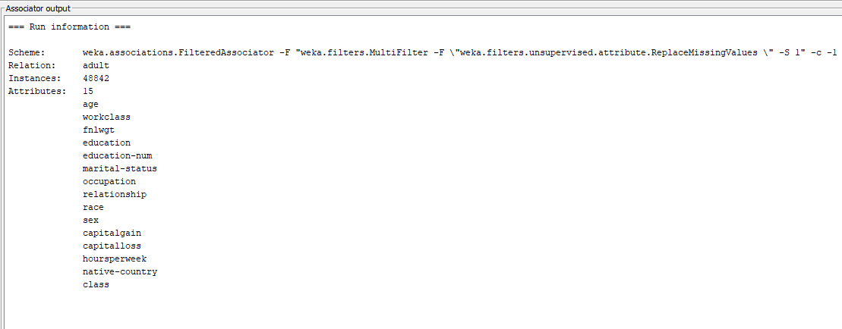
Figure 9: Association analysis
(Source: Self-Created using WEKA)

Techniques for sampling
Oversampling (such as SMOTE) and undersampling are used for balancing the classes distribution in an instance where a dataset shows the skewness of the data (with the considerably high occurrence of one class relatively to others). The contributed algorithm model may be more attribute to class imbalance; and therefore respond more effectively. The quaternary stage include the other procedures, processing, can perform crucial role in enhancing the dataset and interpret them correctly. These actions could consist of.

Feature selection
The research results in the initial stage will not only came into view, as being more vital or impactful than others, in making out the pollution level, but as well in distinguishing between the clusters forming or showing out the uncommon patterns exposed. By applying feature selection methods to identify and retain the most informative features while eliminating the duplicates or the elements that do not contribute to the model’s performance/inference, it is possible to enhance the model’s performance and interpretability. Noticing and managing outliers in a dataset makes a huge variance in the final result of the analysis, especially while applying clustering and regression models or others. Getting to know outliers using the proper approaches, for example, elimination or separate handling, will contribute to the strength of the assessments and their precision.
Data transformation
Therefore, for a better fit of the model to these tendencies change of transformation (such as logarithmic, polynomial) may be needed in case of initial analysis shows that the correlations are non-linear or several characteristics of input data does not correspond to prior assumptions of certain algorithms.
Dimensionality reduction
When there are too many data attributes in the dataset it can be projected into the lower-dimensional data space with the most important data information preserved by the dimensionality reduction techniques like principal component analysis (PCA) and Linear Discriminant Analysis (LDA). The position involves exploring new platforms that could improve the algorithm's effectiveness and lower the system's computing demands.

Sampling strategies
A nullification method by the form of oversampling or undersampling is created for the purposes of balancing the class distributions in an imbalanced dataset, where one class is poorly represented in contrast to others. This could as well improve the performance of the classifiers that highly depend on class imbalanced instance weighting, the approach of high class imbalances with unequal class weighting they are highly sensitive. Making any the principal additional main pre-processing stages may be supposeding after careful utilizing the dataset examination, initial analysis results and aim of a particular analysis on top of that. The fundamental starting point for data analysis and choice of data pre-processing method is domain knowledge and subject matter expertise in climate monitoring and air pollution. Those are the fields for which data is collected.

Discussion of any interesting patterns identified and how they would be reported back in an appropriate business or scientific context
The study of myriads of spatiotemporal analyses performed on the dataset of air pollution can uncover several surprising and thought-provoking trends and insights that could aid in the development of future studies, policy decisions, and plans of environmental management. While conducting such analyses, a report of trends would need to be appropriately and clearly communicated to those with relevant stakeholder roles, such as research institutions, environmental agencies, legislators, and the society at large. The detection of information-competent sites located at various random places based on the type of pollution recorded is what could be observed as one of the patterns. Take for instance the clustering analysis that helps in identifying the station clusters that continually exhibit the enhanced concentration of a particular pollutant including SO2 and NO2 (Hammoodi et al. 2021). This is an indication that in that particular region, there are massive industrial operations or vehicle emissions. Thematic visualization technique was applied for putting pollution hotspots on spatial coordinates in Hyderabad and Vishakhapatnam, so the problems could be seen visually.

Reflection on the process and its results
Using association analysis, clustering, and classification, analysis of the air pollution dataset shows to be a good one, with steps of illumination and brightening. It has demonstrated that data mining and the machine learning method are much a bigger complement to features hidden in plain data than might be revealed just by a quick glance at it. By using the holistic methodology that combines different approaches, each of which has a unique angle that makes the data understood in different ways, holistic biology is one of the most effective. It was possible to minimize the meticulousness of the process since the classification analysis revealed the factors that affect pollution levels, leading to the identification of targeted areas for interventions or policy changes. Knowing which stations share similar pollution patterns by clustering analysis in order to find some hot-spots or with are concerned problem. Co-clustering patterns were also observed to be able to differentiate the similar pollutants by the analysis of associations, which may help determine what are the research focus and emission control solutions. The method of directed discovery with defined goals and especially hypotheses helped us in producing conclusions that are acceptable to common sense and focused on practical conclusions. It demonstrates how significant the role of the area specialist or the professional in the domain is for the critical comprehension of the insight and its subsequent transformation into new directions for further study or practical recommendations. Although the process produced insightful results, it also highlighted the difficulties and constraints associated with using real-world datasets. The necessity of meticulous data cleaning and preparation, the existence of missing values, and the possibility of outliers brought to light the significance of strict data management procedures and the use of suitable pre-processing methods.

Reference List
Journals
Attwal, K.P.S. and Dhiman, A.S., 2020. Exploring data mining tool-Weka and using Weka to build and evaluate predictive models. Advances and Applications in Mathematical Sciences, 19(6), pp.451-469.
Rezaei, E., Ghoreyshi, K., Dimitrov, Y., Sadique, K.M. and Campos, J., 2021. Data Mining with WEKA.
Kotak, P. and Modi, H., 2020, October. Enhancing the data mining tool WEKA. In 2020 5th International Conference on Computing, Communication and Security (ICCCS) (pp. 1-6). IEEE.
Ratra, R. and Gulia, P., 2020. Experimental evaluation of open source data mining tools (WEKA and Orange). International Journal of Engineering Trends and Technology, 68(8), pp.30-35.
Ratra, R., Gulia, P. and Gill, N.S., 2021, July. Performance Analysis of Classification Techniques in Data Mining using WEKA. In Proceedings of the International Conference on Innovative Computing & Communication (ICICC).
Alpan, K. and İlgi, G.S., 2020, October. Classification of diabetes dataset with data mining techniques by using WEKA approach. In 2020 4th International Symposium on Multidisciplinary Studies and Innovative Technologies (ISMSIT) (pp. 1-7). IEEE.
Díaz, J., Espinosa, R. and Hochstetter, J., 2022, June. Towards More Clean Results in Data Visualization: A Weka Usability Experiment. In International Conference on Human-Computer Interaction (pp. 389-400). Cham: Springer International Publishing.
Dey, A., 2020. Prediction and analysis of student performance by data mining in WEKA. West Bengal University of Technology.
Maryum, F., 2020. Heart patients dataset analysis using weka tool. Easy chair.
Tasfia, S., Reno, S., Jahan, N. and Al Mamun, A., 2024, January. Exploring Weka and Python for Educational Data Mining: Naïve Bayes vs. J48. In 2024 5th International Conference on Mobile Computing and Sustainable Informatics (ICMCSI) (pp. 470-475). IEEE.
Li, Y., 2022, July. Application of Data Mining Technology Based on Weka in Student Management. In EAI International Conference, BigIoT-EDU (pp. 225-235). Cham: Springer Nature Switzerland.
Triayudi, A., Widyarto, W.O. and Rosalina, V., 2022, June. Analysis of educational data mining using WEKA for the performance students achievements. In Proceedings of the 2nd International Conference on Electronics, Biomedical Engineering, and Health Informatics: ICEBEHI 2021, 3–4 November, Surabaya, Indonesia (pp. 1-10). Singapore: Springer Nature Singapore.
Duran, Z., Akargöl, İ. and Doğan, T., 2023. Data Mining, Weka Decision Trees. Orclever Proceedings of Research and Development, 3(1), pp.401-416.
Al-Taie, R.R.K., Saleh, B.J., Saedi, A.Y.F. and Salman, L.A., 2021. Analysis of WEKA data mining algorithms Bayes net, random forest, MLP and SMO for heart disease prediction system: A case study in Iraq. International Journal of Electrical and Computer Engineering, 11(6), p.5229.
Dalla, L.O.F.B. and Ahmad, T.M.A., 2023. HEART DISEASE PREDICTION VIA USING MACHINE LEARNING TECHNIQUES WITH DISTRIBUTED SYSTEM AND WEKA VISUALIZATION. Journal of Southwest Jiaotong University, 58(4).
Wijaya, H.O.L., 2022. Analysis of Sales Transactions in Increasing Sales Promotion Using the WEKA Tool: Datamining. Adpebi Science Series, pp.1-8.
Chhillar, R.S., 2021. Analyzing predictive algorithms in data mining for cardiovascular disease using WEKA tool. International Journal of Advanced Computer Science and Applications, 12(8).
Triayudi, A. and Widyarto, W.O., 2021, June. Educational data mining analysis using classification techniques. In Journal of Physics: Conference Series (Vol. 1933, No. 1, p. 012061). IOP Publishing.
Manimannan, G. and Priya, R.L., 2020. Weka classification and prediction of COVID-19 pandemic affected districts of tamilnadu-A case study. Arya Bhatta Journal of Mathematics and Informatics, 12(2), pp.123-134.
Ghazal, T.M., Afifi, M.A. and Kalra, D., 2020. Data Mining and Exploration: A Comparison Study among Data Mining Techniques on Iris Data Set. Talent Development & Excellence, 12(1), pp.3854-3861.
Qamar, U. and Raza, M.S., 2023. Practical Data Science with WEKA. In Data Science Concepts and Techniques with Applications (pp. 393-448). Cham: Springer International Publishing.
Merlini, D. and Rossini, M., 2021. Text categorization with WEKA: A survey. Machine Learning with Applications, 4, p.100033.
Villavicencio, C.N., Macrohon, J.J.E., Inbaraj, X.A., Jeng, J.H. and Hsieh, J.G., 2021. Covid-19 prediction applying supervised machine learning algorithms with comparative analysis using weka. Algorithms, 14(7), p.201.
Zamir, Z.B., 2023. Can the WEKA Data Mining Tool be Used in Developing an Economic Growth Model?. Journal of Accounting, Business and Management (JABM), 30(2), pp.27-36.
Basha, M.S.A., Sucharitha, M.M., Devi, A.U., Ashok, M. and Oveis, P.M., 2023, March. Exploring Machine Learning Models to Predict the Diamond Price: A Data Mining Utility Using Weka. In 2023 9th International Conference on Advanced Computing and Communication Systems (ICACCS) (Vol. 1, pp. 1870-1877). IEEE.
Siafis, V. and Rangoussi, M., 2021. VISUALIZATION OF EDUCATIONAL DATA MINED FROM E-LEARNING PLATFORMS: A COMPARATIVE EVALUATION OF TOOLS. In ICERI2021 Proceedings (pp. 2875-2884). IATED.
Hammoodi, M.S., Al Essa, H.A. and Hanon, W.A., 2021, February. The Waikato open source frameworks (WEKA and MOA) for machine learning techniques. In Journal of Physics: Conference Series (Vol. 1804, No. 1, p. 012133). IOP Publishing.

