Effective Team Work and Communication

Student Name : Khalilur Rahman
Student ID : 212262
Module Code : BMSW4002
Module Name : Effective Team Work and Communication
Lecturer’s Name : Saqib Shamim

Table of Contents
Introduction 3
Different Models of Communication 4
Shannon Weaver Model of Communication 4
Schramm Model of Communication 5
Berlo’s SMCR Communication Model 7
Different Communication skills 9
Advantages and Disadvantages of Technology in Communication 10
Advantages of Technology in Communication 10
Disadvantages of Technology in Communication 10
Conclusion 11
References 12
Presentation slides……………………………………………………………………………………..14

Introduction
Effective teamwork and communication can be referred to as one of the most significant tasks for any organisation that helps the organisation effectively manage the teams as well as establishes proper communications with others for achieving the organisational goals and objectives (Pollak, 2020). Several communication models help organisations effectively communicate with their clients and customers. Different communication skills are also required for the development of the communication processes within an organisation that increases the information flow among different business functions that makes it easier for the organisation to achieve the goals and desired objectives. This assessment aims at providing a clear concept about effective teamwork and communication for the progress of business activities. It helps the organisations to contract with potential clients for the betterment of the organisational tasks. This overall assessment will help to understand the significance of effective teamwork and communication for the well-being of the organisational activities.

Different Models of Communication
There are different models of communication that helps organisations to use effective communication for the development of organisational tasks. Three different models of communication are provided just below.

Shannon Weaver Model of Communication
A cyclical model of communication that helps to provide proper infrastructure for analysing how any information is sent and received can be addressed as the Shannon Weaver communication model. This model of communication is a mathematical communication model including seven different concepts (the last concept which is feedback was added later) that makes it a cyclical model rather than a linear model. Because of its vast popularity, this model is known as the mother of all communication models (Al-Fedaghi, 2012).
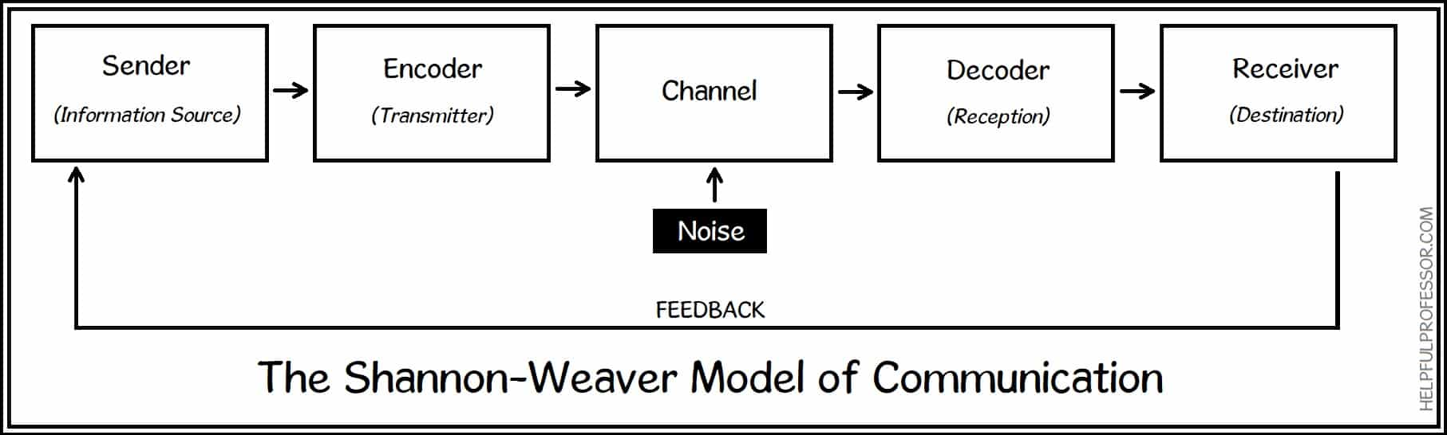
Figure 1: The Shannon Weaver Model of Communication (Al-Fedaghi, 2012)
The first component of the Shannon Weaver model of communication is the sender who sends any messages or information to another person. The sender is the source of information that has to be sent anywhere. A person who calls another to tell something or to give any information is the best example of a sender. The second component of this model is the encoder that encodes the digital data into analogue data for transmitting the data using any of the communication channels. The encoder is the transmitter that helps for turning the data from binary digits to radio waves. The third component of this model is the channel. The channel of correspondence is the foundation that conveys data from the source and is transmitted to the decoder and collector (Gillespie and Schiffman, 2018). We here and there likewise call this the 'medium'. The subsequent stage in the Shannon Weaver model is 'commotion'. Clamour intrudes on a message while it's on the way from the shipper to the collector. It's named after the possibility that 'commotion' could interfere with how we might interpret a message. There are two sorts of commotion: interior and outside. The next component of this model is the decoder that helps to turn the radio waves or analogue data into digital or binary data that can be readable by the receiver. Decoder helps to make the information understandable to the receiver. The next component of this is the receiver of the information given by the sender is known as the model. The receiver is the second person in the entire conversation and he is the person with whom the sender is trying to communicate. At this stage, the message or the information gets its destination. The person on the other side of a mobile phone can be the example of a receiver. The last component of this communication model is the feedback that is engaged with answering the sender's information or message to the receiver. This stage has made this communication model a cyclical model. Only for two-way communication, feedback can occur.

Schramm Model of Communication
The communication of Schramm can be characterized as a recurrent model of communication in which a message or data and its input or affirmation pass in the middle of a source and beneficiary (Schramm, 2018). The Schramm model was affected by the hypotheses of another scholar Osgood, and to that end, it is additionally called as Osgood and Schramm communication model or Encode-Decode communication model. This communication model is one of the most used traditional communication ways that implies a two-way street where the information moves between the sender and receiver back and forth. To comprehend the information by both the source and recipient is the base idea behind this communication model. Some elements in the Schramm's communication model are provided just below:
- Source of Information: A person or object who sends the information to another can be addressed by the source of information or a sender.
- Encoder: An encoder encodes any message or information for converting the digital messages into a code or radio wave signals to transmit the information.
- Decoder: A decoder decodes the messages and information for making the information understandable to the receiver. This step helps for decoding the radio wave for producing understandable information.
- Interpreter: This component is engaged with interpreting the message for the receiver.

Figure 2: Elements of Schramm's Communication Model (Schramm, 2017)
Receiver: The message's recipient is the person who receives it, and the sender wishes to transmit it. (Schramm, 2018).
- Message: Message is the initial information that is sent by the sender to the receiver.
Feedback: In two-way communication, feedback is the process of answering the message of the sender by the receiver (Adams et al., 2018).
Medium: Medium is the channel by which the message has been sent.
- Semantic Noise: Noise in the communication cycle is alluded to as semantic clamour. The commotion degrades the message, making it fall flat and the communication interaction fizzle.
There are some advantages to how this communication is used by different individuals and organisations. The advantages of this model include flexibility in the communication, allowing both receiver and sender for transmitting the message to others, easy understanding of messages and information, two-way communication, depiction of a situation, and others. Along with the advantages, the limitation of this model is the complex processes for establishing communication.

Berlo’s SMCR Communication Model
David Berlo's SMCR Model of Communication addresses the course of communication in its easiest structure. The abbreviation SMCR represents sender, message, channel, and receiver (Muyanga and Phiri, 2021). Berlo's SMCR Model of Communication portrays the various parts that structure the fundamental course of communication. Subsequently this communication tool also emphasises message coding and decoding, it has the potential to be used for more effective communication.
This is the easiest form of communication having minimum components. Berlo’s communication model includes only four components including sender, message, channel, and receiver. This is a one-way communication method used by televisions, radio, and other one-way communications.
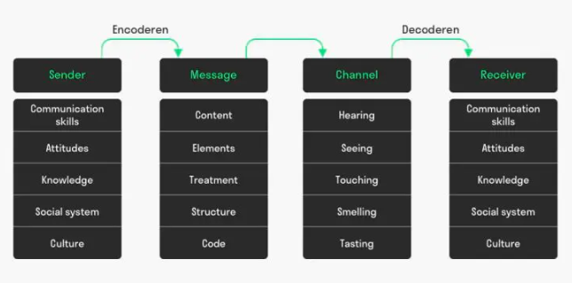
Figure 3: Berlo's Communication Model (Boby, 2022)
The first component of Berlo’s Communication Model is the sender which is affected by the communication skills, the attitude of the sender, proper communication knowledge, social systems, culture, and others. The next component of this model is the message that includes the content, element of the message including audio, text, video, or another format, the structure of the message, and others. Channel is the third stage that includes the proper hearing for audio information, seeing for video information, touching, smelling, and testing for physical information (Saud, Jufri, Rahman, and Salam, 2014). The receiver is the last component of this model that is also affected by the factors which the sender may affect.
Berlo's SMCR Model of Communication presents the communication interaction in its least difficult structure. The model is divided into four parts, each of which is affected by different factors. To ensure that the message is delivered as effectively as possible, the shipper and the collector should have some common ground. Communication skills play an important role in this. Culture, information, and disposition are all important aspects to consider. In one community, what is deemed disrespectful in another, is perfectly acceptable. Communication is not always as smooth as one might hope. Disturbances, uproar, and an odd cycle are just a few of the concerns that could prevent legitimate connection. (Berlo, 2017).

Different Communication skills
Different communication skills help an individual for better communication in both academic and professional aspects. Different communication skills are provided just below:
Active Listening
Active listening is one of the most important communication skills that assistance for better communication. A person or an individual should be an active listener for proper communication. Active listening helps for getting proper attention to the audience that helps engage them. It helps to motivate the co-workers as well as other members to play a significant role in proper communication (David, 2016).
Communication Method
It is very crucial to use the proper communication method while communicating with others. An individual should have proper knowledge about the communication methods that help for attracting the audience. An individual should know the proper use of emails, letters, meetings, instant messaging, phone calls, and other communication methods to connect with the audience.
Volume and Clarity
While speaking in a meeting to communicate with the audience, an individual should keep the volume clear and audible for the audience. It helps attract the audience to the speaker. Speaking too slow can be a reason for the sickening of the audience whereas a too-loud voice can be the reason for disrespect.
Responsiveness
Being responsive is another big skill of proper communication that helps to attract the audience to the speaker (DesAutels, 2021). Being responsive is also regarded as the courtesy of an individual while giving any speech or communicating with others.

Example of bad communication at work
I was Once given a task to compile an incident report, although I was give lots of data for the report but the very importat data was missing. The time and date and the details of parties involed in the incident, I could not complete the report and it was delayed by 4 days until I was given the needed information.

Advantages and Disadvantages of Technology in Communication

Advantages of Technology in Communication
Technology has made it easier for people to live a comfortable life. Technology has also helped to establish easier communication. The advantages of technology in communication are provided just below:
- Fast Exchange of Information: Use of technology helps for exchanging information in a fast way using different tech tools including the internet, smartphones, phone calls, emails, and other channels (Wentao, Jinyu, and Zhonggen, 2017).
- Improve Communication: Technological tools have improved the entire communication process. It makes it easier to improve overall communication.
- Increase Participation: Virtual communication has ensured the increment of participants for any meeting.
- Supporting open Discussion: Different tech tools for communication have supported the open discussion. Different video chatting tools are used that enable people to stay connected for making better decisions staying far.

Disadvantages of Technology in Communication
Though there are different advantages of technology in communication, there are several limitations to using the technology in communication. The disadvantages of technology in communication are –
- Expensive: Using technology for better communication is still expensive to implement in all the sectors (Wentao, Jinyu, and Zhonggen, 2017).
- Security Issues: There is a security issue with losing the message or leaking the information while using technological tools. It is not a fully safe method of communication.

Conclusion
There is a huge importance of proper communication for any individual as well as for any organisation that helps for better decision-making for the betterment of the individual and the organisation. This assessment has provided three different communication models including the Shannon-Weaver communication model, Schramm’s Communication Model, and Berlo’s SMCR communication model for understanding the communication model and using it effectively. Different communication skills are also provided in this assessment including the proper use of communication methods, active listening, responsiveness, and others. Different advantages and disadvantages of using technology in communication are also provided in this assessment. This overall report will help to understand the way of effective communication.

References
Adams, W., Edelstein, A., Mayer, M., Schramm, W. and Atwood, E., (2018). Other Foreign Communications. Communication Booknotes, 13(4), pp.44-45.
Al-Fedaghi, S., (2012). A Conceptual Foundation for the Shannon-Weaver Model of Communication. International Journal of Soft Computing, 7(1), pp.12-19.
Berlo, D., (2017). Communication as Process: Review and Commentary. Annals of the International Communication Association, 1(1), pp.11-27.
Boby, (2022). Berlo's SMCR Model of Communication. [online] tools here. Available at: <https://www.toolshero.com/communication-skills/berlos-smcr-model-of-communication/> [Accessed 18 April 2022].
David, (2016). Active Listening: Web-based Assessment Tool for Communication and Active Listening Skill Development. TechTrends, 53(6), pp.24-34.
DesAutels, P., (2021). Communication Perception and Responsiveness. Journal of Communication, 43(3), pp.334-346.
Gillespie, D. and Schiffman, R., (2018). A Critique of the Shannon-Weaver Theory of Communication and Its Implications for Business. Research and Theory for Business Practice, 32(2), pp.216-225.
Muyanga, C. and Phiri, J., (2021). Assessment of Effective Communication in International Schools in Developing Countries Based on the Berlo’s SMCR Model. Open Journal of Business and Management, 09(01), pp.448-459.
Pollak, K., (2020). Teaching effective communication by modeling effective communication. Education and Counseling, 103(2), pp.423-427.
Saud, S., Jufri, A., Rahman, M. and Salam, S., (2014). Learning communication for Increasing Skills. Journal of Communication, 5(5).
Schramm, W., (2018). Information Theory and Mass Communication. Journalism Quarterly, 32(2), pp.131-146.
Schramm, W., (2017). The Unique Perspective of Communication: A Retrospective View. Journal of Communication, 33(3), pp.6-17.
Wentao, C., Jinyu, Z. and Zhonggen, Y., (2017). Advantages and Disadvantages of Technology in Communication. International Journal of Information and Communication Technology Education, 13(1), pp.61-71.



