Client: Swansea Museum
Phil.Treseder@swansea.gov.uk
Mobile: 07775 916160
Authors: Katie Joseph & Cameron Morgan
Classification: Private
Katie Joseph and Cameron Morgan are independent student consultants undertaking market research for Swansea museum in order to investigate students and cultural attractions.
Students & Cultural Attractions
P Number:1704023/1900374



Key
Katie- Black
Cameron-Red

Executive summary
The introduction gives an overview of the organisation chosen for this research project, including methods of data collections and research that will be used to carry out the project. The brief history of Swansea Museum was discussed including the current guardianship of the museum and the main exhibits that they showcase.

The museum is attempting to gain the attention of students from within the city and this was a big aspect that had to be incorporated into the research of this report. As such the entire base of participants from the first survey were all students with over 80% of them studying in Swansea. The number of responses that the consultants received equalled that of 0.28 of the student population in Swansea. Other than the survey’s all data was secondary source and consisted of journals and articles, this was due to COVID 19 and government-issued guidelines to limit in-person contact. To offer recommendations that would suit the needs of the museum the consultants collected and analysed different strategies utilized by other cultural attractions and museums. A brainstorming session was also held with the consultant's contact at the museum, Phil Treseder who gave feedback which ultimately led to more feasible recommendations and helped to fix some mistakes which could have altered the report to show false data

The findings serve to answer and provide data to the question of what students would like to see and do in Swansea Museum. Due to COVID 19, the virtual side to the museum was also explored while providing recommendations post-COVID 19 in a bid to attract people to visit again with the hopes of converting them into repeat visitors.
From the findings which were backed up with secondary research and input from the brainstorming, session recommendations were drawn and included which related back to each of the questions in each survey.

The conclusions were based on the key findings within the report which then would help support the recommendations further on. Covid19 issues were discussed and how there was limited access to research for the consultants, especially primary research which was a key issue throughout the report. The conclusions discussed Swansea Museum’s lack of presence online, and the lack of virtual communication which should be developed on for the future, with many other museums doing the same, this is especially important surrounding the issues with Covid19 and many organisations and businesses adapting to work online. How virtual reality could also be incorporated with the lack of links that the museum has with university students which were again one of the main issues with the museum.

The consultant’s identified key recommendations which would be the most feasible to implement and from the consultant’s viewpoint the most likely to attract students. The key recommendations identified were for the museum to partner with the university in which they would take photography and videography students and offer volunteering placements. This came from feedback in the brainstorming session and was discussed so that students could help manage social media and to help set up and maintain virtual experiences for the museum. Another key recommendation was to explore improving or changing the museum’s social media content so that it may appeal more to a younger audience such as students and engage more with the general public. One of the final recommendations was for there to be a continuous development process to Swansea Museums virtual experience. This would include the museum holding Facebook live sessions and giving lectures to setting up artefacts in the museum’s collection to be digitally recreated for visitors to view and interact with online.

Contents
0
Key 1
Executive summary 1
Contents 2
Introduction 3
Methodology 4
Findings 6
Conclusions 19
Recommendations 21
Appendix 22
23
24
24
24
24
27
Bibliography 28
References 29

Introduction
The organisation chosen for this consultancy project is Swansea museum, Swansea museum is the oldest museum in Wales and opened back in 1841, the museum was founded by the royal institute of South Wales back in 1835. And as of 1990, the museum has been under the guardianship of the county of Swansea. (MuseumsWales,2020) Swansea Museum has a range of different exhibits such as a real Egyptian mummy, and a Welsh kitchen, as well as changing exhibitions throughout the year. Swansea Museum has recently joined with the Dylan Thomas Centre, Glynn Vivian Art Gallery, and the West Glamorgan Archive Service creating 4 sites offering a range of educational facilities for schools.

On behalf of Swansea Museum, this project is looking into the motivations for university students to participate in cultural attractions and what entices them to want to visit. The reason for this is to discover the types of exhibits and exhibitions students are interested in and gather data to help Swansea Museum consider new possibilities and ideas to incorporate into the museum. Due to the current circumstances surrounded with Covid19 virtual experiences such as virtual tours of the exhibitions and items in the museum will be taken into consideration for the foreseeable future, with the research being carried out it will conclude whether virtual experiences is something that students would be interested in seeing due to not being able to visit cultural attractions.

For this project, data will be collected using a mixture of primary and secondary research. The main data collection will be carried out using a survey created by the consultants that will be sent out to students, the survey sent out has a mix of qualitative and quantitative questions. Due to issues with Covid19 secondary research will be the main focus of this project. Gathering the majority of information using online resources and library resources such as articles, Journal articles and books. With primary resources limited the only option to collect primary data was through the survey.

Methodology
To conduct the research necessary for the project and for the museum secondary source data was the ideal option due to the accessibility and the abundant nature of the material. Primary data such as interviews were considered in the early stages of the project and carried out however due to changes brought on by COVID 19 to the project these interviews were no longer relevant or useable. Nevertheless, primary data was still an invaluable option of collecting information in the form of surveys. Initially, this project was focused on the new school curriculum and surveys to be sent to teachers in these schools to gather thoughts and opinions in regard to how Swansea Museum could fit into this curriculum. However, in the current unprecedented situation of a global pandemic which is COVID 19 the project had to be altered in order for the consultants to comply with new government guidelines and policies. The project changed from teacher input in the form of surveys to university students in Swansea but still relying on surveys for research and primary data. The way in which the data for this project was gathered was by accessing the internet and sifting through scholarly articles and online books. Primary data was gathered by sending out surveys via the use of social media and emails. Then analysing the data received by student participants. The reasons behind using surveys as the primary data collecting method are due to the fast responses by participants and the ability to review the data at any time. The data is also backed up ensuring the results can always be accessed. The COVID 19 virus has served both to highlight and create further weaknesses within the project. One of the limitations that the consultants faced when conducting secondary data research was the lack of detailed scholarly articles pertaining to Swansea Museum and the project undertaken. To counter this the consultants combined the primary survey data with strategies used by other museums to come up with solutions and recommendations.

The consultant’s surveys were first piloted on a university lecturer before being sent out to ensure any mistakes were not present and to receive feedback on how they could be improved. To help further analyse and critically evaluate the findings one of the first questions posed to participants related to age. This helped the consultants to determine how representative of the population the participants of each of the surveys were. The first survey was only open to students and within Swansea, 24,000 students are studying at Swansea University or the University of Wales Trinity St David (Swansea - Key facts and figures about Swansea, 2020). The survey received 66 responses and so this represents just 0.28% of the student population in Swansea. While this is just a very minor percentage of students the answers helped to form a base from which findings could be analysed and recommendations put forth. Research from the findings was analysed further by the use of bar graphs and this helped to ensure the data was more reliable. In order to better critique the findings and ensure the recommendations put forth were informed and would benefit the museum, a brainstorming session was held. This meeting consisted of the consultants and the employer, Phil a staff member who works for Swansea Museum. The meeting had to be held online due to limitations incurred from COVID 19. The employer gave their thoughts and opinions on the information collected and analysed by the consultants and also helped to rectify any mistakes that were present at the time. This then helped the consultants to explore new ideas and look at previously collected data differently.

The consultants had to adapt to the unfortunate situation that unfolded however this left limitations on the project and ways in which the project could have been improved. A limitation imposed by COVID 19 meant that the consultants could no longer meet up and conduct meetings and go over the findings as methodically as planned. This limited the detail in which key aspects of the report could be carried out. The timing of the virus interrupted key meetings between the consultants whom each had to carry out this project online and communication limited to just messages, emails, and calls. Planned lectures with crucial information were transferred online and delayed, all of these limitations culminated in the overall project having to change leaving the consultants with limited time to complete the project. While the bulk of the findings came from surveys the consultants sent out, interviews as a form of primary data should have been included and helped to form more concise and detailed results. They also would have provided the opportunity to include key quotes and information from figures with a detailed knowledge in their respective field. Interviews were planned and recorded however, due to the virus affecting the project they could no longer be included.

Findings
The findings in this report come from two surveys. The first survey was focused around students and the data was used to inform the consultants of what students would like to see and do in Swansea Museum. The second survey centred on the virtual aspect of the museum and was answered by the general public rather than focusing on students. The findings will be backed by secondary research to provide further substance and backup the results of the survey. The questions asked were aimed at answering the question “Do students enjoy visiting cultural attractions and what they would like to see”. Among these questions the theme of a virtual visitor experience was also explored and what can be done in order for Swansea Museum to offer this type of experience in the future. While Swansea has many variations of cultural attractions Swansea Museum attracts a high volume of visitors each year and is one of the most popular places to visit for local culture and heritage. In the consultant’s survey to back this statement up one of the first questions posed to participants was “Have you ever visited any of these cultural attractions?” with the answers being kept locally to Swansea. In this question, participants were given the choice of Swansea Museum, Glyn Vivian Art Gallery, Dylan Thomas Centre, or none of the above. The results from this question were matched with visitor numbers analysed by both the National Museum of Wales, 2018 and Gov.Wales, 2018. In the survey, Swansea Museum was the most visited by students at 44% while results from the National Museum of Wales show the overall visitor numbers of Swansea Museum to be at 115,000 in 2017. In a report conducted by McAllister for Gov.Wales, it shows that the Glyn Vivian Art Gallery had 42,682 visitors and the Dylan Thomas Centre had 157,685 visitors. These numbers demonstrate Swansea Museum is one of the most visited cultural attractions by students however due to the current situation with the virus this could change. The museum suffers from a weak online presence in the sense of online interaction and engagement. While visitor numbers will drop drastically over the coming months due to the virus the museum should use this crucial time to improve their online presence.
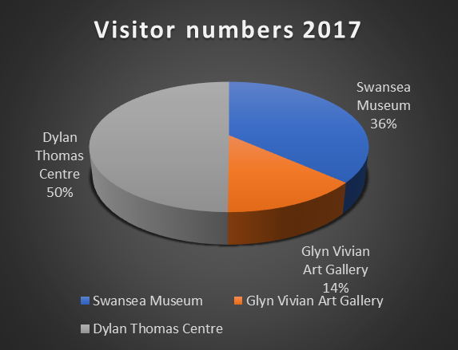
The museums that generate the most footfall are ones who commit to engaging with users online. For Swansea Museum to utilise social media in the most effective way to attract more students the tone of the posts should be more suited to their audience (How Museums Can Use Social Media? - MuseumNext, 2019). Students are in general terms usually younger and as such typically relate to posts involving humour and keep up with the latest trends. Swansea Museum could take advantage of this and change the tone of their future posts so that they may appeal more to a student audience thus increasing the chance of visits from students.
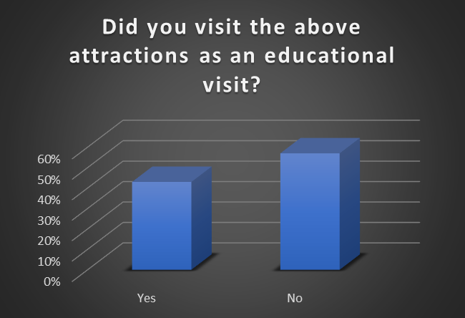
Museums around the world typically receive visitors that are on or a part of an educational visit rather than visiting for leisure purposes nevertheless this is not always the case. In the case of Swansea Museum, it is part of a student city and as such the museum can provide greats forms and quantity of research which can be included in ongoing studies. To test the purposes of visits by students in Swansea the consultants posed the question of whether the above cultural attractions are visited as part of an educational visit? An overwhelming 57% of participants answered “no” while 43% answered with a “yes”. This can be attributed to the locality and free entry each of the attractions offers. However, the main “hook” that gets visitors through the door of each of these attractions are the frequent rotation of exhibitions and events. The Glynn Vivian held 8 varied exhibitions in 2018 (Swansea - Glynn Vivian Past Exhibitions, 2020) and to promote these operates 7 different social media accounts. This creates competition between the local cultural attractions. One of the issues Swansea Museum faces in trying to draw students in the doors is the lack of exhibitions more suited to younger people or student interest. A past exhibition Swansea Museum hosted was “Copperopolis” in which it looked into the years of when Swansea provided the majority of the world's copper. While this provides interest to a select audience this lacks appeal to the younger generation. As Swansea is known as a “student city” there are currently over 24,000 students studying at Swansea University or the University of Wales Trinity St David (Swansea - Key facts and figures about Swansea, 2020). The average age of these students is between 16-24 and as such exhibitions need to be more tailored towards this audience in order to increase the overall attractiveness of the museum to students. The consultants visited the museum, sat in, and observed a lecture/game workshop for a group of 60 students all of whom were a minimum of 3+ hours of travel away. This demonstrated the museum has a strong connection to other parts of the country but is struggling to get local students through the doors. In this instance these students visited as part of an educational visit and while there the workshop generated the most interest and enthusiasm. The idea of a more interactive and more relevant to students’ approach to exhibitions could prove to be beneficial in attracting a younger audience such as students. A report conducted by the Smithsonian Institution concluded that “visitors under age 25 were more likely than other visitors to find introspective experiences most satisfying”, “while those between the ages of 25 and 44 were more likely to say that social experiences were most satisfying”. Gould defines introspective as ‘an ongoing process of tracking, experiencing, and reflecting on one's own thoughts, mental images, feelings, sensations, and behaviours. Taking both of these quotes into consideration Swansea Museum could introduce exhibits that invoke personal reflections and strong feelings upon viewing. They could set out to provoke visitors thus leading to repeat visits so that visitors want to come back and resolve the feelings imparted upon them from the exhibits.
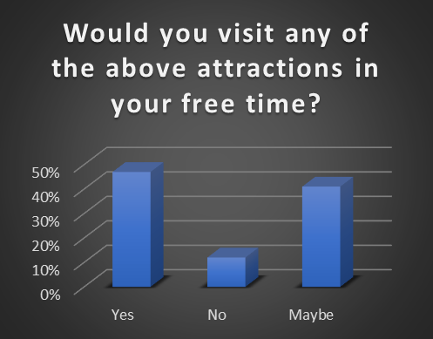
The next question the consultants posed was “Would you visit any of the above attractions in your free time?”. Participants responded positively with 47% answering yes while only 12% answered with no. The remaining 41% responded with maybe, these answers demonstrate a shown interest in the aforementioned venues. However, these results also indicate hesitation from students as perhaps they feel these venues do not offer something of major appeal to them. This is where Swansea Museum should offer more student-friendly incentives such as workshops or exhibitions suited to their needs.
Swansea Museum could partner with universities around Swansea and could then proceed to set up exhibitions or offer lectures and workshops revolving around student’s area of study. While the motivations behind the visits would consist of educational purposes these visits would also fall under the category of free time. Partnering with a university would provide numerous benefits for both the museum and the students involved and this would be one way in which to encourage visits from students. In a report conducted by Bonacchi and Willcocks on the “Realities and impacts of museum-university partnerships in England,” they found as a result of the partnership museums saw the benefit of new audiences. Further impacts of the partnerships saw museums receiving further funding, Swansea Museum would be able to allocate the funding to excellent use in many various ways such as introducing new exhibitions, the maintenance of the museum itself etc. This would help to further incentivise students to visit and turn students from a maybe into a yes to visit in their free time.
A crucial way to attracting a higher attendance from students is to ascertain the type of topics they are looking in or interested in. As such this type of question was included in the survey and the consultants asked participants “What type of topics would draw you to visit a cultural attraction?”. This question gave participants the option to give multiple answers as such the following percentages will go over the 100% limit. The highest number of participants at 58% show a keen interest in World War. This result provides potential as Swansea Museum offer amazing exhibitions and provide fantastic lectures surrounding World War 2. The following topics of science and local history shared the same percentage of 53%. Other answers participants were given a choice of included climate change in which 52% responded, ancient Egypt with 45%, art with 44% and lastly transport was the lowest with only 17%. While transport is the lowest in terms of interest Swansea Museum have a unique opportunity of turning this around. Swansea city hosted the world’s first fare-paying passenger railway service. While learning the history of transport does not often excite the student audience being a world first in any subject receives much higher interest. This would not only appeal to the student audience but also the general public. However, it is not just the topic itself that provides interest but the way in which it is presented. In order for a museum to see a repeat of visitors, they must offer a varied selection of engaging ways in which visitors can learn or gain a new experience. One of the most popular methods for museums to employ is by offering workshops in which visitors can engage in something more practical. While many view museums as ‘boring’ by introducing activities combined with lectures or even guided tours this can persuade many more to visit (Eveliina, 2016). The results from the consultant’s survey back up this statement. The results had shown 59% of participants would be more likely to visit Swansea Museum for a workshop while only 53% of participants would be interested in lectures.
Due to current circumstances workshops are not feasible for the museum to carry out as is the case with many other cultural attractions around the world. However, many cultural attractions are turning towards the virtual world to keep people’s interest. While bigger museums such as the Tate and the British Museum have more resources at their disposal to carry out virtual classes and workshops this does not prevent Swansea Museum from offering this as well. While Swansea Museum is limited in what they can offer the consultants found that the demand is there for people wanting to attend a virtual class and workshops online. Participants in the survey showed resounding enthusiasm with 92% saying they would attend a virtual class while only 8% said no. This is not only something that could be offered now but also post COVID 19 which can serve to help reopen the museum to visitors and keep the interest there. In keeping with the virtual side of the museum, it could be possible to offer digital artefacts so that visitors can interact with 3d objects online while also learning about the history of said item (Cassidy et al., 2018). In a brainstorming session with Phil, he suggested linking up with the university and working with film and photography students who could help with the virtual aspects of the museum. This could involve running social media pages, setting up virtual tours or even setting up artefacts in the museum to be a part of the virtual landscape.

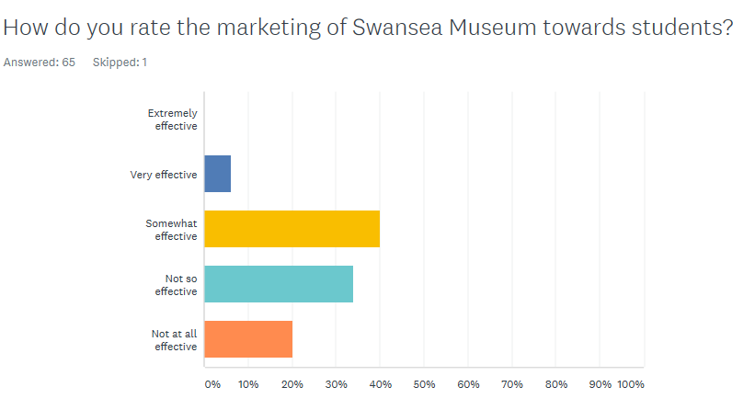
Participants were asked to rate the marketing of Swansea museum towards students, results showed that the majority found that marketing at the museum was somewhat effective at 40% and not so effective at 33.85%. 20% found that the marketing was not at all effective, 6.15% said it was very effective while 0% found it to be not at all effective. These results conclude that the majority of students feel as though marketing at Swansea museum isn’t as strong as it could be, from these findings the museum could look at ways to market towards students more, social media could possibly be the most effective way to do this, it’s easy and less costly than other forms of marketing. (Smartinsights,2020) Student events tend to become more successful if they are advertised on Facebook and other social media platforms. Visit Swansea Bay carried out a recent visitor survey in 2019 to assess the visitor profile and the motivations of travel for tourists to Swansea Bay, one of the questions asked visitors ‘which of these categories influences your decision to visit’. The highest at 36% stated that the coast and beaches were a significant factor of visiting Swansea Bay, and 28% visited for scenery and landscape. The motivations to visit for attractions are at a low of 5% suggesting that Swansea have a lack of attractions to offer visitors (Visitswanseabayvisitorsurvey,2020), with motivations being very low for visitor attractions this potentially negatively affects Swansea Museum from bringing in customers. Through brainstorming with Phil, who is a staff member at Swansea Museum it was discussed that the museum had fewer links with the University of Wales Trinity St David’s compared to Swansea University. One of the ideas that were highlighted was to link up with the photography and videography students at UWTSD and potentially offer volunteering placements for students, to work alongside the museum and create virtual experiences to use on social media platforms. By doing this the museum is able to create relationships with UWTSD while developing on the advertisement and virtual side that the museum could expand on.
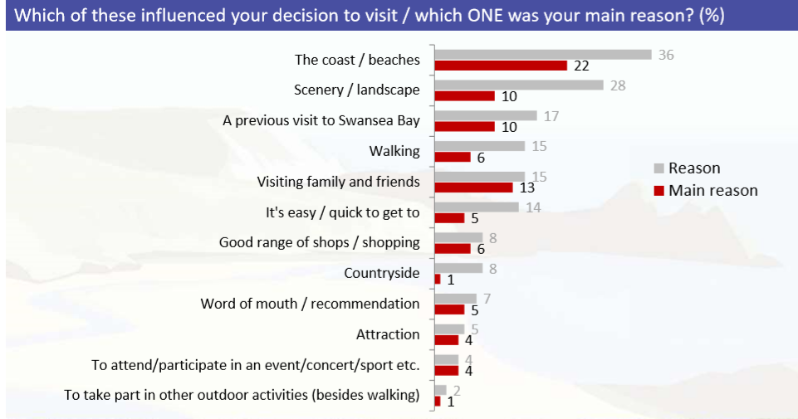

(SwanseaBayVisitorSurvey,2020)
Students were asked an open question on what they know about Swansea museum, the reasoning for this question is to get a broad understanding of the marketing initiatives of Swansea museum and which items or exhibitions have done well in the past. 58 responses out of 66 participants had left a comment for this question, 37 responses recorded out of the 58 had stated they knew ‘nothing’ about Swansea Museum or ‘not much’. Other answers stated that students had seen or heard of the ‘Egyptian section’ that the museum has to offer which includes a real-life mummy. From this information collected it has shown that the Egyptian artefacts have been the most known items from students. A few students stated that the museum covered the local history and world war, and some students acknowledged some events that the museum had hosted in the past, including live music and history exhibitions. Swansea museum should look into how to better the advertisement of other exhibits within the museum, compare the marketing strategies they used to advertise the Egyptian section and how they can use the strategies for current and future exhibits. Majority of responses stated that students had visited as children with schools and knew that the museum is popular for primary school trips. From this research, it suggests that Swansea Museum have difficulty to attract other types of students to the museum and cater mostly for the younger school years, how the museum can connect better with university students will be discussed throughout the findings of this report.

Through carrying out research on the advertisement of the Egyptian mummy it shows that Swansea museums have used many marketing initiatives such as the ‘meet the mummy’ page on the Swansea museum website which discusses the history of the mummy and where it came from (Swanseamuseum,2020). Visit Swansea bay also has a page named ‘welcome to Swansea museum’ which covers a brief history of the museum and the Egyptian exhibit (Visitswanseabay,2020). From brainstorming with the client new ideas were discussed on how to incorporate marketing with new virtual experiences that Swansea Museum could potentially offer the public. Ideas discussed between the consultants and the client was the potential of having an online virtual tour of Swansea Museum, through discussion it was concluded that this idea wasn’t suitable for Swansea Museum compared to the larger museums that offer this on their social media platforms. The reason for this is because of the museum being at a smaller scale compared to other attractions that offer this experience such as the Natural History Museum, and The British Museum both large scale and situated in London. From a study carried out by Mary Ann Murazzi from Birmingham Egyptology it was stated that although virtual tours enhance cultural awareness, the physical interaction with the item or exhibition is lost through virtual experiences. Because Swansea Museum is a small size attraction, a virtual tour could give away all that the museum has to offer through media, and this could potentially have a negative effect on visitors to the museum itself. Because of this, it was discussed that the possibility of using ‘360-degree photos on Facebook’ this way the museum is able to showcase items or exhibitions using virtual photos but are not giving to much away, this is a positive marketing initiative as a way forward for the museum to get involved with virtual reality and use social media platforms as a way of advertising the museum. The client has said that online figures have risen during the lockdown, with the museum receiving a high volume of twitter and Facebook page interactions. Offering some form of virtual experience for the public will increase viewers to the page and could be a great way of advertisement for the museum.
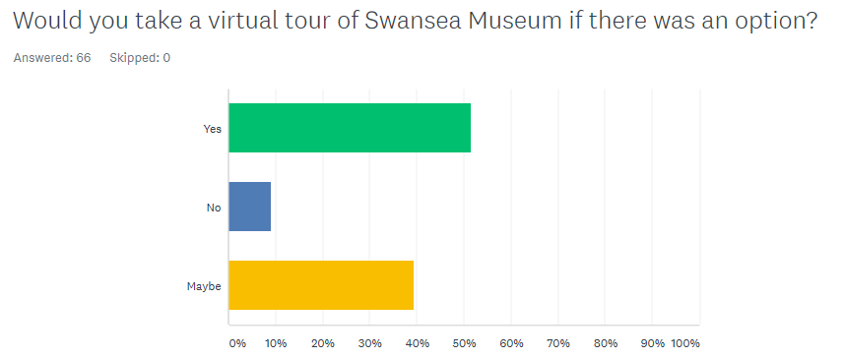
Due to Coronavirus, many organisations are adapting business online for the foreseeable future (omega,2018), the survey asked students whether they’d be interested in seeing a virtual tour of the museum. Results showed that 52% of people would be interested in taking a virtual tour of the museum, while 9% said it would not be of interest to them and 39% said that they would potentially be interested in a virtual tour. These findings show that the majority of students would potentially take part in a virtual tour. From this, it suggests that Swansea museum should create a stronger online presence and consider the possibility of creating a virtual tour either on the Swansea Museum Facebook page which would be a great way to target students to get involved. Rosamond Hutt who wrote an article for the world economic forum stated that world-famous cultural attractions that have seen closure due to the outbreak of Covid19, are now welcoming virtual visitors to the institutes. Places such as the Louvre in Paris are offering virtual tours on social media platforms. Google arts have also partnered with 1,200 museums across the globe to showcase exhibits and exhibitions. (World economic forum,2020) Consumer appetite for online virtual tours of cultural attractions is becoming increasingly more popular than ever before with most stuck at home looking for entertainment online. The British Museum online collection has increased unprecedentedly with 2,000 visitors a day before the outbreak, to 175,000 within a week, with highest visitor numbers at 78,000 a day (Newstatesman,2020). Results from the second survey carried out which was completed by the general public one of the questions asked which platform would they rather take part in a virtual experience, the options given were ‘social media’. ’online website’ or ‘other. 59% were interested in virtual experiences carried out through social media, and 39% preferred using the official online website. One person also stated that using the meetings app called ‘zoom’ would be of interest.
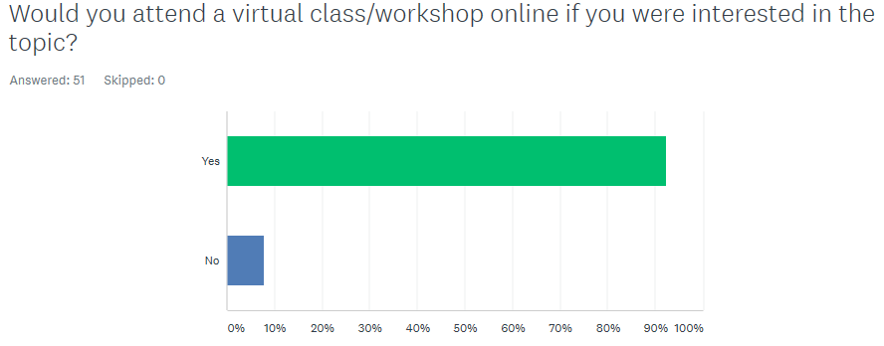
Although an overwhelming amount of students (52%) were interested in seeing an online virtual tour from Swansea Museum, from discussion with the client it was concluded that due to the size and scale of the museum a virtual tour would perhaps give away too much and the museum could potentially be affected with lack of visitor numbers post Covid19. Through carrying out the second survey which was specifically targeted to the general public on different types of virtual experiences that the museum could potentially offer. 92% of participants said that online workshops and virtual lessons would be of interest to them. Online workshops from Swansea museum could consist of lectures on the different types of topics that the museum have to offer, this could include Egyptian artefacts, world war, and the local history of Swansea. Although the second survey was targeted to the general public, with Swansea Museum looking to build stronger links with the local universities, online lessons and workshops could be the positive step forward for the museum. MOOC stands for ‘massive open online course’ which is an online learning base that students from all across the world use. This learning supplier has thousands of different courses covering different topics and areas, with the majority of courses being free of charge. Many museums are turning to these websites to reach out to new audiences, museums can upload content on to these platforms of workshops on different topics. (Museumnext,2019) Swansea Museum could consider using these platforms to engage with the general public offering them digital online learning, by doing this the museum is able to control what the audience sees, and ‘shine a light on their own collections and theories’.(Museumnext,2019) Using these platforms could allow the museum to potentially link up with the universities by promoting online courses to help them with course work, or to self-learn.
The last question on the survey asks students if they had previously visited Swansea museum, and if they had what exhibitions or items on show caught their attention and why. Many responses from this question stated ‘N/A’ this could suggest that many of the participants hadn’t visited the museum in the past and had nothing to discuss for this question. Many had also stated that they had not visited the museum in a long period of time, suggesting that they had visited while in primary school and that they had not been given a reason to return. The respondents who had given valid answers which were 17 out of 43 responses for this question, said that the mummy and Egyptian section, and local history were the exhibits they had caught their attention the most. While the remaining 23 participants skipped the question overall, suggesting that the remaining 23 also found this question ‘not applicable’, this could be because they had not visited or that they were too young to remember. From the results of the first survey which highlighted the most popular exhibits in the museum for students, and with 92% interested in seeing online workshops and lectures which was concluded from the second survey, which was based entirely on the future of ‘virtual experiences’ from the museum. Swansea Museum could carry out lectures on the most popular exhibits, using social media, online learning platforms which offer learning to students, link up with Swansea University and UWTSD to potentially carry out workshops online for them to help with studies.
Following on from the survey results it showed that many people were unaware of a lot that Swansea Museum has to offer, and that advertisement from the museum isn’t as strong as it could be. From a report on ‘Audience development - A crucial role for successful museum management strategies’ carried out by Christian WATL the importance of audience development and how it is crucial to museums was discussed. Audience development is the process of improving the service of what a museum already has to offer the public and continuously making sure that the museum is staying relevant, audience development is about knowing the target market of the museum and offering a service for every type of person. For Hans Christian Anderson audience development means ‘enriching the experience of your visitors by helping them to learn more and deepening their enjoyment of what you have to offer’. Museums should also cater to niche target markets, to do this museum should offer multiple experiences including social, and learning, doing this will create an environment for a museum to become more successful. Management strategy is one of the key strategies to take into consideration to better the success of any type of visitor attraction. Society in the modern day is better educated and more culturally diverse. The business mission for a museum is to make sure that all operational factors within the museum fit into the modern way of life.
Morris Hargreaves and Mcintyre a company based in Manchester developed a chart for the report based on Maslow’s Hierarchy of Needs, the reason for this was to show visitor motivations to museums. The graph created is useful for museums to group the types of needs that should be met while visiting a cultural attraction. The graph groups visitors into 4 key motivational factors which are, the socially motivated visitors, the intellectually, the emotionally, and the spiritually motivated visitors. Socially motivated visitors are the highest at 48% to museums, 39% are intellectually motivated visitors, the emotionally motivated visitors are at 11%, while the spiritually motivated is 3% (Morris Hargreaves, Mcintyre, 2001) (Needs Hierarchy after Maslow,1970). Socially motivated visitors visit museums for socialisation, for this type of visitor its important that museums hold events which help to engage the social visitors. Swansea Museum has been successful within event hosting with temporary past exhibitions, by hosting temporary exhibitions it motivates new and existing visitors to return for something new to see. Swansea Museum should keep displaying new exhibitions in the future. With the museum not able to do this due to the pandemic they should brainstorm ideas for future exhibitions and events they could host post Covid19. The intellectually motivated visitors are the type that visit museums to improve and develop their general knowledge from exhibits and items that are to offer. Swansea Museum although a small museum has many exhibits and items to offer the public from a range of world war artefacts, Egyptian history, local history, the museum have also hosted many changing exhibitions over the years including music and art exhibitions. Then comes in the emotionally motivated visitor which seek deeply moving experiences, through items and artefacts, Swansea Museum are able to cater for this type of visitors through art, and music and the variety of changing exhibitions throughout the year. The spiritually motivated visitors look for peace and escapism (Museum Gallery Interpretation and Material Culture,2011). Swansea Museum are able to cater for all forms of visitor motivations with the mixture of exhibits and exhibitions to offer, it is important that the client always searches for new ideas on how to please visitors and keep them returning for more.
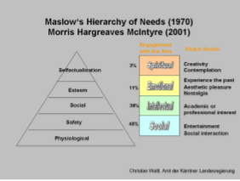

Needs Hierarchy after Maslow (1970) and Morris, Hargreaves, McIntyre (2001)

Conclusions
- To conclude this research study the different types of research methods was discussed, to begin with, for the key findings the consultants used a mix of primary and secondary research. Due to current circumstances with Covid-19 lack of primary research was carried out, two different surveys had used one targeted towards students which were based on mostly Swansea Museum and what the museum has to offer. The second survey consisted of virtual experiences, which was used to help gather information for the recommendations for Swansea Museum. Within this research study, secondary research was used to back up the findings from the survey, a mix of online resources and academic were included.
- The findings discussed the impacts that Covid19 has had on the overall project and the effects of the virus on Swansea Museum and visitor numbers. What had stood out the most through survey research was the lack of presence from Swansea Museum on online platforms and social media. Ideas were discussed on how the museum could develop their social media platforms, and the possibilities of the future for virtual experiences in the museum online to target the public and students. Recommendations for Swansea museum to potentially host online educational sessions for students, on all types of platforms including educational based platforms online that offer a ton of different lectures and workshops for students on all types of subjects.
- Throughout the key finding’s issues were discussed based around Covid19 and how this negatively impacts the future of the museum, this was taken into great consideration when developing ideas for virtual experiences for the museum. Through research and brainstorming with the client, it was concluded that virtual tours have a positive impact on the large scale museums who carry these out such as the British Museum in London, but for Swansea Museum, this could negatively impact the visitor numbers to the museum post Covid19. The museum has a lack of exhibits to showcase through a virtual tour, and this may draw away visitors if they have already seen everything the museum has. However, it was discussed that the use of 360 virtual photos of selected exhibits could be a good idea for the museum, using this type of tool will engage with people online and on social media, and is a great advertising initiative to get the public to visit the museum to see the full extent of what the museum has.
- The lack of relationship that the museum had with universities was discovered throughout the key findings, Swansea Museum has some links with Swansea University but lack links with UWTSD, how the museum could link up through videography and photography students was suggested, and potentially linking to provide online learning or self-learning.
- Virtual experiences had a strong presence throughout, the idea of a virtual tour was ruled out, online sessions using Facebook and other social media platforms have been considered, with the visitor profile numbers to the museum's social media rising throughout the lockdown.
- Maslow’s Hierarchy of Needs was discussed which was developed using the different visitor motivations to museums and how Swansea Museum caters for these visitors and how they can develop in the future to cater for the different visitor types.
.

Recommendations
- After conducting an analysis of the findings, the consultants saw opportunities for improvements and as such offer recommendations for Swansea Museum based upon the findings and the conclusions drawn from them. One aspect of the museum that the consultants felt was particularly weak was the lack of apparent links with universities in Swansea. While the museum does work closely with primary schools there is an obvious divide when it comes to universities. This is a missed opportunity that the museum could take advantage of. By partnering with universities in close proximity, the museum could link with culture and heritage modules that students are undertaking at university and this would allow for field trips to be taken to the museum to increase their understanding of the topic area. This would not only have the benefit of increased single trips and increased group visits, but this would also encourage repeat visits from students and more interaction with museum staff.
- Social media plays an important part in promoting businesses and products and can help spread awareness in what a business offers in only a matter of minutes. In a time where everyone must stay indoors, and organisations close their doors social media plays a crucial role in keeping organisations relevant. Swansea Museum runs 3 social media pages and offers interesting content on their pages however, from the consultant’s point of view much of the content does not engage with the public. By posting content that encourages the public to participate in or even ask questions to the public within their posts, this will get each post seen by many more people. Post’s encouraging people to comment with stories of their past if it relates to the post and also gently reminding the public to like and share also boosts their visibility and over time popularity. These tactics are employed by other cultural attractions such as the British Museum and have proved to be quite successful.
- Swansea Museum has many exhibitions at their disposal with some such as the ancient Egypt mummy being a deciding factor for many people to go and visit the museum. Nevertheless, to attract repeat visitors’ museums need to frequently rotate their exhibitions and while the museum has held one or two previous interactive exhibitions they are too far and few between. As such it is the consultant’s recommendation that in order to start attracting visitors back to the museum post-COVID that new interactive exhibitions be set up. As ancient Egypt is one of the most popular exhibitions this could be made to incorporate some interactivity for visitors. This could take form in ways such as trying on time period styled clothing, solving a puzzle using hieroglyphics which may extend to other parts of the museum and visitors creating a pyramid themselves.
- Swansea Museum should look into developing their online virtual experience presence, whether that is through using social media sites such as Facebook, or through the online website platform. Examples of some new ideas for virtual experiences through carrying out research of other cultural attractions, the British Museum in London have the largest indoor street space on google street view, the museum offers 60 virtual gallery tours, that offer views of Rosetta Stone Egyptian Sculpture Gallery and the Sainsbury African Galleries (TheBritishMuseum,2020). The natural history museum in London has been offering the public live online sessions weekly using their Facebook page, the sessions cover topics such as ‘The social side of the killer whale’ and ‘Lego life forums’. Swansea Museum should use these examples from other cultural attractions to develop their own online virtual platform.

Appendix
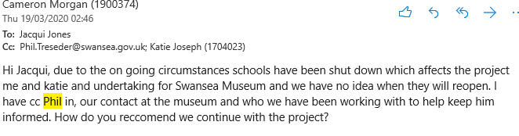
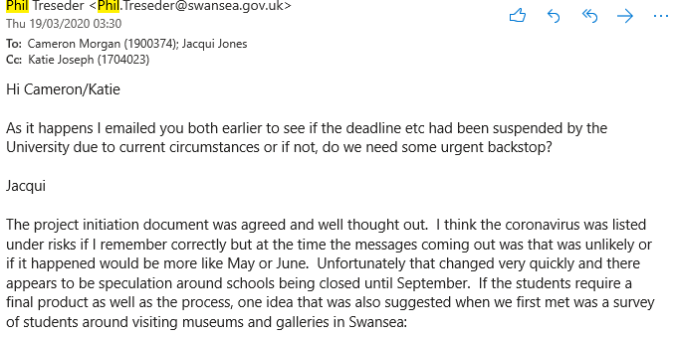
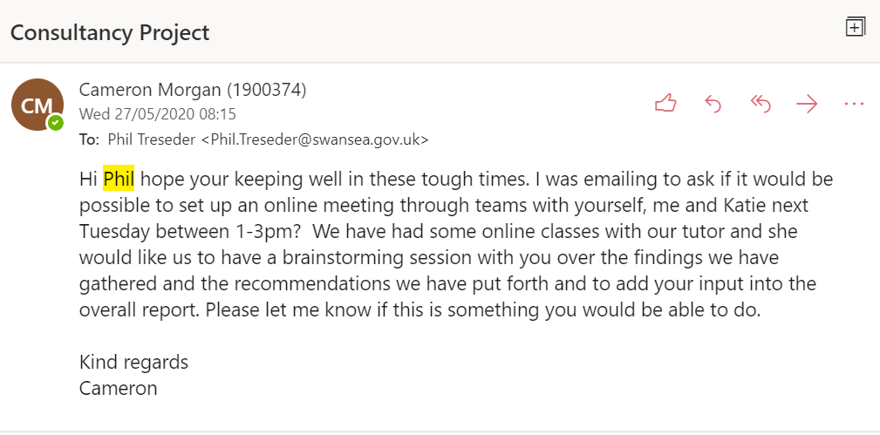

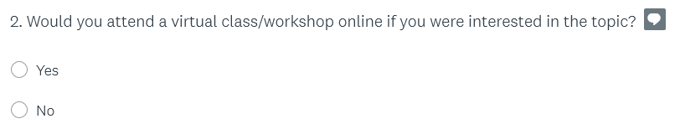

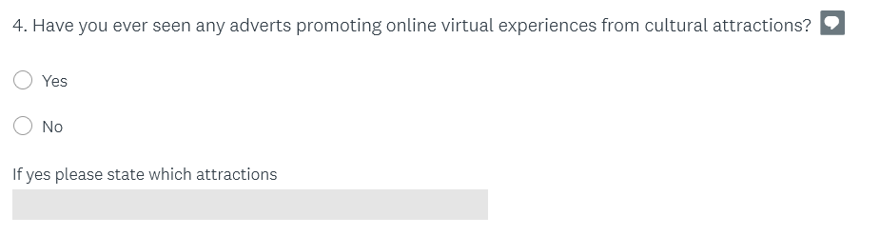
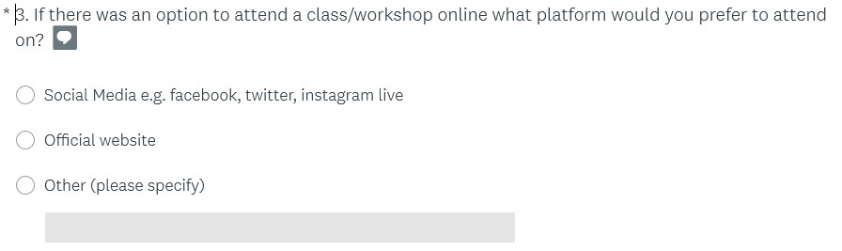
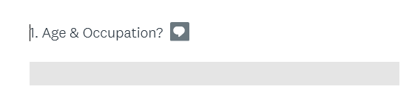
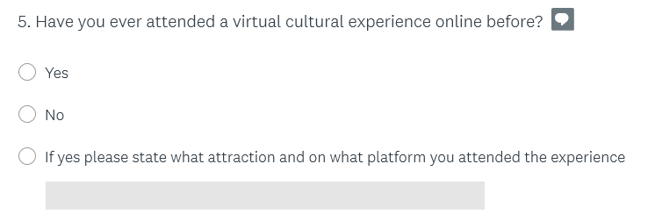

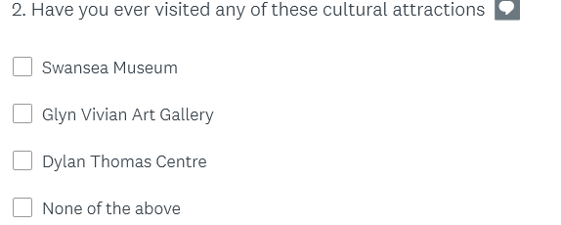
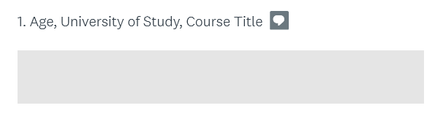

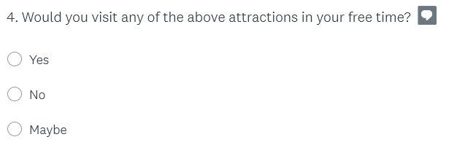
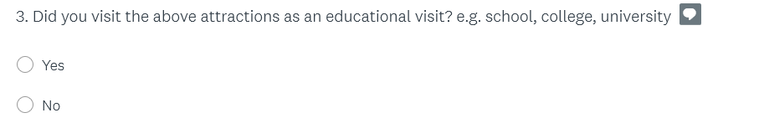

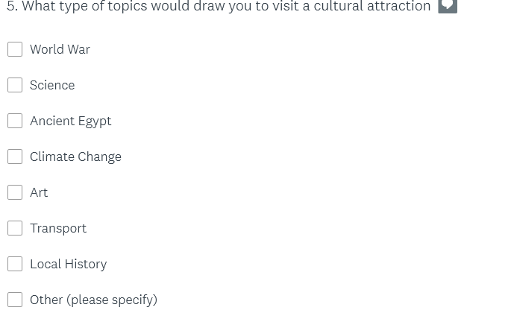

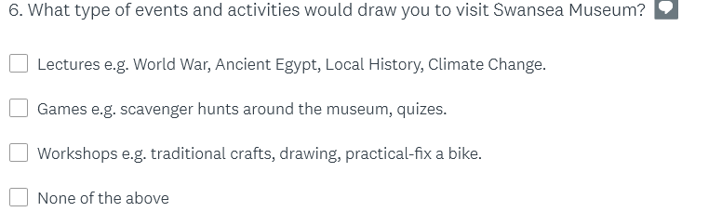

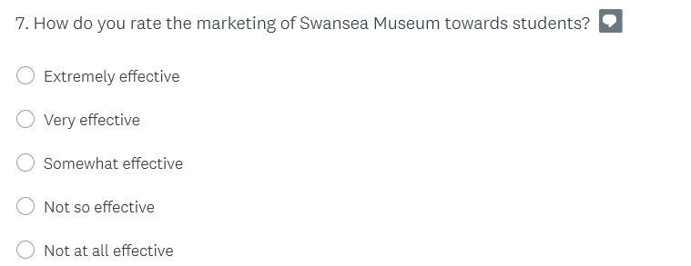

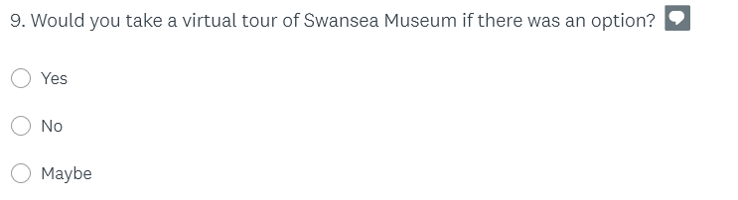
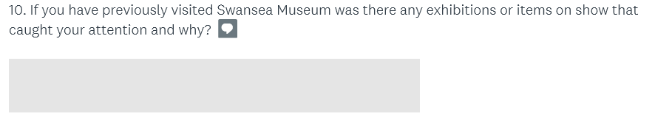

Duration | When | Who | Notes
1hr | 10/12/19 | Cameron & Phil | This was the first meeting between the consultants and the organisation. In this meeting, the type of work the consultants would undertake for the museum was discussed.
1hr | 23/01/20 | Katie & Phil | The project was changed to accommodate the museum's needs and a new plan put in place.
2hr | 03/03/20 | Cameron, Katie & Phil | The consultants discussed the PID with the organisation and to set in stone exactly what the consultants would do for the museum.
3hr | 14/04/20 | Cameron, Katie & Phil | The consultants attended a class & workshop the museum put on for a school to observe and analyse for the final report. Two interviews took place discussing what the museums currently offers, the future of the museum and improvements.
1hr 30min | 02/06/20 | Cameron, Katie & Phil | This was the final brainstorming session before the final report would be published. Input from the organisation was noted to be included in the report.

Email from the client that he’s happy for us to upload
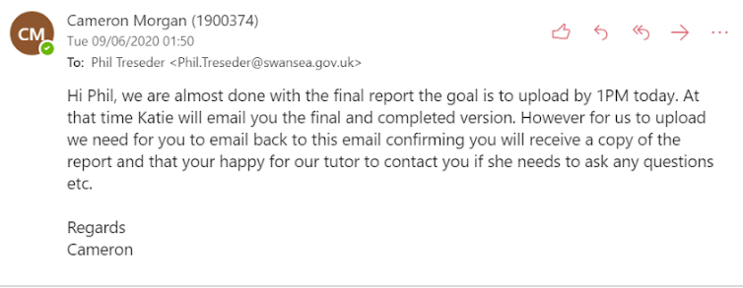

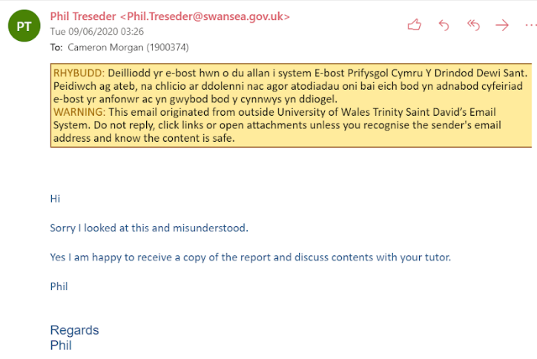

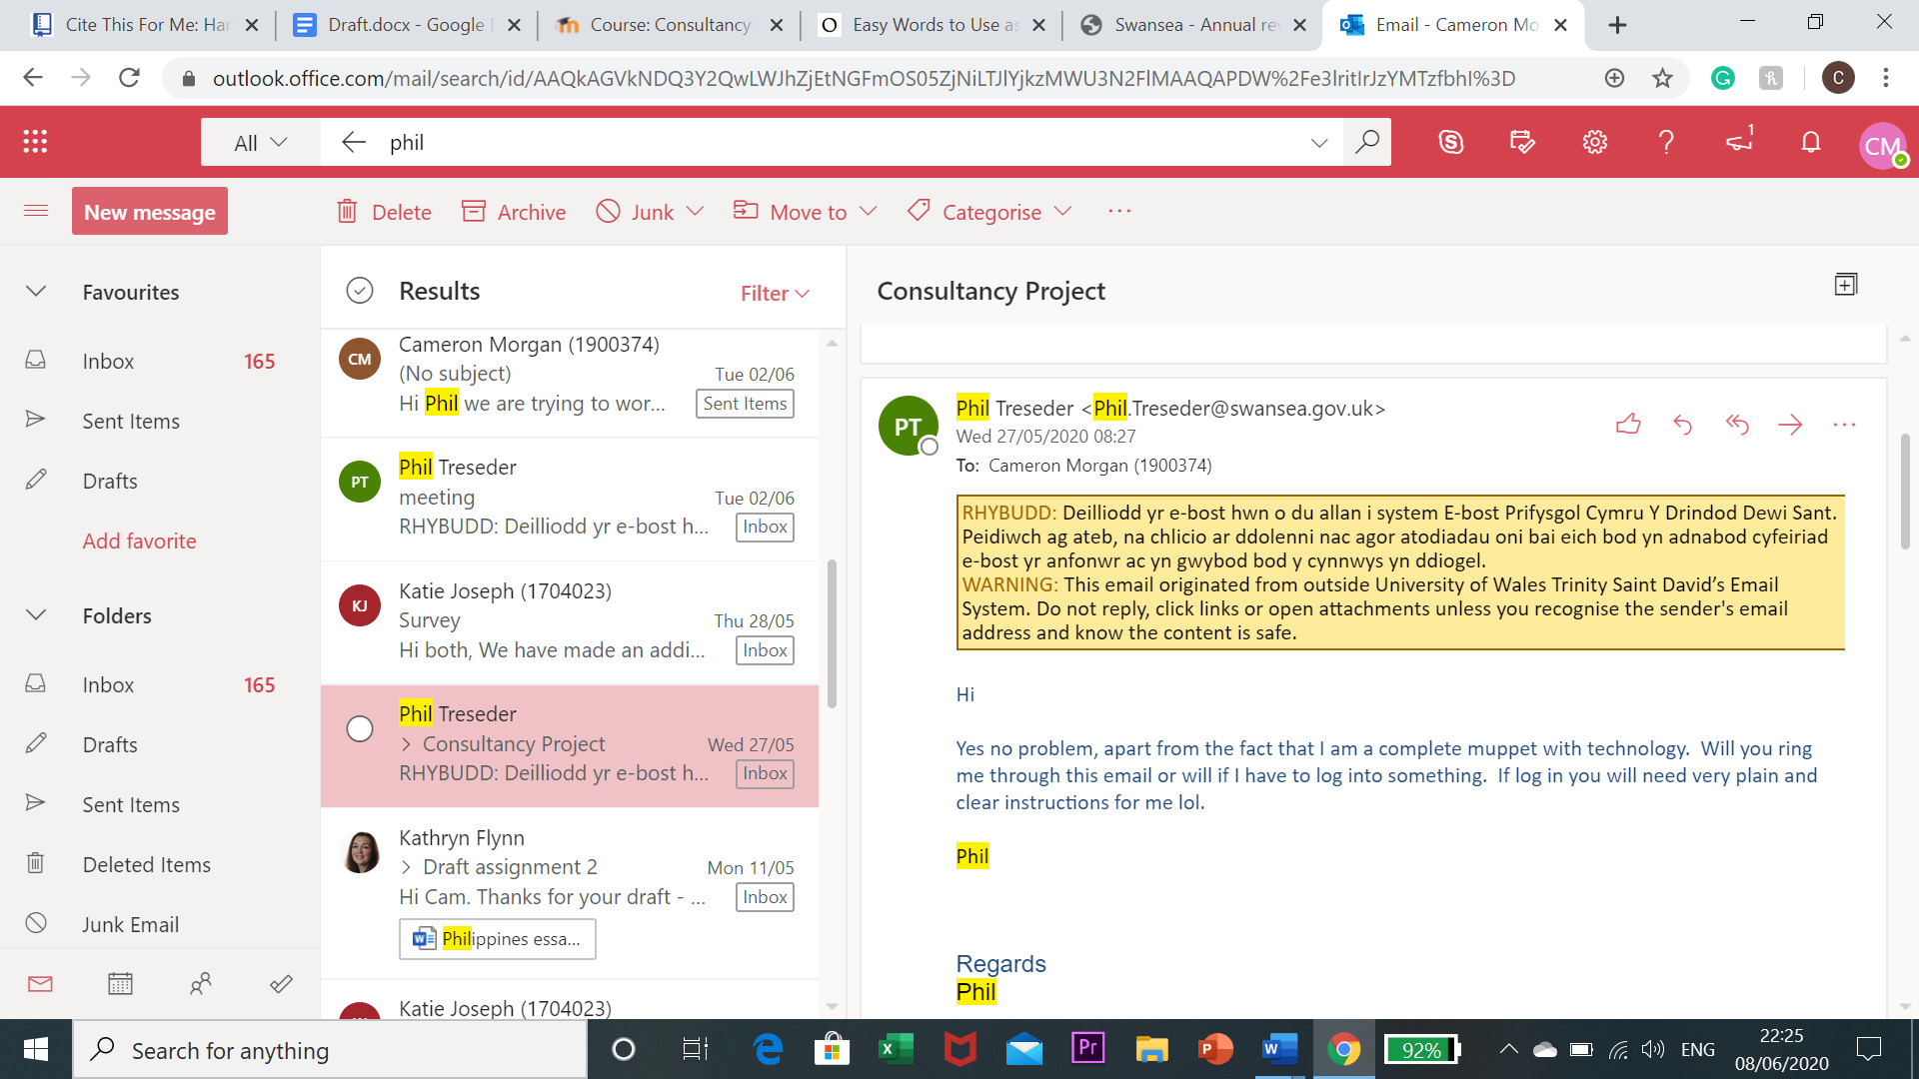

Bibliography
Kolb, B.M., 2002. Ethnic preference for the arts: The role of the social experience as attendance motivation. International Journal of Nonprofit and Voluntary Sector Marketing, 7(2), pp.172-181.

Sheng, C.W. and Chen, M.C., 2012. A study of experience expectations of museum visitors. Tourism management, 33(1), pp.53-60.

Damala, A., Cubaud, P., Bationo, A., Houlier, P. and Marchal, I., 2008, September. Bridging the gap between the digital and the physical: design and evaluation of a mobile augmented reality guide for the museum visit. In Proceedings of the 3rd international conference on Digital Interactive Media in Entertainment and Arts (pp. 120-127)
Shaw, C., 2009. What Is A Social Experience? – Contribution to Definition for New Book. [online] CX Consulting. Available at: <https://beyondphilosophy.com/what-social-experience-contribution-definition-new-book/#:~:text=So%20what%20is%20a%20social,(Maslow).> [Accessed 5 June 2020].
Kolb, B.M., 2002. Ethnic preference for the arts: The role of the social experience as attendance motivation. International Journal of Nonprofit and Voluntary Sector Marketing, 7(2), pp.172-181.

Sheng, C.W. and Chen, M.C., 2012. A study of experience expectations of museum visitors. Tourism management, 33(1), pp.53-60.

Damala, A., Cubaud, P., Bationo, A., Houlier, P. and Marchal, I., 2008, September. Bridging the gap between the digital and the physical: design and evaluation of a mobile augmented reality guide for the museum visit. In Proceedings of the 3rd international conference on Digital Interactive Media in Entertainment and Arts (pp. 120-127).

Taylor & Francis. 2020. Using Special Events to Motivate Visitors to Attend Art Galleries. [online] Available at: <https://www.tandfonline.com/doi/abs/10.1080/09647770600302103> [Accessed 8 June 2020].

Avraham, E. and Ketter, E., 2008. Media strategies for marketing places in crisis: Improving the image of cities, countries, and tourist destinations. Routledge.

Corbos, A Popsecu, R. (2011). MUSEUMS, MARKETING, TOURISM AND URBAN DEVELOPMENT. THE BRITISH MUSEUM - A SUCCESSFUL MODEL FOR ROMANIAN MUSEUMS. Management & Marketing Journal. 9 (12), p303-314.

Fischer, D. and Levinson, L., 2010. Redefining successful interpretation in art museums. Curator: The Museum Journal, 53(3), pp.299-323.

Fletcher, A. and Lee, M.J., 2012. Current social media uses and evaluations in American museums. Museum Management and Curatorship, 27(5), pp.505-521.

Srivastava, R.K., Shervani, T.A. and Fahey, L., 1999. Marketing, business processes, and shareholder value: an organizationally embedded view of marketing activities and the discipline of marketing. Journal of marketing, 63(4_suppl1), pp.168-179.

References
Bonacchi, C. and Willcocks, J., 2016. Realities and Impacts of Museum-University Partnerships in England. [online] Publicengagement.ac.uk. Available at: <https://www.publicengagement.ac.uk/sites/default/files/publication/mupi_literature_review_and_research_report.pdf> [Accessed 25 May 2020].
British Museum. 2020. How to Explore the British Museum from Home. [online] Available at: <https://blog.britishmuseum.org/how-to-explore-the-british-museum-from-home/> [Accessed 9 June 2020].
Cassidy, C., Fabola, A., Miller, A., Weil, K., Urbina, S., Antas, M. and Cummins, A., 2018. Digital Pathways in Community Museums. Museum International, [online] 70(1-2), pp.126-139. Available at: <https://www.tandfonline.com/doi/pdf/10.1111/muse.12198> [Accessed 6 June 2020].
Coates, C.2019. What Can Massive Open Online Courses Do for Museums? - Museumnext. [online] MuseumNext. Available at: <https://www.museumnext.com/article/what-can-moocs-do-for-museums/> [Accessed 8 June 2020].
Dowling, A. 2018. Museums and Heritage Sites Moving into The Digital Sphere. [online] Available at: <https://www.omegaanalyticsystems.co.uk/post/museums-and-heritage-sites-moving-into-the-digital-spher> [Accessed 8 June 2020].
Eveliina, M., 2016. How Can We Encourage Those Who Rarely Visit Museums to Do So More Often? [online] Medium. Available at: <https://medium.com/@miaeveliina/how-can-we-encourage-those-who-rarely-visit-museums-to-do-so-more-often-441c27cf4770> [Accessed 3 June 2020].
Fritshe, J., 2011. Museum Gallery Interpretation and Material Culture. 1st ed. New York: Routledge, p.155.
Gould, S., 1995. Researcher Introspection as a Method in Consumer Research: Applications, Issues, and Implications. Journal of Consumer Research, [online] 21(4), pp.719-722. Available at: <https://www.jstor.org/stable/2489727?seq=1> [Accessed 5 June 2020].
Hamilton, A.2017. Social Motivation. [online] Serious Science. Available at: <http://serious-science.org/social-motivation-8756> [Accessed 8 June 2020].

Hutt, R. 2020. World-Famous Cultural Institutions Closed Due to Coronavirus Are Welcoming Virtual Visitors. [online] Available at: <https://www.weforum.org/agenda/2020/03/world-famous-cultural-institutions-closed-due-to-coronavirus-are-welcoming-virtual-visitors/> [Accessed 8 June 2020].
McAllister, F., 2018. Visits to Tourist Attractions in Wales 2017. [online] Gov.wales. Available at: <https://gov.wales/sites/default/files/statistics-and-research/2019-05/visits-tourist-attractions-2017-summary.pdf> [Accessed 22 May 2020].
MuseumNext. 2019. How Museums Can Use Social Media? - Museumnext. [online] Available at: <https://www.museumnext.com/article/museums-can-use-social-media/> [Accessed 5 June 2020].
National Museum Wales. 2018. April 2016 - March 2017. [online] Available at: <https://museum.wales/visitor-figures/april2016-march2017/> [Accessed 22 May 2020].
National Museum Wales. 2020. Swansea's Industrial Heritage. [online] Available at: <https://museum.wales/swansea/industry/swansea-museum> [Accessed 8 June 2020].

Shehabi, S., 2020. How Coronavirus Is Making Virtual Galleries Go Viral. [online]
Newstatesman.com. Available at: <https://www.newstatesman.com/culture/art-design/2020/03/virtual-galleries-art-museums-tours-online> [Accessed 8 June 2020].

Smart Insights. 2020. 7 Ways to Reach and Influence Millennials Using Social Media Marketing. [online] Available at: <https://www.smartinsights.com/social-media-marketing/social-media-strategy/7-ways-to-reach-millennials-through-social-media-marketing/amp/> [Accessed 9 June 2020].
Smithsonian Institution. 2002. EXHIBITIONS AND THEIR AUDIENCES: ACTUAL AND POTENTIAL. [online] Si.edu. Available at: <https://www.si.edu/content/opanda/docs/rpts2002/02.09.exhibitaudience.final.pdf> [Accessed 5 June 2020].
Swansea Museum. 2020. Visit Swansea Museum. [online] Swanseamuseum.co.uk. Available at: <http://www.swanseamuseum.co.uk/visit-swansea-museum> [Accessed 8 June 2020].

Swansea Museum. 2020. Visit Swansea Museum. [online] Swanseamuseum.co.uk. Available at: <http://www.swanseamuseum.co.uk/visit-swansea-museum> [Accessed 8 June 2020].
Swansea.gov.uk. 2020. Swansea - Glynn Vivian Past Exhibitions. [online] Available at: <https://www.swansea.gov.uk/article/6242/Glynn-Vivian-Past-Exhibitions> [Accessed 23 May 2020].
Swansea.gov.uk. 2020. Swansea - Key Facts and Figures About Swansea. [online] Available at: <https://www.swansea.gov.uk/businessfactsandfigures> [Accessed 23 May 2020].
Visit Swansea Bay. 2020. At Home with Mummy - Visit Swansea Bay. [online] Available at: <https://www.visitswanseabay.com/swansea-bay-at-home/at-home-with-mummy/> [Accessed 8 June 2020].

Waltl, C., 2006. Museums for visitors: Audience development-A crucial role for successful museum management strategies. Intercom, 2006, pp.3-5.

