

Programme: Master of Business Administration

Module Title: Financial Management

Module Code: LCMB7002

Lecturer: Dr Shengfeng Mei

Student Name: Akash Patel
Student ID: 2538074

Word Count:
Table of contents
1. Financial Health Check 4
1.1 Five-Year Financial Performance of Whitbread Plc 4
1.1.1 Income statement analysis 4
1.1.2 Balance sheet analysis 5
1.2 Liquidity Ratios 5
1.3 Efficiency Ratios 7
1.4 Profitability Ratios 8
1.5 Gearing Ratios 9
1.6 Investment Ratios 11
1.7 Cash Flow Ratios 12
1.8 Liquidity ratio comparison 13
1.8.1 Evaluation with Liquidity ratio with industry benchmark 13
1.8.2 Impact of firm performance based on liquidity ratio 13
2. Working Capital Management Analysis 14
2.1 Discussion of Cash Operating Cycle Performance 14
2.2 Working Capital Challenges 17
2.3 Recommendation to improve liquidity of working capital 17
2.3.1 Optimising inventory 17
2.3.2 Streamlining improvement in accounts receivable 17
2.4 Comparison of financing option 17
2.4.1 Short-Term Financing Options 17
2.4.2 Long-Term Financing Options 18
2.4.3 Comparative Analysis 18
3. Strategic Financial Restructuring Plan 19
3.1 Recommended Financial Restructuring Options 19
3.2 Impact on Financial Restructuring 19
3.2.1 Significance on Shareholder Value 19
3.2.2 Significance of Debt Structure 19
3.2.3 Significance of Operational Flexibility 20
3.3 International Financial Considerations 20
3.3.1 Taxation Considerations 20
3.3.2 Currency Risk 21
3.3.3 Inflation Risk 22
3.4 Discussion on the Ethical and ESG Operations 23
4. Investment Appraisal and Capital Budgeting 24
4.1 Project Overview 24
4.2 Discuss Project Viability 24
4.2.1 Project A Appraisal 24
4.2.2 Project B Appraisal 27
4.2.3 Project C Appraisal 30
4.3 Recommendation based on the company financial performance 32
4.3.1 Selection of project 32
4.3.2 Financial performance 32
4.3.3 Non-Financial Risk 33
4.4 Capital Rationing Analysis (£100 Million Limit) 34
5. Critical Reflection on Artificial Intelligence Usage 36
5.1 AI tools and Acknowledgement 36
5.2 Evaluation of AI Outputs 36
5.3 Contribution Analysis 36
5.3.1 AI-Generated Contributions 36
5.3.2 Independent Critical Analysis 37
5.4 Ethical and Professional Reflection 37
References 38
Appendices 43
Appendix 1: Ratio Analysis 43
Appendix 2: Capital Rationing Analysis 46
Appendix 3: : Income Statement of 2021 and 2022 47
Appendix 4: : Income Statement of 2023 and 2024 48
Appendix 5: Income Statement of 2025 49

1. Financial Health Check

1.1 Five-Year Financial Performance of Whitbread Plc

1.1.1 Income statement analysis
The key income statement analysis also illustrates a strong trend towards improving Whitbread Plc operational standards in post pandemic recovery between 2021-2025. The cumulative growth of revenue is also identified as 396% from “£589.4 million in 2021 to £2,921.9 million in 2025”. For instance, Whitbread Plc also opened 1000 new premier rooms with forward booking service that enable higher guest access in the UK and Germany (Withers, 2025). As a result, operation profit also improved with recovering key loss £839.1 million to profit £509.3 million in 2025. This expansion was also helpful to support net profitability with recovering losses £906.5 million to make stable profit £253.7 million in 2025.
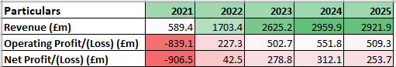
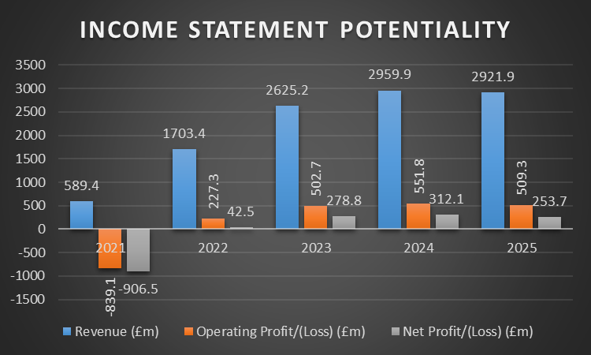
Figure 1: Income statement
(Source: Whitbread Plc, 2021; Whitbread Plc, 2023; Whitbread PLC, 2025)

1.1.2 Balance sheet analysis
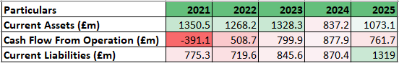
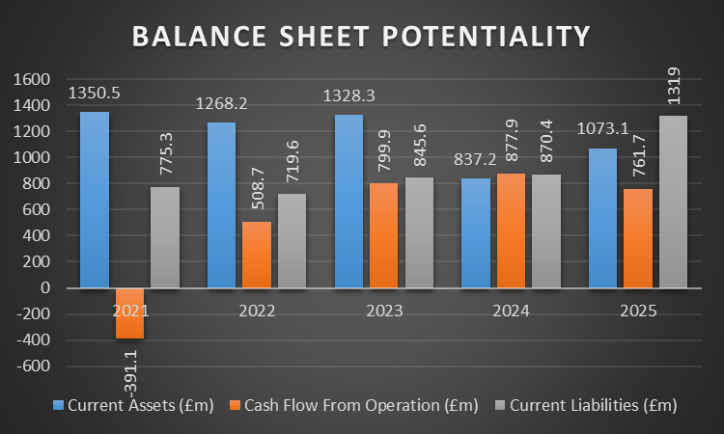
Figure 2: Balance sheet
(Source: Whitbread Plc, 2021; Whitbread Plc, 2023; Whitbread PLC, 2025)
The Whitbread also assured stable balance sheet position with diversifying key instability in liquidity position from 2021-2025. This strong asset base is supported through stable current asset position £9.90 billion in 2025 also be 4% higher as compared to £9.52 billion in 2024. As is ensure strong expansion of property and plan inventory position £4.68 billion and use to right asset value £3.66 billion. On the other hand, current liabilities rose by 70.1% from £775.3 million to £1,319.0 million indicating most pressure on management short term liquidity position of Whitbread Plc. Overall, rise in short term borrowing about £450.0 million influence balancing cash flow position of organization.

1.2 Liquidity Ratios
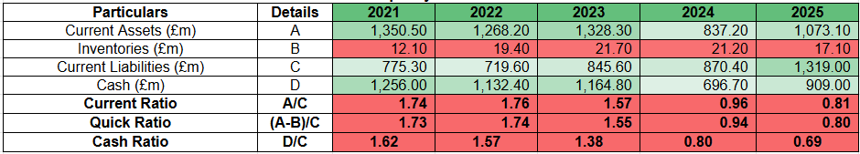
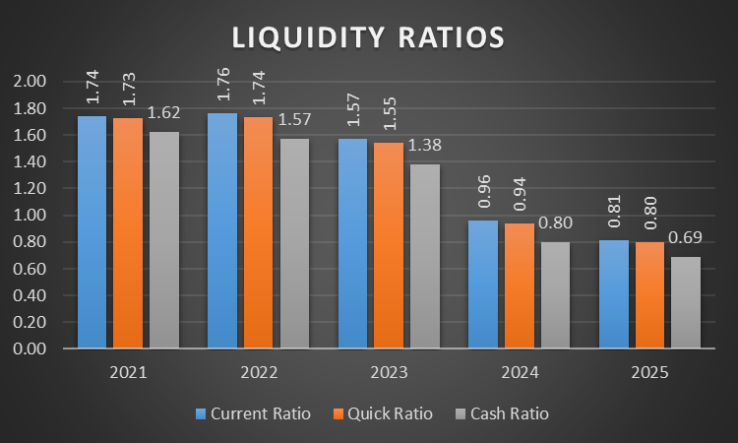
Figure 3: Liquidity ratios
(Source: Whitbread Plc, 2021; Whitbread Plc, 2023; Whitbread PLC, 2025)
Market Trends
In the current scenario, Whitbread Plc has achieved a consistent downtrend in its current ratios “Current Assets ÷ Current Liabilities,” to 0.81 due to selling of business units in 2025. The company has sold hotels worth $2bn for managing its operational losses (Martin, 2026). In addition, Whitbread has also declined its quick ratio “(Current Assets - Inventory) ÷ Current Liabilities” by 53.75%, signifying asset conversion issues in its business operations. The company has also witnessed the absence of adequate financial resources due to the low performance in the cash ratio “(Cash ÷ Current Liability)” to 0.69 in 2025 (Whitbread PLC, 2025). Thus, the existence of low business investments has hampered the service quality of the organisation.
Strength
Strong cash reserves and effective asset management also manage a better operational liquidity position for long-term value creation.
Threat
The decline in current ratio has also hampered the ability of the organization in meeting the financial and operational short-term requirements of business.

1.3 Efficiency Ratios
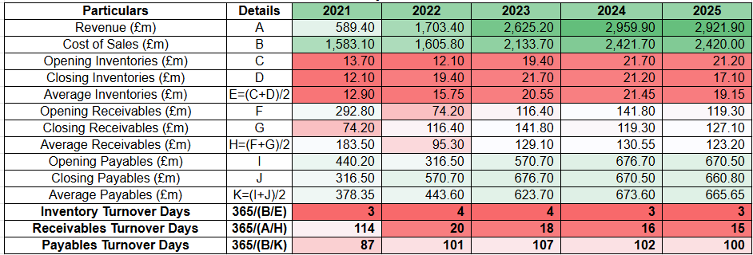
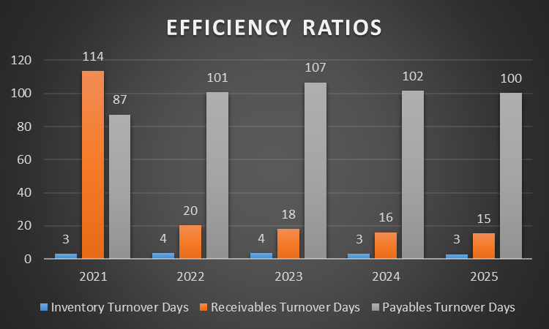
Figure 4: Efficiency ratios
(Source: Whitbread Plc, 2021; Whitbread Plc, 2023; Whitbread PLC, 2025)
Market Trends
The Inventory turnover days of Whitbread Plc are designed by “Average Inventory ÷ Cost of Sales × 365” with a 33.33% increase in 2022 and a decrease of 25% in 2025. Decrease in inventory days is due to operational restructuring at Whitbread Plc by affecting its “Accelerating Growth Plan” by a shift in the employment of employees (Whitbread PLC, 2025). Receivable turnover days are designed by “(Average Trade Payables ÷ Cost of Sales × 365)” decreased to 86.84%. Decline in receivable turnover days is due to poor credit facilities and operational delay due to tight capital management. Payable turnover days “(Average Trade Payables ÷ Cost of Sales × 365)” increased by 14.94% to address better cash flow with strong liquidity maintenance.
Strength
Whitbread Plc enhanced its operational efficiency through reliable maintenance of cash, leading to enhanced restructuring.
Threats
Whitbread Plc distorted its capital due to surging with employment affecting the “Accelerating Growth Plan”.

1.4 Profitability Ratios
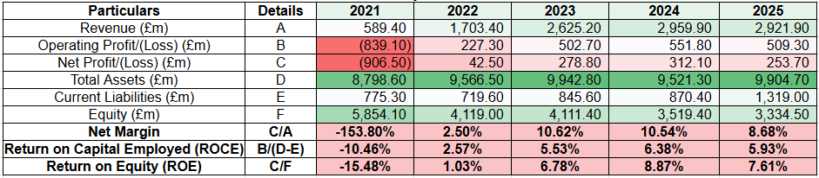
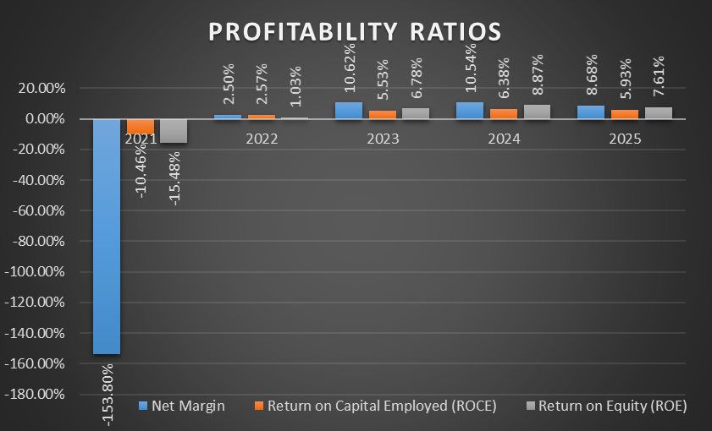
Figure 5: Profitability ratios
(Source: Whitbread Plc, 2021; Whitbread Plc, 2023; Whitbread PLC, 2025)
Market trend
The net profit marginal value can also be calculated through “(Net Profit ÷ Revenue × 100)” as it is in peak 10.62% in 2023 from recovering key loss -153.80% in 2021. However, its slightly down 8.68% in 2025 indicated higher financial cost £188.5 million for adjusting profit after tax in 2025. ROCE was also to be increased from “-10.46% in 2021 to 5.93% in 2025” with its peak value of 6.38 in 2024 “[Operating Profit ÷ (Total Assets – Current Liabilities) × 100]”. However, it slightly declined in 2025 as capital employment reached £8,585.7 million indicating more stability and a long term position creation of Whitbread Plc (Yahoo Finance, 2025).
ROE is also calculated through “(Net Profit ÷ Equity × 100)” to make a high position in 2024 with declining 7.61% in 2025. The decline of shareholders equity position “£5,854.1 million to £3,334.5 million” indicated losing shareholder confidence towards enabling long term investment creation in Whitbread Plc (Whitbread PLC, 2025).
Strength
Strong profitability recovery, improving ROCE and ROE demonstrate efficient operations, capital utilisation, and sustainable shareholder value creation.
Threats
Declining 2025 margins, rising finance costs, and lower equity could weaken future profitability and investor confidence.

1.5 Gearing Ratios
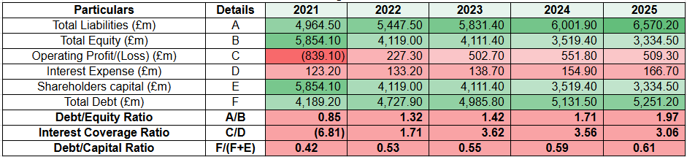
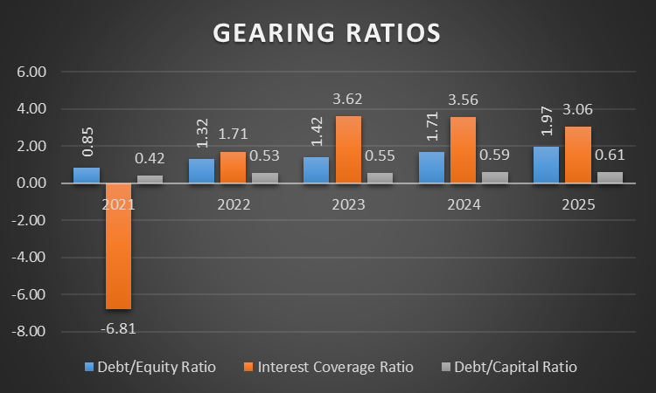
Figure 6: Gearing ratios
(Source: Whitbread Plc, 2021; Whitbread Plc, 2023; Whitbread PLC, 2025)
Market Trends
Gearing ratio measures the company’s “debt to equity” by assessing financial stability in managing business operations. Debt/capital ratio is determined by “Total Debts ÷ (Total Debts + Total Equity)” increases 131.76% due to high rises of borrowing for the maturing of green bonds. The company manages its corporate debt in issuing £300m in green bonds (Whitbread PLC, 2025) that will mature by 2027. Debt/Equity ratio is determined by “(Total Debts ÷ Total Equity)” decreases 55.07% by re-evaluation of assets, which enhances overall equity value. Interest coverage ratio (IC) is determined by “(Operating Income ÷ Interest Expense)”. It increases 45.24% due to high rises in business earnings, enhancing overall sales of the business.
Strength
Whitbread Plc improves its borrowing along with adoption of green bonds, which leads to slowing down corporate debt.
Threats
Whitbread Plc faces high borrowing issues due to credit pressure which affects overall revenue of the business.

1.6 Investment Ratios
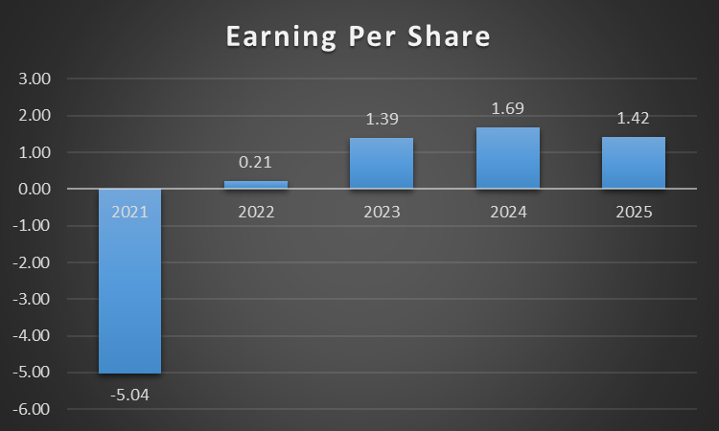
Figure 7: Investment Ratios
(Source: Whitbread Plc, 2021; Whitbread Plc, 2023; Whitbread PLC, 2025)
Market Trends
The investment ratio is a significant parameter that discloses the market performance of the company and strengthens the financial interests of its shareholders. Whitbread Plc has achieved a positive trend in its EPS “(Net Income ÷ Outstanding Shares)” to 577% that illustrates an enhancement in its trust level among investors. For instance, the company has increased its net income by £154m due to improvement in its service quality in 2025 (London Stock Exchange, 2025). Thus, the improvement in the revenue has provided opportunities for Whitbread Plc in providing strong returns to the investments of its shareholders.
Strength
The availability of a higher EPS value has also improved the market growth of Whitbread Plc.
Threat
The rapid valuation of the shareholder wealth of Whitbread Plc has caused overvaluation of its investments that has hampered the growth of the shares.

1.7 Cash Flow Ratios
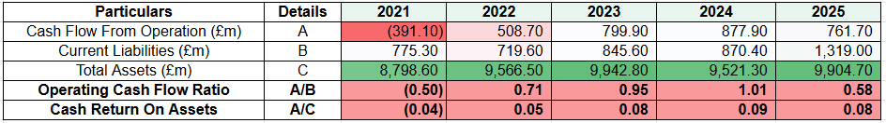
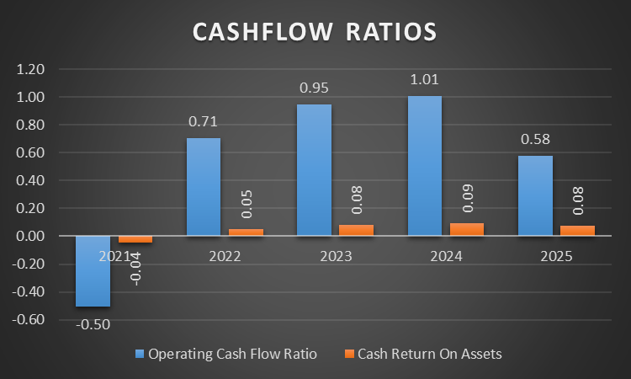
Figure 8: Cash Flow ratios
(Source: Whitbread Plc, 2021; Whitbread Plc, 2023; Whitbread PLC, 2025)
Market trend
The operating position of cash flow “(Cash Flow from Operations ÷ Current Liabilities)” also rose 216.0% as compared to -0.50 in 2021 with its peak value of more than industry benchmark 1 associated 2024. Thus, falling cash flow position 13.2% about £761.7 million is a key reason for instability in managing the positional value of Whitbread Plc (Whitbread PLC, 2025).
“Cash Return on Assets” is generally 300% improvement within a time period of five years calculated through “(Cash Flow from Operations ÷ Total Assets)”. Hence, increased total asset value £9,904.7 million make strong support for manage return position with diversifying operational cash needed for business progression.
Strength
Strong operating cash generation and efficient asset utilisation enhance liquidity, position for maintaining long-term financial stability.
Threats
Declining operating cash flow and rising current liabilities may weaken liquidity and short-term debt repayment capacity.

1.8 Liquidity ratio comparison

1.8.1 Evaluation with Liquidity ratio with industry benchmark
The liquidity performance of Whitbread Plc is a concern as it has not surpassed the industrial average of 2 adopted in the hospitality sector. In addition, the results have also hampered the business investment growth of the organisation. Whitbread Plc has lowered its cash value to £5.4m due to enhancement in its prepaid taxes in 2025 (London Stock Exchange, 2025). The decline in the monetary resources has also caused delays in the provision of proper service to the guests. Overall, the weakening of the customer relationship due to poor quality services has lowered the brand growth of the organisation.

1.8.2 Impact of firm performance based on liquidity ratio
Whitbread PLC's current ratio decreases 53.45% due to reduction in cash reserves affecting the “Accelerating Growth Plan”. The company drained its cash reserves by investing in the growth of the business and its shift in Germany and the UK. In addition, the current ratio of UK hotels increased from 1.2 to 2.0, which indicates a lower rate due to rapid inventory turnover and “short-term debt” maintenance (Hospitality industry, 2024). Thus, increases in the current ratio in the hospitality industry are more reliable for adapting operational decisions and managing clients with payment discounts for accommodation to enhance business performance.

2. Working Capital Management Analysis

2.1 Discussion of Cash Operating Cycle Performance
- Receivable Collection Period
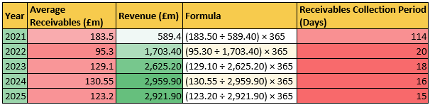
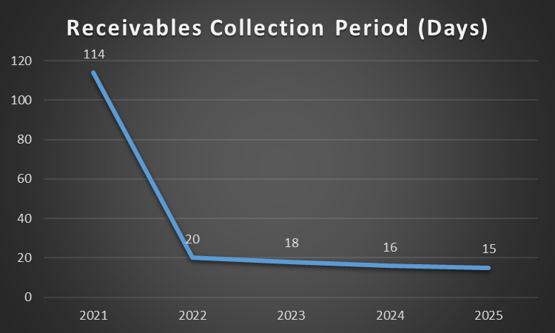
Figure 9: Receivable Collection Period
(Source: Whitbread Plc, 2021; Whitbread Plc, 2023; Whitbread PLC, 2025)
Whitbread Plc has lowered the growth of its average “net receivable value” to £123.2m due to enhancement in consumer overdues in 2025. The decline in recovery efficiency has also hampered the fund enhancement initiatives of the organisation. In addition, Whitbread Plc has also increased its customer dues to £300m in 2025 (Whitbread, 2026). Hence, the absence of effective recovery policies has lowered the growth of the company.
- Payable Payment Period
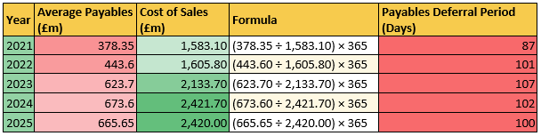
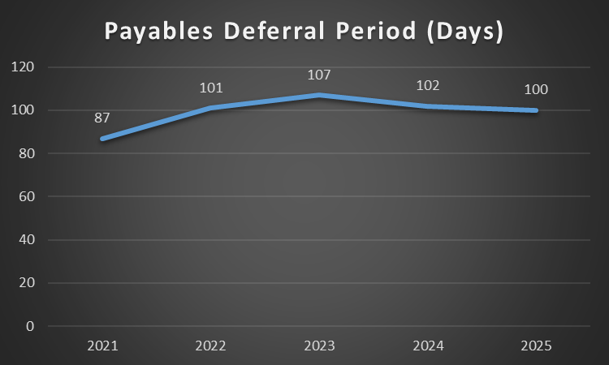
Figure 10: Payment Deferral Period
(Source: Whitbread Plc, 2021; Whitbread Plc, 2023; Whitbread PLC, 2025)
The enhancement of the “Payable Payment Period” to “100 days” has lowered the operational efficiency of Whitbread Plc and hampered its supply of raw materials. As an instance, the creditor value of the organisation has increased to £292m due to low earnings of its operating income (PayPoint, 2025). Hence, the enhancement in the internal debts has caused financial instability to the organisation.
- Inventory Management Period
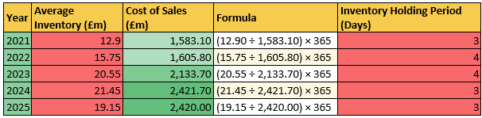
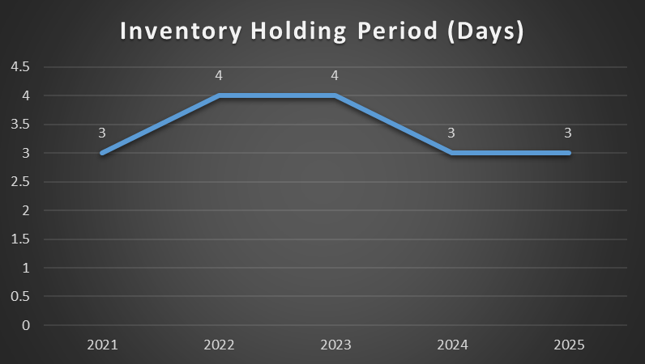
Figure 11: Inventory Holding Period
(Source: Whitbread Plc, 2021; Whitbread Plc, 2023; Whitbread PLC, 2025)
The “Inventory Management Period” at Whitbread PLC is roughly 3 days due to reliable asset maintenance and checking of stocks of “Revenue Per Available Room”. The decrease in inventory days is due to the shifting of restaurant options and adoption of a unique ownership model for accessing competitive edge among its rivals (Whitbread PLC, 2025). Thus, streamline stock management by efficient control of stock and reduction of waste.
- Cash Conversion Period
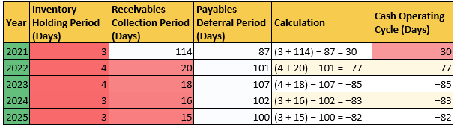
Figure 12: Cash Operating Cycle Evaluation
(Source: Whitbread Plc, 2021; Whitbread Plc, 2023; Whitbread PLC, 2025)
In 2021, “Cash Operating Cycle” (COC) is about 30 days, which decreases 373.33% in 2025 due to faster selling of products from inventory in response to consumer demand. The company manages its capital strategy with guaranteed notes by issuing £400 million in 2025 by adoption of recycling (Whitbread PLC, 2025). Thus, a decrease in COC is beneficial for managing better efficiency in business to less requirement of loans.

2.2 Working Capital Challenges
Low Credit Value
Whitbread Plc has a low credit value that has lowered the brand reputation of the company. The organisation has also achieved an inferior rating of “BBB-‌” due to the decline of its EBIT income to £110m in 2025 (Fitch Ratings, 2026). In addition, the organisation has also observed a decline in its revenue growth by 5% due to inflationary pressure. Hence, the decline in the profit value and low brand image has increased the financial concern level of the organisation.

2.3 Recommendation to improve liquidity of working capital

2.3.1 Optimising inventory
Whitbread PLC enhanced its inventory management across strategic restructuring and involvement of the suppliers for its warehouse expansion in Germany. The company optimises its growth by improving its reach to about 125,000 rooms by highlighting its reliable expansion in Ireland and the UK (Whitbread, 2023). The capacity expansion of rooms leads to a rise of 96,000, which will be achieved by 2030 to 2031, accessing consumer preferences in the UK. That strategic opportunity of Whitbread PLC achieved its ambition in Germany with a rise of 18,000 room capability by 2030 to 2031, leading to enhanced overall brand revenue.

2.3.2 Streamlining improvement in accounts receivable
Whitbread PLC enhances improvement in accounts receivable with "short-term payments” by reducing overall credit facilities. The company collaborated with “C2FO” for the “Whitbread Early Payment Program,” enhancing overall cash flow of the business (C2FO, 2026). This mechanism serves suppliers with cash discounts by analyzing cash invoices, which enhances overall liquidity maintenance. Apart from that, Whitbread PLC manages its bad debts by “Pre-booked revenue,” by the ability to remove credit exposure, enhancing overall sales of the business.

2.4 Comparison of financing option

2.4.1 Short-Term Financing Options
Trade Credit
The “Trade Credit” method provides emergency fund sources to companies in meeting the requirements of its business operations. Whitbread Plc has acquired credit notes worth £400m for financing its expansion operations till 2032 (Whitbread, 2026). Hence, the availability of proper monetary facilities has assisted the company in overcoming market uncertainties and meeting client requirements effectively.
Short-Term Loans
This technique looks after the day-to-day monetary requirements of the company for meeting the expenditure of its venture. Whitbread Plc has increased its cash flow value to £2.5bn due to improvement in its pre-tax profit in 2025 (Yahoo Finance, 2026). Thus, the improvement in the cash margin has provided financial support to the infrastructural projects of the organisation.

2.4.2 Long-Term Financing Options
Equity Capital
Whitbread Plc has provided strength to its market capitalisation through fund diversification strategy and improved its value to £4.5bn in 2025 (AJ Bell, 2026). Hence, the existence of a flexible internal capital structure has assisted the organisation in reducing delays in the completion of its business operations.
Debenture Bonds
Whitbread Plc has also issued debenture bonds worth £400m for meeting its high debt value and recovering dues from the customers and suppliers in 2025 (Cbonds, 2025). Hence, the strengthening of the resource recovery activities has assisted the organisation in reducing market competition.

2.4.3 Comparative Analysis
Whitbread Plc has acquired the opportunity of utilizing the short-term and long-term financial sources that will ensure smooth execution of its business operations. As an instance, the availability of equity and bond capital will strengthen the internal management activities of the company. On the other hand, trade credits will improve the brand reputation level.

3. Strategic Financial Restructuring Plan

3.1 Recommended Financial Restructuring Options
- Divestiture
Divestiture helpful to closure of low value business units towards captivating new investors of higher growth pattern in future (Chen, 2026). Thus, Whitbread Plc also diversified non-core hotel assets towards enabling investment in high-performing Premier Inn locations to enhance ROCE from 5.93%.
- Equity Injection Strategy
Equity injection ensures more recovering additional capitalised value from shareholders towards strengthening company position (Banton, 2026). Hence, issues of new shares also enable reduce risk decline equity value £3.33 billion in 2025 make additional equity beneficial for long term growth.
- Merger and Acquisition
The merger and acquisition process enables the opportunity to expand, combining business segments to achieve growth, market expansion, and operational synergies. Hence, regional hotels located in Germany and the UK should be acquired by Whitbread Plc to improve European market share effectively.

3.2 Impact on Financial Restructuring

3.2.1 Significance on Shareholder Value
Financial restructuring has a reliable impact on shareholder value along with decline in capital cost and enhanced cash flow stability. Whitbread Plc eliminated its capital cost by selling £1.5 billion of property, accessing a shift towards a “pure-play hotel” led to the cut of 3,800 job roles (Reuters Staff, 2026). Thus, a reduction of capital cost is due to selling property, which reduces overall earnings of the business.

3.2.2 Significance of Debt Structure
The company reshapes its debt structure by financial restructuring, changes in repayment, and extension of loans. Whitbread Group Plc revolves around its credit of about £775 million that will mature by 2029, enhancing the liquidity profile (Fitch Rating, 2026). This investment optimises its cash flow by improving credit facilities by accessing strategic opportunities in business. Thus, maintaining debt structure reduce investors confidence by responding with shift in market.

3.2.3 Significance of Operational Flexibility
Financial restructuring has a reliable effect on the operational flexibility of the business by reducing debt and quickly adjusting cash due to market changes. Whitbread Plc enhances its profitability in the German market with branded budget hotel preferences of about 11% and non-branded hotels is about 68% (Strategist and Architect, 2025). Reduction of the hotel room share accessed through property recycling leads to a slowdown of restaurants. Thus, unlocking profitability is due to RevPAR enhancing the overall financial performance of the business.
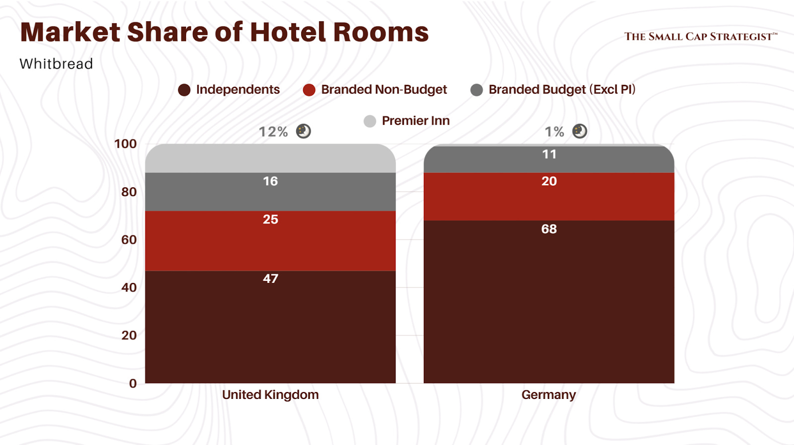
Figure 13: Market share of Whitbread Plc hotels in Germany and UK
(Source: Strategist and Architect, 2025)

3.3 International Financial Considerations

3.3.1 Taxation Considerations
Taxation also refers to the key business tax paid by corporate authority to run business segments in an effective manner. Hence, the corporate rate is about 26.5% in the UK as compared to lower than 30% of Germany expansion (Bilal, 2026; Trading Economics, 2026). Hence, UK is becoming low risk adheres to expansion in premier Inn in Germany for long term.
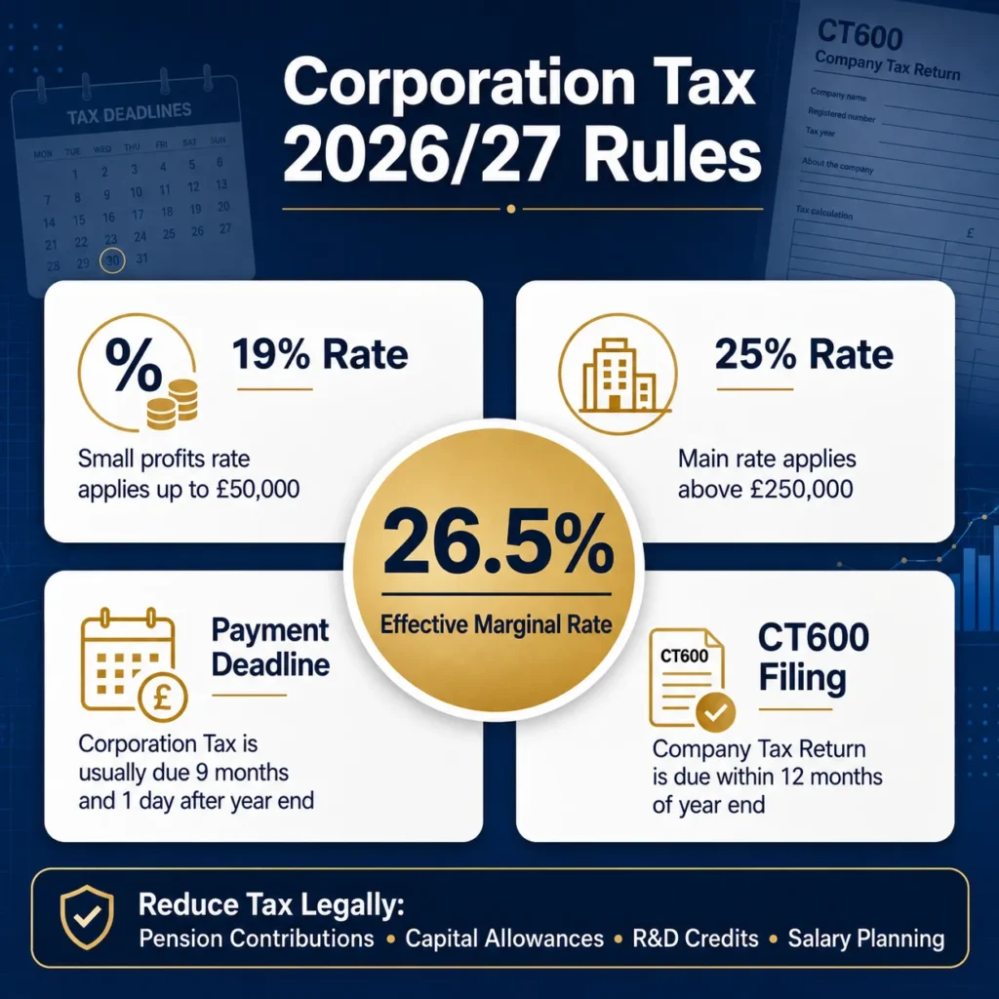
Figure 14: Corporate Tax Rate of UK
(Source: Bilal, 2026)

3.3.2 Currency Risk
The fluctuation of exchange rates highly influences current risk exposure in business progression of Whitbread Plc. Hence, the GBP/EUR exchange rate also increased by 3.1% “€1.145 in February to €1.180 in July” also indicated the opportunity of forward contracts with expansion of Premier Inn opportunities towards reducing transaction risk.
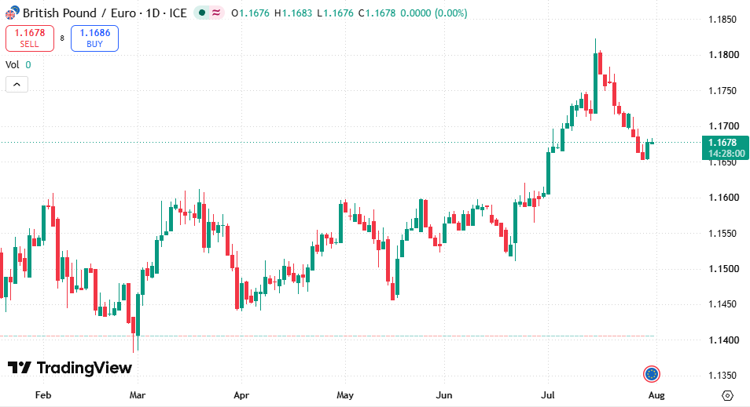
Figure 15: Exchange rate
(Source: TradingView, 2026)

3.3.3 Inflation Risk
Inflation risk also indicates the rise of operational cost to improve premier occupancy rates and reduce consumer purchasing power directly impact business. For instance, reducing the inflation rate in the UK by about 2.6% in June as compared to Germany's 2.2% indicated more opportunity and less risk in UK operations associated with rising labour, food, utility, and maintenance costs (Trading Economics, 2026).
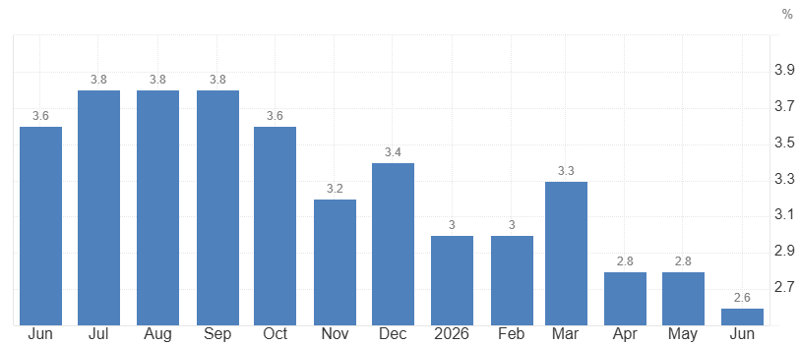
Figure 16: CPI inflation rate UK
(Source: Trading Economics, 2026)

3.4 Discussion on the Ethical and ESG Operations
- Corporate Social Responsibility
Whitbread Plc has collaborated with “Great Ormond Street Hospital Children's Charity” worth £20m for promoting importance of health and hygiene to children and young adults in 2025 (Gosh Charity, 2025). In addition, the business tie-up has also provided opportunities for the company in providing employment to local skilled individuals. Thus, the adoption of the community development partnerships has improved the goodwill of Whitbread among its stakeholders.
- Environmental Sustainability
Whitbread has executed an environmental programme worth £7bn that promotes the use of sustainable timber materials for developing hotel furniture (Whitbread, 2026). The investment has also reduced the carbon valuation of the business operations carried out by the organisation. Hence, the adoption of organic wood has assisted the organisation in improving sustainability in its business operations.
- ESG Performance and Reporting
Whitbread Plc has developed programmes such as “Winning Teams”, “Force For Good” with an intent to promote sustainability and teamwork within its work environment (Whitbread, 2024). Thus, the adoption of the initiatives has ensured smooth transmission of service information and improved its operational stability.

4. Investment Appraisal and Capital Budgeting

4.1 Project Overview
Investment appraisal is a reliable process to develop a business by NPV, ARR, IRR, PBP, and PI to manage overall cash flow. As stated by Andon, Baxter and Chua (2023), the significance of investment appraisal highlights the overall viability of the project analysing financial stability and reliable resource allocation to ensure strategic alignment. Initial investment of Project A is £50m, with its cash inflow of about £54m, with the annual depreciation of about £10m per year. However, Project B has a cash inflow of about £55m, with a PBP of about 4.55 years in Year 4 by maximizing its return to enhance profitability. Cash flow at Project C is about £60m, with its PBP of 3.6 years in Year 3 with reliable recovery of cash with shorter payback and operational adjustment. Project B serves faster liquidity, whereas Project C serves profitability by responding to operational delays and shifts in the market. Project A manages its cash flow in lowering cash flows compared to Project C. However, Project B has the ability to pay short bills and resolve credit lines with flexible loans. Project C achieves its nominal return of cash enhanced operational disruption enhance value creation in the project.

4.2 Discuss Project Viability

4.2.1 Project A Appraisal
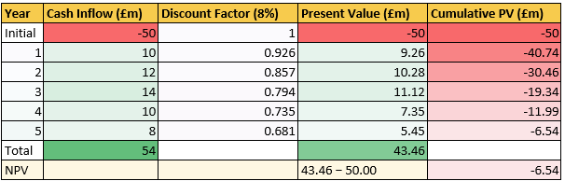
Figure 17: NPV
(Source: Self-developed)
The use of NPV is reliable for analyzing the profitability position of an organization by linking its present value of investment (Fernando, 2026). Hence, this NPV analysis also assures unviable investment opportunity for project A within 8% discounting rate. Present value of cash flow generating negative NPV £6.54 million reduces shareholders returns.
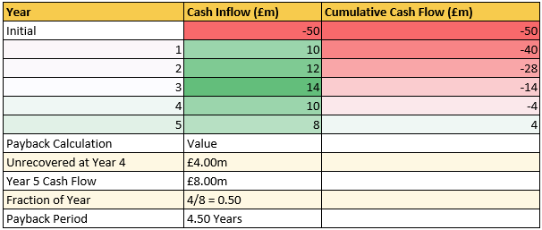
Figure 18: PBP
(Source: Self-developed)
The PBP value also assures shareholders about the returning period of actual investment for generating positive cash flow through investment (Kagan, 2026). Hence, initial investor cover in 4.50 years indicated a long payback period and also to raise debenture value of investment for Whitbread Plc.
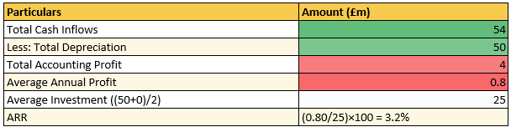
Figure 19: ARR
(Source: Self-developed)
The ARR value is significant for defining annual average return potentiality of a project within a particular time for investment period (Hargrave, 2025). Thus, an average invested value of £25 million also assured profit for Whitbread Plc about £0.8 million. Overall, ARR 3.2% indicated lower return capability falling below investment target.
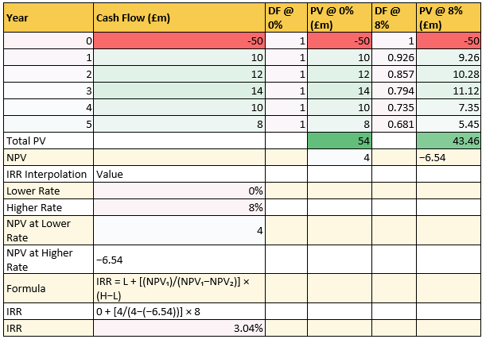
Figure 20: IRR
(Source: Self-developed)
The IRR is a significant financial appraisal technique that approves discounting rates to maintain NPV position zero effectively (Fernando, 2026). Hence, in this case interpolation of 0% and 8% also raised NPV value £4 million and −£6.54 million respectively. Overall, IRR below 8% assure rejection from shareholders to fail minimum criteria of investment.
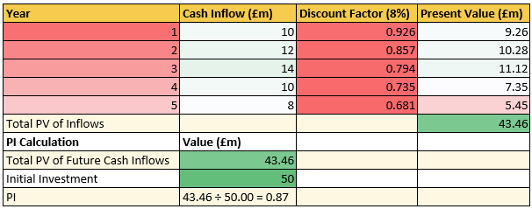
Figure 21: PI
(Source: Self-developed)
The PI value most significant for investors for analysis key future cash flow generation against investment of per £1. Hence, in this case PI of 0.87 indicated “for every £1 invested return potentiality about £0.87 indicated loss for a longer time period.

4.2.2 Project B Appraisal
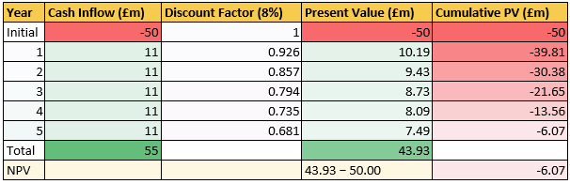
Figure 22: NPV
(Source: Self-Developed)
Project B has experienced a negative NPV of -£6.07m due to its low present value of £43.93m in 5 years. Hence, the decline in the income of the business plan has also reduced its feasibility of a viable funding option among the investors.
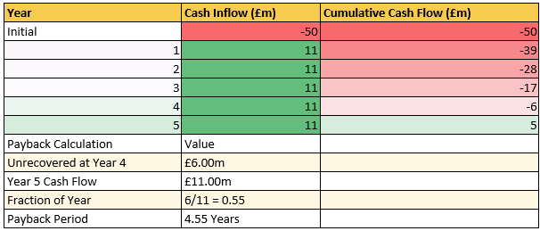
Figure 23: PBP
(Source: Self-Developed)
The project has witnessed the existence of an unrecovered investment of £6m that has increased its PBP value to 4.55 years. Overall, the occurrence of delay in acquiring proper returns to the funding amount has also lowered the credibility of the business plan among companies such as Whitbread Plc.
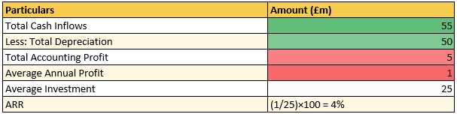
Figure 24: ARR
(Source: Self-Developed)
Project B has also provided a low average return of £1m to the invested amount of £25% in the 5 years. In addition, it also has a lower ARR value of 4% in comparison to other business plans. Hence, the provision of low profits has reduced the investor engagement level of the project.
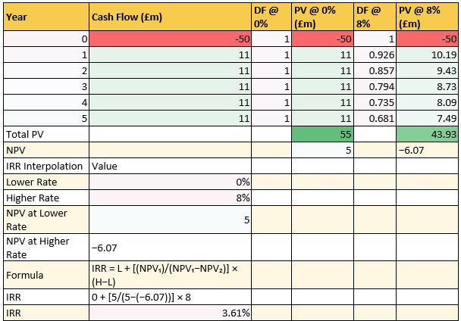
Figure 25: IRR
(Source: Self-Developed)
The PV value of Project B has declined from £10.19m in year 1 to £7.49m in year 5. On the other hand, the IRR growth of the business plan has also reduced to 3.61% due to low project value. Thus, the decline in investments has reduced the revenue enhancement of the business plan.
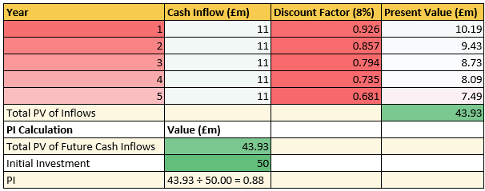
Figure 26: PI
(Source: Self-Developed)
The "Profitability Index” score of Project B is 0.88 that signifies lower income growth of the investment operations. Thus, the decline in the profits will reduce the goodwill of the business plan among investors

4.2.3 Project C Appraisal
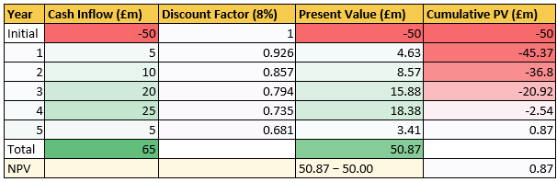
Figure 27: NPV
(Source: Self-Developed)
Project C has a present value £-50m, with its total cash inflow about £65m and the total NPV is about £0.87m. The positive NPV lowers the initial cost by ability to raise its capital, which leads to a boost in overall sales volume of the business by refinancing of debt.
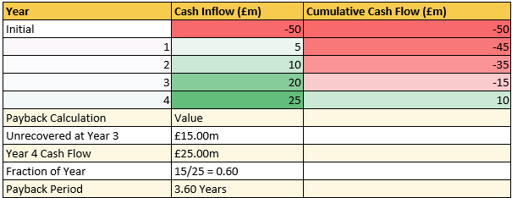
Figure 28: PBP
(Source: Self-Developed)
The PBP for Project C is 3.60 years, managing its cash flow of about £25m in Year 4, which lowers the risk of addressing faster cash flow. Project C reduces its cash exposure by highlighting long-term shifts for value creation of the project.
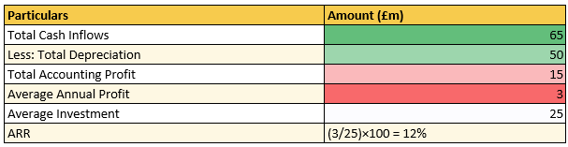
Figure 29: ARR
(Source: Self-Developed)
Project C has an ARR of about 12.0%, with its annual profit of about £3m addressed by accessing the revenue of the project. This rise in ARR is achieved in acquiring new customers, highlighting stable progress to respond with failure in the market.
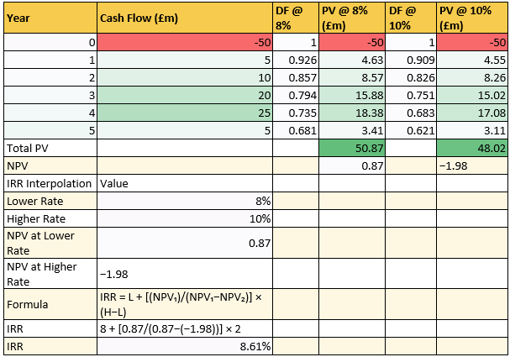
Figure 30: IRR
(Source: Self-Developed)
Project C has an IRR rate of about 8.61% with its PV of £0.87m at an 8% discount rate and £1.98m at 10% discount rate. 8.61% IRR is considered good, due to stable debt and the ability to invest on bonds to reduce debt which leads to low risk at the project.
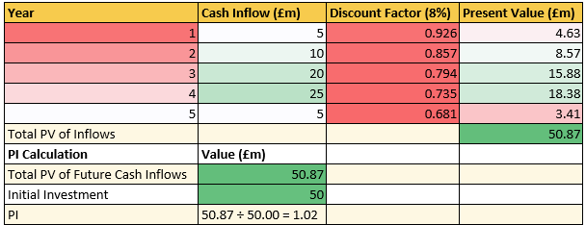
Figure 31: PI
(Source: Self-Developed)
Project C has a PI of about £1.02m, with its profit volume about £50.87m, which is due to positive NPV with its initial investment in managing cash. This enhances the positive return by accessing errors in managing cash flow and significant investment in managing cash return.

4.3 Recommendation based on the company financial performance

4.3.1 Selection of project
From the overall project, Project C is the reliable option with its positive NPV, which leads to enhanced wealth for the shareholders. This project has a high ARR, accessing overall profit along with initial investment. IRR rate is financially acceptable, as it manages cash flow by reinvestment process.

4.3.2 Financial performance
- Liquidity
The adoption of Project C will provide opportunities for Whitbread in enhancing its cash flow value by £10m that will also strengthen its internal financial structure. As an example, the company has increased its property investments by £1.5bn for expanding its infrastructural units and catering the needs of a large consumer base (LSE, 2026). Thus, the strengthening of the cash flow position has assisted Whitbread in overcoming the financial crisis.
- Profitability
Project C will also provide a higher PI score of 1.03 to Whitbread Plc that will assist in improving the market position of the organisation. The company will achieve a net income growth of 12% due to steady consumer demands in 2029. Thus, the adoption of the long-term project investment strategy will help Whitbread Plc in strengthening its brand image and acquire competitive advantage.
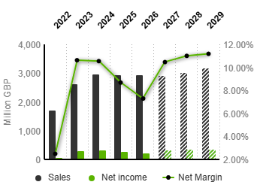
Figure 32: Net Income Growth
(Source: Market Screener, 2026)

4.3.3 Non-Financial Risk
- Customer loyalty
Project C has a strong cash inflow to build a loyal customer base, which reduces borrowing risk. In UK hospitals, changes in consumer preferences are based on “digital booking", service quality and sustainability initiatives enhance the reputation of the brand. Whitbread Plc has 73% of loyal customers relying on the quality of the accommodation facilities, enhancing operational capability (Whitbread, 2024). This leads to high rates of guest retention and repeat customer leads to enhance overall profit of business.
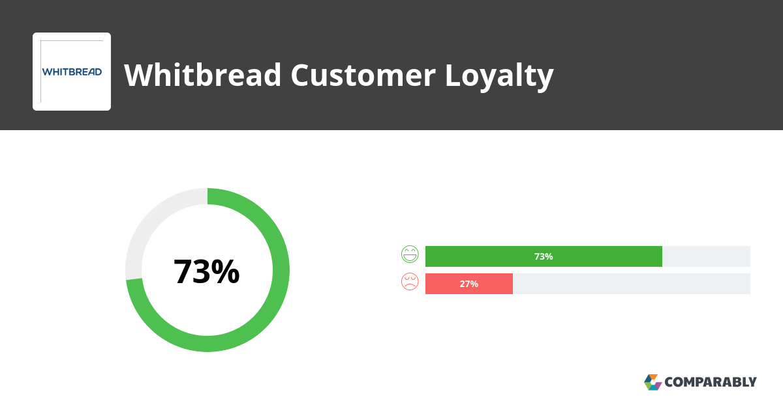
Figure 33: customer loyalty
(Source: Whitbread, 2024)
- Political risk
Project C faced political risk due to rises in operational costs and changes in taxation affecting the overall reputation of the project. Whitbread Plc raised its business rate about £40–50 million due to changes in tax affecting overall cash flow of the business. This in turn leads to strategic changes in business planning due to weaker consumer spending.

4.4 Capital Rationing Analysis (£100 Million Limit)
The capital allocation of £100 Million Limit also makes project B and project C most suitable optimal investment while maintaining a combined NPV position -£5.20 million. It is also the highest NPV with PI value 0.95 and ARR value 8% ensuring smooth investment recovery through a five year time period. Overall, lesser payback with 4 years’ time period also indicated positive investment flow in project B and C combination.
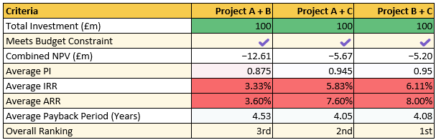
Figure 34: Capital rationing
(Source: Self-developed)

5. Critical Reflection on Artificial Intelligence Usage

5.1 AI tools and Acknowledgement
The adoption of ChatGPT, Gemini and Claude are more effective for completing this task by providing reliable financial ratio making information and drawing conclusions in achieving project objectives (Wójcik et al., 2025). The uses of these tools serve reliable information regarding financial concepts, investment proposals, accounting procedures and financial formula of ratios for accessing trends of the business. However, this tool provides generalised help to assess the financial value of slightly differ that is addressed in analyzing the annual report of the company for reliable decision-making. Predictive forecasting of the company is accessed verifying past data and trends in highlighting cash flow and revenue (Jenčová et al., 2025). The financial instruction provided by the prompt serves structured results such as cash flow planning and variance analysis, and enhances professional integrity. In order to gather financial predictions, the use of Excel tools is more reliable to predict accurate results by ability to achieve reliable insights.

5.2 Evaluation of AI Outputs
“Cross-Document Verification” and “Retrieval-Augmented Generation” are methods used for accessing financial interpretation (Malali, 2025). Use of this method helps to carry out financial insights and cash flow statements of the business. Verifying accuracy in information is carried out by the use of annual reports by preventing hallucinations. AI-generated output gathered along with the use of ChatGPT, Gemini, and Claude enhances overall accuracy in describing reliable information. The financial information used for accomplishing this task includes liquidity, profitability, solvency, and investment ratios (Agusta and Hati, 2018). These calculations are supported by Excel analysis with manual putting data for preventing disparity provided in AI recognisation. “Potential hallucinations” are identified by accessing AI-generated information throughout the research and use of original source checking by following potential integrity.

5.3 Contribution Analysis

5.3.1 AI-Generated Contributions
The inclusion of the AI tools has assisted me in strengthening the authenticity of my calculations and research formulas that also improved my investigation outlook. Although, I had observed contradicting responses from the technology during the development of the project appraisals that has negligibly altered the values of my project. Overall, the AI tools have improved the structural and technical quality of my research regarding the financial performance of Whitbread Plc.

5.3.2 Independent Critical Analysis
My independent critical analysis aspect illustrates personal contributions towards the completion of the research project. As an instance, I utilized company accounts and annual reports for acquiring financial data of 5 years regarding Whitbread Plc. I also assembled the information and adopted ratio tools for understanding the growth trend of the company. In addition, I also carried out a detailed research regarding operational activities of the organisation by utilizing peer-reviewed journals and updated new articles. Thus, the adoption of the financial and non-financial tools has assisted me in improving my research capacity.

5.4 Ethical and Professional Reflection
In the research work, I have focused on executing the completion of the aspects through my own efforts that has also improved my professional confidence. The information included in the investigation process has been in alignment with the guidelines of the “Copyright and Patent Act (1988)” (Government of UK, 1988). This has also improved the ethical standard of my investigation process. I have also included the financial data from the annual report and authentic company websites for analysing its operational performance. According to Chen et al. (2024), the adoption of organisational information within the research work has improved the quality and authenticity of the investigation process. Hence, the strengthening of the ethical standards of the collected data has improved the quality of my project.

References
Agusta, R.F. and Hati, S.W. (2018). Calculation of Liquidity, Solvency and Profitability Ratio in Manufacturing Company. [online] ResearchGate. Politeknik Negeri Batam. Available at: https://www.researchgate.net/publication/344794916_Calculation_of_Liquidity_Solvency_and_Profitability_Ratio_in_Manufacturing_Compan
AJ Bell (2026). Whitbread PLC share price (LSE:WTB) | AJ Bell. [online] Ajbell.co.uk. Available at: https://www.ajbell.co.uk/market-research/LSE:WTB.
Andon, P., Baxter, J. and Chua, W.F. (2023). Affect and Reason in Uncertain Accounting Settings: The Case of Capital Investment Appraisal. doi:10.1111/acfi.13185.
Banton, C. (2026). How Capital Injections Keep Companies Afloat. [online] Investopedia. Available at: https://www.investopedia.com/terms/c/capital-injection.asp
Bilal, M. (2026). Corporation Tax UK 2026: Rates & How to Reduce It | Protax. [online] Protax Consultants. Available at: https://www.protax.org.uk/articles/corporation-tax-uk-2026-rates-deadlines/
C2FO (2026). Whitbread Early Payment Program | C2FO. [online] Whitbread Early Payment | C2FO. Available at: https://whitbread.c2fo.com/
Cbonds (2025). Cbonds. [online] Cbonds. Available at: https://cbonds.com/bonds/146257/.
Chen, J. (2026). What happens in divestitures. [online] Investopedia. Available at: https://www.investopedia.com/terms/d/divestiture.asp
Chen, W., Wu, W., Ouyang, Z., Fu, Y., Li, M. and Huang, G.Q. (2024). Event-based data authenticity analytics for IoT and blockchain-enabled ESG disclosure. Computers & Industrial Engineering, pp.109992–109992. doi:10.1016/j.cie.2024.109992.
Fernando, J. (2026a). Internal Rate of Return (IRR): Formula and Examples. [online] Investopedia. Available at: https://www.investopedia.com/terms/i/irr.asp
Fernando, J. (2026b). Net present value (NPV): What it Means and Steps to Calculate It. [online] Investopedia. Available at: https://www.investopedia.com/terms/n/npv.asp
Fitch Rating (2026). Fitch Downgrades Whitbread to “BBB-”; Outlook Stable . [online] Fitchratings.com. Available at: https://www.fitchratings.com/research/corporate-finance/fitch-downgrades-whitbread-to-bbb-outlook-stable-19-05-2026
Fitch Ratings (2026). [online] Fitchratings.com. Available at: https://www.fitchratings.com/research/corporate-finance/fitch-downgrades-whitbread-to-bbb-outlook-stable-19-05-2026.
Gosh Charity (2025). Meet Our Partners. [online] GOSH Charity. Available at: https://www.gosh.org/get-involved/corporate-fundraising/meet-our-supporters/.
Government of UK (1988). Copyright, Designs and Patents Act 1988. [online] Legislation.gov.uk. www.legislation.gov.uk. Available at: https://www.legislation.gov.uk/ukpga/1988/48/contents.
Hargrave, M. (2025). Should You Be Using Average Return or Geometric Mean? [online] Investopedia. Available at: https://www.investopedia.com/terms/a/averagereturn.asp
Hospitality industry (2024). Key liquidity ratios for hotel financial health | Hospitality.Institute. [online] Hospitality.Institute. Available at: https://hospitality.institute/mha805/key-liquidity-ratios-hotel-financial-health/
Jenčová, S., Vašaničová, P., Košíková, M. and Miškufová, M. (2025). A Time Series Approach to Forecasting Financial Indicators in the Wholesale and Retail Trade. World, 6(1), pp.5–5. doi:10.3390/world6010005.
Kagan, J. (2026). Payback period: Definition, formula, and calculation. [online] Investopedia. Available at: https://www.investopedia.com/terms/p/paybackperiod.asp
London Stock Exchange (2025). London Stock Exchange | London Stock Exchange. [online] Londonstockexchange.com. Available at: https://www.londonstockexchange.com/news-article/WTB/whitbread-interim-results/17280887.
LSE (2026). London Stock Exchange | London Stock Exchange. [online] Londonstockexchange.com. Available at: https://www.londonstockexchange.com/news-article/wtb/outcome-of-business-review/17570770.
Malali, N. (2025). The role of retrieval-augmented generation (RAG) in financial document processing: Automating compliance and reporting. International Journal of Management Technology, 12(3), pp.26–46. doi:10.37745/ijmt.2013/vol12n32646.
Market Screener (2026). Whitbread Plc. [online] MarketScreener India. Available at: https://in.marketscreener.com/quote/stock/WHITBREAD-PLC-4006657/.
Martin, L. (2026). Whitbread to Sell $2 Billion in Hotels and Cut 3,800 Jobs in Strategic Overhaul. [online] Skift. Available at: https://skift.com/2026/04/30/whitbread-sell-hotels-cut-jobs-strategic-overhaul/.
PayPoint (2025). [online] Available at: https://www.investegate.co.uk/announcement/rns/whitbread--wtb/preliminary-results-announcement/9545332.
Reuters Staff (2026). Premier Inn owner Whitbread to cut up to 3,800 jobs in strategy shift. Reuters. [online] 30 Apr. Available at: https://www.reuters.com/sustainability/sustainable-finance-reporting/premier-inn-owner-whitbread-extends-restaurant-overhaul-all-sites-cut-3800-jobs-2026-04-30/
Strategist, S. and Architect (2025). Whitbread PLC - Overview & Highlights. [online] Substack.com. The Small Cap Strategist. Available at: https://tscsw.substack.com/p/whitbread-plc-overview-and-highlights .
Trading Economics (2026). United Kingdom Inflation Rate. [online] Trading Economics. Available at: https://tradingeconomics.com/united-kingdom/inflation-cpi
Trading Economics (2026a). Germany corporate tax rate. [online] Tradingeconomics.com. TRADING ECONOMICS. Available at: https://tradingeconomics.com/germany/corporate-tax-rate.
TradingView (2026). [online] TradingView. Available at: https://in.tradingview.com/chart/?symbol=FX_IDC%3AGBPEUR
Whitbread (2023). Why Invest? [online] Whitbread PLC. Available at: https://www.whitbread.co.uk/investors/why-invest/
Whitbread (2024). [online] Available at: https://cdn.whitbread.co.uk/media/2023/05/Corporate-Governance-Statement.pdf.
Whitbread (2024). Whitbread NPS & Customer Reviews. [online] Comparably. Available at: https://www.comparably.com/brands/whitbread-22458
Whitbread (2026). Corporate debt. [online] Whitbread PLC. Available at: https://www.whitbread.co.uk/investors/corporate-debt/.
Whitbread Plc (2021). Premier Inn Annual Report and Accounts 2021/22. [online] Available at: https://cdn.whitbread.co.uk/media/2022/05/Whitbread_AR21-1.pdf.
Whitbread Plc (2023). Building advantage on our. [online] Available at: https://cdn.whitbread.co.uk/media/2024/05/Whitbread-PLC-Annual-Report-and-Accounts-2023_Single_pages-1.pdf.
Whitbread PLC (2025). FY25 Results . [online] Available at: https://cdn.whitbread.co.uk/media/2025/05/Whitbread-FY25-RNS.pdf.
Whitbread Plc (2025). Investing in growth Annual Report and Accounts 2024/25. [online] Available at: https://cdn.whitbread.co.uk/media/2025/05/Whitbread-PLC-Annual-Report-and-Accounts-2024-25.pdf.
Whitbread PLC (2025). Our Business Model and Strategy. [online] Whitbread PLC. Available at: https://www.whitbread.co.uk/about-us/our-business-model/
Whitbread, S. (2026). Supporting the use of timber grown in suitable locations in Britain also contributes to our natural capital, ecosystem service benefits, nature recovery, environmental improvement and climate resilience too. [online] LinkedIn. Available at: https://www.linkedin.com/posts/steve-whitbread-771a1766_supporting-the-use-of-timber-grown-in-suitable-activity-7453684025447333888-LkwL/.
Withers, P. (2025). Whitbread opens 1,000 new Premier Inn rooms since March 2024 - Whitbread Plc. [online] Whitbread PLC. Available at: https://www.whitbread.co.uk/whitbread-opens-1000-new-premier-inn-rooms-since-march-2024/
Wójcik, D., Adamiak, O., Czerepak, G., Tokarczuk, O. and Szalewski, L. (2025). A bi-linguistic comparative analysis of ChatGPT-4, Gemini, and Claude performance on polish medical–dental final examinations. Scientific Reports, [online] 15(1). doi:10.1038/s41598-025-17030-0.
Yahoo Finance (2025). Whitbread plc (WTB.L) Income Statement - Yahoo Finance. [online] Yahoo Finance. Available at: https://finance.yahoo.com/quote/WTB.L/financials/
Yahoo Finance (2026). Whitbread H2 Earnings Call Highlights. [online] Yahoo Finance. Available at: https://finance.yahoo.com/markets/stocks/articles/whitbread-h2-earnings-call-highlights-132014600.html

Appendices

Appendix 1: Ratio Analysis
Profitability Ratios:
Particulars | Details | 2021 | 2022 | 2023 | 2024 | 2025
Revenue (£m) | A | 589.40 | 1,703.40 | 2,625.20 | 2,959.90 | 2,921.90
Operating Profit/(Loss) (£m) | B | (839.10) | 227.30 | 502.70 | 551.80 | 509.30
Net Profit/(Loss) (£m) | C | (906.50) | 42.50 | 278.80 | 312.10 | 253.70
Total Assets (£m) | D | 8,798.60 | 9,566.50 | 9,942.80 | 9,521.30 | 9,904.70
Current Liabilities (£m) | E | 775.30 | 719.60 | 845.60 | 870.40 | 1,319.00
Equity (£m) | F | 5,854.10 | 4,119.00 | 4,111.40 | 3,519.40 | 3,334.50
Net Margin | C/A | -153.80% | 2.50% | 10.62% | 10.54% | 8.68%
Return on Capital Employed (ROCE) | B/(D-E) | -10.46% | 2.57% | 5.53% | 6.38% | 5.93%
Return on Equity (ROE) | C/F | -15.48% | 1.03% | 6.78% | 8.87% | 7.61%
Liquidity Ratios:-
Particulars | Details | 2021 | 2022 | 2023 | 2024 | 2025
Current Assets (£m) | A | 1,350.50 | 1,268.20 | 1,328.30 | 837.20 | 1,073.10
Inventories (£m) | B | 12.10 | 19.40 | 21.70 | 21.20 | 17.10
Current Liabilities (£m) | C | 775.30 | 719.60 | 845.60 | 870.40 | 1,319.00
Cash (£m) | D | 1,256.00 | 1,132.40 | 1,164.80 | 696.70 | 909.00
Current Ratio | A/C | 1.74 | 1.76 | 1.57 | 0.96 | 0.81
Quick Ratio | (A-B)/C | 1.73 | 1.74 | 1.55 | 0.94 | 0.80
Cash Ratio | D/C | 1.62 | 1.57 | 1.38 | 0.80 | 0.69
Gearing Ratios:-
Particulars | Details | 2021 | 2022 | 2023 | 2024 | 2025
Total Liabilities (£m) | A | 4,964.50 | 5,447.50 | 5,831.40 | 6,001.90 | 6,570.20
Total Equity (£m) | B | 5,854.10 | 4,119.00 | 4,111.40 | 3,519.40 | 3,334.50
Operating Profit/(Loss) (£m) | C | (839.10) | 227.30 | 502.70 | 551.80 | 509.30
Interest Expense (£m) | D | 123.20 | 133.20 | 138.70 | 154.90 | 166.70
Shareholders capital (£m) | E | 5,854.10 | 4,119.00 | 4,111.40 | 3,519.40 | 3,334.50
Total Debt (£m) | F | 4,189.20 | 4,727.90 | 4,985.80 | 5,131.50 | 5,251.20
Debt/Equity Ratio | A/B | 0.85 | 1.32 | 1.42 | 1.71 | 1.97
Interest Coverage Ratio | C/D | (6.81) | 1.71 | 3.62 | 3.56 | 3.06
Debt/Capital Ratio | F/(F+E) | 0.42 | 0.53 | 0.55 | 0.59 | 0.61
Efficiency Ratios:-
Particulars | Details | 2021 | 2022 | 2023 | 2024 | 2025
Revenue (£m) | A | 589.40 | 1,703.40 | 2,625.20 | 2,959.90 | 2,921.90
Cost of Sales (£m) | B | 1,583.10 | 1,605.80 | 2,133.70 | 2,421.70 | 2,420.00
Opening Inventories (£m) | C | 13.70 | 12.10 | 19.40 | 21.70 | 21.20
Closing Inventories (£m) | D | 12.10 | 19.40 | 21.70 | 21.20 | 17.10
Average Inventories (£m) | E=(C+D)/2 | 12.90 | 15.75 | 20.55 | 21.45 | 19.15
Opening Receivables (£m) | F | 292.80 | 74.20 | 116.40 | 141.80 | 119.30
Closing Receivables (£m) | G | 74.20 | 116.40 | 141.80 | 119.30 | 127.10
Average Receivables (£m) | H=(F+G)/2 | 183.50 | 95.30 | 129.10 | 130.55 | 123.20
Opening Payables (£m) | I | 440.20 | 316.50 | 570.70 | 676.70 | 670.50
Closing Payables (£m) | J | 316.50 | 570.70 | 676.70 | 670.50 | 660.80
Average Payables (£m) | K=(I+J)/2 | 378.35 | 443.60 | 623.70 | 673.60 | 665.65
Inventory Turnover Days | 365/(B/E) | 3 | 4 | 4 | 3 | 3
Receivables Turnover Days | 365/(A/H) | 114 | 20 | 18 | 16 | 15
Payables Turnover Days | 365/(B/K) | 87 | 101 | 107 | 102 | 100
Investment Ratios:-
Particulars | Details | 2021 | 2022 | 2023 | 2024 | 2025
No Of Share (m) | A | 180.00 | 200.00 | 200.00 | 185.00 | 179.00
Net Income (£m) | B | (906.50) | 42.50 | 278.80 | 312.10 | 253.70
Earning Per Share | B/A | (5.04) | 0.21 | 1.39 | 1.69 | 1.42
Cash Flow Ratios:-
Particulars | Details | 2021 | 2022 | 2023 | 2024 | 2025
Cash Flow From Operation (£m) | A | (391.10) | 508.70 | 799.90 | 877.90 | 761.70
Current Liabilities (£m) | B | 775.30 | 719.60 | 845.60 | 870.40 | 1,319.00
Total Assets (£m) | C | 8,798.60 | 9,566.50 | 9,942.80 | 9,521.30 | 9,904.70
Operating Cash Flow Ratio | A/B | (0.50) | 0.71 | 0.95 | 1.01 | 0.58
Cash Return On Assets | A/C | (0.04) | 0.05 | 0.08 | 0.09 | 0.08

Appendix 2: Capital Rationing Analysis
Project Combination | Total Investment (£m) | Combined NPV (£m) | Average PI | Average IRR | Decision
Project A + Project B | 100 | −12.61 | 0.875 | 3.33% | Reject
Project A + Project C | 100 | −5.67 | 0.945 | 5.83% | Less Preferred
Project B + Project C | 100 | −5.20 | 0.95 | 6.11% | Preferred Option

Appendix 3: : Income Statement of 2021 and 2022
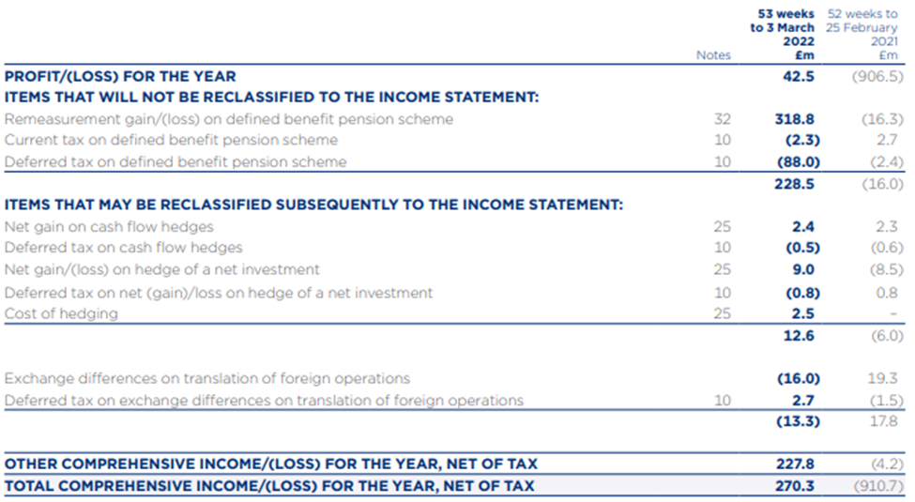

Appendix 4: : Income Statement of 2023 and 2024
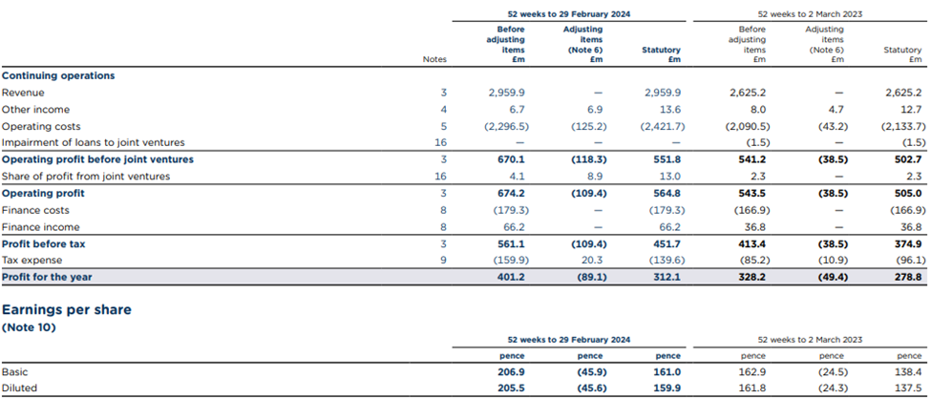

Appendix 5: Income Statement of 2025


