Lab – Understanding Ethernet Cable Standards
Topology
Addressing Table
Device | Interface | IP Address | Subnet Mask | Default Gateway
PC-A | NIC | 192.168.10.1 | 255.255.255.0 | N/A
PC-B | NIC | 192.168.10.2 | 255.255.255.0 | N/A
Objectives
Part 1: Analyze Ethernet Cabling Standards and Pinouts
Part 2: Build an Ethernet Crossover Cable
Part 3: Test an Ethernet Crossover Cable
Background / Scenario
In this lab, you will build and terminate an Ethernet crossover cable and test it by connecting two PCs together and pinging between them. You will first analyze the Telecommunications Industry Association/Electronic Industries Association (TIA/EIA) 568-A and 568-B standards and how they apply to Ethernet cables. You will then construct an Ethernet crossover cable and test it. Finally, you will use the cable you just constructed to connect two PCs together and test it by pinging between them.
Note: With autosensing capabilities available on many devices, such as the Cisco 1941 Integrated Services Router (ISR) switch, you may see straight-through cables connecting like devices.
Required Resources
- One length of cable, either Category 5 or 5e. Cable length should be 0.6 to 0.9m (2 to 3 ft.)
- 2 RJ-45 connectors
- RJ-45 crimping tool
- Wire cutter
- Wire stripper
- Ethernet cable tester (optional)
- 2 PCs (Windows 7 or 8)
- Analyze Ethernet Cabling Standards and Pinouts
The TIA/EIA has specified unshielded twisted pair (UTP) cabling standards for use in LAN cabling environments. TIA/EIA 568-A and 568-B stipulates the commercial cabling standards for LAN installations; these are the standards most commonly used in LAN cabling for organizations and they determine which color wire is used on each pin.
With a crossover cable, the second and third pairs on the RJ-45 connector at one end of the cable are reversed at the other end, which reverses the send and receive pairs. The cable pinouts are the 568-A standard on one end and the 568-B standard on the other end. Crossover cables are normally used to connect hubs to hubs or switches to switches, but they can also be used to directly connect two hosts to create a simple network.
Reflection:
Write a research report (Max word count 600) on Cat 5e and 6 Ethernet cable standards.

Research Report Relating to Cat 5e and Cat 6 Cable Standards

What is Cat 5e Cable

Category 5 Enhanced or Cat 5e is a 4 unshielded twisted paired (UTP) coppered wire cable, for use in LAN cabling environments. A network cable with the performance capability of 100-250MHZ frequency, 10 BASE fast Ethernet, 1000 BASE Gigabit Ethernet and can be used to the maximum length of 100M (Burjiz K. Soorty, 2010). Cat 5e has twists of between 1 ½ to 2 twists per CM and is the most common used cable residentially and commercially due to the price, it is the least expensive out of the two (Burjiz K. Soorty, 2010).

What is Cat 6 Cable

Category 6 is an unshielded twisted pair (UTP) cable. A four-pair copper cable with the capability of bandwidths of gigabit speeds. It has a 250 MHZ minimum frequency and a 500MHZ maximum frequency which uses a thicker-gauge wire, this enable the capability of 100 BASE-T Fast ethernet, 1000 BASE-T Gigabit ethernet and 10G BASE-T 10 Gigabit ethernet, it has a reduced maximum length of 55 metres for the 10 Gigabit ethernet. The Cat 6 Ethernet cable has splines which separate the twisted paired wires which makes it thicker and more rigid, it has increased cable shielding. The cables are twisted more per CM reducing the noise and interferences of the signal [2].

In comparison Cat 5e and Cat 6 Ethernet cables are both Unshielded twisted pair, they are both copper wires, they both have the same colour code wires green, orange, blue and brown.
A twisted cable has the advantages of reducing electromagnetic interferences (EMI), external magnetic radiation and crosstalk between wires, these unwanted signals are cancelled out between internal and external wires.
As shown in fig 1 Cat 6 has a reduced Attenuation which indicates lower crosstalk and electrical interferences, has a better shield against Nearside crosstalk (NEXT), PS-NEXT, EL-FLEXT and the PS-ELFLEXT when tested at 100Mhz. this shows that the Cat6 cable has less cross talk and electromagnetic interferences enabling it to transfer more data and reduce noise [3].

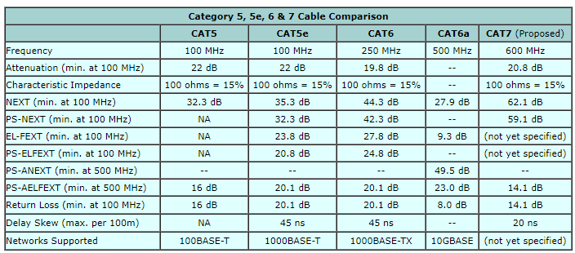
[4] Fig 1 Table of Cable category standards
To conclude both Cat 5e and Cat 6 network cables are both unshielded four twisted paired copper wires, which reduce electromagnetic interferences and crosstalk between internal and external wires, both use the RJ45 connectors, both support the Gigabit network and both cables are can be used on older equipment.
Cat 5e is more commonly used in residential homes and small business as it is a lot cheaper to buy and has a maximum cable range of 100M to achieve 1Gbps and 100-250Mhz.
Where Cat 6 is better for larger commercial businesses. It is more expensive, has a maximum cable range of 100M to achieve 250-500Mhz when supporting 10 Gbps, it is faster, has less errors and can transport more data with significantly lower signal noise and interferences [3] [4].

Reference list

References

[1] | e. a. Burjiz K. Soorty, “Performance Comparison of Catorgory 5e vs Catorgory 6 Cabling Systems for both IPv6 in Gigabit Ethernet,” 16 September 2010. [Online]. Available: Performance Comparison of Category 5e vs. Category 6 Cabling Systems for both IPv4 and IPv6 in Gigabit Ethernet. [Accessed 12 November 2019].
[2] | P. T. USA, “KNOW YOUR CATS,” 20 February 2016. [Online]. Available: https://planetechusa.com/demystifying-ethernet-types-difference-between-cat5e-cat-6-and-cat7/. [Accessed 20 November 2019].
[3] | MULTICOM.INC, “Cat5 vs Cat6 Cable,” 2019. [Online]. Available: https://www.multicominc.com/training/technical-resources/cat5-vs-cat6-cable/. [Accessed 21 November 2019].
[4] | CABLEK INDUSTRIES, “category 5, 5e, 6, 6a and 7 cable standards,” 2019. [Online]. Available: http://www.cablek.com/technical-reference/cat-5---5e--6--6a---7--8-standards. [Accessed 20 November 2019].

  - Analyze diagrams and tables for the TIA/EIA 568-A standard Ethernet cable.
The following table and diagrams display the color scheme and pinouts, as well as the function of the four pairs of wires used for the 568-A standard.
Note: In LAN installations using 100Base-T (100 Mb/s), only two pairs out of the four are used.
568-A 10/100/1000Base-TX Ethernet
Pin Number | Pair Number | Wire Color | 10Base-T Signal  100Base-TX Signal | 1000Base-T Signal
1 | 2 | White/Green | Transmit | BI_DA+
2 | 2 | Green | Transmit | BI_DA-
3 | 3 | White/Orange | Receive | BI_DB+
4 | 1 | Blue | Not Used | BI_DC+
5 | 1 | White/Blue | Not Used | BI_DC-
6 | 3 | Orange | Receive | BI_DB-
7 | 4 | White/Brown | Not Used | BI_DD+
8 | 4 | Brown | Not Used | BI_DD-

The following diagrams display how the wire color and pinouts align with an RJ-45 jack for the 568-A standard.
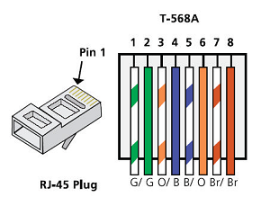
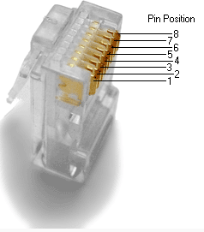
  - Analyze diagrams and tables for the TIA/EIA 568-B standard Ethernet cable.
The following table and diagram display the color scheme and pinouts for the 568-B standard.
568-B 10/100/1000-BaseTX Ethernet
Pin Number | Pair Number | Wire Color | 10Base-T Signal  100Base-TX Signal | 1000Base-T Signal
1 | 2 | White/Orange | Transmit | BI_DA+
2 | 2 | Orange | Transmit | BI_DA-
3 | 3 | White/Green | Receive | BI_DB+
4 | 1 | Blue | Not Used | BI_DC+
5 | 1 | White/Blue | Not Used | BI_DC-
6 | 3 | Green | Receive | BI_DB-
7 | 4 | White/Brown | Not Used | BI_DD+
8 | 4 | Brown | Not Used | BI_DD-
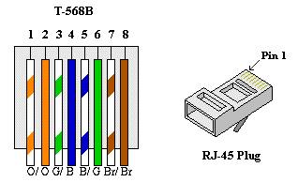

- Build an Ethernet Crossover Cable
A crossover cable has the second and third pairs on the RJ-45 connector at one end, reversed at the other end (refer to the table in Part 1, Step 2). The cable pinouts are the 568-A standard on one end and the 568-B standard on the other end. The two following diagrams illustrate this concept.
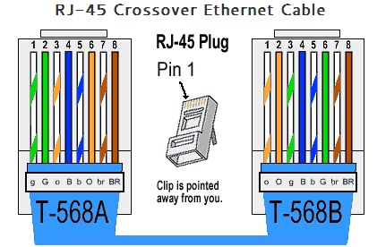
  - Build and terminate a TIA/EIA 568-A cable end.
    - Determine the cable length required. (Your instructor will let you know the cable length you should make.)
Note: If you were making a cable in a production environment, the general guideline is to add another 12 in. (30.48 cm) to the length.
    - Cut off a piece of cable to the desired length and using your wire stripper, remove 5.08 cm (2 in.) of the cable jacket from both ends.
    - Hold the four pairs of twisted cables tightly where the jacket was cut away. Reorganize the cable pairs into the order of the 568-A wiring standard. Refer to the diagrams, if necessary. Take as much care as possible to maintain the twists in the cable; this provides noise cancellation.
    - Flatten, straighten, and line up the wires using your thumb and forefinger.
    - Ensure that the cable wires are still in the correct order for the 568-A standard. Using your wire cutters, trim the four pairs in a straight line to within 1.25 to 1.9 cm (1/2 to 3/4 in.).
    - Place an RJ-45 connector on the end of your cable, with the prong on the underside pointing downward. Firmly insert the wires into the RJ-45 connector. All wires should be seen at the end of the connector in their proper positions. If the wires are not extending to the end of the connector, take the cable out, rearrange the wires as necessary, and reinsert the wires back into the RJ-45 connector.
    - If everything is correct, insert the RJ-45 connector with cable into the crimper. Crimp down hard enough to force the contacts on the RJ-45 connector through the insulation on the wires, thus completing the conducting path. See the following diagram for an example.
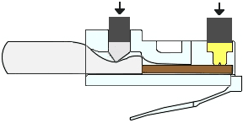
  - Build and terminate a TIA/EIA 568-B cable end.
Repeat steps 1a to 1g using the 568-B color wiring scheme for the other end.
- Test an Ethernet Crossover Cable
  - Test the cable.
Many cable testers will test for length and mapping of wires. If the cable tester has a wire map feature, it verifies which pins on one end of the cable are connected to which pins on the other end.
If your instructor has a cable tester, test the crossover cable for functionality. If it fails, check with your instructor first as to whether you should re-cable the ends and re-test.
  - Connect two PCs together via NICs using your Ethernet crossover cable.
    - Working with a lab partner, set your PC to one of the IP addresses shown in the Addressing Table (see page 1). For example, if your PC is PC-A, your IP address should be set to 192.168.10.1 with a 24-bit subnet mask. You partner’s IP address should be 192.168.10.2. The default gateway address can be left empty.
    - Using the crossover cable you made, connect the two PCs together via their NICs.
    - On the PC-A command prompt, ping the PC-B IP address.
Note: The Windows firewall may have to be temporarily disabled for pings to be successful. If the firewall is disabled, make sure you re-enable it at the conclusion of this lab.
    - Repeat the process and ping from PC-B to PC-A.
Assuming IP addressing and firewall are not issues, your pings should be successful if the cables were properly made.
Reflection
  - Which part of making cables did you find the most difficult?
Ensuring that the wires stay in place when you push them in, and remembering to order of the colours of the wires _______________________________________________________________________________________
  - Why do you have to learn how to make a cable if you can easily buy pre-made cables?
To help understand how cables work, how they are put together and you can make longer cables if you need. _______________________________________________________________________________________

