
Student Name | Prathamkumar Himmatlal Solanki
Student ID | 2430951
Programme | MSc Public Health and Social Care in Practice
Module | Practice-Based Research
Module code | LCHS7008
Lecturer | Dr Diola Bijlhout
Assignment Title | Component 2  Written Research Proposal
Word Count | 2507

Table of Contents
Research Title 3
Problem Statement 3
Introduction 4
Rationale 5
Research Question, Aim and Objectives 6
Research Methodology 7
Ethical Considerations 10
Implication of Research 10
Plan of Work and Time Schedule 11
References 13

Research Title
The impact of pulmonary rehabilitation on quality of life and hospital readmission rates in patients with Chronic Obstructive Pulmonary Disease (COPD) in the UK: Systematic Review

Problem Statement
Chronic Obstructive Pulmonary Disease or COPD is the fourth cause of death globally (Wang et al., 2025). As of 2021, over 3.5 million global deaths occurred due to COPD where patients experience breathing difficulties or chronic lung infections (WHO, 2024). The prevalence rate of COPD in the UK has rapidly increased due to high smoking rates and occupational exposure.
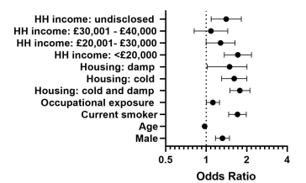
Figure 1: Socioeconomic factors are related with COPD
(Source: Williams et al., 2022)
According to Figure 1, multiple socioeconomic factors are responsible for increasing the prevalence rate of COPD in the UK over the past decade. The existence of poor housing quality to low income and past occupational exposure are correlated with the high prevalence of this long-term illness and increase the hospitalisation rate (Williams et al., 2022). A total number of 6000 people are living with this chronic disease where nearly 4000 patients suffer from acute attacks (severe coughing or breathlessness) in a year. It is found that structural inequality is the primary concern for the UK people who not only live in damp houses but also are low paid in the society (Respiratory Therapy, 2022). Conversely, 2.1 million people living with undiagnosed COPD in the world where societal and economic burden mostly affects their clinical treatment and increases mortality rate. The high medication cost to access advanced treatments hinders accessibility for the general population based on the required emergency care or hospitalisation. Due to this limitation and lack of social support create significant barriers for patients to access COPD treatments in the UK (Wright et al., 2022).
Besides low socio-economic status, delay of clinical intervention or early diagnosis highlights the presence of a lack of integrated care in the healthcare setting. It emphasises that the delay in contracting with healthcare professionals is another burden for COPD patients to access primary care services in a timely manner (Anzueto, Hoy and Gainer, 2025). Therefore, to reduce the prevalence rate of COPD among patients in the UK, the pulmonary rehabilitation programme is an effective way. It not only provides comprehensive care to people but also contributes to reducing the rate of hospital readmission along with promoting psychological well-being (Anzueto, Hoy and Gainer, 2025).

Introduction
Background of the study
As a progressive and chronic illness COPD significantly increases the health crisis in the UK where older people are mostly affected who are over the age of 40. Alternatively, people under 40 years old are diagnosed with this illness due to the deficiency of alpha-1 antitrypsin and experience early-onset bronchitis (Stone et al., 2023). This significant impairment of lung function requires structured intervention for managing symptoms and reducing the hospital readmission rate of patients. It is identified that aged between 40 to 70 years of COPD patients' health conditions are associated with high risks of hospital admission and mortality (Hanlon et al., 2022). It evaluates poor health outcomes and highlights patients' extrapulmonary complications including muscle weakness or osteoporosis that may indicate frailty (Sansbury et al., 2022).
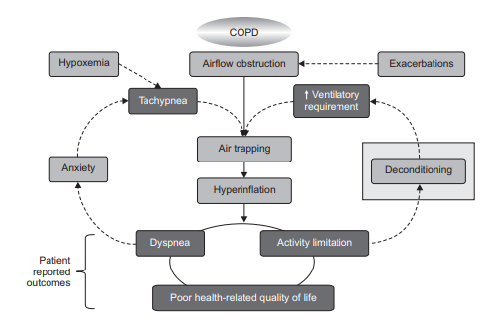
Figure 2: Poor health-related outcomes experienced by COPD patients
(Source: Arnold, Dolezal and Cooper, 2020)
It needs a structured based clinical intervention pulmonary rehabilitation (PR) for treating the illness of COPD. PR is primarily reflected as a comprehensive clinical intervention which helps to offer patient-tailored therapies for treating patients with chronic conditions who are diagnosed with COPD along with contributing to improve physical and psychological well-being (Arnold, Dolezal and Cooper, 2020). According to the Timing Theory, targeted clinical intervention needs to assess patient condition for understaging their physical health and positively influence their negative behaviour and emotions into better health outcomes. Therefore, as a multidisciplinary intervention, PR significantly improves patients' quality of life and decreases hospital readmissions by lowering chronic exacerbations (Han et al., 2023).

Rationale
The PR significantly helps to reduce hospital readmission rates through improving the quality of life of the COPD patients by enhancing their breath capacity and reducing anxiety. This study intends to justify the impact of PR on the quality of life and the hospital readmission rate of patients due to COPD. Stone et al. (2022), stated that COPD is the second most frequent lung disorder in the UK, with a diagnosis of around 1.2 million individuals, which results in the expense of £1.8 billion annually. However, understanding the importance of the PR will be helpful for the patients to improve their quality of life and reduce the chances of hospital readmission. This will be helpful for them to save money in this cost-of-living crisis situation in the UK (Fleg et al., 2020).
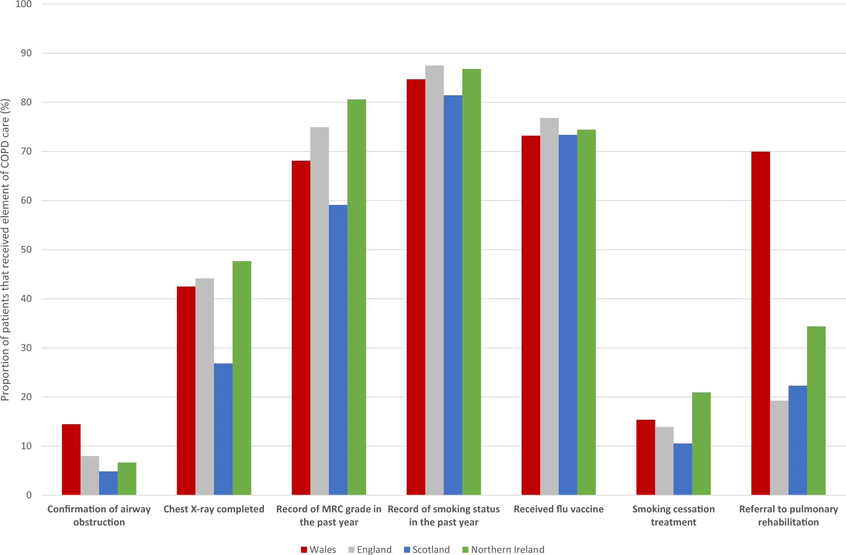
Figure 3: The proportion of patients getting COPD care key items in Welsh, English, Scottish, and Northern Irish practices in CPRD GOLD
(Source: Stone et al., 2022)
In the view of Dayana et al. (2026), it is derived that the PR is the most effective solution for the improvement of the muscular function, diminishing the dyspnea, and ultimately improving endurance in the physical activities.
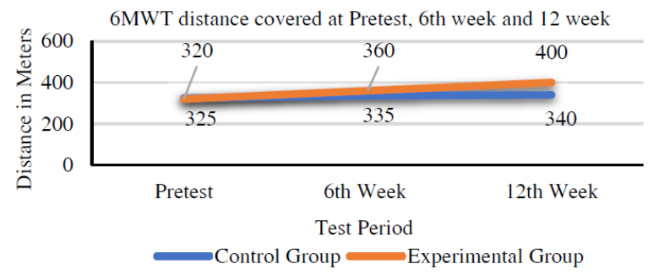
Figure 4: The walk test performance
(Source: Dayana et al., 2026)
Additionally, the walk test performance by Dayana et al. (2026), reveals that PR significantly improves the lung function and endurance of individuals with COPD. Therefore, from the overall statement, it can be summarised that through acknowledging the importance of PR for COPD patients, this study fortifies the necessity of PR for every individual in the UK, as only 1 in 10 individuals receive PR in their need in recent times (Liu et al.,2018). Hence, this will be helpful to improve their quality of life and reduce their hospital readmission.

Research Question, Aim and Objectives
Research Question
How does pulmonary rehabilitation impact quality of life and hospital readmission rates among UK patients with COPD?
Research Aim
To evaluate the clinical effectiveness of pulmonary rehabilitation to improve the quality of life and reduce hospital readmissions of patients diagnosed with COPD.
Research Objectives
- To critically analyse rehabilitation programmes impact on people with COPD in the UK.
- To measure the effectiveness of pulmonary rehabilitation in improving patients' quality of life by using clinical tools, the CAT score and the St George’s Respiratory Questionnaire.
- To examine whether pulmonary rehabilitation reduces hospital readmissions within 6 to 12 months after treatment.
- To identify the barriers or influential factors for patients in taking part in pulmonary rehabilitation programmes in the UK.

Research Methodology
Conceptual Framework
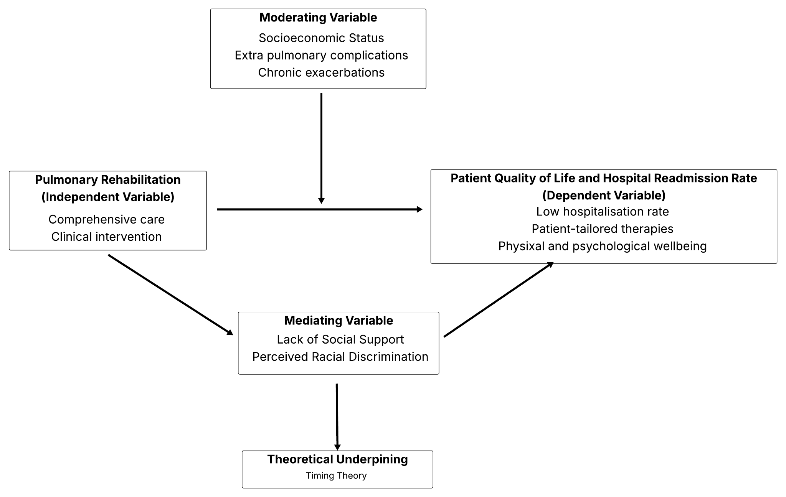
Figure 5: Conceptual Framework
(Source: Self-created)
According to Figure 5, it is outlined that the independent variable is pulmonary rehabilitation whereas the dependent variables are COPD patients’ quality of life and the hospital readmission rate (Lu et al., 2023). The conceptual figure outlined that to improve patients' quality of life and reduce hospital readmission rate in the UK healthcare setting, PR intervention is an effective way to combat COPD. However, several socioeconomic burdens create barriers (social stigma, lack of social support, high medication cost and others) for the patients to access equitable care services which increase the chronic illness prevalence rate and adversely affect their quality of life (Pleasants, Riley and Mannino, 2016). Hence, the overall discussion demonstrates that the illness rapidly increases patient mortality rate in the UK who are diagnosed with chronic exacerbations.
Research Design
The systematic review or systematic literature review (SLR) will be used in this study for illustrating pulmonary rehabilitation program effectiveness in improving patients' quality of life and hospital readmission rate of COPD patients in the UK. As discussed by Lame (2019), for synthesising scientific evidence of health science the research will outline the clinical intervention of PR to diagnose health conditions of COPD patients. As well as, identifying barriers and influential factors of the PR intervention through assessment of evidence-based outcomes.
Focusing on the evidence-based practice, PICO is used to formulate the research question in order to research PR intervention’s impact on patients' quality of life and hospital readmission for treating COPD within the UK healthcare context (Eriksen and Frandsen, 2018). Therefore, by using the PICO framework, the formulated research question will be demonstrated below.
Population (P): Patients with Chronic Obstructive Pulmonary Disease (COPD)
Intervention (I): Pulmonary rehabilitation programs
Comparison (C): Usual care (No rehab, Community Care)
Outcome (O): Quality of life and Hospital readmission rate
“What is the impact of pulmonary rehabilitation, compared to usual care in improving quality of life and hospital readmission rates among patients with Chronic Obstructive Pulmonary Disease (COPD) in the UK?”.
Data Collection Method
Within the context of SLR, the Systematic Review and Meta-Analyses will be used as a data collection method. It will be used for analysing the findings of PR impact in improving COPD patients’ quality of life and reducing hospitalisation rates in the UK. According to the PRISMA guidelines, before conducting the systematic review of this study the researcher will screen all collected sources and remove outdated or duplicate information. Thereafter, synthesise relevant articles which will meet review criteria and evaluate the most beneficial outcomes related to PR intervention clinical effectiveness for treating COPD in the UK (Parums, 2021). Hence, the synthesised information will produce evidence-based outcomes and will enhance the review's reliability within the research context.
Data Sources
To search information related to the pulmonary rehabilitation program impact for improving COPD diagnosed patients’ quality of life and the hospital readmission rate from different databases which are ScienceDirect, PubMed and Google Scholar.
Selection Criteria
Search Terms
For searching the impact of PR for treating illness of COPD and improving patients’ quality of life some keywords will be used and discussed below through the boolean operators.
Boolean Operators | AND | “Rehabilitation” AND “COPD”, “Exercise Training” AND “Health Status”
Boolean Operators | OR | “Hospitalisation” OR “Readmission”, "Pulmonary Rehabilitation" OR "Rehabilitation Programs"
Boolean Operators | NOT | NOT Other Chronic Diseases
Table 1: Boolean Operators
(Source: Self-created)
Time Frame
Collected journal articles will be published within the previous 10 years and considering the impact of pulmonary rehabilitation for improving COPD patients’ quality of life as well as focusing on the UK healthcare environment. Therefore, the study will discuss whether PR’s clinical effectiveness works or not to reduce hospital rates of COPD patients.
Inclusion and Exclusion Criteria
Criteria | Inclusion | Exclusion
Types of Publication | Peer-reviewed journal articles and Books | Non peer-reviewed sources (Blogs, Magazines, Editorial contents)
Text Availability | Full text article | Only availability of abstract
Methodological Implication | Empirical research context (Qualitative and Quantitative)  Systematic Reviews | Master thesis, Doctoral dissertation
Time-period | 2016 to 2026 | Before 2016
Language | Only English | Non-English
Table 2: Identification of inclusion and exclusion criteria
(Source: Self-created)
Data Analysis Technique
Based on the design of a systematic review, the thematic analysis will emphasise and evaluate qualitative discussion related to pulmonary rehabilitation impact on COPD patients' quality of life and hospital readmission rates in the UK. For this qualitative study, the analysis provides an in-depth insight regarding PR intervention effects on COPD patients' hospital readmission and leading a quality life for a long time (Christou, 2022). Therefore, the researcher will be able to make the study context-based themes and synthesise the required information through the philosophical underpinnings. However, the dependency of subjectivity may produce biased outcomes for the research which may highlight the adverse impact of PR intervention for supporting COPD patients' physical and mental wellness (Javadi and Zarea, 2016).

Ethical Considerations
Ethical considerations are the fundamental pillar of a research, which upholds the acceptability and integrity of the study. In this research, the confidentiality and anonymity of the information will be maintained to uphold the trustworthiness of the research. Through adhering to the ethical consideration, this study will maintain the validity and reliability of the findings (Nii Laryeafio and Ogbewe, 2023). Additionally, the citation and references will be properly given to maintain the integrity and the honesty of the research (Santini, 2018). Moreover, the General Data Protection Regulation (GDPR) 2018 will be maintained in this study to ensure the fair and lawful use of the information and to protect data. Furthermore, data manipulation will be excluded from the study to prevent misleading results and maintain ethical standards. Additionally, no decision will be based on the perspective of one author, to prevent bias in the study (Baldwin et al., 2022). Hence, through adhering to these dynamics in this study, the study will seek to maintain accountability of the information presented and uphold transparency.

Implication of Research
The present research emphasises the impact of pulmonary rehabilitation on measuring the clinical effectiveness of UK people (who are diagnosed with COPD) quality of life and decreasing hospital readmission rate. Focusing on the existing literature synthesis through SLR, the research will highlight the prevalence rate of COPD and its adverse impact on the UK population. As per the discussion of Zhang et al. (2022), the pulmonary rehabilitation program significantly improves the exercise capacity of patients and encourages them to lead a quality of life through psychological well-being. This refinement will help to enhance healthcare professionals' knowledge regarding patient assessment and transform their negative long-term behavioural issues into positive attributes.
Additionally, Nici (2021) stated that after participation in PR programmes, patients get relief from rehospitalisation or receive medication benefits to treat COPD exacerbation. It is optimised that after completion of the PR intervention course, the patient hospitalisation rate is reduced. Therefore, the study insight will help to improve patient-centered outcome of the UK healthcare setting along with addressing socioeconomic disparities for the future research. It will not only build the best healthcare practice for enhancing patients' quality of life but also decrease financial constraints in the healthcare system.
However, the over-reliance on pulmonary functions or improper clinical diagnosis increases the life risk of patients and globally enhances the mortality rate (Al Wachami et al., 2024). Therefore, quality care is important to minimise poor healthcare practices and improve patient quality of life through effective care such as early diagnosis, and the design of smoking cessation programs. Lastly, making patient-centred policy will be the most suitable healthcare intervention to assess patient health conditions and deliver them the required quality care to treat COPD (Singh et al., 2023).

Plan of Work and Time Schedule
Focusing on a well-structured roadmap, the present study intends to be completed within a timeline where the Gantt chart is used for managing project tasks in a timely manner. As a project management tool, Gantt charts will not only facilitate the project manager to complete every task within the allotted schedule but also measure progress individually (Jordan, 2026).

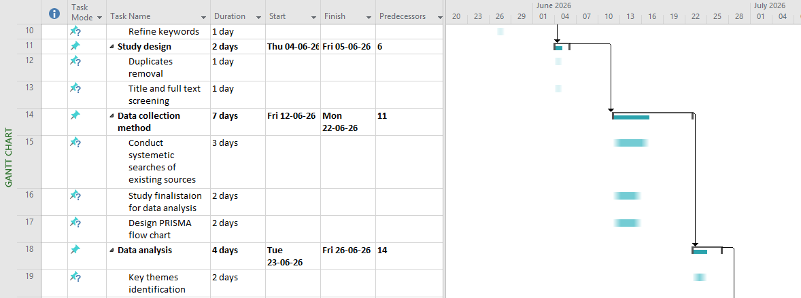
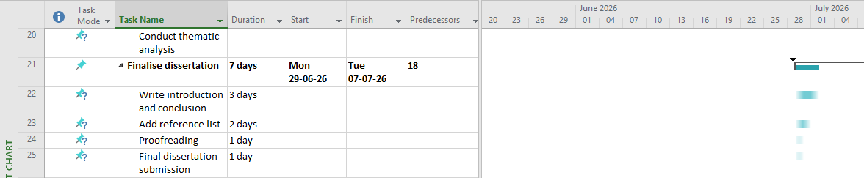
Figure 6: Gantt Chart
(Source: Self-created)
Figure 6 outlines that the entire research will take nearly two months to complete and analyse the final outcomes related to the PR intervention impact of COPD patients’ quality life and their readmission to hospitals in the UK healthcare setting. Within the research context, multiple stages including “Development of Proposal”, “Designing of Literature Search”, “Study design”, “Data collection method and analysis” along with “Finalise dissertation”. For maintaining methodological implication, the PICO framework will be used for developing the research question and synthesising required searches through proper planning and collecting sources for in-depth discussion over the effect of pulmonary rehabilitation on COPD patients' health conditions in the UK.

References
Al Wachami, N., Guennouni, M., Iderdar, Y., Boumendil, K., Arraji, M., Mourajid, Y., Bouchachi, F.Z., Barkaoui, M., Louerdi, M.L., Hilali, A. and Chahboune, M. (2024) ‘Estimating the global prevalence of chronic obstructive pulmonary disease (COPD): a systematic review and meta-analysis’, BMC Public Health, 24(1), p.297. Available at: https://doi.org/10.1186/s12889-024-17686-9
Anzueto, A., Hoy, H. and Gainer, C. (2025) ‘Challenges and opportunities for the management of COPD: a narrative review of patient and health care professional perspectives’, Chronic Obstructive Pulmonary Diseases: Journal of the COPD Foundation, 12(4), p.339. Available at: https://doi.org/10.15326/jcopdf.2024.0597
Arnold, M.T., Dolezal, B.A. and Cooper, C.B. (2020) ‘Pulmonary rehabilitation for chronic obstructive pulmonary disease: highly effective but often overlooked’, Tuberculosis and respiratory diseases, 83(4), p.257. Available at: https://doi.org/10.4046/trd.2020.0064
Baldwin, J.R., Pingault, J.B., Schoeler, T., Sallis, H.M. and Munafò, M.R., (2022) ‘Protecting against researcher bias in secondary data analysis: challenges and potential solutions’, European journal of epidemiology, 37(1), pp.1-10. Available at: 10.1007/s10654-021-00839-0
Christou, P.A. (2022) ‘How to use thematic analysis in qualitative research’, Journal of Qualitative Research in Tourism, 3(2), pp.79-95. Available at: doi: 10.4337/jqrt.2023.0006 (Accessed: 16 April 2026).
Dayana, B.A.A., Kamal, S. and Thenmozhi, P. (2026) ‘Impact of Pulmonary Rehabilitation (PR) on Functional Exercise Capacity among Chronic Obstructive Pulmonary Disease (COPD) Patients: Pilot Study’, Journal of Pioneering Medical Sciences, 14, pp.15-19. Available at: https://doi.org/10.47310/jpms2025141203 (Accessed: 16 April 2026).
Eriksen, M.B. and Frandsen, T.F. (2018) ‘The impact of patient, intervention, comparison, outcome (PICO) as a search strategy tool on literature search quality: a systematic review’, Journal of the Medical Library Association: JMLA, 106(4), p.420. Available at: DOI: dx.doi.org/10.5195/jmla.2018.345
Fleg, J.L., Keteyian, S.J., Peterson, P.N., Benzo, R., Finkelstein, J., Forman, D.E., Gaalema, D.E., Cooper, L.S., Punturieri, A., Joseph, L. and Shero, S. (2020) ‘Increasing use of cardiac and pulmonary rehabilitation in traditional and community settings: opportunities to reduce health care disparities’, Journal of cardiopulmonary rehabilitation and prevention, 40(6), pp.350-355. Available at: doi:10.1097/HCR.0000000000000527
Han, M., Fu, Y., Ji, Q., Deng, X. and Fang, X. (2023) ‘The effectiveness of theory-based smoking cessation interventions in patients with chronic obstructive pulmonary disease: a meta-analysis’, BMC Public Health, 23(1), p.1510. Available at: https://doi.org/10.1186/s12889-023-16441-w
Hanlon, P., Lewsey, J., Quint, J.K., Jani, B.D., Nicholl, B.I., McAllister, D.A. and Mair, F.S. (2022) ‘Frailty in COPD: an analysis of prevalence and clinical impact using UK Biobank’, BMJ open respiratory research, 9(1). Available at: http://dx.doi.org/10.1136/bmjresp-2022-001314
Javadi, M. and Zarea, K. (2016) ‘Understanding thematic analysis and its pitfall’, Journal of client care, 1(1), pp.33-39.
Jordan, K. (2026) Project planning.
Lame, G. (2019) ‘Systematic literature reviews: An introduction. In Proceedings of the design society: international conference on engineering design (Vol. 1, No. 1, pp. 1633-1642)’, Cambridge University Press. Available at: DOI:10.1017/ dsi.2019.169
Liu, Y., Dickerson, T., Early, F., Fuld, J. and Clarkson, P.J. (2018) ‘Understanding influences on the uptake of pulmonary rehabilitation in the East of England: an Inclusive Design/mixed-methods study protocol’, BMJ open, 8(4), p.e020750. Available at: 10.1136/bmjopen-2017-020750
Lu, H.Y., Chen, C.F., Lee, D.L., Tsai, Y.J. and Lin, P.C. (2023) ‘Effects of early pulmonary rehabilitation on hospitalized patients with acute exacerbation of chronic obstructive pulmonary disease: a systematic review and meta-analysis’, International Journal of Chronic Obstructive Pulmonary Disease, pp.881-893. Available at: https://doi.org/10.2147/COPD.S397361
Nici, L. (2021) ‘Pulmonary rehabilitation after a chronic obstructive pulmonary disease exacerbation: impact on readmission risk in a real-world setting’, American journal of respiratory and critical care medicine, 204(9), pp.1005-1006. Available at: https://doi.org/10.1164/rccm.202107-1768ED
Nii Laryeafio, M. and Ogbewe, O.C. (2023) ‘Ethical consideration dilemma: systematic review of ethics in qualitative data collection through interviews’, Journal of Ethics in Entrepreneurship and Technology, 3(2), pp.94-110. Available at: http://dx.doi.org/10.1108/JEET-09-2022-0014
Parums, D.V. (2021) ‘Review articles, systematic reviews, meta-analysis, and the updated preferred reporting items for systematic reviews and meta-analyses (PRISMA) 2020 guidelines’, Medical science monitor: international medical journal of experimental and clinical research, 27, pp.e934475-1. Available at: DOI: 10.12659/MSM.934475
Pleasants, R.A., Riley, I.L. and Mannino, D.M. (2016) ‘Defining and targeting health disparities in chronic obstructive pulmonary disease’, International journal of chronic obstructive pulmonary disease, pp.2475-2496. Available at: https://doi.org/10.2147/COPD.S79077
Respiratory Therapy (2022) COPD: Damp Housing Driving Lung Disease Deaths. Available at: https://respiratory-therapy.com/disorders-diseases/chronic-pulmonary-disorders/copd/copd-and-damp-housing/#:~:text=A%20survey%20of%20nearly%206%2C000,worsening%20exacerbations%2C%20noted%20study%20authors. (Accessed: 16 April 2026).
Sansbury, L.B., Lipson, D.A., Bains, C., Anley, G.A., Rothnie, K.J. and Ismaila, A.S. (2022) ‘Disease burden and healthcare utilization among patients with chronic obstructive pulmonary disease (COPD) in England’, International Journal of Chronic Obstructive Pulmonary Disease, pp.415-426. Available at: https://doi.org/10.2147/copd.s336158
Santini, A. (2018) ‘The importance of referencing’, The Journal of Critical Care Medicine, 4(1), p.3. Available at: 10.1515/jccm-2018-0002
Singh, D.N., Kaur, H., Roy, S., Juvekar, S., Pinnock, H. and Agarwal, D. (2023) ‘Needs assessment for introducing pulmonary rehabilitation for chronic obstructive pulmonary disease management in a rural Indian setting: a qualitative study’, BMJ Open Respiratory Research, 10(1). Available at: https://doi.org/10.1136/bmjresp-2023-001696
Stone, P.W., Hickman, K., Holmes, S., Feary, J.R. and Quint, J.K. (2022) ‘Comparison of COPD primary care in england, scotland, wales, and northern Ireland’, Npj Primary Care Respiratory Medicine, 32(1), p.46. Available at: https://doi.org/10.1038/s41533-022-00305-8
Stone, P.W., Osen, M., Ellis, A., Coaker, R. and Quint, J.K. (2023) ‘Prevalence of chronic obstructive pulmonary disease in England from 2000 to 2019’, International Journal of Chronic Obstructive Pulmonary Disease, pp.1565-1574. Available at: https://doi.org/10.2147/COPD.S411739
Wang, X., Gou, A., Wang, J., Li, J. and Gou, C. (2025) ‘Global trends and future projections of COPD burden under low-temperature risk: a 1990–2041 analysis based on GBD 2021’, BMC Pulmonary Medicine, 25(1), p.403. Available at: https://doi.org/10.1186/s12890-025-03811-w
WHO (2024) Chronic obstructive pulmonary disease (COPD). Available at: https://www.who.int/news-room/fact-sheets/detail/chronic-obstructive-pulmonary-disease-(copd) (Accessed: 16 April 2026).
Williams, P.J., Cumella, A., Philip, K.E.J., Laverty, A.A. and Hopkinson, N.S. (2022) ‘Smoking and socioeconomic factors linked to acute exacerbations of COPD: analysis from an Asthma+ Lung UK survey’, BMJ Open Respiratory Research, 9(1). Available at: http://dx.doi.org/10.1136/bmjresp-2022-001290 (Accessed: 16 April 2026).
Wright, A., Vioix, H., de Silva, S., Langham, S., Cook, J., Capstick, T. and Quint, J.K. (2022) ‘Cost–consequence analysis of COPD treatment according to NICE and GOLD recommendations compared with current clinical practice in the UK’, BMJ open, 12(6), p.e059158. Available at: http://dx.doi.org/10.1136/bmjopen-2021-059158
Zhang, H., Hu, D., Xu, Y., Wu, L. and Lou, L. (2022) ‘Effect of pulmonary rehabilitation in patients with chronic obstructive pulmonary disease: a systematic review and meta-analysis of randomized controlled trials’, Annals of medicine, 54(1), pp.262-273. Available at: https://doi.org/10.1080/07853890.2021.1999494

