

Programme: BA Business Management
Module: Managing People AS1
Module code: LCBB5004
Lecturer: Charles Oham

Student Name: Anastasia Slepuhin
Student ID: 2013044

Table of Contents
Introduction 3
Case in favor of adapting flexible and remote working forms 4
Diversity and inclusion 5
Optimized productivity 5
Increase in employee morale 7
Reduction in overhead costs 8
Enhanced employee retention 9
Role of Human Resource Management in promoting diversity and inclusion through flexible working 10
The case against adopting flexible and remote working forms 11
Conclusion 14
References 15

Introduction
The flexible forms of working have become very prevalent during the global pandemic of Covid-19 and almost all organizations had to adopt the forms of flexible and remote working. As a result, during the pandemic, the flexible and remote working forms had become very popular and the demand for such flexible working forms are expected to continue even in the post-pandemic period. A study by ACAS has already found that 55% of the employers are expecting an increase in the number of staff working through flexible or remote working forms in a part of the weeks while 49% of them are expecting an increase in the number of employees working in such flexible forms of workings all the week (Hunter, 2019). This indicates that a change in the working practices and preferences in working forms has come during the pandemic and research suggests that this will continue after the pandemic as well. While flexible and remote working forms bring several benefits and aids to the organizations, adding value to human resource management, it can have some negative impacts on employees and organizational operations as well.
In this report, cases both in favor of and against the flexible and remote working forms have been made assessing and evaluating the merits and demerits of such flexible working forms as a Human Resource Manager of a retail organization of the UK which is currently employing 1000 staff in different locations. For this purpose, a critical evaluation on the advantages of adopting flexible working forms in the organization has been made focusing on how it would promote diversity and inclusion. Moreover, the negative impacts that the adaptation of the flexible and remote working forms may have on human resource management operations have been assessed and analyzed in the report focusing on how it may cause inequality in the workplace.

Case in favor of adapting flexible and remote working forms
Remote working refers to the work form and practice where an employee can perform his/her jobs and duties from a location different than the central office which is operated by the employer while flexible working refers to the form of working where an employee can perform their jobs and duties in flexible hours and is not restricted to perform his/her jobs on a rigidly set schedule.
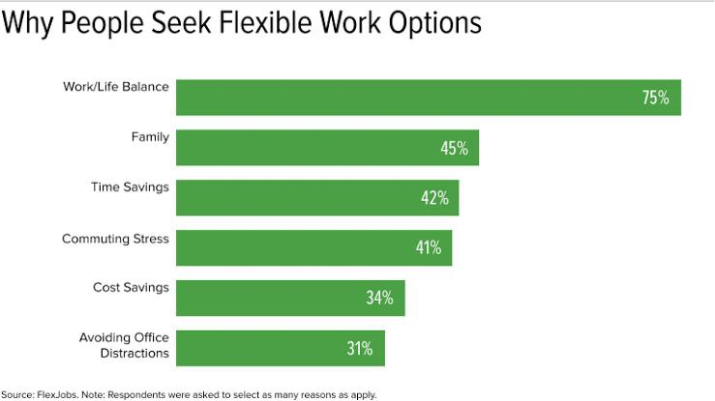
Figure 1: Why people seek flexible work options
Source: (Putra, et al, 2020)
Flexible working hours, compressed work schedule, job sharing, telecommuting, etc. (Soga, et al, 2022). are different forms of flexible and remote working. Such different forms of flexible working and remote working have been widely used during the pandemic situation and also were in use before that as the rise of industrialization increased its demand. But in the post-pandemic market, the demand for flexible working forms has reached its peak and studies also suggest that flexible and remote working forms can be highly beneficial for organizations and their human resource management if controlled implementation and regulations can be ensured (Putra, et al, 2020). Adopting flexible and remote working forms can be beneficial for this organization as well and the values that this can add to the organization have been addressed and discussed below.

Diversity and inclusion
- Flexible and remote working forms can highly assist in creating the values of diversity and inclusion in workplace culture. Flexible work forms encourage people with diversified characteristics and backgrounds to participate and allow them to hold a place in the organization (Shifrin, and Michel, 2021). For example, through adopting flexible and remote working forms, the organization can hire employees who may belong from a different nation and that employee can work and perform his/her duties without having to move to the central office of the organization. He/she can also perform the duties in flexible working hours using telecommunicating approaches.
- Not only for hiring skilled employees and staff from foreign nations, but flexible and remote working forms also encourages diversity through providing opportunities to individuals of different genders, age, and with fluctuating health conditions as well (Kahn, 2022). A study on the rising demand for flexible work settings has identified that the demand will boost geographical diversity and enhance inclusive participation of individuals from different genders, races and ethnicity by 72% and will also enhance participation of disabled peoples by 79% (Hunter, 2019). Based on such optimized values of diversity and inclusion, it has been identified that flexible and remote work forms shall be adopted by the organization for increasing diversity and inclusion which will ultimately assist in adding greater values to the organization.

Optimized productivity
Studies suggest that flexible work forms have had a significant positive impact on the productivity of the employees working under such forms. Flexible and remote forms of work settings assist and highly contributes to boosting the productivity of the employees.
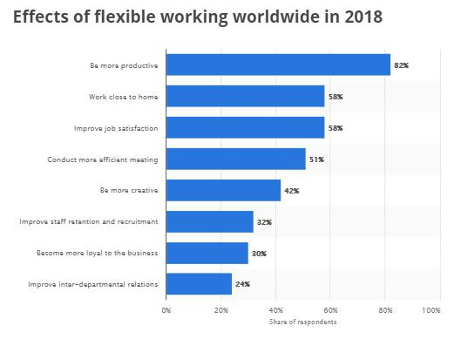
Figure 2: Effects of flexible working worldwide
Source: (Soga, et al, 2022)
As the above graph illustrates, research conducted in 2018 on the effects of flexible working worldwide has found that the most prominent effect of such work forms is that it makes the employees more productive as this the study has addressed that flexible working increased employee productivity by 82% (Soga, et al, 2022). Flexible working forms boosts employee productivity as it provides the employees the freedom to work according to their time preferences without having to follow any rigid schedule. Thus, it has been apprehended that flexible work forms shall be adapted in the organization to boost employee productivity and ensure integration of optimized efficiency in its operations through maintaining maximized productivity.

Increase in employee morale
Remote and flexible work settings have been proved to be playing a positive role in enhancing employee morale and improving job satisfaction as well. flexible and remote work settings increase the level of employee morale by reducing the level of stress and strengthening loyalty towards the organization.
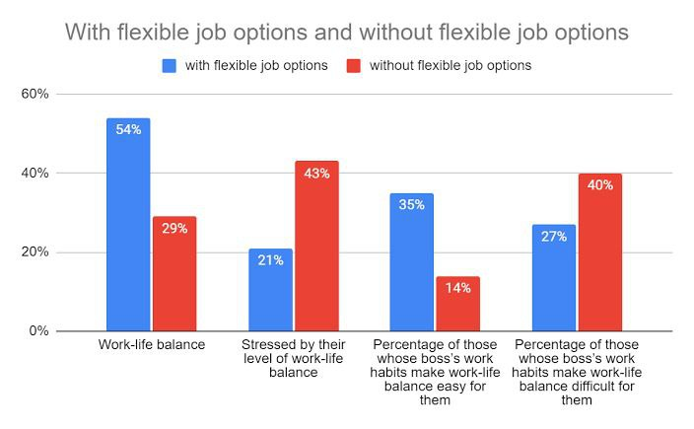
Figure 3: Effects of flexible job options
Source: (Shifrin, and Michel, 2021)
As the graph illustrates, 43% of employees without flexible job options suffer from stress by their level of work-life balance while only 21% suffer from the same problem with flexible job options which is comparatively very low (Shifrin, and Michel, 2021). Thus, it's evident that employees working in flexible work settings require to deal with low stress as they can keep a work-life balance through performing their duties at flexible times and this ultimately assists in increasing employee morale and their level of job satisfaction.

Reduction in overhead costs
Flexible and remote work settings contribute to decreasing the overhead costs of working space and also reduce the commuting time. It assists in reducing the overhead costs since, inflexible work settings, the employer doesn’t need to spend much on office space as a portion of the employees would work from home through remote workings (Sulaymonov, 2020). Moreover, it reduces costs since less equipment is required in such work settings and the employee’s travel costs also are reduced.
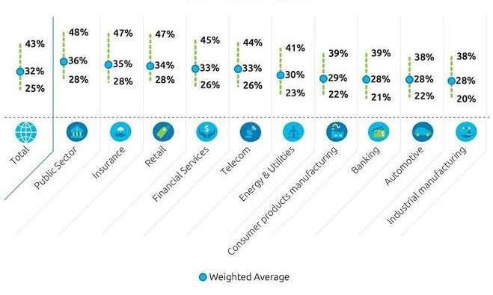
Figure 4: Cost savings from remote work arrangements
Source: (Davitkovski, et al, 2020)
As the above graph showcases, a range of costs are saved from adopting remote working such as the cost of insurance, financial services, energy, utilities, etc. In these multifaceted ways, adapting the flexible and remote work settings would assist the organization in attaining greater efficiency through reducing its overhead costs.

Enhanced employee retention
As flexible and remote work settings provide the employees with opportunities to maintain a better work-life balance, reduces the work-related stress of the employees, and provides them with the opportunity to work according to their preferred schedule rather than making them follow any rigid schedule, it makes the employees satisfied about their jobs which ultimately results in increased employee retention rate.
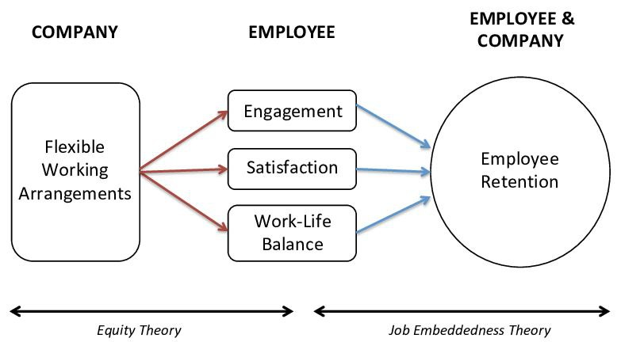
Figure 5: Effects of flexible working arrangements on employee retention
Source: (Putra, et al, 2020)
According to the equity and job embeddedness theory, flexible working arrangements positively affect employee engagement, employee satisfaction, and work-life balance which ultimately assists in enhancing employee retention which has been showcased above.
Based on the overall evaluation and assessment, it can be stated that the organization shall adopt flexible and remote working arrangements which will positively affect its human resources and generate greater values in the organization.

Role of Human Resource Management in promoting diversity and inclusion through flexible working
- As it has been evident from the discussion in the previous section, flexible working arrangements provide the opportunity of increasing diversity and inclusion in any organization through encouraging inclusive participation of individuals from diversified geographics or with diversified backgrounds such as race, ethnicity, etc.
- Though flexible and remote work arrangements facilitate the integration of the values of diversity and inclusion, Human Resource Management needs to play a significant role in this regard. (Putra, et al, 2020) For this purpose, HRM must ensure maintaining effective communication with all its employees whether they are working remotely or working in office-centric arrangements.
- It must also ensure equal treatment to all the staff and employees of the organization regardless of the work settings in which they might be working. In other words, the employees working remotely shall not encounter any unequal treatments in the organizations (Hunter, 2019). Finally, optimized employee engagement shall be ensured and for this purpose, the HR department authorities may conduct one-on-one meetings periodically and conduct employee surveys for the employees working in remote and flexible work settings to hear out their concerns and take actions accordingly (Shifrin, and Michel, 2021).
These roles played by HR would significantly assist in promoting diversity and inclusion in the organization through flexible and remote working and will also ensure capturing the optimized values and benefits from the adaptation of such forms.

The case against adopting flexible and remote working forms
Though flexible and remote working forms adds multifaceted values in an organization through boosting workforce productivity and optimizing the level of diversity and inclusion, it has some demerits as well and research suggests that one of the most crucial drawbacks of adopting remote work forms is that it tends to generate inequality in the organization. The first form of inequality is generated by the adaptation of flexible and remote work arrangements because such remote forms of work can not be implemented in all job positions (Xiao, et al, 2019). The research was conducted to identify the percentage of the jobs that can be performed remotely which assessed 800 job positions and occupations and the research findings suggest that only 37% of the occupations under assessment can be performed remotely (Caros, et al, 2022). The study also reflected that most jobs that are suitable for remote work forms and which can be remotely performed are those that are which-collar and well-paid occupations.
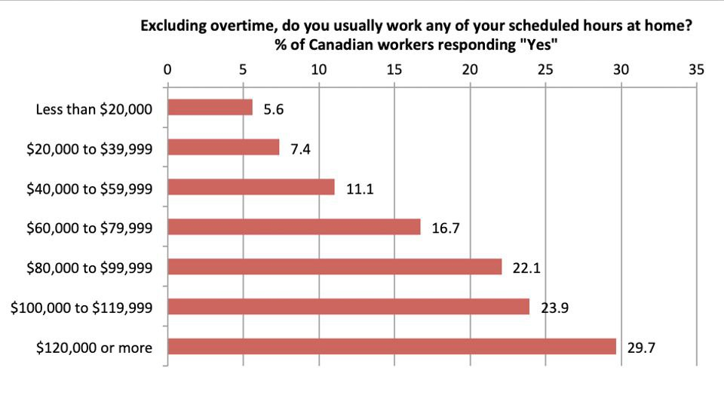
Figure 6: % of workers getting flexible job benefits
Source: (Davitkovski, et al, 2020)
As the above graph showcases, only 5% of the employees who have a monthly income of less than $20000 get the opportunity of working through flexible and remote work settings and arrangements. This rate increases as the number of payments increases and are the maximum of 29.7% for those employees who are paid more than $120000 (Mackeldey, 2022). This indicates that the employees who are paid well are getting the opportunity of flexible and remote workings while those with low income are not getting this opportunity. As a result, the level of inequality in the organizational workforce gets worsen as the well-paid employees are better off while the low-paid employees are being neglected both in terms of work-life balance and based on their financial benefits.
According to the State of Workplace Discrimination Report 2021, 80% of the employees who are working remotely encounter discrimination in their workplaces (Jarrahi, et al, 2021). Different forms of discrimination have been identified to be occurring in workforces according to the report which includes discrimination towards the female workers through inappropriate behavior in the remote environment, discrimination towards the employees from different races or ethnic groups, etc. in Deloitte, a survey on 5000 female workers had been conducted during the covid-19 pandemic to identify their experience on remote working settings where it had been identified that 52% of the female workers are encountering with some forms of harassments and discrimination during the remote working experiences (Kahn, 2022). In another survey, it was identified that 42% of the transgender employees responded to the fact that they faced increased discrimination during the flexible and remote working arrangements.
Other than the drawbacks of remote and flexible work settings which have been identified above which are increased inequality and discrimination in the workforce, there are some other risks of adapting the flexible and remote work settings to which the organization may be exploited through the adaptation of such work arrangements. First of all, research suggests that remote working arrangement decreases the rate of employee engagement as the employees working through remote work settings generally communicate through telecommuting which decreases the rate of physical and face-to-face communication. As a result, employee engagement remains a risk. Moreover, the organization will also have to bear the risk of employee inactivity (Hosoi, et al, 2021). Moreover, it's highly common in remote and flexible work settings that the employees become bored and may feel fatigued as they do not work in the competitive environment of the central offices. It may also cause employee isolation and adversely affect the mental health of the employees (Davitkovski, et al, 2020). finally, the employees who are working through flexible and remote work arrangements may face difficulties and challenges in their career progressions because many organizations tend to overlook the contributions and the efforts of the employees working remotely.
As the overall discussion and analysis suggest, adopting flexible and remote work settings can cause some downfalls in the organization regarding workplace inequality, discrimination, and other relevant areas of employee management and HRM. Thus, based on the overall discussion, it can be concluded that the organization shall not adopt such works arrangements to avoid such challenges and drawbacks.

Conclusion
Based on the assessment made throughout the report, it can be concluded that flexible and remote work arrangements have both some merits and demerits. But as the demand for adopting such work forms is rapidly increasing in the current situation, and as the benefits of integrating such form arrangements outnumber its demerits, the organization shall focus on adopting these forms but shall also ensure optimized control of HR activities so that its risks can be minimized.

References
Caros, N.S., Guo, X. and Zhao, J., 2022. The emerging spectrum of flexible work locations: implications for travel demand and carbon emissions. arXiv preprint arXiv:2201.01281.
Davitkovski, M., Sarkanjac, S.J. and Sarkanjac, B., 2020. The effects of flexible work in the IT industry.
Hosoi, M., Reiter, L. and Zabel, D., 2021. Reshaping Perspectives on Flexible Work: The Impact of COVID-19 on Academic Library Management. portal: Libraries and the Academy, 21(4), pp.695-713.
Hunter, P., 2019. Remote working in research: An increasing usage of flexible work arrangements can improve productivity and creativity. EMBO reports 20(1), p.e47435.
Jarrahi, M.H., Newlands, G., Butler, B., Savage, S., Lutz, C., Dunn, M., and Sawyer, S., 2021. Flexible work and personal digital infrastructures. Communications of the ACM, 64(7), pp.72-79.
Kahn, M.E., 2022. Going Remote: How the Flexible Work Economy Can Improve Our Lives and Our Cities. Univ of California Press.
Mackeldey, L., 2022. Flexible work schedules: the future of work arrangements in Finland and Germany.
Putra, K.C., Pratama, T.A., Linggautama, R.A. and Prasetyaningtyas, S.W., 2020. The Impact of Flexible Working Hours, Remote Working, and Work-Life Balance to Employee Satisfaction in Banking Industry during Covid-19 Pandemic Period. Journal of Business and Management Review, 1(5), pp.341-353.
Shifrin, N.V. and Michel, J.S., 2021. Flexible work arrangements and employee health: A meta-analytic review. Work & Stress, pp.1-26.
Soga, L.R., Bolade-Ogunfodun, Y., Mariani, M., Nasr, R. and Laker, B., 2022. Unmasking the other face of flexible working practices: A systematic literature review. Journal of Business Research, 142, pp.648-662.
Sulaymonov, A., 2020. Flexible working practices: urgency or future?. Modern Economy, 11(07), p.1342.
Xiao, Y., Shen, D., Zou, G., Wu, A., Liu, L., Duley, W.W., and Zhou, Y.N., 2019. Self-powered, flexible, and remote-controlled breath monitor based on TiO2 nanowire networks. Nanotechnology, 30(32), p.325503.

