Self Reflection Student name: Irina Dode Student id:2123684

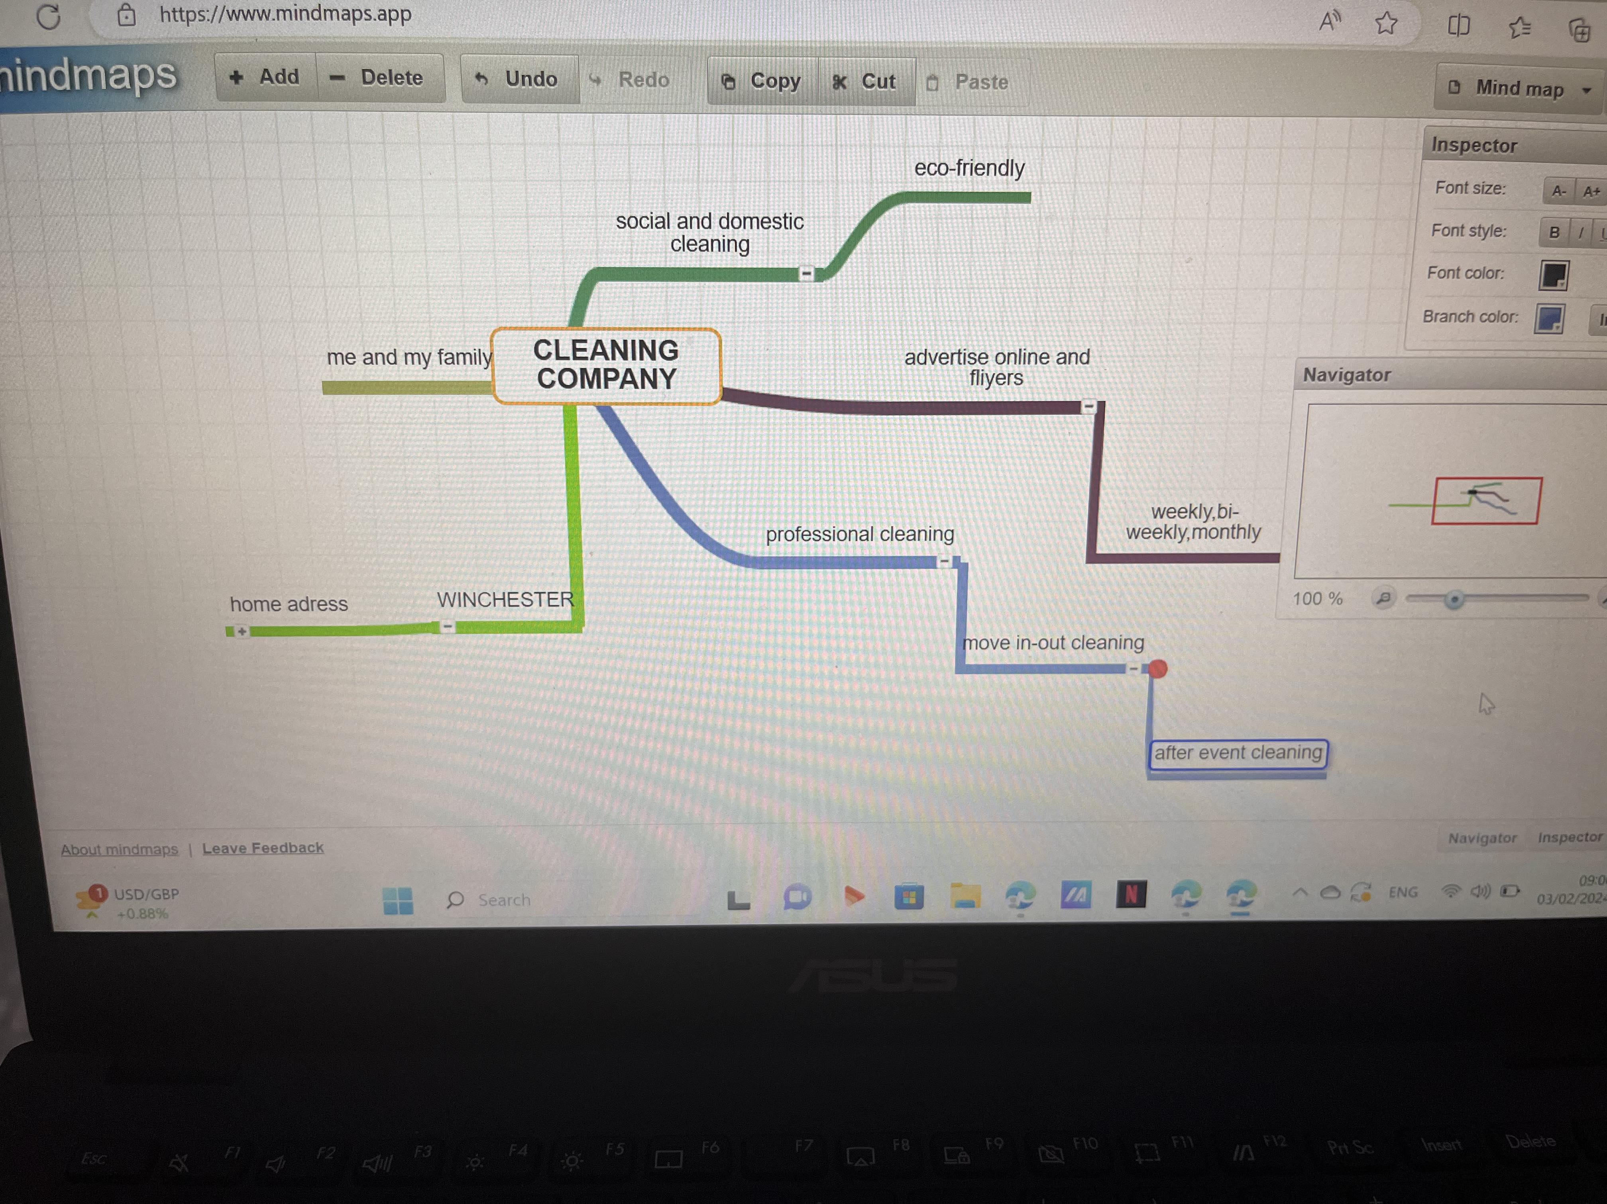

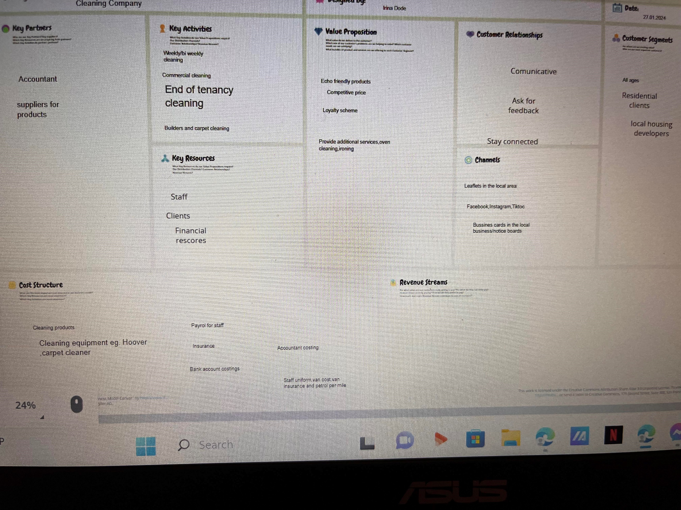

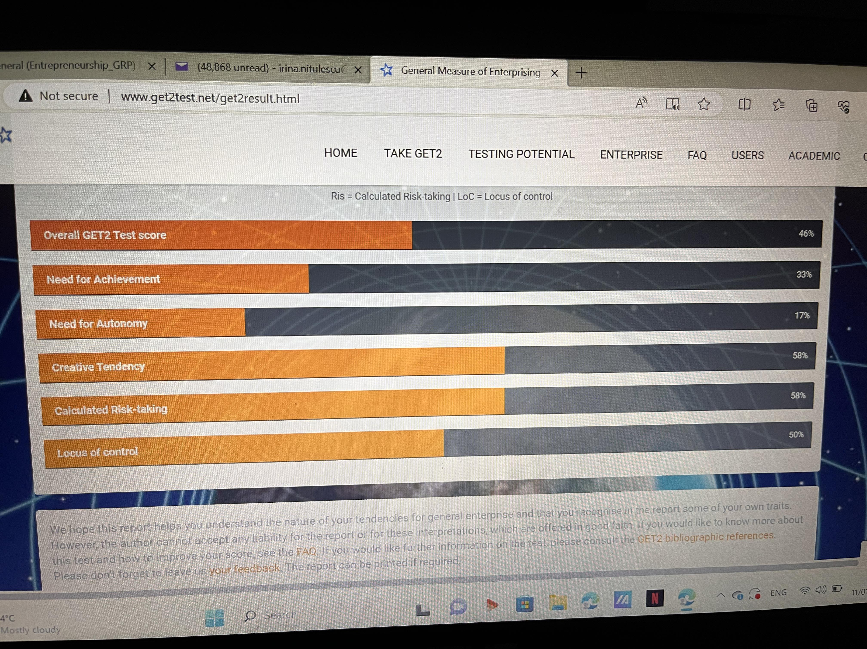
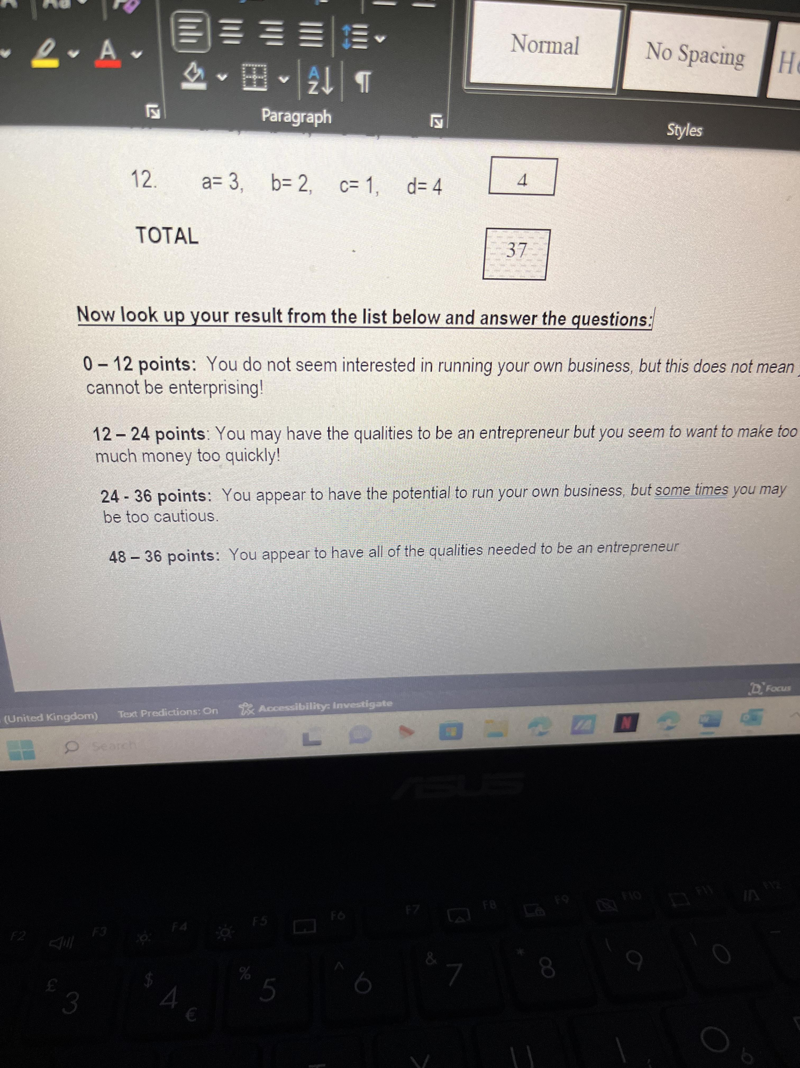

On reflection of my business there is so many key factors to it. I will firstly need to open it with HMRC within doing this I will need to instruct an accountant, the accountant will be a key partner to my business as they will manage payroll, self-assessment, yearly accounts and any communication that needs to be done with HMRC. Another key partner will be finding the most appropriate supplier for equipment/products, without this cost element I wouldn’t be able to run the business.

Once my business has been approved from HMRC I will need to open a business bank account, there is a costing element with this for bank charges. I will need the bank account to pay for all costings including staff wages.

I will then need to get a domain for my business which in turn I will need a host for my email and website. The website will play a keyroll with channels alongside a facebook page, Instagram page and ticktock. These channels (FB, IG, Ticktock) are for free and will be good advertising for the business as there is not cost for this.
Alongside using the channels I will need to also leaflet the local area as I understand that not everyone will use every channel and I need to create revenue from every source possible. In turn I would expect that I would start to create interest in my business and will start to get some clients.

I will need to buy a van (costing) for the business to carry the cleaning equipment and I would advise also on the van with the business logo, contact details and logo. This is again great advertising. The van would be an investment for the business although it is a high cost at the same time.

Before I would be able to start any clients residential, commercial, end of tenancy, builders cleans, carpet cleaning I will need to get insurance (costing) as this protects myself and the business.

With my business value proposition is key, I need to stand out to other competitors in the area by offering slightly different things which would make my business more unique. I would off clients if they would like echo friendly products to be used in their home or commercial premises. In reflection of this though I would of course need to charge those clients slightly higher price as the product cost is greater.
I would also provide any additional services that the client may request such as oven cleaning and ironing.
Also I would offer bespoke cleaning quotes for end of tenancy/builders cleaning as every property is different. I would gain more revenue with this as each quote will be tailor made to the property and not charge a standard price.

In the first year I would be looking to employ two people as well as myself again this is a costing in regards to their wages, staff uniform and putting them on the insurance to be able to do the job.

