Ayesha Amir
2306141
Specialist Placement: Self Performance Review
BMGM6004
Level 6
Placement Coordinator and Lecturer: Antoinette Milne
a.milne@uwtsd.ac.uk

Word Count: 4189
With Reference: 5379

AI

I acknowledge the use of ChatGPT (www.chatgpt.com) on 11 November 2025 to check my grammar and spelling, as well as to help me understand the assessment requirements in a simplified way to guide my research.

I used the following prompt(s):

- Please check my text for grammar and spelling errors.
- Explain the main points of the assessment in simpler terms to aid my research.

During my placement at the Morgans Hotel, Swansea, I gained practical experience in Food and Beverage operations, Events, and Marketing, which are the three focus areas of this assignment and are relevant to my future business. The Morgans Hotel is a four-star hotel with award-winning recognition across a variety of categories, as shown in Figure 1.1, 1.2, 1.3 and 1.4 and it has a long history dating back to 1902 (Morgans Hotel, 2025b). The hotel’s structure and interior reflect its historical heritage, including the bedding, windows, walls, and overall location, as shown in Figures 6, 22, and 24. The time I spent at the Morgans Hotel allowed me to reflect on how the knowledge gained throughout my studies can be applied in practice and how this experience will influence my future managerial role. Reflecting on my placement has helped me identify the skills I have developed, the challenges I faced, and the areas I aim to improve in my future business through practical learning.
Morgans Hotel offers a breakfast service which runs from 7am to 10am in the morning on weekdays and 7:30am to 10:30am in the morning on weekends. Morgans Hotel has a variety of breakfast sections on the menu and offers hot foods for guests (Morgan Hotel, 2025c). As I have shown in (Figure 2) Morgans Hotel offers wedding packages, birthday packages, staying night packages, and many varieties of packages, as I have shown in (Figure 3). Morgans Hotel has 54 rooms across the hotel and seating for 40 guests in the restaurant. Morgans Hotel focuses on friendly service, high-quality guest experience, and a strong local identity. This means that the hotel employs kind, polite, and professional staff who aim to provide fast and efficient service. The hotel is well presented, clean, and promotes local culture by using and promoting locally sourced food.
The mission of Morgans Hotel is to remain the number one hotel in Swansea. The vision of the hotel is to attract both local guests and tourists from across the world. Morgan Hotel values high quality service and benefits from its prime location near the city centre and the beach. The hotel is committed to maintaining professional standards through industry awards, social media presence, certifications, and by recognising and promoting staff achievements on social media (Cottrell, 2021).
Morgans Hotel departments have a variety of roles in the team, starting from General Manager, Hotel Manager, F&B Managers, F&B Supervisors, Head of Event Manager, Event Coordinator, Head Receptionist, Duty Head, Head of Marketing, Head of Accommodation, Head Chef, and Sous Chefs. The responsibility of each role is very important. The General Manager is the head of the Hotel Manager; their duty is to make decisions about money, staff, and hotel plans and to represent the hotel to owners and outside partners. The Hotel Manager’s duty is to keep the departments running smoothly, solve big problems, keep guests happy, bring the team together, and they have big responsibility for the hotel (Sylvain Boussard, 2021, pp.41-46).
Area 1: Confidence and Competence in Food & Beverage Supervision
At the start of my placement, my role within the hotel focused on understanding the Food and Beverage Manager’s duties. The Food and Beverage Manager is responsible for overseeing food and beverage services such as events, breakfast service, and the bar. Their role includes managing staff responsibilities, monitoring and updating stock levels, controlling costs, and ensuring a high standard of customer service. They also work closely with the team during events, breakfast, and other services, and collaborate with the kitchen to ensure the smooth running of daily operations. Food and Beverage Supervisors are under the Food and Beverage Managers; they take orders from above them, make sure that all jobs are done properly and on time, help solve guest complaints, support the manager through shadowing, assist in events with the managers, and cooperate with other teams. The Head of Events Manager’s duty is to manage and lead events, including planning, receiving guest plans for the event, managing the team, and working with Food and Beverage and the kitchen to run events smoothly. The Event Coordinator’s duty is to organise the guest event details and gather information about what the guest would like (menu, timing, setup, and location), ensure the event runs smoothly on the day, and carry out responsibilities under the Head of Event Manager. The Head Receptionist has an important duty of taking bookings for the day or in advance. Their responsibilities include keeping guests happy, ensuring check-in and check-out run smoothly, managing the front desk team, handling guest issues, and training reception staff. The Duty Manager has responsibilities under the Head Receptionist. The Head of Marketing’s duty is to promote the hotel and build its image, manage social media, promotions, and advertising, and help attract more guests and increase bookings. The Head of Accommodation’s duty is to take charge of guest rooms and housekeeping, ensure the rooms are clean, safe, and ready for the next guest, and manage housekeeping staff and room standards. The Head Chef’s duty is to oversee the kitchen and food quality, manage stocks and deliveries, create menus, control food costs, manage kitchen staff and safety, ensure food is served on time, ensure guests are happy with the food, and communicate with the front-of-house team. The Sous Chef’s duty is to assist the Head Chef, supervise the kitchen and staff during service, and take charge of the kitchen when the Head Chef is not present. My duty at Morgans Hotel was as a supervisor, where I learned so much from the hotel that I can take into my future business. I was shadowing a supervisor at the hotel to achieve the duties and learn. The hotel taught me about customer value, problem-solving, time management, and team training. One of the most important skills I noticed was team training. It is important to have good team training to have long lasting staff and to train new staff in a way that shows you care about them. Morgans Hotel mission is that my future career ambition is to establish my own café and catering business, which I aim to develop based on the knowledge, skills, and practical experience gained during my placement. My long-term career ambition is to become the owner of a café and catering business, where I would be responsible for managing daily operations, overseeing financial performance, promoting the business, developing staff, and planning and delivering events (Walker, 2021, p. 113).
The aim of this reflective essay is to explore how I have developed both personally and professionally during my placement at the Morgans Hotel. It focuses on the challenges I faced, the skills I developed, and the leadership experience I gained, which will support my future business ambitions. To structure this reflection, I will use Kolb’s Reflective Cycle (1984) as it provides a clear framework to describe my experiences, reflect on my feelings, evaluate what happened, analyse why it happened, and plan how I can improve in the future. This reflective process has helped me learn from real industry experience and supports my personal and professional development. It also demonstrates how my placement has contributed to my learning and how these experiences will benefit my future career.
During my placement, I was involved in many day-to-day operational tasks, including supporting breakfast service, assisting supervisors during events and busy service periods, preparing service areas for guests on the same day or the following day, and interacting with guests by offering guidance and support. I also had the opportunity to observe how managers and supervisors made decisions and handled challenging situations during busy periods. These experiences helped me gain a deeper understanding of how hotel operations function behind the scenes and increased my confidence in a service environment. They also allowed me to recognise areas where I need further improvement and helped raise my awareness of supervisory and leadership responsibilities. My placement at the Morgans Hotel has strongly influenced my career ambition to own and manage my own café and catering business in the future. I aim to create a positive and supportive working environment for staff while taking responsibility for food and beverage operations, event coordination, and marketing activities. The skills and experience gained during my placement have helped me understand what is required to manage and lead a successful hospitality business in the future.
The Food and Beverage team at the Morgans Hotel operates differently from many other restaurants, as the hotel does not offer a lunch service and instead focuses solely on providing breakfast for a limited number of hours in the morning. During my supervisor training at the Morgans Hotel, I was responsible for carrying out basic service tasks, including taking breakfast orders from guests using a notebook, which marked the beginning of the service process. Before service commenced, tables, cutlery, and the service station were prepared, and a continental breakfast was set up for guests to enjoy, as shown in Figures 4, 5, and 11. Being a supervisor also involved daily task, cleaning tasks, stock checking, and ordering, as shown in Figures 7.1, 7.2 and 20. As well as stocking the minibar in every room from the cellar, as shown in Figures 9, 18, and 23, my supervisor duties also included keeping track of any missing items by completing reports and placing orders after the breakfast service to ensure that stock was ready for the following day, as shown in Figure 10. When guests arrived, my responsibilities included asking basic but essential questions, such as the number of guests, whether they had any allergies, and their room name to check the breakfast list. Identifying allergies was a key responsibility, as it allowed me to guide guests appropriately before seating them and taking their orders, as shown in Figure 16. However, I initially lacked confidence when explaining menu items and advising guests about allergens, as the ordering system was different from what I was previously familiar with. Allergens were not fully listed on the menu; instead, guests were advised to ask a member of staff. If staff are not properly trained, this could pose a high risk for guests with allergies. However, allergy labels were available only for the continental service, as shown in Figure 28. According to Soon (2020, pp.1-19) It is important to provide staff with allergy training to ensure customer safety. Such training can help prevent cross-contamination in the kitchen and restaurant, ensuring guest safety. Kolb (1984) explains that learning and development occur through experience and reflection; my lack of confidence was due to limited experience with the hotel’s menu and ordering system, as shown in Figure 2. According to Wood (2015, pp.1-19) product knowledge is essential in hospitality for delivering effective food and beverage service, as shown in Figure 7. Effective communication between the kitchen and the restaurant is also vital for managing allergies and providing high-quality service, as shown in Figure 25. Wingate et al. (2021) explore how communication between restaurant staff and customers, as well as with the kitchen, impacts service. A lack of communication can create gaps, so it is important for the restaurant staff to check with the kitchen before serving. Similarly, the kitchen should double-check orders, and the restaurant should have a clear understanding of what the customer wants.
Currently, I can carry out basic food and beverage tasks with confidence; however, in the future, my aim is to become a confident supervisor who can advise guests and support staff independently. A barrier to my development was the fast-paced breakfast service, as the restaurant became very busy in a short period of time. During peak hours, my focus was on serving guests quickly and accurately, which left little time to stop, ask questions, or fully understand the menu and ordering system. This made it harder for me to learn and build confidence, especially as I was new to the supervisor role. However, development could be supported through short courses or mentoring during service. My goal is to improve both my confidence and competence in delivering breakfast service while ensuring guest safety.
Specific: Attend a short course on allergen awareness and menu knowledge and shadow an experienced supervisor or manager during breakfast service to enhance practical skills. Measurable: Successfully advise at least 80% of guests on allergens during breakfast service over two weeks and receive positive feedback from supervisors and managers. Achievable: Training can be provided by the hotel, and shadowing can be scheduled during quieter breakfast sessions to allow learning without compromising service. Relevant: Improving food and beverage skills will help me reach my aim of becoming a confident supervisor who can support staff and guide guests independently. Time-bound: Complete training and shadowing within four weeks, with a review of progress by the end of the month. This goal is based on the SMART framework, which helps learners set clear and realistic targets. As explained by Poe et al. (2021), using SMART goals supports skill development and leads to positive learning outcomes. This approach is particularly helpful for improving my allergen awareness and building my confidence when working in food and beverage service. During my placement, the Morgans Hotel team played an important role in my learning by offering guidance and hands-on experience, allowing me to develop these skills in a real and supportive working environment.

Area 2: Confidence and Leadership in Event Management
At the start of my placement, my role within Event Management/Supervisor was mainly observational rather than leadership based. I supported event preparation and service tasks, such as setting up meeting rooms, preparing bar areas for events, and assisting during Christmas and Beaujolais events; however, key planning and decision-making responsibilities were handled by senior staff. This gave me a valuable insight into how events are organised and delivered in a hotel, even though I did not have the chance to manage events independently. Using Kolb’s Reflective Cycle (1984), this stage represents the concrete experience stage, where learning happens through observing and participating in real workplace situations.
The Morgans Hotel Events team has won numerous awards for consistently delivering high-quality service and creating exceptional guest experiences. As shown in Figure 1.4, the Head of the Events Department is holding these awards, representing a proud achievement for both the team and the hotel (Morgans Hotel, 2025f). Learning from the Events team was an exciting and valuable experience for me. Through this opportunity, I gained insight into how the Morgans Hotel attracts guests for events, how events are promoted, and how they are planned and coordinated in close collaboration with the Food and Beverage team. This experience will be particularly beneficial for my future catering business, especially when hosting weddings, birthday celebrations, and other special events.
Working in the Events department at the Morgans Hotel was exciting but also involved a certain level of pressure, as guests often have high expectations of both the service and the event outcome. However, I remained motivated due to the support and guidance provided by managers and team members, as well as the opportunity to experience a different side of hotel operations. Time management was particularly important, alongside managing high-risk situations and paying close attention to detail when hosting both large-scale events and smaller, more intimate occasions.
One positive aspect of my experience was observing how the Events team communicated effectively with guests and worked closely with the Food and Beverage team to ensure that events ran smoothly, even when challenges arose. This helped me understand the importance of clear communication between the Events team, the Food and Beverage team, and the kitchen. However, I was not always involved in decision-making, which made it difficult for me to feel confident managing events independently. Despite this, observing how events were organised and managed allowed me to develop skills and knowledge that will be useful for my future business. I did assist in some events, such as the meeting event, Christmas event, and Beaujolais. For Beaujolais, I helped prepare by cleaning the glasses on the bar, as shown in Figures 15.1, 15.2, and 26. For meeting events, we set up tables in conference style with white cloths, pens, paper, glass mats, glasses, and water bottles, and arranged a coffee and tea station in the corner, as shown in Figures 26, 27, 31.1, 31.2, and 31.3. Hosting meetings taught me that careful planning is important, even for smaller setups (Julia Charles Event Management, 2023). The Morgans Hotel also uses software to organise and schedule events for guests and to record guest information, storing guest history to allow returning guests to book future events more efficiently. The software used is Guestline (The Access Group, 2025). Another strength of the hotel is the range of offers available for guests, including packages for weddings, birthdays, Christmas events, and many other occasions, all with clear pricing (Morgan Hotel, 2025k). According to Salama (2021, pp.28–29, 96–105), Morgans Hotel planning for every occasion is precise and designed to meet guest standards within a fixed budget and Morgans Hotel has a event bar which is only open when there is a event is on, as shown in figure 29
During my placement, I mainly observed events rather than leading them, with only a few opportunities to lead short tasks. As a result, my learning focused on understanding how things work rather than having full control. This experience showed me that while observation is helpful for learning, active involvement and assisting others are important for building confidence and developing leadership skills in event management. Currently, I have a good understanding of how events are planned and coordinated within a hotel environment. In the future, I aim to confidently plan and manage events independently, using the knowledge and skills I have developed, including effective communication with guests, team coordination, and problem-solving during live events. These skills are essential for my future catering and events business. The Morgans Hotel also demonstrates strong staff care by recognising and celebrating staff birthdays, which highlights the importance of valuing employees as well as guests, as shown in Figure 8. For afternoon tea and meetings, I helped set up a station with saucers and cups after breakfast for the next day, to professional standards, as shown in Figure 12 (Cousins et al., 2022, pp.256–265 and Morgan Hotel, 2025a). Development was limited during events because key decisions were handled by senior staff. I addressed this by observing closely, asking questions, and learning from feedback provided by experienced event coordinators. Outside my placement, I plan to further develop my event management skills by volunteering at community events or assisting with private events.
I want to become more confident in planning and running events by assisting with smaller ones, such as meetings and private functions. I will know I am making progress if I help with at least two events and receive feedback from the event coordinator or supervisor on my performance. I plan to achieve this by shadowing experienced event coordinators and supporting the setup and delivery of events. Developing these skills is important because I aim to run my own café and catering business in the future, where I will organise both private and corporate events. I intend to achieve this goal within the next six months.
Area 3: Marketing and Guest Engagement
During my placement at the Morgans Hotel, I observed how the hotel uses both online and offline marketing to promote its services. These include social media platforms, the hotel website, direct email marketing, customer reviews, video advertisements, content marketing, influencer marketing, and loyalty marketing, along with several other promotional methods. The main marketing approaches used by the Morgans Hotel are in-house advertising, website marketing, direct email marketing, and loyalty marketing. During my time at the Morgans Hotel, my role was primarily observational, which allowed me to understand how these marketing activities are planned and implemented in practice.
The Morgans Hotel most frequently uses a direct email marketing strategy, sending weekly emails to guests who prefer email communication and wish to stay informed about offers, events, and other hotel updates, as shown in Figure 34. According to Valenti et al. (2023), maintaining connections with guests is important for understanding their needs, as different guest mindsets influence the effectiveness of various marketing channels. The Morgans Hotel’s use of in-house advertising is also very effective in encouraging guests to return, fostering stronger relationships, and building trust, which can lead to longer stays. This demonstrates that guests value personal connections and trust, and that many are motivated by discounts and special offers, reflecting the diversity of guest needs.
According to Mishra (2022), for a hotel to be successful in today’s competitive market, it cannot simply wait for customers to arrive; it must actively engage in advertising to appear professional and remain ahead of competitors. Many hotel owners are hesitant to invest in advertising, viewing it as a cost rather than an investment in business growth. While television advertisements and billboards can be effective, they are often expensive. Mishra concludes that in-house marketing is both effective and affordable. In-person advertisements displayed in frames within the hotel are particularly useful, as they target guests who are already on-site, encouraging them to spend on additional services while enhancing the hotel’s professional image and demonstrating that the business is active and successful.
The Morgans Hotel also uses social media to promote the hotel and its team, highlighting their care for guests and showcasing the hotel’s awards (Visit Wales, 2025; Business News Wales, 2025). As shown in Figures 1.1, 1.2, 1.3, 1.4, 30.1, 30.2, 30.3, and 30.4, the hotel maintains active accounts on Instagram (Morgans Hotel, 2025h), Facebook (Morgans Hotel, 2025g), LinkedIn (Morgans Hotel, 2025d), and TikTok (Morgans Hotel, 2025e). On these platforms, the hotel regularly posts daily promotions, while LinkedIn presents a more professional image of the hotel.
Additionally, the hotel builds strong relationships with loyal guests by providing exclusive offers and promotional codes via email or directly within the hotel, ensuring that repeat guests feel valued and appreciated. According to Wood (2015b, pp. 107–115), guest loyalty programmes are important in the hospitality industry because they encourage repeat visits through rewards, discounts, and special treatment. This makes guests feel valued and positively influences their behaviour and spending, as shown in Figures 19 and 32.
The Morgans Hotel’s logo also plays an important role in its branding, as it reflects elegance and luxury through its use of black and gold, which are commonly associated with richness and exclusivity, while white represents calmness and peace (Meliksetyan, 2025, pp. 6–28; Lucky and Special, 2025, pp. 58–65). As shown in Figures 35 and 36, the Morgan Hotel maintains a professional, clean, and sophisticated brand image. This is further reinforced through customised branded items such as pens, pencils, paper, cup mats, and staff uniforms, as shown in Figures 32 and 33. The menu also acts as a marketing tool, with its colour, fabric, and design carefully planned to reflect luxury and quality, as shown in Figure 21.
My development in marketing was limited because my role was mainly observational, and I was not directly involved in creating marketing content, managing social media accounts, or planning campaigns. This limited my opportunity to gain hands-on experience and reduced my confidence in applying marketing skills independently. According to Kolb’s Reflective Cycle (1984), learning happens through hands-on experience and reflection. By observing the hotel’s marketing activities, I was able to understand how different strategies are applied in a real working environment. However, because my involvement was mostly observational rather than practical, my learning progressed more slowly, and I had fewer opportunities to actively develop my skills.
Through this experience, I learned how important marketing and guest engagement are in the hospitality industry. I developed an understanding of how branding, loyalty marketing, and communication with guests help attract direct bookings, encourage repeat visits, and build a positive reputation for the business. In the future, I aim to gain more practical marketing experience by taking part in creating social media posts, assisting with email marketing, and analysing guest feedback. This will help me build confidence and develop the marketing skills needed to successfully promote my future business.
In conclusion, my placement at the Morgans Hotel played an important role in my personal and professional development. By working across three areas at the Morgans Hotel, I gained a clear understanding of how hotel operations function as a business and how different departments work together to provide a high-quality guest experience. Using Kolb’s Reflective Cycle (1984) helped me reflect on my experiences, recognise my strengths, identify areas where I need to improve, and plan how to further develop my skills. Although my role was mainly observational in some areas, particularly in Events and Marketing, this experience helped me build confidence, improve my communication skills, and develop a stronger understanding of supervision, leadership, and guest engagement. The challenges I faced, such as working in a fast-paced service environment and having limited involvement in decision-making, showed me the importance of experience, training, and continuous learning. Overall, this placement confirmed my goal of opening a café and catering business in the future. The skills I developed will support my future career and help me run a successful business in the hospitality industry.

Reference list
Business News Wales (2025). Reception Team at Swansea Hotel Win National Award. [online] Business News Wales. Available at: https://businessnewswales.com/reception-team-at-swansea-hotel-win-national-award/ [Accessed 19 Nov. 2025].
Chen, J. (2025). The Psychology of Color: How Valuable Web Designers Choose Colors. [online] www.flux-academy.com. Available at: https://www.flux-academy.com/blog/the-psychology-of-color-how-valuable-web-designers-choose-colors [Accessed 1 Jan. 2026].
Cottrell, S. (2021). Skills for success: Personal Development and Employability. 4th ed. [online] Basingstoke: Helen Caunce. Available at: https://ebookcentral.proquest.com/lib/trinity/reader.action?docID=6577749&c=UERG&ppg=1 [Accessed 21 Nov. 2025].
Cousins, J., Foskett, D., Graham, D. and Hollier, A. (2022). Food and Beverage Management. 6th ed. [online] Oxford: Goodfellow Publishers Ltd, pp.256–265. Available at: https://ebookcentral.proquest.com/lib/trinity/reader.action?docID=6354742&c=UERG&ppg=1 [Accessed 11 Dec. 2025].
Julia Charles Event Management (2023). How To Design The Best Creative Event Concept. [online] Julia Charles Event Management. Available at: https://www.juliacharleseventmanagement.co.uk/how-to-design-the-best-creative-event-concept/ [Accessed 22 Dec. 2025].
Kolb, D.A. (1984). Experiential Learning: Experience As The Source Of Learning And Development. [online] Research Gate. Available at: https://www.researchgate.net/publication/235701029_Experiential_Learning_Experience_As_The_Source_Of_Learning_And_Development [Accessed 17 Nov. 2025].
Lucky, A. and Special, K. (2025). The Psychology of Color in Branding and Marketing. The Psychology of Color in Branding and Marketing , [online] 5(2), pp.58–65. doi:https://doi.org/10.59298/NIJRE/2025/525865.
MELIKSETYAN, G. (2025). THE PSYCHOLOGICAL MEANING OF COLOR IN DESIGN: A SEMANTIC REVIEW. Main Issues Of Pedagogy And Psychology, [online] 12(1), pp.6–28. doi:https://doi.org/10.24234/miopap.v12i1.64.
Mishra, A. (2022). Impact of Advertising and Marketing in Hospitality Industry. Research Gate, [online] 1(978-81-955884-7-3), pp.64–69. Available at: https://www.researchgate.net/profile/Gurdeep-Singh-59/publication/376582350_Final_Book_IMC_2022/links/657e087f8e2401526ddc33d2/Final-Book-IMC-2022.pdf#page=70 [Accessed 31 Dec. 2025].
Morgans Hotel (2025a). Afternoon Tea - Indulge In Delicious Savoury & Sweet Treats. [online] Morgans Hotel. Available at: https://www.morganshotel.co.uk/upcoming-events/afternoon-tea-2/ [Accessed 30 Dec. 2025].
Morgans Hotel (2025b). History | Morgans Hotel. [online] Morgans Hotel. Available at: https://www.morganshotel.co.uk/history/ [Accessed 27 Dec. 2025].
Morgans Hotel (2025c). Menu. [online] Morgans Hotel. Available at: https://www.morganshotel.co.uk/drink-dine/ [Accessed 18 Nov. 2025].
Morgans Hotel (2025d). Morgan Hotel linkedin. [online] Linkedin. Available at: https://www.linkedin.com/company/morgans-hotel-limited/posts/ [Accessed 29 Dec. 2025].
Morgans Hotel (2025e). Morgan Hotel TikTok. [online] Tiktok.com. Available at: https://www.tiktok.com/@morganshotel [Accessed 29 Dec. 2025].
Morgans Hotel (2025f). Morgan Hotel Wins at the Welsh National Wedding Awards 2025. [online] Instagram. Available at: https://www.instagram.com/p/DQ4eZhQErqv/ [Accessed 19 Nov. 2025].
Morgans Hotel (2025g). Morgans Hotel Facebook. [online] Facebook.com. Available at: https://www.facebook.com/MorgansSwansea [Accessed 29 Dec. 2025].
Morgans Hotel (2025h). Morgans Hotel Instagram. [online] Instagram.com. Available at: https://www.instagram.com/morganshotelswansea [Accessed 29 Dec. 2025].
Morgans Hotel (2025i). Morgans Hotel Swansea Honoured with Tripadvisor Travellers’ Choice Award. [online] Linkedin. Available at: https://www.linkedin.com/posts/morgans-hotel-limited_we-are-so-proud-to-have-won-the-tripadvisor-activity-7323020768177537024-hYDo?utm_source=share&utm_medium=member_desktop&rcm=ACoAAEfZJVsBlacnPS3lNS1ZCGtqjhKNNyQLuE4 [Accessed 20 Nov. 2025].
Morgans Hotel (2025j). Morgans Hotel: Logo – Luxury Rooms in the Heart of Swansea. [online] Morgans Hotel. Available at: https://www.morganshotel.co.uk/.
Morgans Hotel (2025k). Private Parties And Celebrations | Morgans Hotel. [online] Morgans Hotel. Available at: https://www.morganshotel.co.uk/private-functions/ [Accessed 30 Dec. 2025].
Poe, L.F., Brooks, N.G., Korzaan, M., Hulshult, A.R. and Woods, D.M. (2021). Promoting Positive Student Outcomes: The Use of Reflection and Planning Activities with a Growth- Mindset Focus and SMART Goals. Information Systems Education Journal, [online] 19(4), pp.2–10. Available at: https://www.researchgate.net/publication/356508784_Promoting_Positive_Student_Outcomes_The_Use_of_Reflection_and_Planning_Activities_with_a_Growth-_Mindset_Focus_and_SMART_Goals [Accessed 30 Dec. 2025].
Salama, M. (2021). EVENT PROJECT MANAGEMENT : principles, technology and innovation. first edition ed. [online] Oxford: Goodfellow Publishers Ltd, pp.28–29, 96–105. Available at: https://r4-vlebooks-com.ezproxy.uwtsd.ac.uk/Reader?ean=9781911635758 [Accessed 1 Dec. 2025].
Soon, J.M. (2020). ‘Food allergy? Ask before you eat’: Current food allergy training and future training needs in food services. Food Control, [online] 112(0956-7135), p.107129. doi:https://doi.org/10.1016/j.foodcont.2020.107129.
Sylvain Boussard (2021). Food and beverage management in the luxury hotel industry. [online] New York, Ny: Business Expert Press, Llc, pp.41–46. Available at: https://research-ebsco-com.ezproxy.uwtsd.ac.uk/c/onvpsy/ebook-viewer/pdf/pjhvf6ukf5/page/pp_iv?location=https%3A%2F%2Fresearch-ebsco-com.ezproxy.uwtsd.ac.uk%2Fc%2Fonvpsy%2Fsearch%2Fdetails%2Fpjhvf6ukf5%3Fdb%3Dnlebk [Accessed 24 Nov. 2025].
The Access Group (2025). Guestline Software. [online] www.theaccessgroup.com. Available at: https://www.theaccessgroup.com/en-gb/ [Accessed 31 Dec. 2025].
Valenti, A., Srinivasan, S., Yildirim, G. and Pauwels, K. (2023). Direct mail to prospects and email to current customers? Modeling and field-testing multichannel marketing. Journal of the Academy of Marketing Science, [online] 52(3), pp.815–834. doi:https://doi.org/10.1007/s11747-023-00962-2.
Visit Wales (2025). Morgans Hotel | VisitWales. [online] Visitwales.com. Available at: https://www.visitwales.com/accommodation/hotel/morgans-hotel-550441.
Walker, J.R. (2021). Introduction to hospitality. 8th ed. [online] Essex: Pearson Education, p.113. Available at: https://ebookcentral.proquest.com/lib/trinity/reader.action?c=UERG&docID=6371059&ppg=1 [Accessed 30 Dec. 2025].
Wingate, T.G., Jones, S.K., Khakhar, M.K. and Bourdage, J.S. (2021). Speaking of allergies: Communication challenges for restaurant staff and customers. International Journal of Hospitality Management, [online] 96(0278-4319). doi:https://doi.org/10.1016/j.ijhm.2021.102959.
Wood, R.C. (2015a). ‘WHERE ARE WE GOING? THE NATURE OF HOSPITALITY MANAGEMENT’ Hospitality management. [online] Thousand Oaks, Ca: Sage Publications Ltd, pp.1–19. Available at: https://research-ebsco-com.uwtsd.idm.oclc.org/c/onvpsy/ebook-viewer/pdf/i7unnzpxq5?location=https%25253A%25252F%25252Fresearch-ebsco-com.uwtsd.idm.oclc.org%25252Fc%25252Fonvpsy%25252Fsearch%25252Fdetails%25252Fi7unnzpxq5%25253Fdb%25253Dnlebk [Accessed 29 Dec. 2025].
Wood, R.C. (2015b). ‘WOULD YOU LIKE TO JOIN OUR CUSTOMER LOYALTY PROGRAMME? MARKETING AND CONSUMPTION IN HOSPITALITY’ Hospitality Management. [online] Thousand Oaks, Ca: Sage Publications Ltd, pp.107–115. Available at: https://research-ebsco-com.uwtsd.idm.oclc.org/c/onvpsy/ebook-viewer/pdf/i7unnzpxq5?location=https%25253A%25252F%25252Fresearch-ebsco-com.uwtsd.idm.oclc.org%25252Fc%25252Fonvpsy%25252Fsearch%25252Fdetails%25252Fi7unnzpxq5%25253Fdb%25253Dnlebk [Accessed 29 Dec. 2025].

Appendices
1)
Figure 1.1
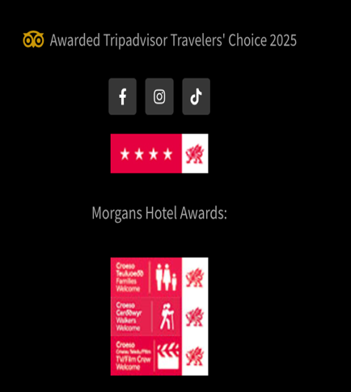
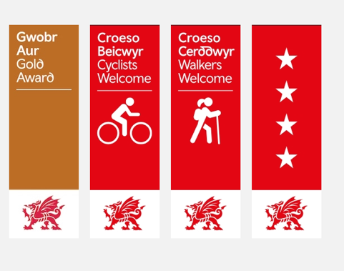

Won visit Wales award that are provide to Morgans Hotel in honour
(Morgans Hotel,2025 and Visit Wales,2025).
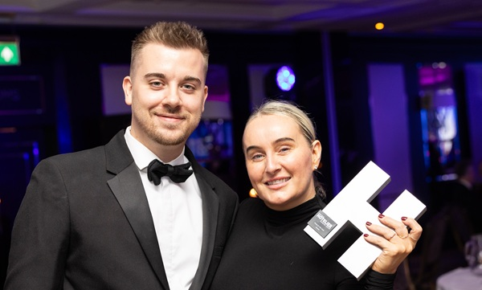
Figure 1.2

Won Morgans Hotel Reception award
(Business News Wales, 2025).
Figure 1.3
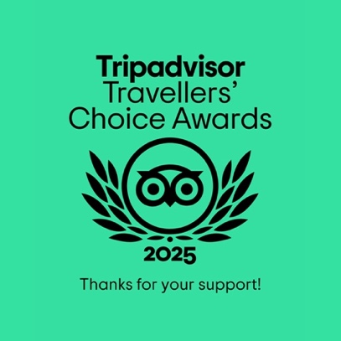

Won Tripadvisor 2025 award
(Morgans Hotel, 2025c).
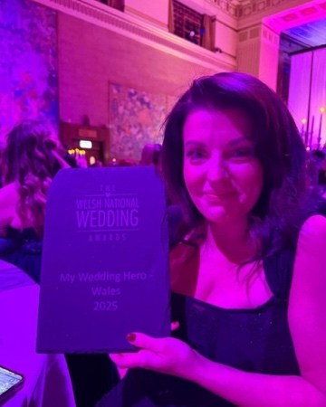
Figure 1.4

Morgans hotel won Wedding events award
(Morgans Hotel, 2025e).

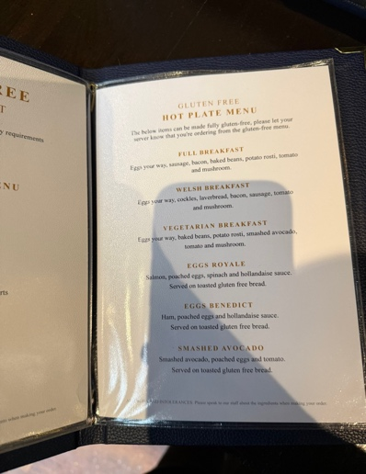
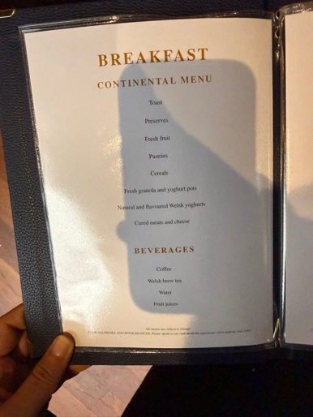
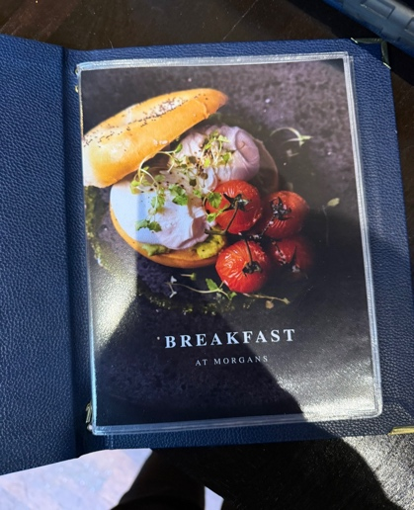
Figure 2

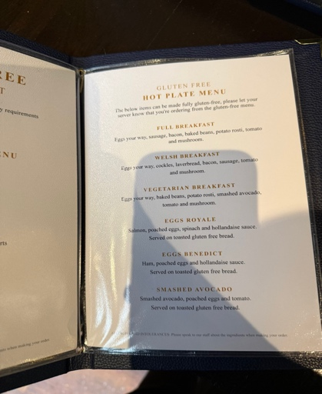

Menu of Morgan Hotel
(Morgans Hotel,2025b).
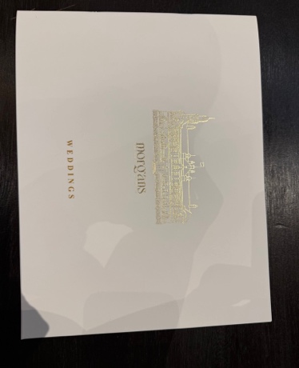
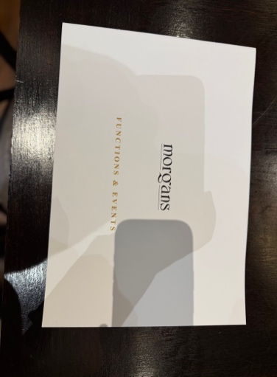
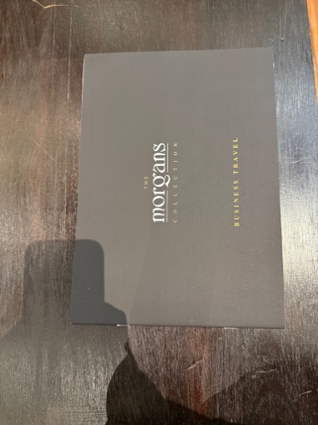
Figure 3

Packages of Morgans Hotel for Events Hosting with inform and history.

Figure 4

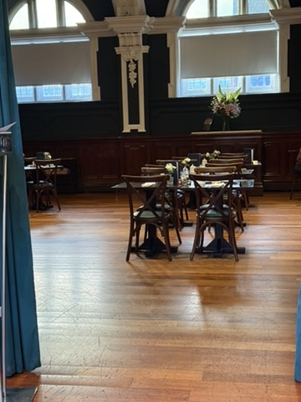
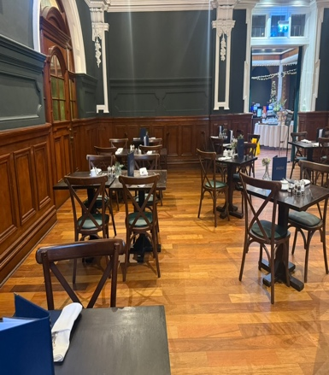

Morgans Hotel Restaurant Table Set up.

Figure 5
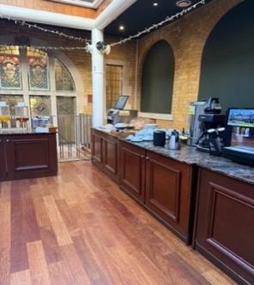
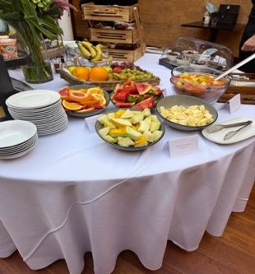
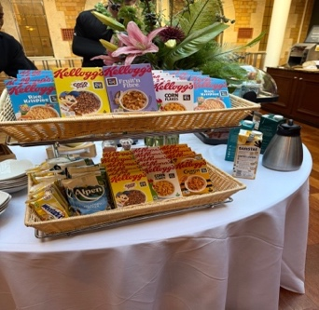
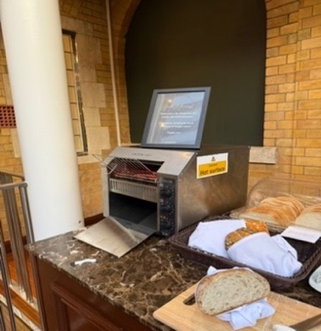

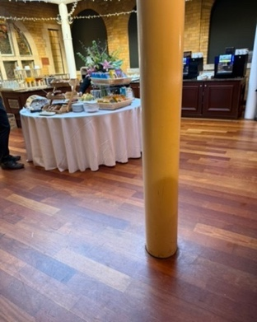
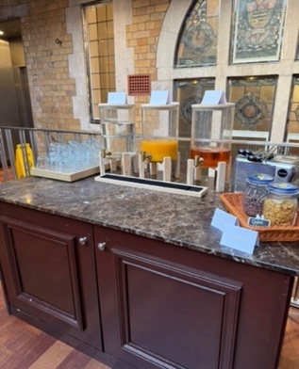

Morgans Hotel Setup of Continent breakfast Service

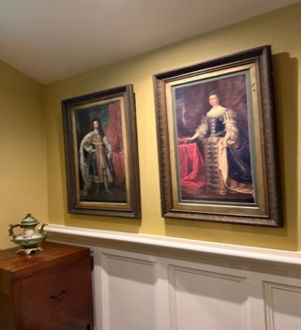
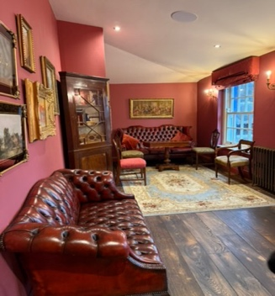
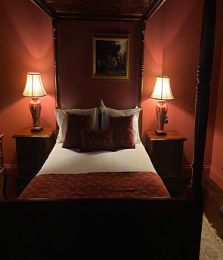
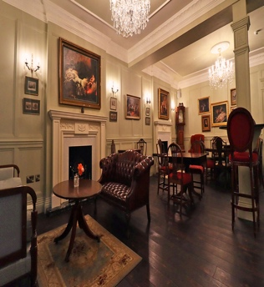
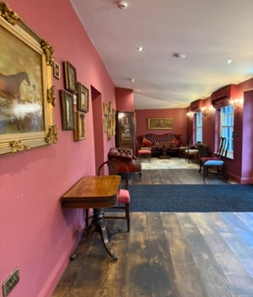
Figure 6

Georgian hotel with history décor and rooms.

7)

Figure 7.1
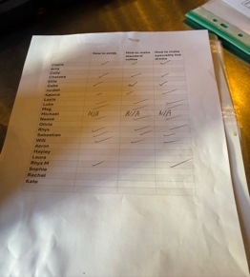

Morgans hotel Staff training

Figure 7.2
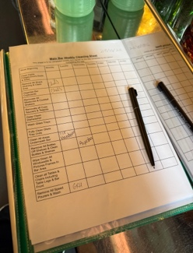

Clean up weekly list for bar

Figure 8
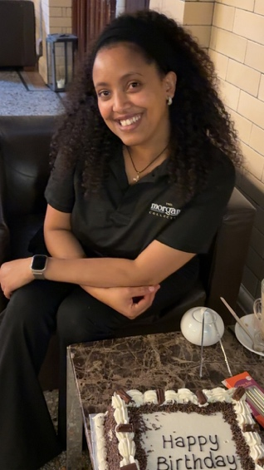

Morgans Hotel Staff birthday

Figure 9

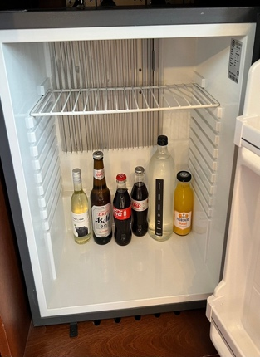
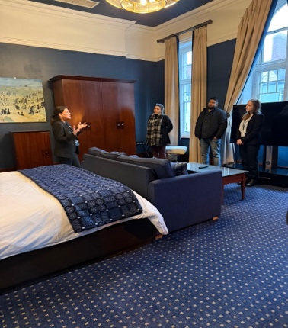

Red square is mini bar in rooms (restocking)

Figure 10
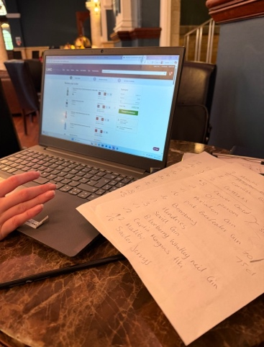
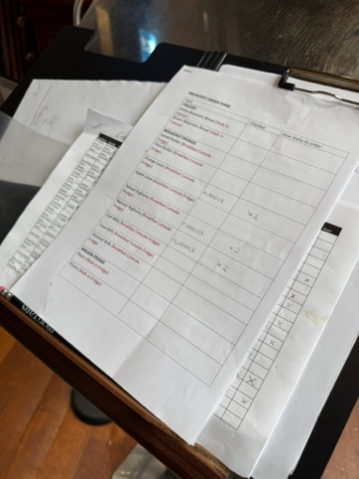

Stock Checking and Ordering through Suppliers Websites
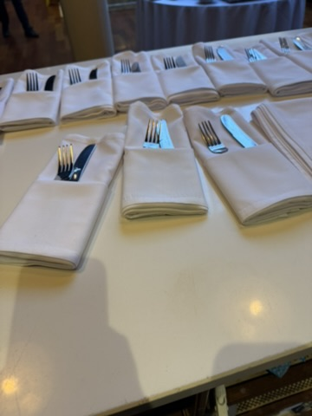
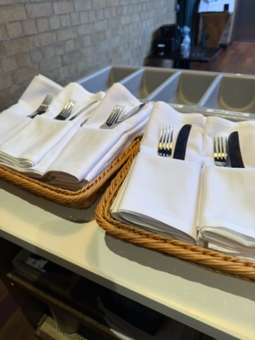
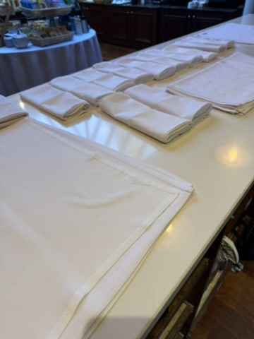
Figure 11

Cutleries and napkin Folding

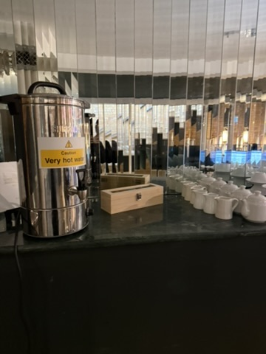
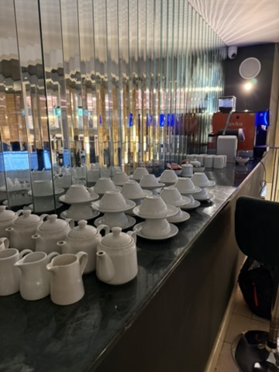
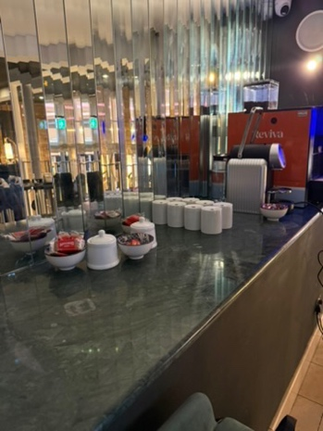
Figure 12
Afternoon tea/Meeting Tea and coffee station Set up

Figure 13
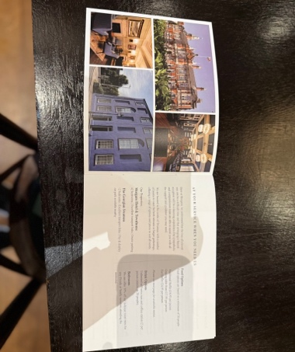
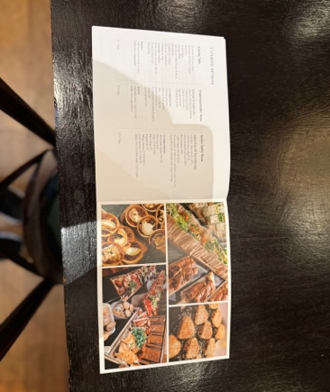

Event Package Guide

Figure 14
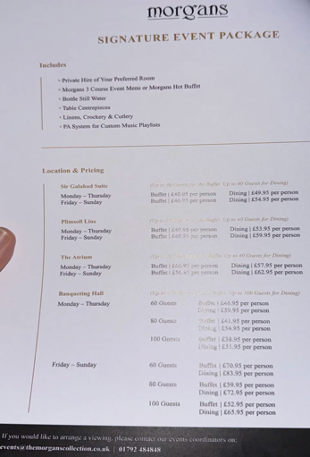
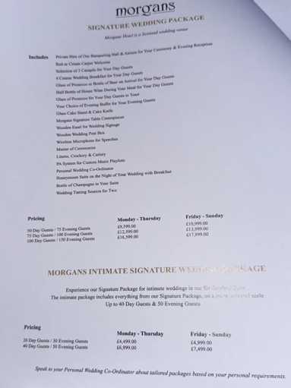

Wedding And Event Package with Cost

Figure 15

15.1
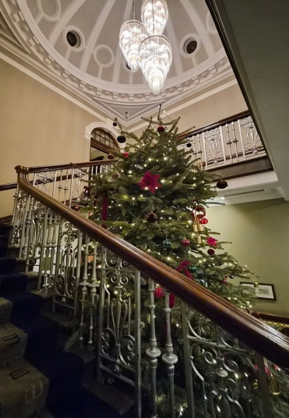
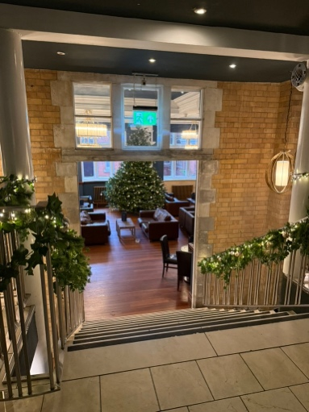

Christmas Set up

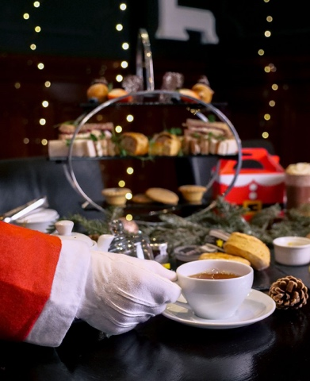
15.2
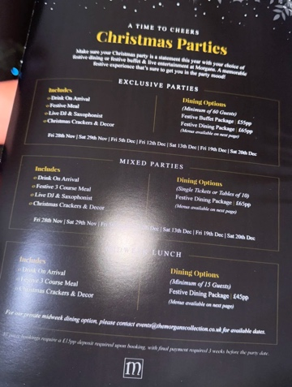
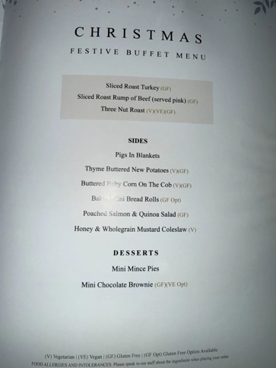
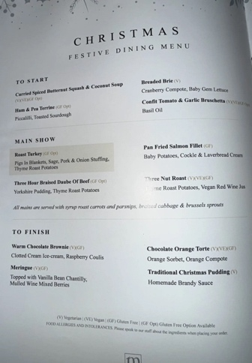
Christmas event

Figure 16
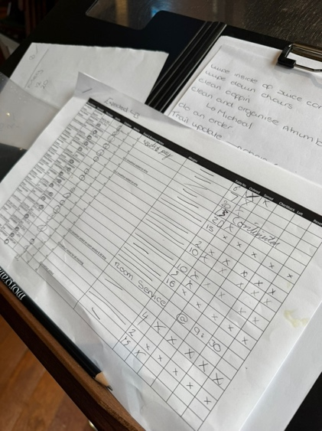

Guest Check List and Allergy Information

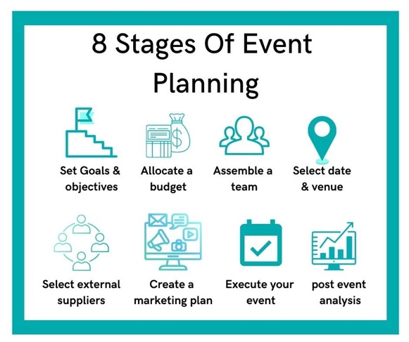
Figure 17

Showing how much planning goes through to have event.
(Julia Charles Event Management, 2023)

Figure 18
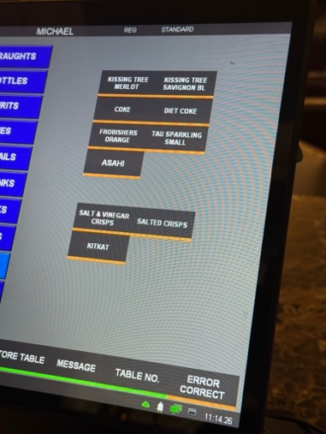

Room Mini Bar stock up guide

Figure 19
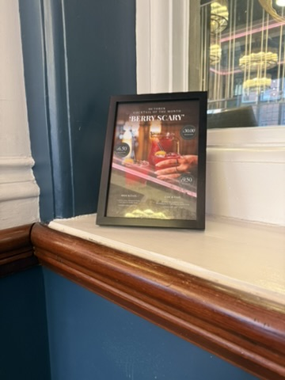
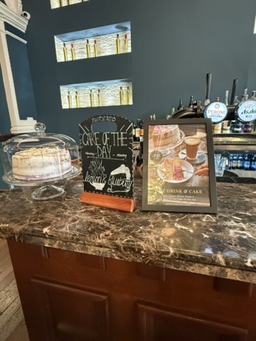
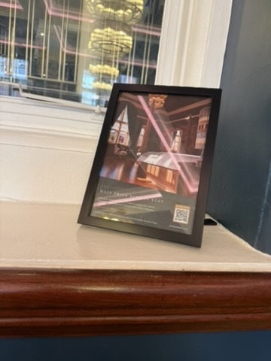

Frame Promotion, Morgans Hotel Marketing strategy

Figure 20
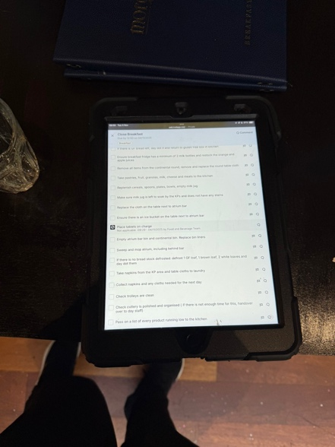

Daily Task App

Figure 21
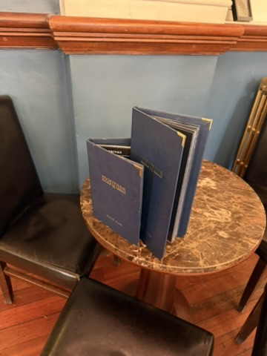

Menu - Morgans Hotel Marketing strategy
Figure 22
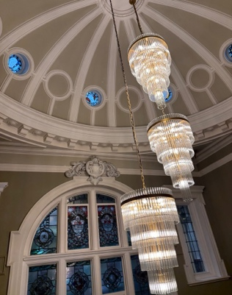

Old History building

Figure 23
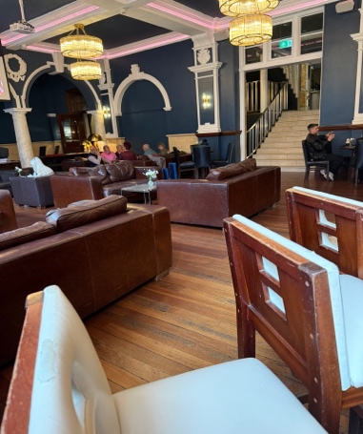
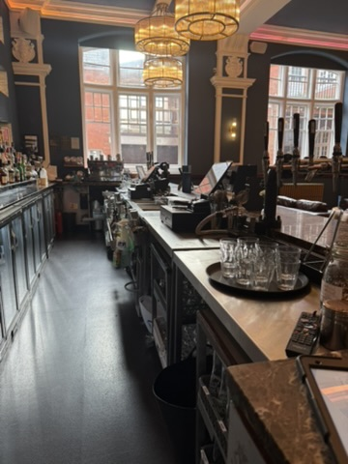

Main Bar

Figure 24
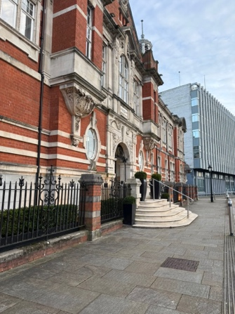

Front Of Hotel

Figure 25
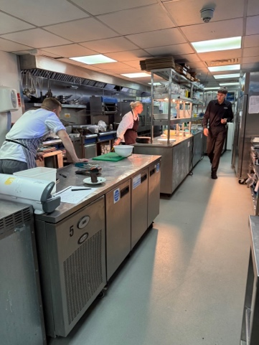

Kitchen and Restaurant Staff communicate at Breakfast

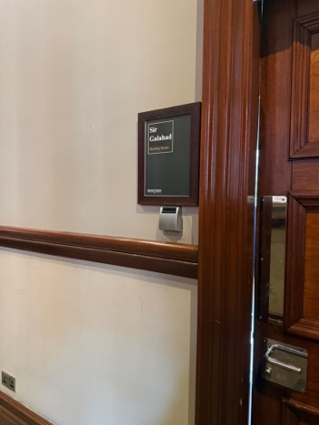
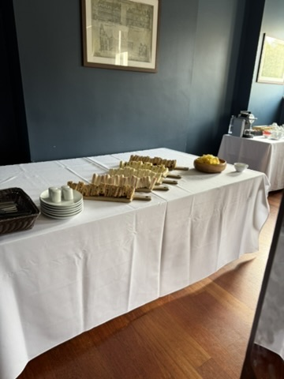
Figure 26

Meeting Event set uo

Figure 27
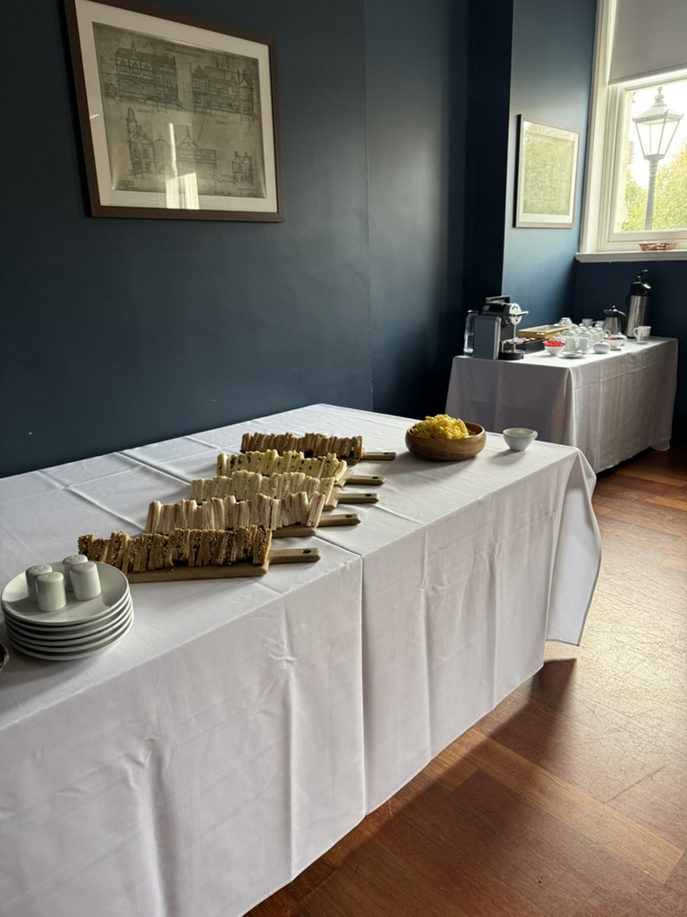
Tea and Coffee station in Meeting Room set up

Figure 28
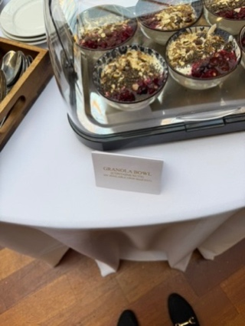

Allergy Labels

Figure 29)
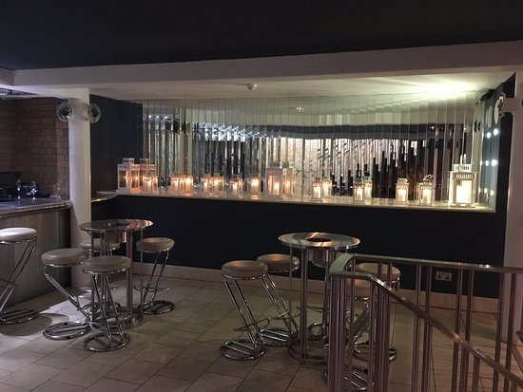
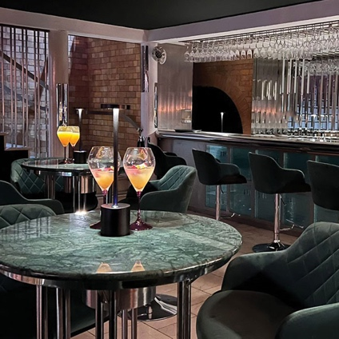

Event Only Bar

30)
Figure 30.1
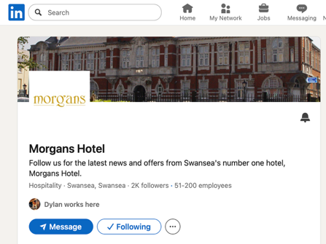

(Morgans Hotel, 2025c)

Figure 30.2
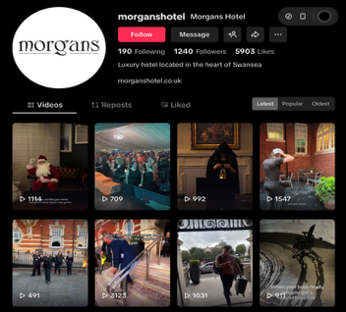

(Morgans Hotel, 2025d)

Figure 30.3
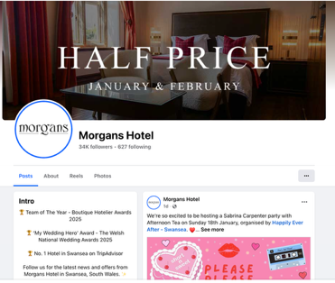

(Morgans Hotel, 2025f)

Figure 30.4
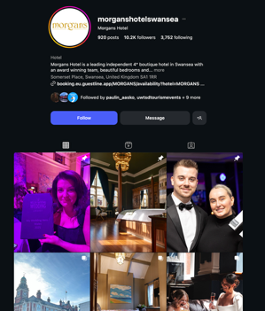

(Morgans Hotel, 2025g)

Figure 31
31.1
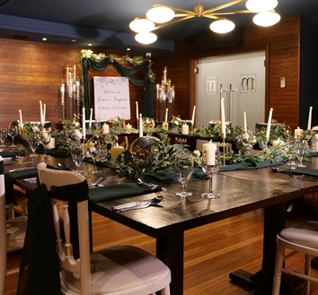

The Plimsoll Line Room – Private events, function room or and can be used as meeting room (Morgans Hotel,2025i).

Figure 31.2
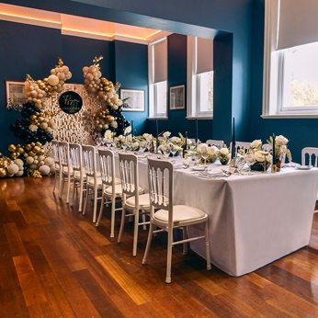

Sir Galahad Suite Room – Private events, functions room and Meeting room (Morgan Hotel, 2025i).

Figure 31.3
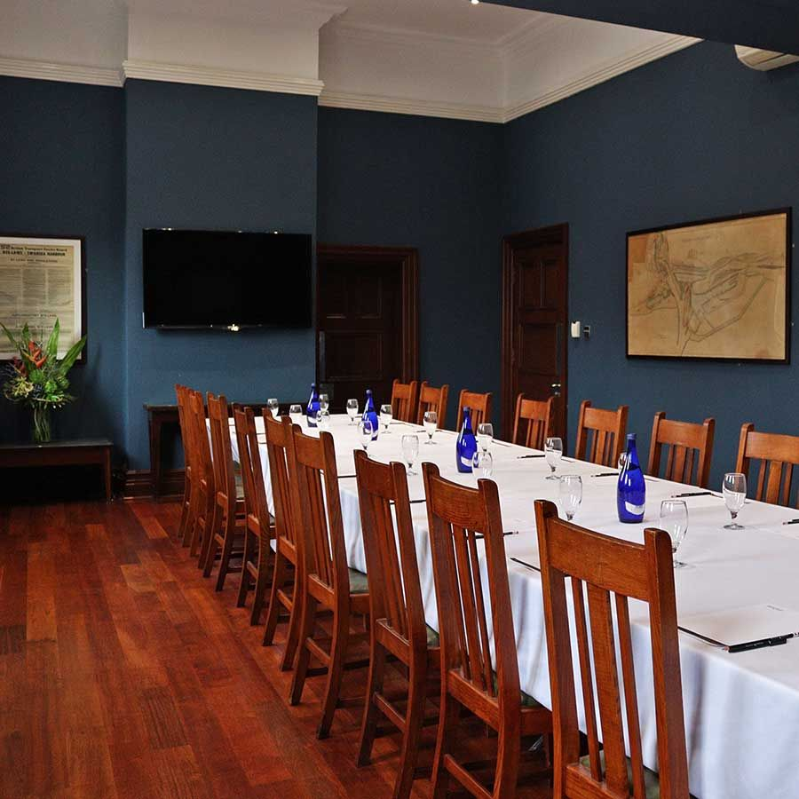
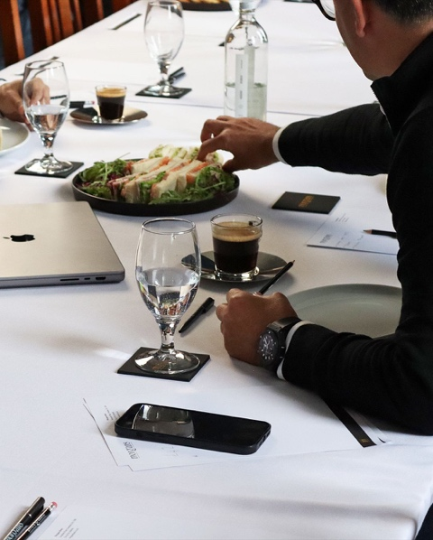
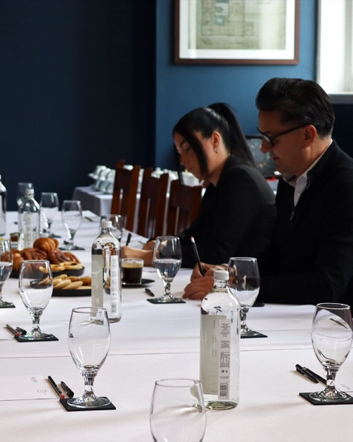

Meeting

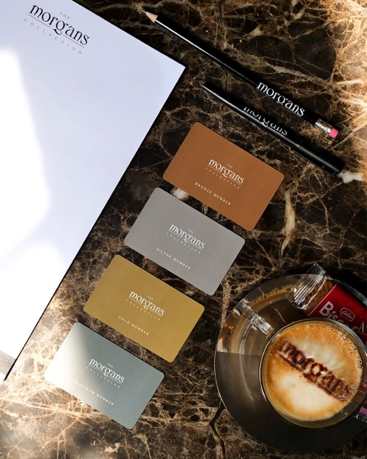
Figure 32

Morgans Hotel Customise Branded Collateral.

Figure 33

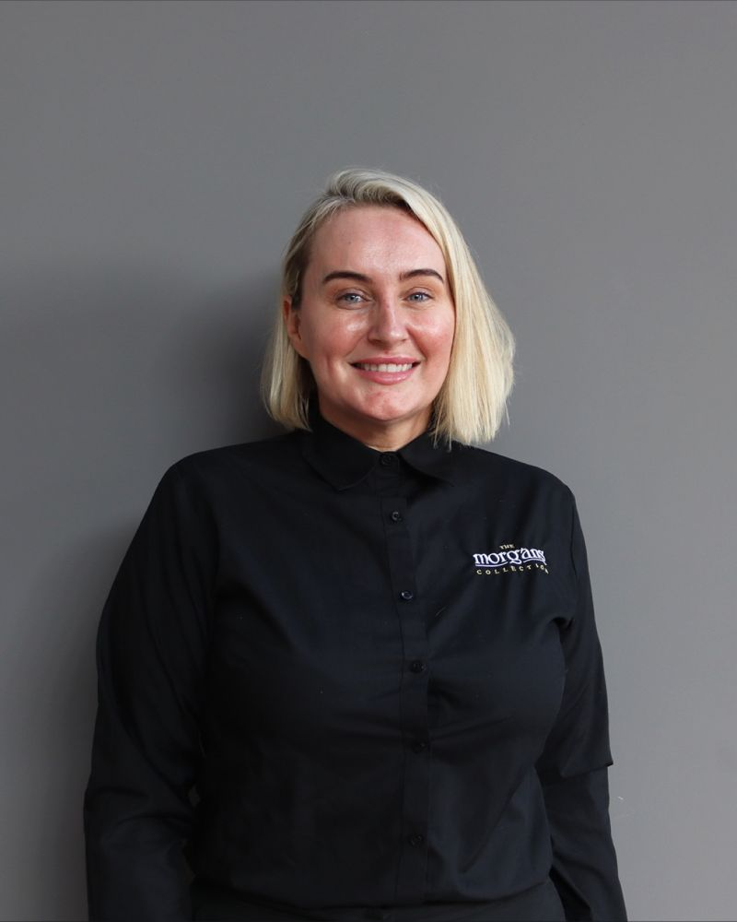
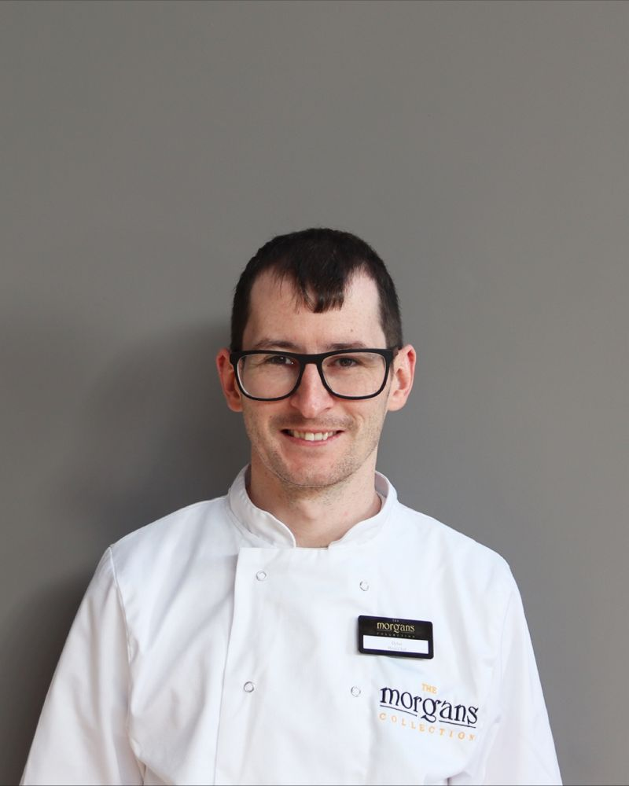

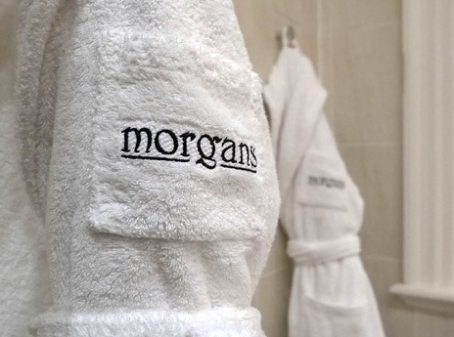

Morgans Hotel Brand Identity System

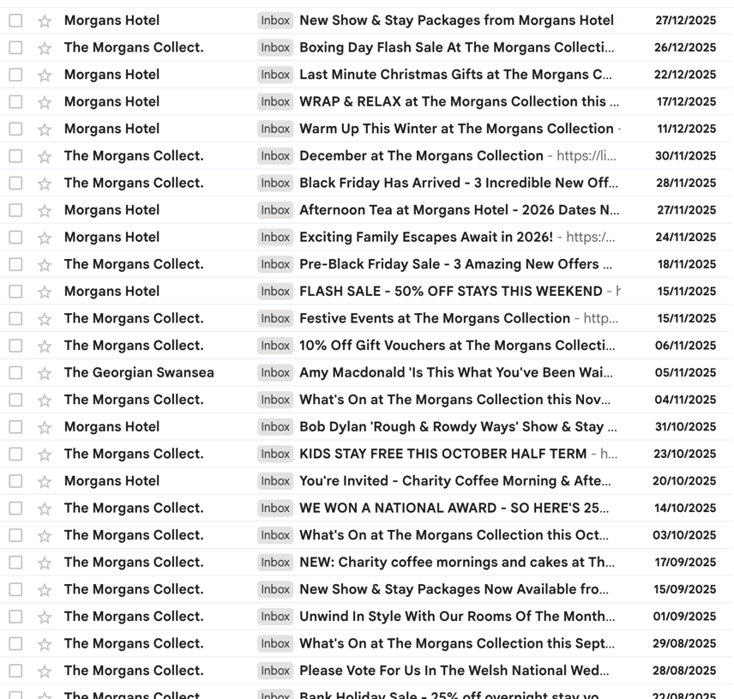
Figure 34

Direct email marketing

Figure 35





Morgans Hotel Logo
Morgons Hotel.

Figure 36
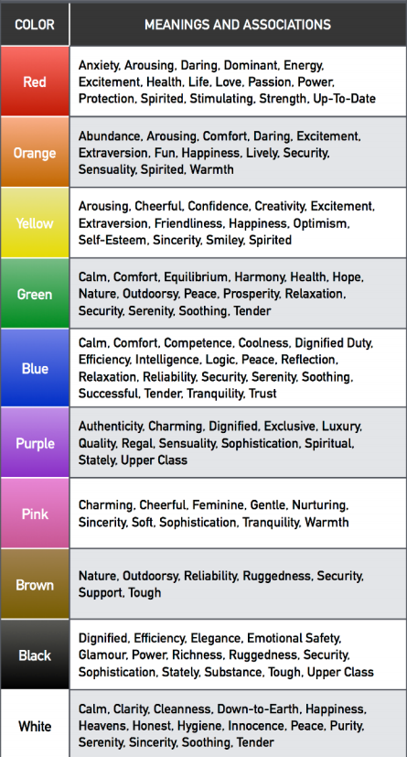

(Chen, 2025) Logo Colour Meaning

