Reflective review on employability skills
Waqar Ali

BMSW 4001

Academic and employability skills

------------------------

giridhar katti

7th December 2021

Introduction

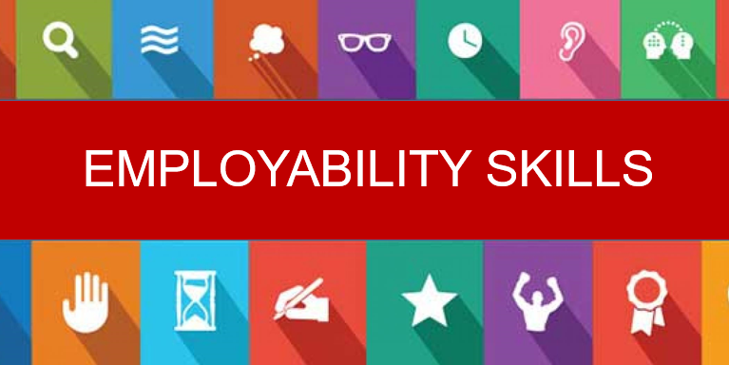
The employability skills I feel I have developed the best in my time learning on this module include: Time Management skills, Presentation skills, Digital skills and Team Working skills.

I will individually describe how each of these skills have developed as I've gone through the module and in conclusion how they potentially will affect my future learning.

It has been a very rewarding and challenging time in my life as I have progressed and will continue my learning journey.

I had identified early on that this would be a major hurdle for me in my learning journey, the way I overcame my problems with time management was to use the 4d’s of time management Drop, Delegate, Delay and Do. This helped me priortise my day in order of importance and doing the tasks required to help my learning first was a major victory for me.
I was easily distracted by my personal technology usage like mobile phone usage and gaming which would take me away from learning effectively. I made daily lists to make sure I was keeping up with my classroom assignments and deadlines. I found myself getting up earlier in the day which improved not only my university work but also my professional life as well.
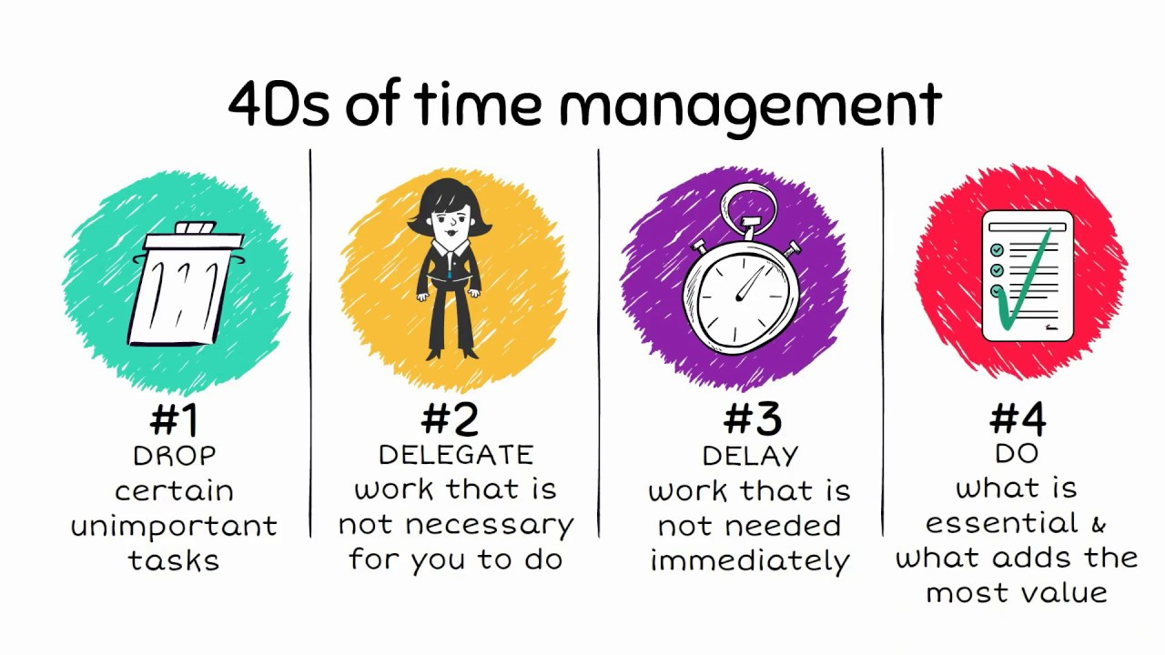
I have learnt to manage my daily routine so effectively that unplanned emergencies are no longer the massive problem they once were as now I have more free time to deal with them. I have a planner in place now for my educational and personal life so I write down what I will be doing day to day, and this has led me to be more productive in everything I ‘m doing.
I use my time so much more now and this is a massive plus for me as previously I found myself never completing anything in its time as I would always be running late.

- List your contents here
- List your contents here
Time Management Skills

Presentation skills

During the time I have been on this module and within the higher education classroom and working online my presentation skills have really developed. The main benefit I have found is that my public speaking skills have really improved, previously my public speaking was very nervous, and I would freeze up when presenting very basic ideas. I now feel more confident when performing presentations in front of the class and in the future, this will help me present to a wider range of people.
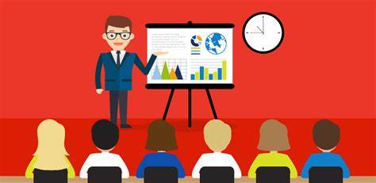
Initially I was very nervous whenever I was asked to present in any way, speak in front of the class but now I am very confident whenever I am asked to present. I have developed a more confident approach when speaking in front of fellow students or teachers and I am able to get my information across well.
During the module I have made various presentations to my classmates and teacher, previously I had many confidence issues when asked to speak publicly.

Using technology in my higher education journey has been thoroughly enjoyable for me.
For example, whenever I have had to produce PowerPoint presentations my work has improved a lot due to the extra teaching I've received when using programmes such as Microsoft word and PowerPoint.
My digital skills very much improved due to having to become familiar with my laptop and the programmes available to allow me to do my work.
I no longer struggle to use software’s, and this is due to my work so far in higher education.
I consider the use of digital skills now to be second nature and very much look forward to a long relationship with technology now that I am lots more confident using it to do my work and create with.

DIGITAL SKILLS

Team Working Skills

Team working has been a massive part of my learning process and a something that I have developed whilst combining with my various students to complete tasks and objectives.
In my classroom learning and online learning platforms I have been working with my fellow classmates to complete tasks when requested by the teacher and I have found the opportunity to work in a team with people from diverse backgrounds which has been immensely enjoyable and made learning fun.
Teamworking has enabled me to work better and gain varying perspectives on the tasks I have completed, my interpersonal skills have really developed as previously I have never really worked as a member of any team in the educational world and have found it to be wonderfully refreshing to me as I have been introduced to new cultures made new bonds while learning.

Conclusion
The many skills that I have learnt so far on my learning journey have developed my range of ability and enhanced my employability in an ever-progressive labor market.
This can only help me in my educational life as well as be applied to any part of my personal life as well as a father and working man.
The skills I have learnt are life changing and have improved my ability to look at issues which previously may have seemed very daunting but when applying the range of skills I have learnt most issues become easily solved.
By using models such as the 4D’S of Time Management to organise my day I am sure that I can be successful in anything that I put my mind to and achieve great things.
The skillset I am developing will also make me an attractive prospect in the world of work as they are very easy to transfer into my industry.
I am at the beginning of my skill development and look forward to enhancing my skillset even more and becoming a more proficient student able to use the various tools that I will need.
My continual learning will also help me acquire a higher position in my company and move upwards by using my skills effectively.

‘’The world of work continues to evolve rapidly, with changes only set to increase in the wake of the covid-19 pandemic. Employers placing value on different skills, and new roles are emerging as growth sectors shift; all the while, an acceleration in economic, societal, and technological advances drive forward the pace of change.’’
Employability Skills Research and Trends | Barclays LifeSkills
‘’Employability skills are those basic skills necessary for getting ,keeping and undo well on the job’’
9-15-00.PDF (face.edu)
Despite the misconceptions, recent studies in Nevada and Canada have been successful in validating, updating, and regionalizing generic employability skills and competencies over time
(employability Skills Toolkit 2000; Richens 1999).
‘’The implementation of employability skills in the instructional process is to integrate them into the classroom for all subjects’’
The Employability Skills Needed To Face the Demands of Work in the Future: Systematic Literature Reviews (degruyter.com)

Academic References

