Report on workplace culture and context
Lecturer: Julie Thomas
UWTSD
Student Number: 1705273
Morom Ali
Submission date: 5th April 2019

Executive summary
In this report, I have been asked to demonstrate my detailed understanding of the workplace and context of one organization which will be Amazon. My report will include the following an environmental analysis of the organization using PESTLE. An analysis of the structure and culture of the organization, using at least 2 models. An analysis of the organization's ethical stance. An explanation of how would need to behave to fit in with cultural norms and be successful in the organization. A comparison of the organization's culture with another organization.

Contents
Executive Summary………………………………………….……..Page 2
Introduction…………………………………………….……..……….Page 4
PESTLE Analysis on Amazon…………..……………………….Page 5
Political Factors affecting Amazon………………………. Page 5 - 6
Economic Factors………………………………………………..Page 6 - 7
Sociocultural Factors Influencing Amazon………………..Page 7- 8
Technological Factors in Amazon Business………………..Page 8 - 9
Legal Factors…………………………………………………………Page 9
Environmental Factors…………………………………………..Page 10 - 11

Amazons Structural Hierarchy…………………………………Page 12 - 13
Cultural Models Identified by Deal and Kennedy……………………Page 14- 15
Cultural Models Identified by Handy and Harrison……………….Page 16 - 17

Corporate social responsibility………………………………….Page 18
Customers…………………………………..……………….……..……Page 18
Employees…………………………………….…………………….…..Page 19
Communities…………………………….………………………...…..Page 19

Cultural norms to fit into Amazon……………………………Page 20 - 21
Lush Limited…………………………………………………………….Page 22- 23
Amazon Action Plan………………………………………………..Page 24
Conclusion………………………………………………………………Page 25
Recommendations…………………………………………………Page 26
Appendix…………………………………………………………………. Page 27
References…………………………………………………………………Page 28 -30

Introduction
Founded in 1994 by Jeff Bezos, Amazon is one of the largest internet retail company in the world. They sell a variety of products from books to electronics accessible to buyers all over the country. They have been able to establish themselves by having competitive prices for the products they have on offer online. Their focus is on e-commerce, artificial intelligence and cloud computing (Amazon, 2019).
Amazon has several of its own products that have been very successful which include Amazon Appstore, Amazon video, Amazon Prime, Amazon Echo, and Amazon Kindle.
“Our vision is to be earth's most customer-centric company; to build a place where people can come to find and discover anything they might want to buy online” (Farfan, 2019).

Pestle Analysis of Amazon
PESTLE is a strategic analytical tool and the acronym stands for political, economic, social, technological, legal factors and environmental. Amazon PESTLE analysis involves the analysis of potential impact these factors have on the business.

Political Factors Affecting Amazon
Amazon benefits from political stability. This creates an opportunity for the company to expand and diversify its business in developed countries, they must follow political and legal regulations in each location that they operate. However, many locations can be limited to online purchases. Therefore they must rely on government assistance to implement, distribute, and profit. Amazon depends considerably on political stability in all countries as well as e-commerce support.
The barriers with e-commerce businesses are not the same as the conventional businesses. Amazon is the leader in the e-commerce area, and it is affected by several political factors. for businesses like Amazon red tape in Asian countries can be a big problem. Red tape and control issues can be problematic as taxes and other political issues are very costly. Political disruption can disrupt the supply chain and result in reduced sales.
Amazon UK may be impacted by Brexit, a move predicted to cause both political and economic disturbance and uncertainty for the UK economy if it takes place. The consequences to leaving the EU are vast, the fact that it is already creating Brexit inflation as prices continue to spiral, due to a weakening pound against the dollar and Euro, a condition that will only get worse if Britain leaves the EU before 2020 (Mintel 2016).

Economic Factors
Amazon’s performance depends on the economic situation of where it operates its online retail business it is one of those businesses that can handle an economic drop and continue to be lucrative. It’s not limited as consumers will always have a need for items available on Amazon. Consumers have more disposable income, allowing consumers to spend more spontaneously on expensive items and entertainment which are all found on Amazon. The economic stability of more progressive nations increases the prospect of boosting their financial success for Amazon in this lucrative market. Such conditions reduce economic issues minimizing risks to the company’s online retail business. The possible economic recession of China endangers Amazon’s business. The Chinese market is one of the major markets that the company hopes to gradually enter. Regardless of Brexit, Amazon is expanding its UK workforce due to the growing demand for the products they sell. Experts believe that Brexit will affect Amazon due to a high chance that future hiring could become more difficult. This is because Amazon tends to rely on low wages. The main threat from a Brexit will be in the relation of tax and the effect on sellers. Depending on what type of economic agreements the UK government negotiates with the EU.

Sociocultural Factors Influencing Amazon

Social conditions determine Amazon’s performance as a leading online retailer. The increasing wealth difference between the rich and poor in many countries threatens Amazon in terms of development as disposable income growth is staggered in certain parts of the world. A higher disposable income is more favorable, in increasing revenue and creating more opportunities for Amazon to expand globally online. Irrespective the company stands to benefit from increasing online buying habits, as more people around the world gain access to the Internet. this benefits Amazon by focusing on market growth and expansion in developing countries.
In many areas of the world, the internet is controlled just because of ethical factors and religious values. This has restricted the sales in many areas for Amazon. The development rate of any business through internet is great. With advances in technology, internet users are increasing every year, with Amazon providing ways which will help to increase market share. Social networks like Twitter and Facebook are visited by hundreds of people every day. This social platform provides direct marketing. Amazon increases awareness via social network marketing strategies.

Technological Factors in Amazon’s Business

Amazon is a technological company, so these factors can greatly impact their profits. Amazon has gone through a great revolution but with the growth of internet access, people now easily access the internet wherever they want. This helps to improve services via mobile devices and shopping worldwide. Amazon lets the user get competitive prices which will help consumers to shop online within reach of mobile internet along with 3G and 4G accessibility. Amazon easily pulls consumers while shopping.
Technology is no doubt a big driver of business success. It presents many advantages that revolve around efficiency and effectiveness. Technology can also be a risk to businesses. Data violations and hacking that compromise the sensitive data of an organization and its consumers, and that lead to fraud.

They’re experimenting with new and creative ways for customers to receive their packages. In 2017, Amazon began testing their new idea of drone deliveries. They must comply with government regulations to allow the use of drones in this way. This shows the creative ways their looki9ng into to deliver to consumers in this fast-paced world.
Legal Factors
Selling overseas will require international laws for Amazon. Most items need separate laws which depend on shipping such as alcohols and chemicals. Rising product regulation is seen as a result of social demands on business organizations. This external factor produces opportunities for Amazon. to strengthen its efforts in reducing counterfeit sale on its online site. Also, the company has opportunities to grow, based on the external factor of easing import and export regulations. The company has opportunities to support its brand image through suitable corporate social responsibility policies that address increasing environmental protection regulations. Such an effort can increase business affordability in the remote or macro-environment.

Environmental Factors

Even though Amazon is mainly an online retail business, its operations are subject to the influence of the conditions of the natural environment
Amazon offers cloud storage which removes the costs for storage device or hardware services for the public. Meaning no need for computer components or hard drives. Online shopping means removing travel time and distance resulting in less pollution. Shipping products require extra packaging for shipment. However, Amazon is seeking ways towards greener shipping solution. Environmental issues have become global due to the ill effects of climate change that have been scientifically determined to be consequences of human activity. There is a global drive to preserve the environment which Amazon are looking at ways to do their part.

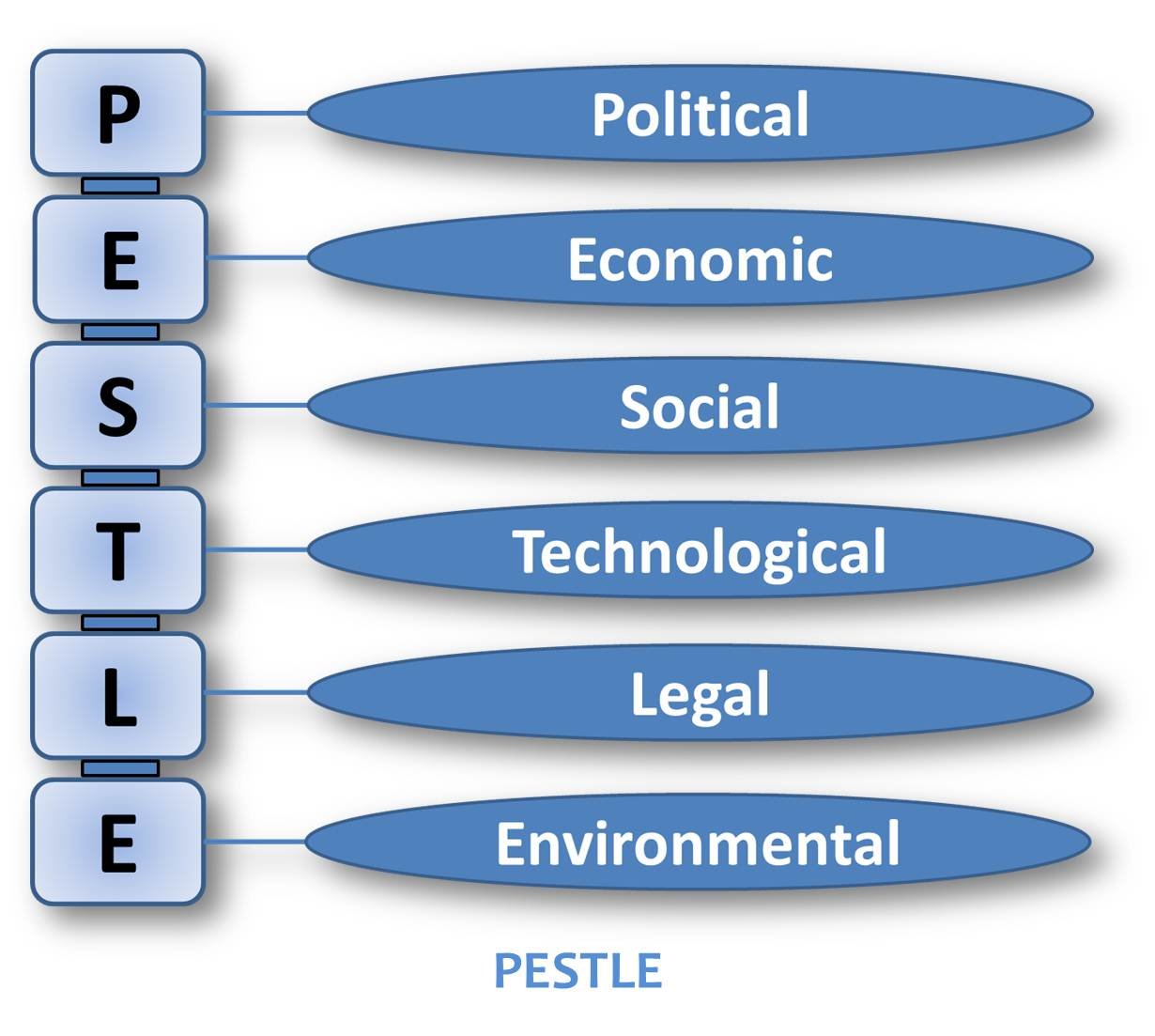

(Usb-ed.com, 2019) (Image 1)

Amazons Structural Hierarchy

Amazon organization structure can be classed as hierarchical. The primary management team includes two CEOs, three Senior Vice Presidents, and one Worldwide Regulator, who is in control of several characteristics of the business who must directly inform Amazon CEO, Jeff Bezos.
There are seven sectors such as information technology, human resources, and legal operations and heads of sectors corresponding to Amazon CEO.
Amazon organizational structure incorporates numerous small teams that deal with numerous parts of the business. Amazon founder and CEO Jeff Bezos are credited with the introduction of ‘two pizza rule". This means that meetings should be held in teams small enough that could be all fed with only two pizzas.
Amazon remains vastly accommodating to adjust to frequent changes in the external marketplace.
Amazon organizational structure allows wide control of global e-commerce operations. An organizational structure creates the strategy and system of interactions among staff
Amazon must sustain an organizational structure that sufficiently supports its expanding market. A developing corporate structure also aids Amazon as a company that adds more products and gradually diversifies its business. The structure balances the technological side of the business, creating Amazon’s corporate structure a determining factor in the company’s power to endure the effects of opponents, such as eBay, Apple, Google, Microsoft, and many other businesses with online and non-online managements.

(Image 2)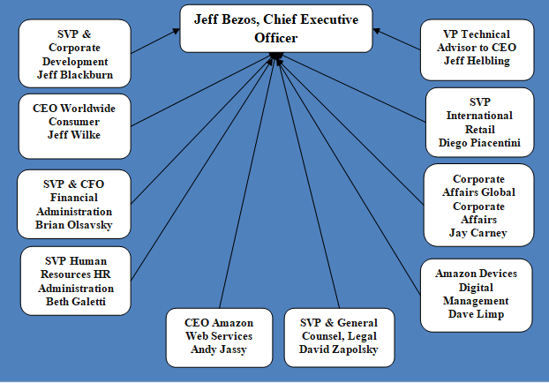

(Dudovskiy, 2019)

Culture Models Identified by Deal and Kennedy

There are numerous models of culture used for Amazon one of the first models of culture was identified by Terrene Deal and Allan Kennedy in their book Corporate culture: the rites and rituals of corporate life published in 1982, the idea of business culture is commonly recognized to be a vital part of business notion as economic control and employee contentment.
Deal and Kennedy regarded organizational culture as "the way things get done around here" for the individual organization. Deal and Kennedy would often assess organizations in regard to their feedback risk degree of doubt in organizational actions. They also recommended four organizational classifications of organizational culture- tough guy macho culture (prompt feedback and high rewards), work hard/play hard culture taking substantial risks and quick feedback. It is mainly suited to substantial businesses that demand good customer service.
The third classification is The Bet your Company Culture in which conclusions are made at a higher risk which may mean waiting years before seeing any results. The need to make the correct choice is so important the cultural fundamentals evolve that values are long-term driven and there is a shared belief in the need to plan, prepare and perform due effectively at all stages of decision making.
The final and fourth classification is The Process Culture which is shared in organizations that have little to no feedback. In this situation, it becomes usual for individuals to get preoccupied with how issues are done instead than with the objectives. Technical quality is often valued, and employees will give more consideration to getting the method and the details right without fundamentally measuring the real outcome.
(image 3)
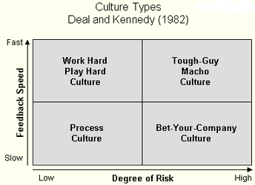
(Google.co.uk, 2019)

Culture Models Identified by Handy and Harrison

Charles Handy (1985) made Roger Harrison's 1972 work popular. The work connected organizational structure to organizational culture.
The work connects the organizational structure and culture. In this case, Amazon’s organization which is led by power cultures such as their structural hierarchy which gives power to a limited amount of people at the top taking control from the top regarding bureaucracy and fast decisions can be made.
The second type is role culture where every person has a specific role within the structure which Amazon does, they employ a management team, senior vice president, regulator and of course the CEO. Some organizations power remains in the hands of a few people and can make decisions. They are the ones in control in the workplace and are the major decision makers. These persons further allot responsibilities to the other employees.
The third is the task culture. where teams are created to solve problems and matrix structures exist with expertise as a typical feature every team member must contribute correspondingly and achieve tasks in the most original way accomplishing task culture
The final type by Charles Handy is Person Culture where individuals have been made to consider they are superior to the organization. The philosophy is used with professional firms such as law, engineering architectural, in addition other service firms

(Image 4)
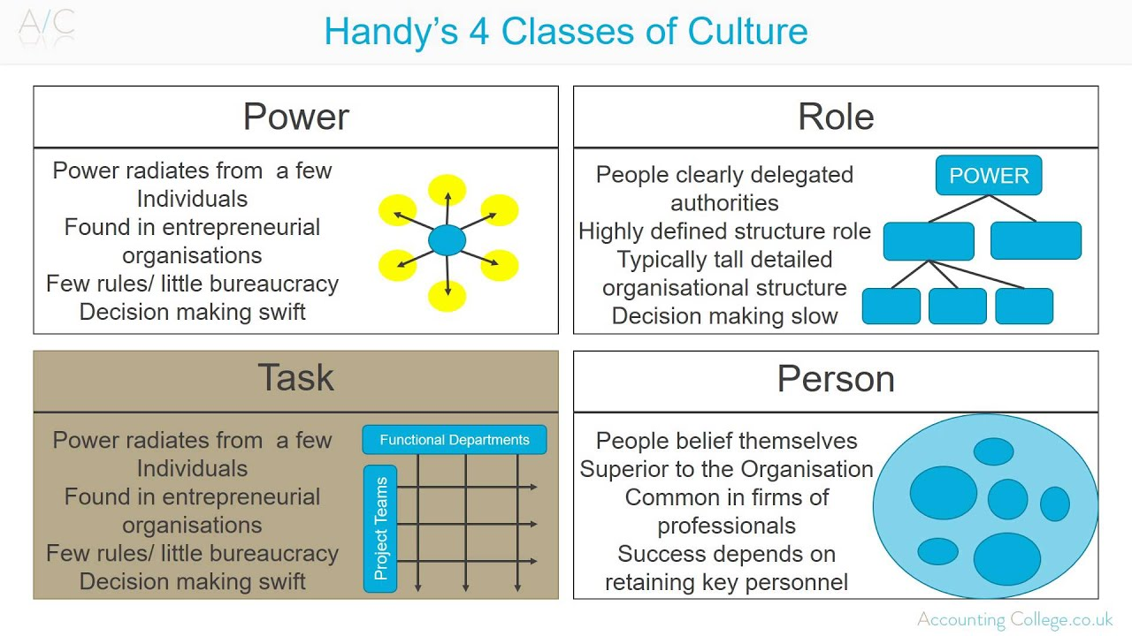
(Google.co.uk, 2019)

Corporate social responsibility

Amazon maintains corporate social responsibility by pursuing the concerns of its main stakeholder their customers, employees and community Amazon’s corporate social responsibility programs are designed to address and satisfy the interests of these stakeholder groups.
Customers
Amazon’s corporate social responsibility policy gives the maximum importance to customers as the vital stakeholder group. The business considers customers as the primary factor of its e-commerce business success, particularly because these stakeholders significantly affect incomes. This reflects amazons cooperate responsibility, which highlights the importance of customers in the business and its development. The interests of these stakeholders are fair pricing, the convenience of service, and online security in performing with the company. Amazon accomplishes all these interests through the importance on service and technology

Employees
Amazon values employees as significant factors of business performance and corporate social responsibility policies and programs. This stakeholder main interest is in competitive compensation and career development. Employees are vital as they support a competitive advantage based on Amazon’s organizational culture. The company’s human resources simplify the growth of new ideas to increase business ability. These stakeholders gain their interests through leadership development and a suitable compensation policy built on the organization’s high progress potential.
Communities
Amazon continues a corporate social responsibility program for communities. These stakeholders are important as they impact customer perception of the company's goods and services. The interests of communities comprise of development support, such as through education, healthcare, and environmental protection. The company addresses these interests mainly through its primary community support, Amazon Smile, where a percentage of sales revenues are donated to customers chosen charities.
Cultural norm to fit in Amazon

Amazon is a fast-paced company and its essential to be on the ball when working for such a large growing business. To work for this company, you’d need to fit in with their cultural norms which are the shared values, beliefs, and customs that influence the behaviors and practices. Because these norms differ from region-to-region, they can impact how a business operates in the international or global market. Amazon's organizational culture, however, has the undesirable attributes of straining employees and the human resources department. Amazon has at times been described as "bruising", "painful" all of which point to a place that is not so good to work. There have been reports on how employees weep at their desks, endure unbelievable pressure and firings for employees who fall flat to meet strict standards and metrics as set by the management. At times there have been claims that Amazon is a "workplace bully" (Yohn, 2018). When an organization is described as such, it shows that its culture may need a transform. Some employees may feel that at times it is the conservative and the not so unique ideas that will work yet they are strained and pushed to be different (Alvesson & Sveningsson, 2015). Unfortunately, all these negative points make it hard to work for Amazon even with the recent rise in wages to try and encourage moral for the employees to compensate for the physical and mental stress. Amazons main problem is that they value employees last and give all their attention to the customers which are fair as they generate revenue, but they must not forget that the company is based on employees doing their work efficiently to be able for them to compete with other companies. Many companies value their employees as they know treating them well will benefit them as a company.

Lush Limited
Recognized for its cruelty-free technique to cosmetics, Lush is a established front-runner in encouraging non-animal testing solutions. Lush also took a realistic method of addressing problematic subjects in the supply chain, such as providing ethics training to all providers. Lush has established a great level of customer relationship with its customers. Their principled business standards are shown through their products, campaigns, people, and service. Employees working in the business hold the company’s values and sincerely believe in it these the employees are made of people who have a desire for their products and for the company’s beliefs such as being against animal cruelty, ethical sourcing, and responsible packaging. These abilities are the top importance when seeking employees so that they can implant the passion for their products so they can convey this across to customers. In a first for a major retailer. They can work without restrictions and give away samples at their own discretion as the company wants to show their trust in them.
Lush’s employees are one of the brand’s ultimate resources. They’re tremendously enthusiastic about the company and its products. This natural passion is infectious. They have great training scheme that the employees are encouraged and shown all their products, so they have the confidence to show them to customers. Amazon would learn a lot from lush and the way they treat their staff. Their staff is treated well compared to Amazon. which makes them thrive when working there encouraging them always to do their best. Also, with Lush, they value their staff as just as much as their customers. They also provide training to a high level which gives their employees a passion for what they sell and do.
Amazons Action Plan
WHO | WHAT | WHEN | HOW | COST
Amazon | Treat employees with less firmness | Soon as possible | Show them that they are apart of a team and let them have freedom in decisions of productivity | N/A
Employees | Creativity skills, decision making, problem solving and communication | Time scale of 3-6 months | Introduce staff training sessions in colleges or universities to broaden their skills | Management would need to look into options available
Amazon | Introduce spacious staff rooms with games and tv staff can unwind | Soon as possible | Delegating a room for staff to take breaks in when they have long shifts | N/A
Amazon | Simplify retail prices and data precision | As soon as they can | Show data of products available and prices from other competitors | N/A
Amazon | Introduce incentives | After probation period | Offer gift cards for hitting targets | N/A
Conclusion
To conclude this report Amazon provides various products like clothing, grocery, electronics, beauty products, and health, mechanical or household items. All these external factors largely affect business rules and regulations. Jeff Bezos has built a company from nothing into a multibillion-dollar company. Regrettably, he has not valued the main people who are the employee instead of treating them with strictness and not allowing them to work more freely without any restrictions. Hopefully he will take into consideration of introducing training session to further educate the staff in decision making and problem solving so that there is an increase in productivity. The primary focus is on the customers and the higher hierarchy structure before any acknowledgment of the employees who should be priority as without them amazon would come to a standstill. Mr. Bezos should invest better in the training and keeping employees happy as this would only benefit him as this would reduce the cost in training new employees to replace the ones who were unhappy with the working situation. Although there are faults with treatment of employees Amazon is undeniable one of the most profitable e-commerce businesses to date.

Recommendations

Amazon has the essential strengths to endure its e-commerce dominance. However, the company encounters a variety of concerns. For instance, Amazon has a limited presence in developing markets. It is recommended that the company must enhance its strategic entry into evolving countries, which present major growth prospects based on rapid economic development. Also, to address the matter of competition against retail firms like eBay, Amazon must consider increasing its stores, which help increase market reach and brand popularity. Another recommendation is for Amazon to address counterfeiting and cybercrime through strengthened information technology measures for organizational and consumer security and protection. Amazon must also address all the problems employees are facing with their working patterns and not being happy with their working conditions and introduce better working conditions.
Making sure that the workers have a peaceful area where they can eat and socialize when on breaks e.g. maybe game room or free beverages machines. Also providing them with regular short breaks instead of just one extended one would make sure the employees don't lose concentration. Providing regular feedback will provide the employees with an insight of how they are doing and if they can improve on anything or whether there are other job opportunities that they can progress onto to further their position in the company. Increase wages according to the performance and position this will encourage employees to stay because they are appreciated for the job

Appendix
(Image 2)
Dudovskiy, J. (2019). Amazon Organizational Structure - Research-Methodology. [online] Research-Methodology. Available at: https://research-methodology.net/amazon-organizational-structure-2/ [Accessed 2 Apr. 2019].
(Image 4)
Google.co.uk. (2019). deal and Kennedy organizational culture - Google Search. [online] Available at: https://www.google.co.uk/search?q=deal+and+kennedy+organisational+culture&source=lnms&tbm=isch&sa=X&ved=0ahUKEwi6lYT9y7LhAhX5RBUIHWB7AB4Q_AUIDigB&biw=1366&bih=620#imgrc=Nq4-tYFEnXkVJM:&spf=1554248807865 [Accessed 2 Apr. 2019].
(Image 3)
Google.co.uk. (2019). handy model of organizational culture - Google Search. [online] Available at: https://www.google.co.uk/search?q=handy+model+of+organisational+culture&source=lnms&tbm=isch&sa=X&ved=0ahUKEwiD6ayWr7LhAhVaSxUIHcaHByUQ_AUIDigB&biw=1366&bih=620#imgrc=sTm32ugHTAuj7M:&spf=1554247955215 [Accessed 2 Apr. 2019].
(Image 1)
Usb-ed.com. (2019). [online] Available at: https://www.usb-ed.com/content/ContentPage%20Images/PESTLE.jpg [Accessed 1 Apr. 2019].

Reference

123writing.com. (2019). 123writing | Amazon Pestle and Swot Analysis 2018. [online] Available at: https://www.123writing.com/sample/amazon-pestle-and-swot-analysis-2018 [Accessed 2 Apr. 2019].

123writing.com. (2019). 123writing | PESTLE and SWOT analysis of Amazon Inc UK 2016-2017. [online] Available at: https://www.123writing.com/free-sample/pestle-and-swot-analysis-of-amazon-inc-uk-2016-2017 [Accessed 2 Apr. 2019].
Alvesson, M., & Sveningsson, S. (2015). Changing Organizational Culture: Cultural Change Work in Progress. Routledge.

Cox, Josie (2017) “Brexit fails to deter Amazon as it announces plans to expand UK workforce by 5,000” The Independent, available [Electronic] at: http://www.independent.co.uk/news/business/news/brexit-amazon-uk-workforce-expansion-a7585276.html [Accessed 02 April 2019]

Dudovskiy, J. (2019). Amazon Organizational Structure - Research-Methodology. [online] Research-Methodology. Available at: https://research-methodology.net/amazon-organizational-structure-2/ [Accessed 2 Apr. 2019].

Dudovskiy, J. (2019). Amazon PESTEL Analysis - Research-Methodology. [online] Research-Methodology. Available at: https://research-methodology.net/amazon-pestel-analysis/ [Accessed 2 Apr. 2019].

Dudovskiy, J. (2019). Harrison’s Model of Culture - Research-Methodology. [online] Research-Methodology. Available at: https://research-methodology.net/harrisons-model-of-culture/ [Accessed 2 Apr. 2019].

Farfan, B. (2019). Amazon’s mission statement. [online]. Available at: https://www.thebalancesmb.com/amazon-mission-statement-4068548 (Accessed: 30 March 2019).

Forbes (2016) “Top 10 Technology Trends for 2016” available [Electronic] at: https://www.forbes.com/sites/gartnergroup/2016/01/15/top-10-technology-trends-for-2016/2/#2b6fe9c12b07 [Accessed 02 April 2019]

Frue, K. (2019). PEST Analysis Of E-Retail Leader Amazon. [online] PESTLE Analysis. Available at: https://pestleanalysis.com/pest-analysis-of-eretail-leader-amazon/ [Accessed 1 Apr. 2019].
Johnson, Tara (2016) “The impact of Brexit on Amazon sellers” available [Electronic] at: http://www.cpcstrategy.com/blog/2016/06/brexit-amazon-sellers/ [Accessed 02 April 2019]

Linkedin.com. (2019). Pestel Analysis - Amazon case study. [online] Available at: https://www.linkedin.com/pulse/pestel-analysis-amazon-case-study-yoann-coraboeuf [Accessed 2 Apr. 2019].

Marketing Dawn. (2019). PESTLE ANALYSIS OF AMAZON. [online] Available at: http://marketingdawn.com/pestle-analysis-of-amazon/ [Accessed 2 Apr. 2019].

Mazzini, Anna (2016) “How do I … avoid using Amazon?” The Guardian, available [Electronic] at: https://www.theguardian.com/uk-news/2016/mar/04/how-do-i-avoid-using-amazon#img-1[Accessed 02 April 2019]

Panmore Institute. (2019). Amazon.com Inc. PESTEL/PESTLE Analysis, Recommendations - Panmore Institute. [online] Available at: http://panmore.com/amazon-com-inc-pestel-pestle-analysis-recommendations [Accessed 1 Apr. 2019].

Panmore Institute. (2019). Amazon.com Inc. Stakeholders, Corporate Social Responsibility (An Analysis) - Panmore Institute. [online] Available at: http://panmore.com/amazon-com-inc-stakeholders-corporate-social-responsibility-analysis [Accessed 4 Apr. 2019].

Panmore Institute. (2019). Amazon.com Inc.’s Organizational Structure Characteristics (An Analysis) - Panmore Institute. [online] Available at: http://panmore.com/amazon-com-inc-organizational-structure-characteristics-analysis [Accessed 2 Apr. 2019].
Pratap, A. (2019). A PESTEL Analysis of Amazon. [online] notesmatic. Available at: https://notesmatic.com/amazon-pestel-analysis/ [Accessed 2 Apr. 2019].

Taylor Harris (2016) “Brexit will complicate Amazon's UK expansion plans” CNBC, available [Electronic] at: http://www.cnbc.com/2016/06/24/brexit-will-complicate-amazons-uk-expansion-plans.html [Accessed 02 May 2019]

Yohn, D. L. (2018, March 13). Company culture doesn’t need to be “warm and fuzzy” to be effective. Retrieved February 27, 2019, from https://qz.com/work/1227352/amazon-proves-company-culture-doesnt-need-to-be-warm-and-fuzzy-to-be-effective/

