

RESEARCH PROPOSAL

THE IMPACT OF INFLUENCER MARKETING ON CONSUMER PURCHASE DECISION IN THE SPORTSWEAR INDUSTRY

Student name: Chandanpreet kaur
Student Id : 2227261
Lecturer: : Dr.Jayalakshmi Gopalkrishnan

Table of Contents
1. Introduction 3
2. Main Body 4
2.1 Methodology 4
2.2 Aims, Objectives and Questions 5
2.2.1 Aims and Objectives 5
2.2.2 Research Questions 6
2.3 Literature Review 6
2.3.1 Brief Review 6
2.3.2 Theoretical Underpinnings 9
2.4 Limitations 9
2.5 Ethical Considerations 10
2.6 Timeframe 10
3. Conclusion 11
Reference List 12

1. Introduction
Influencer marketing has become a dominant force in the marketing landscape that helps to influence customer behaviour. In particular, influencer marketing in the sports industry gained major attention from scholars. Trivedi and Sama, (2020) asserted that the sports influencers are the social media influencers that mainly focus on various sports, nutrition, workouts, and general training. In addition, a sports brand collaborates with influencers to create strong and compelling content, which resonates with the customers. The essence of influencer marketing is proper product promotion and a necessary factor of this marketing form is that influencers need to be recognised with the product (Chopra et al. 2021). This is the reason that people in the sportswear industry have not recommended the product without experience.
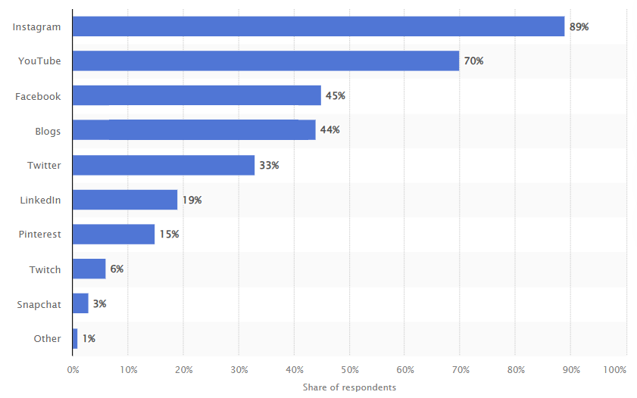
Figure 1: Leading Platforms for the Influencer Marketing
(Source: Dencheva, 2023)
The above figure shows some leading social media platforms regarding influencer marketing all around the world. It has also been shown that 89% of total marketers believe that Instagram is a major platform for influencer marketing (Dencheva, 2023). In this context, through captivating visuals, inspiring narratives, and engaging videos, most sportswear brands capture the essence of determination, athleticism, and empowerment to leave the viewer's impressions.

2. Main Body

2.1 Methodology
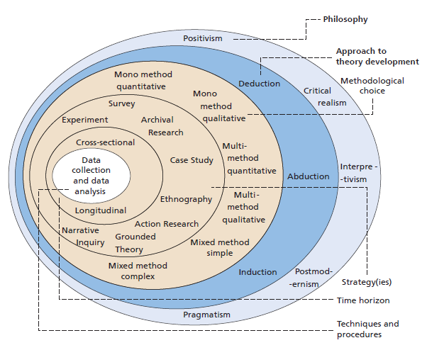
Figure 2: Research onion
(Source: Saunders et al. 2019)
In this research, the methodological structure would be based on the research onion model. As per the views of North and Maçada (2021), the research onion model helps researchers understand the key stages to be followed for developing a proper research methodology. Based on this model, the research philosophy would be described initially, followed by the research approach, strategy and data collection and analysis methods. Research philosophy can be categorised into four major types, positivism, pragmatism, realism and interpretivism. An interpretivism research philosophy involves the integration of human interest into a study. In this regard, Irshaidat (2022) asserted that an interpretivism philosophy helps in profoundly penetrating the complexity of social behaviour and generating accurate insights. Therefore, unlike other philosophies, an interpretivism philosophy would be suitable for investigating the concept of influencer marketing in the context of the sportswear industry.
The following definition of the research philosophy, a research approach will be defined for determining the approach to theory development. Among the deductive, inductive and abductive approaches, an inductive approach will be chosen for this study. An inductive approach involves observations of data for generating data patterns and accordingly, developing a new theory or explanation based on this pattern. As opined by Kyngäs (2020), inductive content analysis helps in reducing the group data through a process of abstraction that allows researchers to answer study questions using concepts, categories and themes. Therefore, contrary to other approaches, an inductive approach will be most suitable for analysing how influencer marketing strategies can affect consumer purchase decisions in the sportswear industry.
A research strategy is used to determine a definite research direction and can be categorised mainly into survey, case study, action research, ethnography and grounded theory. In this study, a grounded theory strategy will be used. Grounded theory is mainly used across systematic methodology that is applied across qualitative research. The findings from the study by Charmaz and Thornberg (2021) asserted that applying grounded theory to qualitative research has allowed an increase in research quality by providing an effective method of theory construction. Therefore, in contrast to other strategies, a grounded theory strategy will be appropriate in determining the challenges faced in the sportswear industry while opting for an influencer marketing strategy.
For research choice, a multi-method will be used based on both secondary and primary qualitative data collection approaches. Accordingly, interviews will be used as the preferred method of primary qualitative data collection, including 5 open-ended questions asked to 5 customers, being regular footwear buyers, in the global sportswear market. According to Thunberg and Arnell (2020), in-person interviews are deemed as a gold standard in qualitative data collection that helps both verbal and non-verbal cues to be taken into account. Hence, conducting interviews can help in analysing the impact of influencer marketing on consumer decision-making processes in the sportswear industry. On the other hand, for secondary qualitative data, various online journals, newspapers and official reports will be used. Online journals will be searched through Google Scholar and the primary databases include Sage, Emerald, Wiley, Springer, Elsevier, Taylor Francis, ScienceDirect, and EBSCO.

2.2 Aims, Objectives and Questions

2.2.1 Aims and Objectives
The primary aim of this study is to determine the impact of influencer marketing on consumer purchase decisions in the sportswear industry. In this regard, the following objectives have been designed.
- To investigate the concept of influencer marketing in the context of the sportswear industry
- To analyse how influencer marketing affects consumer purchase decisions in the sportswear industry
- To determine the challenges that this industry has been facing in opting for influencer marketing
- To recommend ways using which Sportswear companies can ensure effective utilisation of influencer marketing concepts for better consumer purchase decision

2.2.2 Research Questions
- What is the concept of influencer marketing in the context of the sportswear industry?
- How does influencer marketing affect consumer purchase decisions in the sportswear industry?
- What are the challenges that this industry has been facing in opting for influencer marketing?
- How can Sportswear companies ensure the effective utilisation of influencer marketing concepts for better consumer purchase decisions?

2.3 Literature Review

2.3.1 Brief Review
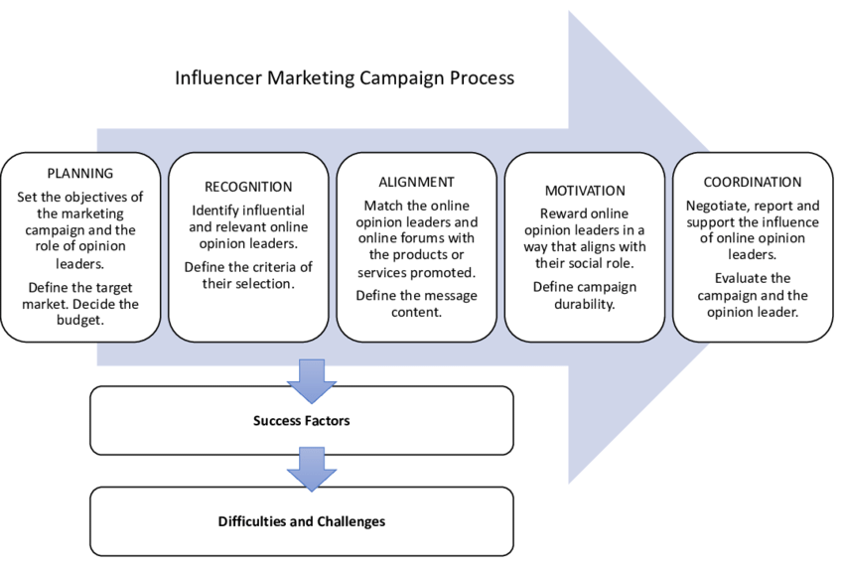
Figure 3: Influencer marketing process
(Source: Inspired by Martínez-López et al. 2020)
Influencer marketing refers to a collaboration between popular social media personalities and various global and local brands for the promotion of products and services across social media. As per the views of Martínez-López et al. (2020), the main purpose of influencer marketing involves facilitating a significant increase in brand awareness and consequently, allowing more traffic to be driven to the official website of the company. Content getting shared through influencers across different social media platforms garners a significant level of attention from online people, thereby allowing brands to gain numerous high-quality and authentic backlinks. Furthermore, the quality of the product or service promotion can improve significantly if proper collaboration and communication are maintained between brands and influencers.
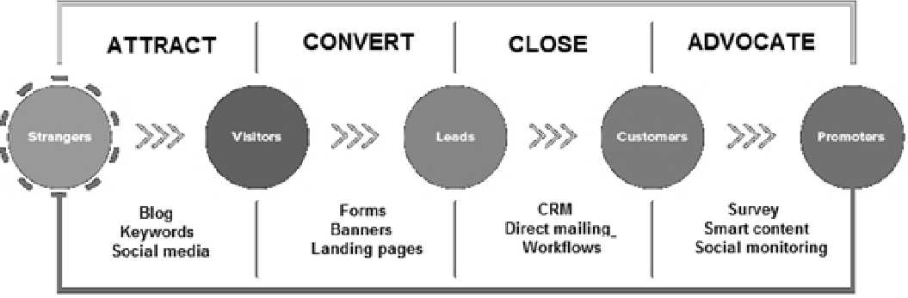
Figure 4: influencer marketing influence on consumer purchase decisions
(Source: Inspired by Belancheet al. 2021)
Influencer marketing has a considerable influence on consumer purchase decisions across respective markets. As per the views of Belancheet al. (2021), when an influencer promotes a certain product, a consumer is more likely to buy such a product. This can be mainly attributed to the fact that the products and services promoted by influencers are deemed to be more authentic by the online population, owing to a deep connection maintained between the influencers and the online audience. Another study by Schouten et al. (2021) asserted that compared to celebrity endorsements, online customers have a greater level of trust for the products promoted through different influencers. Hence, through the implementation of influencer marketing, organisations across different sectors can positively influence consumer purchasing decisions, driving a greater number of online sales.
Influencer marketing, however, can present a wide range of challenges for marketers that ultimately hamper brand reputation across respective markets. In this context, Kim and Han (2020) noted that fake influencers are one of the major concerns associated with influencer marketing. The high number of fake influences across current social media platforms severely impacts the purchasing experience of customers. This leads the customer to develop poor trust towards brands engaging with fake influencers across different social media platforms, which directly impacts local and global sales. On the other hand, Leung et al. (2022) argue that poor campaign implementation by content curators and influencers is another major issue faced when opting for influencer marketing. Due to poor campaign implementation, influencers are unable to create content relevant to the target audience and therefore, causes a significant loss in consumer trust and overall sales.
In response to the aforementioned issues, firms need to adopt appropriate strategies to ensure an effective influencer marketing strategy is conducted that can help attract a large number of potential customers. For instance, the issue related to fake influencers can be mitigated by looking specifically for influencers having an audience that is interested in a particular niche market. Firms should place a keen focus on determining the level of engagement of influencers, alongside identifying the size of the audience across respective social media platforms (Chopra et al. 2021). Organisations should also undertake necessary steps to analyse the content of influencers to determine the topics that the audiences are interested in while ensuring these interests align with the brand values. Another study by Mitchell (2021) asserts that offering incentives to influencers to promote a brand’s products is another means to improve the effectiveness of influencer marketing. Incentives can be offered through various methods including commissions or providing free products or services

2.3.2 Theoretical Underpinnings
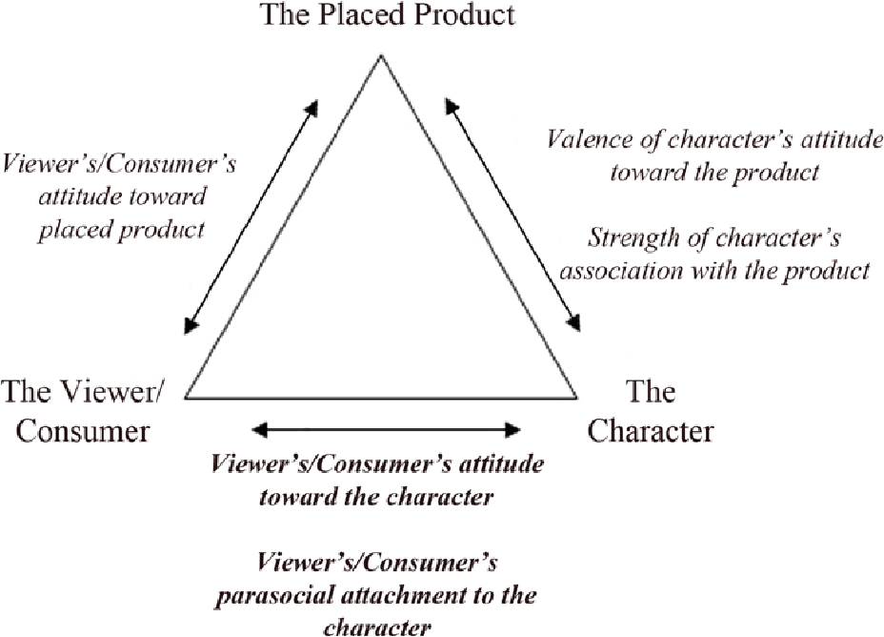
Figure 5: Parasocial interaction theory
(Source: Influenced by Chen et al. 2021)
The “Parasocial interaction theory” is an exposure that garners interest in the persona and becomes such a parasocial relationship that after repeated exposure. Moreover, Zheng et al. (2020) suggested that influencer marketing has become the dominant force in the marketing landscape that influences consumer behaviour in a major way. Through fostering trust, the following theory builds brand awareness along with providing social proof. Moreover, the impact of overall influencer marketing has led to a shift in the way that customers make some purchase decisions. Chen et al. (2021) stated that parasocial interaction theory helps to connect an organisation to credible individuals in a niche community and that as well with a large and engaged following. An organisation can use this theory in implementing influencer marketing that can encourage its followers to interact with the services and products. In this context, organisations working with influencers can promote their services and products through sponsored reviews, content, and recommendations.

2.4 Limitations
The literature reviewed above has a wide range of limitations in terms of the research outcomes presented. Most literature does not include any definite relationship between the concepts discussed and relevant theoretical frameworks. For instance, the study by Belancheet al. (2021) presents a positive relationship between influencer marketing and consumer purchase decisions. However, this study does not include any theoretical link with the above relation made. Furthermore, limitations are also observed in the methodology, wherein only qualitative data has been collected. Qualitative data can be prone to bias and therefore, lowers the authenticity of the study. Furthermore, the absence of any quantitative data prevents any objectivity from being maintained in this study, thereby further declining overall research authenticity.

2.5 Ethical Considerations
As the research will contain primary quantitative and secondary qualitative data thus primary and secondary research ethics concerns have to be maintained. Ethical consideration is most important in primary qualitative research as it involves several external stakeholders as primary population. Secondary research also requires data protection and disclosure related ethics. For this research ethical principles of the “UK Data protection Act 2018” will be considered for future ethical guidance of the research (Legislation.gov.uk, 2023). An ethics form will be filled before starting the research. Participant consent forms will be prepared and distributed to the interview participants before conducting the interview. Data gathered from the participants will not be manipulated and participant information will not be disclosed to maintain proper ethics. Secondary research ethics will be maintained by also maintaining the integrity of the data found from the secondary sources. No tampering of data will be considered for obtaining desired results.

2.6 Timeframe
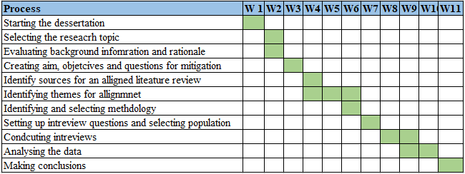
Figure 6: Timescale of the entire research
(Source: Self-developed)
The dissertation will start after topic approval and ethics form submission. The literature review and the data analysis process are expected to take the most time. Identifying themes for discussion, interview question setup, interviewing and result interpretation are the most critical part of the process and thus will ensure the most time allocation.

3. Conclusion
I have chosen to investigate the impact of influencer marketing on decision-making since I believe that social media influence has a positive correlation with the sportswear brand. Moreover, I realise that influencer marketing involves facilitating a significant increase in brand awareness and consequently, allowing more traffic to be driven to the official website of the company. After having recognised the limitations of the previous studies in the same field, I worked to produce a methodology, which would avoid these similar pitfalls as well as portray a strong relationship between a sportswear brand and customer’s decision-making. In this context, both primary and secondary qualitative methods will help impact influencer marketing positively on consumer purchase decisions in the sportswear industry.

Reference List
Belanche, D., Casaló, L.V., Flavián, M. and Ibáñez-Sánchez, S., (2021). Understanding influencer marketing: The role of congruence between influencers, products and consumers. Journal of Business Research, 132, pp.186-195.
Charmaz, K. and Thornberg, R., (2021). The pursuit of quality in grounded theory. Qualitative research in psychology, 18(3), pp.305-327.
Chen, T.Y., Yeh, T.L. and Lee, F.Y., (2021). The impact of Internet celebrity characteristics on followers' impulse purchase behavior: the mediation of attachment and parasocial interaction. Journal of Research in Interactive Marketing, 15(3), pp.483-501.
Chopra, A., Avhad, V. and Jaju, A.S., (2021). Influencer marketing: An exploratory study to identify antecedents of consumer behavior of millennial. Business Perspectives and Research, 9(1), pp.77-91.
Chopra, A., Avhad, V. and Jaju, A.S., (2021). Influencer marketing: An exploratory study to identify antecedents of consumer behavior of millennial. Business Perspectives and Research, 9(1), pp.77-91.
Irshaidat, R., (2022). Interpretivism vs. positivism in political marketing research. Journal of Political Marketing, 21(2), pp.126-160.
Kim, S. and Han, J., (2020). Detecting engagement bots on social influencer marketing. In Social Informatics: 12th International Conference, SocInfo 2020, Pisa, Italy, October 6–9, 2020, Proceedings 12 (pp. 124-136). Springer International Publishing.
Kyngäs, H., (2020). Inductive content analysis. The application of content analysis in nursing science research, pp.13-21.
Legislation.gov.uk, (2023). Data Protection Act 2018. Available at: https://www.legislation.gov.uk/ukpga/2018/12/contents/enacted [Accessed on: 1 December, 2023]
Leung, F.F., Gu, F.F., Li, Y., Zhang, J.Z. and Palmatier, R.W., (2022). Influencer marketing effectiveness. Journal of Marketing, 86(6), pp.93-115.
Martínez-López, F.J., Anaya-Sánchez, R., Fernández Giordano, M. and Lopez-Lopez, D., (2020). Behind influencer marketing: key marketing decisions and their effects on followers’ responses. Journal of Marketing Management, 36(7-8), pp.579-607.
Mitchell, M., (2021). Free ad (vice): Internet influencers and disclosure regulation. The RAND Journal of Economics, 52(1), pp.3-21.
Orth, C.D.O. and Maçada, A.C.G., (2021). Corporate fraud and relationships: a systematic literature review in the light of research onion. Journal of Financial Crime, 28(3), pp.741-764.
Saunders, M., Thornhill, A. and Lewis, P. (2019). Methods for Business Students (8th edition). Pearson Education: London.
Schouten, A.P., Janssen, L. and Verspaget, M., (2021). Celebrity vs. Influencer endorsements in advertising: the role of identification, credibility, and Product-Endorser fit. In Leveraged Marketing Communications (pp. 208-231). Routledge.
Thunberg, S. and Arnell, L., (2022). Pioneering the use of technologies in qualitative research–A research review of the use of digital interviews. International Journal of Social Research Methodology, 25(6), pp.757-768.
Trivedi, J. and Sama, R., (2020). The effect of influencer marketing on consumers’ brand admiration and online purchase intentions: An emerging market perspective. Journal of Internet Commerce, 19(1), pp.103-124.
Zheng, X., Men, J., Xiang, L. and Yang, F., (2020). Role of technology attraction and parasocial interaction in social shopping websites. International Journal of Information Management, 51, p.102043.

