

Assessment 1 – Reading Task Template
PART 1: Upload your photo of your A3 in-class notes here:

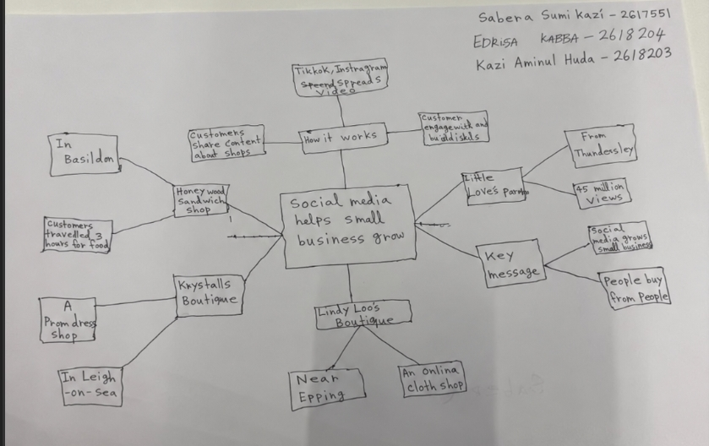

PART 2:
- Answer every question below in 1-3 full sentences.
- Use your own words. Do not use generative AI to answer these questions.
- Include a specific detail from the text when asked.
REMINDER
- The main idea is the overall message of the whole text.
- A key point helps to explain the main idea.
- A specific detail or example from the text shows that the key point is true.

- What is the main idea of the whole text?

The main idea of the text shows how social media can help small businesses grow and become more successful. It shows how TikTok and Instagram can help businesses become well known and attract more customers.

- What is one key point that supports the main idea, and which specific example from the text shows this?

One key point is that social media can encourage people to travel long distances to visit a business. For example, customers travelled three hours to Honywood Sandwich Shop in Basildon to try its chicken burger after seeing posts about it online.

- What is a different key point that supports the main idea, and which specific example from the text shows this?

Another key point is that social media helps small businesses reach a much wider audience. For example, the text show Little Love's Pamper Bus received around 45 million views on social media in less than a year, which helped the business grow.

4. Which part of the text do you think is most important, and why?

I think the most important part is the story about Little Love's Pamper Bus. It shows how sharing videos online can turn a small business idea into something much bigger by attracting attention from many people and increasing business.

Reflection:
5. What did you find difficult in this task (including in-class components), and why was it difficult?

To be honest, I found it difficult to understand some parts of the text when I first read it. Some of the words were unfamiliar to me, so I had to spend more time reading to understand what the writer was trying to explain.

6. What helped you with this difficulty, and how did it help you?

Reading the text slowly and going over the difficult parts helped me understand it better. I also found that writing down simple notes in my mind map made it easier to remember the main points and answer the questions.

