Catalin Michea
Student ID: 2232219
ACCA4031
Software & Apps fort Business
Task 1:
The industry is rife with cutting-edge e-Commerce website software options. Some of the most well-known ones are shown here. These programs make it simple for companies to launch and maintain their own web shops.
- Squarespace is a website creator that includes an online storefront. It provides a variety of storefront layouts to choose from, as well as capabilities for handling customer orders, stock, and deliveries. You can use the Squarespace mobile app to run your online business from anywhere.
- Cloud-based e-commerce platform 3dcart includes capabilities including product and order administration, as well as payment processing, affiliate management, and marketing tools. It also has a mobile app that allows you to manage your business from anywhere and editable templates to get you started.
- Wix is an e-commerce-ready website builder with an integrated online shop. It includes marketing, inventory, payment, and template customization features. Wix also has a mobile app so you can run your business from anywhere.
- OpenCart is a free and open-source e-commerce platform that includes capabilities for managing inventory, taking payments, promoting sales, and more. The templates are also editable, and it can communicate with other programs.
In the end, it's up to the individual company to choose what e-Commerce website software best fits its demands. Before making a final choice, think about things like price, usability, scalability, and adaptability. Before settling on a single option, businesses should do their homework and examine all of their available options.
Task 2:
Much software that accommodates different business needs exist today. The following are examples of some of the most typical uses:
- Software Package from Microsoft: Word, Excel, PowerPoint, and Outlook are all part of this productivity package. Word processing, data analysis, presentation, and email management are all common uses for these programs.
- Software for managing sales, marketing, and customer support interactions with customers; sometimes known as customer relationship management (CRM) software. CRM systems like Salesforce, Hubspot, and Zoho are a few examples.
- Planning, organizing, and keeping tabs on projects are all made easier with the help of project management software. Asana, Trello, and Basecamp are just a few examples.
- Bookkeeping, invoicing, and tax preparation are just some of the financial tasks that may be streamlined with the aid of accounting software. Software like QuickBooks, Xero, and FreshBooks are a few examples.
- Tools for facilitating communication and cooperation among members of a team, regardless of their physical location. Slack, Microsoft Teams, and Zoom are just a few examples.
- Human resources (HR) software allows firms to keep track of employee information, perks, compensation, and performance. As an example, consider BambooHR, ADP, or Gusto.
These are but a handful of the many programs designed specifically for use in commercial enterprises. The requirements of the business and its workers should guide the selection of appropriate software.
Mind Map:
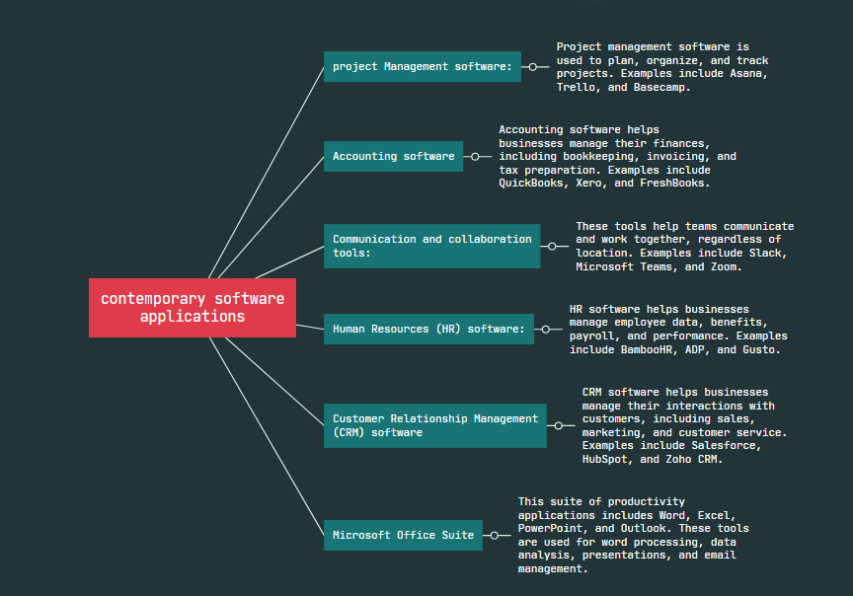
Task 3:
A).
There are a number of modern office programs that businesses can use to create, store, analyze, and show information and data. Here are a few of the most well-known:
- The Microsoft Word: This is a program for creating and editing documents that works with words. It has many features, such as tools for formatting, templates, and ways to work together. Users can make documents like letters, reports, and proposals that look professional with Word.

- Microsoft Excel: Excel is a spreadsheet program used to organize, analyze, and show off data. Formulas, charts, and pivot tables are just some of the powerful tools it gives you for analyzing data. Excel lets users make budgets, financial statements, and other reports that are based on data.
- Microsoft PowerPoint: PowerPoint is a program for making presentations and slideshows. It has many features, like animations, themes, and templates. Users can make interesting presentations with PowerPoint for meetings, conferences, and other events.
- Google Docs is a word processor that you can use on the web. It is similar to Microsoft Word. It has many features, such as real-time collaboration, comments, and a history of changes. With Google Docs, people can make and change documents from anywhere and work together in real time.
- Google Sheets is a spreadsheet program that you can use on the web. It is similar to Microsoft Excel. It has many different features, such as formulas, charts, and pivot tables. Users can use Google Sheets to organize and analyze data from anywhere and work together in real time.
B).
I tested some business-related features of Google Docs for this task. Here are some screenshots with short explanations:
- I started by creating a new document and naming it "Marketing Plan".
- Next, I added some text to the document, including headings and body text. I also used the formatting tools to make the text bold, italic, and underlined.
- I added some images to the document to make it more visually appealing. I used the "Insert Image" tool to upload images from my computer and position them in the document.
- I used the collaboration feature to invite other team members to edit the document. We were able to work on the document together in real-time, and leave comments for each other.
Google Docs is a great tool for creating and sharing documents in a business environment. Its real-time collaboration feature makes it easy to work with others, and the export feature allows for easy sharing with stakeholders outside of the organization. Overall, it's a great alternative to traditional word processing applications like Microsoft Word.

Screenshot:
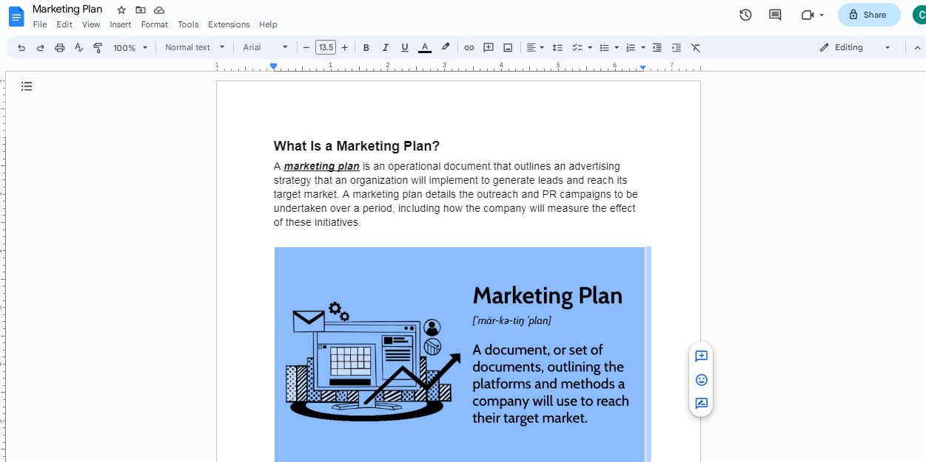
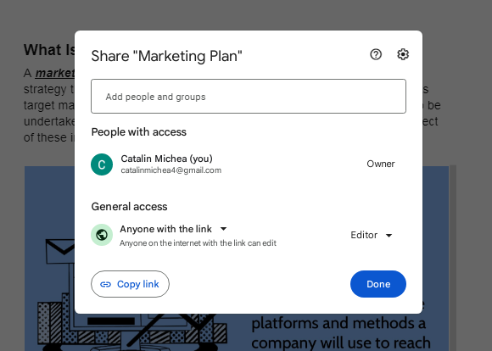

Task 4:
For this, I choose (ii) part to test Data Analytics software. Below are the steps demonstrating how I use Google Data Studio to create a digital dashboard for data analytics.
- First log in to Google account and navigate to Google Data Studio
- Click on the "Blank Report" button to start a new report.
- Connect to data source by clicking on the "Add Data" button.
- Once connected to data source, now you can start creating visualizations by dragging and dropping chart types from the toolbar on the right-hand side of the screen. You can also customize the visualizations by selecting different dimensions and metrics.
- To create a dashboard, click on the "Add Page" button and choose "Blank Page" or "Duplicate Page." Then, add visualizations to the page by dragging and dropping them from the toolbar.
- Customize the layout of your dashboard by resizing and rearranging the visualizations. You can also add filters and controls to allow users to interact with the data.
- Once you have created your dashboard, you can share it with others by clicking on the "Share" button in the top right-hand corner of the screen. You can choose to share it with specific individuals or make it public.
Screenshot:
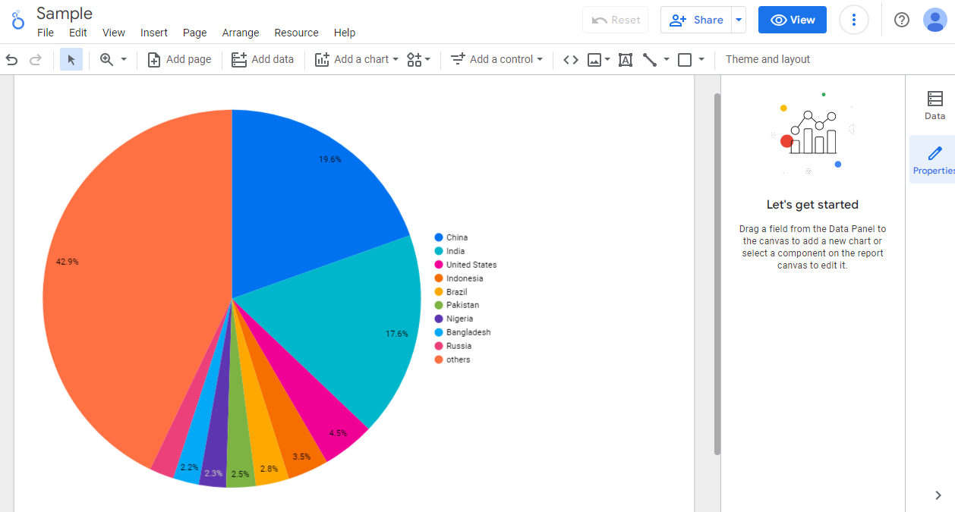
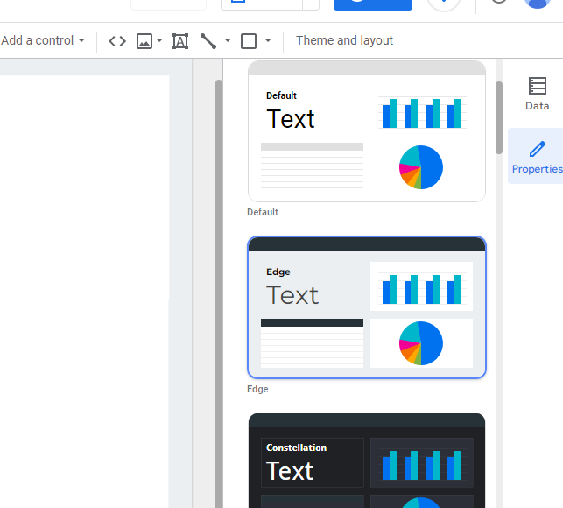

Task 5:
A).
Applications for communication, collaboration, and project management are now an important part of how businesses run today. Here are some modern apps and their most important features:
- Microsoft Teams is an app that lets people talk, work together, and share files in real time. It has things like instant messaging, audio and video conferencing, file sharing, and the ability to work with other Microsoft Office programs.
- Asana is a project management tool that lets users organize and keep track of projects and tasks. It has things like managing projects and tasks, working as a team, dashboards, and timelines.
- Trello is a tool for organizing and prioritizing tasks and projects. It is a visual way to manage projects. It has things like boards, cards, lists, checklists, and tools for working together.
- Slack is a tool for communication and teamwork that lets users talk to each other and share files in real time. It has things like instant messaging, audio and video conferencing, file sharing, and the ability to work with other apps.
B).
For this task, I tested the features of Trello, a free project management tool. The following are some screenshots with brief descriptions of the practical use of some of its features:

- Creating a new board - Users can create a new board to manage a project or a task.
- Adding a list - Users can add a list to a board to organize tasks.
- Adding a card - Users can add a card to a list to represent a task.
- Assigning a member - Users can assign a team member to a card to indicate who is responsible for the task.
- Adding a due date - Users can add a due date to a card to set a deadline for the task.
- Adding a checklist - Users can add a checklist to a card to break down a task into sub-tasks.
- Moving a card - Users can move a card from one list to another to indicate its status.
These features help in organizing tasks and tracking their progress, ensuring efficient project management and collaboration.
Screenshot:
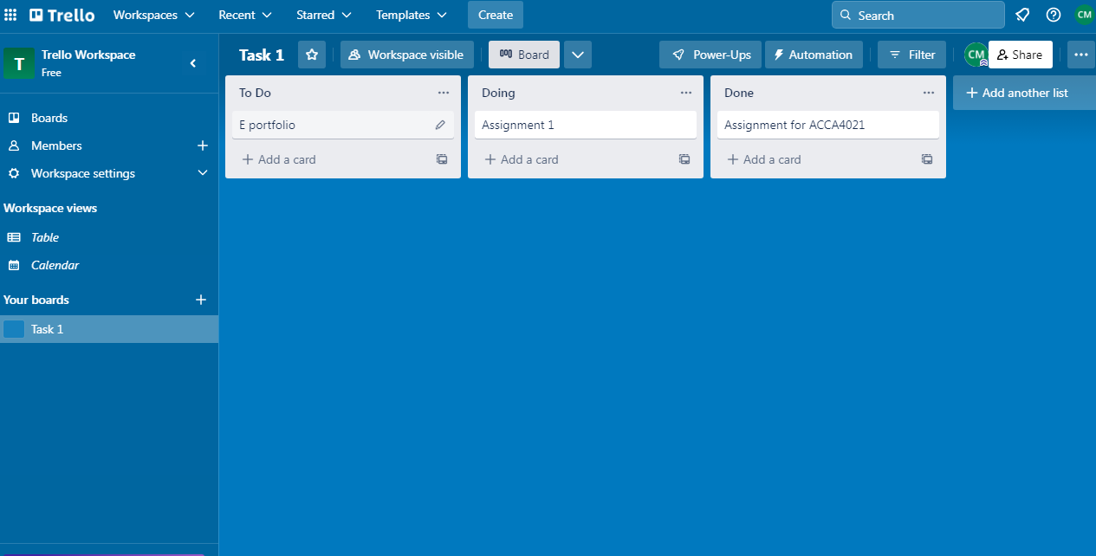
References:
Kruse, K. (2019). The 9 Most Important Software Applications of 2020. Forbes. Retrieved from https://www.forbes.com/sites/forbestechcouncil/2019/12/05/the-9-most-important-software-applications-of-2020/?sh=1d8f80d3f4c4
Tech.co. (2021). Best Project Management Software. Retrieved from https://tech.co/project-management-software
Merchant Maverick. (2021). Best Accounting Software for Small Business. Retrieved from https://www.merchantmaverick.com/best-accounting-software-small-business/
HubSpot. (2021). Best Communication and Collaboration Tools for Remote Teams. Retrieved from https://blog.hubspot.com/remote-work/communication-collaboration-tools
"How to Collaborate on Google Docs in Real Time." HubSpot, Accessed 28 March 2023, https://www.hubspot.com/how-to-collaborate-on-google-docs
"Export a Google Doc." Google Workspace Learning Center, Google, Accessed 28 March 2023, https://support.google.com/a/users/answer/9308834?hl=en

