
Skills for the Workplace
Module Assignment Submission
Student Name: | Jahanara begum
Student Number: | 1710632
Module No: | BMSK 6003
Module Title: | Leading and Implementing Workplace Change

Statement of Confirmation of Authenticity
By the act of making this submission, the student declares that this is the work of the student named above. The work has not, in whole or in part, been knowingly presented elsewhere for assessment, or where assessment has been built on a previous assessment, this has been identified. Where materials have been used from other sources it has been properly acknowledged. If this statement is untrue, the student acknowledges that an assessment offence has been committed.
Attention is drawn to the plagiarism and unfair practice policies of both the University and of ILM.

Contents

Introduction 3

Kurt Lewin’s Model 4, 5

Introduction to Macro & Micro 5

Macro Environmental analysis (PESTLE) 6, 7, 8

Micro Environmental Analysis 8, 9

William Bridge’s Transition Model 10, 11,

Stakeholder Theory 11

Stakeholder Analysis 11, 12

John Kotter’s Model 13, 14, 15

Conclusion 15

References 16, 17 , 18 ,19

Introduction

This report discusses an environmental analysis on micro and macro environments.
In addition, the importance of change in a workforce will be examined within the report, to discuss how businesses require change to help develop a better business strategy. The chosen organisation for this report analysis will be on Matalan.

Matalan Ltd is a British retail company that was conventional in 1985, the founder of the company is businessman known as John Hargreaves (Matalan, 2018). Matalan aims to succeed in providing exceptional value and worth for all families by selling clothing that ranges from women, men, teenagers, children and also home ware. From 2019 Matalan has developed 230 stores within the UK and has opened 30 international franchise stores throughout Europe and the Middle East, as well as this they have an online service that is constantly growing (Matalan, 2020).

McCullough (2019) argued that change in a workforce can be positive for the organisation in different ways such as; provides better business opportunities, encourages innovation, improves staff morale, develops skills and develops staff. This suggests businesses should take chances and take a change with their business strategies to enhance their business ventures for better. Also how important it is to keep up with change in order to stay competitive and develop as a business as well.

Change can be identified in many different ways when it comes to different workforces, as different organisations will have their own force for change. In general there are four types of change; 1) Life cycle, which suggests stages of growth, 2) dialectical (struggle-based), which is based on the social relations and interplay 3) evolutionary is based on the sustainability strategies, and 4) teleological (vision-based) relates to the strategic vision, (Clegg et al, 2015).

Although there are ways to change for organisation to develop for better, not everyone involved in an organisation like to change or agree with change, as some would argue it can be negative. As Dawson (2006) argues if an organisation is necessary for change to progress, then those involved within the workforce may agree to support the change in process. However, in relation to employees if the management team in an organisation decide to change specific workplace controls for the business profit, employees may not support this if this affects their level of work for the business such as their hours, pay or priorities.

Coaching is a key element when implementing change in workforces, as many leaders need to coach their individuals before they hand them new tasks. As well the leaders themselves sometimes need their own coaching as they fail to understand that it is not easy to process change. Therefore this further suggests how change is not easy to adjust to, as there are steps before that need to be understood and processed (Berlin, Eaton & Associates, 2013).

Kurt Lewin (1951)
Lewin believed that behaviours and attitudes were part of forces that are directed in one of two directions. The types of forces are driving and restraining forces, driving forces help encourage individuals towards change and resisting forces avoid individuals from meeting or processing those changes. Therefore, for change in behaviour to happen there must be recognition of the driving and restrainign forces that occur. For example, if the forces that are resisting change are lower than the driving forces for change, then there is a higher chance that changes can be made and met. But if both forces are equal the chances of change occuring are very low. This further suggest how lewin’s models helps understand how change can be affected in dynamic forces and how these should be assessed to help progress be made with organsiational change (Theordore, 2020).
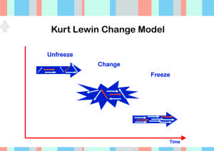

Kurt Lewin (1951) developed a theory of change model where he identified three steps for his model, 1) unfreeze (ready to change), 2) change (Implementation) and 3) refreezing (Making it stick) (Morrison, 2014). The first stage of unfreezing requires you to unfreeze existing conduct and attitudes for the change process, the second stage of changing requires you to place things where it is required. Lastly stage three after the success of changing things around you would refreeze the process again (Clegg et al, 2015).

Lewin’s model stressed the importance of improvement; the framework allows organisations to apply a ‘change effort’ within their workforce in a practical and effective way. The model has three areas where it can assist organisations; minimise the disruption of the structure’s operations, make sure that the amendment is adopted permanently and make a radical change. Although the model helps use change for better, the model theory can only be effective if those involved are able to agree with the change and put it into action (Morrison, 2014).

Additionally, the three steps identify how the change will take place, during the unfreeze stage can be implemented where a workforce has been placed within the same position for a long period, that eventually the organisation may be off tasks, not meeting aims or progressing. Therefore the unfreezing aspect helps establish what situation the organisation is in to help break it down and change the repeating habits that is preventing the business to progress. In other words, what is preventing the business to grow must be re-examined to put change into place (Morrison, 2014).

The next step of ‘change’ can take place once those within the workforce are able to express their minds, however in order to be an effective change it will require time and effort. As this would mean that new responsibilities and roles will take place, which suggests employees and staff would need to adapt to this, and not everyone can adapt in the same pace as some may be slower than others. As well as this, it would be a downfall for the workplace as it will slow the process of the organisation down as things are changing, as the time will take for change to be taught (Morrison, 2014).

Lastly, the last step of ‘Making it stick’ will help the change become stable in the workforce. The change should be implemented once it has been reached so that the organisation can keep up with its changes and new directions for the workforce. However, this does not mean the changes have ended, as continuous change can still be made in workforce to further progress (Morrison, 2014).

In addition, organisations are involved within a business environment, the movement of change impacts businesses in two different aspects; 1) Micro Environment Factors which is Internal and 2) Macro Environment Factors which is External. These two fundamentals help businesses develop decisions that will generate a tactical business plan.

The microenvironment involves elements that are secured inside the organisation; it has immediate contact with the organisation therefore will have an impact on the business outcome immediately. The many elements that are involved are suppliers, customers, competitors, employees, media and shareholders. The difference to this is macro environments which is based on the outside elements, the organisation does not have the authority to stop specific changes, however, can still affect how the organisation operates. The macro environments that impact the business are; political environment, economic environment, social environment, technological environment, legal environment and environmental, these elements are analysed through a PESTLE analysis. Overall both micro and macro environments help encounter the business as a whole to ensure specific elements can be developed to help improve the business services and performance (Surbhi, 2015).

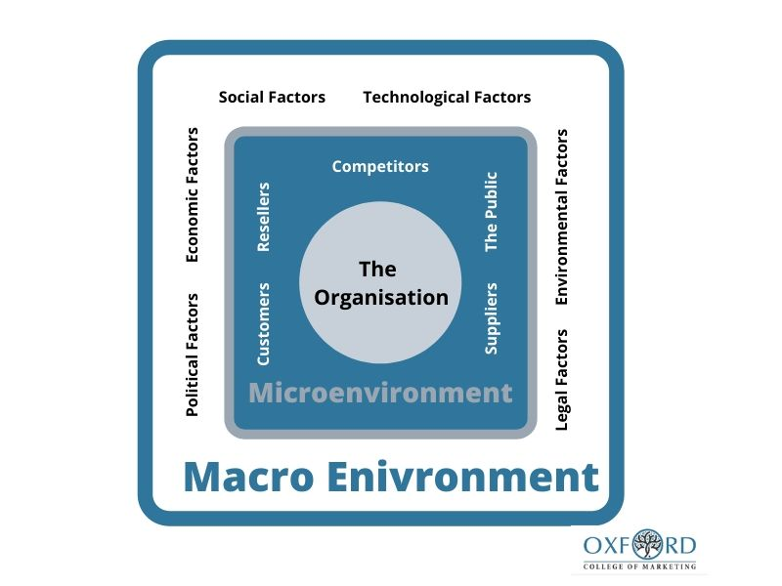

(Oxford College of Marketing, 2020).

Macroeconomic factors

Brexit- Political

Political matter is beyond organisations control, it represents influences, restriction and opportunity for businesses. Political matter can have a cultural change to the business as well as capability change. One political change that will have a major change for all businesses is Brexit (Sammut-Bonnici, T, 2015).
With Boris Johnson still negotiating a deal with the European parties for Brexit, it is still uncertain what the deal will constitute upon. Since the referendum that took place in 2016, there still has been no agreement put in place leaving businesses in uncertain position of what its business operation will look like in the near future.
An important issue that would affect businesses is the transition period towards Brexit especially with the change in trading conditions oversees. Businesses like Matalan plc would struggle to bind a contract with the overseas manufacturer due to continuous unstable economy mainly caused by the Covid-19 pandemic. With a bad trade deal in place businesses would not be able to get the top price and quality products from their manufacturer. Businesses would have threats from suppliers and lose the bargaining power in in sourcing quality goods for cheap as prices. (IBIS world, 2018).

Brexit has already had an immense impact on the currency exchange especially the power of sterling so far, whereby the value of sterling has decreased against other currency. According to (Matalan, 2020) it clarifies that the retail company sources is imported from Bangladesh. The reduction of sterling value would have a major impact on business expense, thus creating a scenario whereby Matalan will be required to spend more money for the same number of goods and therefore obtaining lower business profits.

Material usage- Environmental

Material usage has become a prominent area where the public has been looking at over the last couple of years, especially when there is climate change targets to be met worldwide by 2050(Institute for Government, 2020).
With animal fur being banned already for product use in the UK, it has meant that retail clothing shops like Matalan have to substitute the real animal fur for artificial fur (Matalan 2020). However, there have been recent parliamentary inquests of substituting artificial fur for real animal fur. The reason for the substitution is because artificial fur is very difficult to recycle, leading to landfill sites being filled thus more carbon footprint (Petter, 2018).

If the parliament does decide to change the use of material for certain products like animal fur, it would cause issues for businesses like Matalan. The retail industry would see a change in their organisation, because the organisation would need to revaluate its product portfolio which can potentially become very costly. It could potentially mean retail firm like Matalan would have to find alternative suppliers that provide material with ethical means and ensure that company is displaying a good corporate citizenship.

Fashion change -Social

Fashion is always changing with new trends depending on events and season. Retail firm like Matalan must act very quickly to the high demand in change or else they would not be able to compete in the market with its competitors and lose its market share. Since Covid-19 we have seen a huge swift in clothing, as individual went from office wear to comfort wear due to the lockdown (GGTN, 2020).

Fabric facemask has become a necessary need rather than a want and therefore clothing firms like Matalan had to act very fast in ordering to get these products in sourced and sell it online to consumers before other competitors during the lockdown period. According to Matalan (2020) trading updates, the company has saw a 24% increase in online sales, many of which was the need for comfort fashion clothing rather than office wear or outwear. The trading statements also stated that because of the pandemic some of Matalan stocks has become out of fashion or not needed by the consumers due to unprecedented times whereby a local lockdown can happen any time. It has led to Matalan having a difficult task to decide the number of stocks to order, and what product should then actually in source.

Technology innovation- Technology

Businesses have seen many changes in how their business is run. One major player that has changed how the business is run today compared to before is the innovation of technology. Technology has changed hugely and perhaps made business easier to run once full training has been given. Retailers like Matalan have started investing in more technology in order get a competitive edge in the market.
One tool that has been developed and being fully used in fashion firms like ASOS is image recognition (Share my insight, 2020) The lucrative technology recognises alerts on market trend and sends signals to the firms, this allows firms to react fast and bring out products before competitors, without the timeless online research browsing of consumers needs and wants.

Matalan issued on their annual account that the Covid-19 pandemic has meant that the firm has been solely focus in investing in social distance protocols and keeping employees and customers safe rather than investing in innovative technology like image recognition (Matalan 2020). The firm took due diligence in health and safety for the public, which would get a good reputation, however the lack of investment in innovated technology would only cause to lose sales and fall behind its market competitors. (Matalan 2020)

GDPR regulations- Legal

In 2018, a regulation has been passed by the parliament for all business to comply with called general data protection regulation (GDPR). The new legislation replaces data protection Act 1999 and is created to handle close personal information about consumers and employees (Business matters, 2018)

Like all businesses, Matalan has been affected by the new regime as the business is enormously reliant upon handling consumer’s data. With increase online service, especially during the pandemic period, it is crucial that the firm keeps confidential information about consumers in a protected way. A leak of consumer information can only cause bad business image.

COVID-19 -Economical

The Covid-19 disease has led to a worldwide pandemic and has affected every aspect from a business point of view. In many jurisdictions it has led to lockdown and therefore a standstill in business trades and uncertainty of their financial outlook. One of the main industry sectors that have been affected by the pandemic is the retail industry.
From 23rd of March all non-essential UK business was closed, which was ordered by the government and was only allowed to trade online delivery services during the lockdown period. (BBC 2020)

Matalan was significant affected during the lockdown period, as 85% of sales cAME from UK alone. Not only did the retail firm lost many revenue from sales, the firm was not able to attain a “corona virus large business interruption loan scheme or the Covid Corporate financing Facility” (Matalan, 2020) to help the financial side of the business.

With Matalan primarily focusing on fashion, it means that those stocks should be sold at a pace whereby it does not become an obsolete stock and therefore a loss for the firm. Unfortunately, Covid-19 has led to Matalan significantly changing and reshaping its incoming volume of stocks and having a major clearance on obsolete stocks in order to reduce the deficit per item (Matalan 2020).

During the lockdown period in the UK, the government had laid out a furlough scheme in order to help sectors like Matalan to pay their employees during the unprecedented period. Matalan have put in 10,000 employees on the coronavirus retention scheme in order to help the firm financially. However, with the scheme coming to an end in October 2020, there are higher chances that there will be employees becoming redundant. Many firms have already decided to cut jobs such as Debenhams, in order to maintain stability cash flow. Furthermore the national statistics published that it has seen the highest level of unemployment over the last two years at 4.1% which again is negative news for Matalan as it means consumer will have less spending ability and therefore demand would fall in many sectors such as travel and leisure as well as retail (BBC news 2020).

Microeconomics Factors

Employees

Employees plays a pivotal part in any business, they are the faces the consumer see every day in stores and plays a significant role in generating sales in the business. It is important businesses keep their employees happy by motivating their employees, with monetary and non-monetary remunerations.
With Covid-19 having a major impact right across all business organisation, it has led to business having emergency board meetings, regarding their employees pay during the lockdown period and forecast for the future. Board meeting consisted on deciding on employee’s contracts, how each employee will get paid, pay cuts and also redundancies. Matalan took advantage and used the furlough scheme that the chancellor brought out in his briefing to pay for 10,000 of their staffs. (Matalan, 2020). The major criteria of the furlough scheme are that employees will get paid a maximum of 80% of their wage per month. Matalan also decided not to pay the remainder 20% to give all staffs 100% wage during the lockdown period. Employees are likely to be demotivated by this change. The furlough scheme is expected to end at the end of October 2020, it is still unknown how future outlook will look like for Matalan in terms of keeping employees and recruiting employees. This change could potentially be a negative one for employee as they could become redundant.

Customers

It is important to observe customer’s needs and wants in order supply their demand. When the government gave the go-ahead to reopen non-essential stores in the UK after the lockdown, it was important that during that long period of time when Matalan was not dealing with face to face customer, the firm researched into consumer’s behaviour. Post lockdown has seen a huge change in consumer’s behaviour; many are concerned whether it is safe to go into stores (BBC News, 2020). Business were required to have protocols such as one way systems, face mask, and hand sanitizers across the stores in order to keep both customers and employers safe. In (Matalan, 2020) annual report, the company gave full guidance in stating that customers safety is their number one target and they have put out the necessary needs in stores so that customers feels confidence in coming into stores and shop. The new guidelines would mean extra cost for Matalan, in terms of having hand sanitizers in every stores and just having an extra employee in front of the store checking that customers are falling rules and regulation and ensuring the store in not over crowded.

Supplier

In the current competitive environment especially with the ongoing pandemic, it is significant to have a really good relationship with suppliers in order to meet business objectives. Suppliers are one of the key fundaments in a business strategy (Lemke, F et al, 2003). Matalan has a very long relationship with its suppliers which are located in Bangladesh. By having a long relationship with its suppliers, meant that Matalan can embrace bargaining power with its supplier, by bring in good quality products for cheap pricing. During the pandemic, it has become difficult for shipping products around the world to stores, because all shipping planes have become very limited. As UK was in pandemic, Matalan was also ordering less products from its suppliers as stores was closed and sales has dropped rapidly.
However according to (Matalan, 2020) Covid-19 business update, the business has in fact engaged with all its suppliers, in order to keep a good relationship with them and reassure the suppliers that they would be ordering more supplies once the stores reopen for customers.

Bridge’s Transition Model

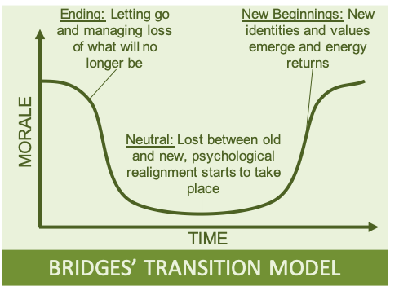
William Bridge developed a transition model where he describes three stages that help development of individual and psychological transition. Many other theorists such as Lewin, Elisabeth Kubler Ross and Scharmer’s theory have similarities with Bridges model (World of Work Project, 2019).

The first stage of his model is ‘Ending’ this stage requires individuals to forget and release the way things were before to help move forward. This is telling individuals to let go of previous responsibilities and their old selves. This can impact individual’s emotional wellbeing to let go of what they was used to. The second stage is the ‘Neutral zone’ which is once they have let go of their old lives and personal feelings, they are introduced to a new way of learning different things which they are not aware of. This stage helps understand new ways of different beginnings. The last stage is ‘New beginnings’ which helps individuals accept their new beginnings and develop their selves to new processes. They learn ways they never knew they could learn. However, not all can adjust to new beginnings and might find it hard to change to a new way of things (WOWP, 2019).

The transition model not only develops employees and staff members but it can also relate to leaders who need transition to help lead change in their workplace. Being a leader does not mean they are perfect in handling their organisations, sometimes those leader lack confidence and understanding to lead change. The transition model emphasises that change can happen, but individuals need to transition in order to move forward with the new changes they come across as some changes me be hard to process (BEA, 2013).

The model stresses the importance of understand one’s own self before adjusting to changes that are handed to you. This is important when it comes to change in workplaces as leaders may not understand that all workers can easily change as they will have their own difficulties and trials to face.

Evaluate how organisational stakeholders can be efficiently led through complex work place change?

Stakeholder theory is a view of the relationship between a business and its stakeholder. A stakeholder can be a person or group that has an interest in the organisation.

The stakeholder will be affected by the organisations actions and outcome. Many organisation has common types of stakeholders, these are; employees, suppliers, government, shareholders, and directors. Each stakeholder has diverse interest in the organisation which can lead to a stakeholder conflict (CFI, 2020). R. Edward Freeman initially detailed out the stakeholder theory back in 1984, where he addressed upon the importance of organisation management, business values and management having a fiduciary responsibility to stakeholders of the business (Stakeholder theory 2018). It is very important to firstly understand who the organisation stakeholders are and evaluate their power and influence towards the organisation. This can be done by doing a stakeholder analysis.

The Stakeholder analysis matrix
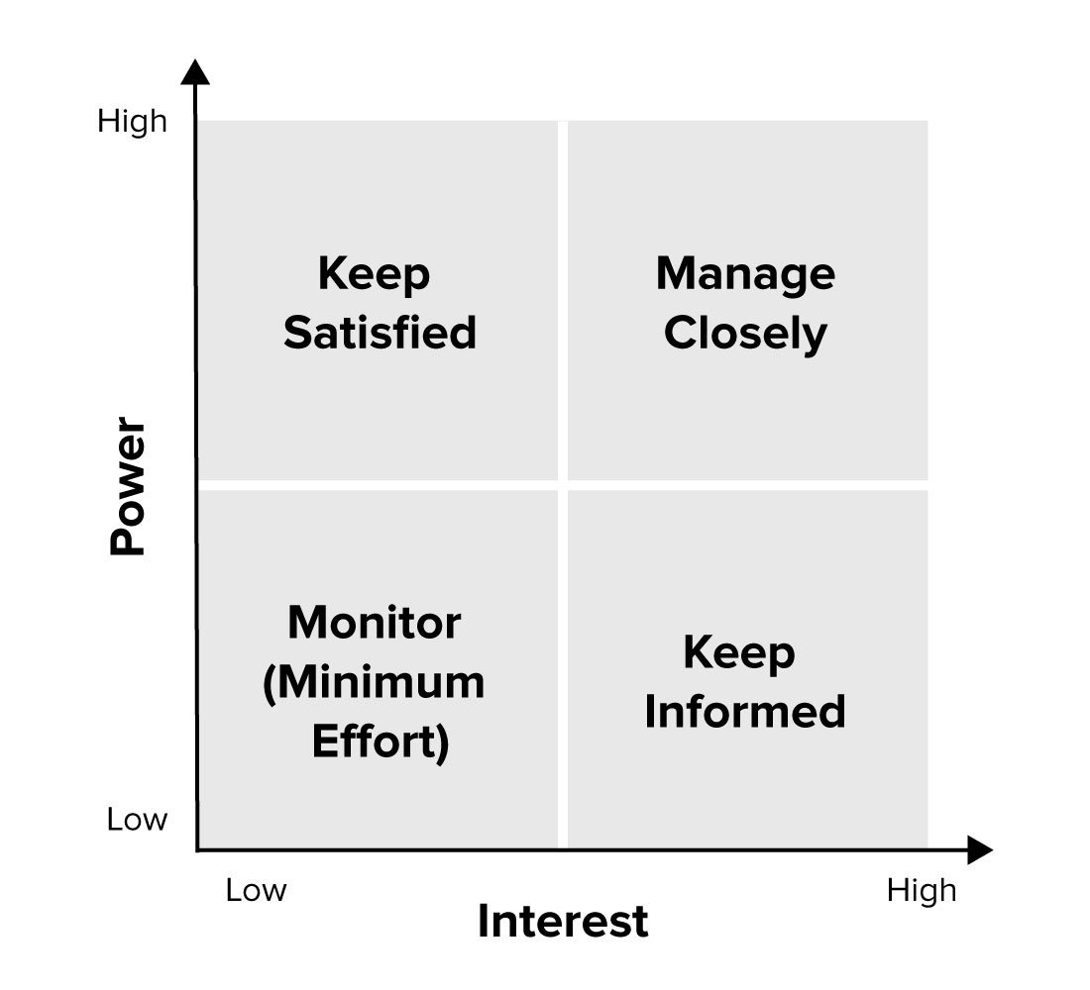

(MindTools, 2020)

According to the matrix, there are some stakeholder that holds high power and interest in the organisation. These types of stakeholder must be satisfied at all cost, as they play a key integral role in the organisation. For example, Matalan plc key players would be their investors and customers. They are the driving force for an organisation making revenue and profit. Any complex changes must be communicated towards them as they have the most influence and power for an organisation to do well.

There are some stakeholders that have high power, but low interest in what the organisation does. These types of stakeholder’s just needs to be satisfied with the organisation approach. The government/authority tends to make lots of complex change, for example bringing out new COVID-19 guidelines for organisation to follow. The government/authority does not have a huge interest in how the organisation follow these new guidelines, these type of stakeholder just care if they follow it. If guidelines are not followed, the government have enough authority to close the premises down until they are satisfied. There are some stakeholders that have low power, but very high interest in the organisation such as employees, suppliers and local community. These stakeholders are unable to make complex work place changes, but they should be informed with any changes that have been take place by the organisation. Once informed with organisation changes, these stakeholders would look to change their performances in order to meet the new change that the organisation has imbedded. Lastly, there are some stakeholders of an organisation that has low power and low interest in the organisation. Any complex changes would not need to be communicated to them excessively; however it is good for an organisation to monitor these types of stakeholder in case of a conflict (MindTools, 2020)

The benefits of the stakeholder analysis are that it helps avoid stakeholder conflicts, because the analysis looks at each possible stakeholder problems and how to deal with them. It also helps the organisation to facilitate the planning stage smoothly. However the group of stakeholders that have limited involvement and low priority in the stakeholder matrix analysis at times can be forgotten by the management of the organisation and potentially can cause a stakeholder conflict.

It is common for organisation to make a complex work place change; these changes are business strategy to reach business targets. Strategic transformational change is a type of complex changes that organisation makes, these transformational changes can be due to the current environment and implication. Changes are significant, a business makes a work place change so that it is able to tackle any previous obstacle as well as add value to the organisation. Complex work place change is normally implemented by individual that are in top of the hierarchy of the organisation. It is significant for them to communicate the changes that are going to take place right down the chain of command, in that way the change is being addressed and managed properly. Furthermore it will motivate the stakeholders to visual the clear goal of the organisation and set their own requirements in order to make that work place change happen effectively. Stakeholders such as directors and managers would have to manage the risk when there has been a workforce change. It is up to these stakeholders to engage with other stakeholders such as employees that they have enough preparation and workforce in order to tackle the complex workforce change. Not only would it enhances the communication between the stakeholders, it will also motivate the stakeholders in countering change and any future changes with ease (Knoll, 2020).

Kotter’s 8 Stages of Change Process

Moving on, John Kotter developed an 8 stage model on leading change and has been associated with educational organisations as well as human services (Haas, 2020). His model stresses the importance of effective change management approaches, by providing a guideline on curriculum change for stakeholders to engage with (Cummings & Worley, 2015).

Smaros (2017) discusses how Kotter’s 8 stage model can be identified within the retail industry which is important as Matalan belongs in the retail sector. She argued that Kotter’s model helps establish successful change within the retail industry by organising the stages with the workforce’s desired change.
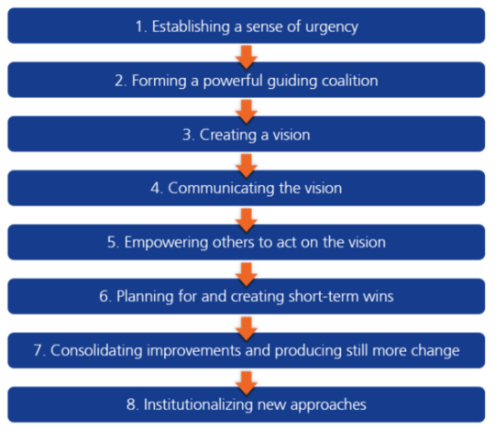

(Smaros, 2017).

The first stage- Matalan’s urgency for change has been caused by the covid-19 pandemic. Which means the culture change and capability were impacted. Due to the covid- 19 taking place many retail industries have had to change their workforce’s routines to imbed covid-19 regulations.

The second stage- Matalan have imbedded the protocols of covid 19 through communication with employees and customers from directors and seniors of the company, who have trained and introduced the new change on the shop floors as well as online services such as click and collect appointments. The management teams in Matalan have had to deliver the new changes of covid-19 and made sure it was introduced correctly. Jahshan (2020) states that Matalan imbedded the new strict health and safety measures in the 15 stores they had reopened after covid lockdown, where staffs were given PPE and social distancing rules were applied. As well as this, the home ware department of Matalan have introduced click and collect through a car park routine to ensure safety measures are met.

Third stage-
Past- Before covid-19 appeared the retail industry was able to process smoothly, with sales of £1.1 billion and had benefited from pre-tax profits of £30 million during 2019. The shop floor was busy and sales were up and running both on shop floors and online.

Present- The policies took over the organisation on how to run specific measures for covid-19, however as stores have reopened Matalan has found it more appropriate for its high street rivals to process in a Covid-19 submissive way. As prices have reduced to invite more customers to shop, although this has been seen as a frontrunner for the covid problem for the future, it is all dependent on how well adjusted and secure Matalan will become in the next years (Santamaria, 2020). Davis (2020) argued that Hargreaves made sure that the change of covid-19 is implemented, and he confidently states that Matalan is prepared and confident to improve against their revival of the lockdown measures.

Future- Matalan has experienced what covid-19 has changed within the workforce and can now prepare themselves for future instances, as covid-19 is still an unpredictable matter. Also, the founder of Matalan John Hargreaves has requested a £50 million from banks of Barclays and Lloyds, to ensure he can prepare for future measures with Covid 19 as it seems to be uncertain over when it will disappear (Santamaria, 2020). This is because Matalan’s future could be as stake without the cash injection by the summer.

Fourth stage- Matalan has made sure communication and vision is portrayed amongst the employees and customers who have to make sure they know about the covid-19 measures. This is evident as stores have reopened and staffs are in shop floors following protocols, the employees have made sure covid-19 measures are introduced to customers by directing them throughout the workplace.

Fifth stage – It is important to remove obstacles that can affect the workforce change; therefore, employees must have a vision of what is expected from them for them to progress the change in their workforce. The furlough scheme was implemented by the government for organisations, which therefore motivated employees of Matalan to stay within the organisation. Matalan has ensured the furlough was given to employees to help pay 80% of their wages as during the covid employees were pressured to work when stores were still open, which impacted on their emotional wellbeing as well as mental. Matalan argued that furlough scheme was “common sense” for their employees and also made sure their employees were safe by pressuring the GMB to allow their workers to access furlough scheme (GMB Union, 2020).

Sixth stage- When the government made a change Matalan had to act on it quickly; there were no negotiations around it as it was a rigid rule that had to be implemented within the workforce. Matalan already have online services but due to covid- they are able to promote this for long-term change to help with the business population in store that has been affected and still make sales online.

Seventh stage- Matalan has looked at the change of covid-19 and has worked by implementing the changes into the shop floor. As the Matalan Covid-19 investor updates states that Matalan have gone above and beyond with the safety measures, as they prioritise protecting the safety of customers and workers in store. The recent safety measures that have been placed are: floor stickers to show distancing positions for customers, sanitizers are available throughout the store to use for equipment and hands, employees and staff are trained to supervise social distancing, deliveries are schedules to prevent overcrowding, fitting rooms, cafes and toilets have been closed until further notice, regular cleaning takes place throughout the shop floor, for support contact numbers are available for staff and the number of customers entering and leaving is being monitored and controlled to prevent large crowds and physical touch (Brill et al, 2020).

Eight stage- Matalan has stressed the importance of following covid-19 regulations if they did not follow procedures this would not deliver corporate culture. As well as this they would have consequences with the government who will assess Matalan’s process with the covid-19 situation, which can impact employee’s jobs and Matalan’s future. Matalan have ensured they followed the Government guidance and WHO and have developed more measures to follow and keep those involved to continuously follow the rules (Rigby, 2020).

Conclusion

In conclusion, most evidently change requires a lot of effort and understanding for change to be effective for a workforce. In order for a workforce to deliver change, the organisation must find a purpose for change which they then have to deliver to their stakeholder’s, who will assess how the change impacts and influences them. Furthermore, the micro and macro factors have a major change for organisations, as they have to orientate their procedures in order to tackle those factors. This suggests why change is significant for an organisation to progress and achieve its objectives.

References

BBC News. (2020). Young People hit as unemployment rate rises [Online], Available at: https://www.bbc.co.uk/news/business-54146833(Accessed 16th September 2020)

BBC News. (2020). Corona virus: Strict new curbs on life in UK announced by PM [Online], Available at: https://www.bbc.co.uk/news/uk-52012432(Accessed 17th September 2020)

BBC News (2020). Corona virus: Consumers ‘should shop with confidence”, says PM [Online], Available at: https://www.bbc.co.uk/news/business-53041178 (Accessed 17th September 2020).

Berlin, Eaton & Associates. (2013). Leading Transition: A New Model for Change. Management Consultants. [Online] Available at: http://www.crowe-associates.co.uk/wp-content/uploads/2013/08/WilliamBridgesTransitionandChangeModel.pdf. (Accessed 20 September).

Business matters. (2018). How will GDPR regulation impact on the UK’s retail sector? [Online], Available at: https://www.bmmagazine.co.uk/in-business/gdpr-regulations-impact-uks-retail-sector/. (Accessed 16th September 2020).

Brill, J. Goodhew, G, Purdon, E. &. Duncan, F. (2020). Matalan Cobid-19 Investor Update. [Onlibe] Available at: file: https://www.tisegroup.com/umbraco/surface/proxyapi/getnewspdf?id=286557&name=Matalan%20Finance%20plc. (Accessed 22 September).

Clegg, S. R. Kornberger, M. &. Pitsis, T. (2015). In Management and Organisation: An Introduction to Theory and Practise. Fourth Edition. London. SAGE. Ch. 15, pp. 361-394.

CFI. (2020). What is a stakeholder? [Online], Available at: https://corporatefinanceinstitute.com/resources/knowledge/finance/stakeholder/ Accessed 22nd September 2020

Cummings TG. &. Worley CG. (2015). Organization Development and Change. 10th Ed. Chapter 2. United States: Cengage Learning;. pp. 21–44.

Dawson, P. M. (2006). Change Management. University of Wollongong. The Blackwell Encyclopaedia of Sociology. 427-431.

Davis, G. (2020). Matalan to focus on supporting digital proposition as it reports challenging year. Essentail Retail. [Online] Available at: https://www.essentialretail.com/news/matalan-reports-challenging-year/. (Accessed 22 September).

GGTN (2020)Comfort clothing: the pandemic fashion trend [Online], Available at: https://newseu.cgtn.com/news/2020-05-19/Comfort-clothing-The-pandemic-fashion-trend-QB2xijTkTC/index.html(Accessed 16th September 2020).

GMB Union. (2020). Matalan workers offered furlough in ‘massive win' for GMB. Article by GMB Union. [Online] Available at: https://www.gmb.org.uk/news/matalan-workers-offered-furlough-massive-win-gmb. (Accessed 22 September).

Haas, M, R, C. Munzer, B, W. Santen, S, A. Hopson, L, R. Haas, N, L. Overbeek, D. Peterson, W, J. Cranford, J, A. &. Huang, R, D. (2020). DidacticsRevolution: Applying Kotter’s 8-Step Change Management Model to Residency Didactics. West J Emerg Med. 21 (1): 65-70.

IBIS world (2018) Clothing Retailing in the UK [Online], Available at: http://clients1.ibisworld.co.uk.ergo.southwales.ac.uk/reports/uk/brexitupdate/default.aspx?entid=3060(Accessed 18th September 2020)

Institute for government (2020) UK net zero target. [Online], Available at: https://www.instituteforgovernment.org.uk/explainers/net-zero-target(Accessed 16th September 2020).

Jahshan, E. (2020). Matalan reopens 15 stores based on “essential” homewares guidance. Retail Gazette. [Online] Available at: https://www.retailgazette.co.uk/blog/2020/05/matalan-reopens-15-stores-based-on-essential-homewares-guidance/. (Accessed 22 September).

Knoll. (2020). Managing Workplace change: A people-based perspective [Online], Available at:https://www.knoll.com/knollnewsdetail/managing-workplace-change-a-people-based-perspective Accessed 23rd September 2020

Lemke, F and Goffin, K and Szwejczewski M (2003) Investigating the meaning of supplier-manufactuer partnership-an exploratory study. International Journal of Physical Distribution and logistics Management, Vol 33, Issue 1, pp12-35

McCullough, K. (2019). Why change in the Workplace is Good! A Guide for Companies. [Online], Available at: https://www.karenmccullough.com/change-in-the-workplace-a-guide-for-companies/#:~:text=Change%20in%20an%20organization%20leads,opportunities%20and%20improves%20staff%20morale. (Accessed 15 September 2020).

Matalan. (2018) About Matalan [Online], Available at: https://www.matalan.co.uk/corporate (Accessed 14 September 2020).

Matalan. (2020). About Matalan. [Online], Available at: https://www.matalan.co.uk/corporate. (Accessed 14 September 2020).

Matalan (2020) Matalan Covid-19 Business Update [Online], Available at: https://production-matalanlive-assets.s3-eu-west-1.amazonaws.com/uploads/asset_file/asset_file/274127/1586609888.9444337-Matalan_Covid-19_Update.pdf(Accessed 15th September 2020)

Morrison, M. (2014). Kurt Lewin Change Theory Three Step Model – unfreeze, change, freeze. RapidBI. [Online] Available at: https://rapidbi.com/kurt-lewin-three-step-change theory/#:~:text=The%20Kurt%20Lewin%20change%20theory%20model%20is%20based,and%20must%20be%20made%20as%20seamless%20as%20possible. (Accessed 18 September).

Matalan. (2020). Bangladesh Update [Online], Available at:https://www.matalan.co.uk/corporate/bangladesh-update(Accessed 18th September 2020)
Malalan. (2020). Matalan results for the 53 weeks ended 29 February 2020 [Online], Available at: https://production-matalanlive-assets.s3-eu-west-1.amazonaws.com/uploads/asset_file/asset_file/277901/1593011139.2797585-Matalan_Q4_FY20_Press_Release_Final.pdf (Accessed 15th September 2020)
Matalan. (2020). Matalan Covid-19 Business update [Online], Available at: https://production-matalanlive-assets.s3-eu-west-1.amazonaws.com/uploads/asset_file/asset_file/274127/1586609888.9444337-Matalan_Covid-19_Update.pdf(Accessed 16th September 2020)

Matalan. (2018). Matalan bondholder report [Online], Available at: https://production-matalanlive-assets.s3-eu-west-1.amazonaws.com/uploads/asset_file/asset_file/160343/1516002433.5243497-Matalan_Bondholder_Report.pdf(Accessed on 15thSeptember 2020)

Matalan. (2020). Ethical sourcing policy [Online], Available at: https://www.matalan.co.uk/corporate/ethical-sourcing-policy(Accessed 15th September 2020

Mindtools. (2020). Stakeholder Analysis [Online], Available at: https://www.mindtools.com/pages/article/newPPM_07.htm. (Accessed 23rd September 2020)

Oxford College of Marketing (2020) The impact of Micro and Macro environment factors on marketing [Online], Available at: https://blog.oxfordcollegeofmarketing.com/2014/11/04/the-impact-of-micro-and-macro-environment-factors-on-marketing/ (Accessed at 16th September 2020)

Petter, O. (2018). Fashion industry turns a blind eye with unsustainable fake fur, says MP Mary Creagh [Online], Available at: https://www.independent.co.uk/life-style/fashion/fake-fur-unsustainable-fast-fashion-faux-unethical-mary-creagh-mp-a8685721.html .(Accessed 16th September 2020).

Rigby, C. (2020). UPDATED Coronavirus round-up: Halfords, Asos, Matalan, Nosto, Awin, Nielsen, Aldi, Hammerson, Ikea, Mothercare and more on Covid-19. Internet Retailing. [Online] Available at: https://internetretailing.net/covid-19/covid-19/updated-coronavirus-round-up-halfords-asos-matalan-nosto-awin-nielsen-aldi-hammerson-ikea-mothercare-and-more-on-covid-19-21179. (Accessed 22 September).

Smaros, J. (2017). Applying Kotter’s 8-Step Change Management Process To Retail. Retail Touch Points Team. [Online] Available at: https://retailtouchpoints.com/blog/applying-kotters-8-step-change-management-process. (Accessed 22 September).

Santamaria, B. (2020). Matalan seeks extra cash as it prepares for post-Covid-19 future. Fashion Network. [Online] Available at: https://ww.fashionnetwork.com/news/Matalan-seeks-extra-cash-as-it-prepares-for-post-covid-19-future,1214828.html. (Accessed 22 September).

Share My Insight. (2020). Real time product monitoring using retail image recognition [Online],Available at:https://www.sharemyinsight.com/index.php/retail-image-recognition/(Accessed 15th September 2020).

Stakeholder theory. (2018). About the stakeholder theory [Online], Available at: http://stakeholdertheory.org/about/. (Accessed 23rd September 2020).

Sammut-Bonnici. (2015). Microenvironment, Wiley Enclycopedia of Management, Vol 12 Strategic Management https://doi.org/10.1002/9781118785317.weom090501

Surbhi, S. (2015). Differences Between Micro and Macro Environment. Key differences. [Online], Available at: https://keydifferences.com/difference-between-micro-internal-and-macro-external-environment.html#Definition. (Accessed 16 September 2020).

Theodore. (2020). Lewin’s Change Theory (Definition + Examples). Practical Psychology. [Online] Available at: https://practicalpie.com/lewins-change-theory/.

World of Work Project. (2019). Bridges’ Transition Model for Change. [Online] Available at: https://worldofwork.io/2019/07/bridges-transition-model-for-change/. (Accessed 20 September).

