FESTO Cyber Physical production system – goods dispatch process automation development
COBOT End effector Design and Developmet

June 2, 2022
University of Wales Trinity Saint David

Table of Contents
Introduction 2
Main Findings 2
Product Design Specification (PDS) 2
Quality Function Deployment 3
Designs 4
Design One and Analysis 5
Design Failure Mode and Effect Analysis 5
Design for X 6
Design Two and Analysis 7
Design Three and Analysis 11
Gripper Strength Analysis 12
Final Design Solution 13
Conclusion 15
Bibliography 16

Introduction
Industrial control and automation manufacturer, Festo, require a Universal Robots UR3 collaborative robot (COBOT) to be integrated into their existing cyber-physical production system. The COBOT’s primary function will be to unload finished goods in the form of mobile phones from the systems output station and place the goods onto an autonomous guided vehicle to be taken to inventory. The COBOT and pedestal it will be mounted to are already available, the task is to design and develop a suitable end effector to be used by the robot to conduct the task in question.
This report will outline and document the steps taken during the design and analysis stages of the project, explaining why certain decisions were made and how a suitable solution for the problem was achieved.

Main Findings

Product Design Specification (PDS)
The product design specification sets out the requirements the product needs to comply with. It will outline its purpose, features it must have, usability needs as well as constraints, reliability, and performance requirements. It also sets the product release date (Geddes, 2022).
Having a clear and thorough PDS will help to guide decision making throughout the project as well as help to gauge success at the end as it can be compared with the result to see if the product meets the requirements.
Purpose
End effectors are required for a new UR3 collaborative robot (UR3 COBOT). UR3 COBOT will be located on Festo’s cyber-physical production system. The robots end effectors are required to unload finished goods (mobile phones) from the production system and place them safely onto an autonomous guided vehicle (AGV).
Features
The new end effector must be capable of high-volume manufacturing, must be mechanically operated and it must be robust and dependable enough to withstand a production environment.
Universal robots state the maximum payload of a UR3 is 3KG. The end effector as well as a mobile phone in its heaviest configuration must be less than this to not overload the robot (2015).
The end effector must also be safe to have a collaborative robot as these are conventionally unguarded, the end effector cannot have sharp edges or abrasive faces.
Usability
The product will need to be easy to install and maintain. Fastening methods between components must be accessible and non-permanent allowing for the quick removal and replacement of worn parts.
The end effector should also be designed with programming in mind. The method of gripping or picking should be quick for the robot to conduct as well as cope with slight inaccuracies in COBOT, mobile phone or AGV positioning. Feedback from the end effector will be needed to allow the system to see if the UR3 has or has not picked a mobile phone.
Reliability
The COBOT end effectors must be dependable in a mass production environment. Actuators must be able to cycle thousands of times per day, and grippers must withstand clamping forces and associated wear from cycling thousands of times per day.
Mechanical fasteners, air and electrical connections must be capable of withstanding vibrations and the shock of clamping or picking. Another feature the end effector requires is piping or wiring that is compatible with robotic movements to prevent premature wear, fraying and failure.
Performance
The end effectors performance will be based on its ability to pick a mobile phone safely, keep a firm hold of it as the robot moves and then place the phone safely down on the AGV. This process must not damage (crush or scratch) any finished goods and should be repeatable over thousands of cycles.
Product Release Date
The product release date for the UR3 end effectors is the June 17th, 2022.

Quality Function Deployment
Quality function deployment (QFD) is an analysis method commonly used by designers to consider the needs and wants of the customer and the design. QFD’s listen to the voice of the customer to prioritise these needs and wants (Kent, 2016).
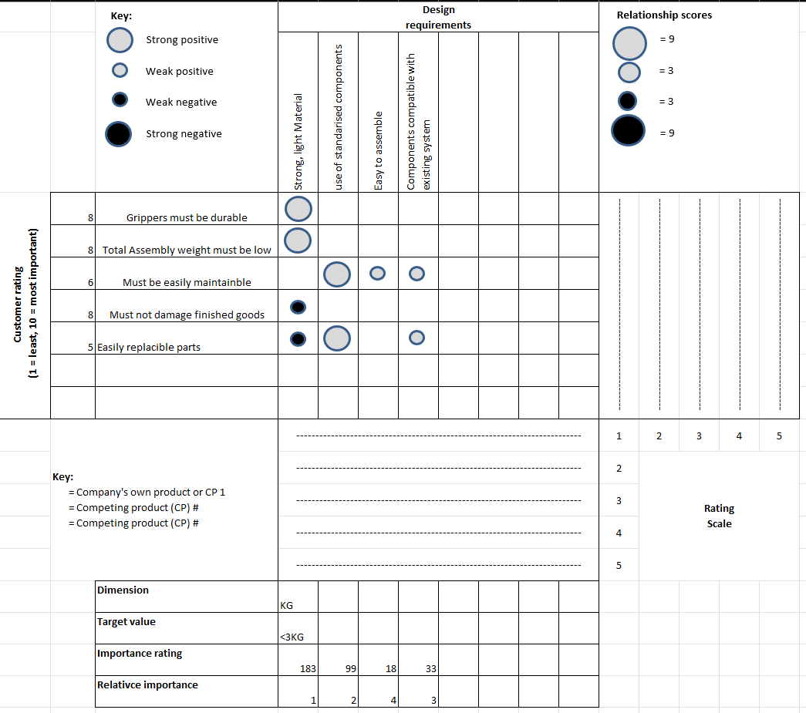
Figure 1- QFD table for the COBOT end effector
Figure 1. is a simple QFD for the COBOT end effectors, it prioritises the customers wants on the left-hand side, the design requirements needed to satisfy the customers are then listed along the top of the table. The relationship between the wants and the design requirements are scored from strong positive to strong negative. Importance ratings are then calculated, from here, relative importance can be given to prioritise the design requirements. For the COBOT end effectors the use of strong, yet light material is needed so that the COBOT’s weight limit of 3KG is not surpassed. The least important requirement is for the end effector to be easy to assemble as in theory it should not be assembled or dis-assembled regularly.

Designs
Before any designs could be produced critical measurements relating to the mobile phones and the end effector mounts on the UR3 COBOT needed to be gathered from the CAD drawings provided.
Figure 1. is a technical drawing of the mobile phone, including only the dimensions needed to design the end effector.
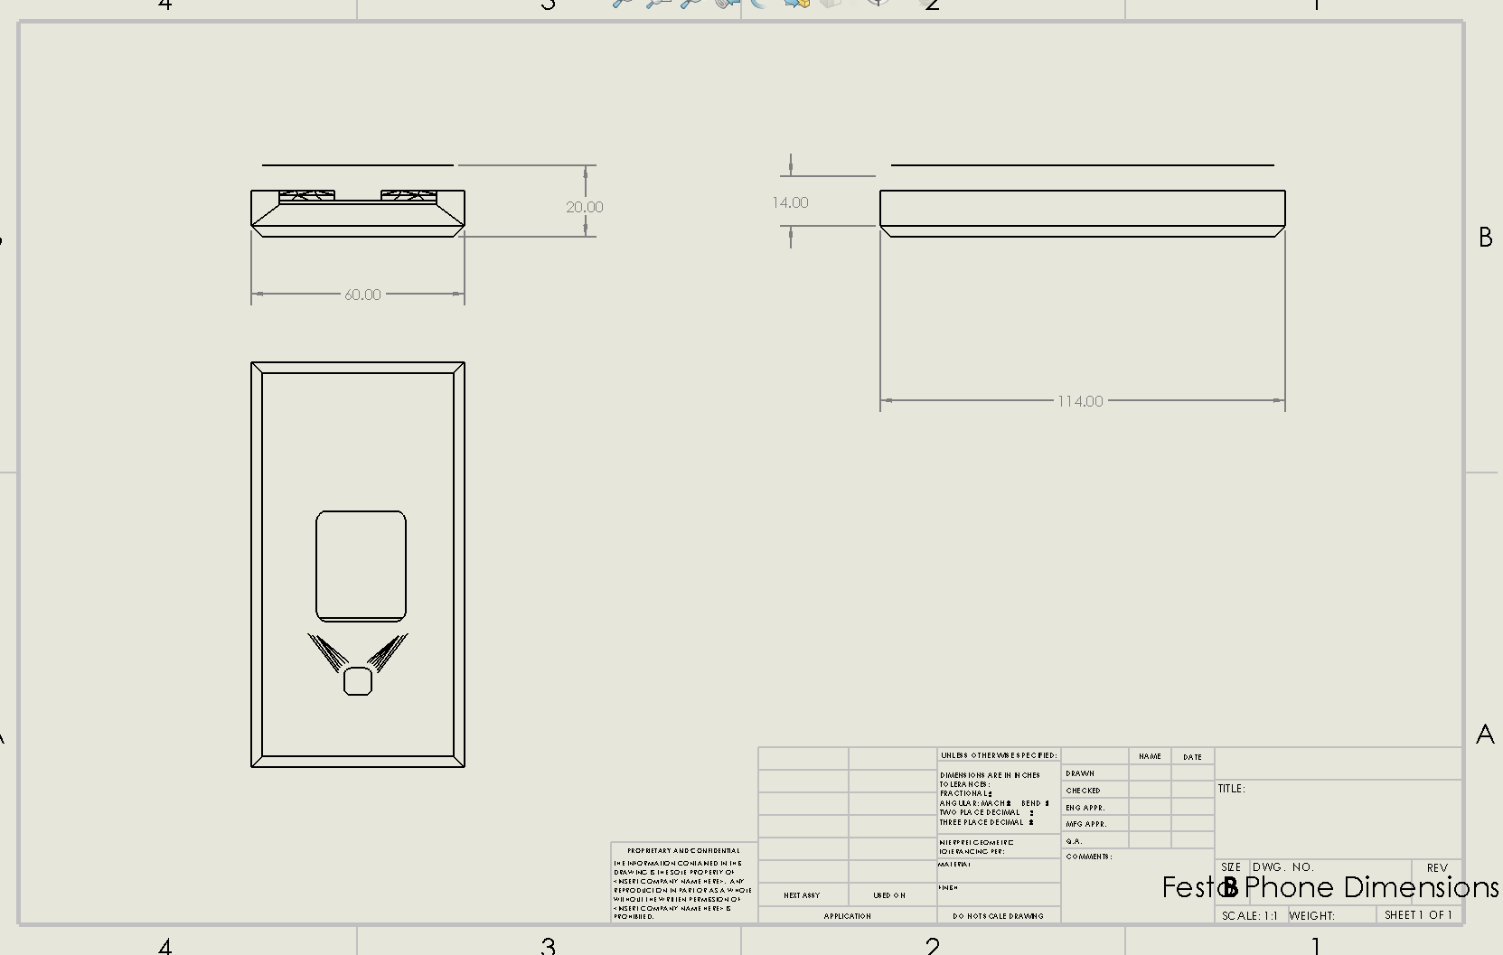
Figure 2- Mobile phone critical dimensions
With access to an already assembled CAD model of the COBOT I could use the measuring tool within Solidworks to measure the distance between and the diameter of the end effector mounting holes (Figures 2 and 3).
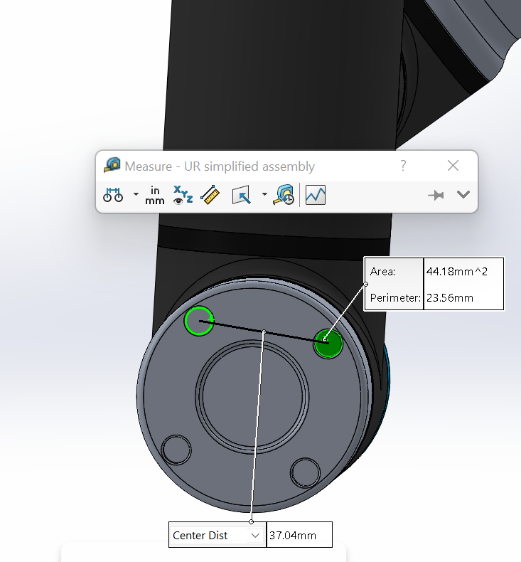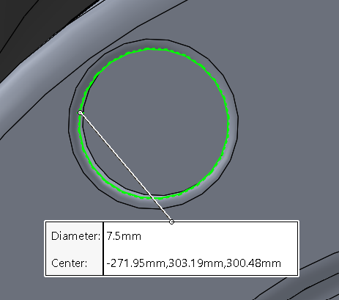
Figure 3- End effector mount hole spacing measurements Figure 3- End effector hole mount diameter.

Design One and Analysis
Using the already gathered data an initial end effector design could be created, it consisted of two aluminium CNC machined grippers and a Festo HGPL-B-25 parallel pneumatic actuator. This would work with the COBOT positioning the grippers over a mobile phone located in the output station. The grippers would then close by operating the pneumatic actuator, with the grippers remaining closed the COBOT could move the phone onto the autonomous guided vehicle.
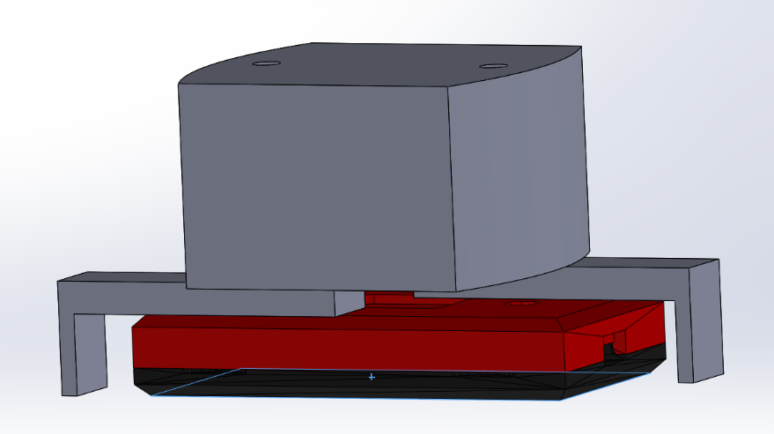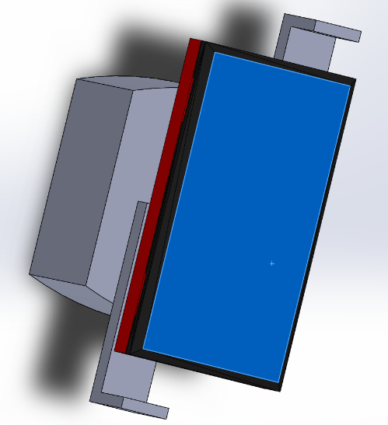
Figure 4- Two views of how the end effector would operate
As part of the design improvement process, analysis was conducted of the design, comparing it with the customer and design requirements. The analysis consisted of a design failure mode and effect analysis (DFMEA), design for manufacture and assembly analyses.

Design Failure Mode and Effect Analysis
Chris Montgomery (2019) suggests that design failure mode and effect analyses are important to help foresee issues and to keep written documentation of design changes with their reasonings. Figure 5 shows the DFMEA for the initial design, each issue is scored one to ten on its severity if the issue occurs, the likelihood of occurrence and the detectability of the issue. These scores are then multiplied to give a risk priority number (RPN), the issue with the highest number indicates what needs to be address first. After a recommended action is put into place the RPN can be calculated again to gauge the improvement.
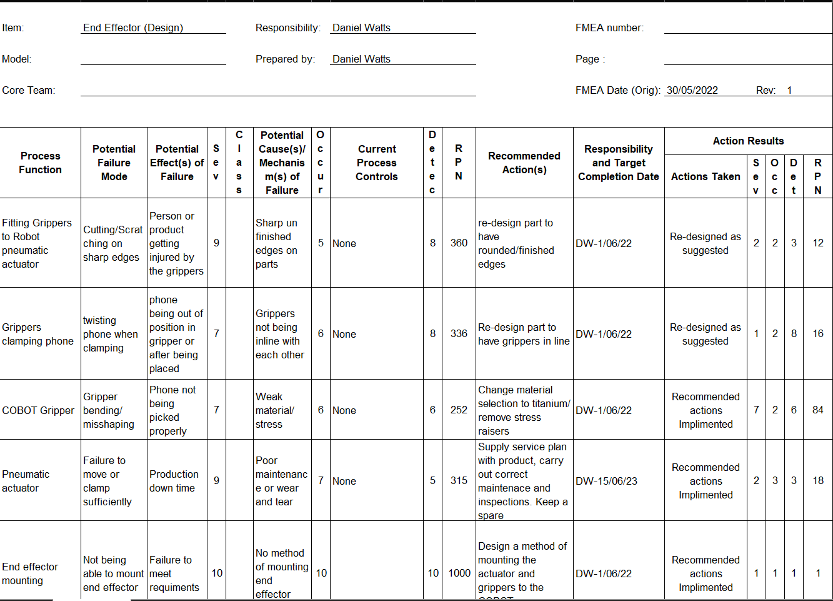
Figure 5- DMEA of initial end effector
As can be seen in figure 5 the DFMEA has proved useful in identifying issues and failings in the design compared with the customers requirements. The main issue of this design indicated by a RPN of 1000 was that a method of mounting the end effector to the COBOT had not been designed, without this the end effector would be useless, other issues included sharp edges on the grippers and the phone not being clamped central. The RPN of the initial design compared to a new design shows how much of an effect the recommended actions would have to the outcome of the project, especially for the bottom function (figure 5), that is addressing the lack of a design considering the mounting of the end effector to the COBOT, the initial RPN for this was 1000, because without a mounting solution the end effector could not be used, with an effective design solution in place the RPN drops massively to one, however following Claxton and Allen’s (2017) advice the DFMEA will need to be repeated for the second design with all of its new features.

Design for X
In line with the recommendations of Siim Sild (2021), the design was analysed using some of the design for excellence (DFX) methodologies including, design for manufacturing and design for assembly.
The Design for manufacturing analysis looked at the number of processes required to manufacture each component, materials used and their machinability as well as the use of standardised components. Design one consists of two grippers, one pneumatic actuator and six DIN EN ISO 4762 M5x12 cap screws.
The grippers are designed to be machined in one process from aluminium and there is only one gripper design, meaning they are interchangeable on each side of the actuator and the manufacturing process is identical for both. Aluminium is the chosen material due to it being low weight, strong, easy to machine and will be less damaging to the mobile phones compared to steel. The grippers will be fastened to the actuator using three cap screws each, the DIN EN ISO 4762 M5x12 cap screws where selected as they are cheap and readily available from many different suppliers. The choice of pneumatic gripper (Festo HGPL-B-25) meets the requirements of task with an end-to-end stroke of 40mm a rated picking weight off 1000g and a weight of 1015g (FESTO, 2021). The Use of a Festo actuator also helped with commonality of parts with the cyber-physical production system, this will prove to be a benefit when spare parts are required as their will already be a relationship with a FESTO parts supplier.
When considering design for assembly, the aim was to make it as easy as possible, even though ‘easy to assemble’ was ranked last in the quality function deployment analysis. It was ranked last because it is unlikely to be built in massive quantities where assembly times need to be kept to a minimum.
Ideas to simplify assembly were to reduce the total number of components in the assembly and of them components make them as standardised as possible. For example, the grippers used for the end effector are the same for both sides of the actuator so they will have the same part number, also all the bolts used to mount the grippers are the same to avoid confusion when fitting and unnecessary tool changes.

Design Two and Analysis
Following the design failure mode and effect analysis of the first end effector, a second more refined design was made. As figure 6 shows the part has changed, it now has rounded edges all around to prevent cut and abrasion injuries to people and finished goods. The second design now also features a curve, this allows both grippers to apply pressure when picking a mobile phone at the centre, opposite each other, this should reduce any chance of the phone twisting in the gripper jaws.
The fastening methods of three M5x12 cap screws remain. However, to address the issue that arose in the DFMEA of the gripper bending over time with use under stress or if it bumped against something the material choice and manufacturing process has changed. The grippers will now be produced from titanium alloy using an additive manufacturing process. This will increase the grippers strength and durability whilst remaining light weight as aluminium alloy has a yield strength of 95MPa and titanium alloy has a yield strength of 730MPa (The Engineering Toolbox, 2019). This is important as in the quality function deployment analysis the use of a ‘strong, light material’ for the grippers ranked first in the design requirements and the design specification required the grippers to be capable of withstanding mass production.
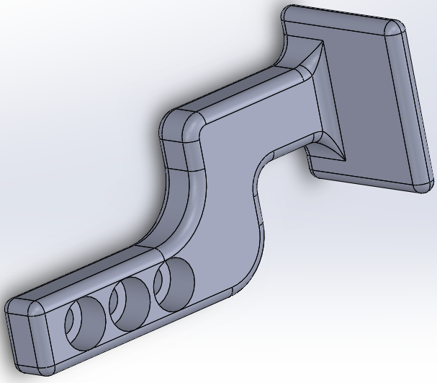
Figure 6- 2nd Gripper design following initial analysis
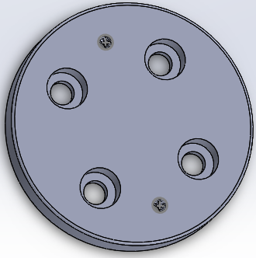
Figure 7- End effector mounting plate
The method of mounting the end effector to the COBOT will be a CNC machined aluminium plate. The plate will be mounted to the COBOT using four, M8x12 cap screws through the four counter-bored holes as can be seen on figure 7. The pneumatic actuator will then be fastened to the mounting plate using two M6x30 cap screws, these will screw into two threaded holes in the mounting plate.
The design for assembly principles remains the same for this design, the grippers can again be used on either side of the actuator to avoid confusion, the same FESTO actuator and the same standard of cap screws are being used to help with standardisation. A new issue that had been thought of was how the grippers could be fitted to the actuator slightly out of alignment, not perpendicular to the phone, this could cause uneven pressure on the phone and the gripper. The potential effects of this could be damage to the phones casing or over time damage to the gripper caused by excessive stress.
The mounting plate however has no obvious way of making sure it is mounted to the COBOT in the correct orientation, this may cause confusion and incorrect fitting to the COBOT, so the end effector could be fitted 90º off, without modification to the COBOT itself this issue will be hard to address.
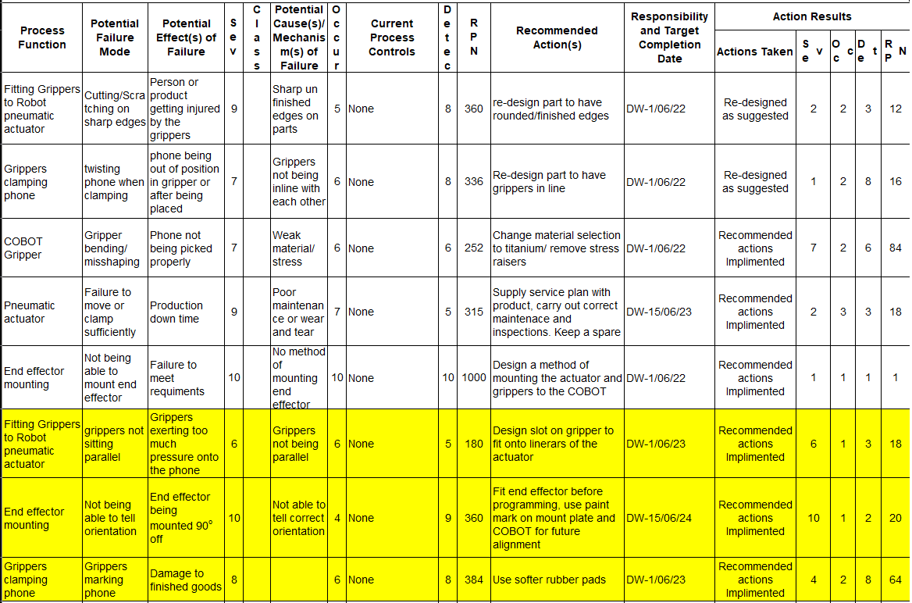
Figure 8-DFMEA of the second end effector design
Figure 8 above shows the DFMEA of the design, the highlighted section are the issues with the second design. To fix these issues the design would need to be modified to incorporate soft rubber pads onto the clamping surfaces to reduce the changes of damaging finished goods and the grippers would need have a shallow slot added to the surface that contact the linear of the actuator allowing them to sit parallel to one another. By adding this it also fits in with the design tool poke-yoke, this is a Japanese derived tool to make things fail safe or error proof (ASQ, 2020). With a slot on the gripper to fit over the linear of the actuator they cannot be mounted with the gripper surface anything other than perpendicular to the actuators motion.
To address the orientation problem with the mounting plate the end effector would have to be fitted before the COBOT is programmed to avoid contact with the unload station and one it has been fitted the mount plate would need to be marked in line with a mark on the COBOT end effector mount so if the end effector is removed for any reason the mark can be matched up during re-fitting.
With the end effector now closer to its final form thought could be given to how it would operate in the real world and how it would interact with the cyber-physical systems dispatch station. Aligning with the advice of Ghosh (2010) this involved another failure mode and effect analysis but this time analysing the process.
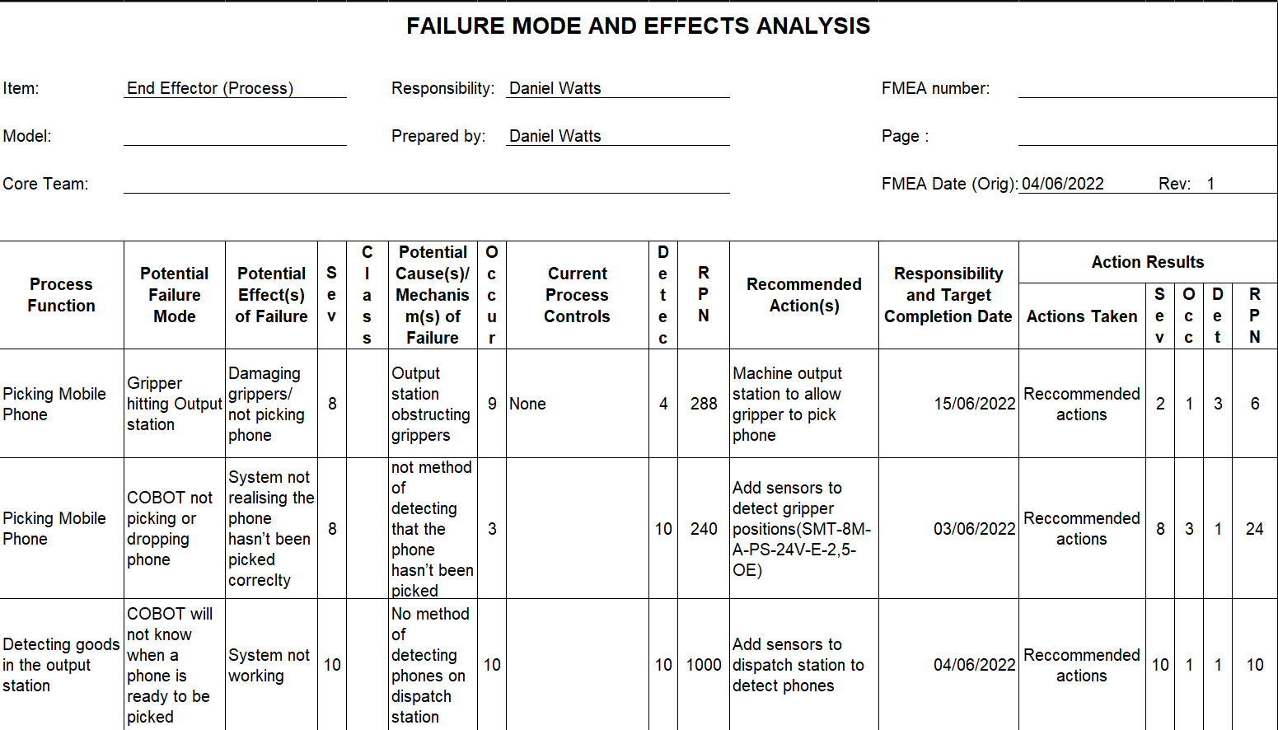
Figure 9-PFMEA for the COBOT end effector
This analysis noticed three issues, the first being that the grippers would contact the slides on the dispatch station as the edges are raised. To fix this both slides will need to be removed from the station and be machined on either side to allow the grippers access to pick phones. The areas are outlined below in figure 10.
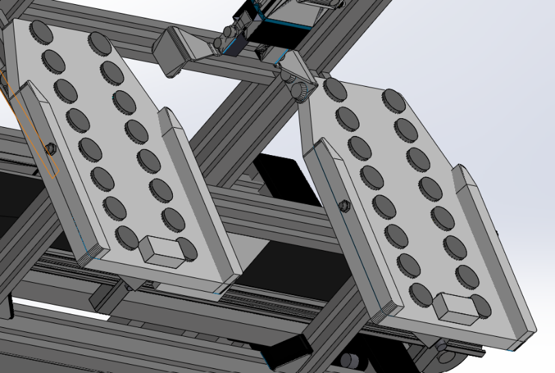
Figure 10- Output station slides without modifications
The second issue is the lack of a detection system to be able to notice if a phone has been picked or not. The recommended action to fix this will be to use three inexpensive FESTO SMT-8M-A-PS-24V-E-2,5-OE sensors, reed switches. The pneumatic actuator will already have slots in to accommodate the sensors. These will tell the control system what state the gripper is in, one will be fully open, one will be fully closed, and one will be phone picked as the gripper will not be fully closed when it has clamped around a phone. If the gripper goes to the fully closed position the system will know a phone has not been picked an alarm can be raised.
The third issue is the lack of a detection method to identify if a phone is ready to be picked and which station the phone is in, to counter this one FESTO SOOD-BS-R-PN-30 optical sensor mounted using a compatible FESTO SAMH-L2-L-A bracket will be fitted to each dispatch station.

Design Three and Analysis
Again, the design has been altered following the findings of the previous design and process failure mode and effect analyses. One change was to use off the shelf rubber stops on the grippers to reduce the chance of marking any finished goods. To accommodate these the gripper design needed to be changed to have two holes with M3 threads so the stops could be screwed in. By using off the shelf stops the number of design and manufacturing processes could be kept to a minimum following the DFM principles.
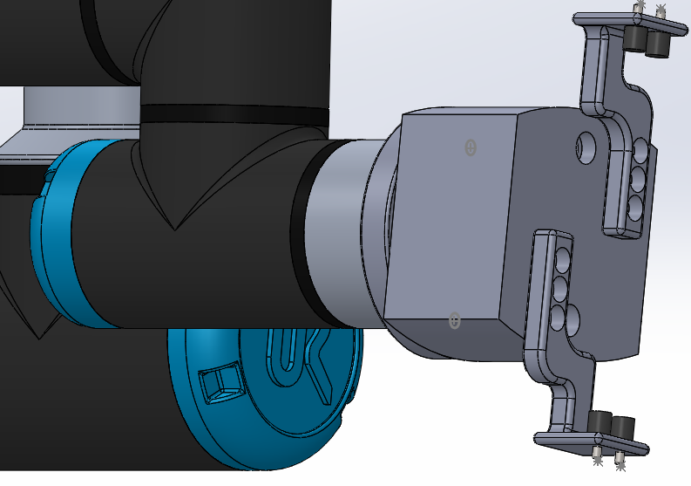
Figure 11- End effector (design 3) Mounted to the COBOT
The second change as can be seen below in figure 12 is the use of three reed switch sensors allowing the control system of the COBOT and the dispatch station to see what position the gripper is in and if it has failed to pick correctly. The use of FESTO sensors in this design fits the DFA methodologies as they are known to be compatible with the existing hardware and software of the cyber physical system. The same applies with the optical sensors and brackets to be used on the dispatch station
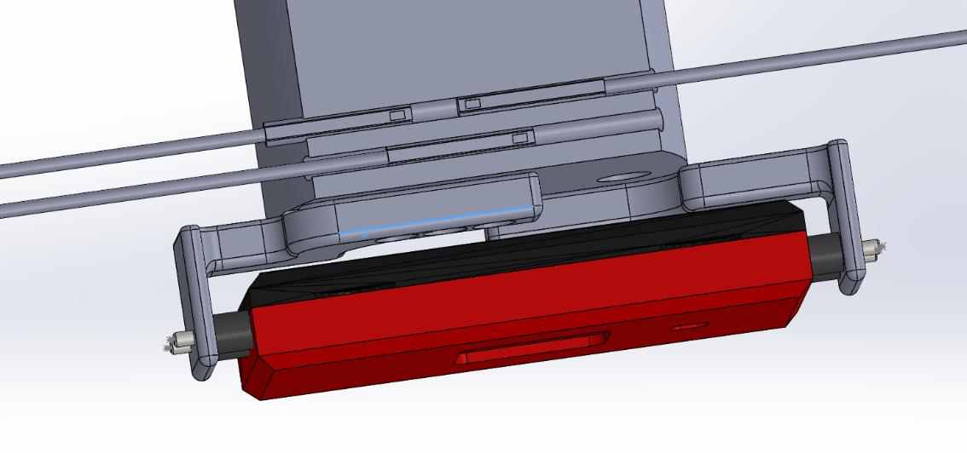
Figure 12- Third gripper design with reed switches clamping a mobile phone
Following these design changes the design failure mode and effect analysis was conducted again to find any new potential issues. As figure 13 shows the only new issue was the grippers potential failure from excessive force being applied through the grippers by the pneumatic actuator. The recommended actions of the DFMEA were to analyse the gripper strength using a computer simulation.
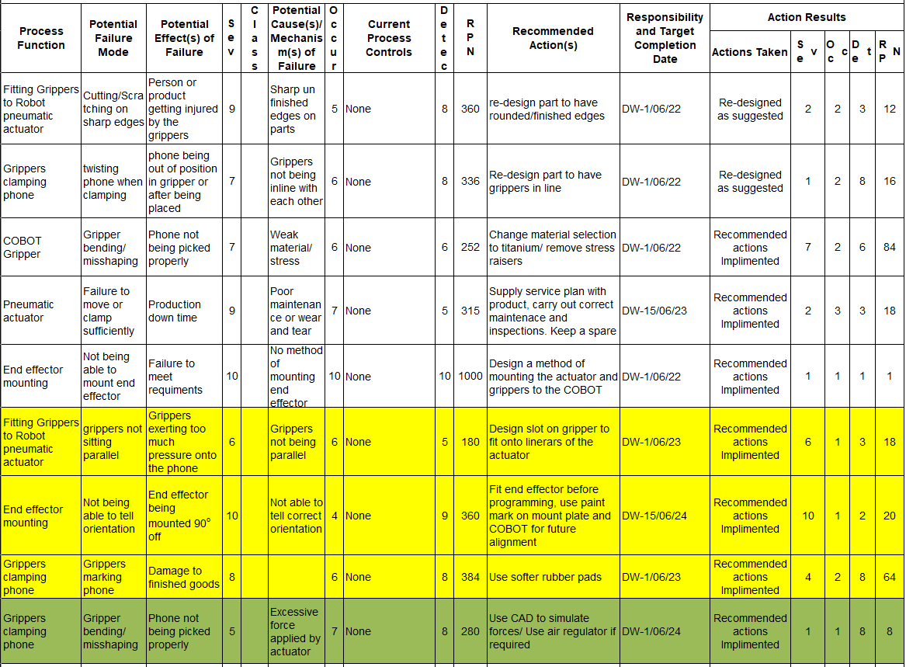
Figure 13- DFMEA of the third Gripper assembly solution

Gripper Strength Analysis
Following the advice of CADimensions (2020) analysis of the gripper was conducted to help avoid issue with the gripper’s strength arising in the future. Using the Solidworks Simulation Xpress tool the gripper design could be evaluated. The conditions used in the test were using the maximum force available from the pneumatic gripper, 256N at 0.7MPa. The material used for the gripper itself was titanium alloy which is the intended material from which to manufacture the gripper.
The results of the simulation showed a great degree of deflection in the grippers which can be seen in figure 13 along with some high stress areas shown in red. This level of force being applied in the real world would cause failure or critically deformation. This amount of force being applied to the phones would also damage their casings which is unacceptable and goes against the design specifications.
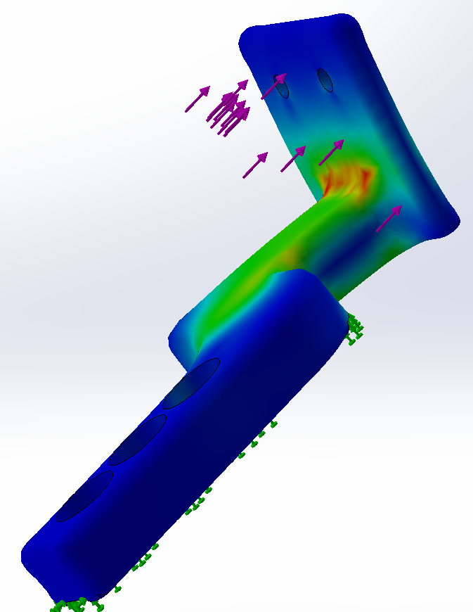
Figure 14-Simulation analysis of gripper three design
To avoid this issue the air supply to the pneumatic actuator will need to be regulated to a lower pressure, a suitable regulator for this task would be the FESTO MS-LFR-B-G2, this can lower the supplied air pressure as low as 0.3MPa allowing the clamping forces to be reduced.
The simulation was conducted again but with the force reduced from 256N down to 120N which is the lower limit of the actuator. This resulted with the maximum stress figure within the structure of the gripper being $1.8×{10}^{7}N/m^{2}$ lower than the yield strength of $1.4×{10}^{8}N/m^{2}$. Therefore, the gripper is unlikely to deform or break during operation with the use of an air pressure regulator.

Final Design Solution
The final design solution for the UR3 COBOT to unload finished goods from the cyber-physical systems dispatch station is design three with the addition of an air pressure regulator. This design consists of two grippers to clamp a phone along its length. The grippers are fitted with two rubber stops to prevent damaging the phones casing and to evenly distribute forces. The grippers are fastened to a Festo parallel gripper cylinder with up to 40mm of stroke, allowing clearance of the phone before clamping. The design features a detection system consisting of three sensors to detect if a phone has been clamped successfully or not.
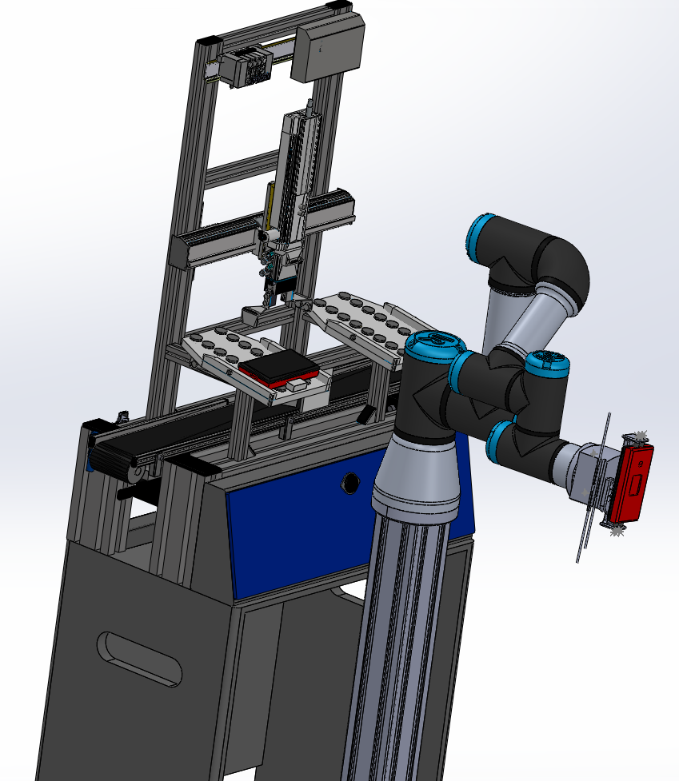
Figure 15- End effector solution fitted to the COBOT alongside the dispatch station.
Using the recommendation from Corns (1992), the Lucas design for analysis method was conducted to compare design one with the final design. The Lucas method analyses how easy the assembly is to manage as well as how easy it is to fit together. A higher means it is more risky or harder to work with. Figure 15 shows no improvement between designs in easiness to assemble, however this is not an issue with this design as it will not be produced on a scale where fitting times are important to reduce.
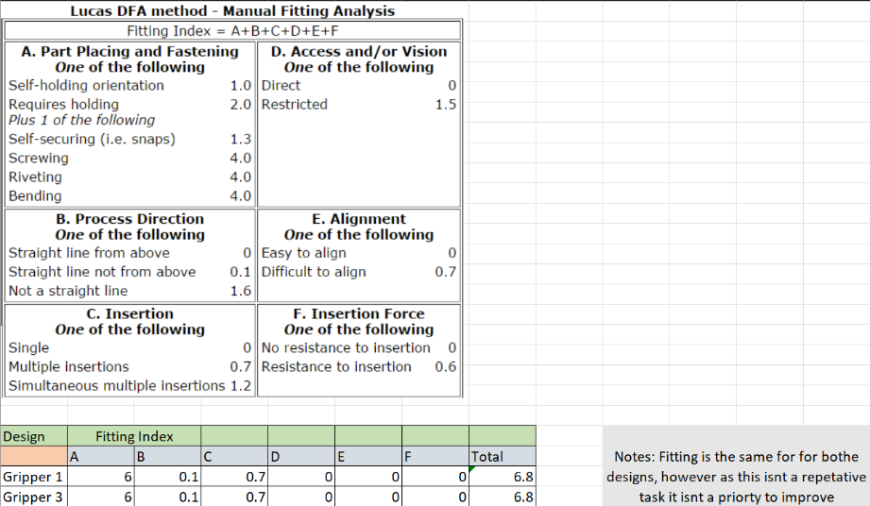
Figure 16- Lucas DFA Manual fitting comparison
Figure 17 shows an improvement between design one and three. This is down to the rounding of sharp edges reducing the chances of cutting or abrasive injuries from handling the components.
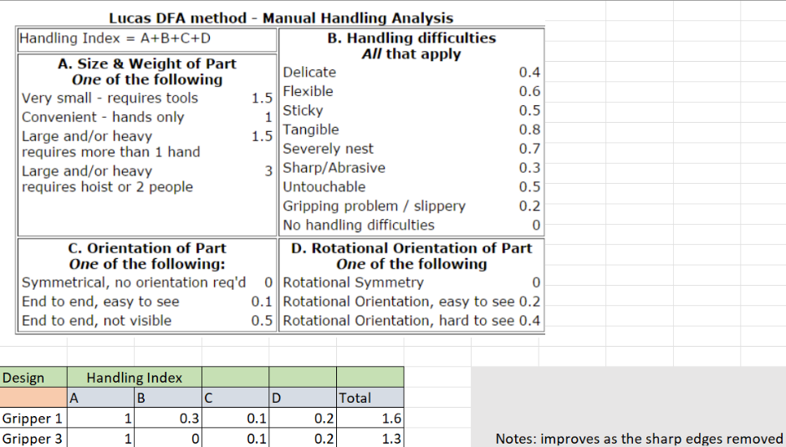
Figure 17- Lucas DFA manual handling

Conclusion
In conclusion, the design process and final solution has been a success. This can be said as the solution meets the key requirements set out in the product design specification, the end effector will be able to be mounted to a UR3 COBOT, will be capable of withstanding the punishment and stresses of mass production, is easy to manufacture and will be dependable. The total mass of the end effector is also calculated to be 1675.85g, light enough to allow the COBOT to operate correctly whilst holding a phone. Components selection was thought through carefully, using standardised components such as FESTO actuators, sensors, and a regulator to help in the case of maintenance or sourcing spare parts as the rest of the cyber-physical production system consists of FESTO components meaning technicians will be familiar with the technology and a relationship with a supplier will have already been established. The gripper will also be able to perform its duty without damaging any finished goods thanks to the soft rubber stops used and the air pressure regulator to prevent crushing. The project has also been completed within the period set.
Design analysis tools have been a significant help in this project, the product design specification set clear objectives that the end effector must produce. Similarly, the quality function deployment analysis set out a criterion to achieve for success but also prioritised them helping to focus the design process. As suggested by Montgomery (2019) and Claxton and Campbell (2017), continued use of both design and process failure mode and effect analysis’s throughout allowed design revisions to be thought of, assessed, and then prioritised before manufacture. The design for excellence tools (DFA, DFM, Lucas Method) helped to keep the designs as simple as possible by reviewing the quantity of parts, the standardisation of parts and the how complex or risky assembly is.
Without CAD software allowing measurements of the existing system, the phones, showing assemblies and the alignments between components as well simulating forces on components the design would not have achieved what it has. CAD allowed visualisation of assemblies without having to buy materials or waste time on prototypes. The force simulation on the grippers allowed an issue to be delt with before product which otherwise could not have been foreseen.

Bibliography
ASQ, 2020. What is mistake proofing?. [Online]
Available at: https://asq.org/quality-resources/mistake-proofing#:~:text=Mistake%20proofing%2C%20or%20its%20Japanese,a%20common%20process%20analysis%20tool.
[Accessed 05 06 2022].
CADimensions, 2020. CAD Simulation Explained. Everything You Need To Know. [Online]
Available at: https://www.cadimensions.com/blog/cad-simulation-explained-everything-you-need-to-know/
[Accessed 05 06 2022].
Claxton, K. & Campbell-Allen, N., 2017. Failure modes effects analysis (FMEA) for review of a diagnostic genetic laboratory process. s.l.:Emerald Publishing Limited.
Corns, M. S. a. S., 1992. Lucas Design for Assembly method applied at Hawker Siddeley Switchgear. s.l.:IET.
FESTO, 2021. Parrellel Gripper HGPL-B. [Online]
Available at: https://www.festo.com/media/pim/421/D15000100122421.PDF
[Accessed 04 06 2022].
Geddes, D., 2022. What is a product design specification?. [Online]
Available at: https://www.technicalfoamservices.co.uk/blog/what-is-a-product-design-specification-pds/#:~:text=A%20product%20design%20specification%20(PDS)%20is%20a%20document%20that%20contains,new%20product%20must%20adhere%20to.
Ghosh, M., 2010. Whats is a PFMEA?: Process Excellence Network. [Online]
Available at: https://www.processexcellencenetwork.com/lean-six-sigma-business-performance/articles/process-failure-mode-effects-analysis-pfmea#:~:text=A%20Process%20Failure%20Mode%20Effects,potential%20failures%20of%20a%20process.
[Accessed 05 06 2022].
Kent, R., 2016. Quality Management in Plastics Processing. 1 ed. s.l.:William Andrew.
Montgomery, C., 2019. What is DMFEA: ANSYS. [Online]
Available at: https://www.ansys.com/en-gb/blog/what-is-dfmea#:~:text=Design%20failure%20mode%20and%20effect%20analysis%20(DFMEA)%20is%20a%20systematic,of%20these%20failures%20or%20actions.
[Accessed 04 06 2022].
Sild, S., 2021. Design for manufacturing: Fractory. [Online]
Available at: https://fractory.com/design-for-manufacturing-dfm/
[Accessed 04 06 2022].
The Engineering Toolbox, 2019. Young's Modulus, Tensile Strength and Yield Strength Values for some Materials. [Online]
Available at: https://www.engineeringtoolbox.com/young-modulus-d_417.html
[Accessed 05 06 2022].
Universal Robots, 2015. Universal Robots UR3. [Online]
Available at: https://www.universal-robots.com/media/240787/ur3_us.pdf
[Accessed 2022 06 11].

