

Name:Ali Miah
Student Number:1709388
Module code: BMSK4003
Module Title: Digital Skills and Research Methods
Module Lecturer’s Name: Mrs. Renuga Jayakumar

Table of Contents
Introduction: 3
Web Based Email: 3
Tablets and Smartphones: 6
Workplace Efficiency of Using Web Based Email: 7
1. Employee Motivation and Hassle Free Working Performance: 7
2. Achieving Organizational Goals and Objectives: 7
Workplace Efficiency of Using Tablets and Smartphones: 7
Practical Examples: 8
Increasing Staff Employability with Technologies: 8
1. Effective Communication: 8
2. Analytical Thinking: 8
3. Teamwork: 8
4. Learning and Development: 9
Social Media: 9
Advantages and Disadvantages of Social Networks for Searching Job: 10
Advantages: 10
Disadvantages: 10
Preferred Network: 10
Conclusion: 11
References: 12

Introduction:
This is the age of globalization and technological boom has already expanded in every sectors. Organizational behavior, employee motivation and engagement in the workplace now a days are dependent on the various technological use and skills which are very important for employees and as well as for organizations. Using technology is a blessing for 21st century. Workplace behavior and environment has already been influenced by the technological use and rapid globalization and thus economic development and lifestyles have changed. Employees in the organization need some suitable workplace environment and technology made the environment effective and efficient. There are many technology found for effective and efficient workplace environment. Among them Web based email, tablets and smartphones, cloud storage system, web conferencing, offline applications etc. are the main options for an organization. So, we are going to analyze web based email, what are the usefulness of web based email and how tablets and smartphones make a workplace effective for working, usefulness of those options and how employability may create by those options for candidates.

Web Based Email:
We based email is now a days a most used technology and means of communication in the workplace environment. Web based email actually runs on the web server and it requires a data connection or internet connection with a device and that actually enables the two-way communication between sender and receiver. According to Fisher, he stated that web based email actually contains a web server and domain which can be more effective in organization for communication (Fisher, 2014). There are a lot of web based email domain are found. Among them Gmail from Google, Yahoo Mail from Yahoo, Outlook and Hotmail from Microsoft are the most prominent web based email service providers. Google has Gmail which actually a domain name and rated with @gmail.com. It is basically uses for personal work, corporate and official work. Gmail has its own cloud storage system name Google Drive. For personal uses, Gmail has 15 GB cloud storage system for its users and for business purpose, Gmail has 1 TB cloud storage. Gmail has its own platform for use. For laptop and PC, it has www.gmail.com and for smartphones and tablets, Gmail has applicants for users. The best part of web based email is to attach a file with any size. According to Mosley, organizational performance and output totally dependent on the web based email and thus companies are opening their own domain for an efficient and effective workplace environment (Mosley, 2012).
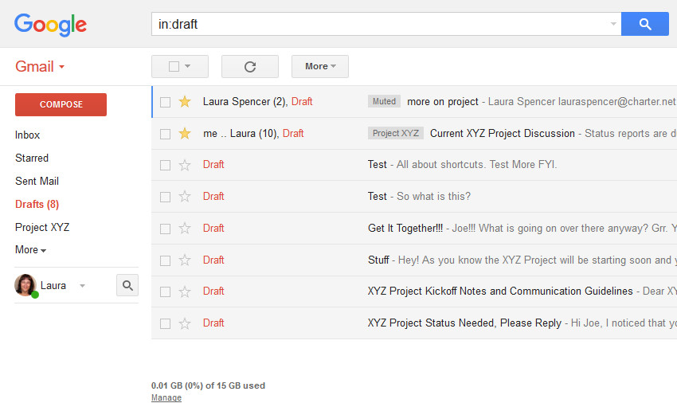
Figure: Web Based Email (Domain: Google; Gmail)
Source: https://business.tutsplus.com/tutorials/customize-your-gmail-interface-with-themes--cms-27295
Apart from this, different web based email service providers are also be found. Yahoo, Outlook are also the important web based email service providers for both personal and commercial use.
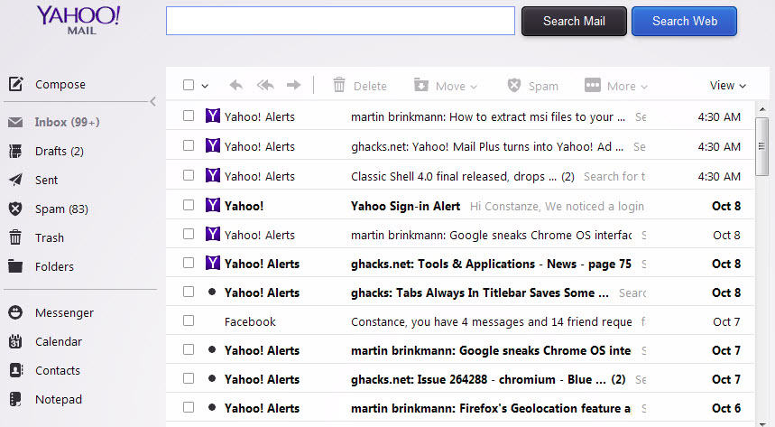
Figure: Web Based Email (Domain: Yahoo; Yahoo Mail)
Source: https://www.ghacks.net/2013/10/09/change-back-style-text-new-yahoo-mail/
Yahoo has also the same features like Google and it has its cloud storage system for personal and non-personal uses. For personal use, cloud limit is 5 GB and for non-personal uses, it has 1 TB storage facilities for users. All those domain have the same file attaching facilities which actually transfers any files.
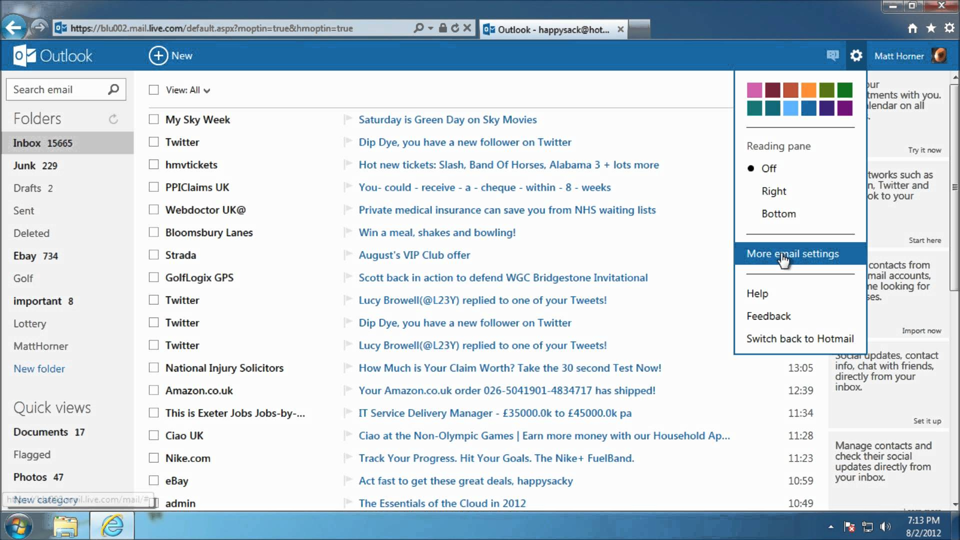
Figure: Web Based Email (Domain: Microsoft; Outlook)
Source: https://i.ytimg.com/vi/n79SWatlgbI/maxresdefault.jpg
Microsoft also come up with Outlook and Hotmail which also known as web based email service providers. Almost every web based email service providers have the similar features and cloud storage facilities for both personal and non-personal use. In organization, these web based email services are frequently using for a better working environment and performance in an efficient way.

Tablets and Smartphones:
In this age of globalization, tablets and smartphones are the most significant devices for maintaining communication in the workplace. According to Sarah, digitalization and innovation has an importance in the workplace behavior and organizational performance with latest devices like smartphones, tablets, laptops (Sarah, 2015). So, various devices and gadgets have already made a great impact in the workplace environment. Smartphones and tablets have various features like email checking, corporate conferencing, web conferencing, chatting etc. Organizations are want to minimize input and maximize output. So, tablets and smartphones has some features and facilities which actually reduces the hassle of work for employees and make a better output which actually leads to obtain the specific goal for organization. Tablets and smartphones actually have different brands and operating system. Organizations mainly focus on the employee friendliness of the use of those devices. Because of the cellular data and high speed broadband internet, using tablets and smartphone are increasing day by day (Hern, 2016).

Figure: Tablets and Smartphones
Source: https://www.pensitdown.com/wp-content/uploads/2014/10/pensitdown1.jpg

Workplace Efficiency of Using Web Based Email:
Organizations are recruiting candidates with different hard and soft skills with some other qualification depending on the post/circular. Web based email has some factors which actually increase the efficiency in the organizational workplace. They are given below-

Employee Motivation and Hassle Free Working Performance:
According to Taylor, he stated that web based email and website can reduce the hassle for a customer care service agent and thus working performance and level of output will increase (Taylor, 2011). Employees of organizations will communicate both internally and externally with the help of web based email and thus employee motivation and workplace environment will be higher.

Achieving Organizational Goals and Objectives:
Employees using web based email are always free from the back lock of work and thus their target and goal will be achieved with maximum working performance. Now a days, most of the companies and firms are using web based email to set and give a direction about the working details, information via email to their employees and customers which actually increase the efficiency and effectiveness of workplace environment.

Workplace Efficiency of Using Tablets and Smartphones:
Tablets and smartphones are a part of our daily life. With the help of those devices, employees can be able to check email, maintain communication, video calling and conferencing. Workplace efficiency and effectiveness mainly depends on the employees of an organizations. According to Kotler, he stated that customer satisfaction is dependent on perceive and expected services by customers (Kotler, 2009). Employees can easily maintain communications with their clients and customers and give response via smartphone. Feedback form customers can be gathered by smartphone by accessing website and web abased email of an organization. So, employee satisfaction in workplace as well as customer/client satisfaction also be measured. Social media presence is also a factor for organizations. Facebook, Twitter, YouTube etc. are mostly operated by smart devices now a days and for brand recognition, recruiters are screening social media analyst for operating their social platforms. Maintaining those platforms need different hard skills and so, workplace efficiency with customer satisfaction is also be dependent on smart devices and technology.

Practical Examples:
Because of the web based email and smart devices, organizations are prominently updating their products and services and thus they need to recruit skilled personnel. In recent years, every large organizations have web based email and contact information for their clients and employees. For example, Google and Apple, they both have their web based email for communication and their segmented products and services. The presence of social media already made themselves a superior organization in the market and thus employees feel that workplace environment is good for them. As a result, employee perception and expectation will be positive towards Google and Apple.

Increasing Staff Employability with Technologies:
Modern workplace is very much competitive. According to James. A. he stated that efficient workplace can mostly dependent on various hard skills like networking, typing, web based communication and these skills increase the employability for an organization (James, 2009). These technologies like web based email, smartphones various electronic devices have some positive outcome which actually increase the employability of staffs. They are given below-

Effective Communication:
Communication in this modern era actually involves with web based communication via various domain like Google, Yahoo, Outlook, Hotmail or internal domain and phone calls using smartphones and tablets, web conferencing and face to face meetings.

Analytical Thinking:
Business and business portfolios are changing due to different internal external reasons. So, employees can develop the employability including various hard and soft skills with the proper use of technology.

Teamwork:
Employees now a days solve many difficult and critical tasks with a team and for effective team work, web based email can maintain a flexible communication among all the team members and can solve the problem in a very short period of time. According to Russel, he stated that using technology and smart devices can make a team work easier than the face to face interactions in a very short period of time (Russel, 2009). So, with the proper use of technology, employability can be improved and different situational problem can be easily solved in an organization.

Learning and Development:
Using technology will enable the personal development for employees. Employees can develop various soft and hard skills with the help of web based email, tablets and smartphones.

Social Media:
There are many social networking site. The most popular social networking sites are-
Facebook, Twitter, YouTube, LinkedIn, etc.
My Facebook account’s picture is given below-
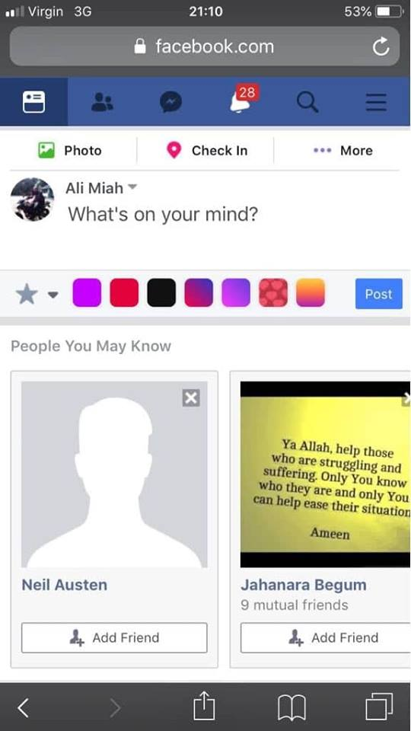
Figure: My Facebook Account

Advantages and Disadvantages of Social Networks for Searching Job:

Advantages:
The main advantages are, it is not time consuming and expensive. People interactions will be more accurate through social media. Facebook group, LinkedIn job circular are helping employees to find their suitable jobs with expected skills requirements in various organizations. With the help of LinkedIn, one can easily make his/her resume in a structured way which will help him/her in future. Customization will enable the communication among the network. Networking is very much important for employees now a days and thus LinkedIn already given some techniques and shortcuts to candidates for applying, searching their desired jobs.

Disadvantages:
Sometimes it is very much risky for candidates to accumulate and apply all job circulars. Sometimes, because of some fake job posting on social media like Facebook, Twitter, LinkedIn candidates get confused and thus it reflects a negative effect for employability through digitalization. Hence, some employees can search jobs in social networking when he/she has a job at present which actually create a problem between his/her supervisor or boss in social platforms.

Preferred Network:
As a candidate, I mostly prefer Facebook and LinkedIn for searching jobs. As those platforms are now a days very popular and monitored by officials of organizations. As a student, these platforms are very much flexible and user friendly as jobs are available to apply. The main reasons for preferring LinkedIn are given below-
- LinkedIn is easy to use.
- It has customized resume making opportunities which actually helps fresher’s to apply in a job.
- To cope up with the digitalization, it is a necessary and useful platform for candidates.
- LinkedIn is not time consuming.
- Can maintain a good network and community in the corporate world.
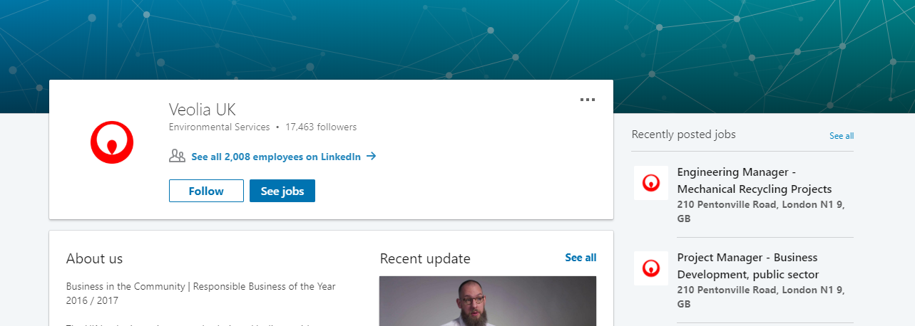
Figure: LinkedIn Job Circular

Conclusion:
Digital skills are common phenomenon now a days. Organizations are very much tech oriented and thus they are recruiting employees with not only having soft skills but also having different IT skills like networking, data analyst etc. Web based email, cloud service, using different gadgets already made the workplace efficient and effective. Employees are also adopted with those technology and have skills to operate smart devices, troubleshooting network etc. on their own. As, big companies rapidly changing their functional areas of operation, employees are also getting used to the technology. As a result, it is making workplace environment effective and efficient thus employee satisfaction and employability increasing rapidly in organizations day by day.

References:
1. Fisher. (2014). Web Based Email and Effectiveness in the Workplace. An Analysis of Organizational Efficiency with Technology, UK, 2(1), 53-56.
2. Hern, A. (2016, August 6). Smartphone now most popular way to browse internet – Ofcom report. Retrieved from The Guardian: https://www.theguardian.com/technology/2015/aug/06/smartphones-most-popular-way-to-browse-internet-ofcom
3. James. (2009). Workplace Efficiency and Technology. (Kramer, Ed.) An Analysis of Employee Motivation in Workplace, 15, 110-114.
4. Kotler. (2009). Services Marketing (5 ed., Vol. 15). Chicago: Pearson Publication.
5. Mosley. (2012). Skills for Managers. (James, Ed.) Technlogical Effectiveness in the Workplace, 3, 56-78.
6. Russel. (2009). Digital Skills and Communications for Managers (10 ed., Vol. 13). NY: Pearson Publication.
7. Sarah. (2015). Digitalization in the Workplace. An Analysis of Innovative and Technological Use of Organizations, 1(4), 110-113.
8. Taylor. (2011). Customer Care Service and Communication. How Effective Web Based Email and Two Way Communication is for Vodafone, UK, 2, 70-76.

