WORKSHEET 5 – TESTING (Treasure Hunt)

For this worksheet, there are several possible approaches to the problem.
Create your own test set to show the strengths and/or limitations of your solution. Use as many of the boxes below as you need.

Test: Same Position Input

Screenshot(s) of output:
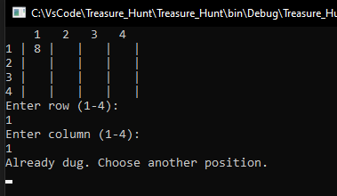
Result:
YES it did work as it was planned, as it the variable selectedPosition for both row and colomns get check and if it been already selected it will prompt to the user “Already dug. Choose another position!”

Test: Negative Input Value

Screenshot(s) of output:
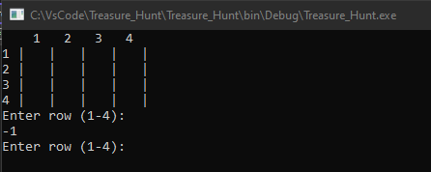
Result:
No I should have added a validation prompt in the ValidInput method. To fix this I added an else if statement into the method and made the int input <=0 so when values is less than or equal to zero it will print out “Error. Enter a value bigger than 0.
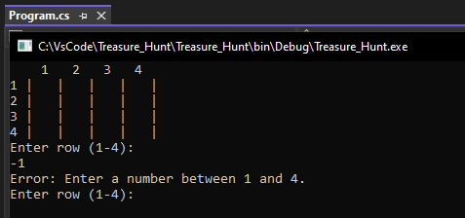

Test: User Tries++

Screenshot(s) of output:
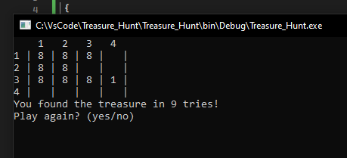
Result:
YES it did work, by implementing a variable called tries and to increase by 1 (++) every turn. It allows us to increase it and help the user to see how many tries it takes them.
This tries prompt get’s shown at the end when the user has won.
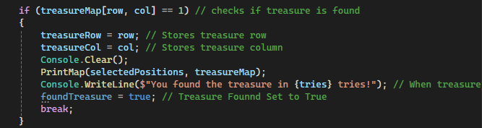

When the treasure map identifies a array containing value that equals to 1. It will prompt the user
Console.WriteLine($"You found the treasure in {tries} tries!")
$Will call the variable in the WriteLine function

Test: Negative Input Value

Screenshot(s) of output:
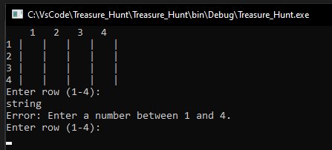
Result:
Yes it did work as it was supposed to as the (!int.TryParse.(Console.ReadLine() helps capture the input to be an integer and not a string.
This will prompt the error WriteLine which will tell the user to ;
Enter a number between " + min + " and " + max + ".")
The min value being 1 from the array size for a column/row.

The max value being 4 from the array size for the column/row.

Test: Replay ability of the Treasure Hunt

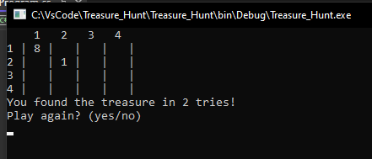
Screenshot(s) of output:

Result:
Yes it did work as it was supposed as the Boolean value set to the variable ReplayAgain will commence a new game for the user.
While this happens it will generate a new treasure map allowing the user to replay again. It will also reset the tries variable back to 0 as it we are restarting the game again,
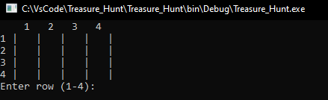
By typing in yes (or y for faster input) you can regenerate the new map with a new random position set for the new game.

Test: Replace Winning Treasure with 1
Replace misses with 8

Screenshot(s) of output:
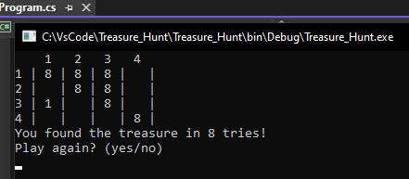
Result:
Yes it did work as it replaced the selected Position with 1 as it was the selected random position the game has generated randomly.
It will prompt the user that he has found the treasure and also let you know in how many tries.
For every miss it has replaced 8 as well showing the user the position that already have been selected.

Final code:
using System;

class TreasureHunt
{
static int[,] GenerateTreasureMap() //Method To Create Map
{
int[,] map = new int[4, 4]; // Multidimensional Array 4 by 4 Grid
Random rand = new Random(); // random function for generating random treasure position
int treasureRow = rand.Next(0, 4); // random row for treasure position
int treasureCol = rand.Next(0, 4); // random column for treasure position
map[treasureRow, treasureCol] = 1; // Marks the treasure map in the random coloumne/row
return map; // Returns the generated map
}

static int ValidInput(string prompt, int min, int max) //Method for getting Valid Input
{
int input;
do
{
Console.WriteLine(prompt); // displays the prompt
if (!int.TryParse(Console.ReadLine(), out input) || input < min || input > max)
{
Console.WriteLine("Error: Enter a number between " + min + " and " + max + ".");
}
else if (input <= 0)
{
Console.WriteLine("Error: Please enter a value bigger than 0.");
}
} while (input < min || input > max || input <= 0);

return input; // returns the valid input
}

static void Main(string[] args)
{
bool ReplayAgain = true; // Option To User to Replay Again

while (ReplayAgain) // main game loop
{
int[,] treasureMap = GenerateTreasureMap(); // While Replayagain is true it will generate a new treasure map
bool[,] selectedPositions = new bool[4, 4];
bool foundTreasure = false; // flag to track if treasure is found
int treasureRow = -1; // initializes treasure row
int treasureCol = -1; // initializes treasure column
int tries = 0; // count the number of tries

while (!foundTreasure)
{
Console.Clear(); //Clearing The Console To Clear Text and Clutterness
PrintMap(selectedPositions, treasureMap); // Map Print

int row = ValidInput("Enter row (1-4): ", 1, 4) - 1; // User Input for Row
int col = ValidInput("Enter column (1-4): ", 1, 4) - 1; // User Input for Coloumn

if (selectedPositions[row, col]) // checks if position has already been selected
{
Console.WriteLine("Already dug. Choose another position!"); // displays a message
Console.ReadLine();
continue;
}

selectedPositions[row, col] = true; // For Selected Position
tries++; // Increase the tries for every miss

if (treasureMap[row, col] == 1) // checks if treasure is found
{
treasureRow = row; // Stores treasure row
treasureCol = col; // Stores treasure column
Console.Clear();
PrintMap(selectedPositions, treasureMap);
Console.WriteLine($"You found the treasure in {tries} tries!"); // When treasure found display tries
foundTreasure = true; // Treasure Founnd Set to True
break;
}
else
{
Console.WriteLine("Oops, you missed!"); // Message if hit a miss ("8")
Console.ReadLine();
}
}

treasureMap[treasureRow, treasureCol] = 1; // Replaces the found treasure position with 1

Console.WriteLine("Play again? (yes/no)"); // Prompts the user to play again
string playAgainInput = Console.ReadLine().Trim().ToLower(); // User Input for play again (yes/y)
ReplayAgain = (playAgainInput == "yes" || playAgainInput == "y"); // User input to be y or yes (added y just to test faster)
}
}

static void PrintMap(bool[,] selectedPositions, int[,] treasureMap) // Selection Position Method in the treasure map
{
Console.WriteLine(" 1 2 3 4"); // Print column headers

for (int i = 0; i < 4; i++)
{
Console.Write(i + 1 + " | "); // Print row number

for (int j = 0; j < 4; j++)
{
if (selectedPositions[i, j]) // Check if position is dug
{
if (treasureMap[i, j] == 1)
Console.Write("1 | "); // Found treasure Replace with string 1
else
Console.Write("8 | "); // Already dug, no treasure
}
else
{
Console.Write(" | "); // Not dug
}
}
Console.WriteLine(); // New line after each row
}
}
}

