Public Health assignment 2 -
Smoking in Wales
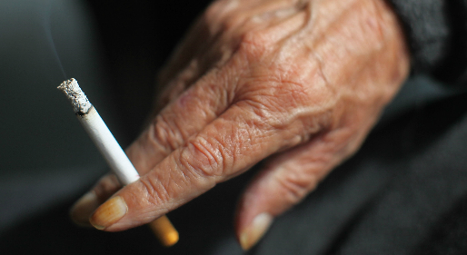

By Sophie Webb

Introduction ………………………………………………………… 3
Smoking in Wales ………………………………………………… 4
One initiative ………………………………………………………. 5
Second Initiative of smoking …………..…………………… 6
Third Initiative of smoking ………..………………………… 7
Conclusion …………………………………………………………. 8
References …………………………………………………………. 9

This report will show the initiatives the Government has created to try and stop people from smoking. The purpose of this report is to bring awareness of smoking’s health issues, which can be cause from smoking and second-hand smoking. All people can be affected by smoking if they are around people who smoke, people can increase the chances of developing heart problems and cancers from breathing in smoke. The government as created initiatives to stop people smoking, one of the initiatives is the smoking ban, this stops people smoking in public places and reduce the effects of second-hand smoking to staff and people who could be in the public places. The second initiatives are the picture of the tabacco, by displaying pictures it can make people aware of what smoking does to your body and to your health. The initiatives are the increase of price of cigarettes, by doing this people will become less interested in smoking because of the cost and the impact that is being made to their income.

The chosen initiative topic is smoking, smoking is a poison from the tar in your cigarettes which enters the blood stream. The National Health Service (2019) discuss how smoking makes your blood thicker, increases your blood pressure and narrows your arteries. By smoking every day, your chances on having a heart attack doubles, this is because the smoke from the cigarettes reduces the amount of oxygen in your blood and the heart will have to beat faster to recreate oxygen. The British Heart Foundation (2019) believes that if you stop smoking, your health will improve dramatically by reducing your risks of developing coronary heart disease, stroke or cancers. 2 in 3 smokers in Wales according to the Health in Wales (2019) want to stop smoking to improve their health, the Welsh Government has set an annual target to the smoking population and hoping it reduces smokers by 16% by 2020. Action on smoking and health (2019) believes that 21% of men smoke and 17% are women. Public health (2019) also adds that people 35 years old and over are more likely to die from smoke related disease, nearly 1 in 5 people. Welsh Assembly Government (2007) believes that second-hand smoking is also affecting a person’s health even if you do not smoke, second-hand smoking can cause lung cancer, heart disease and asthma in children. Smoking is a public health issues because the smoke is harmful to people’s health and it also has environmental and economic effects. According to action on smoking and health Cymru (2019) the ends of the cigarettes are usual ended up on the floor and then they make their way to the sea through drains. The ends of the cigarettes are not biodegradable, and they can stay in the environment up to 15 years after they have been created.

One of the initiatives of smoking is the smoking ban. This ban stops people smoking in enclosed public space, this include restaurants, pubs, nightclubs and workplaces. According to the British Heart Foundation (2019) the smoking ban was one of the biggest public health interventions we’ve seen in the last 15 years. The smoking ban legislation started in Scotland 2006 and it started in the rest of the United Kingdom (UK) in 2007. The Scottish Government (2019) aimed to make the generation smoke free by 2034, they did this to improve people’s health and to improve economic disadvantages which comes from tobacco. Anyanwu et al (2018) believes that having the legislation in place to stop people smoking in public places because it can decrease the number of adolescents smoking and the side effects which can be cause by second-hand smoking. Action on smoking and health (2019) agrees with Anyanwu (2018) second-hand smoking causes breathing problems for other people, which can affect their health. Action on smoking and health (2019) researched that 617 each year were premature deaths caused by second-hand smoking in the workplace. The smoking ban has had a successful effect because it has reduced the amount of people smoking, Forster (2017) agree because they have reported that the smoking rates are the lowest recorded and adult smokers have dropped 20% in the last 10 years, this is because of the smoking ban which does not allow people to smoke in public places. One of the negative impacts the smoking ban was having on smokers were that they were having difficulty adjusting to the legislation, Greeman and McClellan (1991) believe that the smoking ban should accommodate patients with allowing off-unit smoking breaks. According to Triggle (2017) there was less smokers in 2016 when this graph was created, in the previous years before there was a small decrease in smoking over the years but a year after the smoking ban was created it dropped significantly, this is because people would not be able to smoke in places they were at. This would stop people going to certain places or to reduce their cigarette each day, to get their body not to relay on them.
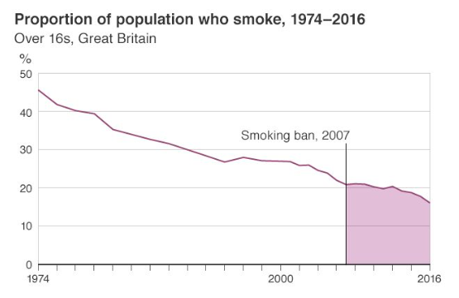
The smoking ban was created in Wales to protect peoples health from second-hand smoking and to reduce the numbers of people who smoked, Centre for Public impact (2016) effects the impact of creating the smoking ban was to impact the public by increasing the air quality, increasing public health and making people aware of the dangers of passive smoking. The smoking ban has had a positive effect of the Government because in 2015 the Government made it illegal to smoke in vehicles with anyone under the age of 18, this is because it protect the children from second-hand smoking and health issues which might develop from other people smoking. in 2019 the Hywel Dda University Health Board (2019) believes to promote a smoke free environment for their staff and patients, this also encourages staff and patient to give up smoking and improve their health.
The second initiative of smoking is the picture on the packaging. The legislation for cigarette packaging changed from 2016, this was to increase the awareness of the health side effects which can be caused by smoking, important information people should know about smoking, information about quitting smoking and where to find help. The Department of Health (2017) believes that the advertisement on the cigarette packages will stop people smoking because the images are inappropriate and upsetting to some people. Doward (2017) and Boseley (2017) both agree that the packages have a massive impact on smokers because the packages have 65% made up of health warnings, the packages also have an increase in price. Public health Wales (2019) believes that drab brown colour will change the appearance of smoking to people and will slowly change people’s attractiveness towards them. Rothwell (2015) et al and the statistic portal (2019) adds that the prices have increased to stop young people from purchasing them, this is because young adults have less income to purchase them than older adults. The prices in 2005 for cigarette were £4.82 a packet and in 2017 the price increased to £9.91.
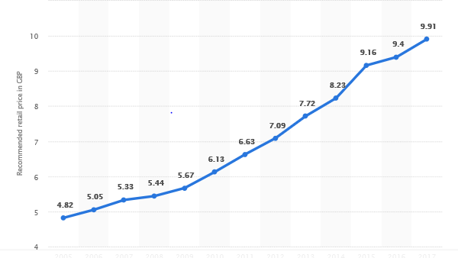
According to Maynard (2016), the smoking packets have been successful because they have reduced the appeal of smoking to the public. They have done this by increasing the awareness of the health risk from smoking, the national Health Service (2019) adds that one of the biggest health risks is cancer. Cancer from smoking can develop in the lungs, mouth, throat, bowel and many more places in the body. Smoking can also damage your heart, your blood circulation, increases your risks of heart attack and strokes. Lee (2016) disagrees with Maynard (2016) because they believe that smokers who have smoked for many years will not look and knowledge at the images of the packages, Lee (2016) believed that the people who smoke resisted the idea of being ordered what to do. Chen (2018) agrees this Lee (2016) because both believe that nearly 60 per cent of people thought the warning were ineffective in getting the current smokers to quit, they believe that the Government should focus on the increase of cost. Action on smoking and health Cymru (2016) believes that the picture will bring awareness to children by educating them on the health effects of smoking, which will have an effect on their parents as the children will ask questions about the picture and will make the patients consider the smoking effects to them and their children. The BBB News Wales (2017) adds on that 800,000 people have changed their attitudes and behaviour towards smoking since the smoking packages have changes, because they are seeing the side effects of smoking if they continue to smoke themselves or passive smoke around their children and other family members.
The third initiative of smoking is increasing the price of cigarettes, independent (2018) believes that increasing the taxation of tobacco can be the most effective way to stop people from smoking, this is because it reduces the affordability of cigarettes. Bader (2011) disagrees with independent (2018) because they believe that long-term smokers will not be affected by the price increase. This is because there is a lack of evidence to provide the effect on older and long-term smokers who have a regular income, compared to young teenagers and adults who have a small or no income. According to the Guardian (2018) the price increase was created by the Government when the legislation was introduced about the plain packaging, this is because they were worried that plain packaging would increase people smoking. Bennett (2018) reported that there will be an increase in 2019 but no further rise reported yet in 2020, this is because the government wants to see if the price increase has made an affect and reduce people smoking. Gooding (2019) reported that the price of a packet of cigarette has increased from £8 in 2014 to £11 in 2018. This is because the legislation of the packaging was created, and the Government increasing the price to try and stop people from smoking
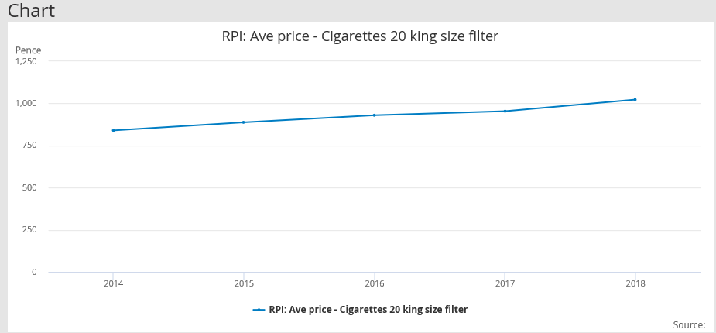

Ikonen (2018) disagrees with the smoking price increase because he believes that if people are willing to pay the price, it is the people’s choice to smoke knowing the risk, they should do what they want, whatever the price is, it is only allowing the rich people to smoke. Ross et al (2011) shows the effectiveness of cigarette price increasing by motivating people to quit smoking because it making people think if smoking is necessary need because of the price it is, it is making people think is smoking worth the money. According to Tabacco manufacturers’ association (2017) three-quarters of smokers in the UK have bought significant amount of tobacco from the black market, abroad or at the airports, this is because if they buy them from the black market, abroad or at the airport they are avoiding taxes which will be cheaper for them. If people continue to buy tabacco abroad, it has not affected them if the government decide to increase the price because they are buying them abroad from themselves and their people.

In this report I have shown research into the Government’s initiatives to try and stop people from smoking, this report brings awareness of the smoking health issues and the side affect from smoking and the effects of second-hand smoking. By the smoking ban, pictures of packaging and the price increase of cigarettes, the government can reduce the amount of people who smoke by each of the initiatives educating adults and children’s about negative affect smoking does to our body. One of the recommendations is to increase the price of cigarettes again because the evidence being report back to the government is showing a decrease in people smoking. This is having a positive effect on people’s health as they are stopped smoking and decreasing the chances of development lung and heart diseases. The second recommendation is to stop creating cigarettes and help the people who smoke to quit. By stop creating cigarettes, everyone will have a positive effect on their health because they are no second-hand smoking from others who smoke, and it encourage all people to improve their health. The government can help people who smoke by offering smoking patches, support groups and positive encouragement.

Reference page:
Action on smoking and health (2019) Wales’ Headline statistics [online] available at https://ash.wales/wales-headline-statistics/ [date accessed 16th April 2019]
Action on smoking and health (2019) Smoke free legislation [PDF] available at https://bmjopen.bmj.com/content/bmjopen/8/3/e022490.full.pdf [date accessed 18th April 2019]
Action on smoking and health Cymru (2019) “Ugly” cigarette packs arrive in Welsh shops [article] available at https://ash.wales/ugly-cigarette-packs-arrive-in-welsh-shops/ [date accessed 1st May 2019]
Action on smoking and health Cymru (2019) Smoking and plastic pollution [article] available at https://ash.wales/campaign/smoking-and-the-environment/ [date accessed 1st May 2019]
Anyanwu, P., Craig, P., Katikireddi, S and Green, M (2018) Impacts of smoke-free public places legislation on inequalities in youth smoking uptake: study protocol for a secondary analysis of UK survey data [article] available at https://bmjopen.bmj.com/content/bmjopen/8/3/e022490.full.pdf [date accessed 18th April 2019]
Bader, P., Boisclair, D and ferrence, R (2011) Effects of tobacco taxation and pricing on smoking behaviour in high risk populations: A knowledge synthesis [article] available at https://www.ncbi.nlm.nih.gov/pmc/articles/PMC3228562/ [date accessed 26th April 2019]
BBC News Wales (2017) Plain tobacco packaging ‘may cut smokers by 300,00 in UK’ [article] available at https://outlook.live.com/mail/inbox/id/AQQkADAwATZiZmYAZC1iNGU0LTY1MjMtMDACLTAwCgAQAD8mygEePJdEs2hW%2FKCnQSE%3D [date accessed 1st May 2019]
Bennett, L (2018) Government confirms tabacco excise to increase in 2019 [article] available at https://www.nzherald.co.nz/nz/news/article.cfm?c_id=1&objectid=12180277 [date accessed 26th April 2019]
Boseley, S (2017) Plain cigarette packaging could drive 300,000 Britons to quit smoking [article] available at https://www.theguardian.com/business/2017/apr/27/plain-cigarette-packaging-could-drive-300000-britons-to-quit-smoking [date accessed 18th April 2019]
British Heart Foundation (2019) How has the smoking ban changed our health [article] available at https://www.bhf.org.uk/informationsupport/heart-matters-magazine/news/smoking-ban [date accessed 16th April 2019]
British Heart Foundation (2019) Smoking [online] available at https://www.bhf.org.uk/informationsupport/risk-factors/smoking [date accessed 1st May 2019]
Centre for Public impact (2016) Smoking ban in England and Wales [article] available at https://www.centreforpublicimpact.org/case-study/smoking-ban-england-and-wales/ [date accessed 1st May 2019]
Chen, D (2018) Graphic images no longer prompting people to quit smoking, warning could focus on cost [article] available at https://www.abc.net.au/news/2018-05-25/smoking-shock-treatment-failing-to-make-people-quit-survey-finds/9797338 [date accessed 20th April 2019]
Doward, J (2017) How tobacco firms flout Uk law on plain packaging [article] available at https://www.theguardian.com/society/2017/apr/09/tobacco-companies-flout-law-plain-packaging [date accessed 18th April 2019)
Forster, K (2017) Smoking ban: Number of UK smokers falls by nearly two million in 10 years [article] available at https://www.independent.co.uk/news/health/smoking-ban-uk-smokers-numbers-fall-two-million-19-cigarettes-tobacco-drop-10-years-a7817236.html [date accessed 18th April 2019]
Furlong, C (2018) Six of the best ways to quit smoking in 2018 [article] available at https://www.theweek.co.uk/79838/five-of-the-best-ways-to-stop-smoking-in-2017 [ate accessed 1st May 2019]
Gooding, P (2019) RPR: ave price – cigarettes 20 king size filter [online] available athttps://www.ons.gov.uk/economy/inflationandpriceindices/timeseries/czmp [date accessed 26th April 2019]
Greeman, M and Mcclellan TA (1991) Negative effects of a smoking ban on an inpatient psychiatry service [article] available at https://www.ncbi.nlm.nih.gov/m/pubmed/2050355/ [date accessed 18th April 2019]
Health in Wales (2019) Background In smoking [article] available at http://www.wales.nhs.uk/healthtopics/lifestyles/smoking [date accessed 1st May 2019]
Hywel Dda University Health Board (2019) Smoke free policy [PDF] available at http://www.wales.nhs.uk/sitesplus/documents/862/293-SmokeFreePolicy-V3.pdf [date accessed 1st May 2019]
Ikonen, C (2018) Cigarette price hike: Outrage over calls for shops to charge £20 per packet [article] available at https://www.dailystar.co.uk/news/latest-news/695457/smoking-cigarettes-price-increase-stop-quit-tobacco-health-news [date accessed 26th April 2019]
Independent (2018) how the tobacco industry meddles with government attempts to stop people smoking [article] available at https://www.independent.co.uk/news/business/analysis-and-features/tobacco-industry-tax-smoking-health-a8630351.html [date accessed 26th April 2019]
Lee, R (2016) Graphic images on cigarette packs do not scare away smokers [article] available at https://www.google.co.uk//s/www.techtimes.com/amp/articles/136228/20160224/graphic-images-on-cigarette-packs-do-not-scare-away-smokers.htm [date accessed 20th April 2019]
Maynard, O (2016) Plain cigarette packaging has arrived, but will it reduce smoking? [article] available at https://www.theguardian.com/science/sifting-the-evidence/2016/may/20/plain-standardised-cigarette-packaging-has-arrived-but-will-it-reduce-smoking [date accessed 20th April 2019]
National Health Service (2019) What are the health risks of smoking? [online] available at https://www.nhs.uk/common-health-questions/lifestyle/what-are-the-health-risks-of-smoking/ [date accessed 20th April 2019]
Public Health (2019) Smoking [online] available at https://www.publichealthnetwork.cymru/en/topics/smoking/ [date accessed 16th April 2019]
Public Health Wales (2019) Public Health Wales welcomes plain packaging for tobacco products [online] available at http://www.wales.nhs.uk/sitesplus/888/news/41455 [date accessed 1st May 2019]
Rothwell, L., Britton, J and Bogdanovica, L (2015) The relation between cigarette price and hand-rolling tobacco consumption in the Uk: an ecological study [article] available at https://bmjopen.bmj.com/content/bmjopen/5/6/e007697.full.pdf [date accessed 18th April 2019]
Ross, H., Blecher, E., Yan, L and Hyland, A (2011) Do cigarette prices motivate smokers to quit? New evidence from the ITC survey [article] available at https://www.ncbi.nlm.nih.gov/m/pubmed/21059183/ [date accessed 26th April 2019]
Tobacco Manufacturer’s Association (2019) Survey reveals the buying of untaxed tabacco hits an all-time high [article] available at http://the-tma.org.uk/2018/08/17/survey-reveals-the-buying-of-untaxed-tobacco-hits-an-all-time-high/ [date accessed 1st May 2019]
The Scottish Government (2019) Smoking [online] available at https://www2.gov.scot/Topics/Health/Services/Smoking [date accessed 18th April 2019]
The Department of Health (2017) Tobacco packaging guidance [PDF] available at https://assets.publishing.service.gov.uk/government/uploads/system/uploads/attachment_data/file/596139/Tobacco_Packaging_Guidance.pdf [date accessed 18th April 2019]
The statistics portal (2019) Recommended retail price (RRP) of cigarettes in the United Kingdom (UK) 2005-2017 [article] available at https://www.statista.com/statistics/414973/cigarette-prices-in-the-united-kingdom/ [date accessed 18th April 2019]
The National Health Service (2019) How smoking affects your body [online] available at https://www.nhs.uk/smokefree/why-quit/smoking-health-problems [date accessed 1st May 2019]
The Guardian (2018) Plain packaging led to rise in price of cigarettes – study [article] available at https://www.theguardian.com/society/2018/dec/18/plain-packaging-led-rise-price-cigarettes-study [date accessed 26th April 2019]
Triggle, N (2017) Pub smoking ban: 10 charts that show the impact [article] available at https://www.bbc.com/news/health-40444460 [date accessed 18th April 2019]
Welsh Assembly Government (2007) Smoking in Wales: Current facts [PDF] available at http://www.wales.nhs.uk/sitesplus/documents/888/WCH%20smoking%20ban%20report%20E%20final.pdf [date accessed 1st May 2019]

