

  - Foreign Languages & Cultural Awareness
BMIH5003
Portfolio 4 components

Student name: Mihaita Ionut Manda

Student ID number: 2232074

Lecturer: Antoinette Milne

Professional reflection
For the professional reflection, the Gibbs model will be used to cover several aspects of the reflection in a systematic manner.
Description: During a bustling breakfast service at our hotel bar, I observed a complex interaction between a Food & Beverage (F&B) employee and a German-speaking guest (Ho, 2020, p. 100). The guest, anticipating a typical German breakfast, was taken aback by our predominantly British menu (Ntounis et al., 2022, pp. 46-59). The situation escalated when the guest requested "Brötchen" (bread rolls), and the employee, unfamiliar with the term, offered toast instead (Smart et al., 2021, p. 102). The guest's dissatisfaction grew as his expectations for a familiar breakfast were not met (Ntounis et al., 2022, pp. 46-59).
A similar incident occurred at the Rossington Hall Hotel in Doncaster, where I worked in the same hospitality setting (Ho, 2020, p. 100). A French guest, Madame Dupont, had specific dietary restrictions due to her health condition. She was a vegetarian and also had a gluten intolerance (Smart et al., 2021, p. 102). However, she struggled to communicate these restrictions due to her limited English proficiency, leading to her receiving a meal that did not meet her dietary needs.
Feelings: Witnessing these incidents made me realize the importance of linguistic and cultural awareness in the hospitality industry (Eid, and Agag, 2020, p.102). I felt a sense of urgency to address these issues to prevent such misunderstandings in the future.
Evaluation: These experiences highlighted the challenges that arise from cultural and linguistic barriers (Smart et al., 2021, p. 102). They underscored the importance of employees in the hospitality industry being proficient in languages and having a detailed understanding of cultural nuances (Smart et al., 2021, p. 102).
Analysis: Cultural variation leads to behavioural and perceptual differences among tourists. Service delivery that recognizes these differences can enhance satisfaction and loyalty. Proper communication is key to a high level of service and customer satisfaction (Eid and Agag, 2020, p. 102).
Conclusion: These incidents have led me to conclude that service failures can result from cultural misunderstandings. Hospitality workers must receive education in different cultures and languages (Ghani et al., 2022, p. 288).
Action Plan: Implement "Language for Hospitality" courses through Babbel and hold bi-monthly "Cultural Insight" workshops with the Doncaster Cultural Society (Eid and Agag, 2020, p.102). These initiatives will directly enhance staff capabilities in meeting diverse guest needs by improving language skills and cultural understanding (Ghani et al., 2022, p. 288).

Training plan
In connection with the training plan, after considering the matters of language and culture faced by our staff to the foreign tour visitors (Achmad and Yulianah, 2022, pp. 1610-1616), a specific training plan is necessary. The attempt is to train all employees on language capabilities and cultural sensitivity to prevent such misunderstandings from happening and increase guest satisfaction.
Education plan of Rossington Hall Hotel, Doncaster
Reflection-based Training Needs: The last example, a recent local German culture, has brought these deficiencies in our team's language proficiency and cultural understanding into the spotlight. Each time there is such a mismatch, it tends to undermine the communication and the satisfaction of the guests, thus highlighting the need to improve these two areas (Tsui and Chen, 2020, p. 1951).
Training Objectives:
Enhance Language Skills: Make efforts to improve employee proficiency in languages most commonly spoken by our guests, such as German or French.
Cultivate Cultural Awareness: Increase staff's understanding of the cultural backgrounds and expectations of our international guests to enhance service personalization (Achmad and Yulianah, 2022, pp. 1610-1616).
Strengthen Communication Techniques: Equip staff with effective communication strategies that cater to a diverse clientele (Tsui and Chen, 2020, p. 1951).
Training Methods and Activities:
Language Workshops: Conduct monthly language workshops that focus on basic conversational skills and hospitality-specific terminology in German, French, and other relevant languages (Mahafzah et al., 2020, pp. 222-230). These workshops will be interactive, utilizing role-playing to simulate real-life scenarios.
Cultural Sensitivity Seminars: Quarterly seminars led by cultural experts will discuss the traditions, norms, and expectations of our primary guest demographics (Sarıoğlan et al., 2021, pp. 688-701). These sessions will include multimedia presentations and guest speakers from various cultural backgrounds (Ntounis et al., 2022, pp. 46-59).
Communication Skills Training: Bi-monthly training sessions will be implemented to teach effective communication strategies, including active listening and clear articulation, adapting to the cultural context of the conversation (Ntounis et al., 2022, pp. 46-59).
Online Learning Modules: Provide ongoing access to online courses and resources for self-paced learning in languages and cultural etiquette, reinforcing formal training (Smart et al., 2021, p. 102859).
Evaluation and Feedback Mechanisms:
Immediate Post-Training Assessments: Evaluate staff immediately after training sessions through quizzes and practical demonstrations to measure their grasp of the language and cultural nuances taught (Eid and Agag, 2020, p. 102642).
Regular Guest Feedback Collection: Utilize guest feedback tools specifically designed to assess satisfaction with staff interactions, focusing on communication and cultural appropriateness (Ghani et al., 2022, p. 2885). This feedback will be reviewed monthly.
Annual Staff Reviews: Conduct detailed annual reviews that assess each staff member's development in language skills, cultural awareness, and communication effectiveness (Wood et al., 2021, p. 102993). Adjust individual learning plans based on these reviews.
Feedback Loop and Continuous Improvement: Establish a continuous improvement mechanism where training methods are regularly updated based on staff performance data (Achmad and Yulianah, 2022, pp. 1610-1616), guest satisfaction scores, and the evolving demographic profile of our guests.
To enhance the Training Plan with specific examples of local providers and programs that can be utilized, consider the following adjustments:
Language Workshops: Partner with "Doncaster Language Learning Center" to deliver customized language workshops in German, French, and other relevant languages, focusing on conversational skills and hospitality-specific terminology.
Cultural Sensitivity Seminars: Engage the "Doncaster Cultural Society" to facilitate quarterly seminars. They will provide guest speakers and multimedia presentations on cultural norms and expectations relevant to the hotel's guest demographics.
Communication Skills Training: Utilize "Communicate Doncaster," a local consultancy, to conduct bi-monthly sessions on effective communication strategies, including active listening and cultural adaptation.
Online Learning Modules: Secure a corporate subscription to online platforms like Coursera or LinkedIn Learning, providing staff with access to self-paced courses in languages, cultural etiquette, and communication skills.
These specific partnerships and programs will enhance the practicality and effectiveness of our training plan, directly aligning with the needs of Rossington Hall Hotel's diverse clientele.

Student self-reflection
For my student self-reflection, I choose to use Gibbs' Reflective Cycle as my framework. This model will help me critically analysed and reflect on my evolving understanding of cultural awareness within the hospitality industry.
Choice of Self-Reflection Model: Gibbs' Reflective Cycle
Gibbs' Reflective Cycle offers a structured approach allowing me to systematically consider the phases of an experience or activity (Mahafzah et al., 2020, pp. 222-230). I will explore the Description, Feelings, Evaluation, Analysis, Conclusion, and Action Plan stages, particularly focusing on my interactions with guests from diverse backgrounds during my internship.
Reflection on Understanding Cultural Awareness
Description: Initially, my understanding of cultural awareness in the hospitality industry was superficial, confined to recognizing obvious cultural symbols and language differences (Mahafzah et al., 2020, pp. 222-230).
Feelings: During an early encounter, I felt both embarrassed and frustrated when I could not understand why a Japanese guest preferred not to look directly into my eyes when speaking. This made me more curious about the deeper cultural understanding (Sarıoğlan et al., 2021, pp. 688-701).
Evaluation: I concluded that cultural awareness is not only about language but also about many other things. This consists of an appreciation and adherence to subtle social cues, dietary habits, and communication customs that may differ from one culture to another (Eid and Agag, 2020, p. 102642).
The reflection on the learning from the experience:
Analysis: Through my experience managing international guests, I have realised how important cultural sensitivity is. In particular, I came to realize that in many cultures in Asia, such as the ones in the Middle East, direct eye contact might indicate disrespect, which is the opposite of what is seen as normal in western countries, where people associate eye contact with being confident and honest (Sarıoğlan et al., 2021, pp. 688-701).
Conclusion: These interactions taught me that effective communication in hospitality is not merely about exchanging words but also about respecting and adapting to cultural expectations and emotional expressions (Ghani et al., 2022, p. 2885).
Reflection on the Importance of the Experience
Action Plan: Enroll in the "Global Etiquette" online course on Coursera and attend monthly cultural workshops hosted by the Doncaster Cultural Society. These steps will enhance my understanding of international customs and improve both my professional skills and personal development.
Concrete Examples
One poignant example was during a banquet event where we hosted a group from the Middle East. I had to quickly adapt our menu and presentation to respect Halal dietary requirements and gender seating preferences (Wood et al., 2021, p. 102993). This experience was crucial in demonstrating that cultural awareness directly impacts service delivery and guest satisfaction. Another example involved a Brazilian couple celebrating an anniversary (Wood et al., 2021, p. 102993). For the Brazilian couple's anniversary, we made the event to be the same as their cultural heritage. This included the venue's chief decoration with the national colours of Brazil as well as the live Bossa Nova band for authentic Brazilian music. The menu had these traditional dishes like "Feijoada" and "Pão de Queijo" that the chef had prepared by himself, who specialized in Brazilian cuisine. Besides, we made sure the couple received personalized service during the whole evening, so that their celebration was not unique, but also culturally relevant. Understanding their cultural background helped me personalize their celebration, making it memorable by incorporating traditional Brazilian elements, which they greatly appreciated. The necessity of cultural competence in enhancing tourist satisfaction and loyalty, I have come to understand the deep value of cultural sensitivity (Ghani et al., 2022, p. 2885). Cultural awareness is not just an added skill but a fundamental aspect of providing quality service in the hospitality industry.

Training presentation

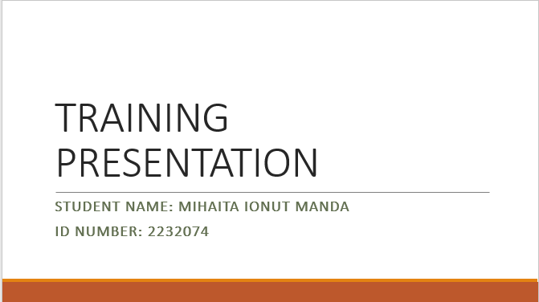

Introduction to Multilingualism
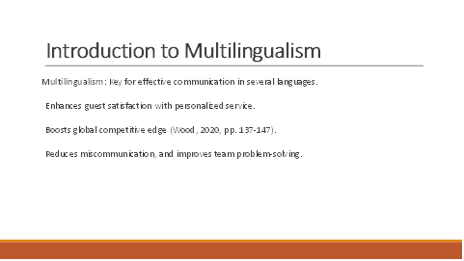

The definition of multilingualism is the ability to communicate effectively in multiple languages (Ioannou and Dukes, 2021, pp. 255-269). They will emphasize its crucial benefits in the hospitality industry, noting that it enhances guest satisfaction through personalized service, boosts the hotel's competitive advantage on a global scale.

Importance of Language awareness skills
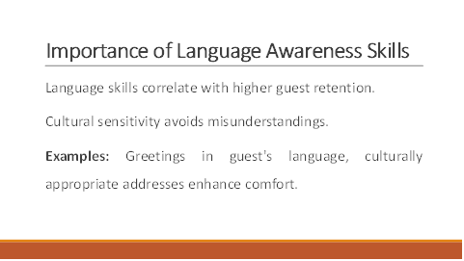
The significant impact of language skills on the hospitality business, emphasises that proficiency in multiple languages directly correlates with higher guest retention rates (Wood, 2020, pp. 137-147). They will highlight the importance of cultural sensitivity in understanding and respecting guest diversity, which helps avoid cultural misunderstandings (Goh et al., 2022).

Case study – Spanish Language
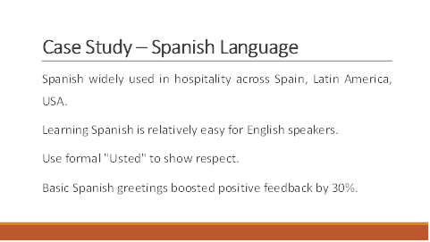

The significance of the Spanish language in hospitality is given its widespread use in Spain, Latin America, and the United States. They will note that Spanish is relatively easy for English speakers to learn (Chan and Hon, 2020, pp. 169-191).

Applying multilingual skills in Rossington Hall Hotel in Doncaster
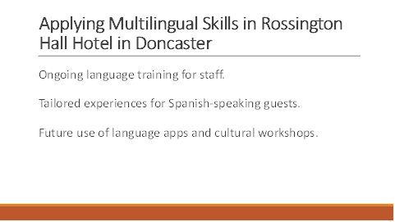

The practical uses of multilingual skills at Rossington Hall Hotel in Doncaster (Goh et al., 2022, pp. 4666-4685). It highlights training programs with ongoing language sessions for staff, guest interactions such as providing Spanish speakers with tailored restaurant recommendations and plans to use language apps and cultural workshops to enhance service (Mark, 2024).

Conclusion

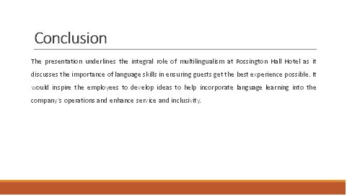

To conclude, the presentation accounts for the importance of multilingualism in Rossington Hall Hotel hospitality. It summarises how language skills can enrich the guest experience. It invites staff to share their opinions with the management committee on including language learning in daily activities, thus developing a more inclusive and efficient service environment.

References
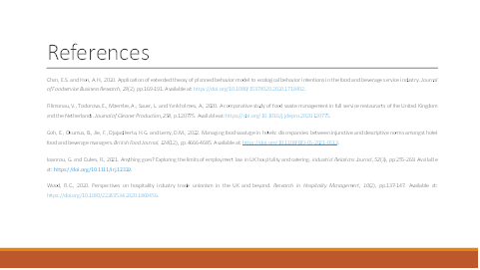

References
Achmad, W. and Yulianah, Y. (2022) Corporate social responsibility of the hospitality industry in realizing sustainable tourism development. Enrichment: Journal of Management, 12(2), pp.1610-1616. Available at: https://doi.org/10.35335/enrichment.v12i2.447.
Chan, E.S. and Hon, A.H. (2020) Application of extended theory of planned behavior model to ecological behavior intentions in the food and beverage service industry. Journal of Foodservice Business Research, 23(2), pp.169-191. Available at: https://doi.org/10.1080/15378020.2020.1718402.
Eid, R. and Agag, G. (2020) Determinants of innovative behaviour in the hotel industry: A cross-cultural study. International Journal of Hospitality Management, 91, p.102642. Available at: https://doi.org/10.1016/j.ijhm.2020.102642.
Filimonau, V., Todorova, E., Mzembe, A., Sauer, L. and Yankholmes, A. (2020) A comparative study of food waste management in full service restaurants of the United Kingdom and the Netherlands. Journal of Cleaner Production, 258, p.120775. Available at: https://doi.org/10.1016/j.jclepro.2020.120775.
Ghani, B., Zada, M., Memon, K.R., Ullah, R., Khattak, A., Han, H., Ariza-Montes, A. and Araya-Castillo, L. (2022) Challenges and strategies for employee retention in the hospitality industry: A review. Sustainability, 14(5), p.2885. Available at: https://doi.org/10.3390/su14052885.
Goh, E., Okumus, B., Jie, F., Djajadikerta, H.G. and Lemy, D.M. (2022) Managing food wastage in hotels: discrepancies between injunctive and descriptive norms amongst hotel food and beverage managers. British Food Journal, 124(12), pp.4666-4685. Available at: https://doi.org/10.1108/BFJ-05-2021-0513.
Ho, Y.Y.C. (2020) Communicative language teaching and English as a foreign language undergraduates’ communicative competence in Tourism English. Journal of Hospitality, Leisure, Sport & Tourism Education, 27, p.100271. Available at: https://doi.org/10.1016/j.jhlste.2020.100271.
‌Ioannou, G. and Dukes, R. (2021) Anything goes? Exploring the limits of employment law in UK hospitality and catering. Industrial Relations Journal, 52(3), pp.255-269. Available at: https://doi.org/10.1111/irj.12329.
Ioannou, G. and Dukes, R. (2021) Anything goes? Exploring the limits of employment law in UK hospitality and catering. Industrial Relations Journal, 52(3), pp.255-269. Available at: https://doi.org/10.1111/irj.12329.
Mahafzah, A.G., Aljawarneh, N.M., Alomari, K.A.K., Altahat, S. and Alomari, Z.S. (2020) Impact of customer relationship management on food and beverage service quality: The mediating role of employees satisfaction. Humanities & Social Sciences Reviews, 8(2), pp.222-230. Available at: https://doi.org/10.18510/hssr.2020.8226.
mark (2024). Rossington Hall - Luxury Wedding Venue, Dining & Accommodation Doncaster. [online] Rossington Hall. Available at: https://rossingtonhall.co.uk/ [Accessed 3 May 2024].
Ntounis, N., Parker, C., Skinner, H., Steadman, C. and Warnaby, G. (2022) Tourism and Hospitality industry resilience during the Covid-19 pandemic: Evidence from England. Current Issues in Tourism, 25(1), pp.46-59. Available at: https://doi.org/10.1080/13683500.2021.1883556.
Sarıoğlan, M., Avcıkurt, C. and Deveci, B. (2021) A study on the applicability of in-service hybrid education in food and beverage businesses (The example of culinary trends). Journal of Educational Technology and Online Learning, 4(4), pp.688-701. Available at: https://doi.org/10.31681/jetol.1015981.
Smart, K., Ma, E., Qu, H. and Ding, L. (2021) COVID-19 impacts, coping strategies, and management reflection: A hospitality industry case. International Journal of Hospitality Management, 94, p.102859. Available at: https://doi.org/10.1016/j.ijhm.2021.102859.
Tsui, P.L. and Chen, Y.C. (2020) Sustainable development of hotel food and beverage service training: Learning satisfaction with the situated cognitive apprenticeship approach. Sustainability, 12(5), p.1951. Available at: https://doi.org/10.3390/su12051951.
Wood, B.P., Eid, R. and Agag, G. (2021) A multilevel investigation of the link between ethical leadership behaviour and employees green behaviour in the hospitality industry. International Journal of Hospitality Management, 97, p.102993. Available at: https://doi.org/10.1016/j.ijhm.2021.102993.
Wood, R.C. (2020) Perspectives on hospitality industry trade unionism in the UK and beyond. Research in Hospitality Management, 10(2), pp.137-147. Available at: https://doi.org/10.1080/22243534.2020.1869456

