

Student name: Sonia Maria Mendes Da Cruz Furtado
Student ID: 2412237

Module name: Introduction to Phisiology
Module code: BMHP5023

Lecturer name: Shaila Hussain

Assessment 1

1. Introduction
This case study report will explore adolescents that have been diagnosed with asthma, as a practice nurse working in a GP surgery it has become necessary to run a fortnightly asthma clinic due to the increased number of adolescents being diagnosed with the condition before in childhood coming back to the surgery with aggravation of their asthma condition. In a meeting with the multidisciplinary team, it was discussed the importance of developing a care plan to help the adolescents understand and manage their condition safely and obtain efficient outcomes as they grow older and starting smoking, vaping and frequenting crowded environments as bars and clubs. This report will provide the adolescents with the information needed for them to understand their respiratory system and its functions, it will include what asthma is and risk factors associated. Furthermore, this report will also explain the respiratory system structures and mechanical process of respiration, the gas exchange in the lungs, irritants such as dust causes impact on breathing leading to swelling in the lung. Additionally, this report will examine how recording and tracking breathing levels help patients with asthma control and monitor their condition safely. Finally, it will include important recommendations of proposed evidence-based strategies in terms of health and social care, including health promotion, to improve the health and well-being of adolescents living with asthma and how lifestyle changes could promote better health.

What is asthma?
Asthma is chronic inflammatory lung disease that affects the airways, known as breathing tubes, which take air to the lungs, it is a long-term non-infectious disease, which affects both children and adults. (WHO, 2025). Asthma results from the inflammation and the tightening of the muscles around the airways making it difficult for a person to breath (WHO, 2025). According, to Statista Research Department (2024) in England under five adults have been diagnosed with the disease, while ten per cent of children’s were diagnosed. Although considered the most chronic lung disease with prevalence among kids it affects individuals of any age. In 2019, approximate 262 billion people were affected and a reason of 455 000 deaths (World Health Organization 2024). In the year 2024, England recorded 854,922 emergency admissions to hospital for respiratory disease, a rate of 1,428 (1,424 to 1,432) per 100,000 population (GOV.UK, 2025). Symptoms of asthma vary, it may intensify specially with exercise and at night, exposure to triggers such as chilly weather dust, fumes, and perfumes. Common signs are intense cough specially at bedtime, wheezing, breathlessness and chest tightness, these symptoms can be mild but in certain cases severe (WHO, 2025).

Risk factors associated with asthma

The risk factors associated with asthma could range from either personal or family allergy background, such as eczema, asthma, allergic rhinitis, and nasal polyps, allergies are observed to happen the most among children over three years old, being sensitive to certain allergens is one of the biggest reason asthmas can happen (Statista Research Department, 2024). Comorbid rhinitis and sinusitis often happen in individuals with asthma; however, comorbid rhinitis is often connected with a more severe disease, asthma is known to be more prominent in boys than girls in childhood, however chronic asthma happens in adulthood more on female than male, overweight and obesity is known to worsen asthma and make the control of asthma worse as due to lack of exercise and reduced lung volume will cause breathless, however, in the United Kingdom colds and flu are the most common triggers for sufferers, followed by weather change and dust (Statista Research Department, 2024). Other factors include exposure to smoking including e-cigarettes, environmental exposure that irritates the lungs such as mould and fungal spores, noxious chemicals, and indoor and outdoor air pollution. House dust mites, pollen, pets if the individual is sensitized (National Institute for Health and Care Excellence, 2025; NHS, 2025).

2. Structure of the respiratory system

The process of mechanical respiration

One of central organ of respiratory system are the lungs, however the system works together with other organs to make the process happen such as the nose and nasal cavity, where the air enters into the human body is filtered, warmed and moistened, than the air is transported to the pharynx (throat) where food and air pass through and connects the mouth and nose to the trachea, through the larynx known as the voice box found on the top of the trachea where is found the vocal cords, and impedes food from going to the person airways into the trachea known as (windpipe) a tube that maintain itself open is supported by rings of cartilage and is essential to transport air from the throat to the lungs, bronchi, the trachea divides in two bronchi situated in the lungs, inside the lungs , the bronchi divide into little bronchioles terminating in small air sacks known as alveoli where the oxygen goes to the body and dioxide carbon is removed when the person briefs out (Cleveland Clinic, 2024). The respiratory system carries oxygen from the air briefed into the body cells, to convert glucose into energy. When the human being briefs in, oxygen is carried to cell that turns sugar into energy, in the form of adenosine triphosphate (ATP). The conversion of glucose produces carbon dioxide as a waste and returns through the respiratory system and is exhaled when a person briefs out. The process includes breathing, gas exchange in the lungs, transport to the blood and cellular respiration (Menefee et al., 2020).

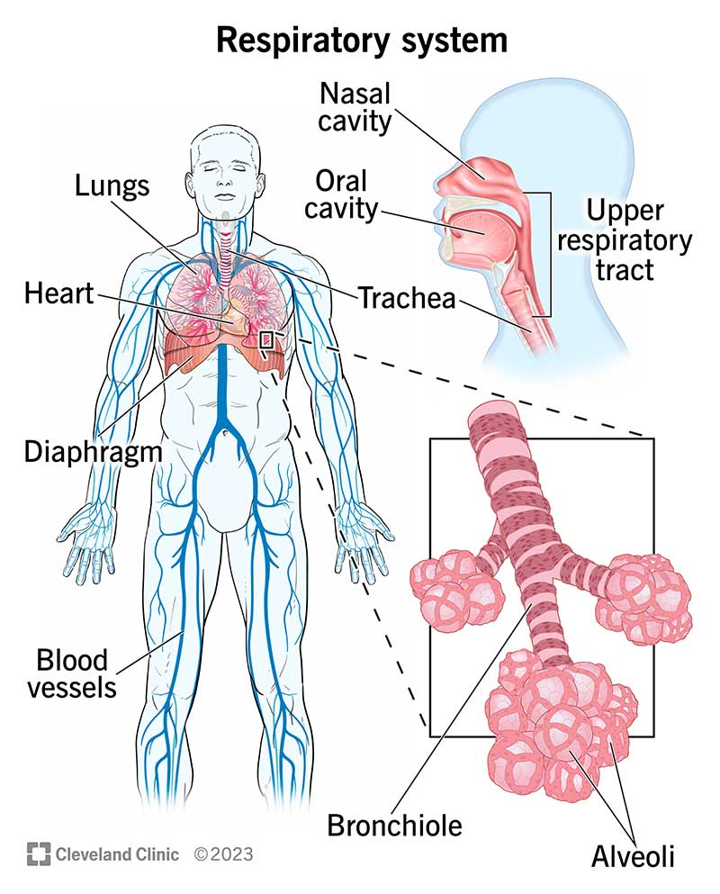(Cleveland Clinic, 2023)
Diagram 1. demonstrates the organs of the respiratory system.

3. Gas exchange in lungs
When an individual briefs air in, it goes down the windpipe and travels into the lungs, goes through the bronchial tubes into small air sacs called alveoli that are surrounded through small vessels called capillaries. Oxygen from the air passes into the blood when a person breathes it in, carbon dioxide in the blood is transported into the alveoli and is briefed out. Oxygen is combined with a protein in the blood known as haemoglobin and transport it to all the body. In the lungs gas exchange happens in the alveoli while oxygen and carbon dioxide passes through respiratory membrane (Asthma + Lung UK, 2024). The main parts of the human body that enables breathing are the lungs where air goes, the rib cage the bone that protects the lungs and expand when inspiration happens, the external intercostal muscles that are the muscles between the ribs and supports in lifting during inhalation the rib cage and the diaphragm that moves up and down to control breathing (Hollis, 2020).
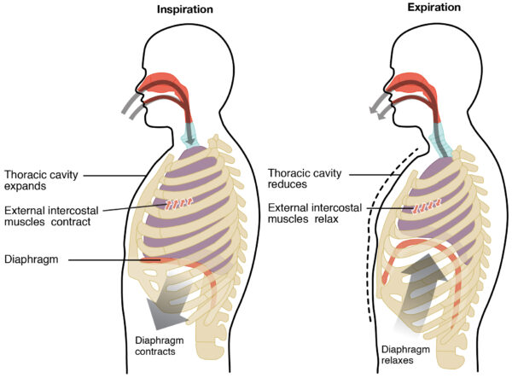(Hollis, 2025)
Figure 2. Demonstrates the anatomical structures involved in respiration.
How increased number of irritants in the respiratory system lead to swelling in the lung tissue, and the impact on adolescents respiration.
Increased levels of irritants in the respiratory system such as cigarette smoke, solvents, ammonia, chloride, smoke, air pollution, when airborne enter inside the lungs inflammation occurs as response of the body to injury and a way to heal itself, this reaction cause production of mucus and swelling in the airways known as viscous substance that involves particles and protects the airways wall and is expelled when coughing. Inflammation is a way for the lungs to heal itself; however constant inflammation can lead to damage the airways and lungs tissues (Myhre, 2023). The swollen of the lungs, leads the air ways to narrow and this make air flow to become harder, making it difficult to brief as air has to move through a tighter passage what requires more effort to breathe, impacting the way oxygen moves into the alveoli slowing down the exit of carbon dioxide from the blood causing a disorder on the way normal gas exchange happens and carbon dioxide can accumulate, as a result symptoms such as coughing, wheezing, exhaustion with physical activities, shortness of breath or chest pain and discomfort, fatigue occurs, however, symptoms may differ from person to person as asthma affects everyone differently, the way it affects a person depends on her symptoms including how well the person responds to the treatment and what triggers them, asthma is often a chronic condition, although in young children asthma often goes away by the time they become adolescent or adults (NHS, 2021).
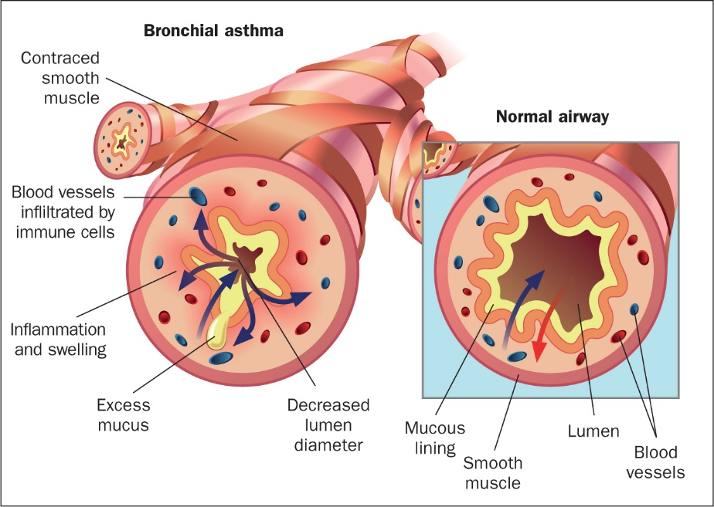 (Wheeldon, 2023).
Diagram 3. Shows airway pathophysiology bronchial asthma inflammation and swelling with excess mucus on the left and normal air way without inflammation.

4. Recording and tracking respiratory functions

Recording and tracking peak flow readings are an effective way to help individuals with asthma monitor and manage their condition safely and often used to diagnose their condition, making peak flow readings a straightforward way patients can measure how fast air can be exhaled from the lungs after a deep inspiration reflecting the level of airway obstruction and respiratory function, if difficult the rate will show the person has asthma and airways are narrowed, although another tests will be needed to confirm the diagnose. For most people inhalers are efficient to low the symptoms and reduce discomfort when used correctly, allowing asthma to have a small impact in their daily life, however, in certain cases individuals experience a severe impact leading to the need of other medications due to the difficulty in controlling the condition (NHS, 2025).

Importance of tracking and recording peak flow

Tracking is important because the score help the patient know whether their condition is getting better or getting worse and it helps the person know if they are having an asthma attack. In addition, when peak flow is measured before and after an asthma trigger exposure, for example a substance a person is allergic to, this may help the person identify and track causes and symptoms (NHS, 2022). If asthma is not controlled and tracked it becomes untreated leading the patient condition to worsen falling on the category of uncontrolled causing discomfort with their symptoms reducing their quality of life, impacting the way they exercise, their physical activities, affecting their productivity due to their symptoms as breathing difficulties cause limits on daily activities, increased risk of fatalities, lung function changes and impact on mental health (Migala, 2023). Consequently, this imposes an urge health and financial burden due to the risk of constant and severe asthma attacks causing pressure on the emergency departments and Hospital admissions and impacts on school attendance and parents missed time from work (CDC, 2022).

5. Recommendations
Research shows that e-cigarettes and smoking are connected to asthma in adolescent and this knowledge can help doctors and schools develop strategies to impede asthma in adolescents from developing (Li, 2022). To help prevent symptoms of asthma and lower the risk of asthma attacks, is important for patients to follow their health care professional’s guidance on how to use inhalers correctly and always keep it with them, regularly exercise in accordance to doctor advice to maintain healthy weight as obesity and overweight makes asthma control and treatment harder, although with precaution if exercise triggers the person symptoms, healthy diet, having flu vaccination updated as viruses such as flu can worsen the symptoms, avoid triggers such as air pollution, vaping, stop smoking, avoid contact with animals, or pollen (NHS, 2025). In addition, to keep asthma controlled it requires self-management looking after own treatment, balancing daily routines and responsibilities, and adapting to the emotional demands of living with the condition (Daines et al., 2020. In a qualitative study throughout ten General Practices involving forty-nine individuals, children with asthma, along with parents and carers described how self-management skills were gradually developed through external sources such as internet and own experience over time with routine tasks and behaviour changes such as taking the medication according to their health care professional direction, became an habit, with only unexpected requiring more reflective problem solving. Only few participants reported the use of a structured action plan, this suggests that healthcare professionals should encourage habitual and reflective aspects of self-management and provide initiative-taking education to help patients have a better outcome on asthma control (Daines et al., 2020).
Health and Social Care interventions include transition support guiding adolescents into adult services encouraging them to think properly about their career options and explain to them that some professions such as hairdressing, farming and others could expose them to dust, fumes, or chemicals that would worsen their condition (NICE.2024). School support as partnership working between schools and health services to deliver asthma information and education, risk-stratified care to identify those at risk and tailor treatment and care tailored to their needs, regular reviews to patients to incorporate person centred care action plans by trained professionals, self- management programs, use of telehealth and IT support such as IT- based monitoring to help patients with self-management, ask adolescents if they smoke or vape and encourage them to stop smoking and provide advice signposting adolescents to NHS services that provide help to patients to stop smoking to improve their health condition (NICE, 2024).

6. Conclusion
In conclusion, asthma is a chronic respiratory disease and is important that adolescents have a clear understanding of physiological process and external factors that can aggravate the symptoms especially during adolescence because, at this stage of their life changes of behaviours happens such as starting vaping, smoking, and exposure to crowded spaces such as bars increase significantly the risk of exacerbations and complications in respiration as it triggers asthma attacks. Providing adolescents with the understanding and knowledge about the respiratory system, how their lung works makes them aware of effects of irritants that can make their condition worsen will equip them with a crucial base for them to manage their health. The use of peak flow measurements regularly to monitor respiratory function allows early detection of changes and asthma control. Furthermore, lifestyle and habits changing recommendations such as stop smoking and vaping, heathy routines as exercise, have a healthy diet, participation in self-management programs, are crucial to adolescents to reduce the symptoms of asthma. In addition, primary care professionals can empower adolescents to manage their asthma safely and effectively by promoting health education, healthy lifestyles choices, and continuously monitoring to ensure long term outcomes in health and quality of life.

References

Hollis, A. (2025). Mechanics of Breathing | Ventilation. [online] Geeky Medics. Available at: https://geekymedics.com/mechanics-of-breathing/.( accessed 30 Nov. 2025)
Asthma + Lung UK (2024). How your lungs work | Asthma + Lung UK. [online] www.asthmaandlung.org.uk. Available at: https://www.asthmaandlung.org.uk/how-your-lungs-work [Accessed 28 Nov. 2025].
CDC (2022). CDC Archives. [online] archive.cdc.gov. Available at: https://archive.cdc.gov/#/details?url=https://www.cdc.gov/asthma/asthma_stats/uncontrolled-asthma-adults-2019.htm [Accessed 30 Nov. 2025].
Cleveland Clinic (2024). Respiratory System: Functions, Facts, Organs & Anatomy. [online] Cleveland Clinic. Available at: https://my.clevelandclinic.org/health/body/21205-respiratory-system [Accessed 28 Nov. 2025].
Cleveland Clinic (2023). Respiratory System. https://my.clevelandclinic.org/-/scassets/images/org/health/articles/respiratory-system. [Accessed 25 Nov. 2025].

Daines, L., Morrow, S., Wiener-Ogilvie, S., Scott, C., Steed, L., Taylor, S.J. and Pinnock, H. (2020). Understanding how patients establish strategies for living with asthma: a qualitative study in UK primary care as part of IMP2ART. British Journal of General Practice, 70(694), pp.e303–e311. doi:https://doi.org/10.3399/bjgp20x708869.
Global Initiative for Asthma (2025). 2025 GINA Severe Asthma Guide - Global Initiative for Asthma - GINA. [online] Global Initiative for Asthma - GINA. Available at: https://ginasthma.org/2025-gina-severe-asthma-guide/ [Accessed 27 Nov. 2025].
GOV.UK (2025). Respiratory disease profile: statistical commentary, June 2025. [online] GOV.UK. Available at: https://www.gov.uk/government/statistics/update-of-indicators-in-the-respiratory-disease-profile-june-2025/respiratory-disease-profile-statistical-commentary-june-2025 [Accessed 27 Nov. 2025].
Li, X., Zhang, Y., Zhang, R., Chen, F., Shao, L. and Zhang, L. (2022). Association Between E-Cigarettes and Asthma in Adolescents: A Systematic Review and Meta-Analysis. American Journal of Preventive Medicine, 62(6), pp.953–960. doi:https://doi.org/10.1016/j.amepre.2022.01.015.
Menefee, W., Jenks, J., Mazzasette, C. and Nguyen, K.-L. (2020). 20.4: The Processes of the Respiratory System. [online] Medicine LibreTexts. Available at: https://med.libretexts.org/Bookshelves/Anatomy_and_Physiology/Human_Anatomy_(OERI)/20%3A_Respiratory_System/20.04%3A_The_Processes_of_the_Respiratory_System [Accessed 27 Nov. 2025].
Migala, J. (2023). What Other Medical Problems Can Occur When Asthma is Untreated? - Asthma. [online] www.healthcentral.com. Available at: https://www.healthcentral.com/article/what-other-medical-problems-can-occur-when-asthma-is-untreated [Accessed 30 Nov. 2025].
Myhre, J. (2023). What to Know about Lung Inflammation. [online] Verywell Health. Available at: https://www.verywellhealth.com/lung-inflammation-1745274 [Accessed 28 Nov. 2025].
National Institute for Health and Care Excellence (2025). What are the risk factors and triggers for asthma? [online] NICE. Available at: https://cks.nice.org.uk/topics/asthma/background-information/risk-factors-triggers/ [Accessed 27 Nov. 2025].
NHS (2021). Asthma. [online] NHS. Available at: https://www.nhs.uk/conditions/asthma/ [Accessed 29 Nov. 2025].
NHS England (2025). Publication reference: PRN01904 Classification: Official. [online] Available at: https://www.england.nhs.uk/wp-content/uploads/2025/03/quality-outcomes-framework-guidance-for-2025-26.pdf.
NHS website (2022). Peak Flow Test. [online] nhs.uk. Available at: https://www.nhs.uk/tests-and-treatments/peak-flow-test/ [Accessed 29 Nov. 2025].
NICE (2024). Recommendations | Asthma: diagnosis, Monitoring and Chronic Asthma Management (BTS, NICE, SIGN) | Guidance | NICE. [online] Nice.org.uk. Available at: https://www.nice.org.uk/guidance/ng245/chapter/Recommendations#asthma-in-adolescents [Accessed 1 Dec. 2025].
Statista Research Department (2024). Topic: Asthma in the United Kingdom. [online] www.statista.com. Available at: https://www.statista.com/topics/3142/asthma-in-the-united-kingdom/ [Accessed 27 Nov. 2025].
Wheeldon, A. (2023). British Journal of Nursing - The respiratory system and associated disorders. [online] British Journal of Nursing. Available at: https://www.britishjournalofnursing.com/content/focus/the-respiratory-system-and-associated-disorders [Accessed 1 Dec. 2025].
World Health Organization (2024). Asthma. [online] World Health Organization. Available at: https://www.who.int/news-room/fact-sheets/detail/asthma [Accessed 27 Nov. 2025].

