Research report The Impact of Impact of Virtual Learning Environment (VLE) – Moodle on students’ learning experience in the University of Wales Trinity Saint David London Campus

Module code BMSW 4003

Student name: Katya Georgieva
Student ID: 1906399

Lecturer name: Modak Koushik

Table of Contents
Introduction 3
Aims and Objectives 4
Secondary Data Analysis 5
Methodology 8
Result Analysis 10
Recommendation 21
Conclusion 21
References 22
Appendix 23
Appendix 2 24

Introduction
The web-based platform that provides digital courses within organizations with study materials, tasks and interacts with the various assessment course structure to enhance students learning experience is Virtual Learning Environment or VLE (Barajas, 2013). With the technological spread, education received massive benefits to provide functional education that bears a significant impact on students learning process. The experience in virtual learning was introduced to progress students learning process from passive to active learners. The platform included experienced teachers and provided educational benefits with technology and practicality.The report discusses the impacts of Virtual Learning Environment on students. The impacts are often not fruitful, as assumed. To determine the effectiveness of virtual learning, a survey has been conducted, and the report analyses the impacts with necessary recommendations. The report consists of both qualitative and quantitative research methods. Most of the research contents are found in the quantitative method. The report also focuses on the advantages and disadvantages faced by students in the VLE learning platform.

Aims and Objectives
Research aim: The research aims to identify the positive and negative impacts of the Virtual Learning Environment (VLE) over the students.
Research Objective: The primary objective of the research is to survey the impacts of Virtual Learning Environments on students. The secondary objectives are:
- To identify a student’s opinion on the Virtual Learning Environment.
- To illustrate the advantages and disadvantages of the Virtual Learning Environment.
- To categorize the acceptance and denial of learning virtually.
- To recognize the availability and flexibility of Virtual Learning Environment.
- To know the influence Virtual Learning Environment makes on students.
- To differentiate the rate of enthusiasm felt by students using Virtual learning technology

Secondary Data Analysis
Digital Learning and its advantages-disadvantages
Learning digital is the core focus of the 21st century. The inclusion of computers in learning has drastically affected conventional teaching methods. With the increasing proficiency of technology by teachers and students, a lot of opportunities emerged in the educational sector. Designing the curriculum and strategical teaching method is student-friendly. The concern is the positive and negative impacts of learning processes. Again, the concerning issue is the computer-based learning. That is, digital learning is providing the actual learning facilities to students or not. Digital learning requires both teachers and student’s interpretation capability both in words and visual context. Notably, the teacher’s role should be much efficient in promoting such contexts. The digitalization of education is undoubtedly expensive. The expensive system switched to lower-cost with the extensiveness of personal computers. Digital learning also increased people’s technological literacy (Blokdyk, 2020).
People bonded with techs and knowledge with instant access to omnipresent data. However, the machines are not fruitful enough if they cannot improve education. Today’s youth communicates through chatrooms, emails, blogs, etc. merely tapping their mobile phones. Educational project work is inclusive of such communications. Students should take advantage of their excitement and tech experiments to connect their teaching with technological use. Finally, digital learning becomes fruitful as the students can increase their self-esteem towards learning and can take benefits with their regular tech interests.

Virtual Learning Environment (VLE) and its influence on students learning
The learning management system that offers courses online supporting and managing resource material over software packages is the Virtual Learning Environment (VLE). The system allows teachers to provide course content using software applications. Online educational platforms like VLE can allow creating course outlines and enroll students. The platform combines interactive elements like questionnaires, quizzes, etc. Virtual Learning Environments can be classified into two types (Hamilton, 2013). The first one is a software package that uploads educational institutions, activities, and resources. Another one is a free software set up by teachers. That is, the former one is institution-led, and the latter one is teacher-led. The issue teachers can find with VLE is that it consumes time for the students who lack adaptability. To provide personalized feedback to students, teachers often prefer the institution-led VLE method. Again, the teachers who prefer teaching according to themselves prefer the teacher-led VLE method. In this sector, the teachers should be technologically expertise. Teaching methods in VLE platforms should be fascinating and making education more meaningful. The technological weakness of teachers can be the weak point to teach in front of tech-savvy students. In VLE, most school teachers are categorized as digital immigrants and students as digital natives. VLE has contributed to ways to forging educational paths. It does not replace teachers in classrooms but provides a significant complement. The teachers and students need to acknowledge the feasibility of an educational setting and shed technological effectiveness with practicality. Most students prefer learning virtually than physically. Some even provided environmental benefits for online exams as it saves up papers and pencils made from trees. Again, some showed their anxiety about online exams, reasoning that they’re less familiar with the learning process. It is a fact that the student’s acceptance of learning and communicating impacted the virtual learning process. It can be summarized that; students have both positive and negative manifestations regarding technology use in the educational field. Most researchers found a positive attitude toward the learning method. The negative impacts should be overcome by providing a flexible educational system by choosing alternatives from the internet.

Students attitudes towards tech-based education
The field of education and learning has become much smoother with the implementation of modern technology. The combination of audio, messages, and video provided a select format in computer-assisted learning. Despite educational benefits in the technological learning field, there are some criticisms (Joel Weiss, 2018). Teachers and institutions perceive that students will enthusiastically receive technological benefits to educate themselves for their experience with technological gadgets. Students grow up with technology as an integrated part of his life. But some students are afraid of technological uses. Some divide up for economic and cultural issues. Though the era is technology-based, often, most teachers and students do not have access to technological devices. All these reasons created a gap of digital competency between the teacher and students. It is evident from different researches that, even having a fear of technological learning, a significant percentage of response towards tech-based learning is positive.

Methodology
The perceptions ofthe Virtual Learning Environment are taken from qualitative and quantitative research instruments. The hypothesis stated in the research is provided with statistics and qualitative instruments (Thomas, 2012). The perceptions of the Virtual Learning Method are analyzed with a set of questionnaires.
Data Collection:
Primary Source: The primary source of data collection was collected from a survey questionnaire.
Secondary Source: The secondary source of data collection is from websites, journals, books, and interviews.
Instrumentation:
Entry Questionnaires: A structured survey is to be completed that inquires on the experience of VLE and its competency level. Following categories of questions are included in the survey:
- Closed-end question: The question’s answer with specific options as simple as Yes or NO.
- Multiple choice question: The questions included in the survey has more than one choice that can be selected according to the respondent’s opinion.
- Likert scale question: The survey question includes the level of agreement a respondent holds about the process.
- Open-end question: The question requires a minimum one statement and provides a free opinion to the survey.
Class Observation Forms: The survey is conducted through online class observation forms mailed to the students. Within a week or two, the students had to respond to the form via email.
Participants: The survey is conducted mainly on the students. About 210 students participated in the survey from different institutions. The respondents are all students inclusive to Virtual Learning Environments.
Ethical Consideration: The respondent’s feedback as confidential. It was informed to the students that personal information would not be revealed. Digital analyzing tools were used to assess the result to avoid any misconduct. Any sort of distractions was influenced to be removed for effective survey results.

Result Analysis
Virtual Learning significantlyincreased students learning engagements (Thomas, 2012). Among 210 students who participated in the survey, a higher mean score in favor of using VLE was found. The probability for the educational information was P = 0.03. From this, it can be analyzed that student’s learning has no impact on Virtual Learning Environment. The platform provides ease learning with satisfaction. From the qualitative research, it is analyzed that VLE visuals are helpful, the communication is informative, and details are required.
Following questionnaires were used to determine the survey result:
Questions | Type
- Please choose your age group | Closed-end question
- What is your opinion on virtual learning and the experience it brings? | Open-end question
- Do you have access to VLEs and Moodle from home? | Yes or No question
- Would you say VLEs affect your studies? | Closed-end question.
- Would you say VLEs play an essential role in your studies? | Closed-end question.
- Would you say you learn more with VLEs than without? | Closed-end question
- Would you say you are encouraged to learn more at your own pace using VLEs? | Closed-end question
- Would you say you feel more communicative through the use of VLEs? | Closed-end question
- Would you consider VLEs as your primary learning resource material hub? | Closed-end question
- How enjoyable would you rate your learning experience when aided by VLEs? | Likert scale question

The key finding from the survey is discussed below. Necessary recommendations are provided at the end of the discussion (Secker, 2014).
Question 1: Please choose your age group?
The question consisted of four options. The respondents from different ages were classified into four groups.
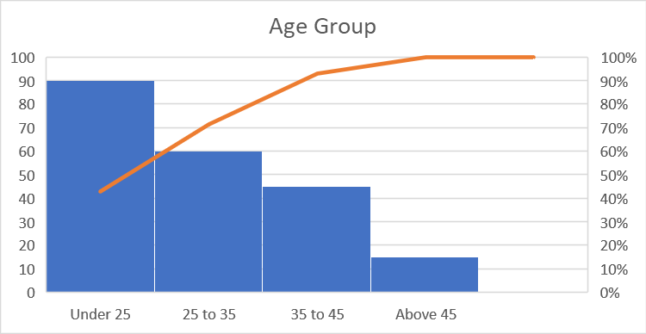
Fig: Age Group of survey respondents
Graphical analysis: Among 210 respondents, 90% of the respondents were from the age group below 25. The least participants were from the age group above 45.
The analysis means that most of the respondents were young and was well attached to technological learning. A very few respondents of middle aged to old were interested in VLE. Which means that young respondents are more in favor to VLE than people of other age.

Question 2: What is your opinion on virtual learning and the experience it brings?
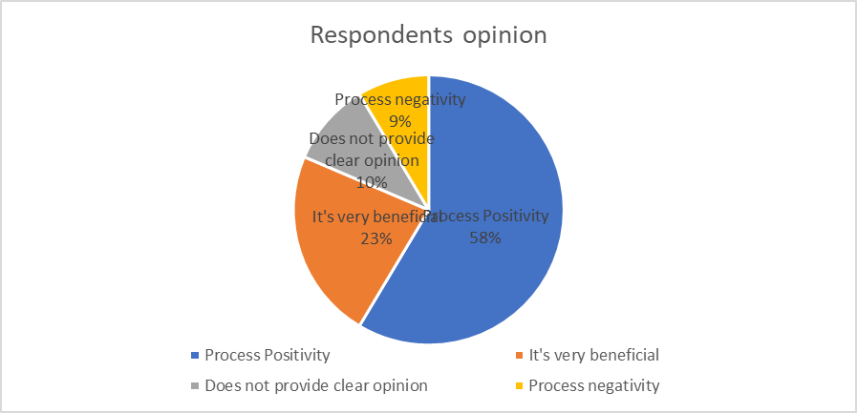
Fig: Respondents opinion
Graphical Analysis: 58% of the respondents showed positive attitude towards VLE experience, 9% showed negative opinion, 23% agreed that they received beneficial experience, while 10% did not provide any clear opinion.
In this analysis, it can be seen that different respondents provided different opinions regarding the survey. Most respondents showed their positive attitude towards virtual learning. Some provided recommendations to improve the learning platform, so the students get more ease with it.

Question 3: Do you have access to VLEs and Moodle from home?
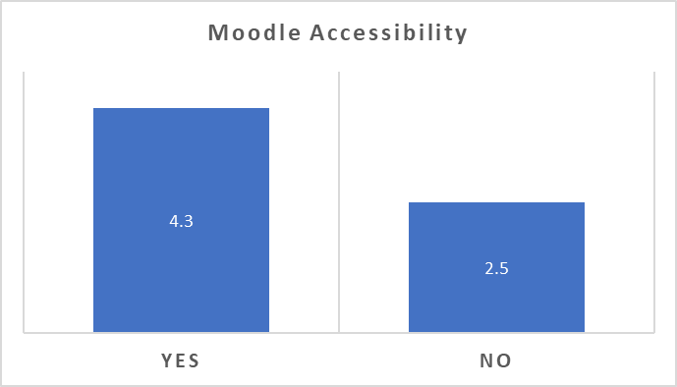
Fig: Respondent accessibility.
Graphical Analysis: The graph demonstrates that out of 210 respondents, a probability value of 4.3 respondent has moodle accessibility from home whereas 2.5 respondents do not.
The question was a Yes or No question with the highest respondents informing that they have accessibility to VLE’s and Moodle from their home. Less but significant respondents provided that they do not have accessibility to VLEs and Moodle from home. To access such activity, it is predicted that most students face a lot of turmoil to educate themselves online.

Question 4: Would you say VLEs affect your studies?
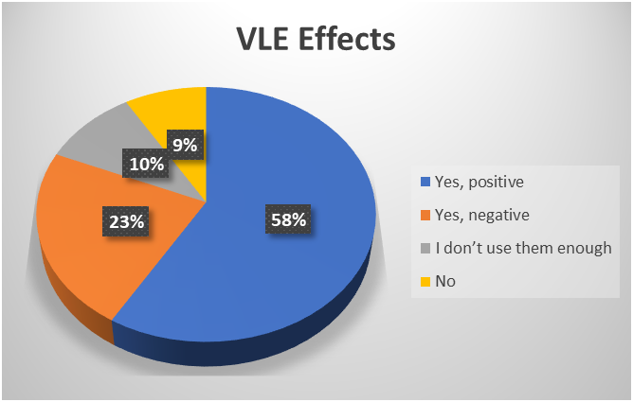
Fig: VLE impacts
Graphical Analysis: The 58% respondents provided that they have a positive impact on VLE. Only 9% of respondents directly ignored the impact of VLE on studies. 10% respondents said that they do not use them enough while 23% said that VLE impact their studies but negatively.
It can be said from the analysis that different students have different opinion regarding the impact of VLE. Most students showed VLE has a good impact on students. To decrease the negative impacts, the teachers and institutions should allow students to share their concerns and reduce them as much as possible.

Question 5: Would you say VLEs play an essential role in your studies?
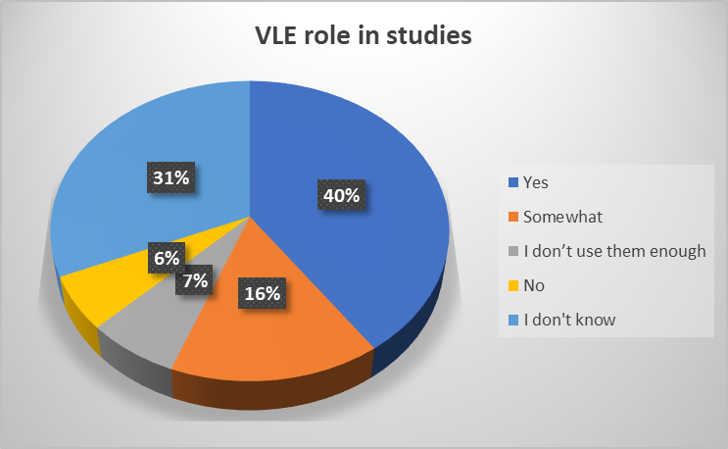
Fig: VLEs role in respondents’ studies
Graphical AnalysisAbout 40% of the respondents said that VLEs plays an essential role in their studies. 31% of respondents are confused about it, while 7% don’t use them enough. 6% student directly ignored VLE’s role in their studies and 16% said VLE somewhat play some role in their studies.
From the analysis, it can be summarized that most respondents feel VLE has a role in their studies. Teachers should talk about the importance and benefits of VLE’s role in studies to the students and should effectively make them feel the crucial role VLE plays in students studies.

Question 6: Would you say you learn more with VLEs than without?
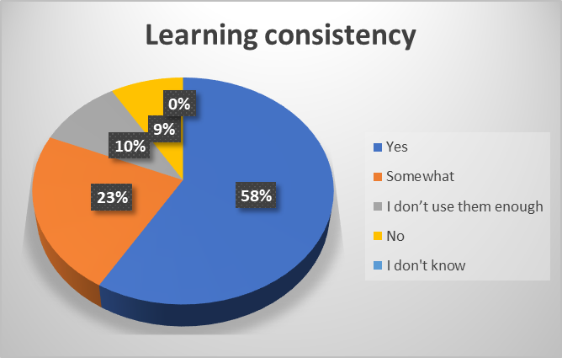
Fig: Respondents learning consistency using VLEs
Graphical Analysis: 58% respondent said that they learn more with VLE than without VLE. 9% ignored the fact saying they learn without VLE more than with VLE. 23% responded that they somewhat learn with VLE while 10% said they do not use them enough. No respondent said that they do not know about the issue.
From the analysis it is seen that a significant respondent responded that they somewhat learn more without VLE. Most of the respondents still on the point that they learn more using VLEs. Teachers should provide more practical and enhance use of learning with VLE and use latest technologies to increase students learning consistency with VLE.

Question 7: Would you say you are encouraged to learn more at your own pace using VLEs?
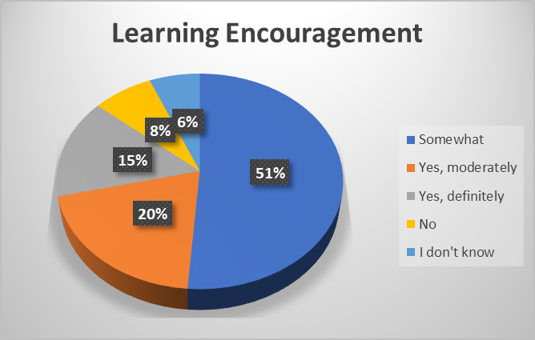
Fig: Respondents learning interests in VLE.
Graphical Analysis: 51% respondent said they were somewhat encourage to learn more at their own pace. 20% provided a moderate answer, 8% said that they do not, while 15% said they definitely are encourage to learn at their own pace using VLE. 6% respondent said they do not know how VLE interests them in the learning process.
From the analysis, it can be seen thatmost of the respondents said that they are somewhat encouraged to learn at their own pace using VLES. All the respondents said that they are encouraged to learn at their own pace. Teachers should be able to motivate their students in VLE platform and should apply interesting teaching methods to encourage them learning.

Question 8: Would you say you feel more communicative through the use of VLEs?
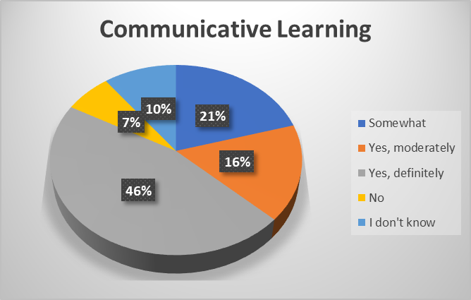
Fig: Respondents opinion in VLEs communicative learning
Graphical Analysis: About 46% of the respondents feel that learning through VLE is communicative. Only 7% do not feel that learning through VLE is not communicative enough. 21% respondent said they somewhat feel VLE is communicative. 16% should moderate respone while 10% said that they do not know.
From the analysis it can be seen that most respondents feel VLE is a communicative learning process. Teachers should talk with the students where theu face issue in VLE platform and apply technological methods to enhance the communicative process.

Question 9: Would you consider VLEs as your primary learning resource material hub?
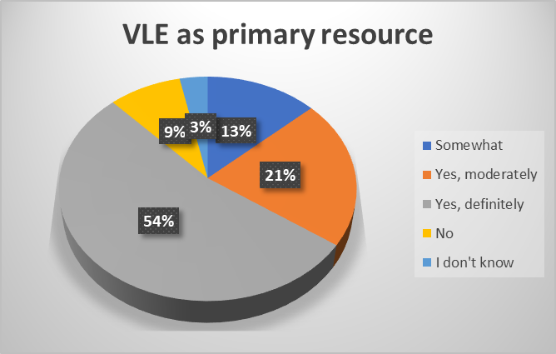
Fig: Respondents opinion on VLEs resource utilization
Graphical Analysis: 54% respondent feel that VLE is the primary source of hub, 21% felt the same but moderately. 13% somewhat thinks VLE as a material hub while 3% said they do not know. 9% respondent ignored the fact that VLE is a primary resource to hub.
From the analysis, it can be seen that most of the respondents think that they will consider VLE as primary learning resource material in the hub. Students should be cooperative towards VLE platform and try to learn the methods to utlize VLE as a primary resource.
Question 10: How enjoyable would you rate your learning experience when aided by VLEs?
The question is the Likert scale. The rate one starts from not enjoyable to rate ten, which is very enjoyable.
1  10% | 2  5% | 3  0% | 4  15% | 5  20% | 6  0% | 7  35% | 8  5% | 9  5% | 10  5%

Graphical Analysis: 35% respondent said they moderately enjoy the learning experience using VLE. While 10% said they enjoy it at least and 5% rated that they enjoy it at best.
From the graphical analysis, it can be seen that most respondents rated that they somewhat enjoy the VLEs learning experience. Teachers and students should be cooperative enough and make the best of VLE platform to provide each other the best learning experience.

Recommendation
It is recommended that students should adopt the learning opportunities at their best and seek assistance during difficulties. Various issues will arrive virtually that arrive physically as well. A cooperative mindset would help the process more flexible.

Conclusion
Virtual Learning Environment is an online platform that assists learning Virtually. The report presents the impact of virtual learning on students. It can be concluded that most students responded positively (Management Association, 2012). Yet some recommendations are offered to improve VLE correlated classes

References
Barajas, M., 2013. Virtual Learning Environments in Higher Education. 5th ed. s.l.:Edicions Universitat Barcelona.
Blokdyk, G., 2020. Virtual Learning Environment A Complete Guide. 1st ed. s.l.:5STARCooks.
Hamilton, M., 2013. Autonomy and Foreign Language Learning in a Virtual Learning Environment. 4th ed. s.l.:A&C Black.
Joel Weiss, J. N. J. H. P. T., 2018. International Handbook of Virtual Learning Environments. 5th ed. s.l.:Springer Science & Business Media.
Management Association, I. R., 2012. Virtual Learning Environments. 5th ed. s.l.:IGI Global.
Russell, D., 2019. Cases on Collaboration in Virtual Learning Environments. 6th ed. s.l.:IGI Global.
Secker, J., 2014. Electronic Resources in the Virtual Learning Environment. 5th ed. s.l.:Elsevier.
Thomas, M., 2012. Design, Implementation, and Evaluation of Virtual Learning Environments. 8th ed. s.l.:IGI Global.
Thomas, M., 2012. Technologies, Innovation, and Change in Personal and Virtual Learning Environments. 3rd ed. s.l.:IGI Global.
Weller, M., 2017. Virtual Learning Environments. 5th ed. s.l.:Routledge.

Appendix
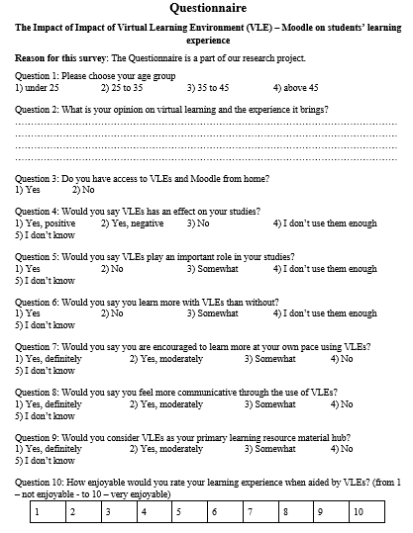

Appendix 2


