Student Name: Muhmmad Naveed Jawed

Student Id Number: 2240728

Programme: BA (Hons) International Gastronomy Management

Module: Marketing & Sales

Module code: BMGM5001

Lecturer: Antoinette Milne

Word Count (or Equivalent): 2000(2166)

Submission Date: 17 May 2024

Assignment 1 – Essay
The sales and marketing concept of Dishoom, the chain of restaurant all over in UK and examining strategies examining 4 Ps of Marketing

Introduction

Dishoom is a popular Indian restaurant chain all over in UK, has significantly garnered a unique dining experience for their customers with beautiful ambience. It is inspired by the Bombay’s old style Irani cafés that incorporates the traditional and modern contemporary elements in its branding and services.

This essay will demonstrate the sales and marketing concepts and strategies of Dishoom, emphasizing on the marketing mix (4 Ps), discusses the use of segmentation, targeting and positioning in its marketing strategy. This essay will also highlight the current strategies and make recommendations to enhance Dishoom’s marketing activities for future growth, keeping the contemporary concerns in the hospitality market into consideration.

The Marketing Mix (4Ps) at Dishoom. Eugene McCarthy, American professor introduced the idea of the 4 Ps of product, price, place or distribution, and promotion, in his popular book called "Basic Marketing." Afterwards this concept was adopted my many other professors like Philip Kotler. (Baker, MJ (2016, April 28))

Evaluating and decoding your marketing strategies are just getting even harder because restaurants have very limited marketing budget and If it gets right restaurants may have competitive edge but if it goes wrong there is no way you buy success. (Taylor, M (2021))

Different combinations of product, price, place and promotions are experimented to attain the desired outcome. (Marketing Mix, 2024,May).
however sometimes marketing especially digital can make or break a restaurant because the product should be equivalent to the promotion. (GA: CNN Atlanta (2018))

Product

While examining marketing mix for Dishoom let’s initiate with the product dishoom offers, is inspired by nostalgic Irani cafés of Bombay. The décor, menu and ambience of the restaurant reflects the blend of Indian Street food favourites like pav bhaji , vada pav and classic Indian food like biryani’s , kebabs and curries .

Wander into any Dishoom on a Wednesday and enjoy a simple yet sublime Bun Maska Chai, offered complimentary between 2pm–5pm.Dishoom has a capacity of 60 – 70 guests within the restaurants and dishoom not just offer table service but also offers takeaways, delivery, and catering services. Recently dishoom initiated their dishoom stores online where you can buy cooking kits with the recipes to have same at home.

A cherished Bombay tradition offered freely.
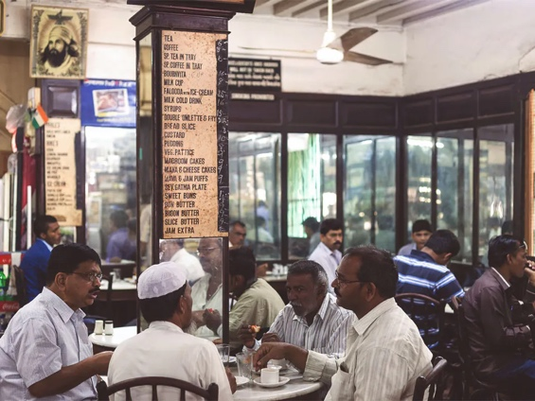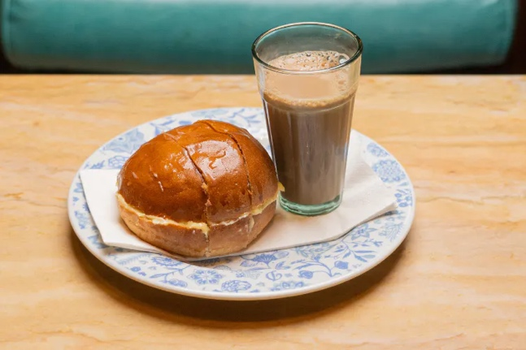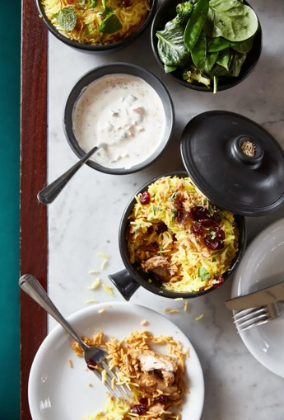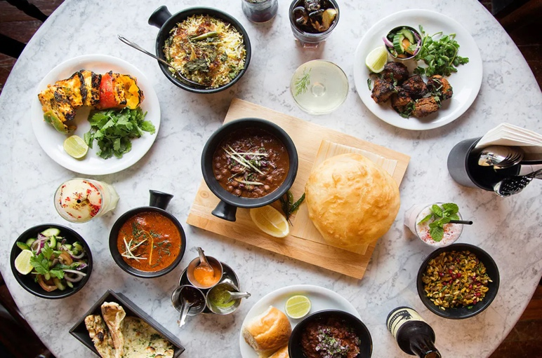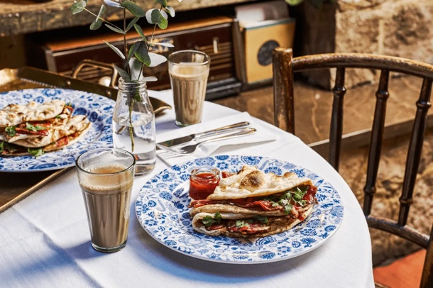(Dishoom.com, 2024, May)

Dishoom recommends a bowl of date and banana porridge or a Bacon roll in Naan bread, Fragrant freshly baked pau with butter with Chai in breakfast to start your day.
At Lunch the welcome their guests with the Roomali Roti Rolls, stuffed with matter paneer, or fresh salads, as before the dusk, sunset café fills with the warmness of old friends meet and chat while slow cooked aromatic biryanis , smoky melt in the mouth grill food and spicy curries make their way to the tables to make it even more pleasant evening . but it’s always better to check with the franchise because the menu might differ from outlet to outlet.
Dishoom also extend its product range with themed events, cookbooks, and merchandise, reinforcing its brand identity. (Dishoom.com, 2024, May)

Price

Restaurant owners often invest in different marketing activities and apply dynamic pricing strategies to attract potential customers and effectively increase their sales. (Schlosser, R. and Chenavaz, R.Y. (2023))

Dishoom positiookn itself as a mid-range restaurant, offering quality food at a reasonable price. Positioning is creating a perception value of your product in the minds of consumer with the comparison of other competitors.
(Kotler, P. and Armstrong, G. (2013)).

Dishoom has set their pricing strategy to acquire attention from broader range of customers, vary from families to young professionals, the approach is to balance the affordability with the perceived value, to ensure that customers feel they are getting the best value for the price and experience offered. Dishoom make sure that pricing should support the value proposition.
(Marketing Strategy Price. (2021) Vd)

Place

Dishoom has strategically chosen the location of the restaurants in central London to attract a diverse clientele, that includes residents, tourist, and office workers. The restaurants are typically located in the vibrant neighbourhoods to maintain high traffic of customer footfall, complemented by the interior design that contributes to ambience, evoking the old-world charm of Bombay’s Irani Cafes while keeping up with the modern classic feel.

Dishoom made themselves widely available all over UK and Managed by 5 Marketing managers based across the UK to maintain and grow 8 restaurant’s and 10 delivery kitchen and online store.

Recently in 5 years opened 4 restaurants in London, Birmigham, Manchester and Edinburgh. Sara Stark (Marketing and Creative Director at Dishoom) some of the recent highlights are.

- Launching of delivery kitchen since July 2020, including 2 new territories (Cambridge and Brighton) beating Deliveroo estimated sales revenue each week and maintaining delivery business as a significant part of the core business.

- Enlarged sales from e-commerce by internal multidisciplinary marketing team with external digital marketing agencies to reform Dishoom stores in November 2020 and increased sales by more than 100% by March 2021.

- Used Market insights and customer perspectives to grow included soft launches twice in Birmingham and ‘new’ Convent Garden

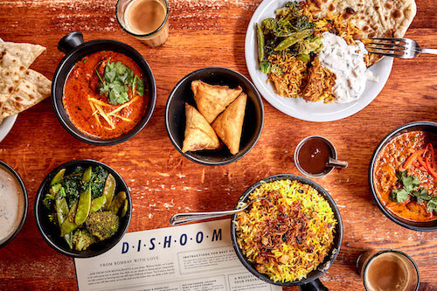(www.clarereidmarketing.co.uk , (2024,May))

Promotion

Promotion is actual efforts that company undertakes that educate the end consumer of the product or services the organisation offers, primarily television advertisements, newspaper, radio and magazines , billboards , public relations events but new age requires internet marketing through social media or search engine optimisation , but all these methods are critically examined with the cost incurred in this methods with return on investment any method is entirely depends on the product or services the organisation has to offer and what kind of brand image organisation wants to build in the consumer’s mind.

Some of the restaurant apply brand endorsements from the celebrity chefs, Hollywood/Bollywood actors, some opt for digital marketing i.e. advertisements on Facebook, google, twitter, TikTok and Instagram. (Marketing plan promotions. (2021))

Dishoom Restaurants employs various promotional strategies, including digital marketing, social media, and public relations. The restaurant believes in strong visibility on online platforms like twitter and Instagram. DIshoom carries a nostalgic emotional message about restaurant’s history and culture, to connect and engage customer, The restaurant also has strong reliance om word of mouth publicity and recommendations from google reviews and trip Advisor.

While promoting the product and services Dishoom emphasised on market research and enquire about the value proposition and brand’s cultural relevance amongst the Generation Z and then designed the channel mix through which they can best engage the audience. (www.clarereidmarketing.co.uk)for continuously 2 years DIshoom was entitled for the “best UK” restaurants and named #36 on the Sunday telegraph list of the top 100 companies with more than 700 employees. (www.superhero.com/dishoom, (2024, May))

Segmentation, targeting and positioning.

Dishoom success is strongly depends on their effective segmentation, targeting, and positioning strategy which gives them competitive advantage over other companies.
Segmentation and Targeting Is the classification of consumers based on Demographics, geographic factors, socio-economic, behavioural/psychographic, and attitudinal traits. (Sleight, P. (2008)) the demographic segmentation considers age, income, and family structure, while psychographic segmentation looks at lifestyle and values.

Geographic segmentation focuses on central London and other key locations where Dishoom has a presence. so practically Dishoom is targeting age of 2 years old to 80 years old, geographically Dishoom is situated in the hearts of major cities.
It’s difficult to identify the right customers to engage in successful marketing campaigns.
(Walters, M. and Bekker, J. (2017))

Primarily Dishoom targets young professionals, families and tourists seeking a unique dining experience with authentic taste and unique dining experience with an Indian curtain. The restaurants attract to the broader audience by offering diverse options in their menus which includes vegetarian and vegan options comes up with a very friendly and welcoming atmosphere. The strategy is inclusive, aims to create a comfortable space for the people who belongs to different backgrounds.

Positioning

DIshoom position itself as a modern classic Indian cuisine with the twist of tradition Irani cage majorly focus on Bombay food. Creating a unique identity that resonates with customers. This positioning allows Dishoom to Differentiate itself in a crowded market and build a loyal customer base.

Dishoom’s marketing communications are implemented to recreate its brand identity and build a relationship with customers. The restaurant applies mix of traditional and digital market channels to approach target market.

Digital Marketing

The range of digital channels use to market products and services to reach end consumer. 8 typically used digital marketing mediums are website marketing, pay-per-click advertisement, content marketing, email marketing, social media marketing, Affiliate marketing, video marketing, text messaging(www.investoipedia.com)
Dishoom has a very strong digital marketing strategy, with an active visibility on social media platforms like Twitter, Instagram, and Facebook.

The restaurant markets engaging content, including behind the scenes (kitchen stories), testimonials from customers and promotional campaigns. Dishoom keep building their brand narrative by storytelling and visually appealing imagery. For example Feed the Lion is a YouTube Channel, that covers the story of the restaurant meet the head chef share the story like, Kanaishka, Mathura,Beneras (restaurants owned by Atul Kochar) have gained more popularity after being published by such online platforms.

Traditional Marketing

With the advent of digital marketing, the traditional marketing cannot be neglected as a large amount of audience still relate to tv, radio, billboards, branding, and event marketing For example Mcdonald’s , coke , pepsi and all these big brands invest heavily on traditional marketing and still reap the benefits out of it .Dishoom should also consider partnerships with the influencers and blogger for example Saudia Arabia is promoting their tourism by Messi (the celebrity footballer ).

Chakk 89 has been endorsed by so many celebrities, These strategies might help Dishoom to keep reminding their existing customers and attract new audience.
Dishoom also encourage their employees by organising events for them and make them feel more like a family member.

Public Relations

Dishoom has embraced a positive media coverage featuring in prominent publications and favourable reviews from food critics.

Dishoom has always maintain a very positive reputation and build a strong value proposition in the minds of their customers.Dishoom has built their PR strongly and took the title for “Best Uk” restaurant and also named #36 on the Sunday telegraph listof the “top 100 companies with more than 700 employees.

Strategies and Recommendations for Future growth:

DIshoom has built a robust brand image in London but there are always opportunities for future growth and enhancement of marketing activities. Here are some of the recommendations:

Dishoom has a solid social media presence, but there is always an opportunity of expansion into new platforms like TikTok, where they can make shot story telling videos to grab attention from new customers. This can target a broader audience as now TikTok is one the most famous advertising platform and people from age 9- 80 everyone watches reels to get more recommendation. TikTok and other social media reels can reach to millions of views and can boost sales by 200 percent.

Creating interesting content for example video tutorials of authentic Indian street food and the stories behind those dishes.

Customer loyalty programme that gives back to the customers for their loyalty towards this eatery so that may be followed by their next coming generation.
Encourage repeat customers by giving them discount cards, invitation to the exclusive events and keeping their opinion for the new menu or addition in the menu that might help building strong relationship
Dishoom should also participate in more corporate events and should grow themselves more socially, should also display their social responsibility to the society.

To create greater value Dishoom should start collaborative value creation as it will affect in every sector. (Austin, J. E., & Seitanidi, M. M. (2012)) Dishoom could explore partnerships with local artists, musicians, or designers to host events and attract new range of customers. because understanding consumer behavior is the core of marketing (Bowie, D. (2017)) Dishoom with other similar restaurants in ce
ntral London. When there was lockdown in covid dishoom quickly launched their famous bacon naan kit at home and start selling it e-commerce platform, called the Dishoom store.

(www.engageinteractive.co.uk (2024 May))
The unique concept of Irani cafes sets it apart from traditional Indian restaurants.
The emphasis on storytelling and cultural nostalgia creates a distinct identity that resonates with customers. Other restaurants in the area may focus on fine dining or specific Indian regions, appealing to different demographics while using traditional marketing channels,Dishoom’s emphasis on digital marketing and social media gives it a competitive edge in reaching a broader audience.

Conclusion

Dishoom's marketing and sales strategies effectively integrate the 4 Ps of marketing with a robust segmentation, targeting, and positioning strategy. The restaurant's unique identity, firm digital presence, and emphasis on storytelling contribute to its achieving organisational goals in the competitive market of restaurant in London.

By implementing the recommended strategies, such as expanding the digital presence, introducing customer loyalty programs, and focusing on sustainability, Dishoom can enhance its marketing activities and achieve potential future growth. Ultimately, Dishoom's approach to marketing and sales offers valuable insights for other restaurants seeking to establish a unique brand identity and connect with a diverse customer base.

References

- ( https://hstalks-com.ezproxy.uwtsd.ac.uk/t/2183/the-marketing-mix/?business)

- (Taylor, M. (2021) Marketing Attribution and Mix Modeling. Carpenteria, CA: linkedin.com.)

- (The Marketing Mix Explained. Anonymous TV Choice, . https://video.alexanderstreet.com/watch/the-marketing-mix-explained.)

- (How Instagram can make or break a restaurant (2018). Atlanta, GA: CNN Newsource Sales.

- https: //www.dishoom.com

- .(Schlosser, R. and Chenavaz, R.Y. (2023) ‘Joint dynamic pricing and marketing‐mix strategies for revenue management applications with stochastic demand’, International transactions in operational research [Preprint]. Available at: https://doi.org/10.1111/itor.13352.)

- Kotler, P. and Armstrong, G. (2013) Principles of marketing. 6th ed. London: Pearson.

- Marketing Strategy Price. . (2021).[Video/DVD] Business Professor. Retrieved from https://video.alexanderstreet.com/watch/marketing-strategy-price

- https://www.clarereidmarketing.co.uk/work/dishoom-marketing

- Marketing plan promotions. (2021). Place of publication not identified: Business Professor.

- . (https://www.clarereidmarketing.co.uk/work/dishoom-marketing

- https://www.coursehero.com/file/143428586/Dishoomdocx/

- https://brand.thisisdefinition.com/insights/dishoom-an-irresistibly-aligned-experience

- Sleight, P. (2008) Targeting & segmentation in marketing. London: Henry Stewart Talks.

- Walters, M. and Bekker, J. (2017) ‘CUSTOMER SUPER-PROFILING DEMONSTRATOR TO ENABLE EFFICIENT TARGETING IN MARKETING CAMPAIGNS’, South African journal of industrial engineering, 28(3), pp. 113–127. Available at: https://doi.org/10.7166/28-3-1846.

- https://www.investopedia.com/terms/d/digital-marketing.asp#:~:text=Digital%20marketing%20is%20the%20use,and%20sell%20products%20and%20services

- https://www.investopedia.com/terms/m/marketing.asp

- .Austin, J. E., & Seitanidi, M. M. (2012). Collaborative Value Creation: A Review of Partnering Between Nonprofits and Businesses. Part 2: Partnership Processes and Outcomes. Nonprofit and Voluntary Sector Quarterly, 41(6), 929-968. https://doi.org/10.1177/0899764012454685

- Bowie, D. (2017) Hospitality marketing. 3rd ed. London: Routledge.

- https://engageinteractive.co.uk/work/digital-marketing-success-for-dishoom-from-engage-leeds-with-love#:~:text=We%20developed%20a%20strategic%20approach,they%20were%20ready%20to%20purchase.

